An Introduction to Stochastic Differential Equations (SDEs)

1. Deterministic vs Random Systems
Ordinary differential equations (ODEs) describe how systems evolve in time under deterministic rules. For example:
dx/dt = b(x), x(0) = x₀
However, in reality, measurements and systems often fluctuate randomly. We can represent this randomness by adding a noise term:
dX = b(X)dt + σ(X)dW

2. What is a Brownian Motion?
Brownian motion W(t) models the random motion of a particle suspended in a fluid. It starts at zero, has independent and normally distributed increments, and continuous but highly irregular paths.

3. The Idea of an SDE
An SDE combines deterministic and random effects:
dXₜ = b(Xₜ)dt + σ(Xₜ)dWₜ
In integral form:
Xₜ = X₀ + ∫₀ᵗ b(Xₛ)ds + ∫₀ᵗ σ(Xₛ)dWₛ
The second term is a stochastic integral.

4. Understanding the Itô Integral
The integral ∫₀ᵗ G(s)dWₛ is defined as a limit of sums:
Σ G(tᵢ)(Wₜᵢ₊₁ − Wₜᵢ)
It captures how random fluctuations accumulate over time. Unlike normal integrals, (dW)² behaves like dt.

5. Itô’s Formula (Chain Rule for Randomness)
If dX = b(X)dt + σ(X)dW, then for a smooth function f(X):
df(X) = f'(X)b(X)dt + f'(X)σ(X)dW + (1/2)f''(X)σ²(X)dt
The extra term (1/2)f''σ²dt arises from the randomness of W.

6. Examples
•Geometric Brownian Motion (finance):
dP = μPdt + σPdW → Pₜ = P₀ exp((μ − σ²/2)t + σWₜ)
• Ornstein–Uhlenbeck process (physics):
dX = −θXdt + σdW models mean-reverting behavior.

7. Key Takeaways
• Brownian motion represents continuous random noise.
• Itô calculus extends differential calculus to random systems.
• SDEs are fundamental in physics, biology, and finance.
Figure 1. Sample Paths of Brownian Motion
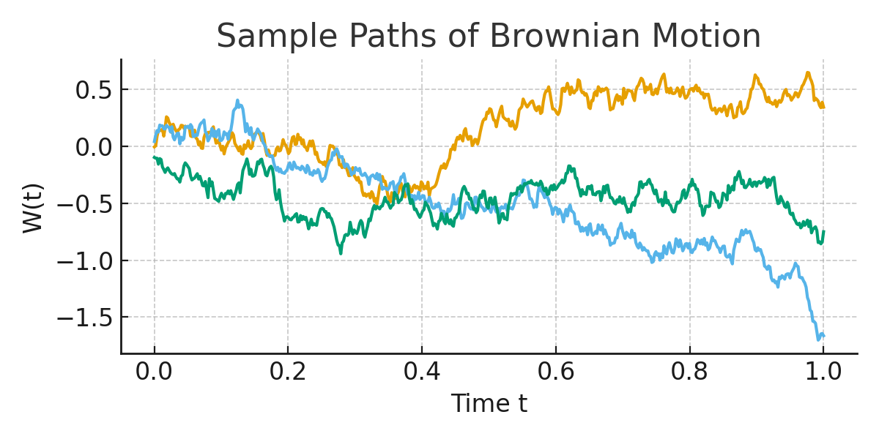
Figure 2. Example: Geometric Brownian Motion (Stock Price Path)
