Intro to C++

Assignment 1 Part 3.5 (Code Snippet Analysis)

**Snippet 1**

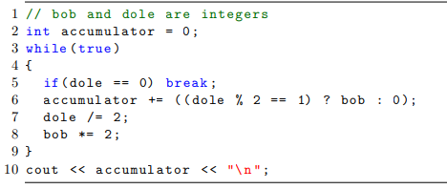

This snippet computes dole times bob. It multiples bob * (binary breakdown of dole). This is $bob_{original}\sum_{0}^{n}{(({dole}_{n}\% 2)*2^{n}) }$ when n is the last iteration before dole = 0. For example, when dole = 6 and bob = 3, the snippet effectively computes 3 * (0*20 + 1 * 21 + 1 * 22) as follows:

Iteration 0:

dole % 2 = 0

accumulator = 0

dole = 3

bob = 6

Iteration 1:

dole % 2 = 1

accumulator = 6

dole = 1

bob = 12

Iteration 2:

dole % 2 = 1

accumulator = 18

dole = 0

bob = 24

BREAK

**Snippet 2**

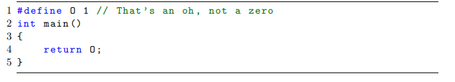

This snippet will return 1 because O is defined as 1.

**Snippet 3**

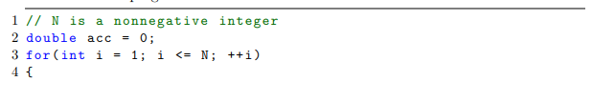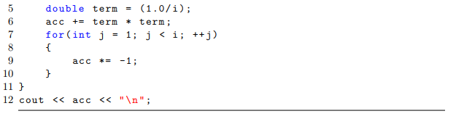

This snippet

Let N = 5:

Iteration 1:

i = 1

term = 1

acc = 1

j loop: acc = 1

Iteration 2:

i = 2

term = 0.25

acc = 1.25

j loop: acc = -1.25

Iteration 3:

i = 3

term = 1/9 = 0.111111111

acc = -1.138888888

j loop: acc = -1.1388888

Iteration 4:

i = 4

term = 1/16 = 0.0625

acc = -1.0763888888

j loop: acc = 1.0763888888

Iteration 5:

i = 5

term = 1/25 = 0.04

acc = 1.1163888888

j loop: acc = 1.1163888888