6.096 Introduction to C++

Assignment 1 Sample Programs

Sample Program 1 did not compile because declaring a variable twice within the same block causes a conflicting declaration.

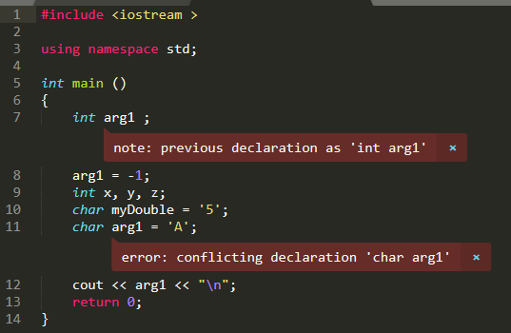

Sample Program 2 compiled and produced this output: A. The re-declaration in the nested block does not cause any errors.

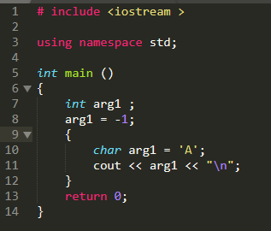

Sample Program 3 outputs A when arg1 is accessed within the inner block because arg1 is declared as A in the inner block.

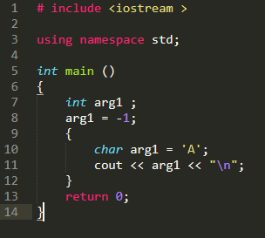

Sample Program outputs -1 when arg1 is accessed within the outer block but after the inner block because arg1 is declared as -1 in the outer block.

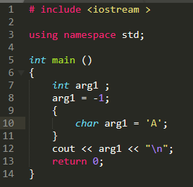

Sample Program 5 does not compile because line 9 should be first. When the include statement is moved to the beginning, the program successfully prints “Hello, World!”

Before:

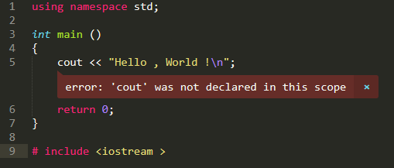

After:

