Feedthrough Inquiry Sheet
For new designs, replacement of other brands, or modifications. Type into the blank cells and click □ to select. Please fill in what you know — MAGRON will discuss the rest with you. Items marked ◎ are shown with the same number in the reference drawing.
Customer
Company |  | Contact / Dept.
Phone |  | E-mail
Equipment | CVD Sputter Implanter Etcher Robot Other: | Date
Current unit | New Replacement → maker / P/N: | Quantity | Prototype: pcs / Annual: pcs
Required delivery |  | Quote needed by
1. Seal type
1-1 Seal type | Vacuum seal Pressure seal (max.: kPa) Dust seal
2. Vacuum / pressure
2-1 Base pressure | Pa: | 2-2 Process pressure | Pa:
2-3 Differential pressure | kPa: | 2-4 Allowable He leak | Pa·m³/s:
2-5 Pressure cycling | No Yes (amplitude: / period: ) | 2-6 Pump-down | Normal Fast / venting: per day
3. Gas / environment
3-1 Process gases | (all gases and partial pressures): | 3-2 Gas nature | Inert Reactive/corrosive / N2 purge OK
3-3 Contamination | Particles/deposits Liquids/solvents/vapor Radiation | 3-4 External field | No Yes / stray flux limit: mT
4. Temperature
4-1 ◎ Temperature reaching the ferrofluid (°C) | max: / min: / normal: | 4-2 Shaft temp. (°C)
4-3 Bake-out | No Yes ( °C, h) | 4-4 ◎ Water cooling | Available ( °C, L/min) No
5. Rotation
5-1 Speed (rpm) | max: / min: / normal: | 5-2 Duty pattern | Continuous Intermittent Reversing
5-3 Duty cycle | h/day, days/year
Reference drawing — numbers are the question numbers. Enter the values in the matching numbered cells.
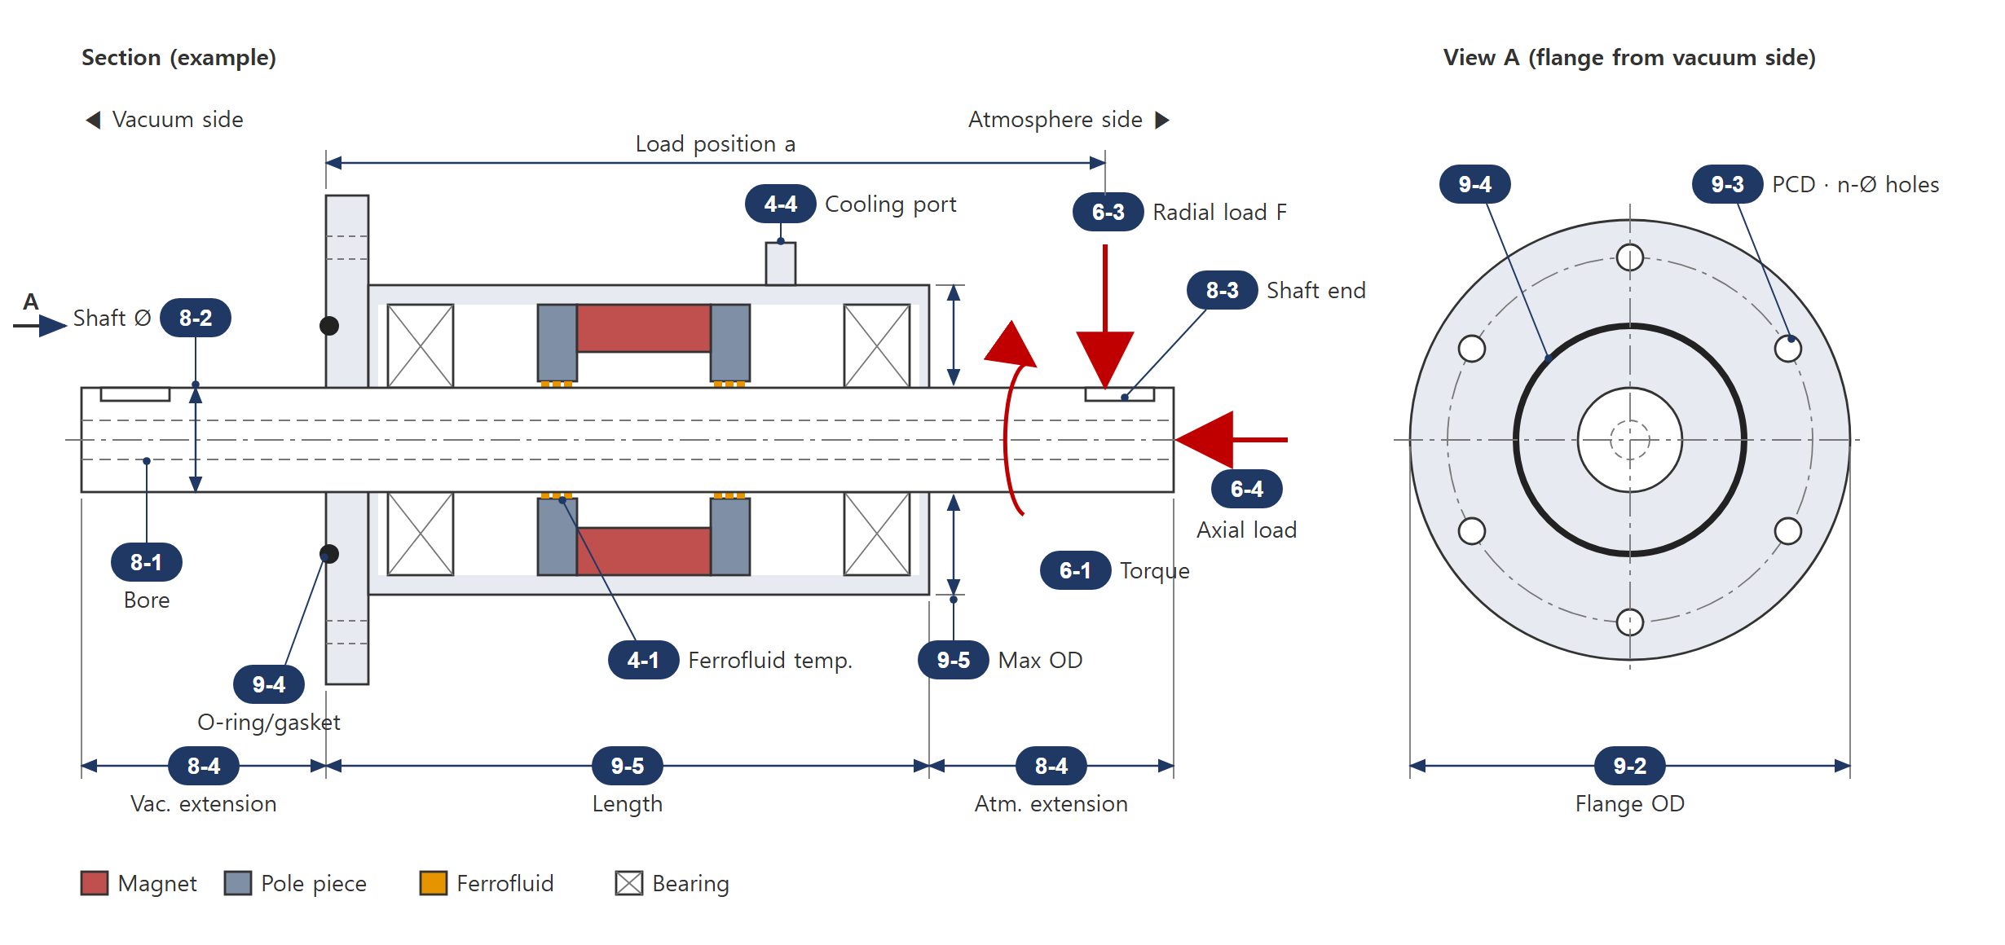
Example only (solid/hollow shaft and flange style vary). If your shape differs, draw it in section 12 or attach a drawing.
6. Loads / torque
6-1 ◎ Transmitted torque (N·m) |  | 6-2 Max. starting torque (N·m)
6-3 ◎ Radial load F | N / position a: mm  acts on vacuum side atm. side | 6-4 ◎ Axial load | N vac→atm atm→vac
6-5 Moment (N·m)
7. Installation / drive
7-1 Orientation | Horizontal Vertical (vac. up) Vertical (vac. down) | 7-2 Drive | Coupling Gear Pulley/belt Direct motor
8. Shaft
8-1 ◎ Shaft type | Solid Hollow (bore Ø: mm) | 8-2 ◎ Diameter / tol. | Ø (tol.: )
8-3 ◎ Shaft ends | Vac Key Flat Thread Plain  Atm Key Flat Thread Plain | 8-4 ◎ Extension (mm) | vac: / atm:
8-5 Allowable runout (mm) | axial: / radial: | 8-6 Allowable play (mm) | axial: / radial:
9. Mounting
9-1 Mounting | Flange (CF KF ISO Custom) Threaded body (M ) Cartridge
9-2 ◎ Flange OD (mm) | Ø | 9-3 ◎ PCD / bolt holes | PCD: / qty-Ø: -Ø
9-4 ◎ Static seal | O-ring Metal gasket (size: ) | 9-5 ◎ Envelope limits (mm) | max OD: / length:
10. Materials (only if specified)
10-1 Housing | SUS304 SUS316L Other: | 10-2 Shaft | SUS630 SUS420J2 Hastelloy Other:
10-3 O-rings | FKM FFKM (Kalrez) Other: | 10-4 Ferrofluid | MAGRON choice PFPE Hydrocarbon Silicone
11. Attachments / remarks
11-1 Attached | Sketch (dimensions + radial load arrows) Drawing/photo/P/N of current unit Equipment layout
11-2 Remarks
12. Installation sketch (draw here if your shape differs from the reference drawing, or attach a file)
12-1 Sketch

