MAGRON CO., LTD. | 705 Haean-ro, Sangnok-gu, Ansan-city, Gyeonggi-do, Republic of Korea | magron@magron.co.kr/ magnet@magron.co.kr
Magnet Inquiry Sheet
For an accurate quotation, please fill in the items below, click □ to select, and return this form. Choose the magnetization pattern code from pages 2–3.
Company |  | Contact person
E-mail / Tel. |  | Date
Country / City

No. | Item | Details / Your answer
1 | Quantity | Order quantity: ____________ pcs ※ MOQ 1,000 pcs (no sample orders)
2 | Annual requirement | ____________ pcs / year
3 | Magnet type | ☐ Sintered NdFeB ☐ SmCo (☐ SmCo5 ☐ Sm2Co17) ☐ Ferrite  ☐ Bonded NdFeB ☐ AlNiCo ☐ NdFeB powder ☐ Magnet assembly ☐ Other: ______
4 | Grade | Grade: ____________ (e.g. N52, N48H, N42SH, Sm2Co17 28 MGOe, Y30)  If unknown → BHmax: ____________ Max. operating temp.: ________ °C
5 | Dimensions & tolerances | Shape: ☐ Disc ☐ Ring ☐ Block ☐ Arc segment ☐ Sphere ☐ Other: ________  Dimensions (mm): ________________________________  Tolerance: ☐ ±0.05 ☐ ±0.1 ☐ Other: ______ ☐ Drawing attached
6 | Plating / coating | ☐ None ☐ Ni-Cu-Ni ☐ Zn ☐ Epoxy ☐ Parylene ☐ Phosphate ☐ Au ☐ Other
7 | Magnetization pattern & condition | Supply condition: ☐ Magnetized ☐ Unmagnetized ☐ Magnetized after assembly  Pattern code (see pages 2–3): ________ (A1~C2)  Multipole → poles: ____ Location: ☐ One face ☐ Both faces ☐ OD ☐ ID ☐ OD+ID  N-pole side / pole position reference: ________
8 | N-pole marking | ☐ Not required ☐ Required → Method: ☐ Paint dot ☐ Separated by tray ☐ Sticker
9 | Application, environment & delivery | Application: ____________ End user: ________  Environment: ☐ Indoor ☐ Humid ☐ Salt ☐ Immersed ☐ Acid/alkali/solvent ☐ Corrosive gas ☐ H2 ☐ Vacuum  Required delivery: __________ Destination (country/city): __________
Other requirements
MAGRON CO., LTD. | 705 Haean-ro, Sangnok-gu, Ansan-city, Gyeonggi-do, Republic of Korea | magron@magron.co.kr/ magnet@magron.co.kr
Magnetization Pattern Reference
■ N pole ■ S pole → Arrow: magnetization direction (S→N). Enter the code (A1~C2) in item 7 on page 1.
A · B Basic & multipole magnetization
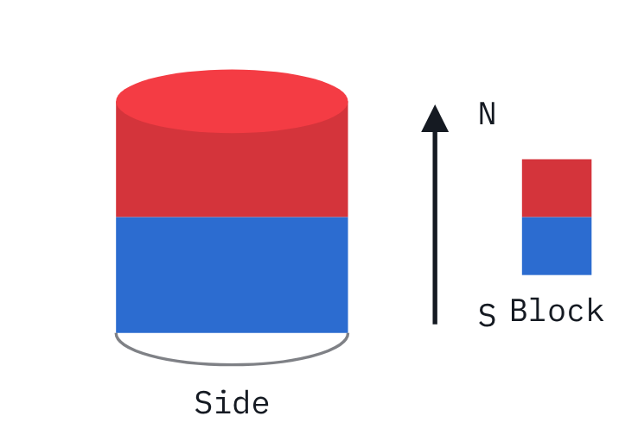  A1 Axial (through thickness)  One flat face N, the opposite face S. Holding, sensors, speakers. | 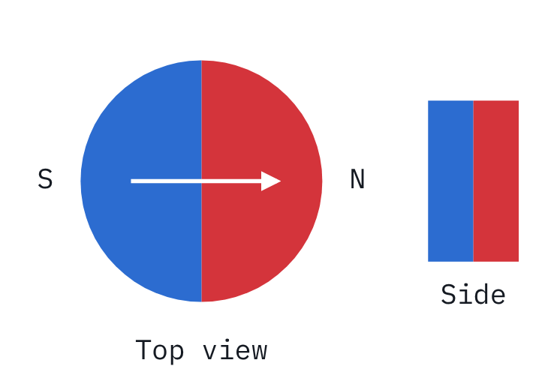  A2 Diametric (through diameter)  Magnetized across the diameter (2 poles). Encoders, rotary sensors, small motors. | 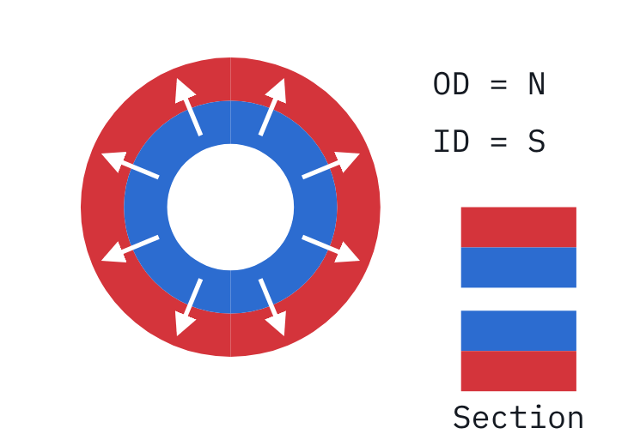  A3 Radial magnetization  Whole OD = N, whole ID = S. State one-piece or segmented.
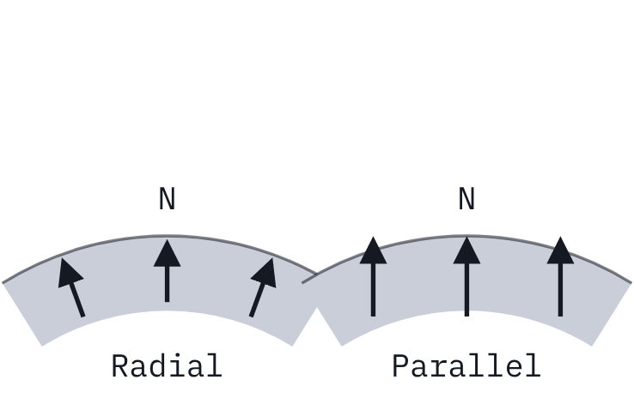  A4 Arc segment (Radial / Parallel)  Arc magnets for motors, magnetized radially or in parallel. | 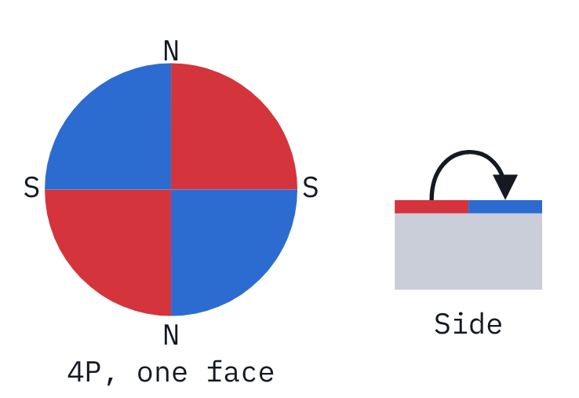  B1 Multipole on one face (sectors)  N/S alternate on one face only (2, 4 or more poles). Weak field on the back. | 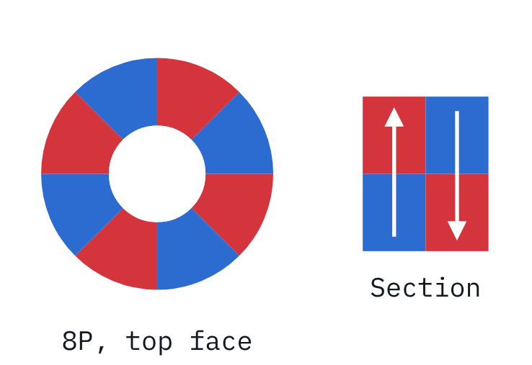  B2 Axial multipole through thickness  Sectors alternate through the thickness; top and bottom poles reversed.

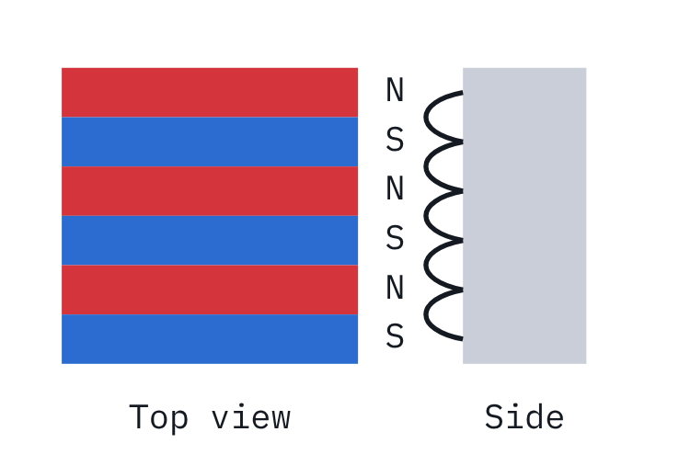  B3 Lateral multipole (stripes)  N/S stripes on one face, specified by pole pitch (mm). Bonded magnets. | 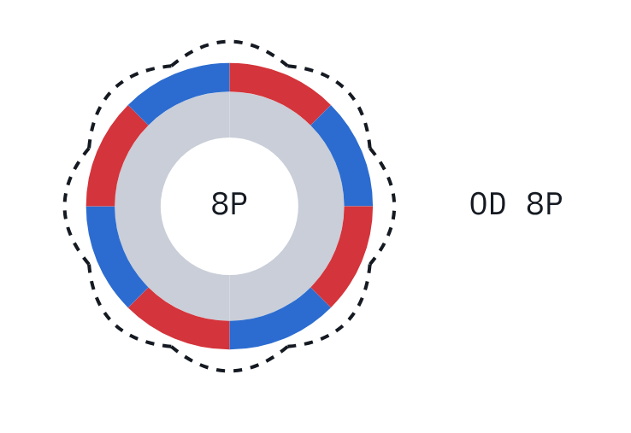  B4 Multipole on OD  Alternating N/S on the outer surface. Inner-rotor motors, encoder rings. | 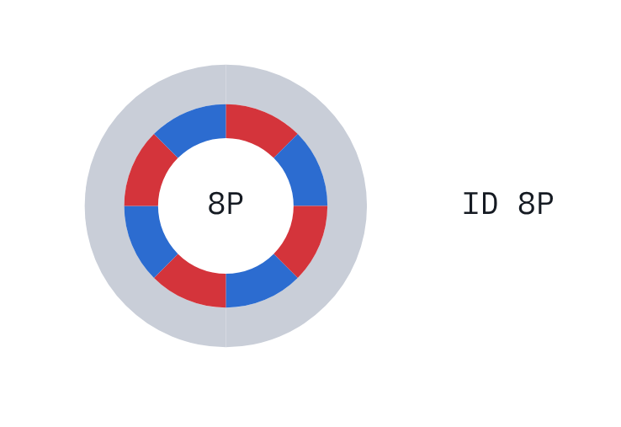  B5 Multipole on ID  Alternating N/S on the inner surface. Outer-rotor motors, couplings.
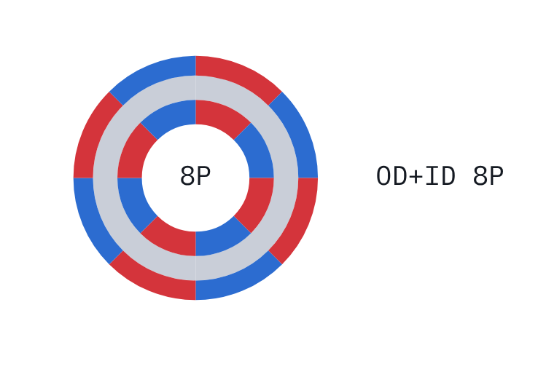  B6 Multipole on OD and ID  Poles on both outer and inner surfaces. Servo and spindle motors. | 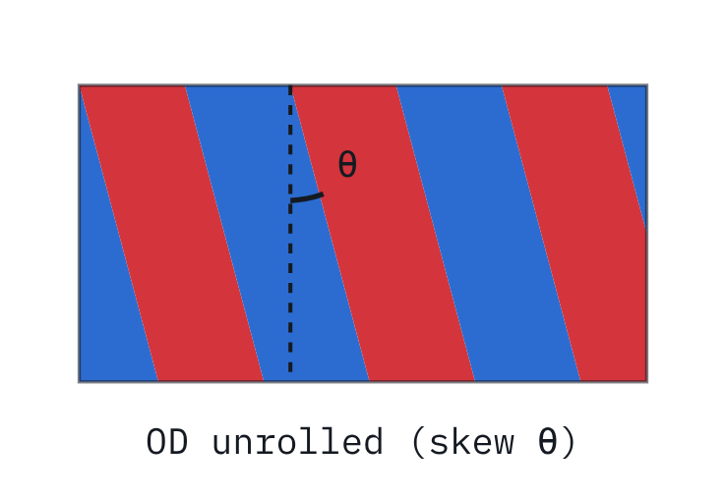  B7 Skewed magnetization  Pole boundaries skewed to reduce cogging torque. Please give the skew angle. | 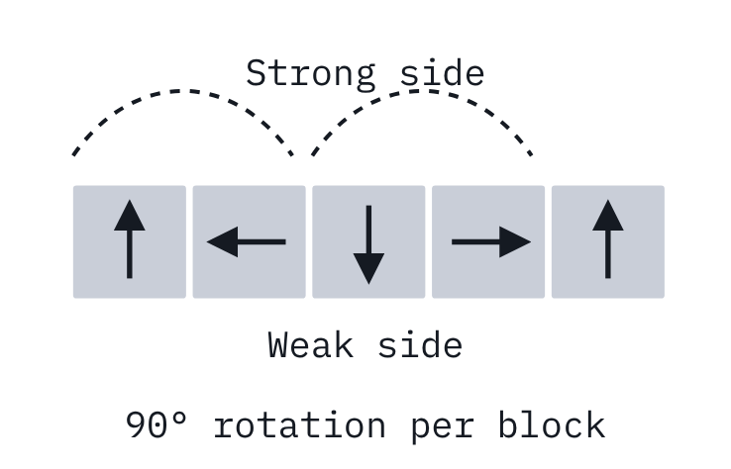  B8 Halbach array  Magnetization rotated 90° per segment; flux concentrated on one side.
B · C Multipole & anisotropic rings
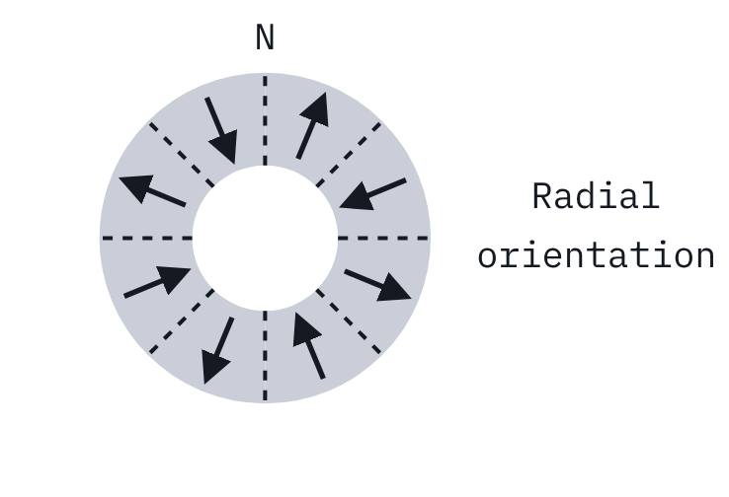  C1 Radial anisotropic ring  Radial orientation. Poles and position adjustable; skew possible. Trapezoidal wave. | 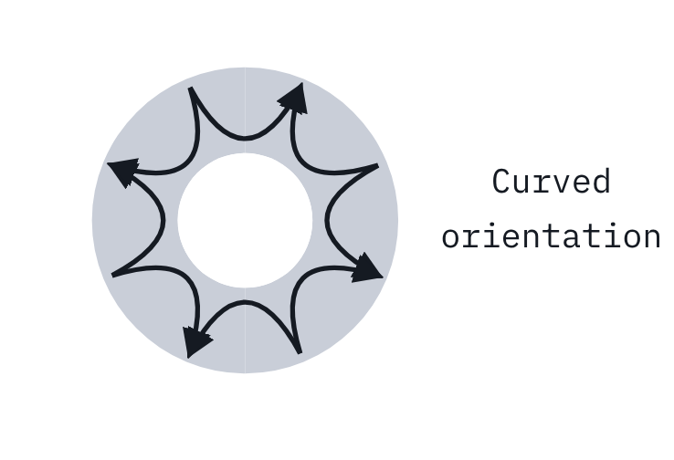  C2 Polar anisotropic ring  Curved pole-to-pole orientation. Sine wave; poles fixed; no skew. | 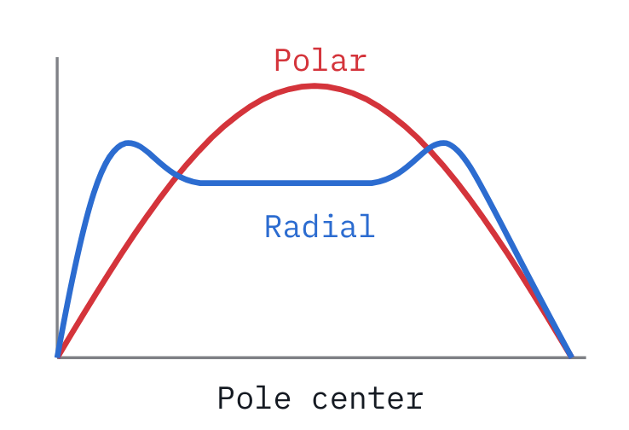  Surface flux distribution (C1 vs C2)  Surface flux density waveform over one pole.
C Radial anisotropic vs polar anisotropic
Item | Radial anisotropic (C1) | Polar anisotropic (C2)
Surface flux waveform | Trapezoidal | Sinusoidal
Number of poles | Set by magnetization | Fixed by orientation
Pole position | Set by magnetization | Fixed
Skewed magnetization | Possible | Not possible
Recommended OD | φ15 ~ 170 mm | φ2 ~ 50 mm
Recommended ID/OD ratio | 0.75 ~ 0.95 | 0.6 ~ 0.8
Recommended length | 5 ~ 60 mm | 5 ~ 60 mm
※ Recommended dimensions are based on the manufacturer’s catalogue; feasibility depends on the material and dimension combination. Please contact us for special specifications.

