SimSE Player’s Manual

# 1. Viewing Resources

You can see the status of all of the major entities in the game, your artifacts, customers, employees, projects, and tools in a few different ways:

1. To view an object’s details, you can first click the area in the corresponding word in upper left-hand corner, next to the SimSE logo, and then all of that particular type of object will appear in the grid to the right. Clicking on one of the avatars will bring that object and all of its attributes into view in the bottom area.
2. For employees, you can also left-click on their avatar in the office, or in the “Current Activities” area on the right. This will bring the employee and his/her attributes into view in the bottom area.
3. You can see a quick “at-a-glance” view of all of the objects of a particular type by clicking on the “ALL” button in the grid after performing step 1. This will bring up a table of all of the different objects and their attributes. You can hide and unhide attributes/columns by right-clicking on the column.

# 2. Interacting with Employees

You can interact with your employees through right-click menus. Right-click on one of their avatars in the office, on their avatar in the “Current Activities” area on the right, or on their avatar in the grid in the upper right-hand portion of the interface, and you will be presented with a menu of options. This is the only way to perform actions in the game.

# 3. Moving Forward through Time

The simulation clock is located in the lower right-hand corner of the user interface. You can move time forward through the game in 2 different ways:

1. Enter the number of clock ticks you wish to advance forward in the clock’s text field, and then click the “Advance Clock” button. If you check the box “Stop at Events”, the clock will go until either: a) one of the employees has something to say, or b) it has already gone forward the specified number of clock ticks, whichever comes first.
2. Click the “Next Event” button, which will cause the simulation to move forward until one of the employees has something to say.

# 4. Awareness

In addition to viewing the status of the simulation objects (artifacts, customers, employees, projects, and tools), there are a couple of other ways to stay abreast of the events that are occurring in your game:

1. The current activities of all of your employees are listed on the right hand side of the GUI.
2. The employees will often inform you of important events, the beginning and ending of activities, hints, and other guidance through pop-up speech bubbles that appear over their heads.

# 5. Ending a Game

Once the game is over, take a look again at your various artifacts, tools, etc. Attributes that were hidden throughout the game will appear (e.g., number of unknown errors), giving you further insight into how you did.

## 5.1 Explanatory (“Analyze”) Tool

At the end of a game, you can access the explanatory tool through the “Analyze” menu in the upper left-hand corner. Using this tool, you can view graphical representations of your game in the form of line graphs, as well as discover insights into some of the rules underlying the game.

### 5.1.1 Generating Graphs

There are three types of graphs that can be generated: object graphs, action graphs, and composite graphs.

An object graph depicts how an object’s attribute values changed over time, and can be generated by choosing an object in the drop-down list labeled, “Object Graph”, choosing one or more of that object’s attributes in the list marked, “Show Attributes”, and then clicking the “Generate Object Graph” button. Figure 1 shows an object graph for an employee’s energy and mood. Time is represented by the horizontal axis and attribute value is represented by the vertical axis. The title of the graph indicates which object’s attributes are being graphed—in this case, a “SoftwareEngineer” Employee named “Andre.” The key below the graph explains which data points correspond to which attributes. Any data point in the graph can be moused over to reveal that point’s exact x- and y-values. In Figure 1, the data point for the energy attribute at clock tick 892 is being moused over, at which point the employee’s energy was 0.48.

An action graph provides a trace of events or actions that occurred in the simulation, and can be generated by choosing one or more actions to graph in the “Action Graph” list and then clicking the “Generate Action Graph” button. Figure 2 shows an example of an action graph that includes three different types of actions: “CreateRequirements”, “ReviewRequirements”, and “CorrectRequirements”, with one occurrence of “CreateRequirements” and two occurrences each of “ReviewRequirements” and “CorrectRequirements” (multiple occurrences are indicated by the number at the end of the action label, e.g., “ReviewRequirementsAction-2”). The x-axis indicates time progression, in clock ticks. The y-axis has no semantics, but only serves as a delineator for graphing actions—each action is graphed on a separate gridline on the y-axis. The key below the x-axis indicates which data points correspond to which actions. The data points for an action begin at the time that action was triggered and end at the time that action was destroyed. For example, in Figure 2 the “CreateRequirements” action, represented by the orange (bottom) line, began at clock tick 0 and ended around clock tick 230.

Mousing over a data point will display the name of the action and a reminder that the data point can be clicked on for more information, as shown for “CreateRequirementsAction-1” in Figure 2. When a data point in an action graph is clicked on, the details and effects of that action are displayed in the form of the screen shown in Figure 3. There are two tabs in this screen: Action Info and Rule Info. As their names indicate, the Action Info tab contains information about the action and the Rule Info tab contains information about the rules that are attached to that action. A rule defines what effect an action has on the rest of the simulation (e.g., one rule for a “CreateCode” action is that the size of the code increases every clock tick by an amount based on the employees’ productivity in coding).

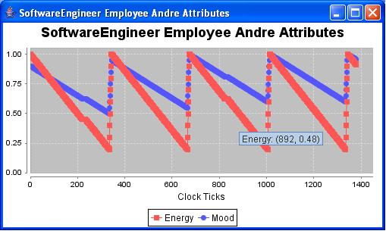

Figure 1: An Object Graph Generated by the Explanatory Tool.

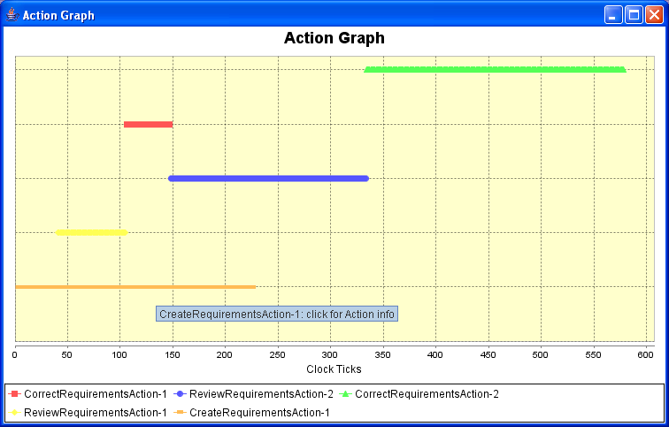

Figure 2: An Action Graph Generated by the Explanatory Tool.

The Action Info tab is divided into three portions, one for each type of information provided about the action. The top portion contains a description of the action. The middle portion displays the participants that were involved in the action during the clock tick of the selected data point (the point that was clicked on to bring up the action information. The bottom portion of the Action Info tab lists all triggers and destroyers for the action, so that the player can see exactly what could have caused the action to either stop or start. A user can click on any one of these triggers or destroyers to bring up a description in the field to the right.

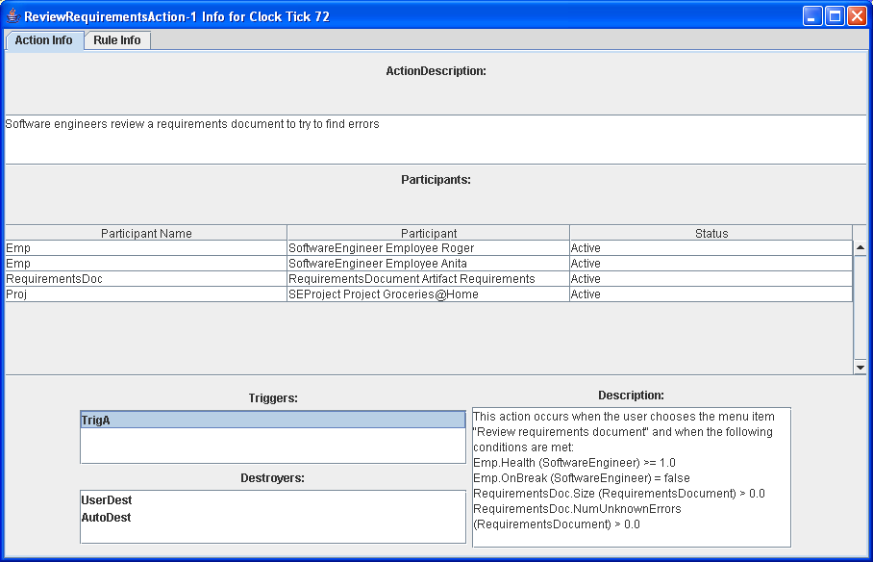

Figure 3: Detailed Action Information brought up by Clicking on an Action in an Action Graph, with the Action Info Tab in Focus.

The Rule Info tab is shown in Figure 4. On the left are listed all of the rules that are attached to the selected action. Trigger rules are those that occur when an action starts. Intermediate rules are those that occur once every clock tick during the duration of the action. Destroyer rules are those that occur when an action stops. Any one of the rules in the list can be clicked on to bring up a description of that rule in the right hand pane.

The third and final type of graph that can be generated is a composite graph. A composite graph shows both an object graph and an action graph lined up on the same time axis (not shown). To generate a composite graph, simply choose the object graph and action graph settings you want, then click “Generate Composite Graph.”

All graphs can be further customized in terms of appearance by right-clicking on the graph—they can be zoomed in or out on, colors can be changed, and labels can be turned on or off. A user can also print a graph or save it as an image if they want to keep it for future reference.

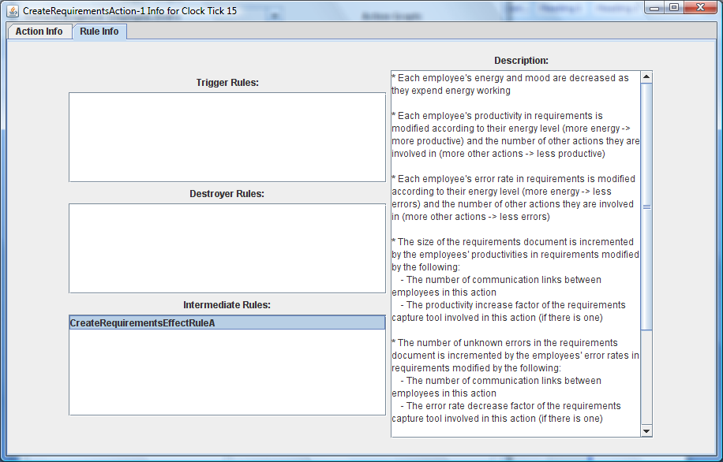

Figure 4: Rule Info Tab of the Action Information Screen.

### 5.1.2 Viewing Rules

In addition to viewing rules through clicking on an action graph, rules can also be viewed through the lower half of the explanatory tool main user interface by choosing an action in the “Actions” drop-down list. This will make the rules appear in the lists below the drop-down list. Any rule in the lists can be clicked on to bring up its description in the window to the right.

# 6. Important Tips for Success

* When you begin the game, there is a
* Tell them to read the starting narrative carefully.
* Say if you’re having trouble to come back to the info screen.
* Show how you can monitor artifacts during development.
* Tell them to read the employees’ speech bubbles carefully.
* Show purpose of a composite graph
* Mention that in explanatory tool, you might see “secret” actions that might be useful and you can click on them to find out what they are (e.g., double productivity in inspection).
* Show how reading a rule can be helpful.
* Point out that lots of people forget to read rules.
* Show how you can usually see exactly how your score is calculated by reading the rules attached to the game-ending action.