Kimberly Gamboa

DEC130 HW1

Thought Behind Prediction of Customer Churn

Since we had to use only the data given to be able to predict customer churn, I tried filtering in MS Excel the training set to only display churned customers. At first, I noticed a discrepancy with the total bill of the customers if I manually multiply the tenure with their monthly charge, so I checked to see if most customers who are charged more than they should be are churning. The result is not all who are charged more churn so it must be something else. 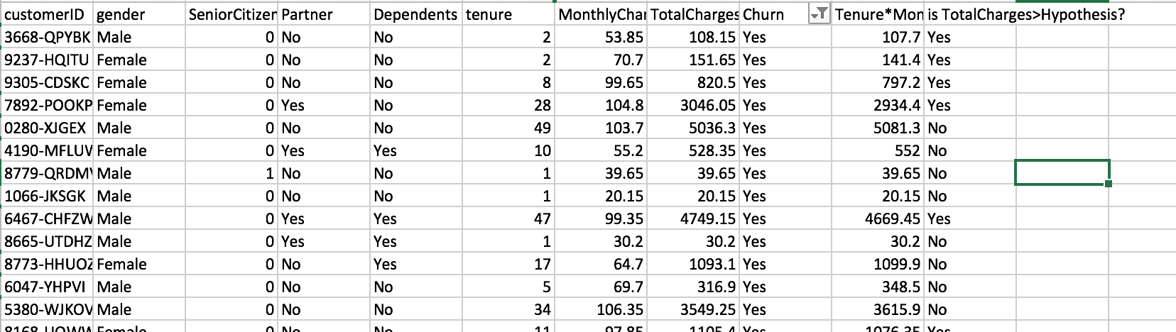

Afterwards, I looked at the other columns if there was a pattern that a column variable was consistently simultaneous with a churned customer and it seemed that the Contract Column was often “Month-to-month” for churned customers.

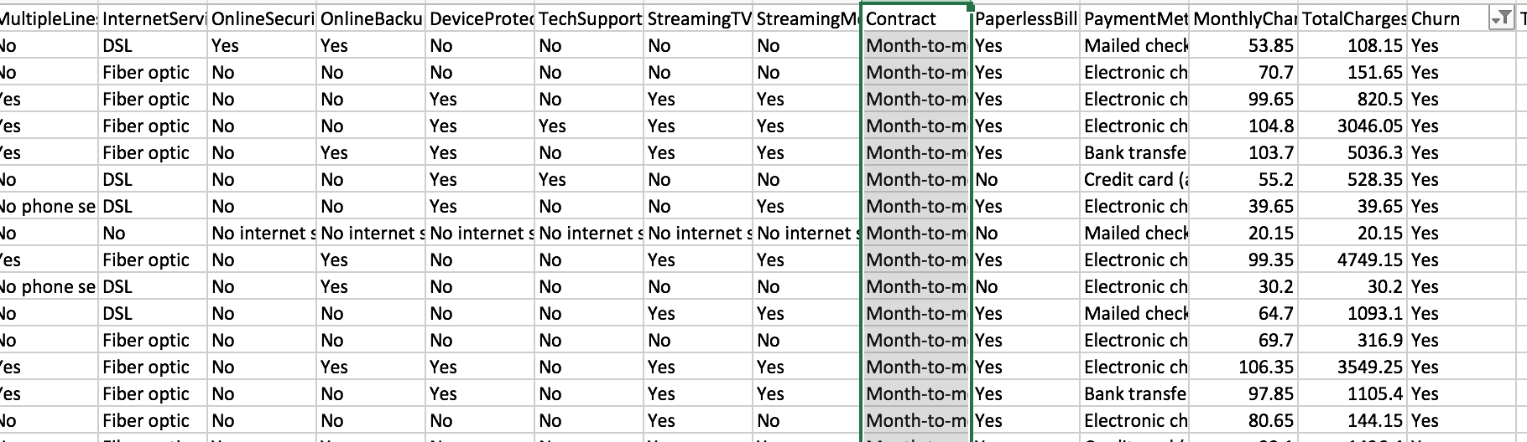

I decided to plot the suspect that I had and it resulted in a huge proportion of churned customers having a month to month contract basis, with next the one year ones.

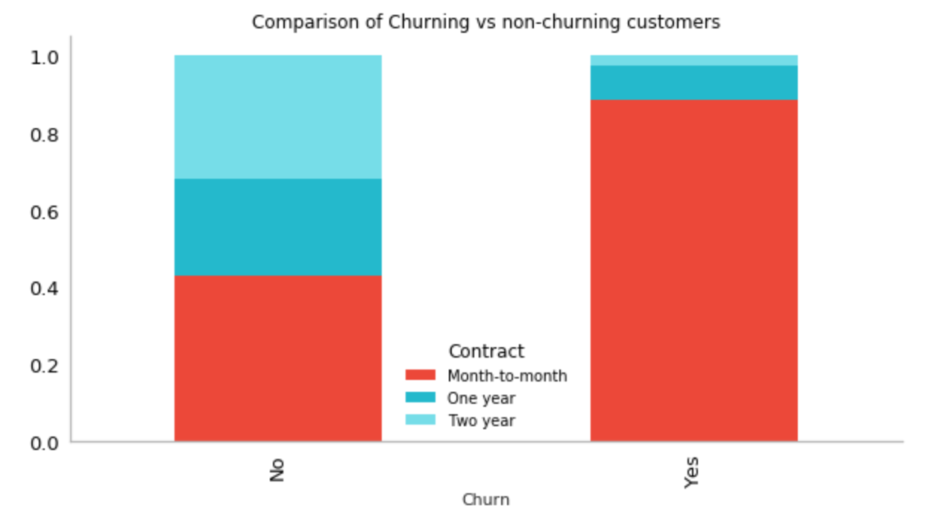

However, the ones who have a month to month contract and still haven’t churned are likely to churn in the future as well. Having no other knowledge of figuring out this problem and unable to perform logistic regression because I don’t know how to do that yet, this is my best prediction.