**Time Series Data Denoising using Autoencoders Report**

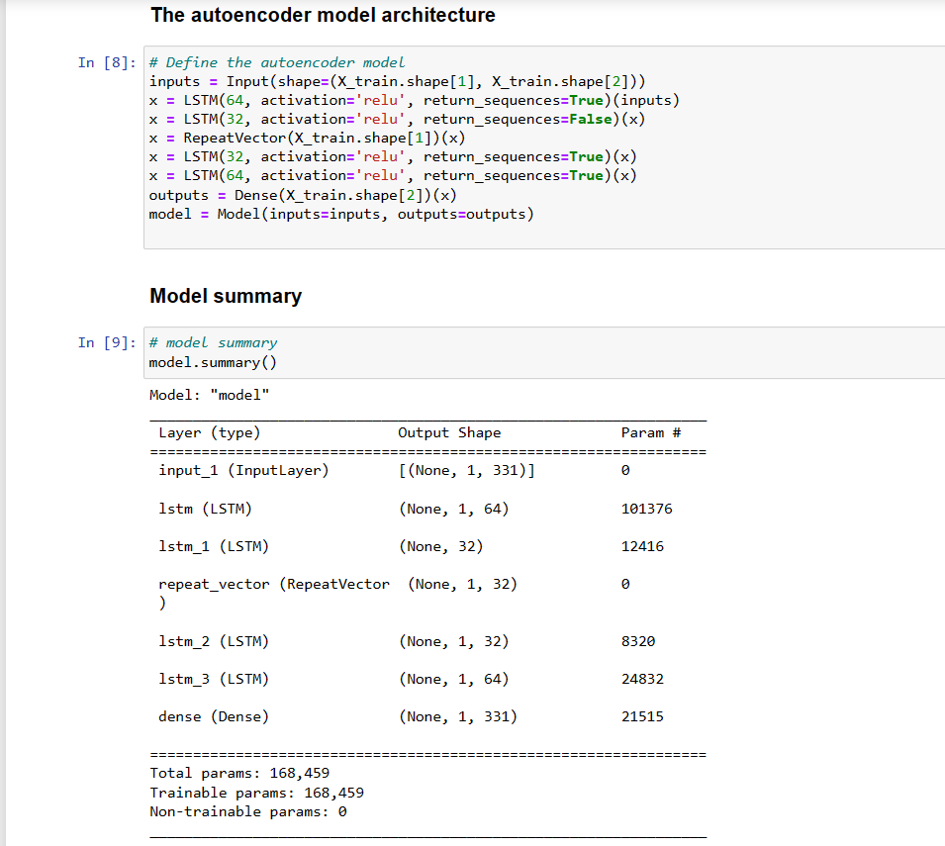

In this task, a Long Short-Term Memory (LSTM) model was used in this autoencoder to denoise the time series. Typically, LSTM is very effective in modeling temporal relationships and handling vanishing gradient problems that are common in standard recurrent neural networks (RNN). Besides, LSTM is well-known for its capability to learn and model sequences of data with long-term dependencies. This makes it well-suited for applications such as time series forecasting.

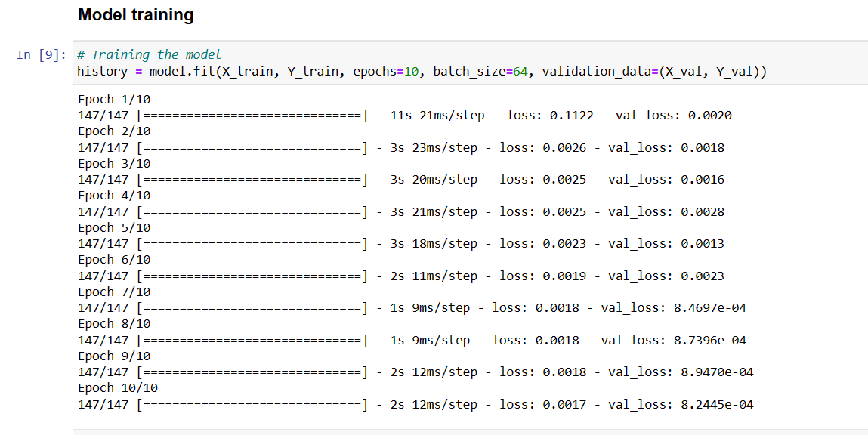

The model training used 10 epochs in which it achieved a lower loss of 0.00170 and a validation loss of 0.000824.

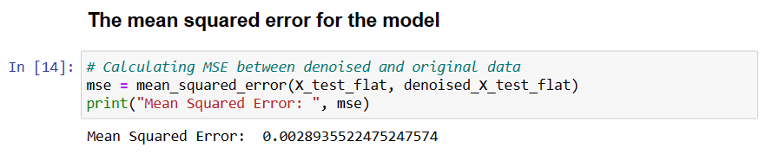

Significantly, the model had a Mean Squared Error (MSE) of 0.0029. This indicates that the denoised data is very close to the original data in terms of their values. Also, it suggests that the autoencoder has done a good job of removing the noise from the time-series data.

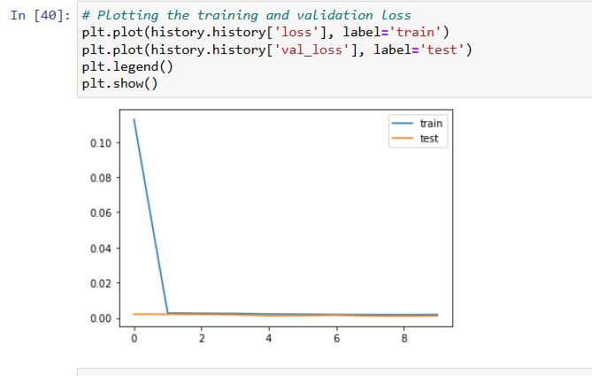

Besides, we can see while training the model achieves a very low loss in a very fast way, making the loss very small. This further upholds how well the model performed.

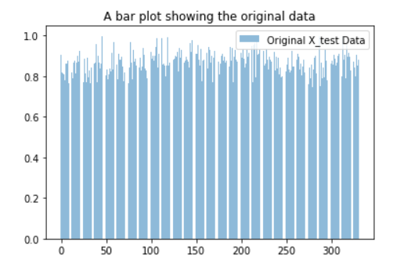

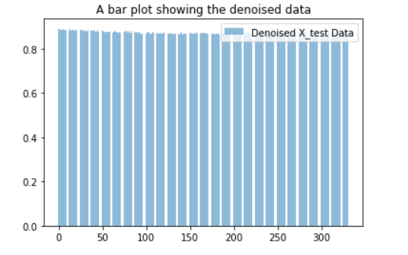

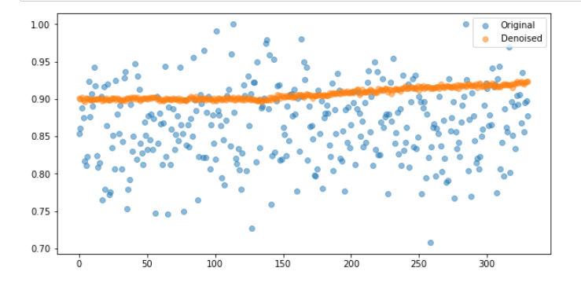

The above images show the original data and the denoised data. In all images, we can see how the autoencoder has removed the noise from the original data.

**Discussion and Conclusion**

One of the advantages of the Long Short-Term Memory (LSTM) model used in this autoencoder is its effectiveness in modeling temporal relationships and handling vanishing gradient problems. It is also well-suited for learning and modeling sequences of data with long-term dependencies, making it suitable for time series forecasting applications. The model achieved a consistent loss and a validation loss of 0.000824 and 0.0017, respectively, and had a Mean Squared Error (MSE) of 0.0029, indicating that it did an excellent job of removing noise from the time-series data. The variance of both the testing and training losses was very small, which further demonstrated the model's performance. The original and denoised data images show how well the autoencoder removed noise from the original data. Therefore, we can conclude that the LSTM autoencoder was successful in denoising the time series data.