1.

B)

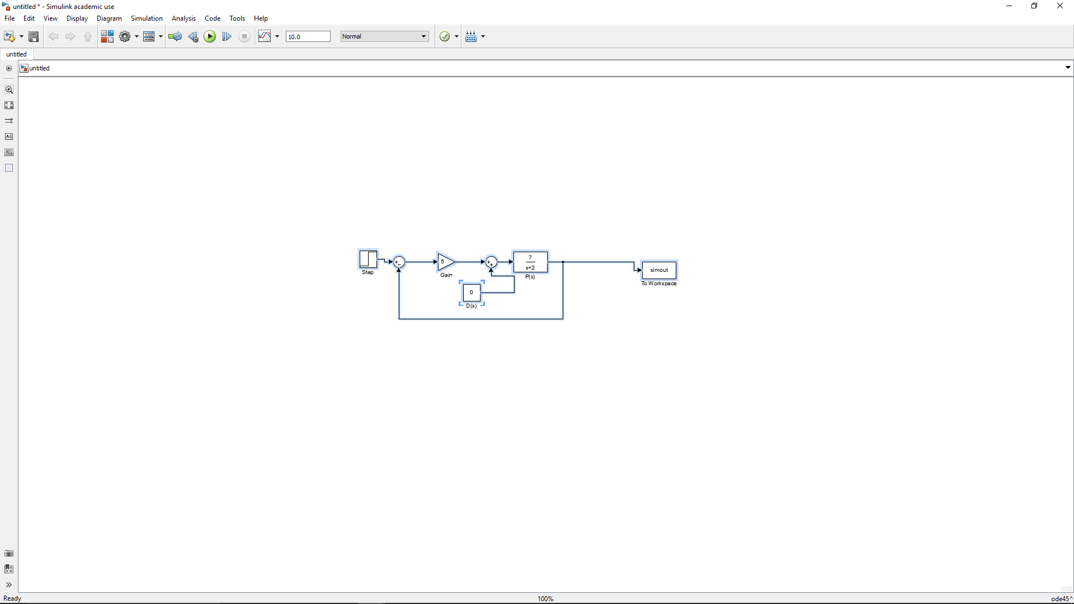

Figure 1: simulink of problem 1a

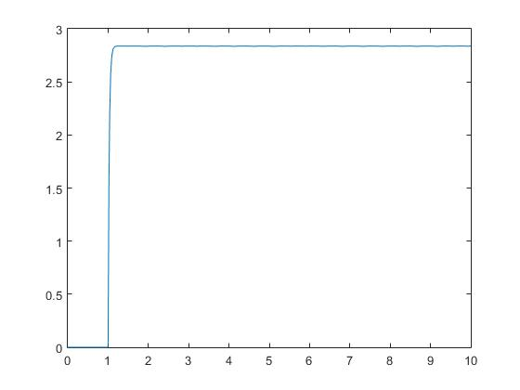

Figure 2: output of figure 1

Ess = (3-max(simout)) = 0.1622