Basic Operators in Python: Arithmetic, Relational, Logical, Identity, and Increment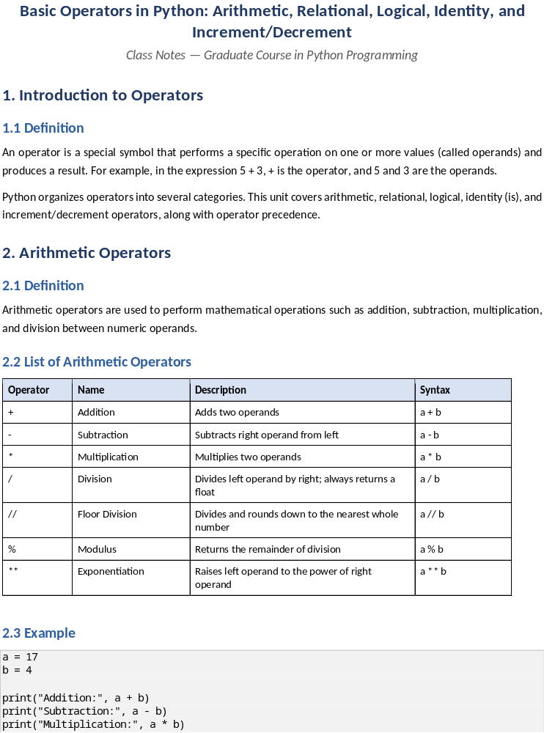/Decrement
Class Notes — Graduate Course in Python Programming

1. Introduction to Operators

1.1 Definition
An operator is a special symbol that performs a specific operation on one or more values (called operands) and produces a result. For example, in the expression 5 + 3, + is the operator, and 5 and 3 are the operands.
Python organizes operators into several categories. This unit covers arithmetic, relational, logical, identity (is), and increment/decrement operators, along with operator precedence.

2. Arithmetic Operators

2.1 Definition
Arithmetic operators are used to perform mathematical operations such as addition, subtraction, multiplication, and division between numeric operands.

2.2 List of Arithmetic Operators
Operator | Name | Description | Syntax
+ | Addition | Adds two operands | a + b
- | Subtraction | Subtracts right operand from left | a - b
* | Multiplication | Multiplies two operands | a * b
/ | Division | Divides left operand by right; always returns a float | a / b
// | Floor Division | Divides and rounds down to the nearest whole number | a // b
% | Modulus | Returns the remainder of division | a % b
** | Exponentiation | Raises left operand to the power of right operand | a ** b

2.3 Example
a = 17
b = 4
print("Addition:", a + b)
print("Subtraction:", a - b)
print("Multiplication:", a * b)
print("Division:", a / b)
print("Floor Division:", a // b)
print("Modulus:", a % b)
print("Exponentiation:", a ** b)
Output:
Addition: 21
Subtraction: 13
Multiplication: 68
Division: 4.25
Floor Division: 4
Modulus: 1
Exponentiation: 83521

2.4 Important Notes
- The / operator always returns a float, even if the result is a whole number (e.g., 10 / 2 gives 5.0, not 5).
- The // operator performs floor division — it rounds the result down toward negative infinity, not simply truncates it.
print(7 // 2) # 3
print(-7 // 2) # -4 (rounds toward negative infinity, not toward zero)
Output:
3
-4

3. Operator Precedence

3.1 Definition
Operator precedence determines the order in which operators are evaluated in an expression containing multiple operators. Operators with higher precedence are evaluated before operators with lower precedence. When two operators have the same precedence, Python evaluates them according to their associativity (usually left to right).
Parentheses () can always be used to override the default precedence and force a particular evaluation order — this is the safest and most readable practice when writing complex expressions.

3.2 Precedence Rules (Highest to Lowest)
The table below lists commonly used operators from highest precedence (evaluated first) to lowest precedence (evaluated last):
Precedence | Operator(s) | Description | Associativity
1 (Highest) | () | Parentheses | —
2 | ** | Exponentiation | Right to Left
3 | +x, -x, ~x | Unary plus, unary minus, bitwise NOT | Right to Left
4 | *, /, //, % | Multiplication, Division, Floor Division, Modulus | Left to Right
5 | +, - | Addition, Subtraction | Left to Right
6 | <, <=, >, >=, !=, == | Relational (Comparison) operators | Left to Right
7 | is, is not | Identity operators | Left to Right
8 | not | Logical NOT | Right to Left
9 | and | Logical AND | Left to Right
10 (Lowest) | or | Logical OR | Left to Right

Note: ** is evaluated right to left, which is why 2 ** 3 ** 2 equals 2 ** (3 ** 2) = 2 ** 9 = 512, and not (2 ** 3) ** 2 = 64.

3.3 Example
result1 = 2 + 3 * 4 ** 2
print(result1) # ** first: 4**2=16, then 3*16=48, then 2+48=50
result2 = (2 + 3) * 4 ** 2
print(result2) # parentheses first: (5) * 16 = 80
result3 = 10 - 4 // 2 + 3 * 2
print(result3) # // first: 4//2=2, * next: 3*2=6, then 10-2+6=14
result4 = 2 ** 3 ** 2
print(result4) # ** is right-to-left: 2 ** (3**2) = 2 ** 9 = 512
Output:
50
80
14
512

3.4 Example — Mixing Arithmetic, Relational, and Logical Operators
x = 5
y = 10
z = 15
result = x + 2 < y and z - 5 == y
print(result)
# Step 1 (arithmetic first): x + 2 = 7, z - 5 = 10
# Step 2 (relational next): 7 < 10 -> True, 10 == 10 -> True
# Step 3 (logical last): True and True -> True
Output:
True
Explanation: Python evaluates arithmetic operators first (highest precedence among those used), then relational operators, and finally logical operators — exactly as shown in the precedence table above.

4. Relational (Comparison) Operators

4.1 Definition
Relational operators (also called comparison operators) compare two operands and return a Boolean result — either True or False.

4.2 List of Relational Operators
Operator | Name | Description | Syntax
== | Equal to | True if both operands are equal | a == b
!= | Not equal to | True if operands are not equal | a != b
> | Greater than | True if left operand is greater | a > b
< | Less than | True if left operand is smaller | a < b
>= | Greater than or equal to | True if left is greater than or equal | a >= b
<= | Less than or equal to | True if left is less than or equal | a <= b

4.3 Example
a = 10
b = 20
print(a == b) # False
print(a != b) # True
print(a > b) # False
print(a < b) # True
print(a >= 10) # True
print(b <= 15) # False
Output:
False
True
False
True
True
False

4.4 Important Note — Assignment vs Equality
A very common beginner mistake is confusing = (assignment operator) with == (equality/relational operator).
x = 5 # assigns the value 5 to x
print(x == 5) # compares x with 5, returns True
Output:
True

4.5 Chained Comparisons
Python allows chaining relational operators, which is not possible in many other languages such as C or Java.
age = 25
print(18 <= age <= 60) # equivalent to: (18 <= age) and (age <= 60)
Output:
True

5. Logical Operators

5.1 Definition
Logical operators are used to combine multiple conditions (Boolean expressions) and return a Boolean result. They are commonly used in decision-making statements (if, while, etc.).

5.2 List of Logical Operators
Operator | Description | Syntax | Result is True when
and | Logical AND | a and b | Both a and b are True
or | Logical OR | a or b | At least one of a or b is True
not | Logical NOT | not a | Reverses/negates the Boolean value of a

5.3 Truth Table
a | b | a and b | a or b | not a
True | True | True | True | False
True | False | False | True | False
False | True | False | True | True
False | False | False | False | True

5.4 Example
age = 22
has_id = True
# Using 'and'
print(age >= 18 and has_id) # True
# Using 'or'
marks = 35
attendance = 80
print(marks >= 40 or attendance >= 75) # True
# Using 'not'
is_raining = False
print(not is_raining) # True
Output:
True
True
True

5.5 Real-World Example — Combining Conditions
age = 20
has_valid_ticket = True
has_id_proof = False
is_eligible = age >= 18 and has_valid_ticket and has_id_proof
print("Eligible to enter:", is_eligible)
Output:
Eligible to enter: False
Explanation: Even though the first two conditions are True, the overall expression evaluates to False because has_id_proof is False, and and requires all conditions to be True.

5.6 Short-Circuit Evaluation
Definition: Python evaluates logical expressions using short-circuit evaluation — meaning it stops evaluating as soon as the final result is determined.
- For and: if the first operand is False, the second is never evaluated (result is already False).
- For or: if the first operand is True, the second is never evaluated (result is already True).
def check():
print("check() was called")
return True
result = False and check()
print(result)
Output:
False
Explanation: check() is never called because Python already knows False and anything will be False.

6. Identity Operator (is)

6.1 Definition
The identity operator checks whether two variables refer to the same object in memory — not whether their values are equal. Python provides two identity operators:
Operator | Description | Syntax
is | Returns True if both operands point to the same object in memory | a is b
is not | Returns True if both operands do not point to the same object in memory | a is not b

Every object in Python has a unique identity (its memory address), which can be checked using the built-in id() function. The is operator essentially compares id(a) == id(b).

6.2 Syntax
a is b
a is not b

6.3 Example
a = [1, 2, 3]
b = [1, 2, 3]
c = a
print(a == b) # True -> values are equal
print(a is b) # False -> different objects in memory
print(a is c) # True -> c refers to the SAME object as a
print(id(a), id(b), id(c))
Output (actual addresses will vary):
True
False
True
140312831234568 140312831235784 140312831234568
Explanation: a and b contain the same values, so a == b is True. However, they are two separate list objects created independently, so a is b is False. Since c = a makes c refer to the exact same object as a, a is c is True.

6.4 A Special Case — Small Integers and Strings
x = 10
y = 10
print(x is y) # True (small integers are cached/interned by CPython)
p = "hello"
q = "hello"
print(p is q) # True (string literals are often interned)
Output:
True
True
Note: CPython internally caches small integers (typically -5 to 256) and some string literals for performance, so is may unexpectedly return True for such values. This behavior is an implementation detail and should never be relied upon in real programs — always use == to compare values, and reserve is strictly for identity checks (most commonly, checking x is None).

6.5 Differentiating is vs ==
Aspect | == (Equality Operator) | is (Identity Operator)
Checks | Whether the values of two operands are equal | Whether two operands refer to the same object in memory
Category | Relational operator | Identity operator
Underlying mechanism | Calls the object's __eq__() method | Compares id(a) == id(b)
Typical use case | Comparing data (numbers, strings, list contents, etc.) | Checking if two references point to the same object; checking against None
Example result | [1,2,3] == [1,2,3] → True | [1,2,3] is [1,2,3] → False

6.6 Example — == vs is Side by Side
list1 = [10, 20, 30]
list2 = [10, 20, 30]
print("Using == :", list1 == list2) # True -> same values
print("Using is :", list1 is list2) # False -> different memory locations
# Best practice: checking for None
value = None
print(value is None) # Correct and recommended way
print(value == None) # Works, but 'is' is preferred for None checks
Output:
Using == : True
Using is : False
True
True
Note: Always use is (not ==) when comparing against None, True, or False, since these are singleton objects in Python (if x is None: rather than if x == None:).

7. Increment and Decrement Operators

7.1 Definition
Increment means increasing the value of a variable, and decrement means decreasing it. Unlike languages such as C, C++, or Java, Python does NOT have dedicated ++ or -- operators. Instead, Python achieves increment/decrement behavior using augmented (compound) assignment operators.
Note: Writing x++ or x-- in Python results in a SyntaxError. Students coming from a C/Java background should pay special attention to this difference.

7.2 Augmented Assignment Operators
Operator | Equivalent To | Description
x += n | x = x + n | Increments x by n
x -= n | x = x - n | Decrements x by n
x *= n | x = x * n | Multiplies x by n
x /= n | x = x / n | Divides x by n
x //= n | x = x // n | Floor-divides x by n
x %= n | x = x % n | Assigns remainder of x / n to x
x **= n | x = x ** n | Raises x to the power n

7.3 Example — Simulating Increment/Decrement
count = 5
# Increment by 1
count += 1
print("After increment:", count)
# Decrement by 1
count -= 1
print("After decrement:", count)
# Increment by a custom step
count += 10
print("After incrementing by 10:", count)
Output:
After increment: 6
After decrement: 5
After incrementing by 10: 15

7.4 Example — Using Increment in a Loop (Practical Use Case)
i = 1
while i <= 5:
print("Count:", i)
i += 1 # increment i by 1 each iteration
Output:
Count: 1
Count: 2
Count: 3
Count: 4
Count: 5

7.5 Why Doesn't Python Have ++ / --?
This is a common conceptual question. In Python, + and - are strictly operators for expressions, and Python's design philosophy avoids operators that produce side effects (i.e., modify a variable) as part of an expression. The ++/-- operators in C-like languages actually mutate the variable as a side effect of evaluating an expression, which conflicts with Python's simpler, more predictable assignment model. Python instead makes the increment an explicit statement (x += 1) rather than an implicit side effect.

8. Quick Recap — Key Terms
Term | Meaning
Operator | Symbol that performs an operation on operands
Operand | Value(s) an operator acts upon
Arithmetic operator | Performs mathematical calculations (+ - * / // % **)
Operator precedence | The order in which operators are evaluated in an expression
Relational operator | Compares two values and returns True/False
Logical operator | Combines Boolean expressions (and, or, not)
Identity operator (is) | Checks whether two variables refer to the same object in memory
Short-circuit evaluation | Stops evaluating a logical expression once the result is determined
Augmented assignment | Combines an operation and assignment in one step (+=, -=, etc.)
Increment/Decrement | Increasing/decreasing a variable's value; done in Python via += / -= (no ++/--)

9. Practice Questions (for students)
- What will be the output of 17 // 5 and 17 % 5? Explain the difference between these two operators.
- Why does Python's / operator always return a float, even when dividing two integers evenly?
- Using the precedence table, manually evaluate: 20 - 3 * 2 ** 2 // 4 + 1. Verify your answer by running it in Python.
- Explain the difference between = and == with an example.
- What is the difference between == and is? Give an example where they produce different results.
- Why should is be preferred over == when checking whether a variable is None?
- What is short-circuit evaluation? Illustrate with an example using or.
- Why does Python not support x++ or x--? What is the correct way to increment a variable in Python?
- Predict the output:
a = 6
b = 3
print(a > b and b > 0 or a < 0)
- Write a program using a while loop that prints all even numbers from 2 to 20 using an increment operator.

