MINISTRY OF EDUCATION AND SCIENCE OF THE REPUBLIC OF KAZAKHSTAN

INTERNATIONAL INFORMATION TECHNOLOGY UNIVERSITY

FACULTY OF INFORMATION TECHNOLOGIES

Department of Computer engineering and information security

COURSE PROJECT

Major 5B070400 – Computer systems and software engineering

Discipline Web technologies

Topic: Welcome.iitu.kz

STUDENT(S): | CSSE-1801K  Olzhabayev B.M.  Ermagambet M.S.  (group and student name) | _____________  (signature)
SUPERVISOR: | Assistant-professor  Mukazhanov N.K.  (position, name) | _____________  (signature)

Almaty 2020

Content

- Introduction........................................................................................... 3
- Main part:
  - Theoretical part...................................................................................... 4
  - Design.....................................................................................................7
  - Implementation (creation of website)....................................................11
- Conclusion …........................................................................................ 30
- References ….........................................................................................30
- Appendix A…........................................................................................30

Introduction

We chose this project because we understand how important it is to receive reliable information about the university for the correct choice of a future profession. We have encountered many people who entered a higher educational institution without knowing absolutely nothing about it and regretted their choice. It came to the countdown, while being left without anything while losing its precious time, which could not have been wasted.
In the modern world, in the real conditions of a pandemic, schoolchildren and such people described above need to receive information online.
The main audience of our project is, first of all, schoolchildren of graduating classes, as well as people wishing to enter our university (including the people described above). For users of our project, we will provide such opportunities as: registration in the system, personal account, online application for admission to the university, receiving notifications about the latest events at the university, etc.Today, especially during a pandemic, all commissions and admissions to all educational institutions are switching to remote control. Our site is equipped with all the powers for the admissions committee and for incoming applicants.
Our site provides registration in the database of all persons who are studying, as well as applicants wishing to enter the International University of Information Technologies and is designed to obtain detailed and reliable information about the necessary documents required for enrollment in this higher educational institution. And also on our website you can find out about different study circles (for example, circles and laboratories of robotics, etc.) and their achievements at the republican and international levels.

Main part:
- Theoretical part
A course project is a research paper written by students during an academic semester and is a significant part of the assessment. Course projects are usually designed to describe an event, concept, or reasoning. A course project is a written original work in which a topic is discussed in detail. Theme of our project “Site of the admission committee of JSC "IITU"”.
We have developed a website for the admissions committee for IITU. As we all know, an admissions committee is an authorized meeting of representatives of a secondary or higher educational institution, headed by the chairman of the admissions committee, which regulates the process of transition of students from primary and secondary general education levels to higher. Thus, those wishing to get a higher education turn from schoolchildren into applicants who have submitted an application for admission and other set of required documents (certificate or diploma, etc.), and, finally, into students if they successfully pass the exams and pass the competition.
Let's dwell a little on the legislation on the selection committee:
The selection committee is created by order of the rector with the aim of:
- informing citizens of the Republic of Kazakhstan, foreign citizens and persons statelessness (hereinafter referred to as citizens, applicants, applicants) on the procedure and conditions of admission to the university for training:
- on educational programs of higher education – programs;
- undergraduate, specialist programs, graduate programs and programs
- training of scientific and pedagogical personnel in graduate school (hereinafter - HE programs);
- on educational programs of secondary vocational education (hereinafter - open source programs);
- carrying out admission of documents, entrance examinations and enrollment of persons, successfully passed the competitive selection (hereinafter referred to as admission), for training in university.
2. The main task of the selection committee is to ensure:
- observance of the rights of citizens to education, established by law RK;
- coordination of the activities of the structural divisions of the university on
organizing and conducting the reception;
- objectivity in assessing the abilities of applicants;
- enrollment of citizens who are most capable and prepared to master basic educational programs of the appropriate level;
- publicity and openness of the work of the selection committee at all stages of the reception.
3. The selection committee in its work is guided by:
- the Constitution of the Republic of Kazakhstan;
- international legal acts, federal laws and other regulatory legal acts of the Republic of Kazakhstan containing norms regulating relations in the field of education;
- the rules of admission to the university;
- these Regulations;
- the Charter on admission to the university;
- other local acts of the university governing admission to the university.
The competence of the selection committee includes interpretation, addition and amendment the rules of admission to the university, as well as solving issues related to admission to university and beyond the admission rules.
4. The composition of the selection committee is approved by the order of the rector, which is chairman of the admissions committee of the university.
In order to organize admission to the branches and college of the university as part of the reception university commissions are created selection commissions, whose activities carried out in accordance with this Regulation.
5. The university admissions committee includes:
- chairman;
- Deputy Chairman, appointed from among the vice-rectors;
- chairmen of selection committees - directors of branches and college;
- Vice-rectors;
- deans of faculties;
- Head of the educational and methodological department.
- executive secretary of the selection committee and his deputies;
- executive secretaries of selection committees;
6. The term of office of the selection committee is one calendar year.
7. The chairman of the selection committee directs all activities of the reception commissions and controls the interaction of structural divisions of the university, ensuring the organization and conduct of the reception. Qualifying activities the commission is chaired by the chairman of the selection commission.
8. The work of the selection committee and office work, as well as personal reception applicants and their parents (legal representatives) are organized by a responsible secretary of the selection (selection) committee.
9. For the timely preparation of the necessary documents and materials, as well as for conducting entrance examinations by the order of the rector, examination commissions, the composition, powers and procedures of which are determined the corresponding regulation approved by the rector of the university.
10. To ensure the work of the selection (selection) committee one month before the start of receiving documents by order of the rector, the technical secretariat is approved from among teachers, engineers and technicians and educational support university staff.
The duties of the technical secretary are determined by an instruction approved by rector of the university.
11. Compositions of examination boards and technical secretariat annually are partially updated.
12. The decisions of the selection committee are drawn up in protocols, which signed by the chairman (deputy chairman) and the executive secretary admissions (selection) committee.
The decisions of the selection committee are made by a simple majority of votes when the presence of at least 2/3 of the approved composition.
13. The chairman, executive secretary and members of the selection committee bear responsibility for non-performance or improper performance of duties in the order, established by the legislation of the Republic of Kazakhstan.
14. This provision is valid until amending or accepting new position.
Today, especially during a pandemic, all commissions and admissions to all educational institutions are switching to remote control. Our site is equipped with all the powers for the admissions committee and for incoming applicants.
Our site provides registration in the database of all persons who are studying, as well as applicants wishing to enter the International University of Information Technologies and is designed to obtain detailed and reliable information about the necessary documents required for enrollment in this higher educational institution. And also on our website you can find out about different study circles (for example, circles and laboratories of robotics, etc.) and their achievements at the republican and international levels. We chose this project because we understand how important it is to receive reliable information about the university for the correct choice of a future profession. We have encountered many people who entered a higher educational institution without knowing absolutely nothing about it and regretted their choice. It came to the countdown, while being left without anything while losing its precious time, which could not have been wasted.
In the modern world, in the real conditions of a pandemic, schoolchildren and such people described above need to receive information online.
The main audience of our project is, first of all, schoolchildren of graduating classes, as well as people wishing to enter our university (including the people described above). For users of our project, we will provide such opportunities as: registration in the system, personal account, online application for admission to the university, receiving notifications about the latest events at the university, etc.
The peculiarity of our project is that applicants can remotely apply for admission, and studying students can receive a certificate of study at this university.
Such projects are just developing in our country, at the moment there are only a few applications. There is a lot of work in this structure and therefore all universities need our project.Since the discipline itself is called Web technology and during the course we studied basic web technologies, in our project we used web technologies such as:
- Css;
- PHP;
- MySQL;
- Java script;
- PHP scripts and others.

- Design

2.1) Your attention is given to the main page of our site, in other words, the page from which everything begins Home Page.
2.2) If you stop on the map of our site, first you go to the Home page and then follow the links to the pages of the pop-up window such as:

- Online registration;
- Page for schoolchildren;
- College;
- Distance learning;
- Contacts.
And it should be noted that these pages are displayed only for registered users, for new site visitors only Home Page and Online registration are displayed.

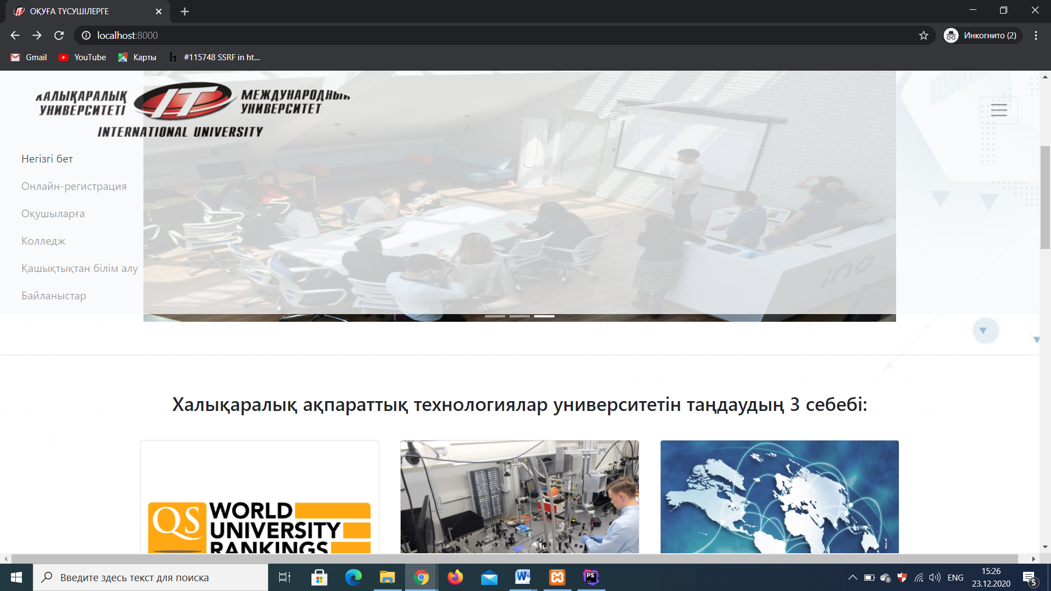

2.3) The home page displays the name and icon of the school in the Navbar in the upper left corner with a pop-up menu. Next, we have a slider with several photos and 3 reasons why an applicant should choose our university, achievements, interesting circles, advantages, etc., and at the end there is a footer.
Next we have the registration page (Online-registration). Here we also have a Navbar as we use it as a template for all pages, forms for filling in data such as first name, last name, birthday, mail, passwords. As we have already said, this page is displayed for unregistered users, user who have an account on our website can click on the Sign in link and enter their account.
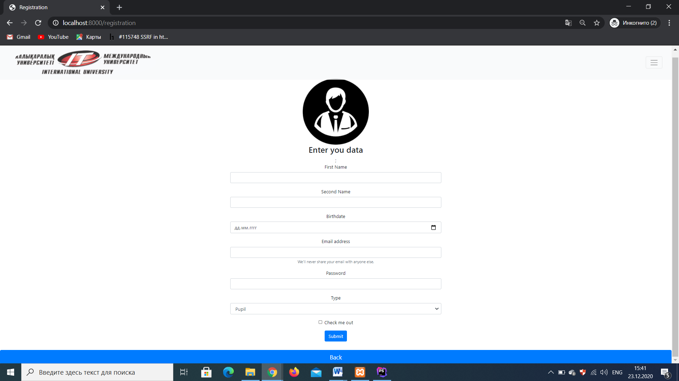

The page that you see below is a page for future students (possibly) of our university here, in separate blocks, the rules for admission, submission of documents, an open day, a consultant for an applicant, contacts, etc. are displayed. On this page, in principle, everything is clear here are only links to selected information pages.

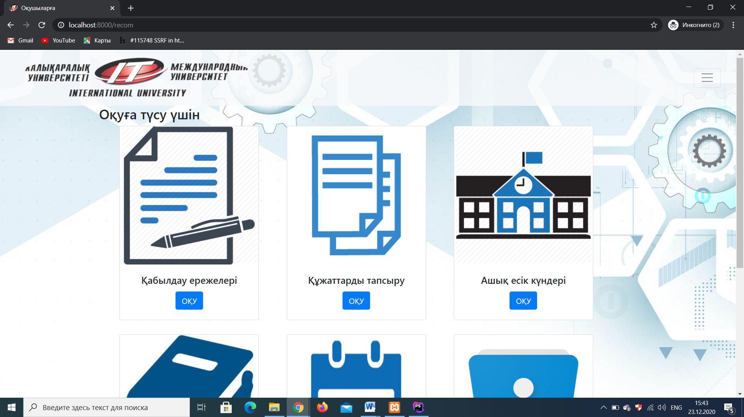

This page is intended for students studying remotely, here we also have a slider first, and then the distance learning channels, the rating of distance learning today, a list of distance learning specialists. On this page, in principle, everything is the same as on the previous page, only links to other individual information pages are displayed.

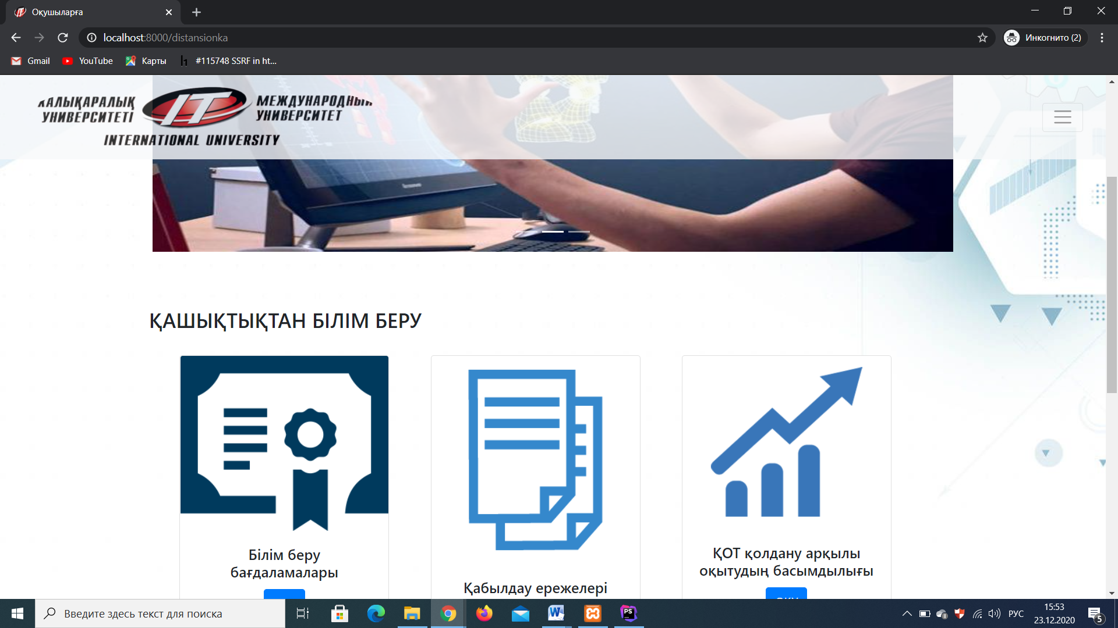

The next page we have is the contact page. here we also have a navbar template followed by contact information and addresses of colleges undergraduate, doctorate and internship schools. Contact information for students and an exchange worker abroad, also on this page the user can leave comments and suggestions, on this page we also display the location data of the university, or rather a map with the location of the university.

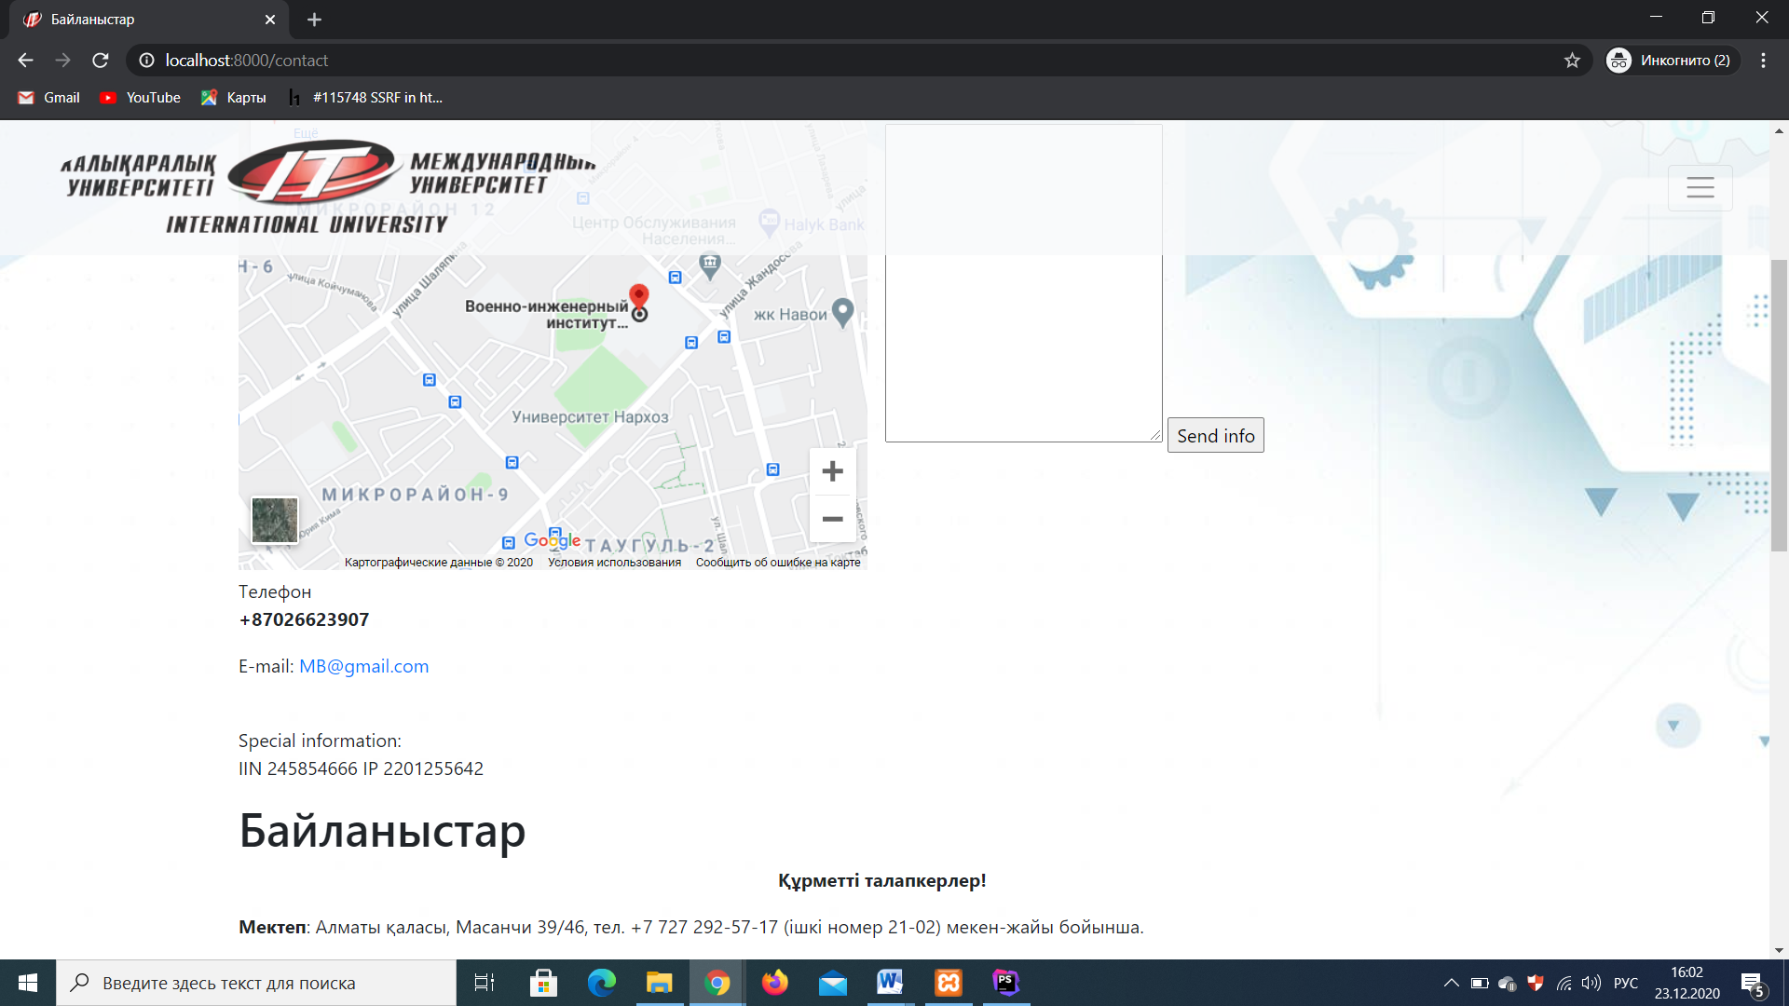
2.4) The design is designed with no frills to be affordable and convenient. We are certainly not designers and the design is not of the highest class, but for use it does not interfere, although it requires some modifications. We used some Bootstrap functionality, CSS and simple HTML code and nothing more.
2.5) The database on our site consists of 5 tables such as administrators, messages, news, students, pupils, users. These tables contain different information, each in its own direction.
The administrators table stores data (login, password) of site administrators who can make changes on the site. Passwords are stored encrypted using the sha1 () function.
The messages table stores messages of wishes and ideas of users who sent them on the contact page to the administrator.
The news table stores information that the admin adds for users, that is, this is a table of news that have a title, description, etc.
Next, we have tables for individual types of users, the names of the tables users, students, pupils they store user data depending on their registration on the site, that is, it depends on what type the registering person has chosen.

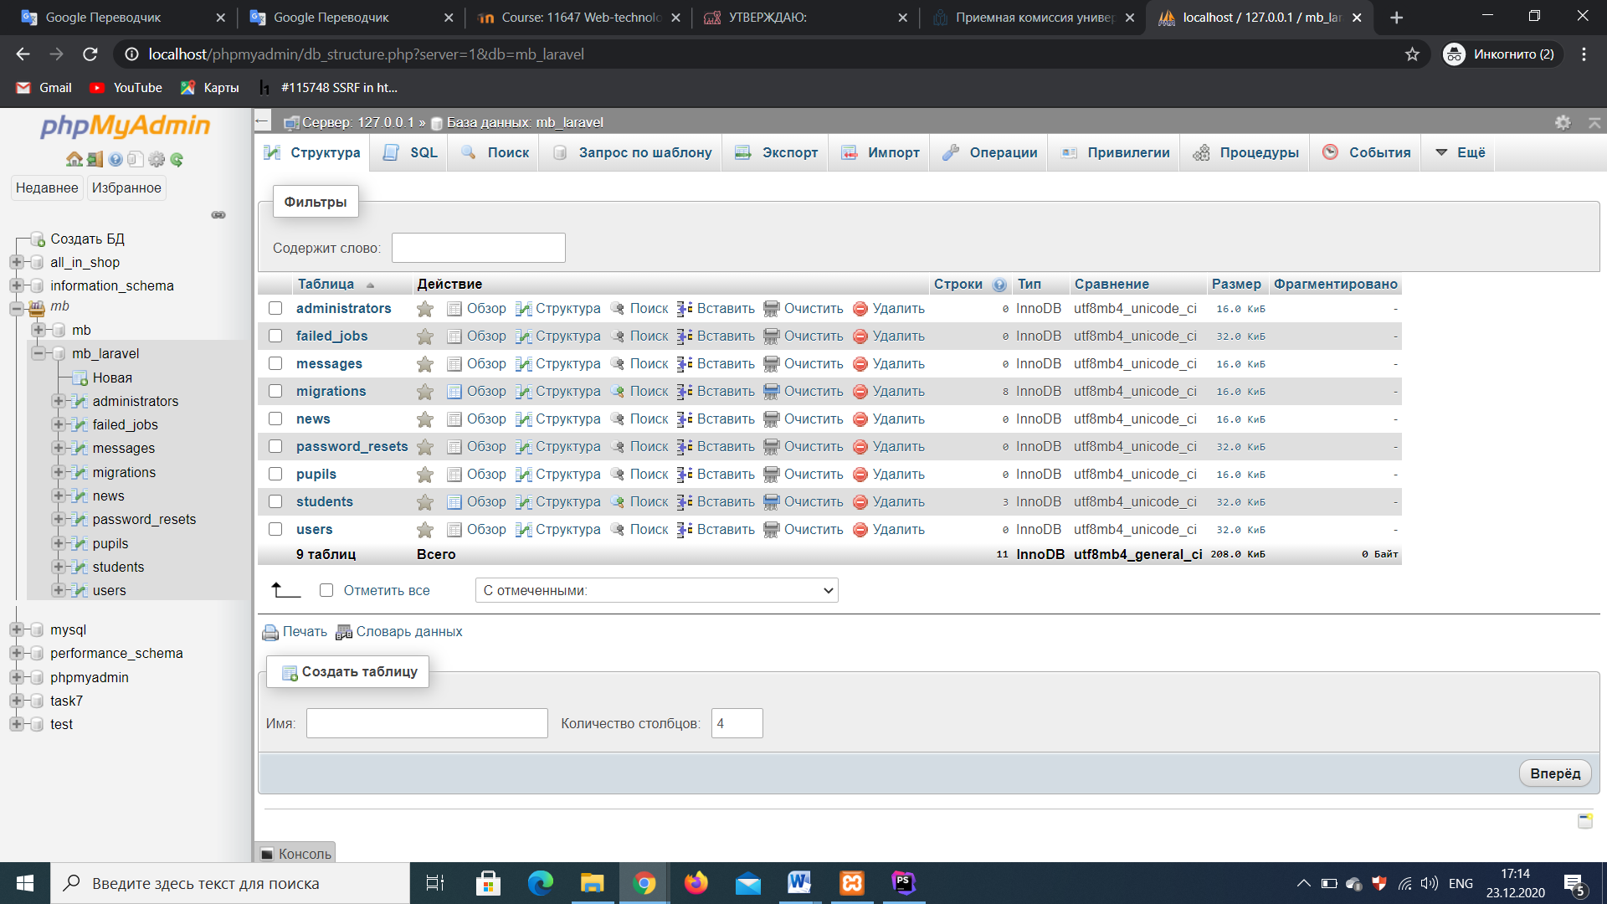

- Implementation (creation of website)
- Index.blade.php
<!DOCTYPE html>
<html lang="en">
<head>
<meta charset="UTF-8">
<meta name="viewport" content="width=device-width, initial-scale=1.0">
<meta http-equiv="X-UA-Compatible" content="ie=edge">
<title>ОҚУҒА ТҮСУШІЛЕРГЕ</title>
<link rel="shortcut icon" href="images/logo.png" type="image/png">
<link rel="stylesheet" href="https://maxcdn.bootstrapcdn.com/bootstrap/4.0.0/css/bootstrap.min.css">
<script src="https://ajax.googleapis.com/ajax/libs/jquery/3.3.1/jquery.min.js"></script>
<script src="https://cdnjs.cloudflare.com/ajax/libs/popper.js/1.12.9/umd/popper.min.js"></script>
<script src="https://maxcdn.bootstrapcdn.com/bootstrap/4.0.0/js/bootstrap.min.js"></script>
<script src="https://use.fontawesome.com/releases/v5.0.8/js/all.js"></script>
<link rel="stylesheet" href="css/main.css">
<style>
html,
body,
header,
.carousel{
height: 60vh;
}
@media(max-width: 740px){
html,
body,
header,
.carousel{
height: 100vh;
}
@media(min-width: 800px) and (max-width: 850px){
html,
body,
header,
.carousel{
height: 100vh;
}
}
}
nav{
opacity: .8;
}
</style>
</head>
<body>
<div>
<nav class="navbar navbar-expend-mb navbar-light bg-light sticky-top">
<div class="container-fluid" >
<a href="#" class="navbar-brad"><img src="images/logo.jpg" class="rounded-circle" width="500" height="100"></a>
<button class="navbar-toggler" type="button"
data-toggle="collapse" data-target="#navbarResponsive">
<span class="navbar-toggler-icon"></span>
</button>
<div class="collapse navbar-collapse " id="navbarResponsive">
<ul class="navbar-nav ml-auto">
<li class="nav-item active" >
<a href="index.blade.php" class="nav-link"> Негізгі бет</a>
</li>
<li class="nav-item " >
<a href="/registration" class="nav-link">Онлайн-регистрация</a>
</li>
<li class="nav-item " >
<a href="/recom" class="nav-link">Оқушыларға</a>
</li>
<li class="nav-item " >
<a href="https://intc.kz/ru/" class="nav-link">Колледж</a>
</li>
<li class="nav-item " >
<a href="/distansionka" class="nav-link">Қашықтықтан білім алу</a>
</li>
<li class="nav-item " >
<a href="/contact" class="nav-link">Байланыстар</a>
</li>
</ul>
</div>
</div>
</nav>
<br>
<div class="container-fluid padding">
<div class="row alert text-center">
<div class="col-12">
<!-- #####SLAIDER####-->
<div class="carousel slide carousel-fade pt-4" data-ride="carousel" id="carousel-ex">
<ol class="carousel-indicators">
<li data-target="#carousel-ex" data-slide-to="0" class="active" ></li>
<li data-target="#carousel-ex" data-slide-to="1"></li>
<li data-target="#carousel-ex" data-slide-to="2"></li>
</ol>
<div class="carousel-inner" role="listbox">
<div class="carousel-item active" >
<div class="view" style="background-repeat: no-repeat; background-size: cover;">
<img src="images/1.jpg" class="img-fluid" style="width: 1100px; height: 390px;">
<div class="carousel-caption">
</div>
</div>
</div>
<div class="carousel-item " >
<div class="view" style="background-repeat: no-repeat; background-size: cover;">
<img src="images/coursere.jpg" class="img-fluid" style="width: 1100px; height: 390px;">
<div class="carousel-caption"></div>
</div>
</div>
<div class="carousel-item " >
<div class="view" style="background-repeat: no-repeat; background-size: cover;">
<img src="images/3.jpg" class="img-fluid" style="width: 1100px; height: 390px;">
<div class="carousel-caption">
<h1 class="display-2"></div>
</div>
</div>
</div>
</div>
</div>
</div>
</div>
<hr>
<br>
<div>
<body background="images/fone.jpg"></body>
<div class="container-fluid padding">
<div class="row alert text-center">
<div class="col-12">
<h3> Халықаралық ақпараттық технологиялар университетін таңдаудың 3 себебі: </h3>
</div>
<hr>
</div>
</div>
<div class="container padding">
<div class="row padding">
<div class="col-md-4">
<div class="card">
<img src="images/reason1.png" class="card-img-top">
<div class="card-body">
<h4 class="card-title">1. Рейтинг университета:</h4>
<p class="card-text">
Международный университет информационных технологий (МУИТ, каз. Халықаралық ақпараттық технологиялар университеті) — ведущее высшее учебное заведение в Центрально - Азиатском регионе в
области подготовки квалифицированных, международно - признанных IT специалистов.
МУИТ вошел в тройку лучших университетов Республики Казахстан по рейтингу НПП "Атамекен" в 2019 году. Согласно рейтингу Независимого казахстанского агентства по обеспечению качества в образовании (НКАОКО), по специальности «Вычислительная техника и программное обеспечение» МУИТ занимает 1-ое место по Республике Казахстан.
</p>
</div>
</div>
</div>
<div class="col-md-4">
<div class="card">
<img src="images/reason2.jpeg" class="card-img-top">
<div class="card-body">
<br>
<h4 class="card-title">2. Лаборатории созданные для студентов:</h4>
<p class="card-text">
На базе нашего университета были созданы различные лаборатории для повышения качества образоварния студентов и развитие в этой сфере:
<ul>
<li>Лаборатория Cisco</li>
<li>Лаборатория Apple Training Center</li>
<li>Лаборатория Microsoft</li>
<li>Лаборатория инноваций Unicef</li>
<li>Лаборатория 3D графики и анимации</li>
</ul>
а также многие другие лаборатории где ты можешь создавать, обучаться и развивать свои знания.
</p>
</div>
</div>
</div>
<div class="col-md-4">
<div class="card">
<img src="images/reason3.jpg" class="card-img-top">
<div class="card-body">
<br>
<h4 class="card-title">3. Международное сотрудничество</h4>
<p class="card-text">
Международное сотрудничество университета осуществляется через совершенствование системы подготовки специалистов в соответствии с международными стандартами, повышения квалификации профессорско-преподавательского состава, использования новых технологий и передового опыта в учебной и научно-исследовательской деятельности путём сотрудничества с зарубежными вузами по прямым договорам.</p>
</div>
</div>
</div>
</div>
</div>
<br>
<hr>
<div class="container-fluid padding">
<h3>ПРЕИМУЩЕСТВА УНИВЕРСИТЕТА</h3>
<div class="row text-center padding">
<div class="row text-center padding">
<div class="col-xs-12 col-sm-6 col-md-4">
<a class="block p-1" href="">
<div class="h-full w-full bg-white rounded shadow-lg p-2 flex flex-col items-center cursor-pointer transition duration-300 hover:shadow-2xl hover:text-brand-red">
<div class="h-16 w-16">
<img class="object-contain h-full w-full" src="images/p2.jpg">
</div>
<span class="text-center text-lg">Интересная и разнообразная студенческая жизнь</span>
</div>
</a>
</div>
<div class="col-xs-12 col-sm-6 col-md-4">
<a class="block p-1" href="">
<div class="h-full w-full bg-white rounded shadow-lg p-2 flex flex-col items-center cursor-pointer transition duration-300 hover:shadow-2xl hover:text-brand-red">
<div class="h-16 w-16">
<img class="object-contain h-full w-full" src="images/p1.jpg">
</div>
<span class="text-center text-lg">Высокий научно-педагогический потенциал</span>
</div>
</a>
</div>
<div class="col-xs-12 col-sm-6 col-md-4">
<a class="block p-1" href="">
<div class="h-full w-full bg-white rounded shadow-lg p-2 flex flex-col items-center cursor-pointer transition duration-300 hover:shadow-2xl hover:text-brand-red">
<div class="h-16 w-16">
<img class="object-contain h-full w-full" src="images/p3.jpg">
</div>
<span class="text-center text-lg">Уникальные образовательные программы</span>
</div>
</a>
</div>
<div class="col-xs-12 col-sm-6 col-md-4">
<a class="block p-1" href="">
<div class="h-full w-full bg-white rounded shadow-lg p-2 flex flex-col items-center cursor-pointer transition duration-300 hover:shadow-2xl hover:text-brand-red">
<div class="h-16 w-16">
<img class="object-contain h-full w-full" src="images/p4.jpg">
</div>
<span class="text-center text-lg">Обменные программы и стажировки за рубежом</span>
</div>
</a>
</div>
<div class="col-xs-12 col-sm-6 col-md-4">
<a class="block p-1" href="">
<div class="h-full w-full bg-white rounded shadow-lg p-2 flex flex-col items-center cursor-pointer transition duration-300 hover:shadow-2xl hover:text-brand-red">
<div class="h-16 w-16">
<img class="object-contain h-full w-full" src="images/p5.jpg">
</div>
<span class="text-center text-lg">Участие в международных IT-соревнованиях и олимпиадах</span>
</div>
</a>
</div>
<div class="col-xs-12 col-sm-6 col-md-4">
<a class="block p-1" href="">
<div class="h-full w-full bg-white rounded shadow-lg p-2 flex flex-col items-center cursor-pointer transition duration-300 hover:shadow-2xl hover:text-brand-red">
<div class="h-16 w-16">
<img class="object-contain h-full w-full" src="images/p6.jpg">
</div>
<span class="text-center text-lg">Производственные практики в лучших IT-компаниях</span>
</div>
</a>
</div>
</div>
<hr class="my-4">
</div>
</div>
</div>
</div>
</body>
<div style="background-color: rgba(77,93,103,0.84) ">
<br>
<div class="container-fluid padding">
<hr>
<div class="col-sm-10 col-md-12">
<p><b>Біздің мекен-жайымыз:</b></p>
<p>
Қазақстан Республикасы, Алматы, 050040, Жандосов көшесі, 71 Тел. 8 (727) 377-33-30, 8 (727) 377-33-33 Факс 8 (727) 377-33-44
</p>
</div>
<hr>
<div class="col-sm-10 col-md-12">
<p>
<a href="https://www.instagram.com/" title="instagram"><img src="images/i.png"></a>
<a href="https://www.youtube.com/" title="youtube"><img src="images/yt.png"></a>
<a href="https://twitter.com/" title="twitter"><img src="images/t.png"></a>
<a href="https://www.facebook.com/" title="facebook"><img src="images/f.png"></a>
</p>
</div>
<br>
</div>
</div>
</html>

- Registration.balde.php
- <?php
// require_once"db/connection.php";
?>
<!DOCTYPE html>
<html lang="en">
<head>
<meta charset="UTF-8">
<meta name="viewport" content="width=device-width, initial-scale=1.0">
<meta http-equiv="X-UA-Compatible" content="ie=edge">
<title>Registration</title>
<link rel="shortcut icon" href="../mb_laravel/public/images/logo.png" type="image/png">
<link rel="stylesheet" href="https://maxcdn.bootstrapcdn.com/bootstrap/4.0.0/css/bootstrap.min.css">
<script src="https://ajax.googleapis.com/ajax/libs/jquery/3.3.1/jquery.min.js"></script>
<script src="https://cdnjs.cloudflare.com/ajax/libs/popper.js/1.12.9/umd/popper.min.js"></script>
<script src="https://maxcdn.bootstrapcdn.com/bootstrap/4.0.0/js/bootstrap.min.js"></script>
<script src="https://use.fontawesome.com/releases/v5.0.8/js/all.js"></script>
<link rel="stylesheet" href="../../../Users/77005/OneDrive/Рабочий%20стол/WEB%20PROG/MB/css/main.css">
<link rel="stylesheet" href="/css/bootstrap.min.css">
<script src="/jquery.min.js"></script>
<script src="/js/bootstrap.min.js"></script>
<link rel="stylesheet" href="https://cdnjs.cloudflare.com/ajax/libs/font-awesome/4.7.0/css/font-awesome.min.css">
</head>
<style>
nav{
opacity: .8;
}
</style>
<nav class="navbar navbar-expend-mb navbar-light bg-light sticky-top">
<div class="container-fluid" >
<a href="#" class="navbar-brad"><img src="images/logo.jpg" class="rounded-circle" width="500" height="100"></a>
<button class="navbar-toggler" type="button"
data-toggle="collapse" data-target="#navbarResponsive">
<span class="navbar-toggler-icon"></span>
</button>
<div class="collapse navbar-collapse " id="navbarResponsive">
<ul class="navbar-nav ml-auto">
<li class="nav-item active" >
<a href="../mb_laravel/resources/views/index.php" class="nav-link"> Негізгі бет</a>
</li>
<li class="nav-item " >
<a href="registration.blade.php" class="nav-link">Онлайн-регистрация</a>
</li>
<li class="nav-item " >
<a href="recom.blade.php" class="nav-link">Оқушыларға</a>
</li>
<li class="nav-item " >
<a href="https://intc.kz/ru/" class="nav-link">Колледж</a>
</li>
<li class="nav-item " >
<a href="../mb_laravel/resources/views/distansionka.php" class="nav-link">Қашықтықтан білім алу</a>
</li>
<li class="nav-item " >
<a href="../mb_laravel/resources/views/contact.php" class="nav-link">Байланыстар</a>
</li>
</ul>
</div>
</div>
</nav>
<body class="login-page">
<div class="container-fluid padding">
<div class="row alert text-center">
<div class="col-sm-4 offset-4">
<div class="login-block">
<img src="images/1.png" alt="Scanfcode">
<h3>Enter you data</h3>
<form action="/registration" method="post">
@csrf;
<div class="form-group">
<label for="name">First Name</label>
<input type="text" class="form-control" id="name" name="name">
</div>
<div class="form-group">
<label for="secondName">Second Name</label>
<input type="text" class="form-control" id="secondName" name="surname">
</div>
<div class="form-group">
<label for="bdate">Birthdate</label>
<input type="date" class="form-control" id="bdate" name="bithdate">
</div>
<div class="form-group">
<label for="exampleInputEmail1">Email address</label>
<input type="email" class="form-control" id="exampleInputEmail1" aria-describedby="emailHelp" name="login">
<small id="emailHelp" class="form-text text-muted">We'll never share your email with anyone else.</small>
</div>
<div class="form-group">
<label for="exampleInputPassword1">Password</label>
<input type="password" class="form-control" id="exampleInputPassword1" name="password">
</div>
<div class="form-group">
<label for="type">Type</label>
<select name="type" id="type" class="form-control">
<option value="pupil">Pupil</option>
<option value="student">Student</option>
</select>
</div>
<div class="form-group form-check">
<input type="checkbox" class="form-check-input" id="exampleCheck1">
<label class="form-check-label" for="exampleCheck1">Check me out</label>
</div>
<button type="submit" class="btn btn-primary">Submit</button>
</form>
</div>
</div>
</div>
</div>
</div>
<a href="../mb_laravel/resources/views/index.php">
<button type="button" class="btn btn-primary btn-lg btn-block">Back</button>
</a>
</body>
</html>

- Contact.blade.php

@extends('templates.header')
@section('content')
<section class="contacts">
<div class="container">
<div class="row">
<div class="col-md-6">
<h1><strong>Байланыстар</strong></h1>
<p>Біздің мекен-жайымыз:<br>Almaty city, Zhandosova 53</p>
<div class="map">
<iframe src="https://www.google.com/maps/embed?pb=!1m23!1m12!1m3!1d5815.232729216264!2d76.86998819140007!3d43.217535255589205!2m3!1f0!2f0!3f0!3m2!1i1024!2i768!4f13.1!4m8!3e6!4m0!4m5!1s0x388368f88bb704ad%3A0x30726c4b292dce7a!2z0JLQvtC10L3QvdC-LdC40L3QttC10L3QtdGA0L3Ri9C5INC40L3RgdGC0LjRgtGD0YIg0YDQsNC00LjQvtGN0LvQtdC60YLRgNC-0L3QuNC60Lgg0Lgg0YHQstGP0LfQuCDQnNCeINCg0JosINC_0YDQvtGB0L_QtdC60YIg0JDQu9GC0YvQvdGB0LDRgNC40L3QsCwg0JDQu9C80LDRgtGL!3m2!1d43.217364499999995!2d76.87317709999999!5e0!3m2!1sru!2skz!4v1603089225508!5m2!1sru!2skz" width="100%" height="450" frameborder="0" style="border:0;" allowfullscreen="" aria-hidden="false" tabindex="0"></iframe>
</div>
<p>Телефон<br><strong>+87026623907</strong></p>
<p>E-mail:
<a class="contacts-link" href="mailto:MEIRAC@gmail.com">MB@gmail.com</a>
</p>
<br>
<p>Special information:<br>IIN 245854666 IP 2201255642</p>
</div>
<div class="col-md-4 col-md-offset-2">
<div class="container-cont">
<div style="text-align:center">
<h2><strong>
Оставьте нам свои контакты</strong></h2>
</div>
<div class="row">
<div class="column">
<form>
<label for="fname">Name</label>
<input type="text" id="fname" name="firstname" placeholder="Your name">
<label for="lname">Surname</label>
<input type="text" id="lname" name="lastname" placeholder="Your surname">
<label for="city">City</label>
<select name="city" id="city">
<option value="Almaty">Almaty</option>
<option value="Nur-Sultan">Nur-Sultan</option>
<option value="Aktau">Aktau</option>
<option value="Shymkent">Shymkent</option>
<option value="Semey">Semey</option>
<option value="Aktobe">Aktobe</option>
<option value="Taldukorgan">Taldukorgan</option>
<option value="Uralsk">Uralsk</option>
</select>
<label for="subject">Some additional info</label>
<textarea name="subject" id="subject" cols="30" rows="10"></textarea>
<input type="submit" value="Send info">
</div>
</div>
</div>
</div>
</div>
</div>
</section>
<div class="container padding">
<section class="static-page-rule">
<div class="wrap">
<h1>Байланыстар</h1>
<p style="text-align: center;"><strong>Құрметті талапкерлер!</strong><strong>&nbsp;</strong></p>
<p><strong>Мектеп</strong>: Алматы қаласы, Масанчи 39/46, тел. +7 727 292-57-17 (ішкі номер 21-02) мекен-жайы бойынша.</p>
<p><strong>Колледж</strong>: Алматы қаласы, Масанчи 39/46, тел. +7 727 292-57-17 (ішкі номер 21-83) мекен-жайы бойынша.</p>
<p><strong>Бакалавриат</strong>: Алматы қаласы, әл-Фараби даңғылы,71</p>
<p>Ө.Жолдасбеков атындағы Студенттер сарайы, 2-қабат,</p>
<p>тел. +7 727 377 33 30, 377 33 33 мекен-жайы бойынша.</p>
<p>Телефон номері :&nbsp;+7 727 221-10-00,&nbsp;+7 727 221-10-10.</p>
<p><strong>Магистратура және докторантура</strong>: Алматы қаласы, әл-Фараби даңғылы,71</p>
<p>Ө.Жолдасбеков атындағы Студенттер сарайы, 2-қабат,</p>
<p>тел. +7 727 377 33 30, 377 33 33 – Қабылдау комиссиясы</p>
<p><strong>Интернатура:&nbsp;</strong></p>
<p>Алматы қаласы, әл-Фараби даңғылы,71</p>
<p>Ө.Жолдасбеков атындағы Студенттер сарайы, 2-қабат,</p>
<p>тел. +7701 76 16115; +7 775 389 4499; +7 778 565 5088; +7 701 722 40451</p>
<p>&nbsp;</p>
<p style="text-align: justify;"><span><span><strong><strong>Шетелдік<strong> талапкерлерге</strong></strong></strong></span></span></p>
<p><strong>Шетелдік талапкерлермен жұмыс жасайтын офистың байланыстары</strong></p>
<p><strong>Мехмет Арслан, Интернационализация және коммерциализация бойынша проректор</strong></p>
<p><strong>&nbsp;</strong>Қазақстан Республикасы, Алматы қаласы, 050040, әл-Фараби даңғылы, 71</p>
<p><strong>Е-</strong><strong>mail:&nbsp;</strong><a href="https://iitu.kz/ru/">international@iitu.kz</a>&nbsp;&nbsp;<span>(Тек халықаралық / шетелдік студенттер байланыса алады!)</span></p>
<p>Тел. +7 (727) 377 33 30</p>
<p>&nbsp;&nbsp;&nbsp;&nbsp;&nbsp;&nbsp; +7 (727) 377 33 33</p>
<p>Ішкі: 1395&nbsp;<span>(Тек халықаралық / шетелдік студенттер байланыса алады!)</span></p>
<p>1930&nbsp;<span>(Тек халықаралық / шетелдік студенттер байланыса алады!)</span></p>
<p style="text-align: justify;"><strong><strong><br></strong></strong></p>
<p></p>
</div>
</section>
@endsection

- Distansionka.blade.php
<!DOCTYPE html>
<html lang="en">
<head>
<meta charset="UTF-8">
<meta name="viewport" content="width=device-width, initial-scale=1.0">
<meta http-equiv="X-UA-Compatible" content="ie=edge">
<title>Оқушыларға</title>
<link rel="shortcut icon" href="images/logo.png" type="image/png">
<link rel="stylesheet" href="https://maxcdn.bootstrapcdn.com/bootstrap/4.0.0/css/bootstrap.min.css">
<script src="https://ajax.googleapis.com/ajax/libs/jquery/3.3.1/jquery.min.js"></script>
<script src="https://cdnjs.cloudflare.com/ajax/libs/popper.js/1.12.9/umd/popper.min.js"></script>
<script src="https://maxcdn.bootstrapcdn.com/bootstrap/4.0.0/js/bootstrap.min.js"></script>
<script src="https://use.fontawesome.com/releases/v5.0.8/js/all.js"></script>
<link rel="stylesheet" href="../../../Users/77005/OneDrive/Рабочий%20стол/WEB%20PROG/MB/css/main.css">
<style>
.nnn {
float: left;
margin-left: 5%;
width: 20%;
margin-bottom: 30px;
}
</style>
</head>
<style>
nav{
opacity: .8;
}
</style>
<body background="images/fone.jpg">
<nav class="navbar navbar-expend-mb navbar-light bg-light sticky-top">
<div class="container-fluid" >
<a href="/" class="navbar-brad"><img src="images/logo.jpg" class="rounded-circle" width="500" height="100"></a>
<button class="navbar-toggler" type="button"
data-toggle="collapse" data-target="#navbarResponsive">
<span class="navbar-toggler-icon"></span>
</button>
<div class="collapse navbar-collapse " id="navbarResponsive">
<ul class="navbar-nav ml-auto">
<li class="nav-item active" >
<a href="/" class="nav-link"> Негізгі бет</a>
</li>
<li class="nav-item " >
<a href="/registration" class="nav-link">Онлайн-регистрация</a>
</li>
<li class="nav-item " >
<a href="/recom" class="nav-link">Оқушыларға</a>
</li>
<li class="nav-item " >
<a href="https://intc.kz/ru/" class="nav-link">Колледж</a>
</li>
<li class="nav-item " >
<a href="/distansionka" class="nav-link">Қашықтықтан білім алу</a>
</li>
<li class="nav-item " >
<a href="/contact" class="nav-link">Байланыстар</a>
</li>
</ul>
</div>
</div>
</nav>
<div class="container-fluid padding">
<div class="row alert text-center">
<div class="col-12">
<!-- #####SLAIDER####-->
<div class="carousel slide carousel-fade pt-4" data-ride="carousel" id="carousel-ex">
<ol class="carousel-indicators">
<li data-target="#carousel-ex" data-slide-to="0" class="active" ></li>
<li data-target="#carousel-ex" data-slide-to="1"></li>
<li data-target="#carousel-ex" data-slide-to="2"></li>
</ol>
<div class="carousel-inner" role="listbox">
<div class="carousel-item active" >
<div class="view" style="background-repeat: no-repeat; background-size: cover;">
<img src="images/d1.png" class="img-fluid" style="width: 1100px; height: 390px;">
<div class="carousel-caption">
</div>
</div>
</div>
<div class="carousel-item " >
<div class="view" style="background-repeat: no-repeat; background-size: cover;">
<img src="images/d2.jpg" class="img-fluid" style="width: 1100px; height: 390px;">
<div class="carousel-caption"></div>
</div>
</div>
<div class="carousel-item " >
<div class="view" style="background-repeat: no-repeat; background-size: cover;">
<img src="images/3.jpg" class="img-fluid" style="width: 1100px; height: 390px;">
<div class="carousel-caption">
<h1 class="display-2"></h1>
</div>
</div>
</div>
</div>
</div>
</div>
</div>
</div>
<br>
<br>
<div class="container padding">
<h3>ҚАШЫҚТЫҚТАН БІЛІМ БЕРУ</h3>
<br>
<div class="row text-center padding">
<div class="card nnn" style="width: 18rem;">
<img src="images/18073.png" class="card-img-top">
<div class="card-body">
<h5 class="card-title">Білім беру бағдаламалары</h5>
<a href="#" class="btn btn-primary">ОҚУ</a>
</div>
</div>
<div class="card nnn" style="width: 18rem;">
<img src="images/17968.png" class="card-img-top">
<div class="card-body">
<h5 class="card-title">Қабылдау ережелері</h5>
<a href="#" class="btn btn-primary">ОҚУ</a>
</div>
</div>
<div class="card nnn" style="width: 18rem;">
<img src="images/17961.png" class="card-img-top">
<div class="card-body">
<h5 class="card-title">ҚОТ қолдану арқылы оқытудың басымдылығы</h5>
<a href="#" class="btn btn-primary">ОҚУ</a>
</div>
</div>
<div class="card nnn" style="width: 18rem;">
<img src="images/18081.png" class="card-img-top">
<div class="card-body">
<h5 class="card-title">Мамандықтардың тізімі мен бағалары</h5>
<a href="#" class="btn btn-primary">ОҚУ</a>
</div>
</div>
<div class="card nnn" style="width: 18rem;">
<img src="images/18237.png" class="card-img-top" style="height: 90%;">
<div class="card-body">
<h5 class="card-title">Ашық есік күндері</h5>
<a href="#" class="btn btn-primary">ОҚУ</a>
</div>
</div>
<div class="card nnn" style="width: 18rem;">
<img src="images/contacts.png" class="card-img-top">
<div class="card-body">
<h5 class="card-title">Байланыстар</h5>
<a href="#" class="btn btn-primary">ОҚУ</a>
</div>
</div>
</div>
</div>
<hr class="my-4">
</div>
<div class="container padding">
<div class="row padding">
</div>
</div>
<a href="../mb_laravel/resources/views/index.php">
<button type="button" class="btn btn-primary btn-lg btn-block">Back</button>
</a>
</body>
</html>

- Recom.blade.php

<!DOCTYPE html>
<html lang="en">
<head>
<meta charset="UTF-8">
<meta name="viewport" content="width=device-width, initial-scale=1.0">
<meta http-equiv="X-UA-Compatible" content="ie=edge">
<title>Оқушыларға</title>
<link rel="shortcut icon" href="images/logo.png" type="image/png">
<link rel="stylesheet" href="https://maxcdn.bootstrapcdn.com/bootstrap/4.0.0/css/bootstrap.min.css">
<script src="https://ajax.googleapis.com/ajax/libs/jquery/3.3.1/jquery.min.js"></script>
<script src="https://cdnjs.cloudflare.com/ajax/libs/popper.js/1.12.9/umd/popper.min.js"></script>
<script src="https://maxcdn.bootstrapcdn.com/bootstrap/4.0.0/js/bootstrap.min.js"></script>
<script src="https://use.fontawesome.com/releases/v5.0.8/js/all.js"></script>
<link rel="stylesheet" href="../../../Users/77005/OneDrive/Рабочий%20стол/WEB%20PROG/MB/css/main.css">
<style>
.nnn {
float: left;
margin-left: 5%;
width: 20%;
margin-bottom: 30px;
}
</style>
</head>
<style>
nav{
opacity: .8;
}
</style>
<body background="images/fone.jpg">
<nav class="navbar navbar-expend-mb navbar-light bg-light sticky-top">
<div class="container-fluid" >
<a href="#" class="navbar-brad"><img src="images/logo.jpg" class="rounded-circle" width="500" height="100"></a>
<button class="navbar-toggler" type="button"
data-toggle="collapse" data-target="#navbarResponsive">
<span class="navbar-toggler-icon"></span>
</button>
<div class="collapse navbar-collapse " id="navbarResponsive">
<ul class="navbar-nav ml-auto">
<li class="nav-item active" >
<a href="../mb_laravel/resources/views/index.php" class="nav-link"> Негізгі бет</a>
</li>
<li class="nav-item " >
<a href="registration.blade.php" class="nav-link">Онлайн-регистрация</a>
</li>
<li class="nav-item " >
<a href="recom.blade.php" class="nav-link">Оқушыларға</a>
</li>
<li class="nav-item " >
<a href="https://intc.kz/ru/" class="nav-link">Колледж</a>
</li>
<li class="nav-item " >
<a href="../mb_laravel/resources/views/distansionka.php" class="nav-link">Қашықтықтан білім алу</a>
</li>
<li class="nav-item " >
<a href="../mb_laravel/resources/views/contact.php" class="nav-link">Байланыстар</a>
</li>
</ul>
</div>
</div>
</nav>
<div class="container padding">
<h3>Оқуға түсу үшін</h3>
<div class="row text-center padding">
<div class="card nnn" style="width: 18rem;">
<img src="images/17966.png" class="card-img-top">
<div class="card-body">
<h5 class="card-title">Қабылдау ережелері</h5>
<a href="#" class="btn btn-primary">ОҚУ</a>
</div>
</div>
<div class="card nnn" style="width: 18rem;">
<img src="images/17968.png" class="card-img-top">
<div class="card-body">
<h5 class="card-title">Құжаттарды тапсыру</h5>
<a href="#" class="btn btn-primary">ОҚУ</a>
</div>
</div>
<div class="card nnn" style="width: 18rem;">
<img src="images/18237.png" class="card-img-top">
<div class="card-body">
<h5 class="card-title">Ашық есік күндері</h5>
<a href="#" class="btn btn-primary">ОҚУ</a>
</div>
</div>
<div class="card nnn" style="width: 18rem;">
<img src="images/19195.png" class="card-img-top">
<div class="card-body">
<h5 class="card-title">Талапкердің жол сілтеушісі</h5>
<a href="#" class="btn btn-primary">ОҚУ</a>
</div>
</div>
<div class="card nnn" style="width: 18rem;">
<img src="images/19379.png" class="card-img-top" style="height: 90%;">
<div class="card-body">
<h5 class="card-title">Талапкердің күнтізбесі</h5>
<a href="#" class="btn btn-primary">ОҚУ</a>
</div>
</div>
<div class="card nnn" style="width: 18rem;">
<img src="images/contacts.png" class="card-img-top">
<div class="card-body">
<h5 class="card-title">Байланыстар</h5>
<a href="#" class="btn btn-primary">ОҚУ</a>
</div>
</div>
</div>
</div>
<hr class="my-4">
</div>
<div class="container padding">
<div class="row padding">
</div>
</div>
<a href="../mb_laravel/resources/views/index.php">
<button type="button" class="btn btn-primary btn-lg btn-block">Back</button>
</a>
</body>
</html>

Creation web database for your websites

SET SQL_MODE = "NO_AUTO_VALUE_ON_ZERO";
START TRANSACTION;
SET time_zone = "+00:00";
CREATE TABLE `administrators` (
`id` bigint(20) UNSIGNED NOT NULL,
`name` varchar(255) COLLATE utf8mb4_unicode_ci NOT NULL,
`surname` varchar(255) COLLATE utf8mb4_unicode_ci NOT NULL,
`login` varchar(255) COLLATE utf8mb4_unicode_ci NOT NULL,
`password` varchar(255) COLLATE utf8mb4_unicode_ci NOT NULL
) ENGINE=InnoDB DEFAULT CHARSET=utf8mb4 COLLATE=utf8mb4_unicode_ci;

INSERT INTO `administrators` (`id`, `name`, `surname`, `login`, `password`) VALUES
(1, 'Magzhan', 'Ermagambet', 'admin', 'admin');

CREATE TABLE `failed_jobs` (
`id` bigint(20) UNSIGNED NOT NULL,
`uuid` varchar(255) COLLATE utf8mb4_unicode_ci NOT NULL,
`connection` text COLLATE utf8mb4_unicode_ci NOT NULL,
`queue` text COLLATE utf8mb4_unicode_ci NOT NULL,
`payload` longtext COLLATE utf8mb4_unicode_ci NOT NULL,
`exception` longtext COLLATE utf8mb4_unicode_ci NOT NULL,
`failed_at` timestamp NOT NULL DEFAULT current_timestamp()
) ENGINE=InnoDB DEFAULT CHARSET=utf8mb4 COLLATE=utf8mb4_unicode_ci;

CREATE TABLE `messages` (
`id` bigint(20) UNSIGNED NOT NULL,
`name` varchar(255) COLLATE utf8mb4_unicode_ci NOT NULL,
`surname` varchar(255) COLLATE utf8mb4_unicode_ci NOT NULL,
`city` varchar(255) COLLATE utf8mb4_unicode_ci NOT NULL,
`text` varchar(255) COLLATE utf8mb4_unicode_ci NOT NULL,
`created_at` timestamp NULL DEFAULT NULL,
`updated_at` timestamp NULL DEFAULT NULL
) ENGINE=InnoDB DEFAULT CHARSET=utf8mb4 COLLATE=utf8mb4_unicode_ci;

INSERT INTO `messages` (`id`, `name`, `surname`, `city`, `text`, `created_at`, `updated_at`) VALUES
(1, 'Bauka', 'Bauka', 'Almaty', 'Жаксы сайт екен', '2020-12-23 23:17:14', '2020-12-23 23:17:14'),
(2, 'Magzhan', 'Ermagambet', 'Qyzylorda', 'Good web-site', '2020-12-23 23:18:23', '2020-12-23 23:18:23');

CREATE TABLE `migrations` (
`id` int(10) UNSIGNED NOT NULL,
`migration` varchar(255) COLLATE utf8mb4_unicode_ci NOT NULL,
`batch` int(11) NOT NULL
) ENGINE=InnoDB DEFAULT CHARSET=utf8mb4 COLLATE=utf8mb4_unicode_ci;

INSERT INTO `migrations` (`id`, `migration`, `batch`) VALUES
(33, '2014_10_12_000000_create_users_table', 1),
(34, '2014_10_12_100000_create_password_resets_table', 1),
(35, '2019_08_19_000000_create_failed_jobs_table', 1),
(36, '2020_12_07_060736_create_students_table', 1),
(37, '2020_12_07_060800_create_pupils_table', 1),
(38, '2020_12_07_060814_create_news_table', 1),
(39, '2020_12_07_060823_create_messages_table', 1),
(40, '2020_12_07_060937_create_administrators_table', 1);

CREATE TABLE `news` (
`id` bigint(20) UNSIGNED NOT NULL,
`title` varchar(255) COLLATE utf8mb4_unicode_ci NOT NULL,
`body` varchar(255) COLLATE utf8mb4_unicode_ci NOT NULL,
`pictureUrl` varchar(255) COLLATE utf8mb4_unicode_ci NOT NULL,
`created_at` timestamp NULL DEFAULT NULL,
`updated_at` timestamp NULL DEFAULT NULL
) ENGINE=InnoDB DEFAULT CHARSET=utf8mb4 COLLATE=utf8mb4_unicode_ci;

CREATE TABLE `password_resets` (
`email` varchar(255) COLLATE utf8mb4_unicode_ci NOT NULL,
`token` varchar(255) COLLATE utf8mb4_unicode_ci NOT NULL,
`created_at` timestamp NULL DEFAULT NULL
) ENGINE=InnoDB DEFAULT CHARSET=utf8mb4 COLLATE=utf8mb4_unicode_ci;

CREATE TABLE `pupils` (
`id` bigint(20) UNSIGNED NOT NULL,
`name` varchar(255) COLLATE utf8mb4_unicode_ci NOT NULL,
`surname` varchar(255) COLLATE utf8mb4_unicode_ci NOT NULL,
`birthdate` date NOT NULL,
`login` varchar(255) COLLATE utf8mb4_unicode_ci NOT NULL,
`password` varchar(255) COLLATE utf8mb4_unicode_ci NOT NULL,
`created_at` timestamp NULL DEFAULT NULL,
`updated_at` timestamp NULL DEFAULT NULL
) ENGINE=InnoDB DEFAULT CHARSET=utf8mb4 COLLATE=utf8mb4_unicode_ci;

INSERT INTO `pupils` (`id`, `name`, `surname`, `birthdate`, `login`, `password`, `created_at`, `updated_at`) VALUES
(1, 'Almas', 'Aubakirov', '2020-12-05', 'almas@mail.ru', 'ea239dc500f7d36414e64f8f3f43d64dac222911', '2020-12-23 22:33:57', '2020-12-23 22:33:57');

CREATE TABLE `students` (
`id` bigint(20) UNSIGNED NOT NULL,
`name` varchar(255) COLLATE utf8mb4_unicode_ci NOT NULL,
`surname` varchar(255) COLLATE utf8mb4_unicode_ci NOT NULL,
`birthdate` date NOT NULL,
`login` varchar(255) COLLATE utf8mb4_unicode_ci NOT NULL,
`password` varchar(255) COLLATE utf8mb4_unicode_ci NOT NULL,
`created_at` timestamp NULL DEFAULT NULL,
`updated_at` timestamp NULL DEFAULT NULL
) ENGINE=InnoDB DEFAULT CHARSET=utf8mb4 COLLATE=utf8mb4_unicode_ci;

CREATE TABLE `users` (
`id` bigint(20) UNSIGNED NOT NULL,
`name` varchar(255) COLLATE utf8mb4_unicode_ci NOT NULL,
`email` varchar(255) COLLATE utf8mb4_unicode_ci NOT NULL,
`email_verified_at` timestamp NULL DEFAULT NULL,
`password` varchar(255) COLLATE utf8mb4_unicode_ci NOT NULL,
`remember_token` varchar(100) COLLATE utf8mb4_unicode_ci DEFAULT NULL,
`created_at` timestamp NULL DEFAULT NULL,
`updated_at` timestamp NULL DEFAULT NULL
) ENGINE=InnoDB DEFAULT CHARSET=utf8mb4 COLLATE=utf8mb4_unicode_ci;

ALTER TABLE `administrators`
ADD PRIMARY KEY (`id`);

ALTER TABLE `failed_jobs`
ADD PRIMARY KEY (`id`),
ADD UNIQUE KEY `failed_jobs_uuid_unique` (`uuid`);

ALTER TABLE `messages`
ADD PRIMARY KEY (`id`);

ALTER TABLE `migrations`
ADD PRIMARY KEY (`id`);

ALTER TABLE `news`
ADD PRIMARY KEY (`id`);

ALTER TABLE `password_resets`
ADD KEY `password_resets_email_index` (`email`);

ALTER TABLE `pupils`
ADD PRIMARY KEY (`id`);

ALTER TABLE `students`
ADD PRIMARY KEY (`id`);

ALTER TABLE `users`
ADD PRIMARY KEY (`id`),
ADD UNIQUE KEY `users_email_unique` (`email`);

ALTER TABLE `administrators`
MODIFY `id` bigint(20) UNSIGNED NOT NULL AUTO_INCREMENT, AUTO_INCREMENT=2;

ALTER TABLE `failed_jobs`
MODIFY `id` bigint(20) UNSIGNED NOT NULL AUTO_INCREMENT;

ALTER TABLE `messages`
MODIFY `id` bigint(20) UNSIGNED NOT NULL AUTO_INCREMENT, AUTO_INCREMENT=3;

ALTER TABLE `migrations`
MODIFY `id` int(10) UNSIGNED NOT NULL AUTO_INCREMENT, AUTO_INCREMENT=41;

ALTER TABLE `news`
MODIFY `id` bigint(20) UNSIGNED NOT NULL AUTO_INCREMENT;

ALTER TABLE `pupils`
MODIFY `id` bigint(20) UNSIGNED NOT NULL AUTO_INCREMENT, AUTO_INCREMENT=2;

ALTER TABLE `students`
MODIFY `id` bigint(20) UNSIGNED NOT NULL AUTO_INCREMENT;

ALTER TABLE `users`
MODIFY `id` bigint(20) UNSIGNED NOT NULL AUTO_INCREMENT;
COMMIT;

Conclusion
The site is easily accessible for all categories of people, very easy to use. Registered users can find reliable and useful information that they need to enter our university. Also, users can send messages and wishes to administrators and take remote and online training and much more. You will learn the rest of the interesting points and subtleties of the site during our defense.

References
- github: https://github.com/magzhan-h1
- https://welcome.kaznu.kz
- https://iitu.kz

Appendix A
PHP (English PHP: Hypertext Preprocessor — "PHP: hypertext preprocessor"; originally PHP/FI (Personal Home Page / Form Interpreter), and later called Personal Home Page Tools — "Tools for creating personal web pages") is a General — purpose scripting language that is intensively used for developing web applications. Currently, it is supported by the vast majority of hosting providers and is one of the leaders among the languages used to create dynamic websites

