**COMSATS University Islamabad**

** Sahiwal Campus**

**MID LAB DATABASE**

**Submitted by:**

Mah Noor

FA23-BCS-332

DATA BASE

**Submitted to:**

Mam Hamna Khalid

CUI, Sahiwal

**Question 1 :**

**CODE**

--SELECT employee_id, last_name

--FROM employees

--WHERE manager_id = '&manager_id'

--ORDER BY &column_name;

**SCREENSHOT:**

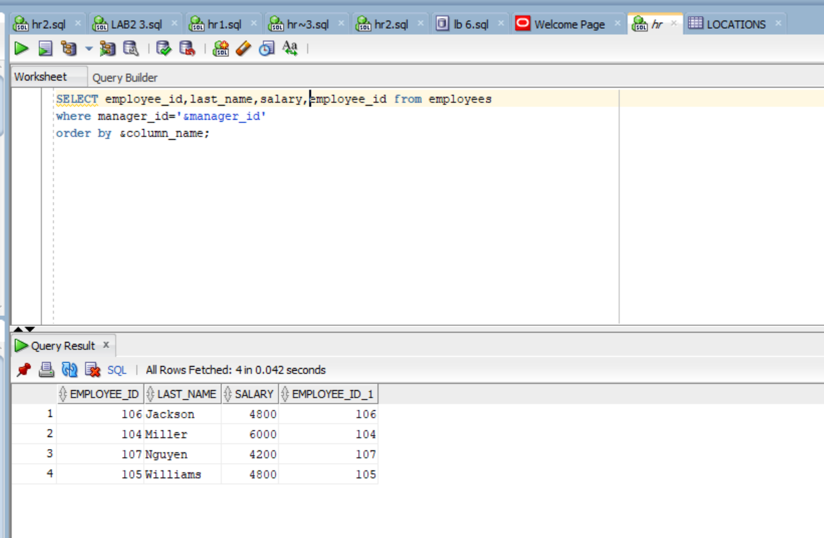

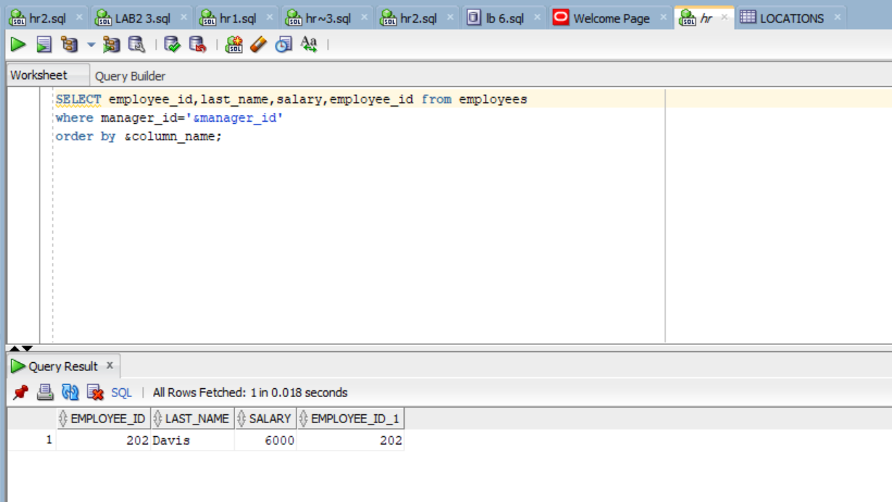

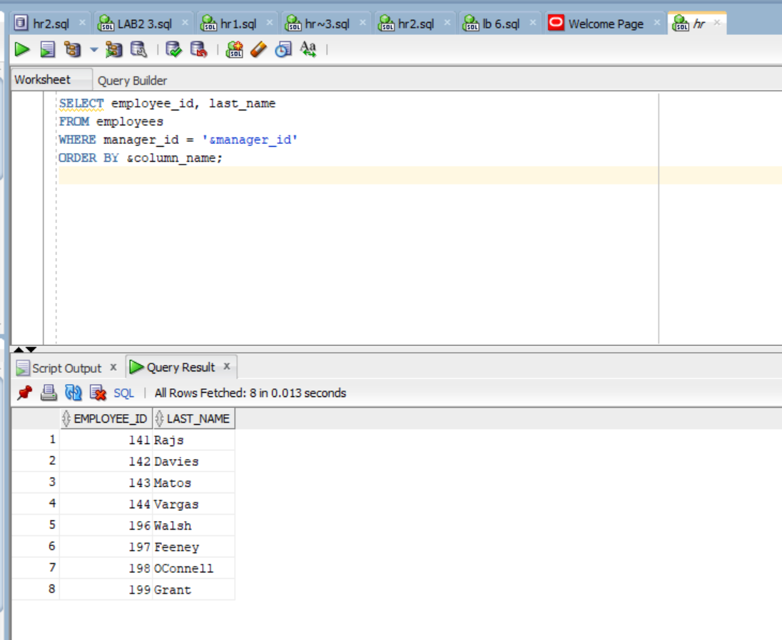

**Question 2:**

**CODE**

SELECT last_name,CEIL(MONTHS_BETWEEN(SYSDATE, hire_date)) AS "MONTHS_WORKED"

FROM employees

ORDER BY MONTHS_WORKED;

**SCREENSHOT:**

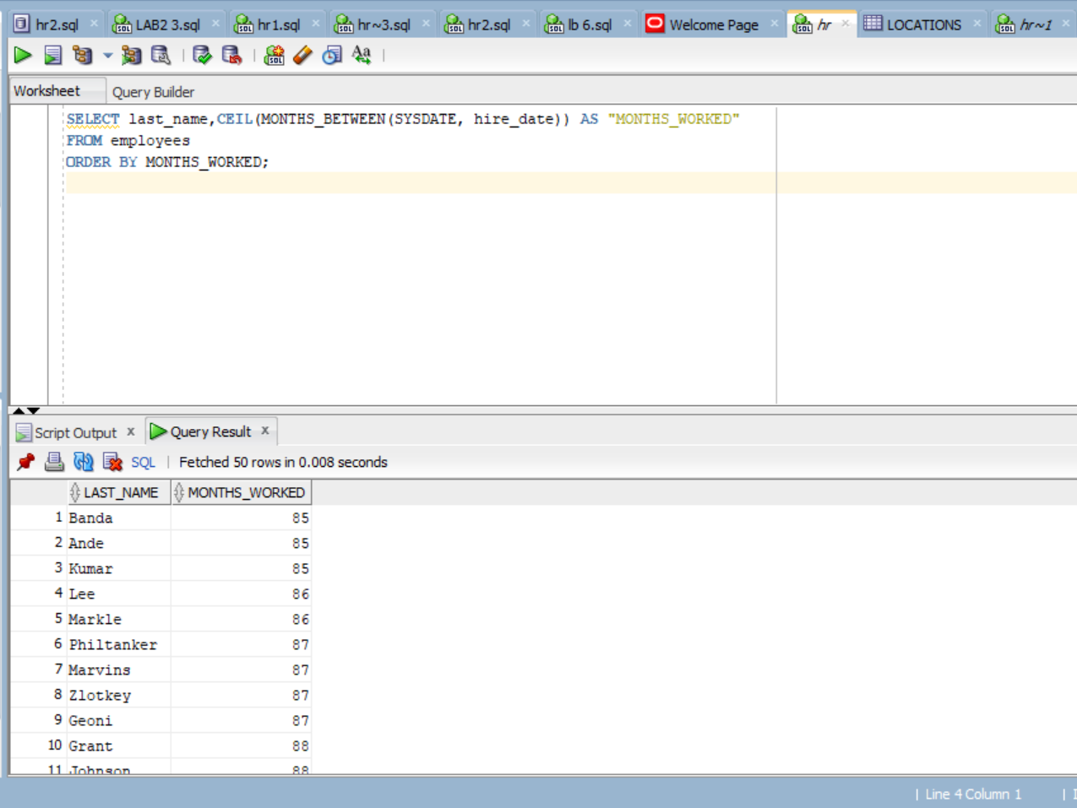

**Question 3 :**

**CODE**

SELECT manager_id,MIN(salary) AS Lowest_Salary

FROM employees

WHERE manager_id IS NOT NULL

GROUP BY manager_id

HAVING MIN(salary) > 6000

ORDER BY Lowest_Salary DESC;

**SCREENSHOT:**

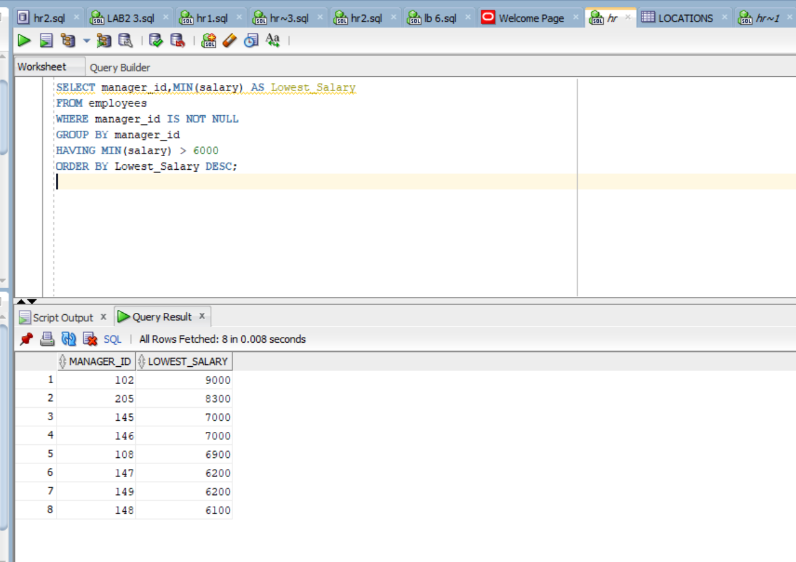

**Question 4 :**

**SCREENSHOT:**

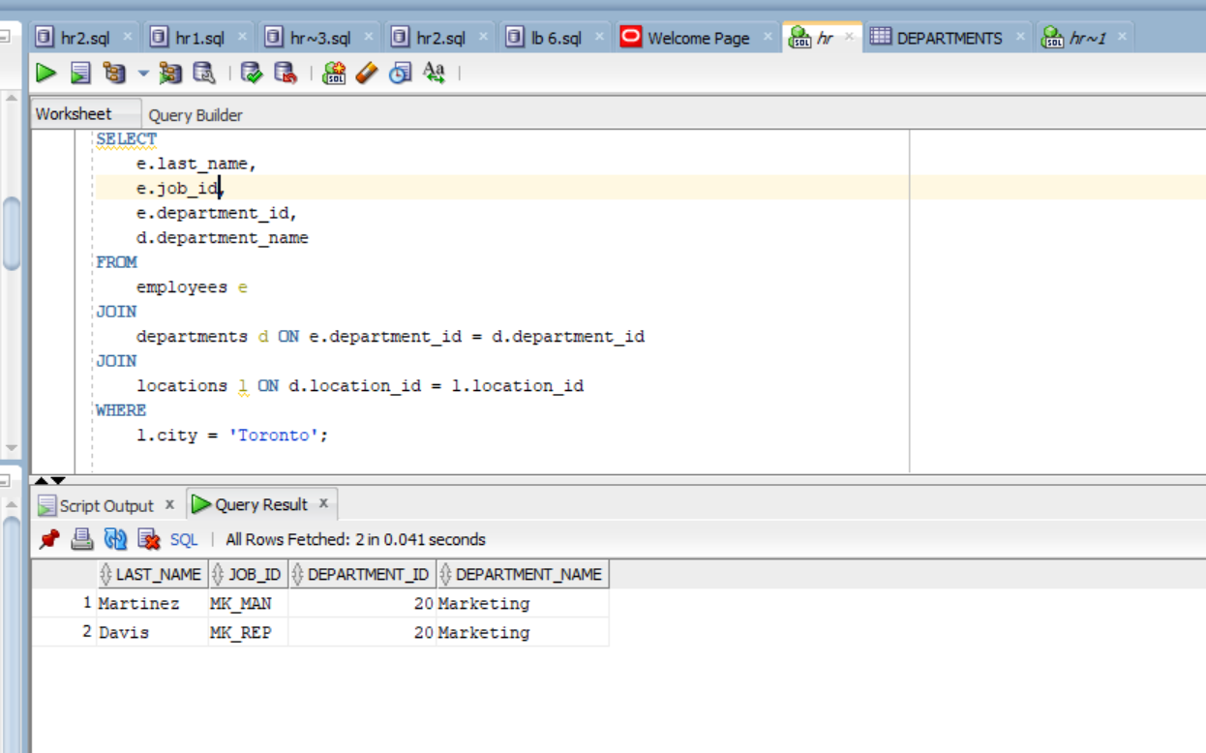

**CODE**

SELECT

e.last_name,

e.job_id,

e.department_id,

d.department_name

FROM

employees e

JOIN

departments d ON e.department_id = d.department_id

JOIN

locations l ON d.location_id = l.location_id

WHERE

l.city = 'Toronto';

**Question 5 :**

**CODE**

Select Count(manager_id) AS NUMBER OF MANAGERS FROM EMPLOYEES;

**SCREENSHOT:**

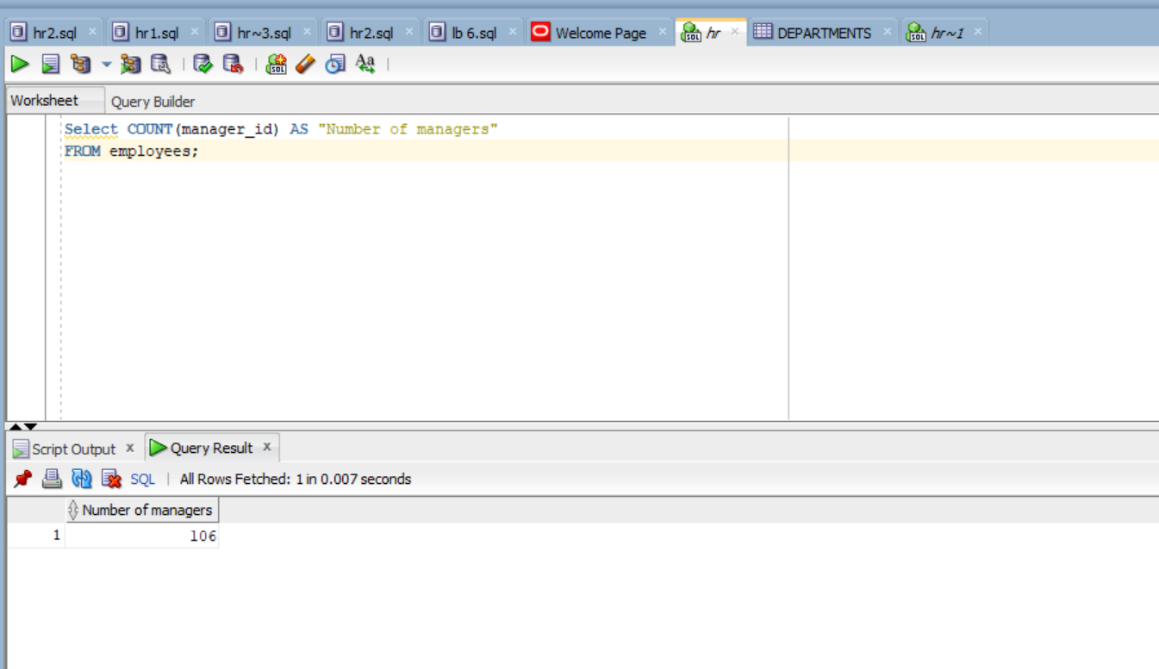**Question 6 :**

**CODE**

SELECT e.First_Name, e.Last_Name

FROM Employees e JOIN Departments d ON e.Department_ID = d.Department_ID

JOIN Locations l ON d.Location_ID = l.Location_ID

JOIN Countries c ON l.Country_ID = c.Country_ID

JOIN Regions r ON c.Region_ID = r.Region_ID

WHERE d.Department_Name = 'Sales'

AND r.Region_Name = 'africa';

**SCREENSHOT:**

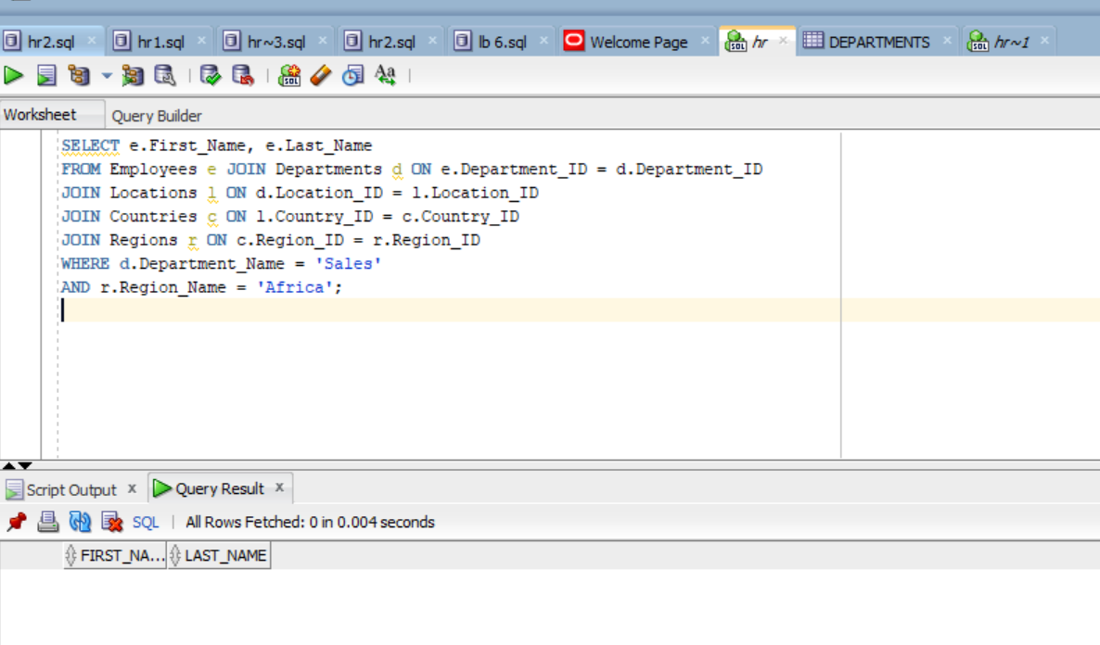

**Question 7 :**

**CODE**

SELECT location_id,STREET_ADDRESS,CITY,STATE_PROVINCE,COUNTRY_ID,COUNTRY_NAME

FROM Locations NATURAL Join countries;

**SCREENSHOT:**

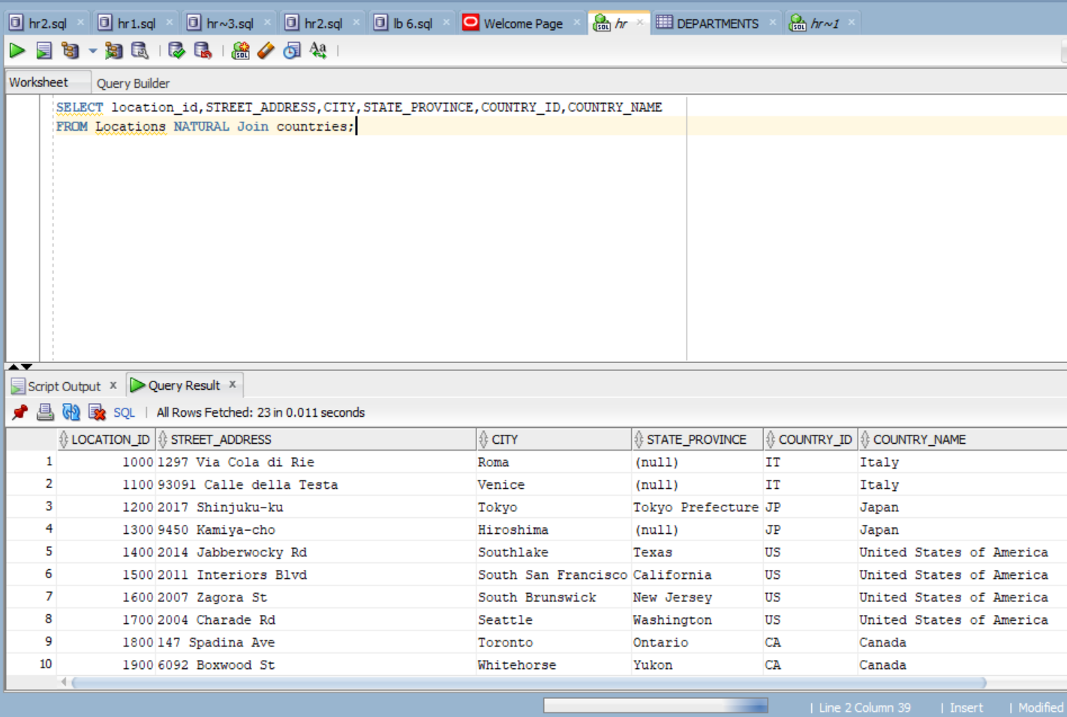

2