GLOBAL APPLICATION UI FLOW
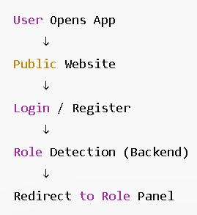

PUBLIC WEBSITE (COMMON FOR ALL USERS)
✅ Purpose
- Branding
- Hotel Info
- Entry Point
- Guest Registration

✅ Public Navbar
Menus:
- Home
- Rooms
- Services
- About
- Contact
- Login
- Register (Guest Only)

✅ Home Page
Sections:
- Hero Section (Hotel Branding)
- Featured Rooms
- Amenities / Services
- About Preview
- Footer

✅ Rooms Page
Components:
- Room Cards Grid
- Room Image
- Room Type
- Price
- Availability Badge
- View Details Button

✅ Login Page (All Roles Use Same Page)
Fields:
- Email / Username
- Password
- Login Button
✔ No role dropdown

✅ Register Page (Guest Only)
Title:
Create Guest Account
Fields:
- Full Name
- Email
- Phone Number
- Password
- Confirm Password
- Register Button
- Link → Login Page

🔐 LOGIN REDIRECTION LOGIC
After login → backend returns role:
- admin → /admin/dashboard
- manager → /manager/dashboard
- receptionist → /reception/dashboard
- housekeeping → /housekeeping/dashboard
- maintenance → /maintenance/dashboard
- guest → /guest/dashboard

LEVEL 2 — PANEL LAYOUT (ALL ROLES)
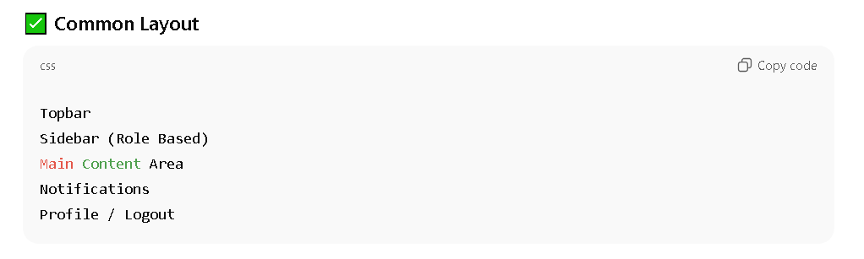

👑 ADMIN PANEL UI
✅ Sidebar Menu
- Dashboard
- User Management
- Room Management
- Reservations
- Billing Overview
- Reports & Analytics
- System Settings
- Notifications
- Profile / Logout

✅ Dashboard Widgets
- Total Rooms
- Active Reservations
- Occupancy Rate
- Revenue Snapshot
- Pending Maintenance

✅ User Management
Screens:
- Staff List
- Add Staff
- Assign Roles
- Activate / Deactivate Users

✅ Room Management
Screens:
- Room Inventory Table
- Add Room
- Edit Room
- Room Types
- Pricing Control
- Room Status Overview

✅ Reservations Control
- View All Reservations
- Filter by Date / Status
- Cancel / Modify Booking

✅ System Settings
- Taxes / Charges
- Policies
- Default Pricing
- Hotel Configurations

✅ Reports & Analytics
- Occupancy Reports
- Revenue Reports
- Booking Trends
- Staff Performance

🧑‍💼 MANAGER PANEL UI
✅ Sidebar Menu
- Dashboard
- Room Status
- Reservations Overview
- Staff Activity
- Maintenance Overview
- Reports
- Profile / Logout

✅ Dashboard Widgets
- Today Occupancy
- Revenue Today
- Rooms Available
- Pending Issues
- Staff Tasks

✅ Room Monitoring
- Room Number
- Type
- Status Badge:
  - Available
  - Occupied
  - Cleaning
  - Maintenance

🛎️ RECEPTIONIST PANEL UI
✅ Sidebar Menu
- Dashboard
- New Reservation
- Reservations List
- Check-In
- Check-Out
- Guest Management
- Room Availability
- Billing / Invoices
- Profile / Logout

✅ New Reservation
Fields:
- Guest Details
- Room Type
- Dates
- Availability Check
- Confirm Booking

✅ Reservations List
- Search Reservation
- Filter by Date
- Edit / Cancel Booking

✅ Check-In Process
Steps:
- Search Reservation
- Assign Room
- Confirm Check-In
- Room Status → Occupied

✅ Check-Out Process
Steps:
- Select Guest
- Charges Calculation
- Add Extra Services
- Payment
- Room Status → Cleaning

✅ Billing Screen
- Invoice Details
- Charges Breakdown
- Print Invoice
- Email Invoice

🧹 HOUSEKEEPING PANEL UI
✅ Sidebar Menu
- Dashboard
- Room Status
- Assigned Tasks
- Report Issue
- Profile / Logout

✅ Room Status Screen
Room States:
- Dirty
- Cleaning
- Clean
- Maintenance Required
Actions:
- Start Cleaning
- Mark Clean
- Report Issue

✅ Tasks Screen
- Task List
- Room Number
- Status:
  - Pending
  - In Progress
  - Completed

🔧 MAINTENANCE PANEL UI
✅ Sidebar Menu
- Dashboard
- Maintenance Requests
- Update Status
- History
- Profile / Logout

✅ Requests Screen
- Room Number
- Issue Description
- Priority Level
- Status:
  - Pending
  - In Progress
  - Resolved
Actions:
- Start Work
- Mark Resolved

🧑‍💻 GUEST PANEL UI
✅ Sidebar Menu
- Dashboard
- My Reservations
- Request Services
- Billing / Payments
- Feedback
- Profile / Logout

✅ Guest Dashboard
- Current Booking
- Room Details
- Stay Duration
- Quick Actions

✅ My Reservations
- Booking History
- Upcoming Reservations
- Booking Details

✅ Request Services
Options:
- Room Service
- Laundry
- Wake-Up Call
- Maintenance Request

✅ Feedback Screen
- Star Rating
- Comments
- Submit Review

✅ GLOBAL ROOM STATUS ENGINE (VERY IMPORTANT)
Unified states:
- Available
- Occupied
- Cleaning
- Maintenance
Transitions:
Check-In → Occupied
Check-Out → Cleaning
Cleaning Done → Available
Issue Found → Maintenance

✅ REGISTER LOGIC (FINALIZED)
✔ Public Register Page → Guest Only
✔ Staff Creation → Admin Panel Only

✅ UI DESIGN PRINCIPLES
✔ Clean & minimal
✔ Same layout for all panels
✔ Clear status badges
✔ Fast navigation
✔ Mobile responsive

