TabPFN method and example

1 What TabPFN is
Foundation models. A foundation model is a model that has already been trained on a large amount of data and can be used for different tasks. We can adapt it to a new task by training it further or by giving it examples to work from, and so the same model can be used across different problems [1]
PFNs. PFN stands for prior-data fitted network. The idea is to generate many datasets from a prior and train a neural network to make predictions on them. Here the prior is a distribution over possible data-generating processes. We sample a process from that distribution, use it to generate a dataset, and train the network to predict outcomes that we have hidden [2]
TabPFN. TabPFN is a PFN for tabular data. Its simulated datasets come from structural causal models with different graphs, functions, and noise. This gives it examples of nonlinear relationships and dependencies between variables [4, 6]

What it estimates
Let $D=\{\left(x_{i},y_{i}\right)\}_{i=1}^{n}$ be our data, with $n$ observations and $d$ predictors. Each $x_{i}∈R^{d}$ contains the predictors for one observation, after encoding, and $y_{i}$ is its outcome. We want to predict the outcome at a new value $x_{*}$. In regression, the estimand is $m_{0}\left(x\right)=E_{P_{0}}\left[Y∣X=x\right]$, where $P_{0}$ is the true population distribution. In classification, we want $P_{0}\left(Y=c∣X=x\right)$ for each class $c$.
To write out the Bayesian formulation, let $H$ describe a possible data-generating process, including its model form, parameters, and noise. Let $π\left(H\right)$ be the prior. We update the probability of each $H$ given the data, then average its predictions using those posterior probabilities: [3]
$$p_{π}\left(H∣D,x_{*}\right) ∝ p\left(D,x_{*}∣H\right) π\left(H\right)$$
$$p_{π}\left(y_{*}∣x_{*},D\right)=∫p\left(y_{*}∣x_{*},H\right) p_{π}\left(H∣D,x_{*}\right) dH$$
The first equation is just the posterior over data-generating processes. The second is the posterior predictive distribution for the new outcome. Here I include $x_{*}$ because the generative model can also describe how the predictors are distributed. With a fixed feature design, we basically just condition the posterior on $D$ alone. TabPFN approximates the prediction in the second equation without explicitly calculating and storing a posterior for every $H$.

How the model is trained
Let $q_{θ}\left(y∣x,D\right)$ be the network’s predicted distribution, where $θ$ contains its weights. For each simulated dataset, we give it some rows with their outcomes, $D_{c}$, and hide the outcomes in the remaining rows, $Q$. The training objective is [2]
Lθ=EH∼π, Dc,Q∼p⋅∣H-1Qx,y∈Q​logqθy∣x,Dc
Here $\left|Q\right|$ is the number of rows with hidden outcomes. We use their actual outcomes to calculate the loss, then update $θ$ by backpropagation. We repeat this with new simulated datasets. Minimizing this loss would recover the prior’s posterior predictive distribution if the network had enough capacity and we could find the optimum. In practice, it is an approximation. [3]

Using it on our data
Once training is finished, the weights $\hat{θ}$ are fixed. Calling .fit() on our dataset prepares the observed rows for the network, including preprocessing and any cached calculations. Calling .predict() uses those rows to predict the new outcomes. We’re not running gradient descent again on our dataset. Fine-tuning would be an additional step. [7]
TabPFN v2 uses attention across the features in each row and across rows in each column. For regression, it predicts probabilities for intervals of possible outcome values, which form a density that is constant within each interior interval, with tails at the ends. The software reverses any outcome transformations and combines ensemble predictions. We use the mean of the resulting distribution as our estimate: [4, 7]
$$\hat{m}\left(x_{*}\right)=∫y q_{\hat{θ}}\left(y∣x_{*},D\right) dy$$
The inputs are the individual predictor values and observed outcomes, along with the predictors for the new rows. We do not average the outcomes before giving them to the model. It uses the relationships in the data to estimate the conditional mean, including nonlinearities and interactions. [4]

How this differs from regression
With ordinary least squares, we choose which terms to include, such as $X$, $X^{2}$, or interactions, and estimate their coefficients from our data. If $z\left(x\right)$ contains those terms, the prediction is $z{\left(x\right)}^{⊤}\hat{β}$, where $\hat{β}$ contains the estimated coefficients. With TabPFN, we do not have to specify all those terms. We give it the data and use its pretrained network to make predictions. It does not directly give us a coefficient estimate and standard error for each predictor.
I would expect TabPFN to be useful when we have limited data and do not know the functional form, provided the relationships are reasonably covered by its pretraining prior. The v2 paper finds strong predictive performance on small and medium datasets. That gives us a reason to try it, but we still need to compare it with other methods on the problem we care about. [4, 9]
If the true relationship is simple and we specify it correctly, standard regression may do better. TabPFN can also struggle when the data differ from its pretraining examples or there is little information near the values we want to predict. Its predictive uncertainty still needs checking, and using it for causal inference requires an identification argument. [5, 9]

2 Example
For the example, I simulated 600 observations with one pretreatment covariate $X$, a binary treatment $T$, and a continuous outcome $Y$. These are the data and results from TabPFN.ipynb. I used seed 42 and the TabPFN v2 regression model, with four ensemble members and CPU inference [8]

How I generated the data
$$X_{i}∼Uniform\left(-1,1\right), T_{i}∼Bernoulli\left(0.5\right)$$
$$Y_{i}\left(0\right)=2+1.5X_{i}+ϵ_{i0}, Y_{i}\left(1\right)=3+3.5X_{i}+ϵ_{i1}$$
$$Y_{i}=\left(1-T_{i}\right)Y_{i}\left(0\right)+T_{i}Y_{i}\left(1\right)=2+1.5X_{i}+T_{i}+2T_{i}X_{i}+ϵ_{i}$$
Here $Y_{i}\left(0\right)$ is the outcome without treatment and $Y_{i}\left(1\right)$ is the outcome with treatment. The errors $ϵ_{i0}$ and $ϵ_{i1}$ are independent $N\left(0,{0.5}^{2}\right)$ draws, independent of $X_{i}$ and treatment assignment. We only observe the outcome for the treatment received, so $ϵ_{i}$ is the corresponding error. Let $μ_{t}\left(x\right)=E\left[Y\left(t\right)∣X=x\right]$ for $t∈\{0,1\}$. The conditional average treatment effect (CATE) is
$$τ\left(x\right)=E\left[Y\left(1\right)-Y\left(0\right)∣X=x\right]=μ_{1}\left(x\right)-μ_{0}\left(x\right)=1+2x$$
To estimate this from observed outcomes, we need consistency, conditional exchangeability $\{Y\left(0\right),Y\left(1\right)\}⊥T∣X$, and overlap $0<P\left(T=1∣X=x\right)<1$. These hold in this simulation. They let us use $E\left[Y∣T=t,X=x\right]$ to estimate $μ_{t}\left(x\right)$. We would need to justify these assumptions separately with real data. [5]

How I estimated the effect
I first split the data into 75% for fitting and 25% for evaluation, stratifying by treatment. This leaves 450 training observations, with 226 controls and 224 treated, and 150 held-out. Neither model sees the held-out outcomes, the unobserved potential outcomes, or the true effects [8]
I then fit one TabPFN model to the controls and another to the treated observations (a T-learner). Each model gets $X$ and the observed $Y$ for its group. Treatment determines which rows go into each model; the only predictor within each model is $X$. Neither model is told the true coefficients. [5, 8]
For the same value of $x$, I have both models predict the mean using output_type="mean". I then subtract: $\hat{τ}\left(x\right)={\hat{μ}}_{1}\left(x\right)-{\hat{μ}}_{0}\left(x\right)$. Each outcome model averages four ensemble predictions. We still have two outcome models. For example at $X=0.5$, the estimates are: [7, 8]
Quantity at X = 0.5 | Known truth | TabPFN estimate
Control mean | 2.750 | 2.743
Treated mean | 4.750 | 4.675
CATE | 2.000 | 1.933
Saved notebook results. The values are rounded separately; the effect is calculated before rounding.
This is the average effect among people with $X=0.5$. An individual’s effect also includes $ϵ_{i1}-ϵ_{i0}$, so people with the same $X$ can have different effects.

Results
I also fit OLS with an intercept and predictors $X$, $T$, and $TX$, using the same training data, which is technically the correct specification for the simulation. Its estimated CATE is ${\hat{τ}}_{OLS}\left(x\right)={\hat{β}}_{T}+{\hat{β}}_{TX}x$. [8]
Because this is a simulation, I know the true CATE and can compare the estimates against it. Let $I_{test}$ be the indices of the $m=150$ held-out observations. The CATE RMSE is
RMSEτ=1mi∈Itest​τXi-τXi2
The CATE mae is the average absolute difference between the estimated and true effects. The observed-outcome RMSE compares the observed $Y_{i}$ with ${\hat{μ}}_{T_{i}}\left(X_{i}\right)$, which also includes the noise in individual outcomes, so it answers a different question from how well we estimated CATE.
Model | CATE RMSE | CATE MAE | Outcome RMSE
TabPFN T-learner | 0.076 | 0.062 | 0.501
OLS with T × X | 0.034 | 0.029 | 0.499
Results from the saved notebook run. Lower values mean smaller errors. All three measures are in outcome units. [8]
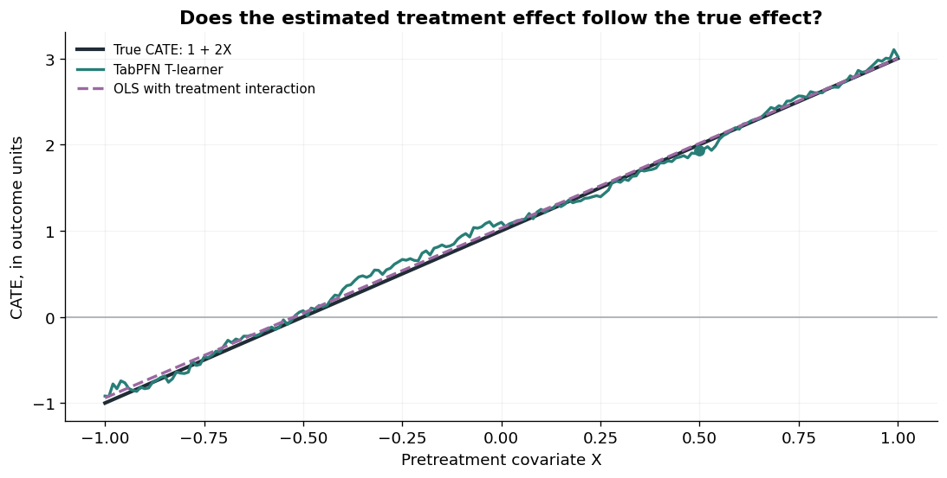
Figure 1. CATE functions from the notebook; the dot marks X = 0.5. [8]
OLS has a lower CATE error here, which makes sense because I gave it the right functional form. TabPFN follows the relationship, but it doesn’t have the leverage of knowing that the two conditional means must be straight lines. Both outcome RMSEs are close to the noise standard deviation of 0.5. I would need to repeat this across datasets before drawing a broader conclusion.
The population ATE is $E\left[τ\left(X\right)\right]=1$. For the particular held-out observations, the average true CATE is 1.046. Averaging the predictions gives 1.077 for TabPFN and 1.076 for OLS. The true sample average differs from 1 because the sample’s average $X$ is not exactly zero. [8]
I have only calculated point estimates here. TabPFN’s outcome prediction intervals don’t give us confidence intervals for CATE or ATE. That would need a separate step. [8]

3 Rows and columns
There is no fixed number of rows or columns that makes TabPFN work well. It depends on the relationship we are trying to estimate, the noise, and how much information the predictors contain. The network’s large pretraining dataset also doesn’t remove the need for enough observations in our own data. [9]

What this means for our example
In this example, each model gets about 225 training observations, which seems to work reasonably well for one covariate, a smooth response, and balanced treatment assignment. But the number in each group matters. If only 10% of the 450 training observations were treated, the treated model would have about 45 observations to work with. We also need both groups represented near the values of $X$ where we want to estimate an effect.
I don’t think we need a lot of columns. One predictor is enough to use TabPFN. Adding relevant pretreatment variables can help prediction or be needed for causal adjustment, but adding irrelevant variables doesn’t really give us more information about the outcome. As the number of relevant variables grows, we generally need more observations to learn how they work together.
For this simple example, I would start with a few hundred observations per group and see how the error changes as I add more. I would expect to need more data with higher noise, more complicated effects, or weaker overlap.

Model limits
Checkpoint | Training rows | Predictor columns
v2 used in the notebook | Up to 10,000 | Up to 500
Current v3.5 base model | Up to 1,000,000 | 6,000 recommended  20,000 ceiling
Official limits as of September 2026. The maximum numbers of rows and columns may not be usable together and depend on the hardware and settings. [6]
These are for how much data the model can handle, but not how much it needs to make good predictions. My notebook installs package version 9.0.0 but selects ModelVersion.V2, so the v2 limits apply. For v2 on a CPU, the repository recommends roughly 1,000 rows or fewer per model; larger datasets are better suited to a GPU. [6, 7, 8]

What I would try next
I would try $N∈\{200,600,2000,8000\}$ total observations and $d∈\{1,5,20,100\}$ predictors. First, I would keep the current outcome equations and add independent irrelevant predictors, which hopefully would let me see what happens when I change the sample size and add columns without adding signal. I would then try nonlinear effects, correlated predictors, and weaker overlap.
I would repeat each setting across 100 simulation seeds, using the same model version and ensemble settings, and evaluate on a large independent test sample. I would compare CATE RMSE, bias, and runtime, and record the number of observations in each treatment group. This should help show how much data we need for a given level of accuracy. I have not run these additional simulations yet.

References
[1] Bommasani, R., et al. (2021). On the Opportunities and Risks of Foundation Models. Stanford Center for Research on Foundation Models. arXiv 2108.07258
[2] Müller, S., Hollmann, N., Pineda Arango, S., Grabocka, J., and Hutter, F. (2022). Transformers Can Do Bayesian Inference. International Conference on Learning Representations. Paper and mathematical formulation
[3] Hollmann, N., Müller, S., Eggensperger, K., and Hutter, F. (2023). TabPFN: A Transformer That Solves Small Tabular Classification Problems in a Second. International Conference on Learning Representations. Original TabPFN paper
[4] Hollmann, N., et al. (2025). Accurate predictions on small data with a tabular foundation model. Nature, 637, 319–326. doi 10.1038/s41586-024-08328-6
[5] Künzel, S. R., Sekhon, J. S., Bickel, P. J., and Yu, B. (2019). Meta-learners for estimating heterogeneous treatment effects using machine learning. Proceedings of the National Academy of Sciences, 116(10), 4156–4165. T-learner and causal setup
[6] Prior Labs. Models. Official checkpoint capabilities and limits. Accessed 18 September 2026. Version comparison
[7] Prior Labs. TabPFN repository and regressor implementation. Accessed 18 September 2026. Repository
Regressor API and mean prediction option
[8] Soltani, M. TabPFN.ipynb. Notebook with saved numerical outputs and figures. Configuration: tabpfn 9.0.0, TabPFN v2 regression, seed 42, N = 600, noise standard deviation 0.5, four ensemble members, CPU.
[9] Müller, S., Reuter, A., Hollmann, N., Rügamer, D., and Hutter, F. (2025). Position: The Future of Bayesian Prediction Is Prior-Fitted. arXiv 2505.23947

