Sales Analysis Report

Project Oveview
This automated report analizes sales performance,customer behavior, and revenue trends using python automation

Key Performance Indicators(KPIs)
Total Revenue : 3,815.00
Total Orders : 5
Average Order Value : 763.0
Total_Customers : 4.00

Visual Analysis
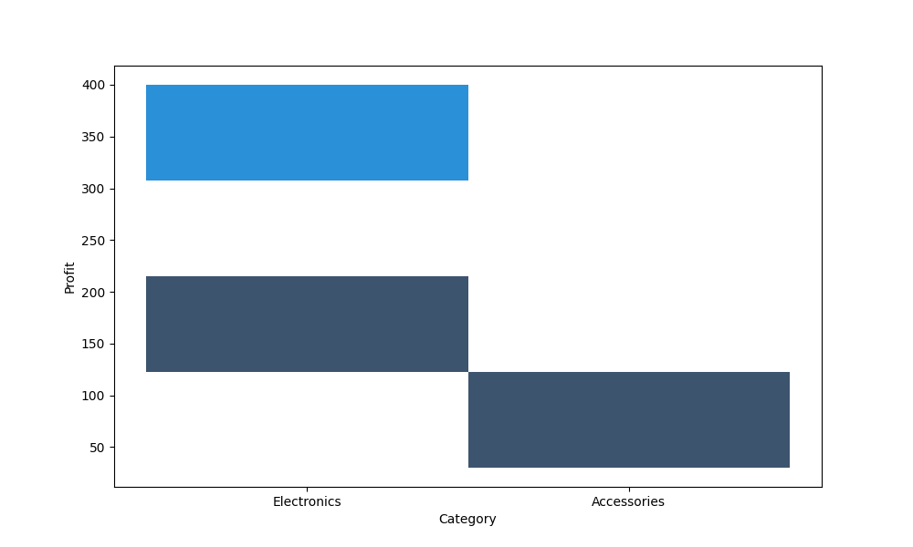
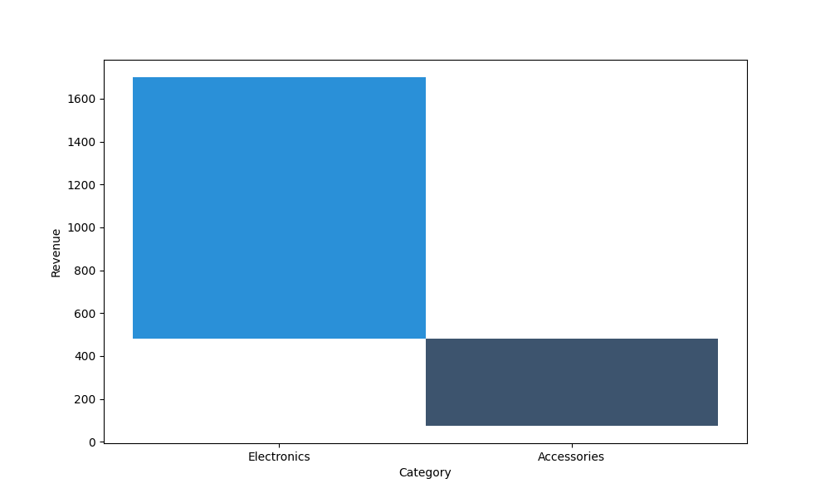
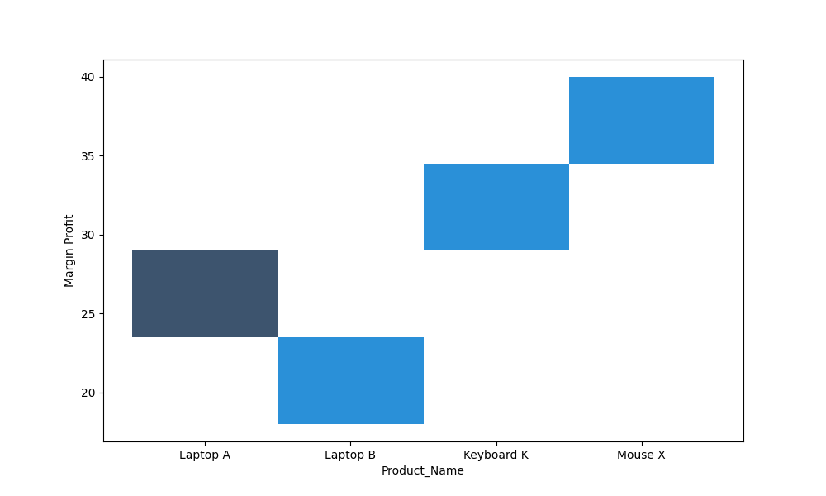
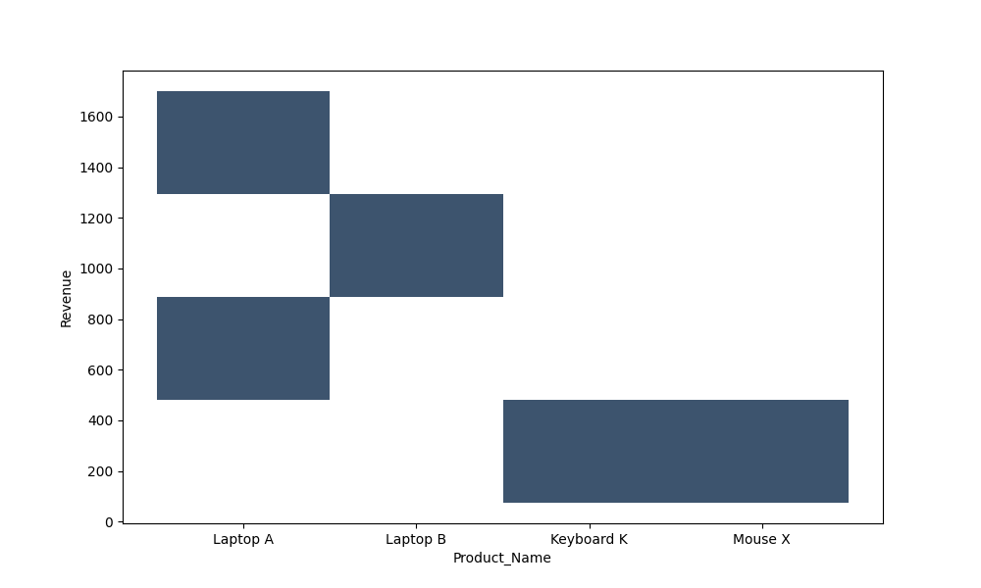
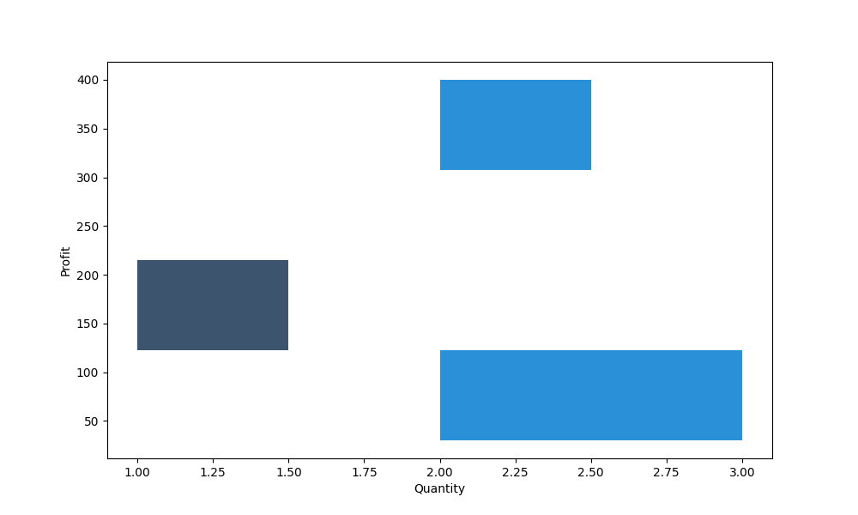
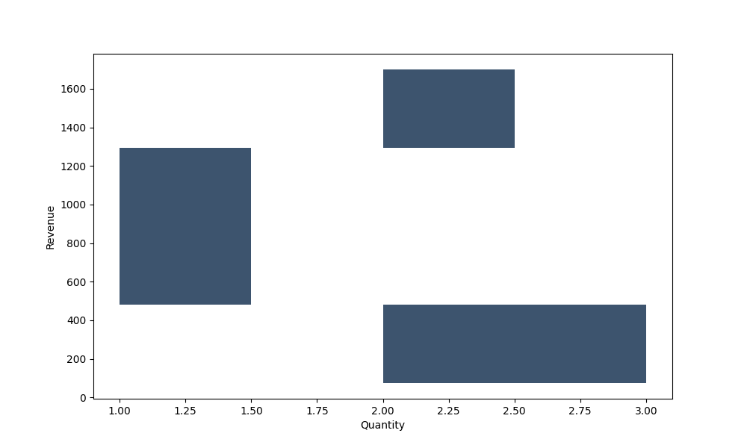

Conclusion
The analysis highlights key revenue drivers and sales patterns. These insights can support data-driven business decisions.

