**TESTING - CC 1**

**S G Maha Prabhu**

**727721eucs067**

1)

package org.example;  
  
import io.github.bonigarcia.wdm.WebDriverManager;  
import org.openqa.selenium.By;  
import org.openqa.selenium.WebDriver;  
import org.openqa.selenium.WebElement;  
import org.openqa.selenium.chrome.ChromeDriver;  
import org.openqa.selenium.edge.EdgeDriver;  
import org.openqa.selenium.support.ui.ExpectedConditions;  
import org.openqa.selenium.support.ui.WebDriverWait;  
  
import java.time.Duration;  
  
import static org.junit.Assert.*assertEquals*;  
  
  
public class Cia1Que1{  
 public static void main(String[] args) throws InterruptedException {  
 WebDriverManager.*edgedriver*().setup();  
 WebDriver driver=new EdgeDriver();  
  
 driver.get("https://www.saucedemo.com/");  
  
 // Enter the username and password and click on the LOGIN button  
 WebElement usernameField = driver.findElement(By.*id*("user-name"));  
 WebElement passwordField = driver.findElement(By.*id*("password"));  
 WebElement loginButton = driver.findElement(By.*id*("login-button"));  
 usernameField.sendKeys("standard_user");  
 passwordField.sendKeys("secret_sauce");  
 loginButton.click();  
  
 // Verify that the user has successfully logged in  
 String expectedTitle = "Swag Labs";  
 *assertEquals*(expectedTitle, driver.getTitle());  
  
 // Add the product to the cart  
 WebElement addToCartButton = driver.findElement(By.*xpath*("//button[text()='Add to cart']"));  
 addToCartButton.click();  
  
 // Verify that the product has been added to the cart  
 Thread.*sleep*(3000);  
 WebElement cartIcon = driver.findElement(By.*className*("shopping_cart_badge"));  
 *assertEquals*("1", cartIcon.getText());  
 WebElement cartLink = driver.findElement(By.*className*("shopping_cart_link"));  
 cartLink.click();  
 WebElement cartItem = driver.findElement(By.*xpath*("//div[@class='cart_item']"));  
 String actualProductName = cartItem.findElement(By.*className*("inventory_item_name")).getText();  
 String expectedProductName = "Sauce Labs Backpack";  
 *assertEquals*(expectedProductName, actualProductName);  
 String actualProductPrice = cartItem.findElement(By.*className*("inventory_item_price")).getText();  
 String expectedProductPrice = "$29.99";  
 *assertEquals*(expectedProductPrice, actualProductPrice);  
  
 // Proceed to checkout and fill the form  
 WebElement checkoutButton = driver.findElement(By.*id*("checkout"));  
 checkoutButton.click();  
 WebElement firstNameField = driver.findElement(By.*id*("first-name"));  
 WebElement lastNameField = driver.findElement(By.*id*("last-name"));  
 WebElement postalCodeField = driver.findElement(By.*id*("postal-code"));  
 WebElement continueButton = driver.findElement(By.*id*("continue"));  
 firstNameField.sendKeys("mohamed");  
 lastNameField.sendKeys("rayhan");  
 postalCodeField.sendKeys("12345");  
 continueButton.click();  
  
 // Verify that the product overview page is displayed  
 Thread.*sleep*(3000);  
 WebElement productOverviewTitle = driver.findElement(By.*className*("title"));  
 *assertEquals*("Checkout: Overview", productOverviewTitle.getText());  
 WebElement productTitle = driver.findElement(By.*xpath*("//div[@class='inventory_item_name']"));  
 *assertEquals*(expectedProductName, productTitle.getText());  
 WebElement productPrice = driver.findElement(By.*xpath*("//div[@class='inventory_item_price']"));  
 *assertEquals*(expectedProductPrice, productPrice.getText());  
  
 // Print the name and price of the product to the console  
 System.*out*.println("Product Name: " + expectedProductName);  
 System.*out*.println("Product Price: " + expectedProductPrice);  
  
 // Assert the title and URL of the page  
 *assertEquals*(expectedTitle, driver.getTitle());  
 String expectedUrl = "https://www.saucedemo.com/checkout-step-two.html";  
 *assertEquals*(expectedUrl, driver.getCurrentUrl());  
  
 // Quit the browser  
 driver.quit();  
 }  
}

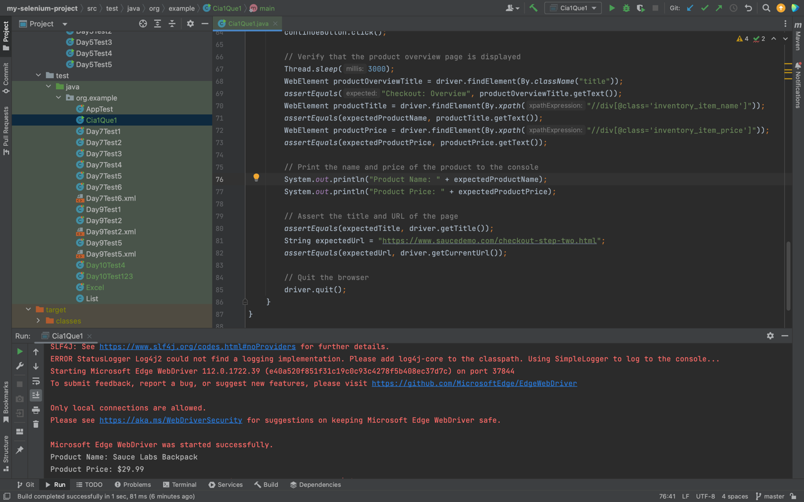

2)

package org.example;  
  
import io.github.bonigarcia.wdm.WebDriverManager;  
import org.openqa.selenium.By;  
import org.openqa.selenium.WebDriver;  
import org.openqa.selenium.WebElement;  
import org.openqa.selenium.chrome.ChromeDriver;  
import org.openqa.selenium.edge.EdgeDriver;  
import org.openqa.selenium.support.ui.Select;  
import java.util.List;  
import static org.junit.Assert.*;  
  
public class Cia1Que2 {  
 public static void main(String[] args) throws InterruptedException {  
 WebDriverManager.*edgedriver*().setup();  
 WebDriver driver=new EdgeDriver();  
 driver.get("https://www.saucedemo.com/");  
  
 // Enter the username and password and click on the LOGIN button  
 WebElement usernameField = driver.findElement(By.*id*("user-name"));  
 WebElement passwordField = driver.findElement(By.*id*("password"));  
 WebElement loginButton = driver.findElement(By.*id*("login-button"));  
 usernameField.sendKeys("standard_user");  
 passwordField.sendKeys("secret_sauce");  
 loginButton.click();  
  
 // Verify that the user has successfully logged in  
 String expectedTitle = "Swag Labs";  
 *assertEquals*(expectedTitle, driver.getTitle());  
  
 // Apply filter from A-Z  
 List<WebElement> productNames = driver.findElements(By.*className*("inventory_item_name"));  
 String name1 = productNames.get(0).getText();  
 System.*out*.println(name1);  
 WebElement sort1 = driver.findElement(By.*className*("product_sort_container"));  
 sort1.click();  
 Select s1=new Select(sort1);  
  
  
  
 // Apply filter from Z-A  
 Thread.*sleep*(3000);  
 sort1.click();  
 s1.selectByIndex(1);  
 List<WebElement> productNames2 = driver.findElements(By.*className*("inventory_item_name"));  
 String name2 = productNames2.get(0).getText();  
 System.*out*.println(name1);  
  
  
  
 // Apply filter from low price to high price  
 Thread.*sleep*(3000);  
 WebElement sort2 = driver.findElement(By.*className*("product_sort_container"));  
 Select s2=new Select(sort2);  
 sort2.click();  
 s2.selectByIndex(2);  
 List<WebElement> productPrices1 = driver.findElements(By.*className*("inventory_item_price"));  
 String price1 = productPrices1.get(0).getText();  
 System.*out*.println(price1);  
  
  
  
 // Apply filter from high price to low price  
 Thread.*sleep*(3000);  
 WebElement sort3 = driver.findElement(By.*className*("product_sort_container"));  
 Select s3=new Select(sort3);  
 sort3.click();  
 s3.selectByIndex(3);  
 List<WebElement> productPrices2 = driver.findElements(By.*className*("inventory_item_price"));  
 String price2 = productPrices2.get(0).getText();  
 System.*out*.println(price2);  
  
  
 // Quit the browser  
 driver.quit();  
 }  
}

