create permissions for two roles - one for the EC2 instance and one for CodeDeploy. Thank you.

This has been created for EC2 instance permission.

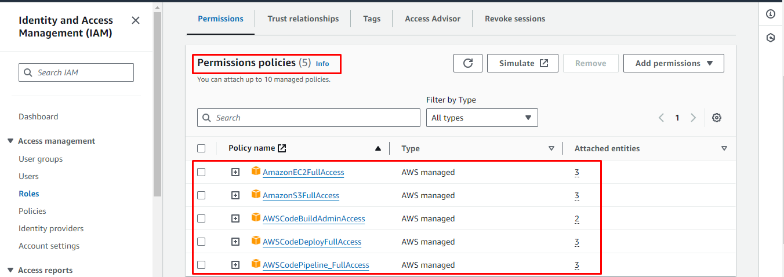

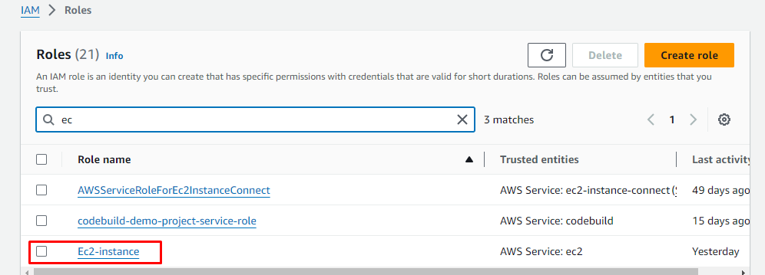

Created the code-deploy role

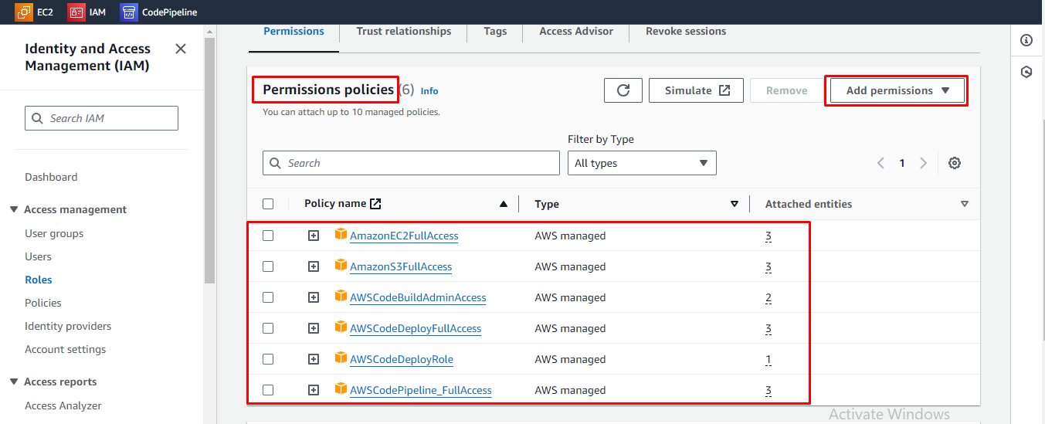

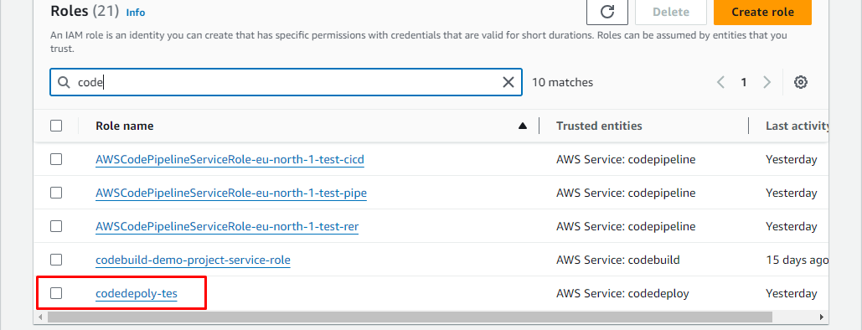

Now Create the Linux instance

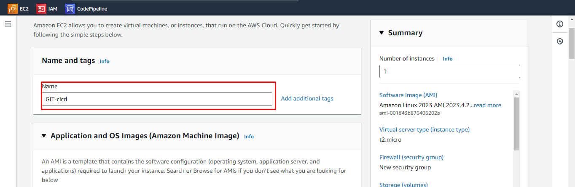

I have selected Linux as my operating system. However, depending on my requirements, I may need to change my operating system.

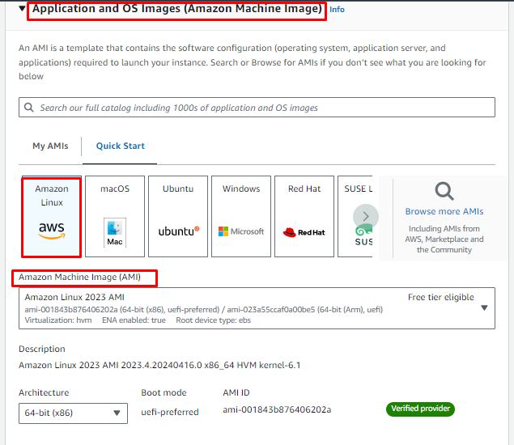

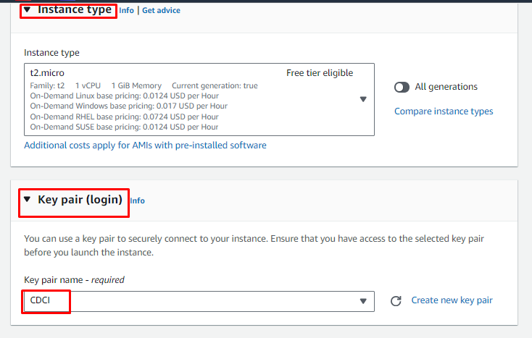

Create a network setting

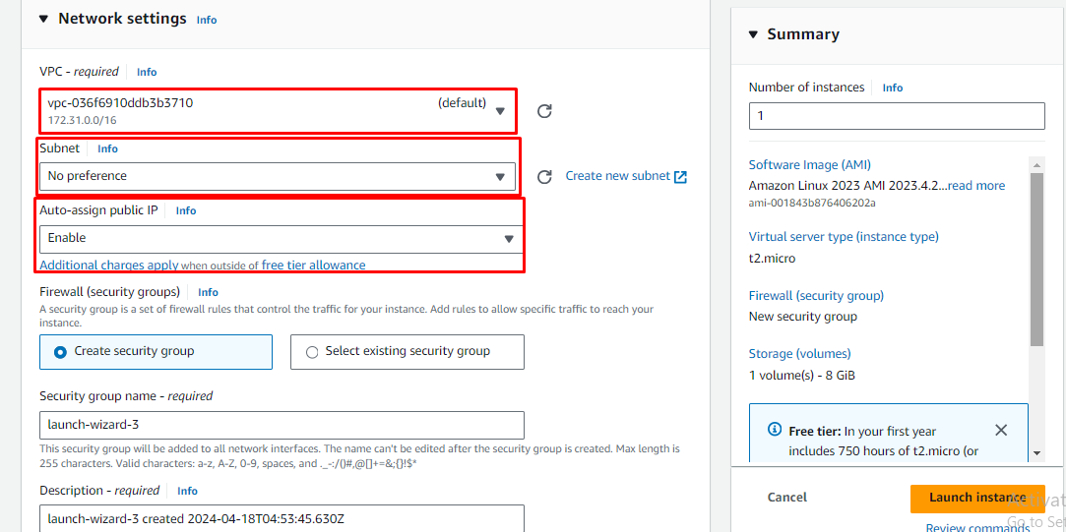

Create an Inbound Security Group Rules

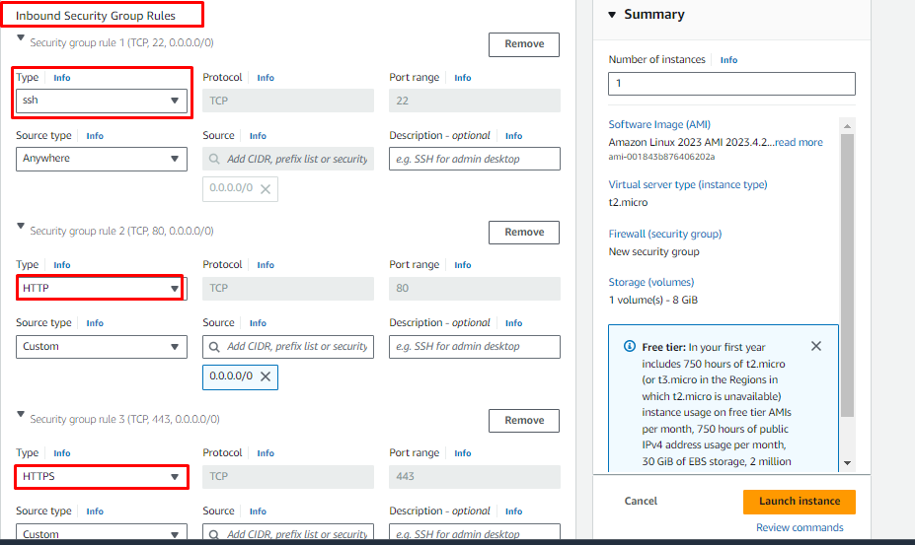

Goto Advanced details and select the IAM instance Profile

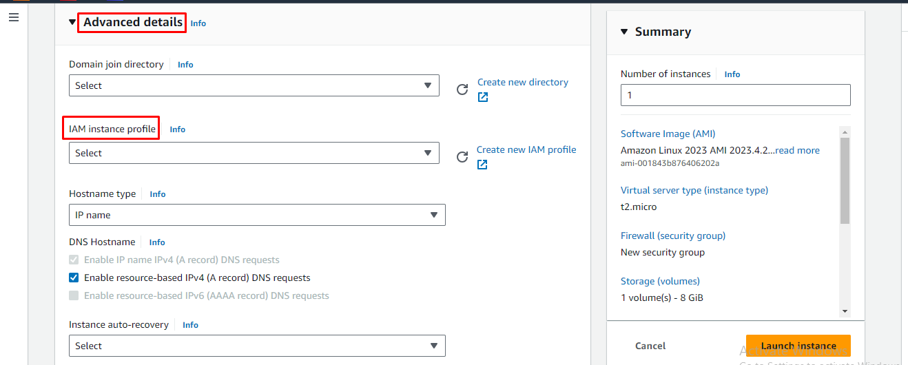

I created a user data script to install both httpd and ssm agents.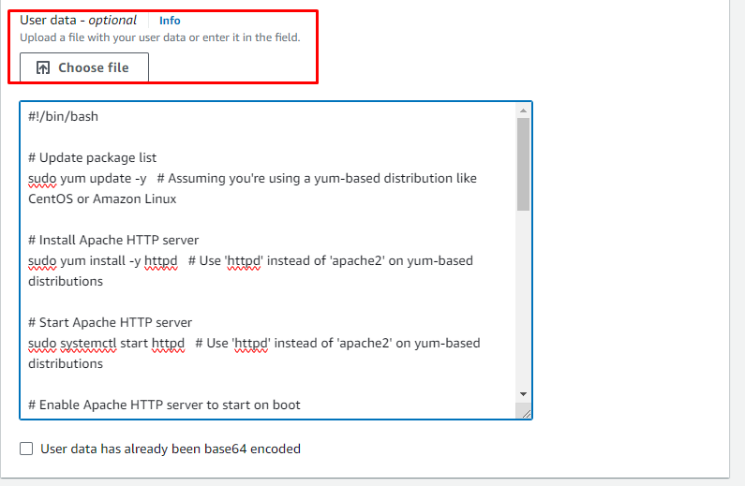

Created a Successfully lunched instance

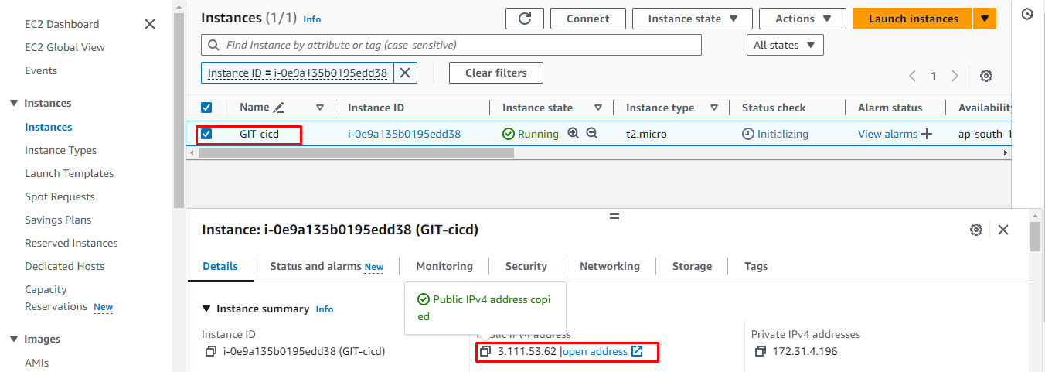

Web working status



Create an Application 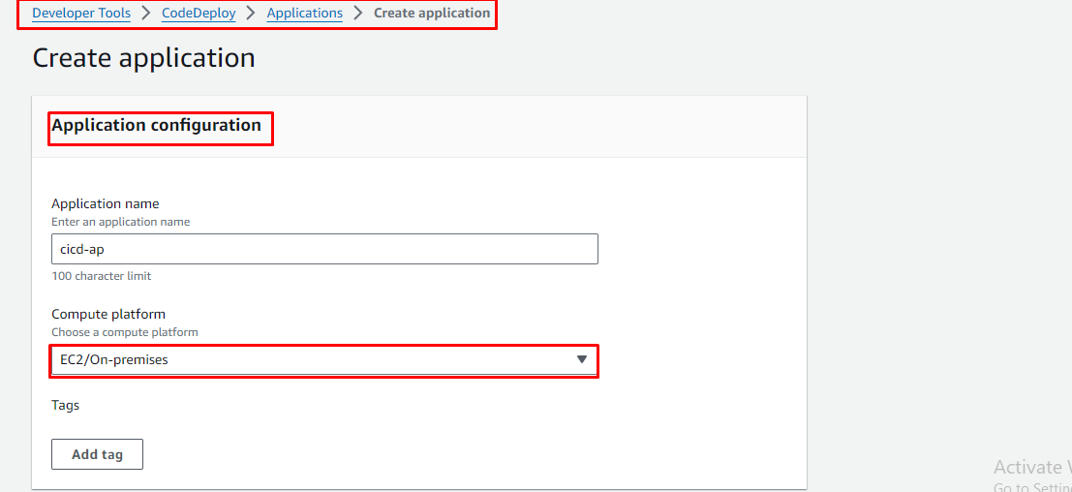

Now create the deployment group

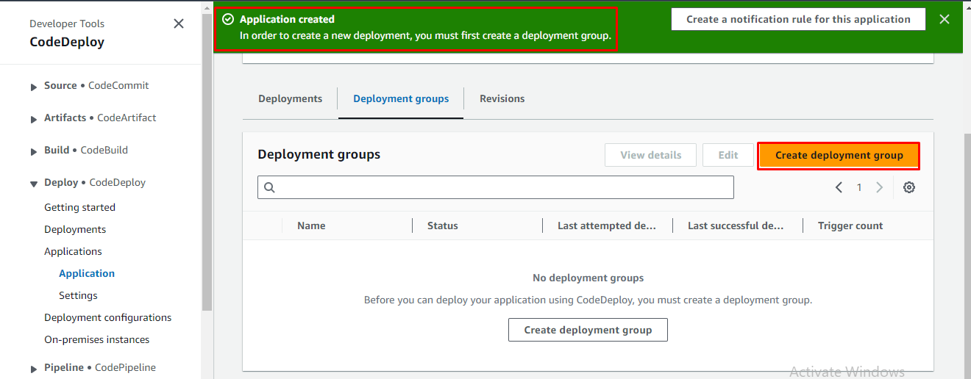

To create a deployment group, click on the "Create Deployment Group" button and provide the service role information as required.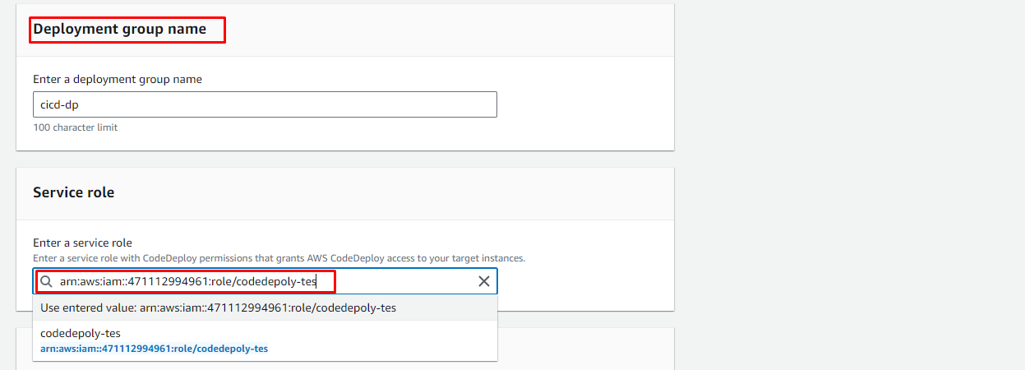

Select the ec2 instance and it will display when you attach the ec2 instance it automation will create

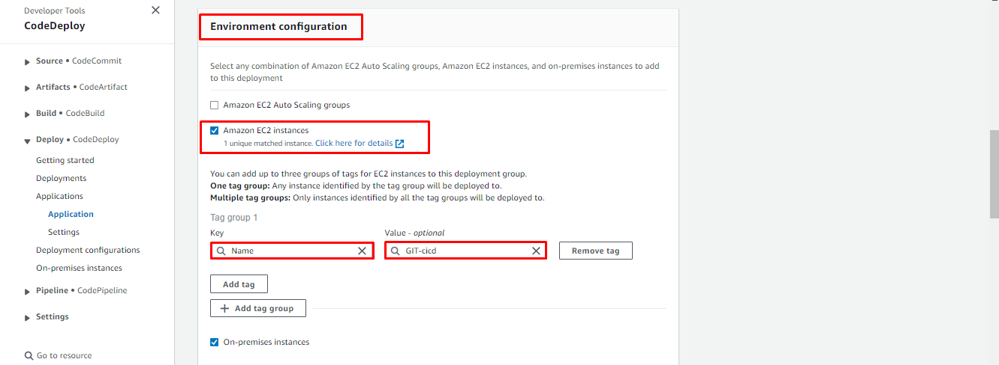

Selected the role Ec2 -instance

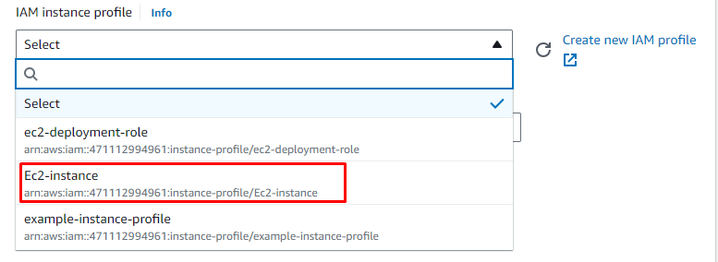

I wasn't able to load balance and create the deployment group.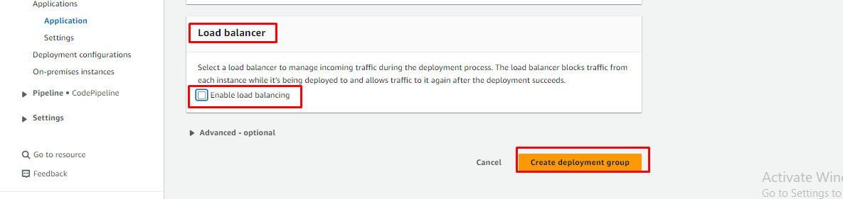

create a code pipeline now.

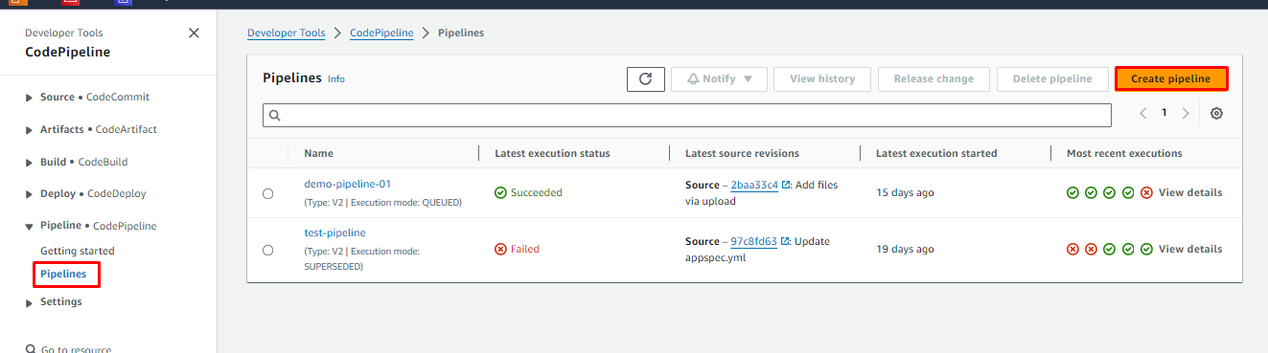

provide a name for the pipeline and specify its type.

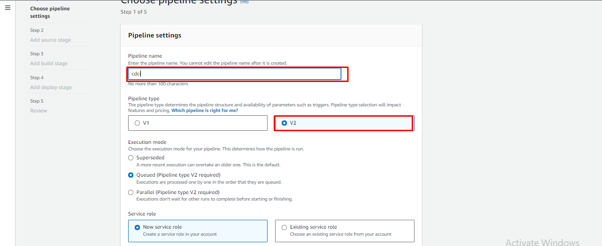

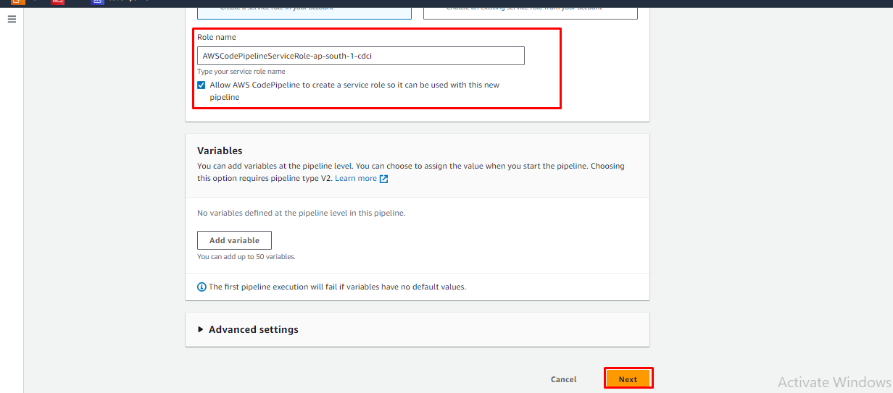

Select GitHub version 1 and connect to GitHub. Then give permission to access the GitHub repository.

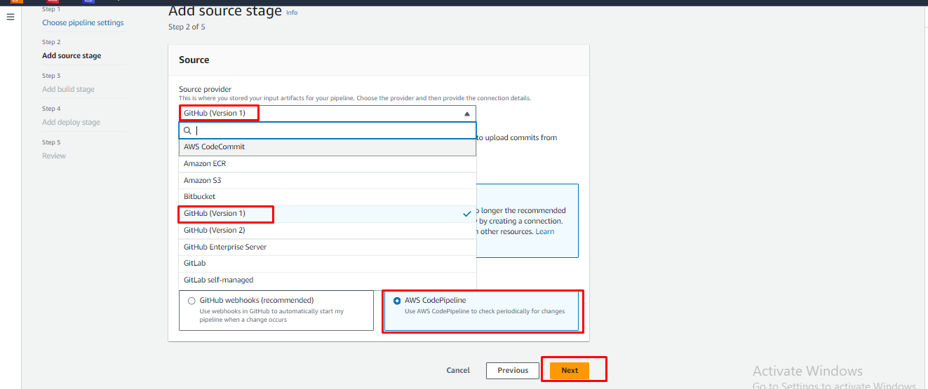

After connecting the GitHub repository, you can choose if you want the repository to be displayed in the GitHub repository list.

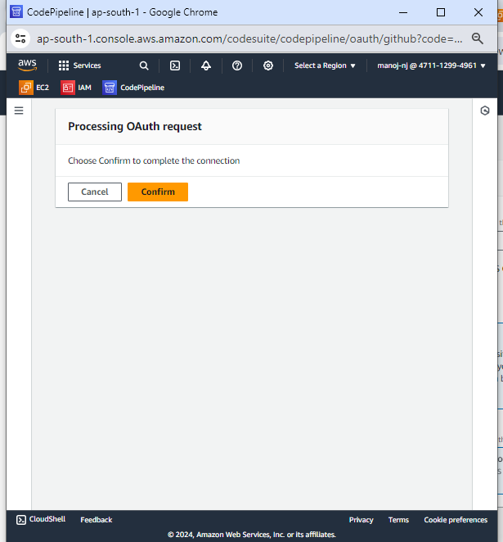

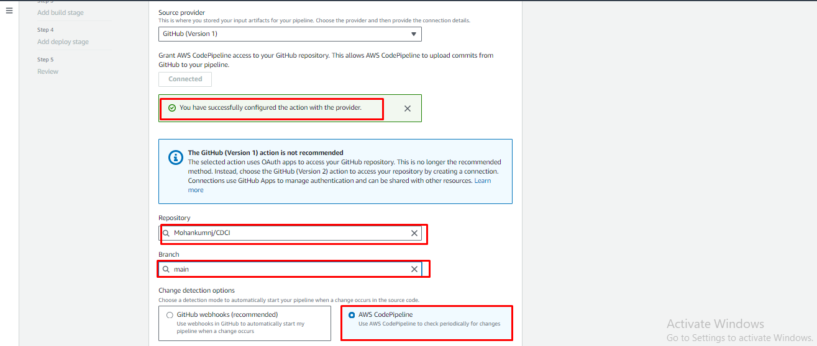

I didn't run the build process and proceeded to deploy the chosen application deployment group.

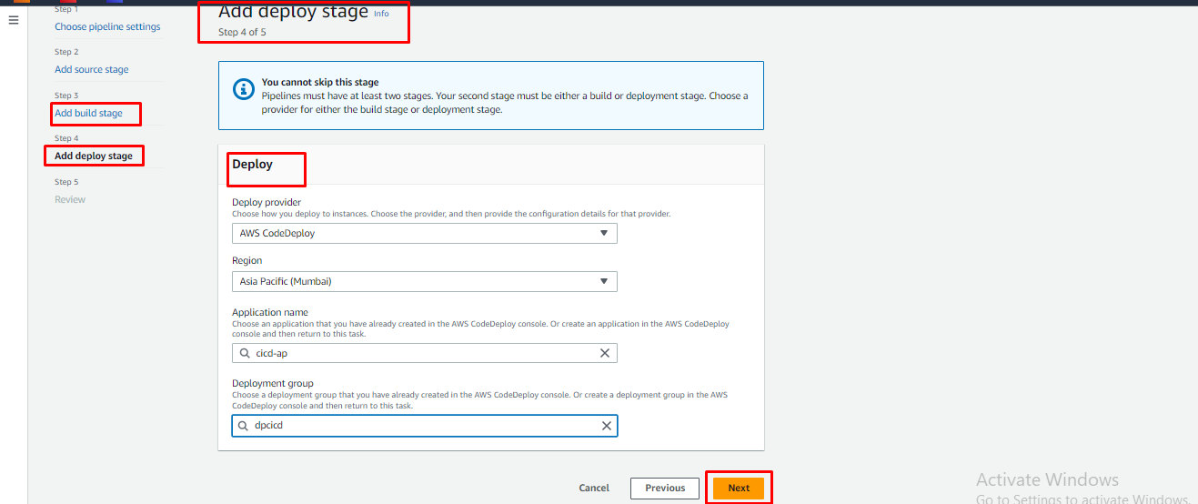

Review All the Steps

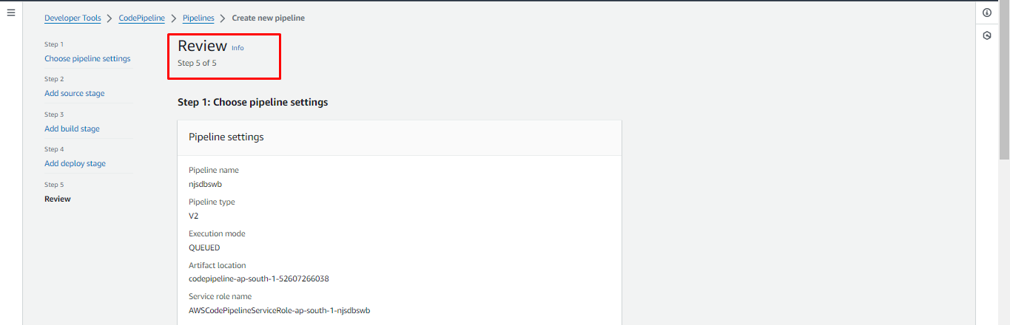

How to deploy a file from Github to a Linux server successfully.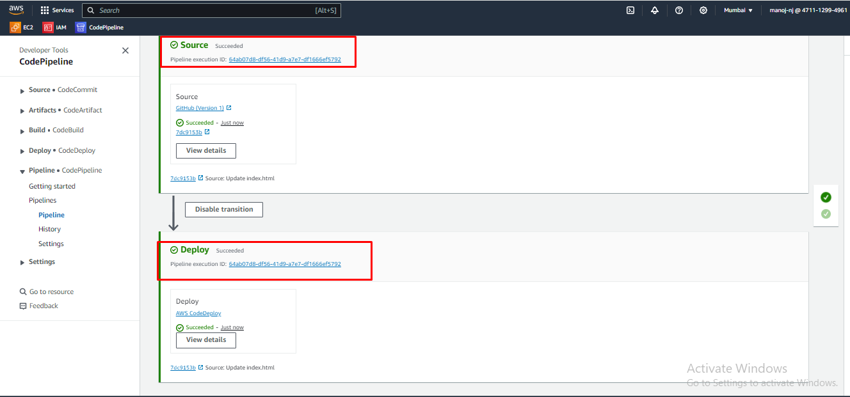

Now I connected the Mobaxterm

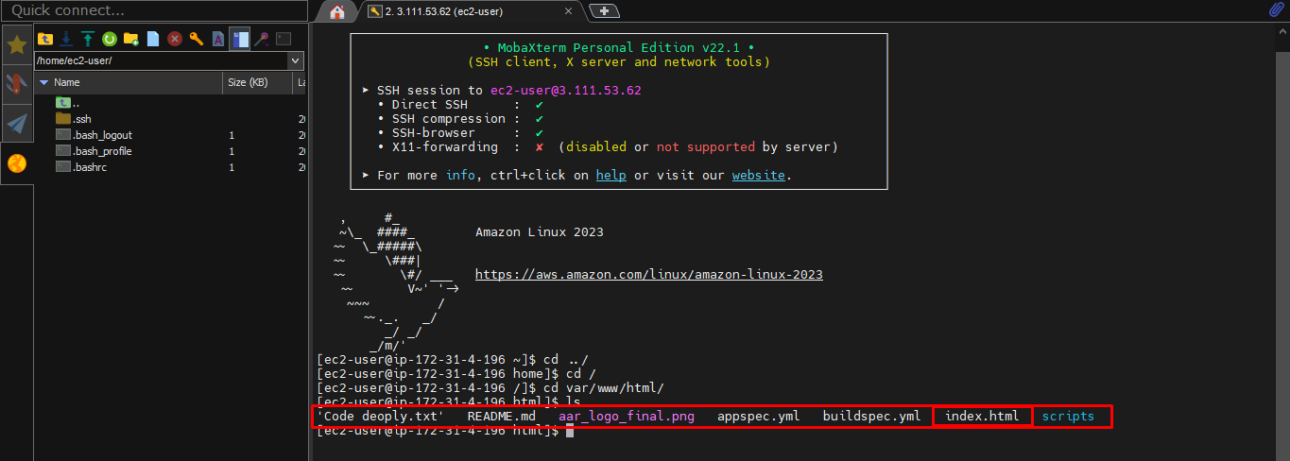

Completed 