DBMS-GITHUB RECORD
TASK 1:
Entities and Attributes
1. USER ( User_ID ,Name,Email,PassworD,Date_of_Birth,Country,Subscription_Type )
2. song(Song_ID,title,duration,release_date,language,genre_id,)
3. Artist(Artist_ID, Artist_Name, Country, Debut_Year)
4. Album(Album_ID, Album_Name, Release_Year, Artist_ID)
5. Genre(Genre_ID, Genre_Name, Description)
6. Playlist(Playlist_ID, Playlist_Name, Creation_Date, User_ID)
7. Recommendation(Recommendation_ID, User_ID, Song_ID)
Relationships
• User ↔Playlist → (one-to-Many)
• Playlist ↔ Song (Many-to-Many)
• Artist ↔ Album→ (One-to-Many)
• Album – Song → (One-to-Many)
• User – Song → (Many-to-Many)
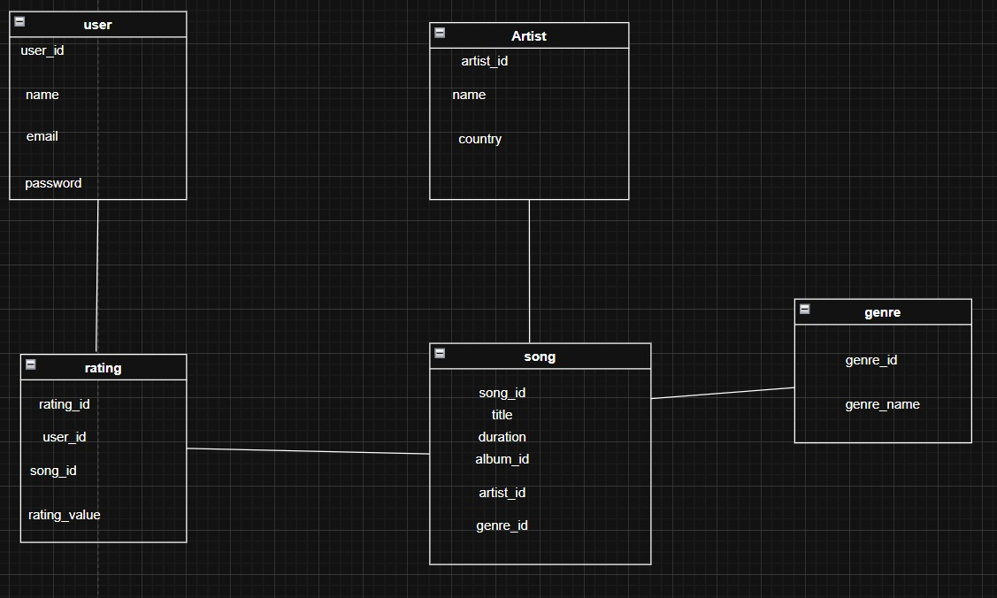

TASK 2:
CREATE TABLE Student (
student_id INT PRIMARY KEY,
name VARCHAR(50),
age INT,
department VARCHAR(30)
);

CREATE TABLE Course (
course_id INT PRIMARY KEY,
course_name VARCHAR(50),
credits INT
);

CREATE TABLE Enrollment (
enroll_id INT PRIMARY KEY,
student_id INT,
course_id INT,
grade CHAR(2),
FOREIGN KEY (student_id) REFERENCES Student(student_id),
FOREIGN KEY (course_id) REFERENCES Course(course_id)
);
INSERT DATA
INSERT INTO Student VALUES (1, 'Anjali', 20, 'CSE');
INSERT INTO Student VALUES (2, 'Ravi', 21, 'IT');

INSERT INTO Course VALUES (101, 'DBMS', 4);
INSERT INTO Course VALUES (102, 'AI', 3);

INSERT INTO Enrollment VALUES (1, 1, 101, 'A');
INSERT INTO Enrollment VALUES (2, 2, 102, 'B');
TASK 3:
CREATE TABLE Student (
student_id INT PRIMARY KEY,
name VARCHAR(50),
age INT,
department VARCHAR(30)
);

CREATE TABLE Course (
course_id INT PRIMARY KEY,
course_name VARCHAR(50),
credits INT
);

CREATE TABLE Enrollment (
enroll_id INT PRIMARY KEY,
student_id INT,
course_id INT,
grade CHAR(2),
FOREIGN KEY (student_id) REFERENCES Student(student_id),
FOREIGN KEY (course_id) REFERENCES Course(course_id)
);
Display student names in uppercase
SELECT UPPER(name) AS STUDENT_NAME FROM Student;

Find age + 5 years
SELECT name, age + 5 AS Age_in_5_Years FROM Student;

Concatenate name and department
SELECT CONCAT(name, ' - ', department) AS Student_Info FROM Student;

Display current date
SELECT SYSDATE FROM dual;

TASK4:
CREATE TABLE Student (
student_id INT PRIMARY KEY,
name VARCHAR(50),
age INT,
department VARCHAR(30)
);

CREATE TABLE Course (
course_id INT PRIMARY KEY,
course_name VARCHAR(50),
credits INT
);

CREATE TABLE Enrollment (
enroll_id INT PRIMARY KEY,
student_id INT,
course_id INT,
grade CHAR(2),
FOREIGN KEY (student_id) REFERENCES Student(student_id),
FOREIGN KEY (course_id) REFERENCES Course(course_id)
);
Display student names in uppercase
SELECT UPPER(name) AS STUDENT_NAME FROM Student;

Find age + 5 years
SELECT name, age + 5 AS Age_in_5_Years FROM Student;

Concatenate name and department
SELECT CONCAT(name, ' - ', department) AS Student_Info FROM Student;

Display current date
SELECT SYSDATE FROM dual;

TASK 5:
CREATE TABLE Student (
student_id INT PRIMARY KEY,
name VARCHAR(50),
age INT,
department VARCHAR(30)
);

CREATE TABLE Course (
course_id INT PRIMARY KEY,
course_name VARCHAR(50),
credits INT
);

CREATE TABLE Enrollment (
enroll_id INT PRIMARY KEY,
student_id INT,
course_id INT,
grade CHAR(2),
FOREIGN KEY (student_id) REFERENCES Student(student_id),
FOREIGN KEY (course_id) REFERENCES Course(course_id)
);
JOIN
SELECT s.name, c.course_name, e.grade
FROM Student s
JOIN Enrollment e ON s.student_id = e.student_id
JOIN Course c ON e.course_id = c.course_id;
RECURSIVE QUIREY
WITH RECURSIVE prereq_chain AS (
SELECT course_id, course_name FROM Course WHERE course_id = 101
UNION ALL
SELECT c.course_id, c.course_name
FROM Course c
JOIN prereq_chain p ON c.course_id = p.course_id + 1
)
SELECT * FROM prereq_chain;

TASK 6:
CREATE TABLE Student (
student_id INT PRIMARY KEY,
name VARCHAR(50),
age INT,
department VARCHAR(30)
);

CREATE TABLE Course (
course_id INT PRIMARY KEY,
course_name VARCHAR(50),
credits INT
);

CREATE TABLE Enrollment (
enroll_id INT PRIMARY KEY,
student_id INT,
course_id INT,
grade CHAR(2),
FOREIGN KEY (student_id) REFERENCES Student(student_id),
FOREIGN KEY (course_id) REFERENCES Course(course_id)
);
CREATE OR REPLACE PROCEDURE display_student_info IS
CURSOR s_cur IS SELECT name, department FROM Student;
s_row s_cur%ROWTYPE;
BEGIN
OPEN s_cur;
LOOP
FETCH s_cur INTO s_row;
EXIT WHEN s_cur%NOTFOUND;
DBMS_OUTPUT.PUT_LINE('Name: ' || s_row.name || ' Dept: ' || s_row.department);
END LOOP;
CLOSE s_cur;
END;

TASK 8:
CREATE TABLE Student (
student_id INT PRIMARY KEY,
name VARCHAR(50),
age INT,
department VARCHAR(30)
);

CREATE TABLE Course (
course_id INT PRIMARY KEY,
course_name VARCHAR(50),
credits INT
);

CREATE TABLE Enrollment (
enroll_id INT PRIMARY KEY,
student_id INT,
course_id INT,
grade CHAR(2),
FOREIGN KEY (student_id) REFERENCES Student(student_id),
FOREIGN KEY (course_id) REFERENCES Course(course_id)
);
CREATE OR REPLACE TRIGGER check_age
BEFORE INSERT ON Student
FOR EACH ROW
BEGIN
IF :NEW.age < 17 THEN
RAISE_APPLICATION_ERROR(-20001, 'Age must be 17 or above');
END IF;
END;
/
TASK 8:
CREATE TABLE Student (
student_id INT PRIMARY KEY,
name VARCHAR(50),
age INT,
department VARCHAR(30)
);

CREATE TABLE Course (
course_id INT PRIMARY KEY,
course_name VARCHAR(50),
credits INT
);

CREATE TABLE Enrollment (
enroll_id INT PRIMARY KEY,
student_id INT,
course_id INT,
grade CHAR(2),
FOREIGN KEY (student_id) REFERENCES Student(student_id),
FOREIGN KEY (course_id) REFERENCES Course(course_id)
);
IMPLEMENTING NORMALIZATION
Student(student_id, name, age, department, course_id, course_name)
FDs:
student_id → name, age, department
course_id → course_name
(student_id, course_id) → grade

TASK 10:
db.createCollection("mylab")
{ "ok" : 1 }
> db.mylab.insertOne({item:"canvas",qty:100,tags:["cotton"],size:{h:28,w:35.5,uom:"cm"}})
{
"acknowledged" : true,
"insertedId" : ObjectId("627d13acc73990c074e6397c")
}
> db.mylab.find({item:"canvas"})
{ "_id" : ObjectId("627d13acc73990c074e6397c"), "item" : "canvas", "qty" : 100, "tags" : [ "cotton" ], "size" : { "h" : 28, "w" : 35.5, "uom" : "cm" } }
> db.mylab.insertMany([{item:"journal",qty:25,tags:["blank","red"],size:{h:14,w:21,uom:"cm"}},{item:"mat",qty:85,tags:["gray"],size:{h:27.9,w:35.5,uom:"cm"}},{item:"mousepad",qty:25,tags:["gel","blue"],size:{h:19,w:22.85,uom:"cm"}}])
{
"acknowledged" : true,
"insertedIds" : [
ObjectId("627d1598c73990c074e6397d"),
ObjectId("627d1598c73990c074e6397e"),
ObjectId("627d1598c73990c074e6397f")
]
}
> db.mylab.find({},{item:1,qty:1})
{ "_id" : ObjectId("627d13acc73990c074e6397c"), "item" : "canvas", "qty" : 100 }
{ "_id" : ObjectId("627d1598c73990c074e6397d"), "item" : "journal", "qty" : 25 }
{ "_id" : ObjectId("627d1598c73990c074e6397e"), "item" : "mat", "qty" : 85 }
{ "_id" : ObjectId("627d1598c73990c074e6397f"), "item" : "mousepad", "qty" : 25 }
> db.mylab.find({},{item:1,qty:1}).pretty()
{
"_id" : ObjectId("627d13acc73990c074e6397c"),
"item" : "canvas",
"qty" : 100
}
{
"_id" : ObjectId("627d1598c73990c074e6397d"),
"item" : "journal",
"qty" : 25
}
{ "_id" : ObjectId("627d1598c73990c074e6397e"), "item" : "mat", "qty" : 85 }
{
"_id" : ObjectId("627d1598c73990c074e6397f"),
"item" : "mousepad",
"qty" : 25
}
> db.mylab.find({item:"canvas"}).pretty().sort({item:-1})
{
"_id" : ObjectId("627d13acc73990c074e6397c"),
"item" : "canvas",
"qty" : 100,
"tags" : [
"cotton"
],
"size" : {
"h" : 28,
"w" : 35.5,
"uom" : "cm"
}
}
> db.mylab.deleteOne({item:"journal"}
...
...
> db.mylab.find({},{item:1,qty:1}).pretty()
{
"_id" : ObjectId("627d13acc73990c074e6397c"),
"item" : "canvas",
"qty" : 100
}
{
"_id" : ObjectId("627d1598c73990c074e6397d"),
"item" : "journal",
"qty" : 25
}
{ "_id" : ObjectId("627d1598c73990c074e6397e"), "item" : "mat", "qty" : 85 }
{
"_id" : ObjectId("627d1598c73990c074e6397f"),
"item" : "mousepad",
"qty" : 25
}

TASK 11:
CRUD OPERATIONS:
CREATE:
db.collection_name.insertOne({key1: value1, key2: value2});
db.collection_name.insertMany([{...}, {...}, {...}]);
EXAMPLE:
// Creating a collection called 'students' and inserting one document
db.students.insertOne({
name: "Lakshmi",
age: 21,
course: "CSE (AIML)",
grade: "A"
});

// Inserting multiple documents
db.students.insertMany([
{name: "Ravi", age: 22, course: "CSE", grade: "B"},
{name: "Priya", age: 20, course: "AIML", grade: "A"}
]);
RETRIVE:
db.collection_name.find(query, projection);
EXAMPLE:
/ Display all students
db.students.find();

// Display students with grade "A"
db.students.find({grade: "A"});

// Display name and course only
db.students.find({}, {name: 1, course: 1, _id: 0});
UPDATE :
db.collection_name.updateOne(filter, update);
db.collection_name.updateMany(filter, update);
EXAMPLE:
// Update one student’s grade
db.students.updateOne(
{name: "Ravi"},
{$set: {grade: "A+"}}
);

// Update multiple documents
db.students.updateMany(
{course: "AIML"},
{$set: {grade: "A"}}
);
DELETE:
db.collection_name.deleteOne(filter);
db.collection_name.deleteMany(filter);
EXAMPLE:
// Delete one record
db.students.deleteOne({name: "Priya"});

// Delete all students with grade "B"
db.students.deleteMany({grade: "B"});

