

**Faculty of Engineering and Technology**

**Electrical and Computer Engineering Department**

**LAB_NAME – LAB_SYMBOL**

**Experiment No. X Report**

**EXPERIMENT_TITLE**

**Prepared by:**

YOUR NAME YOUR_ID

**Partners:**NAME ID

**Instructor**: Dr.DOCTOR NAME  
**Assistant**: Eng. TEACHING_ASSISTAN_NAME

**Section:** SECTION_NUMBER

**Date:** DATE_OF_SUBMISSION

# **Abstract [Heading 1]**

The aim of this experiment….

NOTEs:

* **In Separate page.**
* **3-4 lines max.**
* **Before the table of content.**

**[Auto generated by Microsoft word] References-> Table of Contents**

Table of Contents

**Theory**

Access Lists PAGE_NUMBER

Definition PAGE_NUMBER

Uses PAGE_NUMBER

Access lists Types PAGE_NUMBER

IPv6 PAGE_NUMBER

Definition PAGE_NUMBER

Dual-stack PAGE_NUMBER

Tunneling PAGE_NUMBER

Address Types PAGE_NUMBER

**Procedure and Discussion** 2

**Part A: Access lists** 2

• Task1 PAGE_NUMBER

• Task2 PAGE_NUMBER

• Task3 PAGE_NUMBER

**Part B: IPv6** PAGE_NUMBER

**Conclusion** 3

**References** 4

# **Theory [Heading 1]**

NOTEs:

* New page.
* No copy.
* Anything from the internet / books must be referenced using **[REFERNCE]**.
  + example:

**this paragraph is from a website. this paragraph is from a website. this paragraph is from a website. this paragraph is from a website. this paragraph is from a website.**

**this paragraph is from a website [1].**

# 

# **Procedure and Discussion [Heading 1]**

* SEPARATE PAGE
* the most important part in the report. [must explain the results, give the details of each part]
* must contain all the experiment parts

**Part 1: Title [Heading 2]**

Subtitle [Heading 3]

# **Conclusion [Heading 1]**

NOTEs:

* Separate Page.
* Not more than 1 page.
* Summary of the results of the whole experiment.

# **References [Heading 1]**

**[Use Microsoft word citation]**

[1] [http://www.cisco.com/c/en/us/td/docs/ios/12_2/security/configuration/guide/fsecur_c/scfacls. html](http://www.cisco.com/c/en/us/td/docs/ios/12_2/security/configuration/guide/fsecur_c/scfacls.%20html). Accessed on 27-04-2017 at 7:36PM.

[2] <http://searchenterprisewan.techtarget.com/definition/IPv6>.   
Accessed on 27-04-2017 at 8:14PM.

**General Notes:**

* Pages numbering is very important
  + No numbering for the cover page



* + After cover page till Theory/Introduction(not included): **Roman numeral**



* + **Normal numeral**: From Theory/Introduction to the end of the report



* Standard font type: Times New Roman
* Font size: 12
* Any main title must be **Heading 1**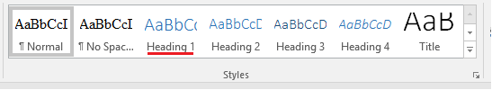
* The **subtitle** must be **Heading 2**, the **sub-subtitle** must be **Heading 3** and so on…
* Anything used from outside must be referenced.
  + The paragraph that was used must be linked with its reference.

Example:

Information Retrieval (IR) can be defined as a software program that deals with the organization, storage, retrieval, and evaluation of information from document repositories, particularly textual information. Information Retrieval is the activity of obtaining material that can usually be documented on an unstructured nature i.e. usually text which satisfies an information need from within large collections which is stored on computers. For example, Information Retrieval can be when a user enters a query into the system [3]

* + Must be added in the references part:
    - If book: BOOKNAME, BOOK_EDITION,by AUTHOR(s)
    - If website: WEBSITE_LINK, accessed on **DATE** at **TIME** [PM/AM].

Example:

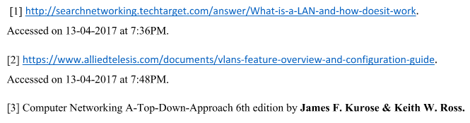

* Any screenshot/picture must have caption as following:

[Select Pic -> Right Click Add Caption] – Don’t do the numbering by hand

Any figure must be mentioned in the paragraph. Example [See Figure 2 which illustrate..]

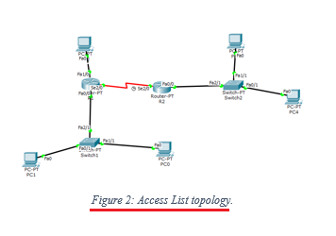

* Any table must have a caption

[Select Table -> Right Click Add Caption] – Don’t do the numbering by hand

Any Table must be mentioned. Example [Table 2 defines..]

