**NAME : Mahalakshmi S**

**ROLL NO : 205229118**

**Lab20: Web App Development for Sentiment Analysis using Flask an Heroku**

**App.py file:**

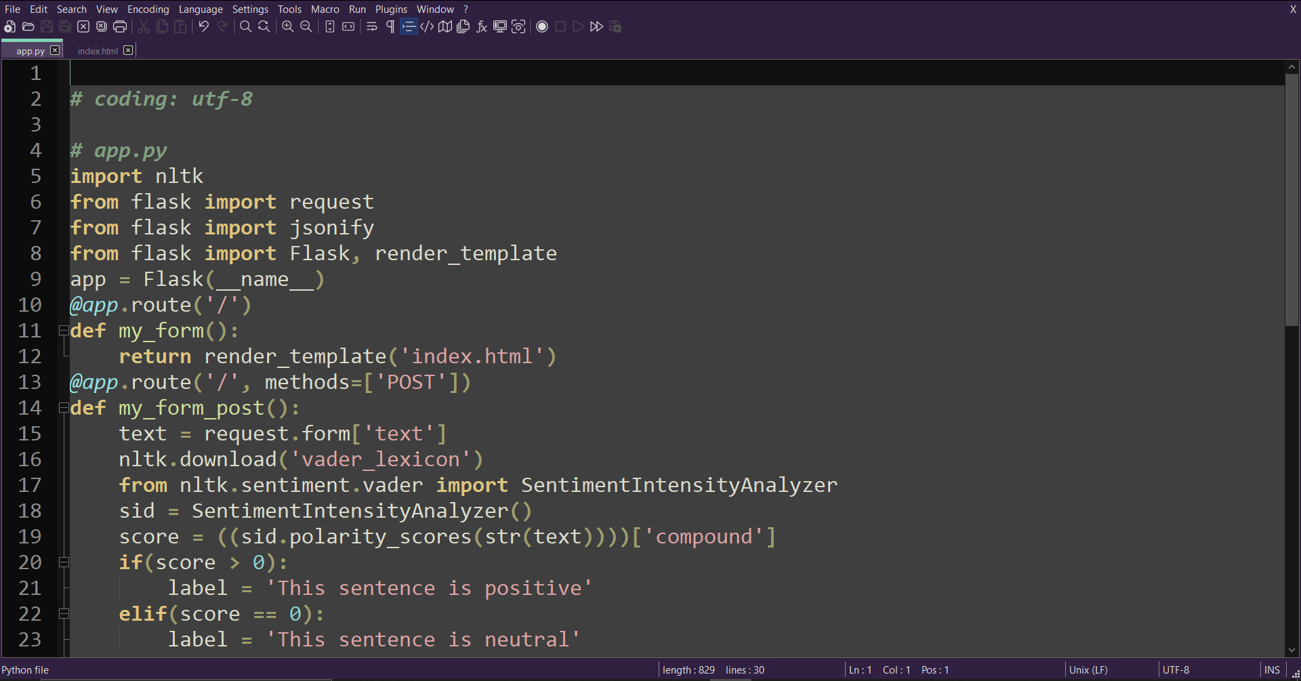

**Index.html**

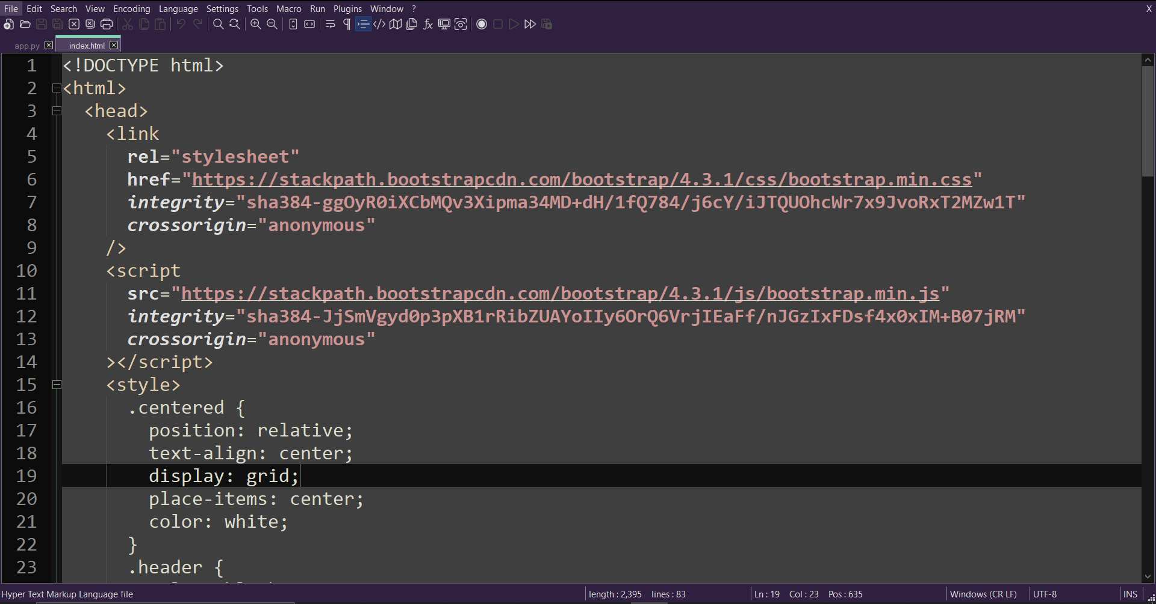

**Creating repo for sentiment analysis**

**Link to my github repo:**  [**shabu22/PDL_LAB-20** (github.com)](https://github.com/MaheshvaranS/sentiment_analysis_mv)

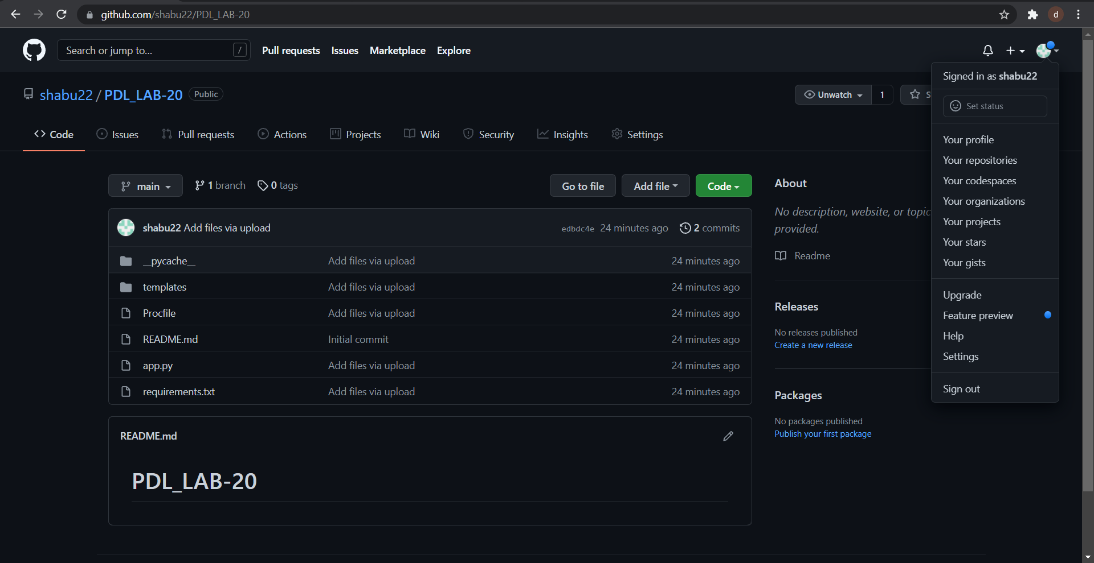

**Connecting GitHub to Heroku:**

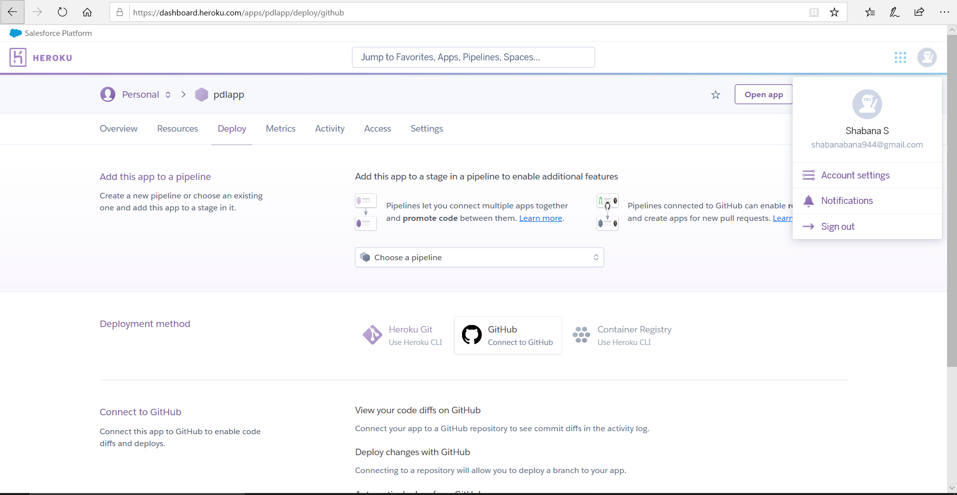

**Heroku app for sentiment analysis**

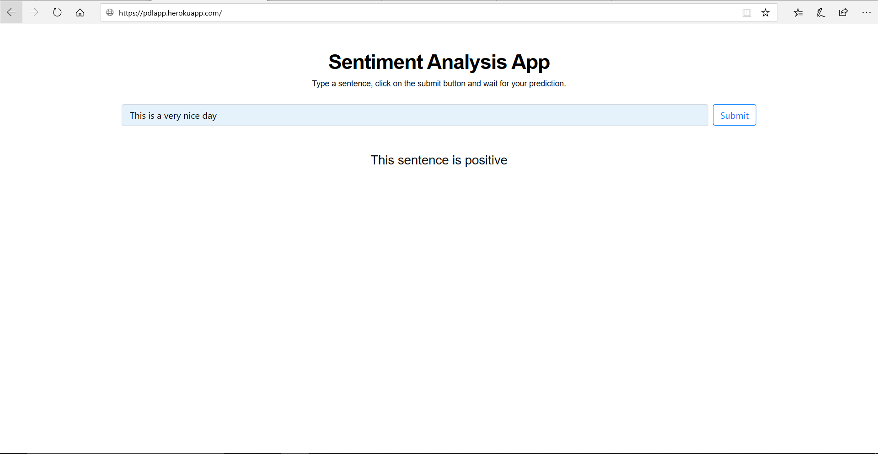

Link to my Heroku app: https:// pdlapp.herokuapp.com/