**Social Media Analytics Lab**

**Instructor: Dr. Janani Selvaraj**

**Lab 14. Creating a Tweet Sentiment Analyser App using Streamlit and Heroku**

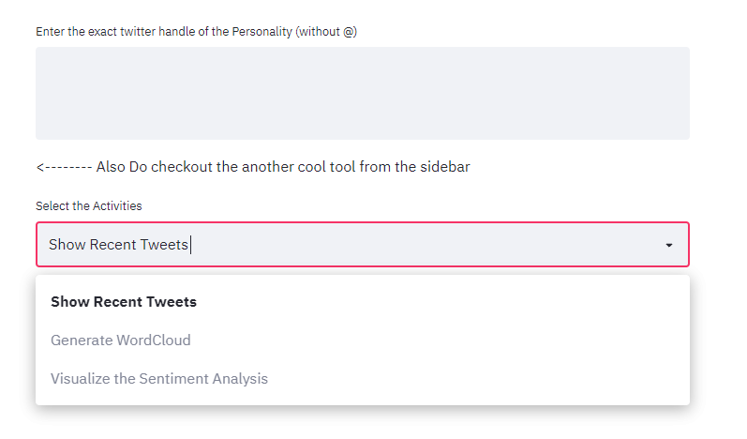

**Example UI of the app**

1. Access the Twitter API by the use of your credentials
2. Collect recent tweets of a username
3. Perform preprocessing steps on the collected tweets
4. Create Word Cloud and perform sentiment analysis
5. Create an app with the above functions in the backend using Streamlit
6. Deploy the app with Heroku