Housing Price Prediction
A Regression Analysis — Final Report
Prepared by: P. Mahalaxmi Reddy

Abstract
Housing valuation is a critical task for buyers, lenders, insurers, and urban planners, yet it depends on a complex interaction of location, income, and structural characteristics. This report presents a supervised regression study that predicts median house value from nine census-derived features across 20,640 residential districts. Three algorithms — Linear Regression, Decision Tree, and Random Forest — were trained on standardized, outlier-filtered data and evaluated using MAE, MSE, RMSE, and R². After hyperparameter tuning via 5-fold cross-validation, the Random Forest Regressor achieved the strongest performance (R² = 0.8116), with median income identified as the dominant predictor, accounting for over half of total feature importance. The tuned model was subsequently used to generate price estimates for five sample districts, demonstrating its practical applicability to real-world valuation tasks.

1. Introduction & Objective
This project develops a machine learning model to predict median house value across residential districts from census-derived features such as location, housing age, room and population counts, household counts, and median income. The objective is to compare regression approaches, identify the strongest predictors of price, and optimize the best-performing model through hyperparameter tuning.
Specific goals of the study are to:
- Predict median house value from eight numeric predictors.
- Benchmark Linear Regression, Decision Tree, and Random Forest models under identical train/test conditions.
- Identify which features most strongly influence price.
- Tune the best-performing model to maximize predictive accuracy.

2. Project Workflow
The analysis followed a standard supervised-learning pipeline, from raw data through to final predictions, illustrated below.
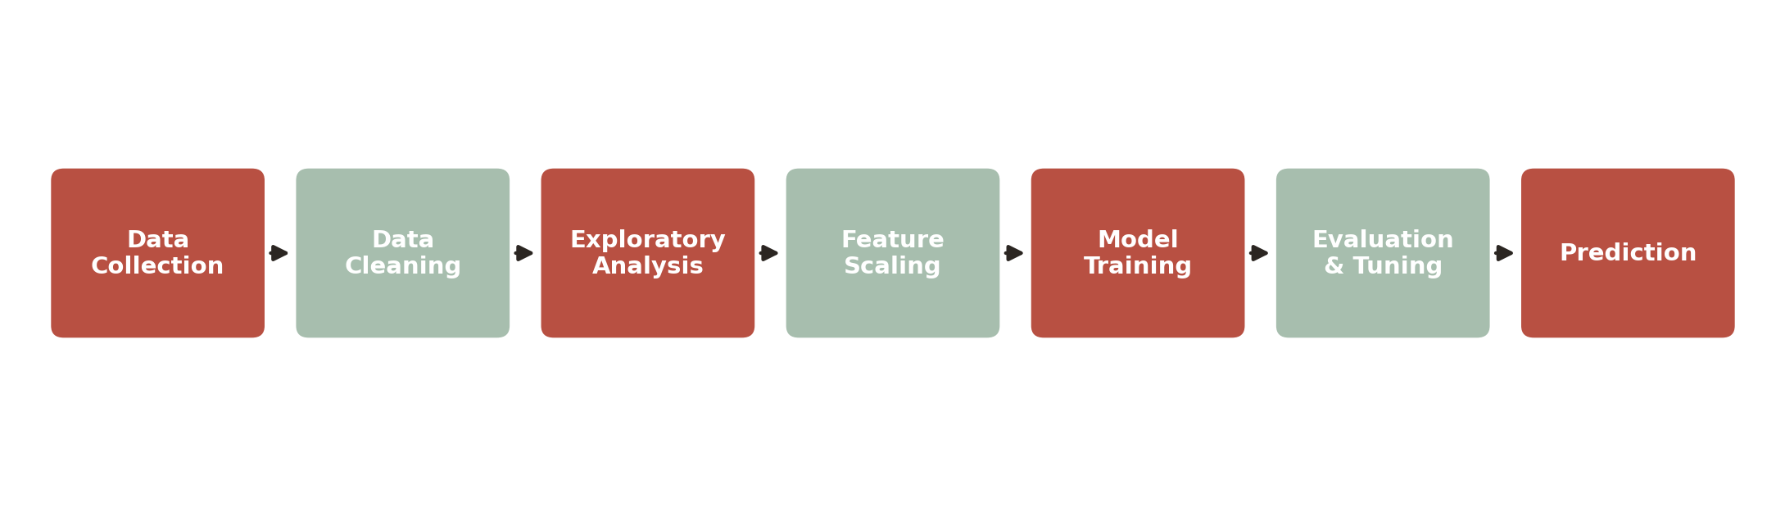
Figure 1. Project workflow.
- Data Collection: import the raw census-derived housing dataset.
- Data Cleaning: impute missing values and remove duplicate records.
- Exploratory Analysis: examine distributions, correlations, and outliers.
- Feature Scaling: standardize predictors and remove outliers via the IQR rule.
- Model Training: fit Linear Regression, Decision Tree, and Random Forest models.
- Evaluation & Tuning: compare metrics and refine the best model with GridSearchCV.
- Prediction: apply the tuned model to new, unseen district data.

3. Dataset & Preprocessing
The dataset contains 20,640 records with 9 numeric features and no categorical columns. Data preparation steps:
- Missing values: 207 records (about 1%) had missing total_bedrooms; these were imputed with the column median.
- Duplicates: none found.
- Outliers: removed using the interquartile range (IQR) rule across all numeric columns, since boxplots showed extreme values in total_rooms, population, and median_income.
- Feature scaling: applied StandardScaler ahead of modeling.
- Train/test split: 80% train, 20% test, random_state=42.

4. Exploratory Data Analysis
Distribution and relationship analysis surfaced several patterns before modeling:
- Most numeric features are right-skewed, with a long tail of high values in total_rooms and population.
- Median income has the strongest positive correlation with house value; latitude and longitude show mild negative relationships, reflecting regional price differences.
- A scatter plot of income vs. house value confirms a clear upward trend, with most prices clustered below $500,000.
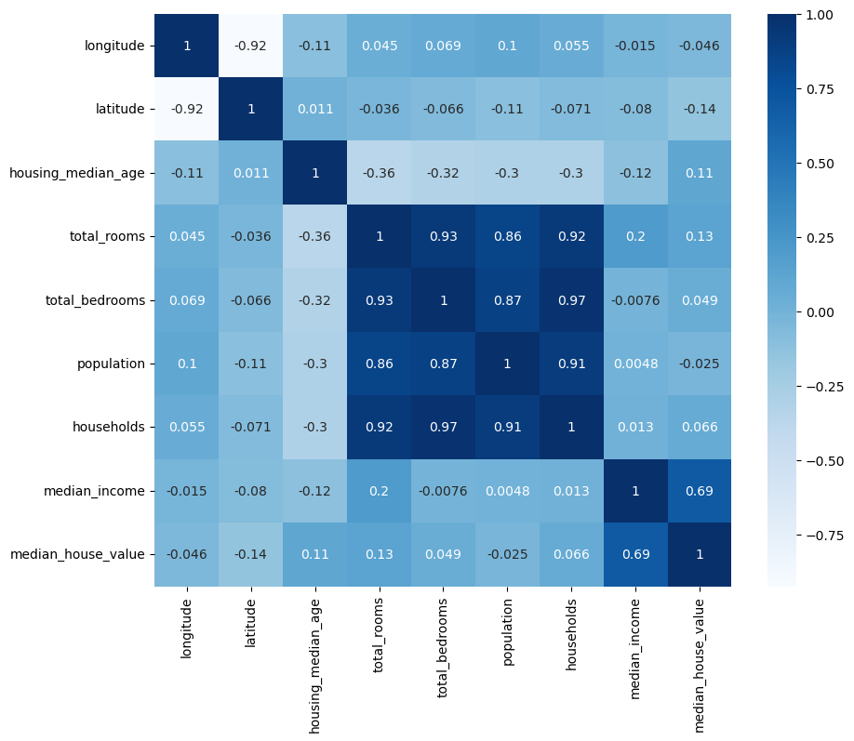
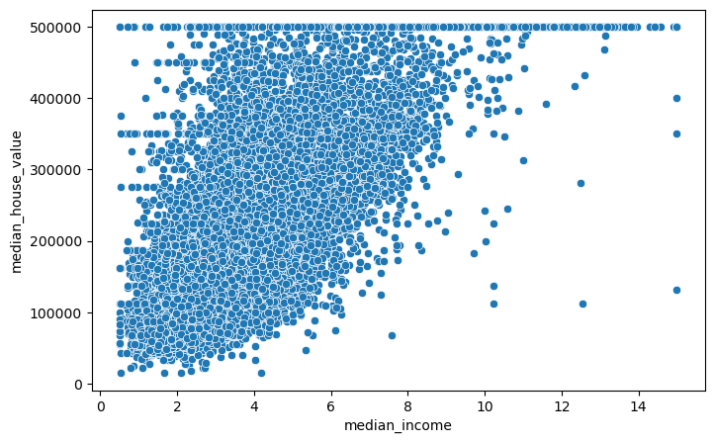
Figure 2. Correlation heatmap of numeric features.

Figure 3. Median income vs. median house value.

5. Modeling Approach
Three regression models were trained on the scaled features and evaluated with MAE, MSE, RMSE, and R² on the held-out test set:
- Linear Regression — baseline linear model.
- Decision Tree Regressor — captures non-linear splits, prone to overfitting.
- Random Forest Regressor — ensemble of trees, better generalization.

6. Technologies Used
The analysis was implemented entirely in Python within a Jupyter Notebook environment, using the following tools:
Category | Tools & Libraries
Language | Python 3
Data Handling | pandas, NumPy
Visualization | Matplotlib, Seaborn
Machine Learning | scikit-learn (LinearRegression, DecisionTreeRegressor, RandomForestRegressor, GridSearchCV, StandardScaler)
Evaluation Metrics | scikit-learn.metrics (MAE, MSE, RMSE, R² Score)
Development Environment | Jupyter Notebook

Model | MAE | MSE | RMSE | R² Score
Linear Regression | 51,810.48 | 5.06 × 10⁹ | 71,133.17 | 0.6139
Decision Tree | 44,299.32 | 4.88 × 10⁹ | 69,869.73 | 0.6275
Random Forest | 32,093.65 | 2.49 × 10⁹ | 49,880.46 | 0.8101
Random Forest (Tuned) | — | — | — | 0.8116

7. Results

Random Forest clearly outperformed the other two models, cutting RMSE by roughly 30% versus Linear Regression and improving R² from ~0.61–0.63 to 0.81. GridSearchCV (5-fold cross-validation over n_estimators, max_depth, min_samples_split) selected n_estimators=200, max_depth=20, min_samples_split=2, lifting test R² slightly further to 0.8116.

Feature Importance (Tuned Random Forest)
Median income dominates the model, accounting for over half of total feature importance — far ahead of location (longitude/latitude) and housing age.
Feature | Importance
Median Income | 0.522
Longitude | 0.155
Latitude | 0.147
Housing Median Age | 0.065
Population | 0.037
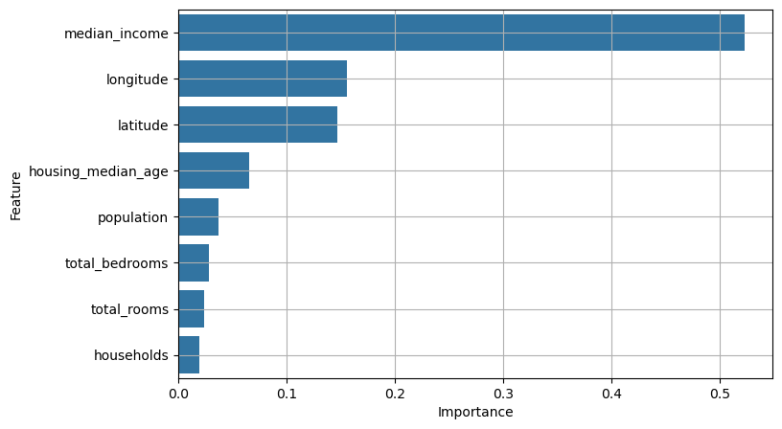
Figure 4. Top 10 feature importances from the tuned Random Forest.

8. Conclusion

Best Model
The Random Forest Regressor performed best, achieving the highest R² (0.8116) and the lowest error following hyperparameter tuning.

Most Influential Feature
Median income is the most influential predictor, accounting for more than half of total feature importance in the tuned model.

Challenges Faced
- Missing values in total_bedrooms required imputation.
- Outlier handling across multiple skewed features.
- Original housing values appear capped near $500,000, which can bias predictions for high-value districts.

Recommended Improvements
- More robust missing-value treatment (e.g. model-based imputation).
- Engineer new features, such as rooms-per-household or bedrooms-per-room ratios.
- Broaden hyperparameter search and consider gradient-boosted models (XGBoost/LightGBM) for further gains.

