Academic Performance Evaluation
- Project Overview and Objectives
This project focuses on analyzing a Students Performance dataset by performing data cleaning, transformation, and visualization using Microsoft Excel and Power BI. The raw dataset is pre-processed in Excel to handle missing values, inconsistencies, and formatting issues.
After cleaning, the dataset is loaded into Power BI to build an interactive dashboard that provides insights into students’ academic performance based on factors such as gender, study habits, parental education, and test scores. The dashboard enables users to explore trends, compare performance metrics, and identify key patterns that influence student outcomes.
- Analyze overall student academic performance using CGPA, SGPA, attendance, and credits.
- Identify factors affecting student performance such as study hours, learning mode, and social media usage.
- Understand student demographics including gender, relationship status, and admission year trends.
- Track student engagement through skills, co-curricular interests, and learning preferences.
- Evaluate technology accessibility such as smartphone and personal computer ownership.
- Monitor academic risk indicators like probation and suspension.
- Help educational institutions make data-driven decisions to improve student outcomes.
- Data Source
Source Description and Timeline: https://data.mendeley.com/datasets/dc3797vf3t/1/files/57b43a3a-a060-4247-afd9-cc17dfbf87f7
and 16/09/2024.
Domain: Education.
- Problem Statement
Educational institutions often collect large amounts of student data, but this data is rarely utilized effectively to improve academic outcomes. The dataset contains information on students’ scores, demographics, and study-related factors; however, it lacks structured insights that can help identify performance trends and key influencing factors
- Attribute Details
Attribute Name | Data Type | Description
Student_ID | Integer / Text | Unique identifier for each student
Admission_Year | Integer | Year the student joined the university
Gender | Text | Gender of the student
Age | Integer | Age of the student
HSC_Passing_Year | Integer | Higher Secondary passing year
Current_Semester | Integer | Current semester of study
Scholarship_Status | Text / Boolean | Indicates if student has scholarship
Transportation | Text / Boolean | Indicates if student uses university transportation
Daily_Study_Hours | Decimal | Average study hours per day
Learning_Mode | Text | Preferred learning mode (Online/Offline/Hybrid)
Smartphone_Available | Text / Boolean | Whether student owns smartphone
Personal_Computer | Text / Boolean | Whether student owns laptop/PC
Social_Media_Hours | Decimal | Average time spent on social media per day
English_Proficiency | Text | Student’s English proficiency level
Attendance_Percentage | Decimal | Average attendance percentage
Probation_Status | Text / Boolean | Whether student is on probation
Suspension_Status | Text / Boolean | Whether student has suspension history
Skills | Text | Student’s skill set / expertise
Interested_Area | Text | Student’s area of academic/career interest
Relationship_Status | Text | Marital/relationship status
Co_Curricular_Activities | Text | Participation in extracurricular activities
Living_With | Text | Student’s living arrangement
Health_Issues | Text | Student health-related issues
SGPA | Decimal | Semester Grade Point Average
Physical_Disabilities | Text / Boolean | Indicates physical disabilities if any
CGPA | Decimal | Cumulative Grade Point Average
Credit | Integer | Total academic credits completed

- Tools & Technologies
Microsoft Excel
- Data cleaning
- Handling missing values
- Data preprocessing
- Initial data analysis
Power BI
- Data modeling
- DAX calculations
- Dashboard creation
- Interactive visualizations
Power Query
- Data transformation
- Data type formatting
- Removing duplicates
- Creating calculated columns
DAX (Data Analysis Expressions)
- Creating KPIs
- Measures for Avg CGPA, Attendance, Credits
- Custom calculations for insights

- Data Pre-Processing (Excel / Power Query)
Excel:
- Data Cleaning and Transformation – Changed column header name, Standardized format, Applied Filters.
Power BI: (Power Query)
- Removed errors, removed columns, capitalized each word, created new index column for student id, used DAX for Calculated Column and Measures, used Visuals for Dashboard.
- Data Modelling and DAX (Power BI)
1. Data Modeling
The dataset is based on a denormalized data model, where most student-related information is stored in a single consolidated Students Data table containing academic, demographic, and behavioural attributes. Separate helper/count tables and a dedicated measure table were created to organize calculated metrics and support category-wise analysis. This approach simplifies data loading and dashboard development for reporting while enabling efficient filtering, aggregation, and visualization in Power BI.

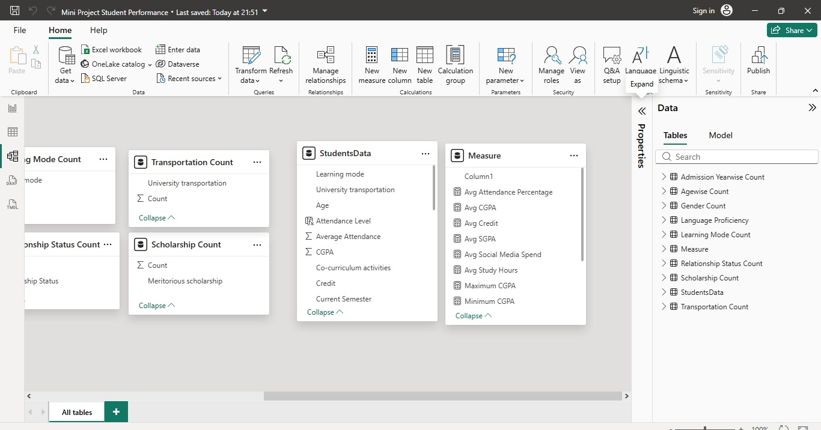

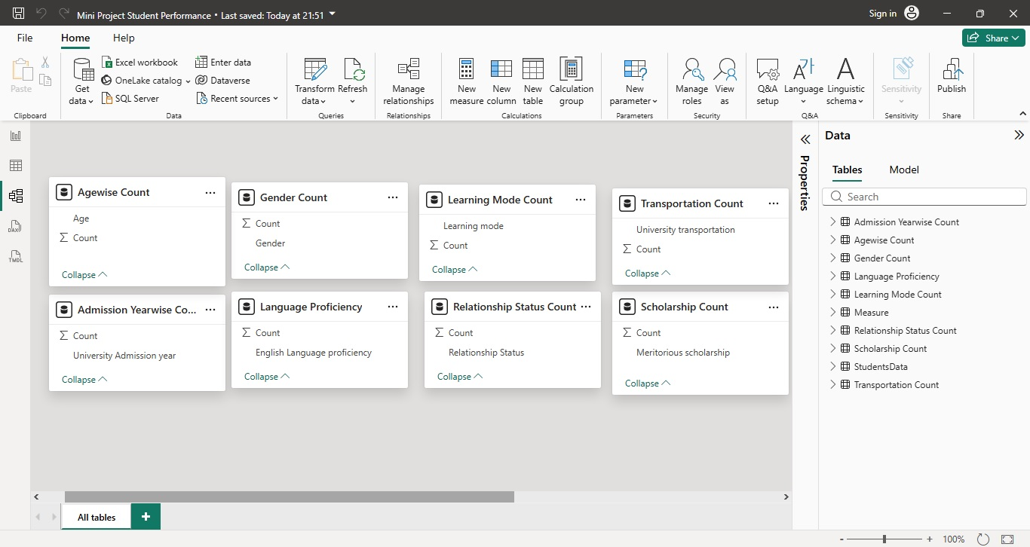

2. DAX (Power BI)
Calculated Column created (Power BI):
- Index Column (Student ID)
- Performance Level (High/Low)
- Attendance Level (Good/Average/Poor)
- Study Level (High/Low)

Measures created (Power BI)
- Total Students – Counts the total number of students in the dataset.
- Average Attendance Percentage – Calculates the average attendance percentage of all students.
- Average CGPA – Shows the average CGPA across students.
- Average Credit – Calculates the average credits earned by students.
- Average SGPA – Displays the average SGPA of students.
- Average Social Media Spend – Measures the average time students spend on social media.
- Average Study Hours – Calculates the average study hours of students.
- Maximum CGPA – Returns the highest CGPA in the dataset.
- Minimum CGPA – Returns the lowest CGPA in the dataset.
- Student Rank – Assigns ranking to students based on academic performance.
- Top 10 Students – Identifies the top 10 students by performance/CGPA.
- Total Credit – Calculates the total credits earned by all students.

- Analysis and Visualizations (Power BI)
• Offline learning mode dominates with 857 students, while 336 students prefer online learning, indicating stronger preference for traditional/offline study methods.
• Average CGPA is 3.17, showing overall students maintain good academic performance.
• Average SGPA is 2.68, suggesting semester-wise performance is moderate compared to cumulative CGPA.
• Minimum CGPA is 0.00, indicating some students may have incomplete/failed academic records.
• Admissions trend has increased sharply after 2020, showing higher student intake in recent academic years.
• Students are distributed across multiple course specializations, with some programs contributing significantly higher enrolment than others.
• Relationship between learning mode and academic metrics can be analysed to identify performance patterns among online/offline learners.
• Gender-wise total credit analysis helps compare academic credit completion between male and female students.

• Relationship status insights may support behavioural/performance correlation analysis if relevant to the study.

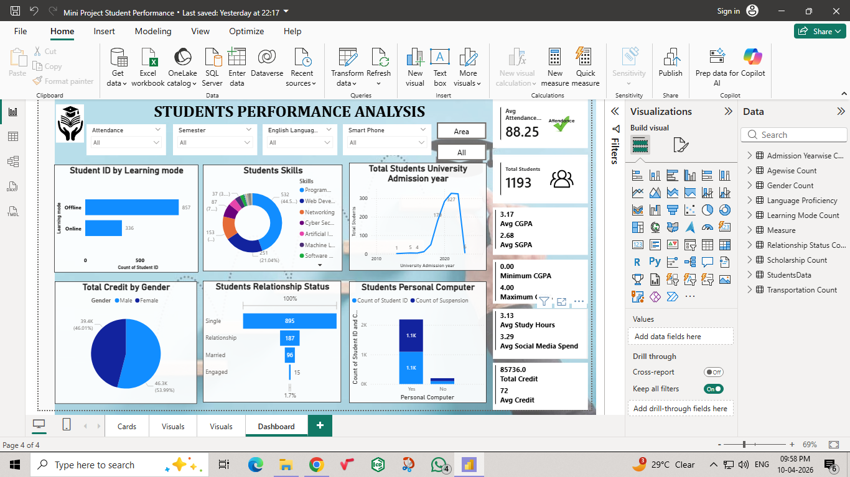

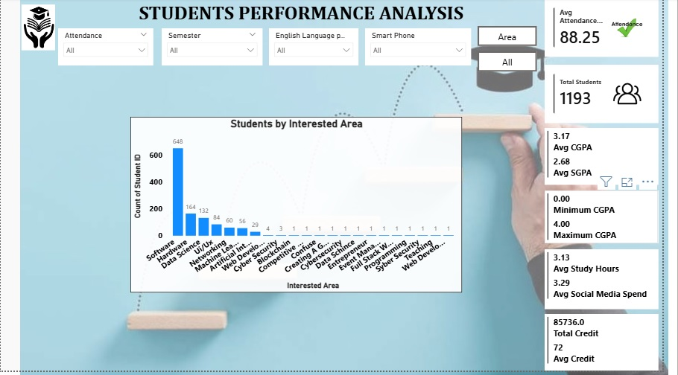

- Insights

Academic Performance
- Average Attendance is 88.25%, indicating generally good attendance.
- Average CGPA is 3.17 and Average SGPA is 2.68, showing moderate academic performance.
- Maximum CGPA is 4.00, while Minimum CGPA is 0.00.
Learning Mode
- Offline learning is preferred by most students (857 students).
- Online learning is chosen by fewer students (336 students).

Skills Distribution
- Most students are interested in Programming/Technical Skills.
- Web Development and Networking are also popular skill areas.

Admission Trend
- Student admissions increased significantly after 2018.
- Peak admission year appears around 2021–2022.

Gender Analysis
- Female students contribute slightly more total credits (53.99%) than male students (46.01%).

Relationship Status
- Majority of students are Single (895 students).
- Smaller portions are in relationships, married, or engaged.

Technology Access
- Nearly all students have a Personal Computer.
- Very few students lack access to computers.

Study Habits
- Average Study Hours: 3.13 hours/day
- Average Social Media Spend: 3.29 hours/day
- Social media usage is slightly higher than study time, which may impact performance.

Credit Analysis
- Total Credit Earned by Students: 85,736
- Average Credit per Student: 72

- Conclusions
The Students Performance Analysis dashboard highlights key insights into student academics and behavior. Students maintain strong attendance with an average of 88.25%, and overall academic performance is satisfactory with an average CGPA of 3.17. Most students prefer offline learning and have access to digital devices such as smartphones and personal computers. Skill analysis shows high interest in programming-related domains, while admission trends indicate steady university growth. Overall, the dashboard supports data-driven decisions to improve student performance and academic planning.

