PROJECT REPORT
Customer Feedback & Synthesizer
AI Agent: FeedbackPulse AI | Built with n8n

Goal of the Project
Customer Feedback & Synthesizer aims to create an AI agent, FeedbackPulse AI, that automatically collects customer reviews, understands what customers are complaining about or asking for, and organizes the findings so the product team knows what to fix first.

Objective
The objective is to develop an n8n-based AI agent that fetches customer reviews on a schedule, uses an AI model to classify sentiment, issue type, and severity, groups similar feedback into recurring issues, assigns a priority, and stores the results in Google Sheets.

Requirements
- n8n: To build and automate the complete workflow.
- Apify API: To fetch customer reviews through the HTTP Request node.
- AI Language Model: To analyze and classify the reviews.
- Google Sheets: To read and store the processed feedback.
- Internet Connection: Required for communication between services.
- Laptop/Desktop: Required for development and testing.

Procedure
- The Schedule Trigger starts the workflow automatically.
- The HTTP Request node fetches customer reviews from the Apify API.
- The Edit Fields node keeps the required fields of each review.
- The Prepare Review node cleans and formats the review text.
- The AI model analyzes sentiment, issue type, category, and severity.
- A JavaScript Code node converts the AI response into structured records.
- Get row(s) in sheet reads the existing records from Google Sheets.
- The If and If1 nodes route the records based on conditions.
- The Append row nodes store the results in Google Sheets.

Project Photos
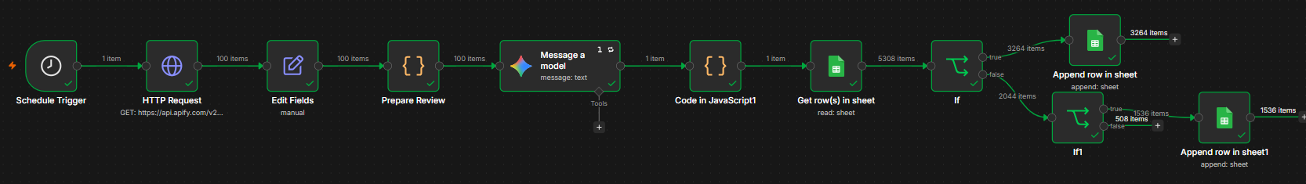
Figure 1: Complete n8n workflow of the Customer Feedback & Synthesizer
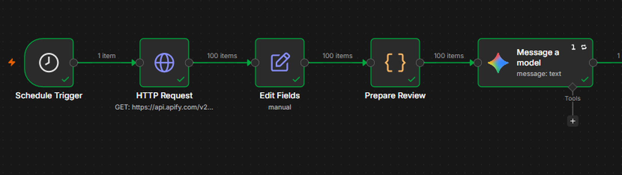
Figure 2: Data collection, preparation, and AI analysis (left half of the workflow)
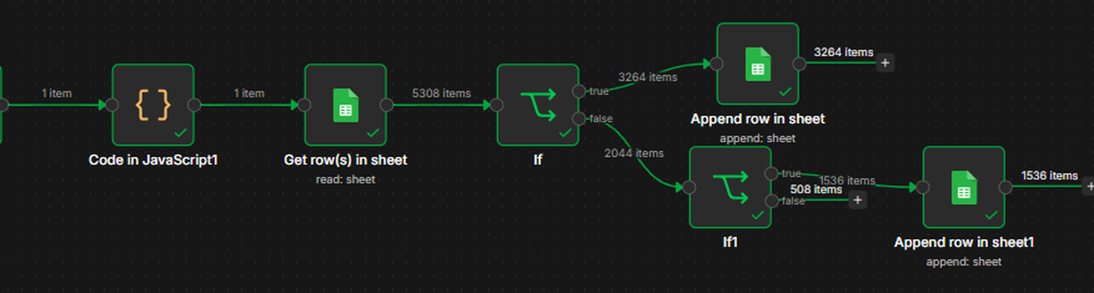
Figure 3: Result parsing, Google Sheets storage, and routing (right half of the workflow)

Conclusion
Customer Feedback & Synthesizer turns a large stream of customer reviews into clear, prioritized findings using AI and n8n. It collects reviews automatically, analyzes them, groups recurring issues, and stores the results in Google Sheets, saving time and reducing manual work for the product team.

Team Members
K. Bhavya Sri
K. Mahalakshmi
K. Naga Lakshmi
N. Indu
K. Meenakshi

