Global Vaccination Data Analysis
Power BI Dashboard Design & Business Report
Domain: Public Health and Epidemiology
Data sources: WHO/UNICEF Coverage, Incidence, Reported Cases, Vaccine Introduction & Schedule (1980–2023, 214 countries)

1. Executive Summary
This report translates the accompanying Exploratory Data Analysis (see Vaccination_EDA_Analysis.ipynb) into a Power BI dashboard design, and maps every question assigned in the project brief to the dashboard, KPI, or visual that answers it. Because this working environment cannot run the Power BI desktop application itself, each dashboard page below is specified as a build blueprint — exact visuals, filters, and DAX measures — alongside a Python-generated preview chart built from the same cleaned data, so the underlying numbers can be verified today and re-created natively in Power BI without rework.
Headline findings from the analysis:
- Global core-vaccine coverage (DTP3, MCV1, POL3) rose from the low-70s% in 2000 to the mid-80s% by 2019, fell 3–5 points during 2020–2021, and has not fully recovered by 2023.
- The African Region trails all WHO regions on DTP3 coverage (74%) — 21 points behind the European Region (95%) — while leading on new-vaccine introduction (81% of countries have introduced Rotavirus vs. 49% in Europe).
- Several countries with ≥90% reported measles coverage (Samoa, Tonga, Madagascar, DR Congo, Ukraine) still experienced large outbreaks — reported national coverage does not guarantee protection.
- HPV vaccination coverage is the largest single gap among all 69 tracked antigens, at 5–20% globally.
- Gender, education, urban/rural, income, population-density, and monthly-date breakdowns are not present in any of the five source tables; questions that require them are flagged as out-of-scope for this data rather than estimated.
214  Countries | 69  Antigens tracked | 13  Diseases tracked | 1980–2023  Years covered

2. Data Overview & Recommended SQL / Power BI Data Model
Five source tables were cleaned (trailing footer rows removed, columns standardized, coverage aggregate levels separated from country-level rows) and are ready to load into a normalized SQL schema. The recommended star schema for Power BI is:

Dimension tables
- dim_country (CODE, Name, WHO_Region, Income/Region groupings)
- dim_vaccine (Antigen/VaccineCode, Description)
- dim_disease (Disease code, Description, Denominator basis)
- dim_year (Year, Decade) — enables consistent year slicers across all fact tables

Fact tables
- fact_coverage (Country, Year, Antigen, Coverage_Category, Target_Number, Doses, Coverage%)
- fact_incidence (Country, Year, Disease, Denominator, Incidence_Rate)
- fact_cases (Country, Year, Disease, Cases)
- fact_vaccine_intro (Country, Year, Vaccine, Introduced Y/N)
- fact_schedule (Country, Year, Vaccine, Schedule_Round, Target_Pop, Age_Administered)
Relationships: all fact tables relate to dim_country (1-to-many on Code/ISO3), dim_year (1-to-many on Year), and either dim_vaccine or dim_disease depending on the table. This lets a single WHO-region or year slicer filter every visual across all five dashboards simultaneously.
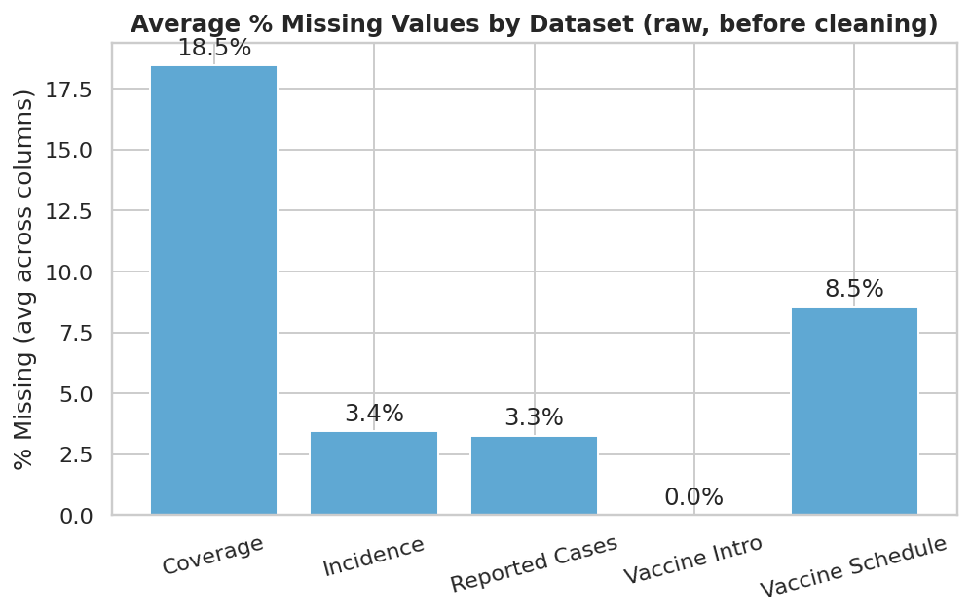
Data completeness check performed before modeling — informs which measures need an explicit 'reporting countries' filter.

3. Power BI Dashboard Suite
Five dashboard pages are recommended, each addressing a cluster of related brief questions. Every page should share a global filter panel (Year range, WHO Region, Country, Antigen/Disease) so users can drill from global to country level without leaving the page.

Dashboard 1: Global KPI Overview
A landing page giving public-health leadership a single-glance status check: current coverage against the 95% WHO target, target-population coverage by vaccine, and the biggest coverage gaps.

Key visuals to build in Power BI
- KPI cards: Global DTP3 / MCV1 / POL3 coverage (current year vs. prior year, vs. 95% target)
- Bar chart: % of target population covered, ranked by vaccine (all 69 antigens, filterable)
- Gauge/KPI: HPV coverage vs. target — flagged as the largest current gap
- Slicer panel: Year, WHO Region, Income group

Illustrative preview (Python/EDA equivalent of the Power BI visual)
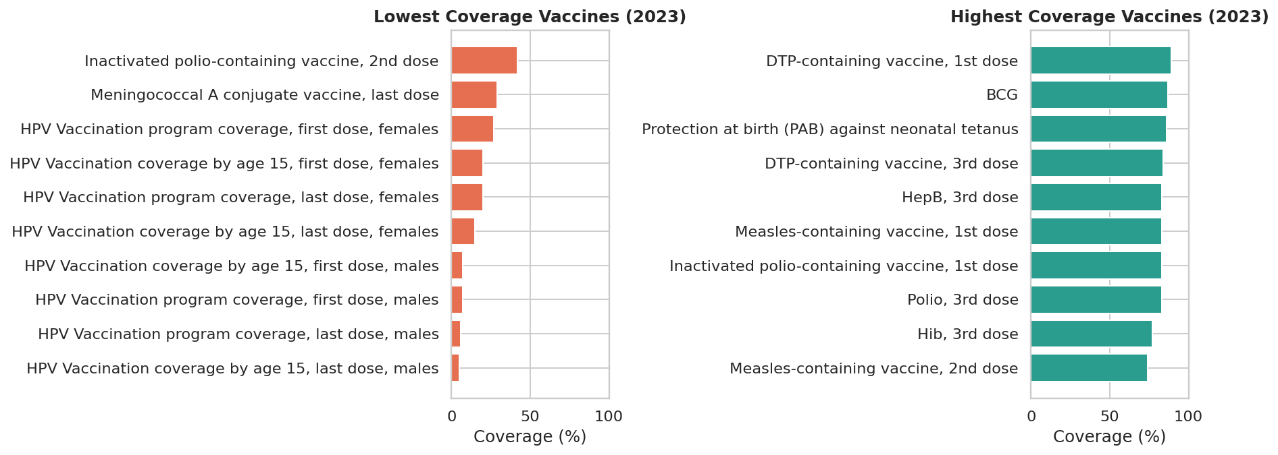
Figure — lowest and highest coverage vaccines, the basis for the Dashboard 1 gap-ranking visual.

Answers these brief questions
- What percentage of the target population has been covered by each vaccine?
- What are the gaps in coverage for vaccines targeting high-priority diseases (e.g., TB, Hepatitis B)?

Suggested DAX measures
Coverage % = DIVIDE(SUM(fact_coverage[Doses]), SUM(fact_coverage[Target_Number]))
Coverage vs Target Gap = [Coverage %] - 0.95

Dashboard 2: Coverage Trends & Dose Drop-off
Tracks programme performance over time: whether coverage is rising or falling, how many children are lost between dose 1 and dose 3, and whether booster (2nd-dose) uptake is improving.

Key visuals to build in Power BI
- Line chart: coverage trend by antigen, 2000–2023, with a COVID-19 shaded band (2020–2021)
- Area/band chart: DTP Dose-1 vs. Dose-3 coverage with the drop-off gap shaded
- Line chart: MCV1 vs. MCV2 coverage (booster uptake) over time
- Reference line at 95% (WHO target) on every trend chart

Illustrative preview (Python/EDA equivalent of the Power BI visual)
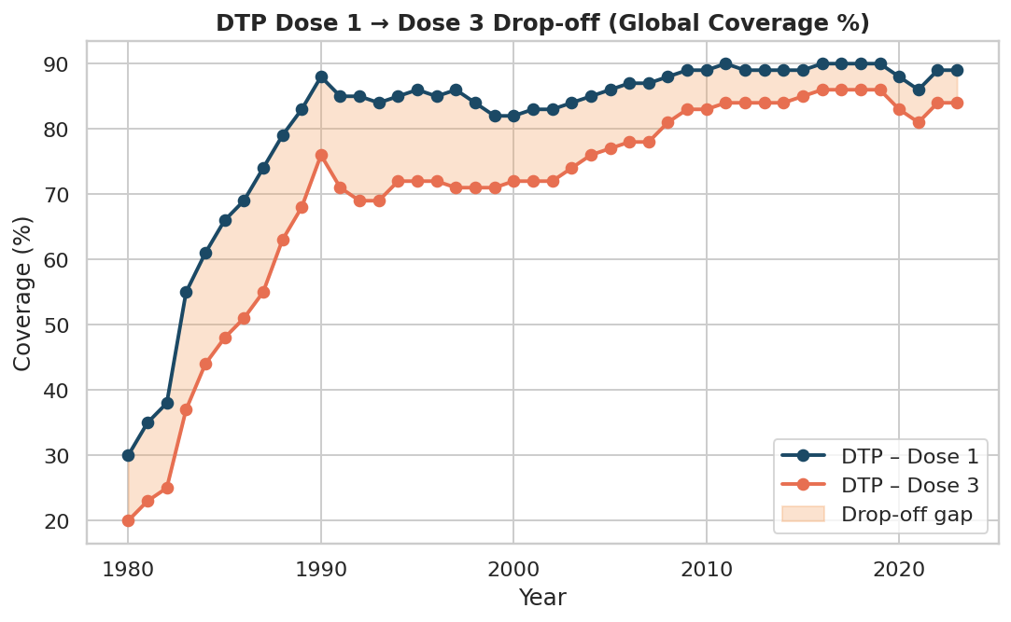
Figure — DTP1 → DTP3 drop-off band, the model for the Dashboard 2 drop-off visual.

Answers these brief questions
- What is the drop-off rate between 1st dose and subsequent doses?
- Has the rate of booster dose uptake increased over time?
- Evaluate effectiveness of a measles campaign launched five years ago (trend + before/after slicer).
- Track global progress toward 95% measles coverage by 2030.

Suggested DAX measures
Dose1-3 Drop-off = CALCULATE([Coverage %], fact_coverage[Antigen]="DTPCV1") - CALCULATE([Coverage %], fact_coverage[Antigen]="DTPCV3")
YoY Coverage Change = [Coverage %] - CALCULATE([Coverage %], DATEADD(dim_year[Year], -1, YEAR))

Dashboard 3: Regional Disparities (WHO Region Deep-Dive)
Ranks WHO regions and countries so resource allocation can target the weakest performers first, and separates 'has the vaccine been introduced' from 'is coverage actually sustained'.

Key visuals to build in Power BI
- Ranked bar chart: DTP3 (or selected antigen) coverage by WHO region, with a 95% target line
- Choropleth map: coverage or incidence by country (Power BI filled map / ArcGIS visual)
- Bar chart: vaccine introduction rate (%) by WHO region for a selected vaccine
- Matrix: country x antigen coverage heat-table, conditional formatting red-to-green

Illustrative preview (Python/EDA equivalent of the Power BI visual)
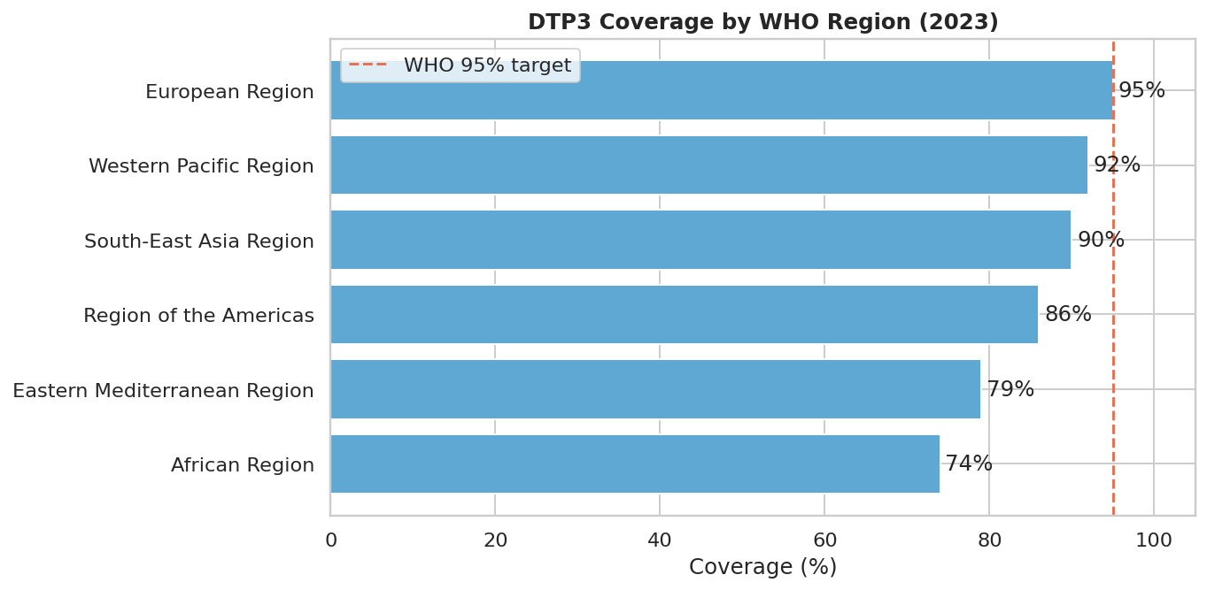
Figure — DTP3 coverage ranked by WHO region against the 95% target line.

Answers these brief questions
- Which regions have high disease incidence despite high vaccination rates?
- Are there specific regions or countries with low coverage despite high availability of vaccines?
- Are certain diseases more prevalent in specific geographic areas?
- Are there significant disparities in vaccine introduction timelines across WHO regions?
- Government agency identifying low-coverage regions for resource allocation.

Suggested DAX measures
Region Rank = RANKX(ALL(dim_country[WHO_Region]), [Coverage %], , ASC)
Below Target Flag = IF([Coverage %] < 0.95, "Below Target", "On Target")

Dashboard 4: Coverage vs. Disease Incidence (Effectiveness & Outbreak Risk)
The analytical core of the dashboard suite: shows whether higher coverage is actually reducing disease, and flags the specific outlier countries where high coverage did not prevent outbreaks.

Key visuals to build in Power BI
- Scatter chart: Coverage % (x-axis) vs. Incidence Rate (y-axis, log scale), one dot per country-year, colored by WHO region, with a trend line
- Line chart: global reported cases over time by disease (log scale)
- Table/alert visual: countries with ≥90% coverage AND incidence above a defined outbreak threshold (conditional formatting flag)
- Correlation matrix (Power BI key-influencers or a matrix visual using a pre-computed correlation table)

Illustrative preview (Python/EDA equivalent of the Power BI visual)
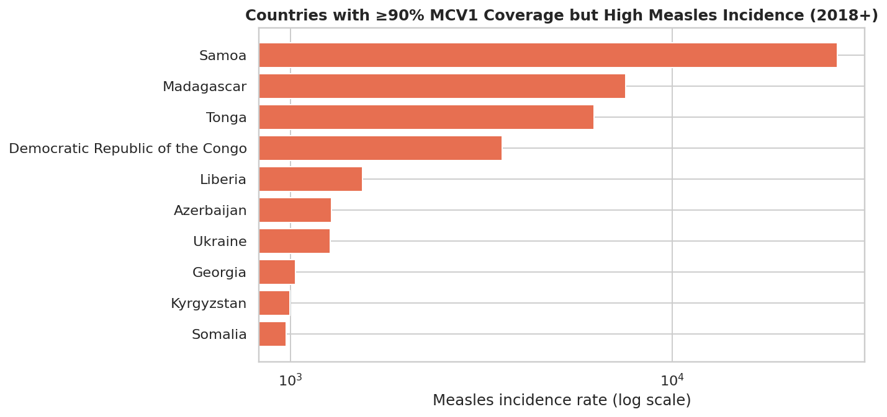
Figure — countries with ≥90% MCV1 coverage that still show high measles incidence; the model for the Dashboard 4 outbreak-risk alert table.

Answers these brief questions
- How do vaccination rates correlate with a decrease in disease incidence?
- What is the trend in disease cases before and after vaccination campaigns?
- Which diseases have shown the most significant reduction in cases due to vaccination?
- How does vaccine coverage correlate with disease reduction for specific antigens?
- Explore polio incidence in populations with no vaccination coverage.

Suggested DAX measures
Outbreak Risk Flag = IF([Coverage %] >= 0.90 && [Incidence Rate] > 1, "High coverage / high incidence", "Normal")
Coverage-Incidence Correlation = COMBINEVALUES computed in Power Query / a pre-aggregated correlation table, since native DAX has no direct CORREL() equivalent

Dashboard 5: Vaccine Introduction & Schedule Explorer
Tracks which countries have adopted which vaccines, when, and what their dosing schedule looks like — supporting new-vaccine rollout planning and schedule-design questions.

Key visuals to build in Power BI
- Timeline/Gantt-style visual: vaccine introduction year by country (filterable by vaccine)
- Bar chart: % of countries introduced, by WHO region and by vaccine
- Table: schedule rounds, target population, and age administered by country and vaccine (2019–2023)
- Slicer: vaccine, WHO region, income group

Illustrative preview (Python/EDA equivalent of the Power BI visual)
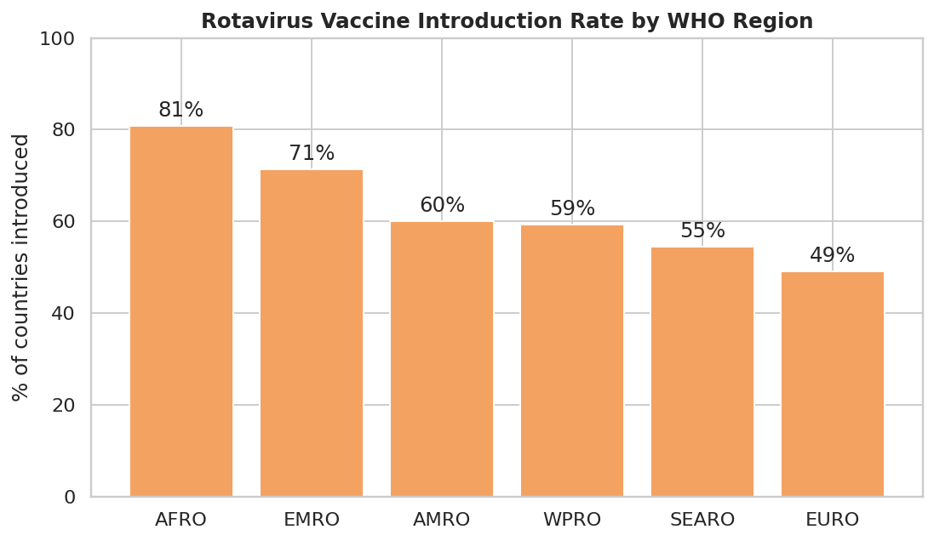
Figure — Rotavirus vaccine introduction rate by WHO region, the model for the Dashboard 5 introduction-rate visual.

Answers these brief questions
- Is there a correlation between vaccine introduction and a decrease in disease cases?
- Are there significant disparities in vaccine introduction timelines across WHO regions?
- How does the vaccination schedule (e.g., booster doses) impact target population coverage?

Suggested DAX measures
Introduction Rate = DIVIDE(CALCULATE(DISTINCTCOUNT(fact_vaccine_intro[Country]), fact_vaccine_intro[Introduced]="Yes"), DISTINCTCOUNT(fact_vaccine_intro[Country]))

4. Full Question-to-Dashboard Mapping
Every question listed in the project brief (Easy, Medium, and Scenario-based) is mapped below to its status and the dashboard or KPI that answers it. 'Not available' means no field in any of the five source tables supports that question — these should be raised with the data owner as a scope gap rather than approximated.
Level | Question (as assigned in the brief) | Status | Dashboard / Note
Easy | How do vaccination rates correlate with a decrease in disease incidence? | Answered | Dashboard 4 – Coverage vs Incidence
Easy | What is the drop-off rate between 1st dose and subsequent doses? | Answered | Dashboard 2 – Coverage Trends & Drop-off
Easy | Are vaccination rates different between genders? | Not available | No gender field in any source table
Easy | How does education level impact vaccination rates? | Not available | No education field in any source table
Easy | What is the urban vs. rural vaccination rate difference? | Not available | No urban/rural field in any source table
Easy | Has the rate of booster dose uptake increased over time? | Answered | Dashboard 2 – Coverage Trends & Drop-off
Easy | Is there a seasonal pattern in vaccination uptake? | Not available | Data is annual only; no month/date field
Easy | How does population density relate to vaccination coverage? | Not available | No population-density field in any source table
Easy | Which regions have high disease incidence despite high vaccination rates? | Answered | Dashboard 4 – Coverage vs Incidence
Medium | Is there a correlation between vaccine introduction and a decrease in disease cases? | Answered | Dashboard 5 – Vaccine Introduction & Schedule
Medium | What is the trend in disease cases before and after vaccination campaigns? | Answered | Dashboard 4 – Coverage vs Incidence
Medium | Which diseases have shown the most significant reduction in cases due to vaccination? | Answered | Dashboard 4 – Coverage vs Incidence
Medium | What percentage of the target population has been covered by each vaccine? | Answered | Dashboard 1 – Global KPI Overview
Medium | How does the vaccination schedule (e.g., booster doses) impact target population coverage? | Partially answered | Dashboard 5 – Vaccine Introduction & Schedule (schedule data only covers 2019-2023)
Medium | Are there significant disparities in vaccine introduction timelines across WHO regions? | Answered | Dashboard 5 – Vaccine Introduction & Schedule
Medium | How does vaccine coverage correlate with disease reduction for specific antigens? | Answered | Dashboard 4 – Coverage vs Incidence
Medium | Are there specific regions or countries with low coverage despite high availability of vaccines? | Answered | Dashboard 3 – Regional Disparities
Medium | What are the gaps in coverage for vaccines targeting high-priority diseases (e.g., TB, Hepatitis B)? | Answered | Dashboard 1 – Global KPI Overview
Medium | Are certain diseases more prevalent in specific geographic areas? | Answered | Dashboard 3 – Regional Disparities
Scenario | Government agency identifying low-coverage regions for resource allocation. | Answered | Dashboard 3 – Regional Disparities
Scenario | Evaluate effectiveness of a measles campaign launched five years ago. | Answered | Dashboard 2 & Dashboard 4 (trend + incidence overlay)
Scenario | Estimate vaccine demand for a disease in the upcoming year. | Partially answered | Dashboard 1 target-population coverage trend; true forecasting needs a modelling layer beyond EDA
Scenario | Ramp up vaccination during a sudden influenza outbreak. | Partially answered | Influenza antigen coverage is trackable on Dashboard 1; outbreak response needs real-time case data not present here
Scenario | Explore polio incidence in populations with no vaccination coverage. | Answered | Dashboard 4 – Coverage vs Incidence (POL3 vs Polio filter)
Scenario | Track global progress toward 95% measles coverage by 2030. | Answered | Dashboard 2 / Dashboard 3 (95% reference line)
Scenario | Allocate vaccines to high-risk groups (children under five, elderly). | Partially answered | Age-group antigens (e.g., Influenza elderly) exist; no population-count breakdown by age
Scenario | Detect disparities across socioeconomic groups within a country. | Not available | No socioeconomic / income field in any source table
Scenario | Determine how vaccination rates vary throughout the year. | Not available | Data is annual only; no month/date field
Scenario | Compare door-to-door vs. centralized vaccination strategy effectiveness. | Not available | No delivery-strategy field in any source table

5. Data Limitations
- No demographic breakdown fields exist in any of the five tables: gender, education level, income/socioeconomic group, or urban/rural classification are all absent.
- No population-density field exists at the country or sub-national level.
- All data is annual; there is no month/date field, so seasonal or within-year patterns cannot be analyzed.
- The vaccine-schedule table only covers 2019–2023, so long-run schedule-change analysis is not possible with this table alone.
- Incidence rates use different denominators across diseases (e.g., per 1,000,000 population vs. per 10,000 live births) — cross-disease incidence comparisons must always state the denominator, never compare raw numbers directly.
- Coverage values reported at country level are national averages; they can mask sub-national pockets of low coverage, which likely explains several of the high-coverage/high-incidence outliers found in Dashboard 4.
Recommendation: if the client can supply a supplementary demographic or sub-national dataset, the Easy-level gender/education/urban-rural/population-density/seasonality questions can be revisited; until then, they should be presented to stakeholders as explicitly out of scope rather than inferred.

6. Next Steps
- Stand up the star-schema SQL database described in Section 2 and load the five cleaned tables (scripts in the accompanying Jupyter notebook).
- Connect Power BI to the SQL database and build the five dashboard pages using the visual and DAX specifications above.
- Set up a scheduled refresh so dashboards stay current as WHO/UNICEF publish updated annual data.
- Add row-level or page-level filters if the dashboard will be shared externally with country-specific stakeholders.
- Revisit the 'Not available' questions in Section 4 if a supplementary demographic dataset becomes available.

