 

# Placement Empowerment Program

***Cloud Computing and DevOps Centre***

Use Cloud Storage Create a storage bucket on your cloud platform and upload/download files. Configure access permissions for the bucket.

Name:Mahalakshmi N Department: IT



# Introduction

This Proof of Concept (PoC) demonstrates the use of **AWS S3 (Simple Storage Service)** to create a storage bucket, upload and download files, and configure access permissions for secure file sharing. AWS S3 is a highly scalable and durable cloud storage service that enables users to store large amounts of data with high availability and low latency. This PoC walks through the essential tasks of working with S3, providing hands-on experience for managing cloud storage.

# Overview

AWS S3 is a widely used cloud storage service offered by Amazon Web Services that allows users to store, manage, and retrieve data objects at scale. The storage structure is based on **buckets** where data is stored in the form of **objects**. This PoC focuses on creating an S3 bucket, uploading files to the bucket, downloading files, and configuring access controls to manage who can access the data stored in the bucket.

The process involves:

1. **Creating an S3 bucket**: A container that holds data objects.
2. **Uploading files**: Storing files (like documents, images, or any binary data) in the S3 bucket.
3. **Downloading files**: Retrieving data from the S3 bucket to local systems.
4. **Configuring access permissions**: Managing security through access policies, including making files publicly accessible or securing them for private access.

.

# Objectives

The primary objectives of this PoC are:

1. **Learn how to create and manage S3 storage buckets**: Understand how to set up a cloud storage solution.
2. **Upload and download files**: Get hands-on experience with managing data in the cloud by transferring files to and from S3.
3. **Configure access permissions**: Explore how to manage access to the S3 bucket, including setting public or private access levels to the data stored.
4. **Understand the key features of AWS S3**: Familiarize with the fundamental concepts of AWS S3, such as durability, scalability, and security.

# Importance

* 1. **Scalable Storage**: AWS S3 allows users to store large amounts of data without worrying about capacity limitations.
  2. **Cost-Effective**: With a pay-as-you-go pricing model, it’s affordable and only charges for the storage used.
  3. **High Durability**: S3 ensures 99.999999999% durability, making it ideal for backup and disaster recovery.
  4. **Security**: Provides strong access controls via IAM, bucket policies, and encryption to secure data.
  5. **Global Access**: Enables easy access to data from anywhere in the world, supporting remote work and global operations.

# Step-by-Step Overview

## Step 1:

1. Go to [AWS Management Console](https://aws.amazon.com/console/).
2. Enter your username and password to log in.

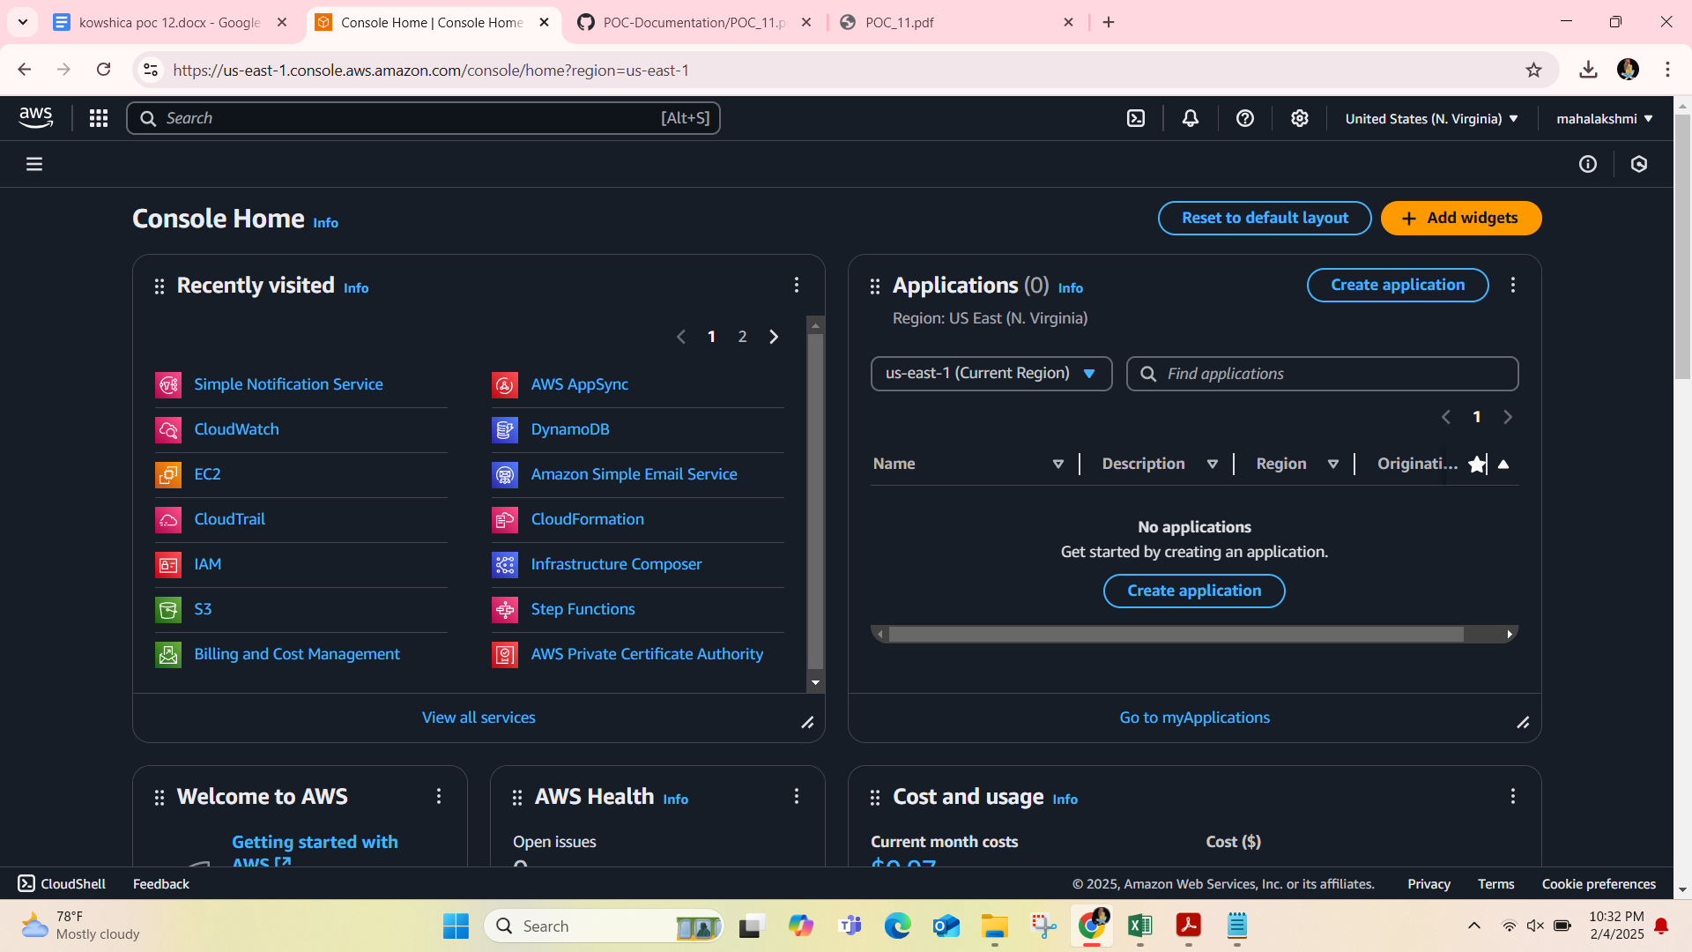

## Step 2:

In the top search bar, type **S3** and select it from the search results.

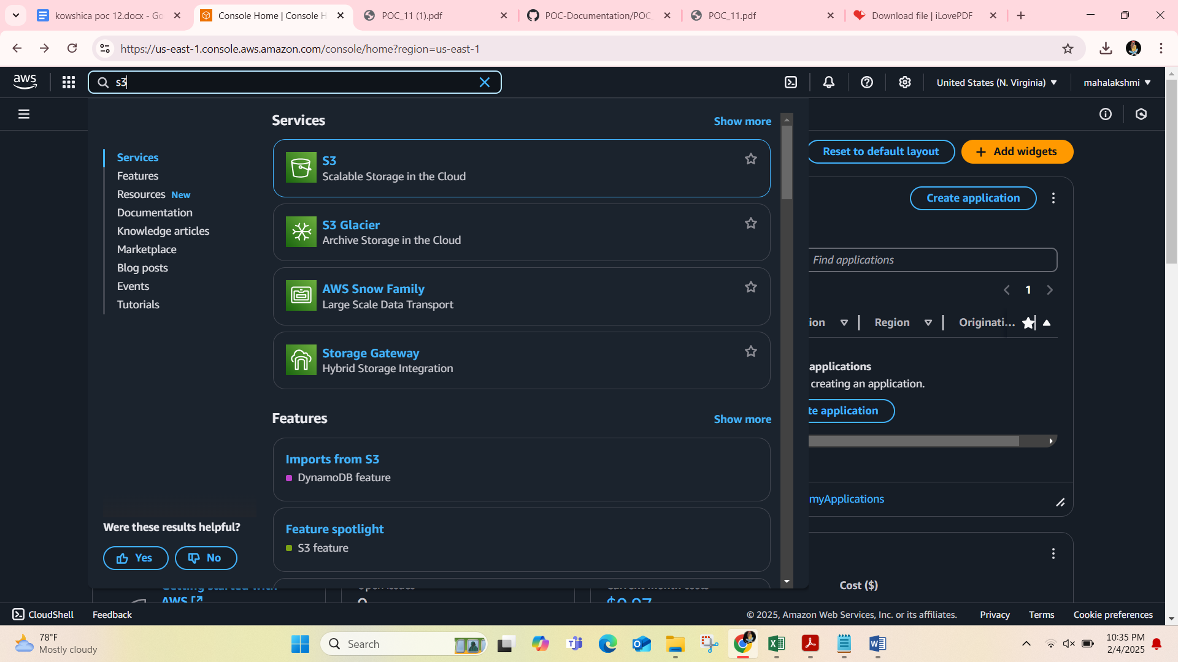

## Step 3:

Click **Create bucket**.

**Bucket name**: Enter a unique name (e.g.,saravana-s3-poc). Leave other settings as default (you can modify later).

## Step 4:

Select your bucket from the list and Click **Upload** → **Add files**.

Choose the file(s) you want to upload from your local machine and Click **Upload**.

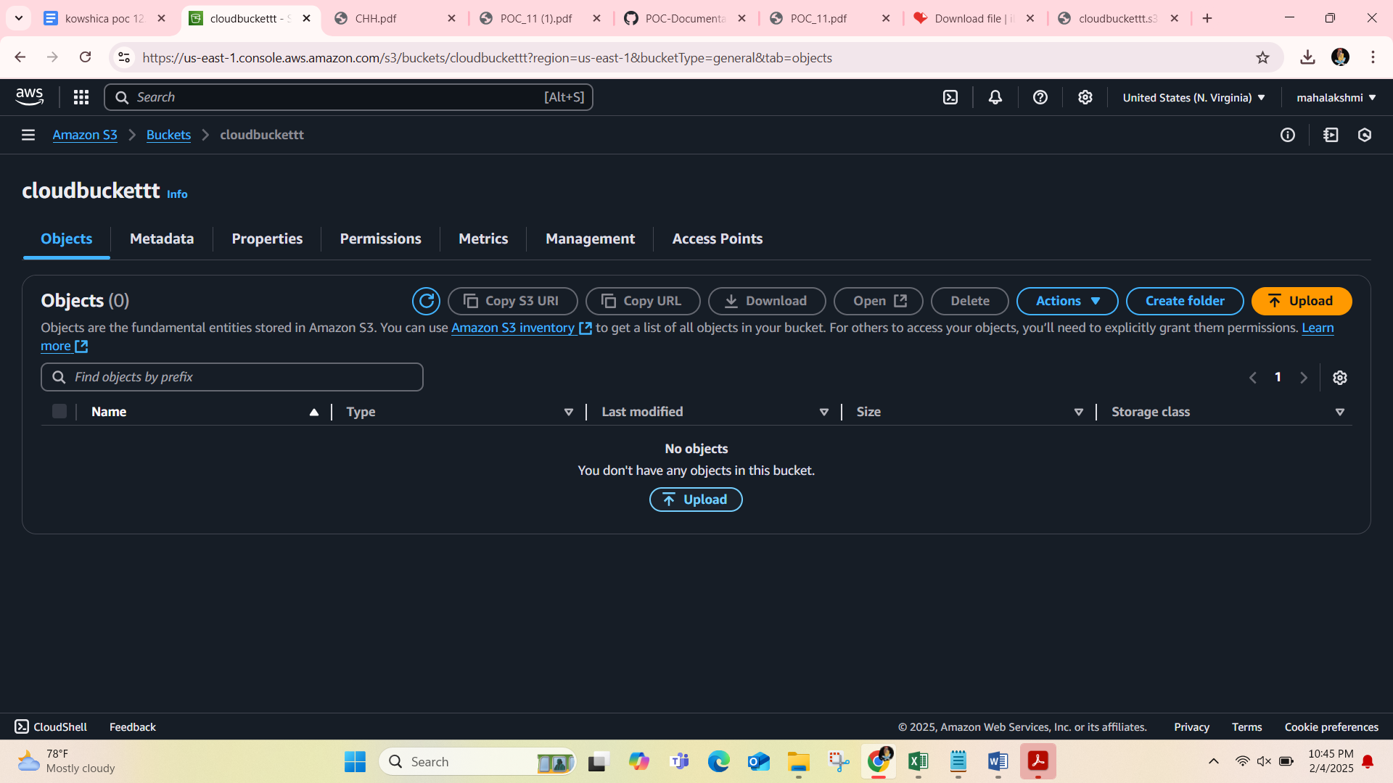

## Step 5:

Navigate to the uploaded file inside your bucket.

Select the file and click **Download** from the **Actions** menu (or click the file name to download directly).

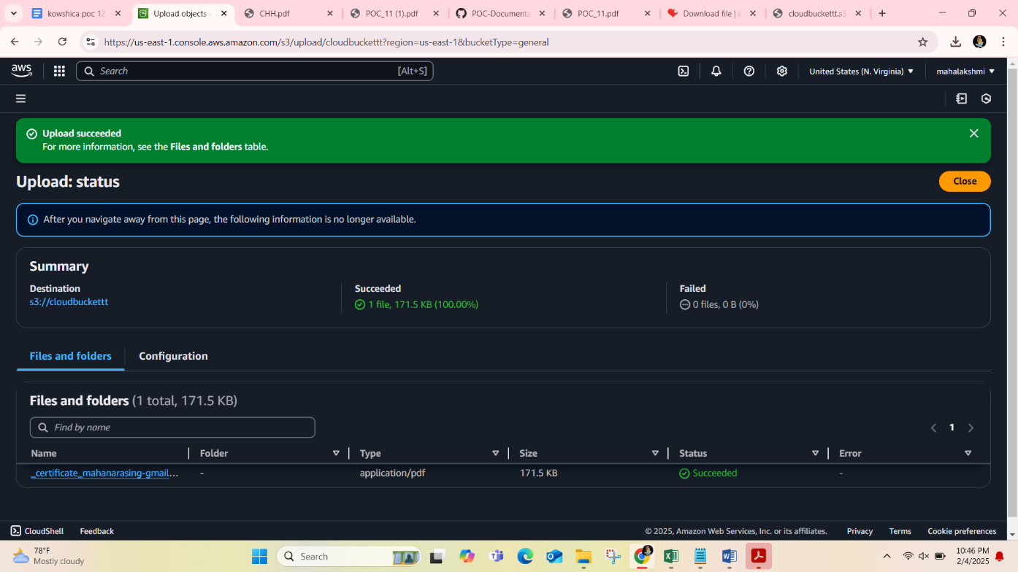

## Step 6:

Navigate to the uploaded file. Click the file name → Go to the **Permissions** tab. Under **Public access**, click **Edit** → Enable public access → Save changes.

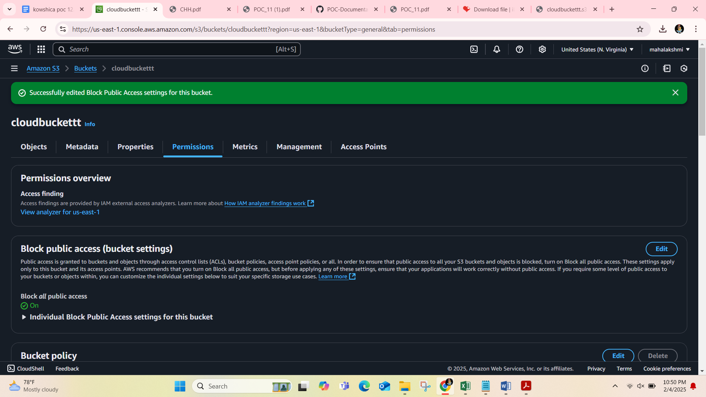

## Step 7:

Go to the **Permissions** tab of your bucket. Scroll down to **Bucket Policy** and click **Edit**.

Add the following example policy to make all files in the bucket publicly accessible:

Replace YOUR_BUCKET_NAME with your bucket name. Save the policy.

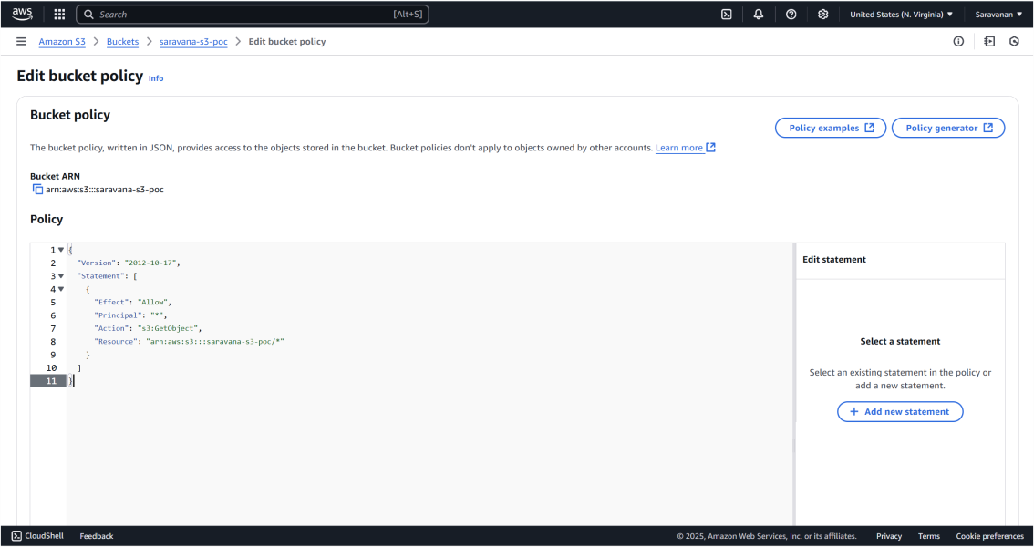

## Step 8:

Copy the Url in Copy URL option

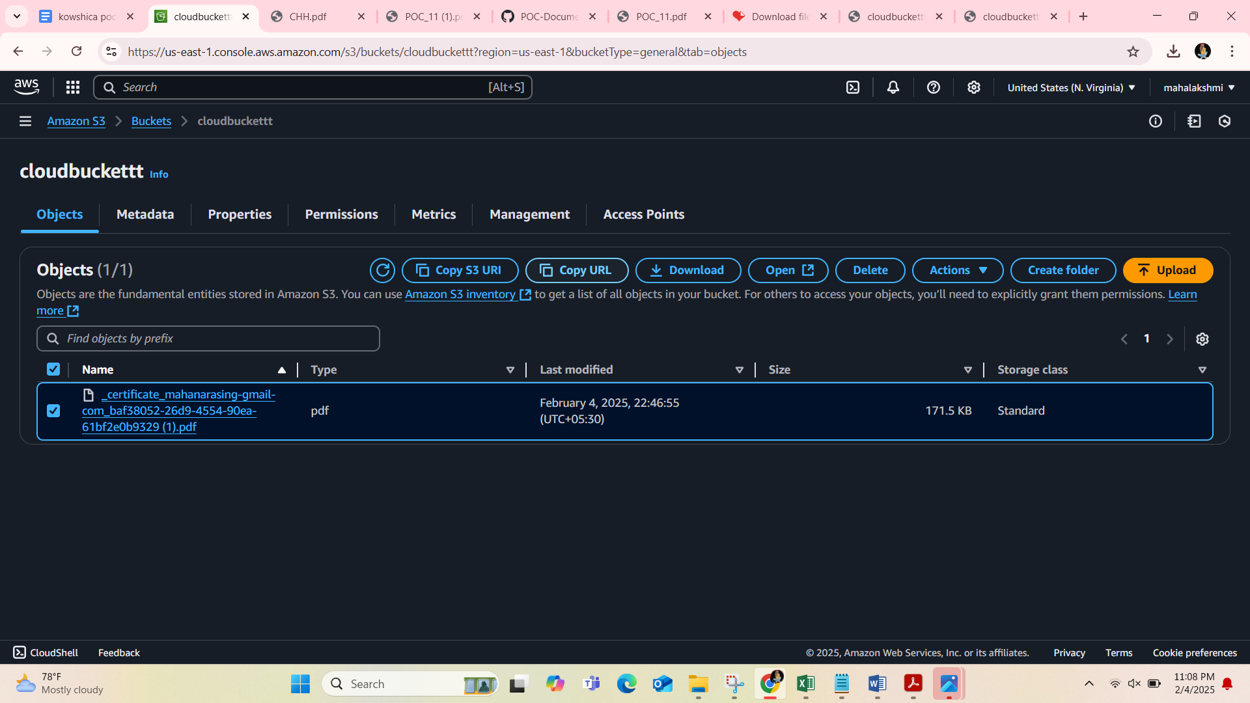

## Step 9:

Paste the link in the new tab and you can see the uploaded file.

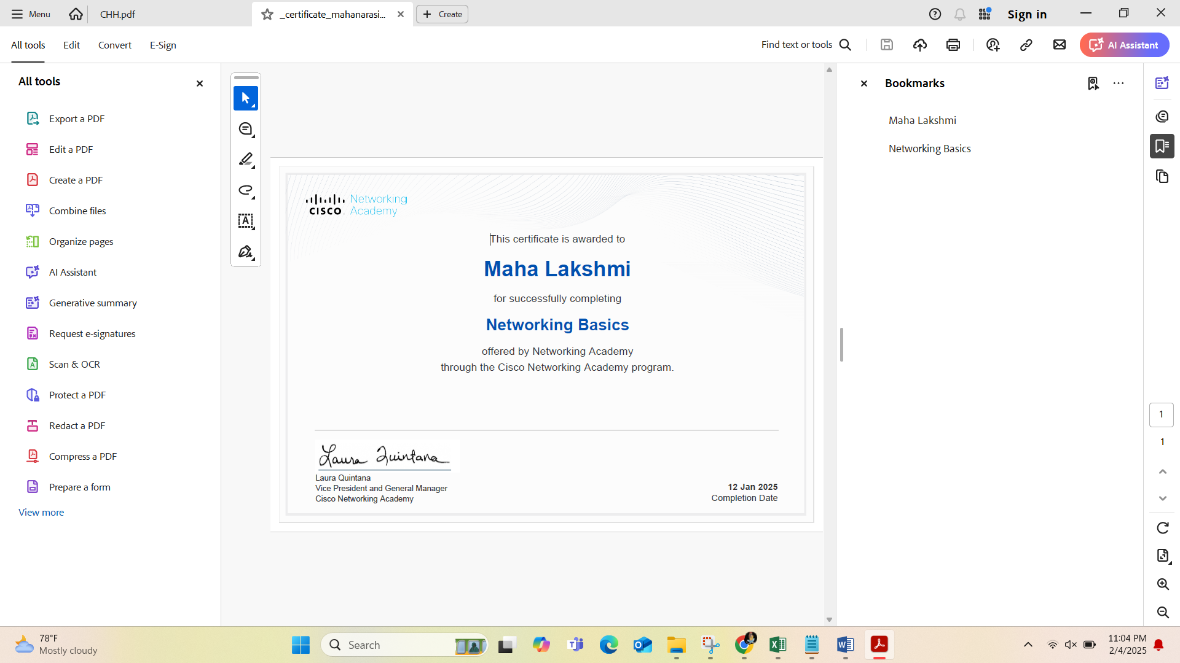

# Outcome

By completing this PoC of setting up an S3 bucket, uploading/downloading files, and configuring access permissions, you will:

1. **Create and Manage an S3 Bucket**: Learn how to set up an S3 bucket for storing and managing objects in the cloud.
2. **Upload and Download Files**: Gain hands-on experience in transferring files to and from the cloud securely and efficiently.
3. **Configure Access Permissions**: Understand how to apply bucket policies and permissions to control access to your data.
4. **Enhance Data Security**: Implement best practices for securing your data using AWS S3’s access controls and encryption options.
5. **Experience AWS S3 Features**: Explore key S3 capabilities such as scalability, durability, and accessibility for real-world applications.

This PoC will provide a solid foundation for working with AWS S3 and understanding its role in modern cloud architectures.