PHASE 8 — PROJECT DEMONSTRATION
INTRODUCTION :
Team ID : SWTID-2026-6232
Project : AI FitTrack — AI-Powered Fitness Tracking Backend API
Team members :
NAME | MAIL ID
John Joseph I | Jovinoooviyam@gmail.com
Kamala kannan V | K7965223@gmail.com
Kanniyappan S | 124csbkanniyappan@gmail.com
Kamesh M | Manidevi859@gmail.com
8.1 Purpose of the Demonstration
The final demonstration shows AI FitTrack working from server start-up through API requests and responses, using screen sharing and voice-over to explain the project name, purpose, benefits, execution process and final output.
8.2 Demo Video Flow
- Project Name — AI FitTrack: AI-powered workout tracking and fitness recommendation API.
- Technology — Node.js, Express.js, MongoDB/Mongoose, JWT, bcrypt and Google Gemini AI.
- Execution — start the backend and show the server running with MongoDB connected.
- Authentication — register, log in and show token generation and profile access.
- Workout & AI Workflow — add, view, update, delete workouts, then generate AI recommendation and insights.
8.3 Demonstration Procedure
Step | Action | What to Explain
1 | Start the backend server (npm start). | API runs on port 5000 and MongoDB is connected.
2 | Register a user and log in. | Account creation, password hashing and JWT token generation.
3 | Add and view workouts. | Workout fields; data saved per authenticated user.
4 | Update and delete a workout. | Modification of records and removal confirmation.
5 | Generate AI workout recommendation. | Age, goal and experience input; personalized plan output.
6 | Generate AI fitness insights. | Workout statistics input; insight output.
7 | Show final responses. | Working APIs, security, database and AI capabilities.
8.4 Actual API Demonstration Screenshots
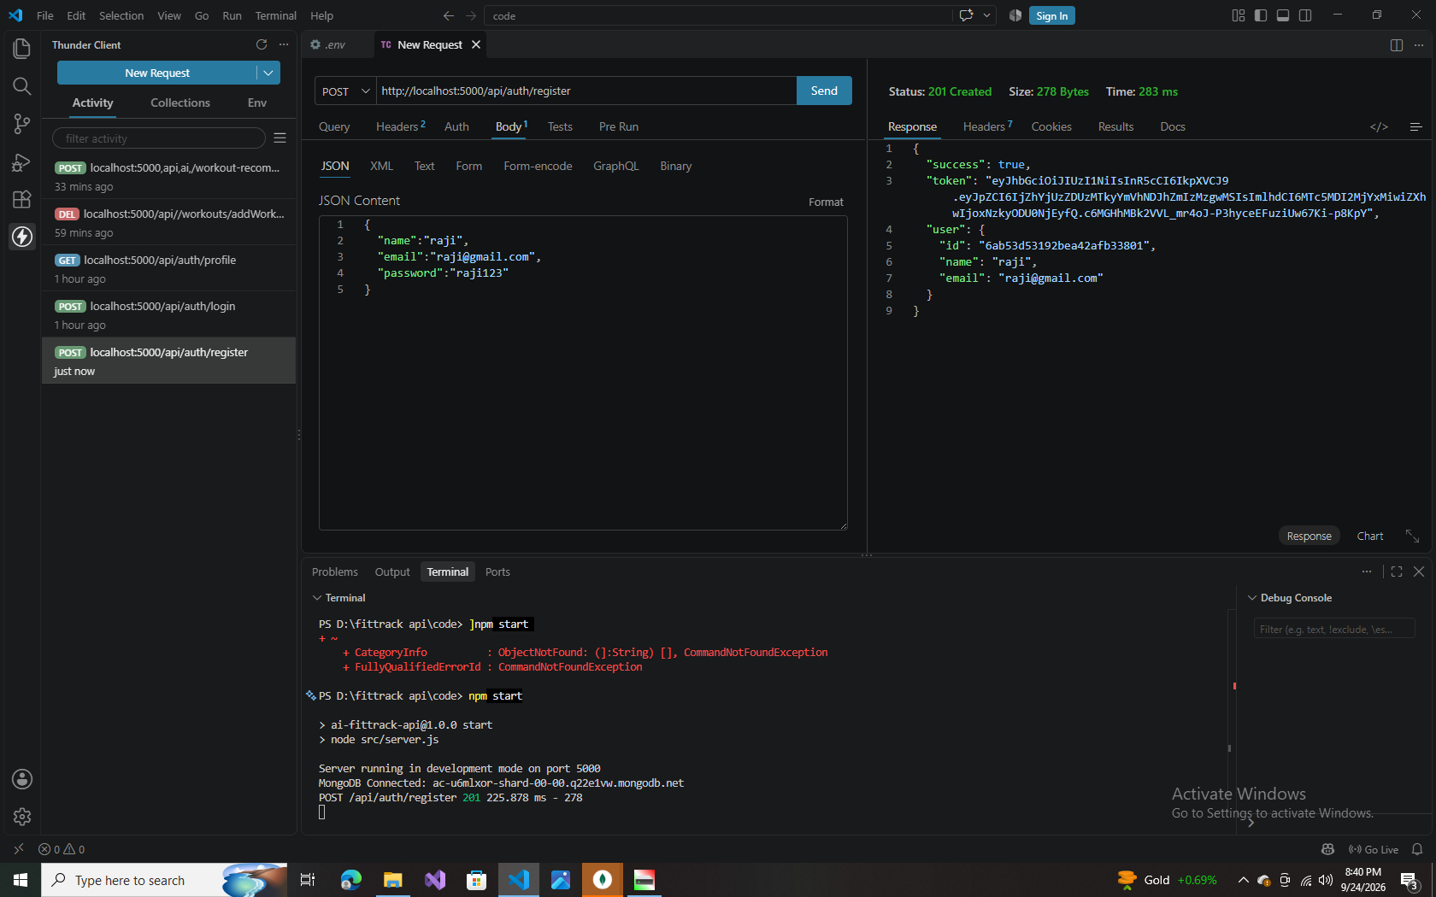  Fig 8.1 — Register API | 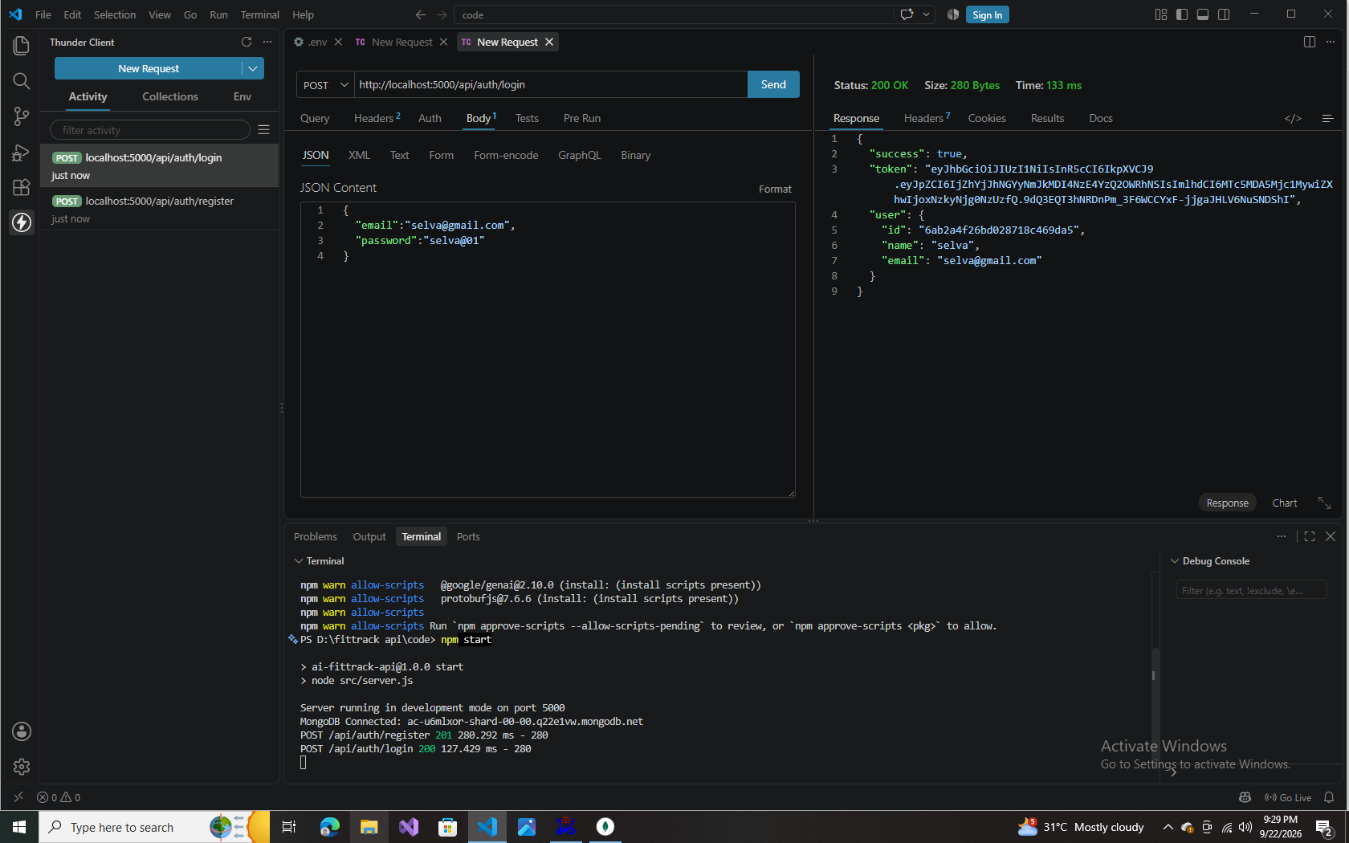  Fig 8.2 — Login API | 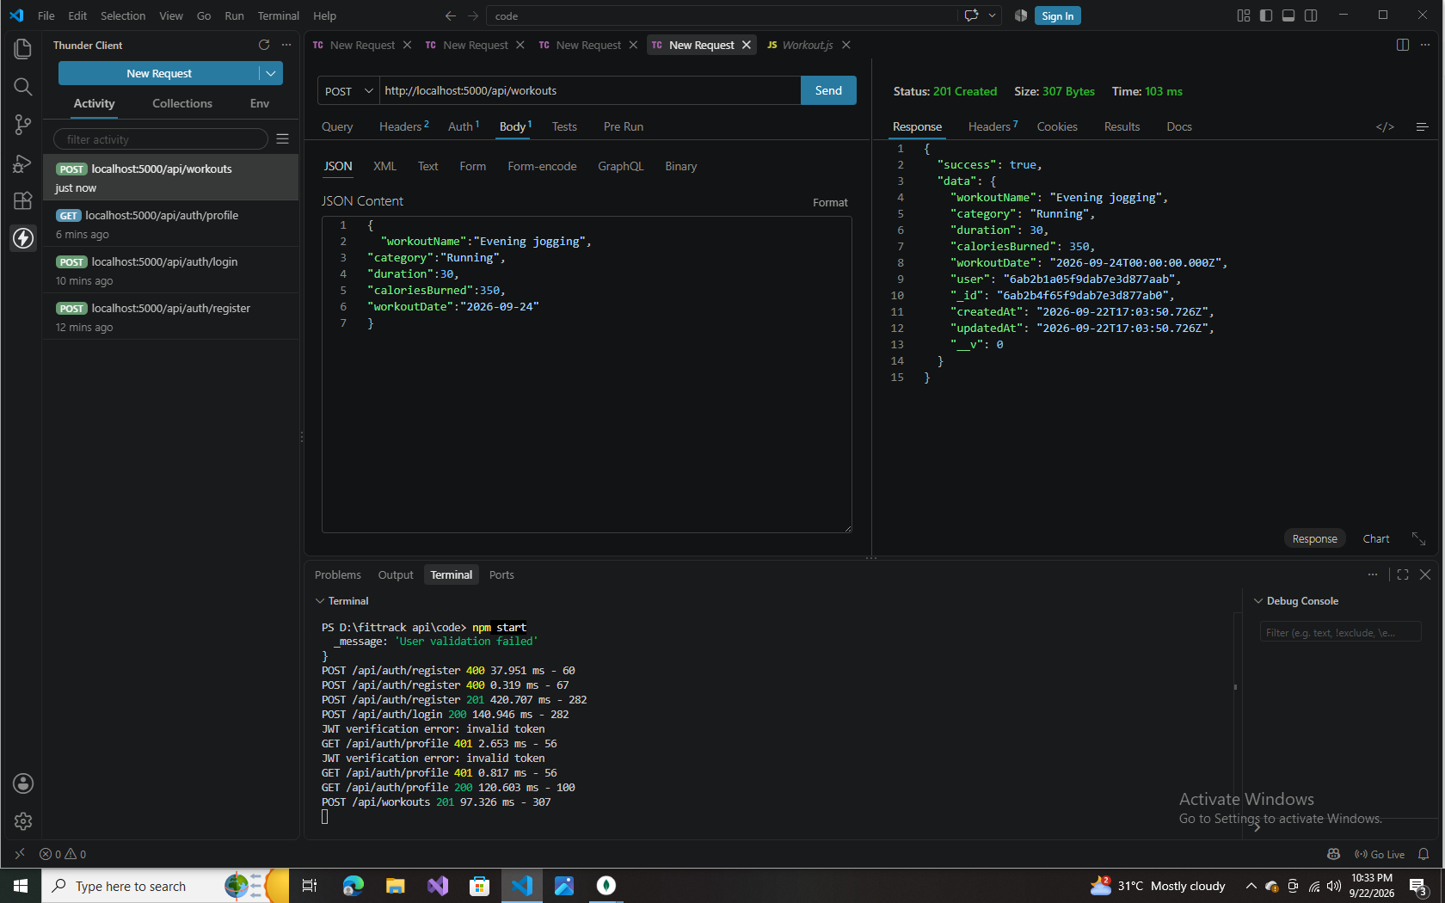  Fig 8.3 — Add Workout
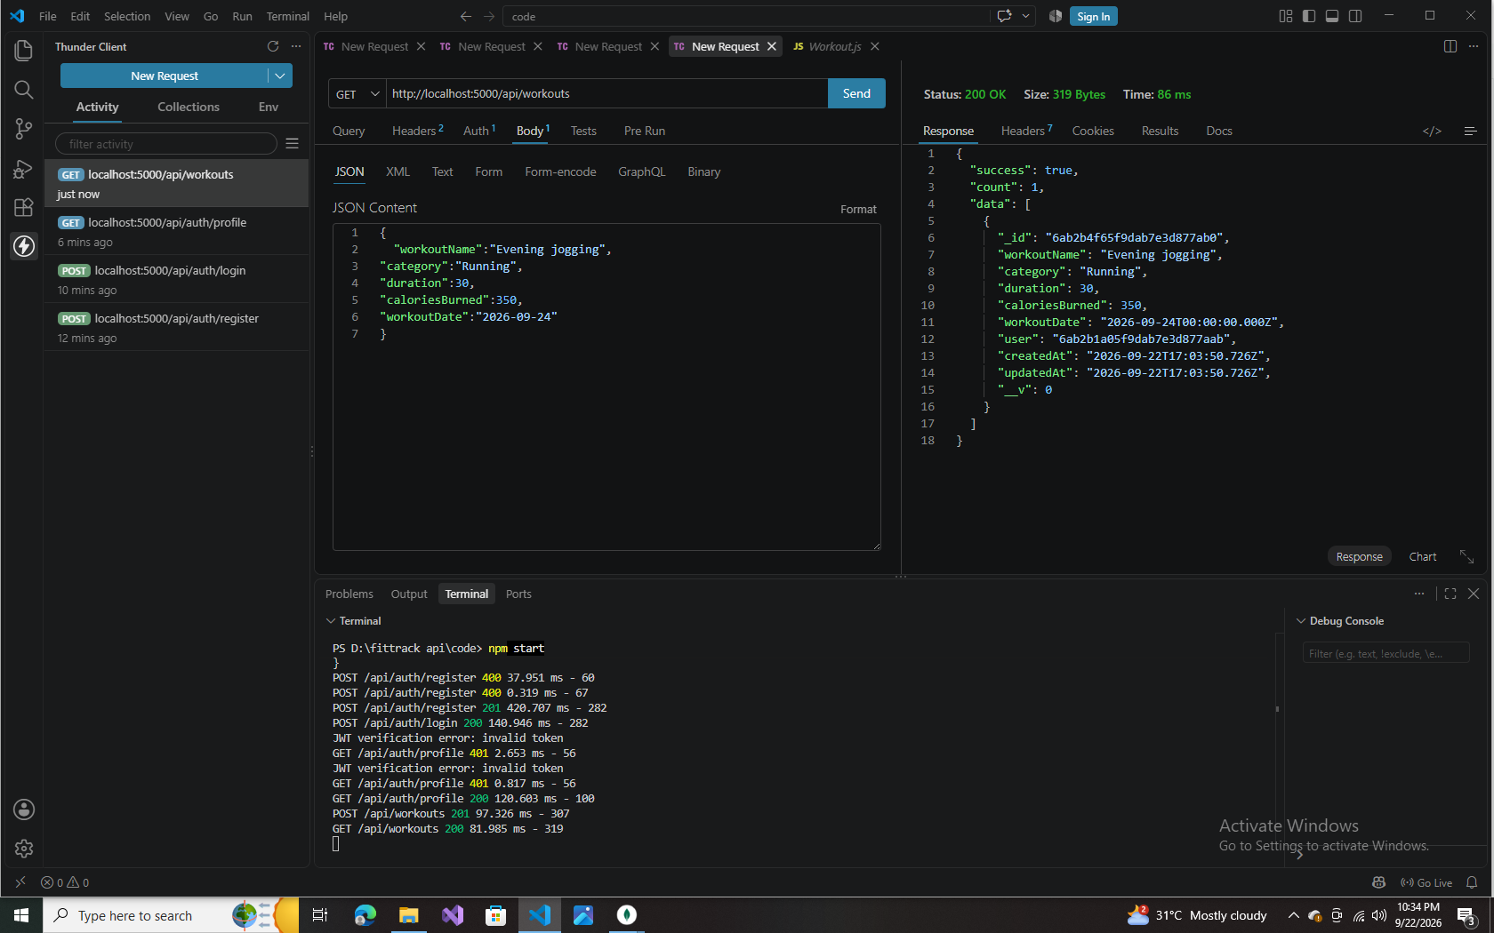  Fig 8.4 — Get All Workouts | 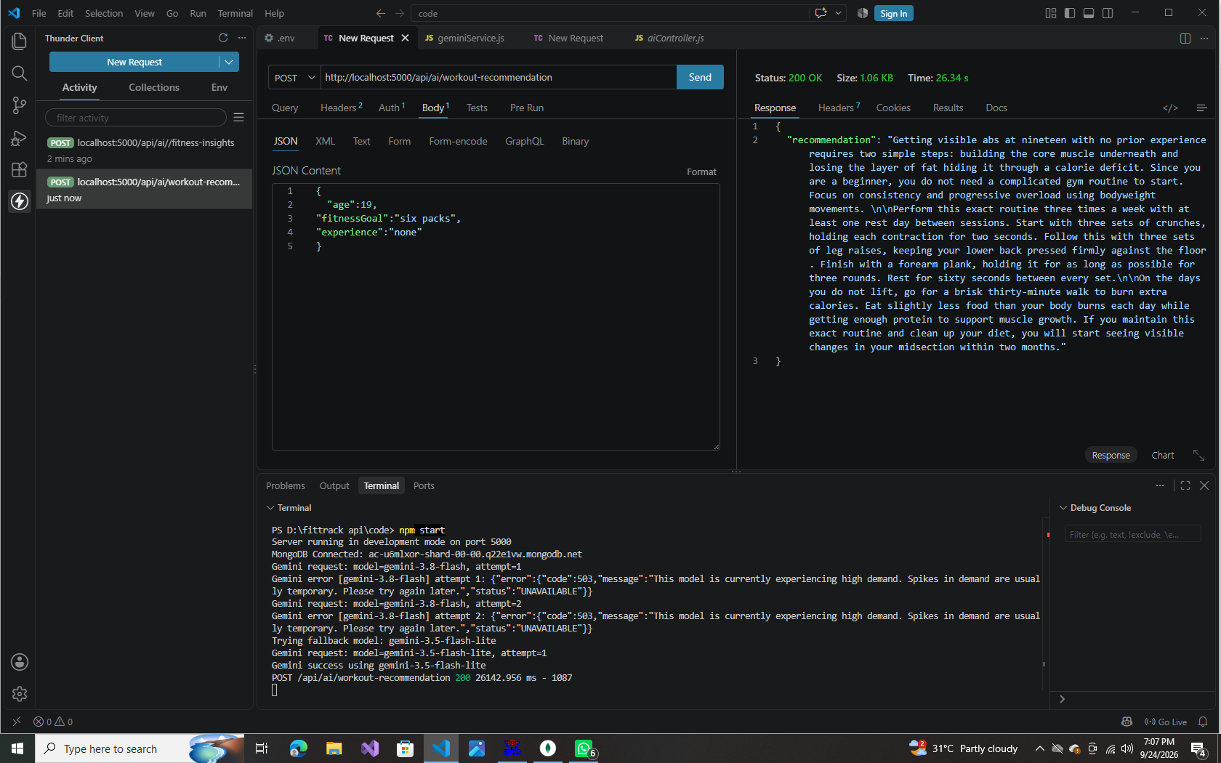  Fig 8.5 — AI Recommendation | 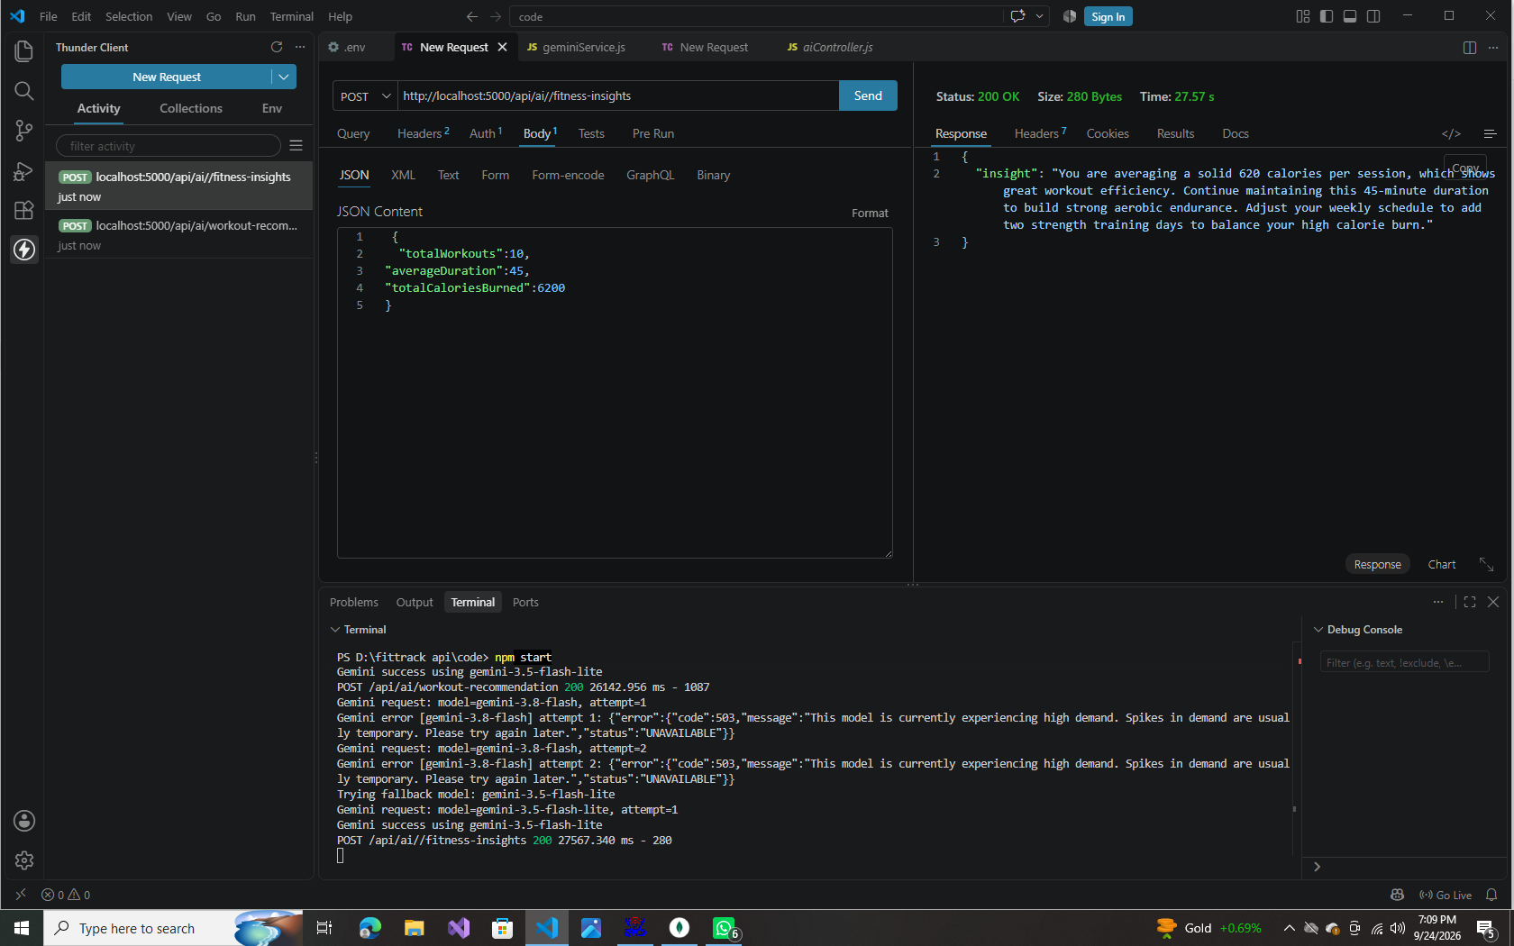  Fig 8.6 — AI Fitness Insights
Demo video link: [to be added]

