|  |
| --- |
| String Matching  Interface |
| Submitted By: SUMAHA SHAH| SANA MARYAM |

Submitted To: Dr. KHALID SALEEM

**Contents**

* + 1. Software System Requirements 2
    2. Introduction 2
    3. Product Overview 2
    4. Specification Requirements 2
    5. External Interface Requirements 2
    6. Software Product Features 2

1.3.0. Software System Attributes 3

1.4.0 Scope 3

* + 1. Input/Output 3
    2. Functionality 3

2.0.0. Use Cases 3

* + 1. List of Use Cases 3
    2. Use Case Diagram 5

3.0.0. Domain Model 6

4.0.0. System Sequence Diagrams 7

5.0.0. Class Diagram 8

# 1.0.0. Software System Requirements

## Introduction

“String matching interface” system is to facilitate the user who has entered the strings and wants to check the similarity between them and to store the result.

### Product Overview

We will design an Android based application, which will get the strings from the user and store the result of similarity between the entered strings and a proper notification will show if a user enters a wrong input.

## Specification Requirements

* + 1. External Interface Requirements
       - User Interfaces

User interface consists of different screens with navigation and hints, in order to enable users, go back and forth with ease of access.

* + - * Hardware Interfaces

Application operates on a handheld device, on which input is taken by finger tap.

* + - * Software Interfaces

Software interface is given by Android OS.

* + - * Communication Protocols

LAN with wireless routers will be used for communication protocols.

* + 1. **Software Product Features:**
       1. **Login and Logout:** All type of users will be able to login with their assigned login ID’s and passwords and hence no unauthorized user could login.
       2. **Get similarity result:** It will facilitate the users to enter the strings and get the percentage of similarity result.
       3. **Save result**: It will store the result of matching similarity.

## Software System Attributes

### Reliability

System will be responsive and accessible 90-95 % of the times without any error or

delay.

* + - * Availability
        + System will be available 24/7 with internet availability. With 5-10% of failure rate but will be working 90-95% of the times.
      * Security
        + If an unauthorized user tries to log in, access will be denied, an error message will be displayed on the screen. Only Admin can perform modifications, and if any other user tries to update then an error message will be displayed. It will be end-to-end encrypted.
      * Maintainability
        + If System goes down or does not provide service, then the problem will be solved within 24 hours.
      * Performance
        + System will perform all actions in under 5-10 seconds.

## 1.4.0 Scope

### Input/output:

### User will enter the strings for which he wants to check the similarity(Input)and system will store the result(output).

### Functionality:

The scope of this system is to facilitate any other person who is interested checking the similarity between the strings and the results will be stored and system will tell the percentage of similarity between the strings.

**2.0.0. Use Case:**

## List of Use Cases:

List of use cases is as follows:

* Login
* Getting similarity result
* Storing result
* Logout

## Use Case Diagram:

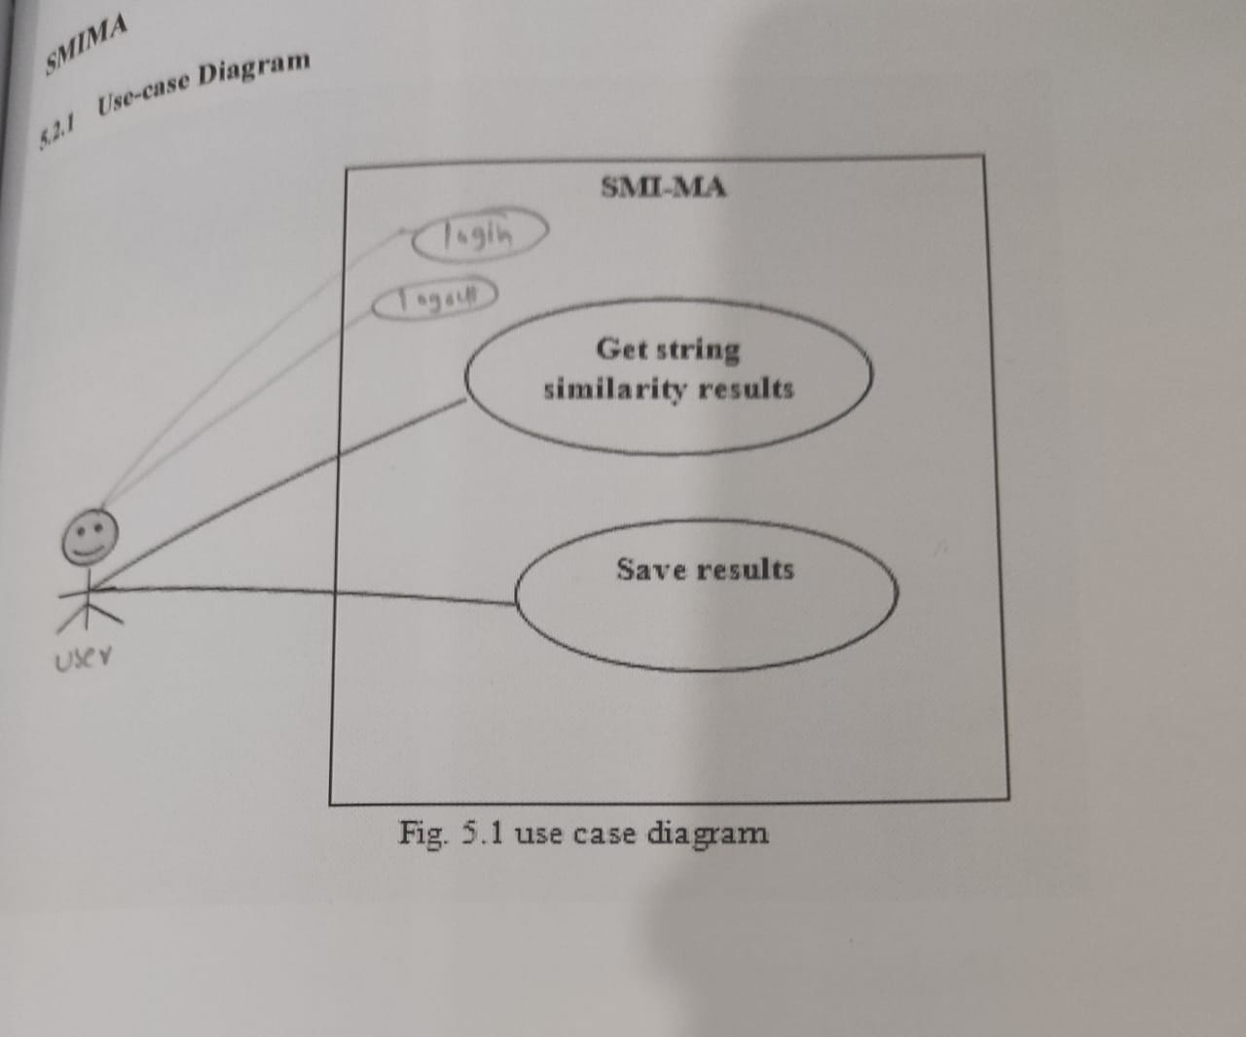

# 3.0.0. Domain Model:

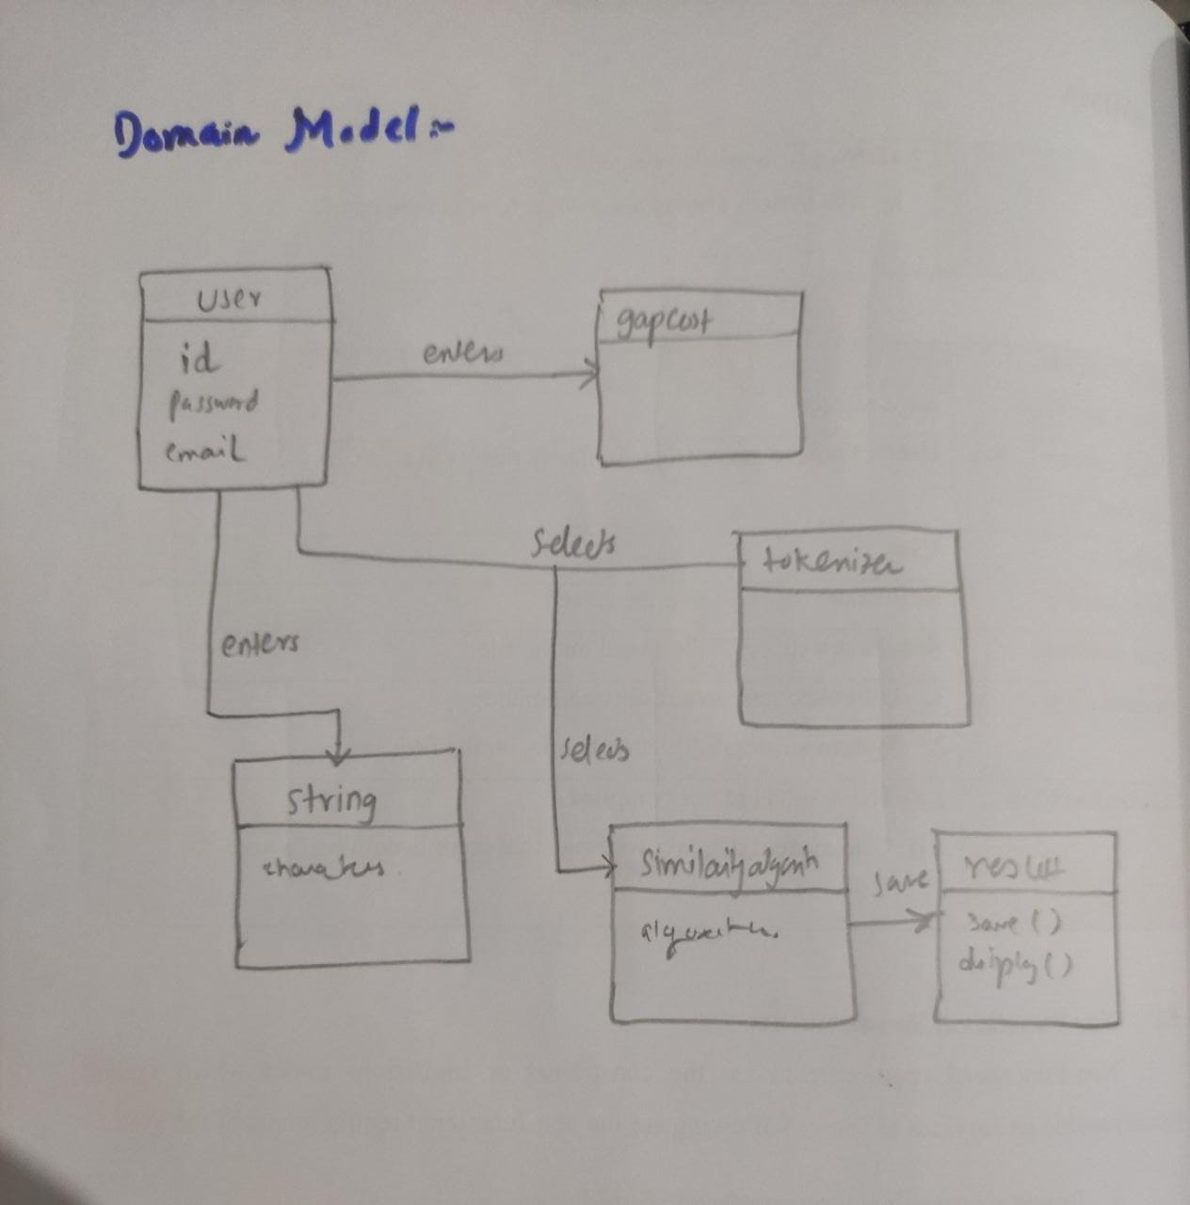

# 4.0.0. System Sequence Diagrams:

* + 1. **Login:**

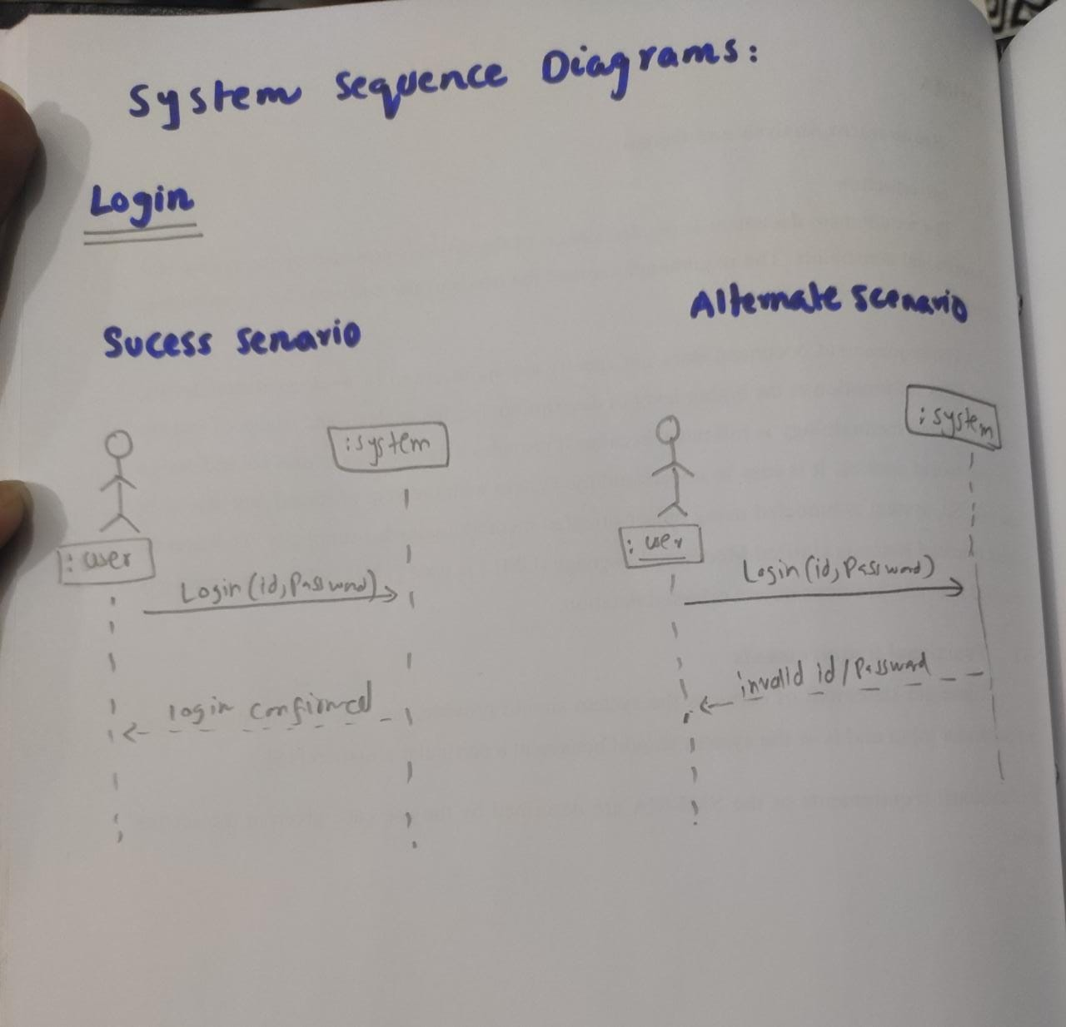

* + 1. **Get Similarity Result:**

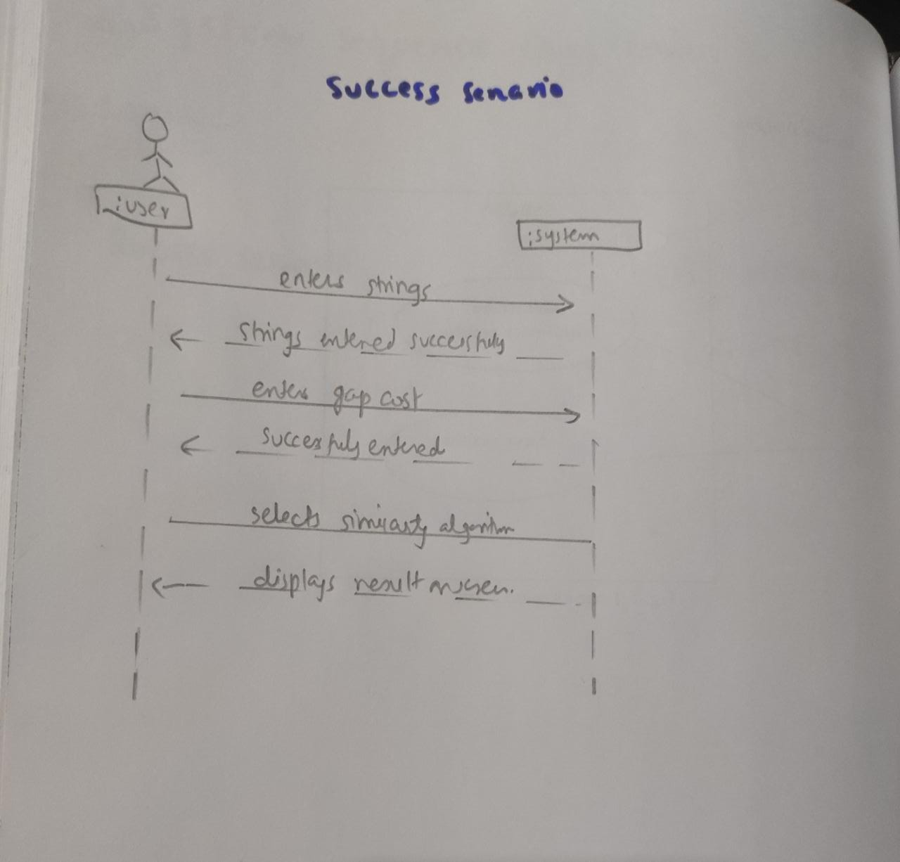

**Save Result:**

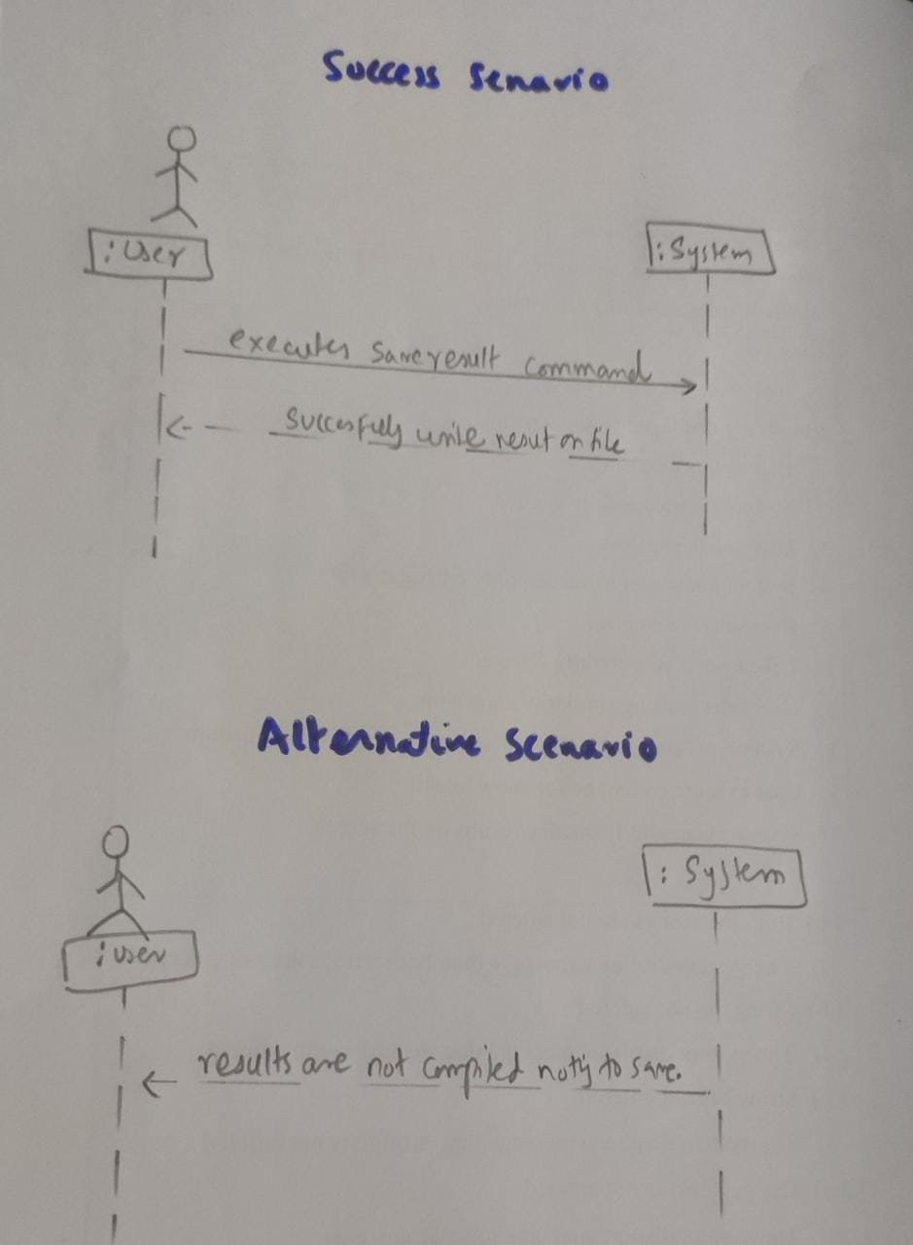

**USE CASES DETAILS:**

* + 1. **USECASE 1:**

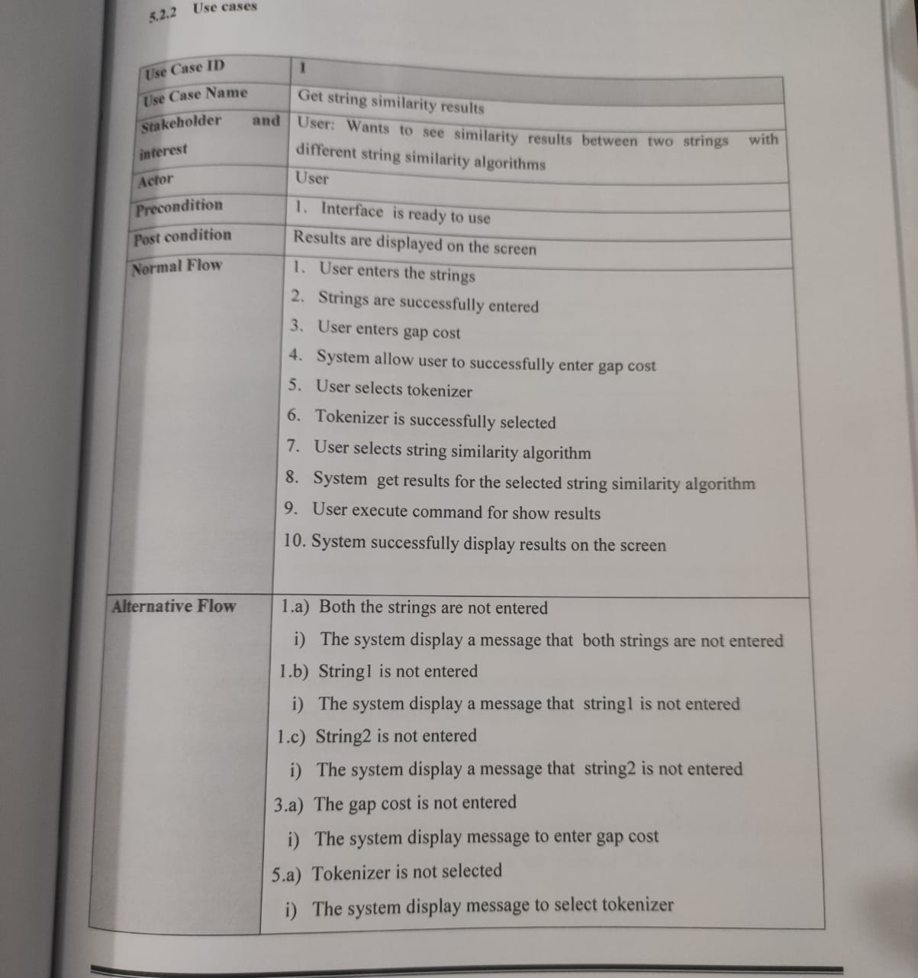

**USECASE 2:**

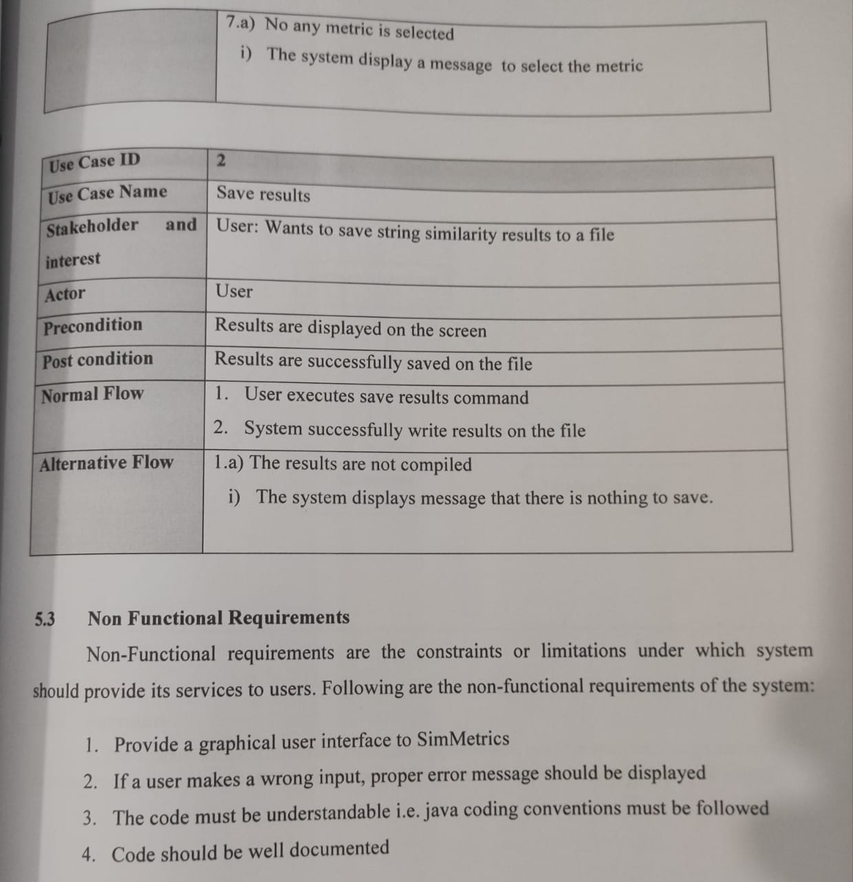

**SYSTEM DESIGN:**

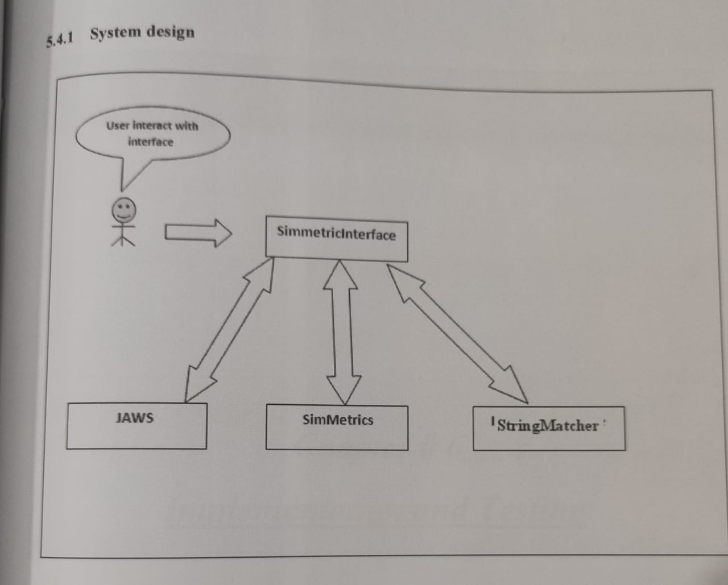

# 5.0.0. Class Diagram:

