

PROJECT TITLE
Air Quality vs Health Symptoms Analyzer
Submitted By
Maha Arshad (B-29350)
Fatima Azam (B-29071)

Submitted To
Ma’am Andleeb Akram
Department of Computer Science
University of South Asia
© University of South Asia. Fall 2026

Abstract .................................................................................... 3
Introduction ............................................................................. 4
Problem Statement .................................................................. 5
Objectives ................................................................................ 6
Literature Review ................................................................... 7
Dataset Description ................................................................ 9
Attribute Details & Ranges .................................................. 10
Data Pre-processing & Cleaning ........................................... 11
Exploratory Data Analysis (EDA) ........................................ 13
System Design & Methodology ............................................ 15
Tools & Technologies ........................................................... 17
Implementation ..................................................................... 18
Model Building ...................................................................... 20
Evaluation Metrics ............................................................... 22
Testing & Results .................................................................. 23
Real-World Applications / Solutions ................................... 25
Challenges & Limitations ..................................................... 26
Conclusion & Future Work .................................................. 27

1. Abstract
Air pollution has become a major environmental and public health concern worldwide. This project, Air Quality vs Health Symptoms Analyzer, aims to study the relationship between air pollution levels and common health symptoms such as cough, headache, and breathing issues.
Using a multi-city dataset, the project applies data analysis and machine learning techniques to identify patterns, correlations, and predictive insights. The results can help in early health risk detection and assist policymakers in improving environmental conditions.

2. Introduction
Air quality directly impacts human health. Pollutants such as PM2.5, PM10, CO, NO2, and O3 are known to cause respiratory and neurological issues.
With increasing urbanization, cities are facing higher pollution levels, making it essential to analyze how environmental factors influence human health.
This project integrates environmental data with health indicators to:
- Understand pollution trends
- Predict health risks
- Support smart city planninh

3. Problem Statement
Despite increasing pollution levels, there is limited accessible analysis linking air quality with real-time health symptoms.
Problem:
How can we analyze and predict the impact of air pollution on human health using data-driven techniques?

4. Objectives
- Analyze air pollution levels across multiple cities
- Identify correlation between AQI and health symptoms
- Build predictive models for health risk detection
- Visualize pollution trends and symptom patterns
- Provide actionable insights for public health awareness

5. Literature Overview (Optional)
Previous studies show:
- High PM2.5 levels are linked to respiratory diseases
- NO2 exposure causes lung irritation
- Long-term exposure leads to chronic illnesses
This project builds upon these findings using data science techniques.

6. Dataset Description
The dataset contains 300 records with daily observations from multiple cities.

Features include:
- Date-wise pollution data
- Multiple cities (diverse environments)
- Health symptom indicators

7. Attribute Details & Ranges
Attribute | Description | Range
date | Observation date | 2024
city | City name | Categorical
AQI | Air Quality Index | 50 – 300
PM2.5 | Fine particles | 20 – 200
PM10 | Coarse particles | 40 – 300
CO | Carbon Monoxide | 0.3 – 2.0
NO2 | Nitrogen Dioxide | 10 – 80
O3 | Ozone | 10 – 60
cough_symptom | Cough presence | 0 / 1
headache_symptom | Headache | 0 / 1
breathing_issue | Breathing difficulty | 0 / 1

8. Data Preprocessing & Cleaning
Steps performed:

Handling Missing Values
- Checked for null values
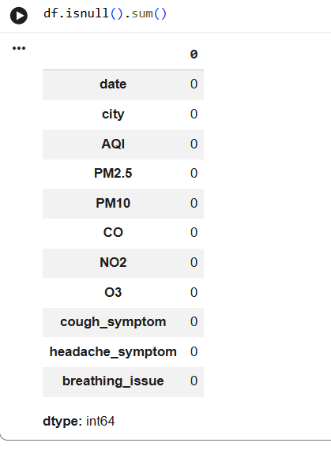
- Filled using mean/median or removed rows
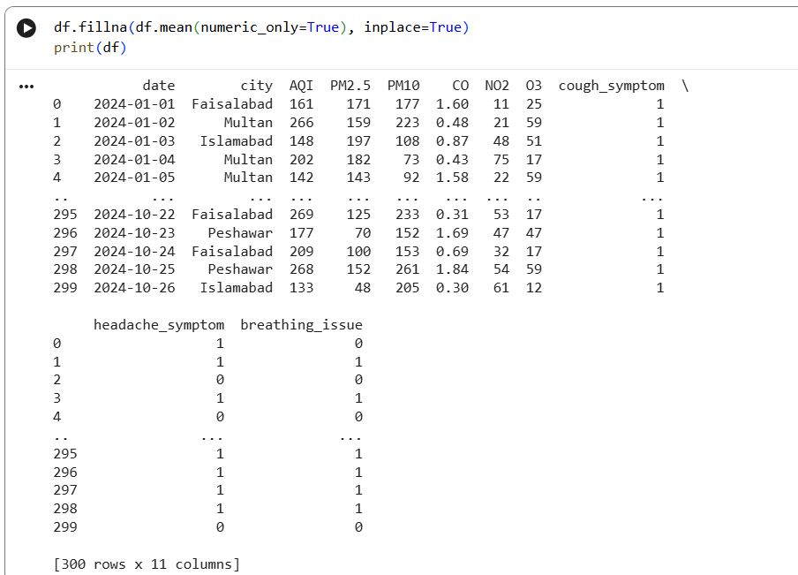

Data Type Conversion
- Converted date to datetime format
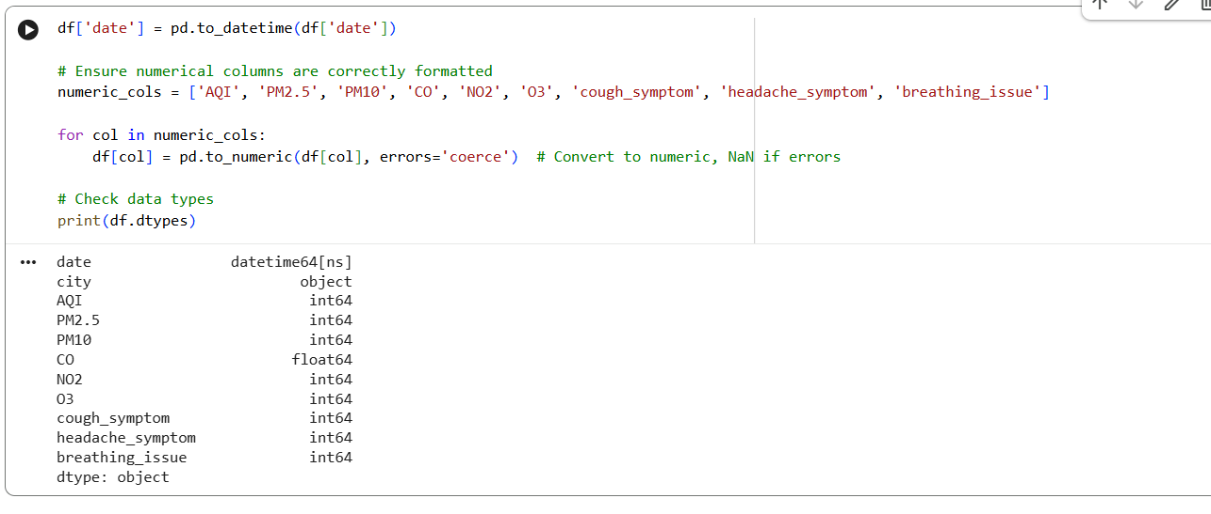
- Ensured numerical columns are correctly formatted

Removing Duplicates
- Duplicate rows removed to maintain data integrity
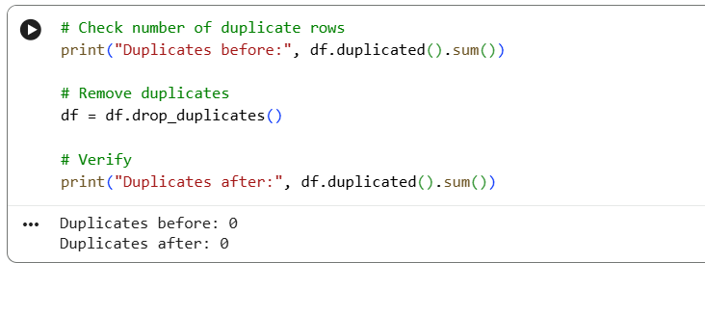

Outlier Detection
- Used boxplots and IQR method
- Extreme values handled or capped
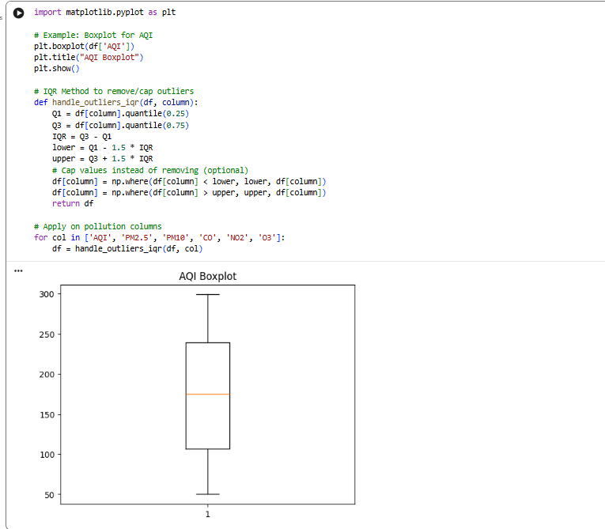

Encoding
- City column encoded if required for ML models
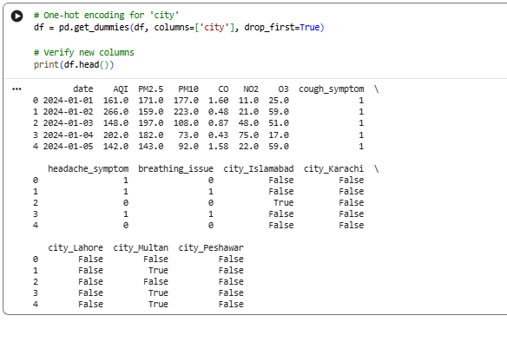

9. Exploratory Data Analysis (EDA)
EDA helps understand patterns:

Key Analysis:
- AQI distribution across cities
- Correlation heatmap
- Symptom frequency vs pollution levels
- Trend analysis over time

Visualizations:
- Bar charts (city-wise AQI)
- Line graphs (time trends)
- Heatmaps (correlation)

10. Methodology

Step-by-step approach:
- Data Collection
- Data Cleaning
- Data Analysis (EDA)
- Feature Selection
- Model Building
- Model Evaluation
- Result Interpretation

11. Tools & Technologies
Category | Tools
Programming | Python
Libraries | Pandas, NumPy
Visualization | Matplotlib, Seaborn
ML Models | Scikit-learn
IDE | VS Code / Jupyter Notebook

12. Model Building (Optional)
Possible models:
- Logistic Regression
- Decision Tree
- Random Forest

Example:
Predict breathing_issue based on pollution levels.

13. Evaluation Metrics
- Accuracy
- Precision
- Recall
- F1-Score
- Confusion Matrix

14. Results & Findings
- Higher AQI correlates with increased health symptoms
- PM2.5 is the most influential pollutant
- Cities with higher pollution show more health risks

15. Real-World Applications / Solutions
- Early warning systems for health risks
- Smart city pollution monitoring
- Healthcare planning
- Government policy improvement

16. Challenges & Limitations
- Synthetic dataset (not real-time)
- Limited health indicators
- No demographic data (age, gender)

17. Future Scope
- Integrate real-time sensor data
- Add weather parameters (temperature, humidity)
- Include hospital records
- Build mobile/web application
- Use deep learning models

18. Conclusion
This project demonstrates how data science can be used to analyze environmental and health data together.
It provides insights into how pollution affects human health and opens pathways for predictive healthcare systems and smarter environmental policies.

