The following files are available after extracting the downloaded merge mail zipped file from Comparion:

* ComparionInvitations.mdb – data source containing the merge mail fields
* (You Project Name).docx – word (mail merge) file
* README.docx – instructions

Here are the steps on how you can use mail merge with Comparion:

**STEP 1:** Open the (You Project Name).docx file.

**STEP 2:** A prompt asking to run an SQL command will pop-out, Click **Yes**.

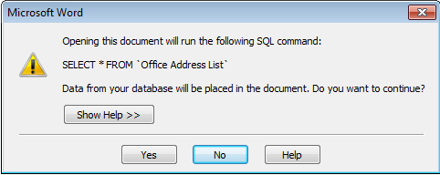

After doing this, the merge mail file will be opened where you will see the default email invitation template.

When an error (incorrect data source path) occurred after you clicked the Yes button above, you just need to enter the correct path of the **ComparionInvitations.mdb** file. See Appendix 1 for instructions.

**STEP 3:** Go to the **Mailings** tab of the opened word file.

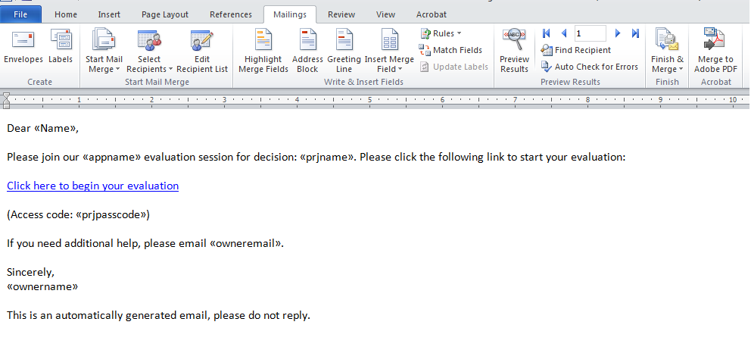

**STEP 4:** Edit the email invitation if desired.

You can add texts, images, urls, etc. on the email. By clicking the **Insert Merge Field**, a list of available fields will be displayed. You just need to select the desired field to insert into where the text cursor is located.

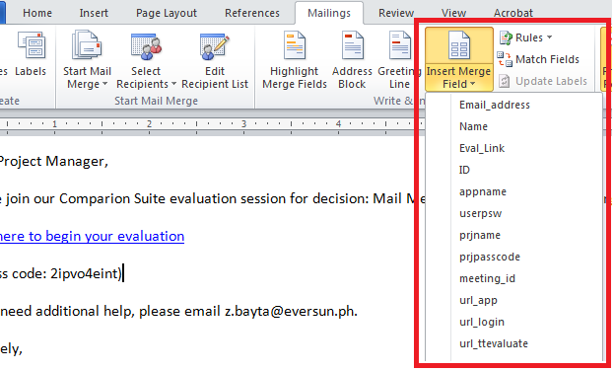

(See Appendix 2 for the list of available field names with their descriptions)

Fields are displayed in <<fieldname>> format in the default view:

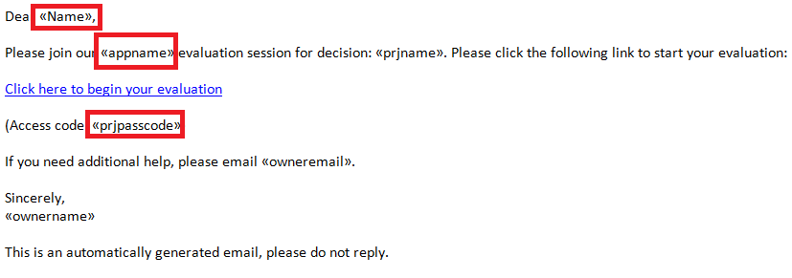

Click the  to view the corresponding value of the fields.

You can also preview the email for each participant using the 

**STEP 5:** When you are ready to send the email, click the **Finish & Merge** button and then select **Send E-mail Messages…**

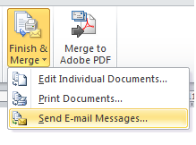

A prompt will appear as shown below:

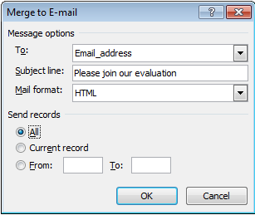

The **Send Records** corresponds to the recipients of the email. **All** is selected by default, you can select to send the email only to some of records.

Click **OK** to start sending the email using the default email set-up on your machine.

**Appendix 1: Data Source is not located**

An error will be displayed when the data source (ComparionInvitations.mdb) is not found as shown below:

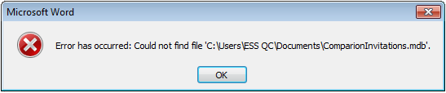

When this occurred, you just need to click the **OK** button on the prompt and another window will appear where you need to enter the correct path of the **ComparionInvitations.mdb** file that you have downloaded:

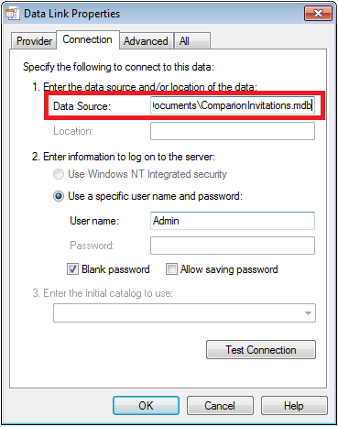

Click **OK** to accept the value and continue working.

**Appendix 2: Merge mail Fields**

|  |  |
| --- | --- |
| **Field Name** | **Description** |
| **General** | |
| useremail | User email address |
| username | User name |
| prjname | Project name |
| ownername | Project owner (sender) name |
| owneremail | Project owner (sender) e-mail |
|  |  |
| **Anytime** | |
| url_evaluate | User token URL for evaluate project |
|  |  |
| **TeamTime** | |
| url_ttevaluate | User token URL for TeamTime session |
| url_meetingid | Application URL with MeetingID |
|  |  |
| **Non-Registered Users** | |
| url_evaluate_anonym | URL for registering and evaluating the project anonymously |
| url_evaluate_signup | URL for registering and evaluating the project |
| url_evaluate_signup_e | URL for registering and evaluating the project (email required) |
| url_evaluate_signup_ep | URL for registering and evaluating the project (email & password required) |
| url_evaluate_signup_n | URL for registering and evaluating the project (User's name required) |
|  |  |
| **Rarely used Fields** | |
| Prjpasscode | Project access code |
| meeting_id | Project MeetingID |
| url_app | Application URL |
| url_login | User token URL for login |