
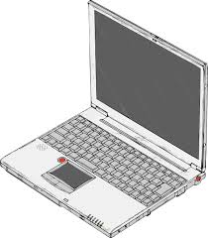
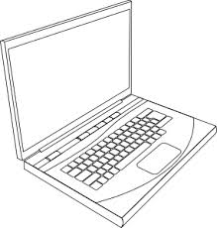
ClientSide program makes RMI call to pass a job and retrieve result.
Remote object receives job, carries out required operation and returns result.
ServerSide program generates remote object stub and binds to RMI registry.
ClientSide program locates registry retrieves remote object stub.

