COMP[1298] Postgraduate Project Proposal
Investigation of Java RMI application for potential security vulnerability

Mahabubur Rashid
MSc Computer Forensics and System Security
000582762
Overview:
RMI or Remote Method Invocation is a java API that is used to perform the Object Oriented equivalent of Remote Procedure Calls with support for serialized objects transfer and distributed garbage collection. Since the transfer of objects takes place between machines in different address spaces, there are various security measures which are controlled by java security manager.
This project will investigate what these security measures are, how and to what extent they are controlled by the java security manager, whether there are any holes in the current scope of the java security manager, and consequently whether such security issues pose any threat to the host of a remote object when unaddressed.
Aims and Objectives:

Aim:
Evaluating the security strength of Java RMI.

Objectives:
The project is broken down in various objectives. These are:

Proposal, Literature Review and Initial Report
Proposal and planning
RMI Technology based literature review and documentation
Reflection & Evaluation of the feedback and implementing any suggestion

Analysis of RMI security aspects
RMI security focused literature review and documentation
Reflection & Evaluation of the feedback and implementing any suggestion

Test bed prototype development
Coding and Testing of a simple RMI based prototype application and GUI layer
An attempt to exploiting security vulnerability by adding malicious code on the Client Side
Documentation

Report Writing
Consolidation of documentations
Reviewing and Critical evaluation: what worked well and what didn't
Evaluation of strengths and weakness
Future works
Tidying up, referencing and finalising report
Task ID | Task Name | Start Date | End Date | Dependencies | Duration | % Complete | Comments
1 | Initial works
1.1 | Researching ideas and Project selection | Not Applicable |  |  |  | 100% | This tasks are now completed.
1.2 | Getting supervisor's approval on project idea |  |  |  |  | 100% | This tasks are now completed.
1.3 | Hands on RMI technology, fixing & resolving technical issues,  research, working on various tutorials,  getting a basic working application |  |  |  |  | 100% | This tasks are now completed.
2 | Proposal, Literature Review and Initial Report | 01/07/14 | 08/07/14 |  | 9 | 46% | Project Title:  Investigation of security implications of Java RMI.
2.1 | Proposal and planning | 01/07/14 | 02/07/14 |  | 2 | 100%
2.2 | Submission of proposal | 03/07/14 | 03/07/14 | 2.1 | 1 | 100%
2.3 | RMI Technology based literature review and documentation + upload on Project Portal | 04/07/14 | 07/07/14 | 2.2 | 4 | 30%
2.4 | Feedback from Supervisor  (Afternoon session would be helpful) | 07/07/14 | 07/07/14 |  | 1 |  | A literature focused feedback at this stage will be regarded very beneficial and would help me:  1. Identify and close any gaps in RMI technology based research and documentation  2. Gauge the depth of research and documentation needed for security analysis  3. Discuss the appropriateness of the planned testbed prototype application
2.5 | Reflection & Evaluation of the feedback and implementing any suggestion | 08/07/14 | 09/07/14 |  | 1
3 | Analysis of RMI security aspects | 10/07/14 | 28/08/14 |  | 18
3.1 | RMI security focused literature review and documentation | 10/07/14 | 20/07/14 |  | 11
3.2 | Feedback from Supervisor | 21/07/14 | 21/07/14 |  | 1 |  | Need to discuss what exploitation and experiments can be carried out:  1. What to be achieved?  2. How to demostrate this achivement?  3. Revisit the planned testbed prototype application
3.3 | Reflection & Evaluation of the feedback and implementing any suggestion | ######## | ######## |  | 6
4 | Test bed prototype development | 01/08/14 | 19/08/14 |  | 20
4.1 | Prototype Application and GUI layer | 01/08/14 | 07/08/14 |  | 7 |  | Currently the plan is to write a simple program that carries out various exhuastive calculations with different number of threads and gauges the performance for lapsed time. This application will measure whether increasing number of threads will increase performance for a given task.
4.2 | Feedback from Supervisor  (Afternoon session due to other appointments in the morning) | 08/08/14 | 08/08/14 |  | 1 |  | Feedback here may be focused on:  1. How the application serves the purpose  2. What can be done to cause a security vulnerability and exploit it
4.3 | Adding security vulnerability code to the Client Side | 09/08/14 | 10/08/14 |  | 2 |  | Client application will try to access user areas on the Server side
4.4 | Exploitation of security vulnerability | 11/08/14 | 12/08/14 |  | 2
4.5 | Feedback from Supervisor | 13/08/14 | 13/08/14 |  | 1 |  | Discuss the findings, what and what not went well, how to present this effectively.
4.6 | Documentation | 14/08/14 | 19/08/14 |  | 6
5 | Report Writing | 20/08/14 | 02/09/14 |  | 14
5.1 | Consolidation of documentations | 20/08/14 | 22/08/14 |  | 3
5.2 | Reviewing and Critical evaluation:  what worked well and what didn't | 23/08/14 | 26/08/14 |  | 4
5.3 | Evaluation of strengths and weakness | 27/08/14 | 28/08/14 |  | 2
5.4 | Future works | 29/08/14 | 29/08/14 |  | 1
5.5 | Tidying up, referencing and finalising report | 30/08/14 | 02/09/14 |  | 3

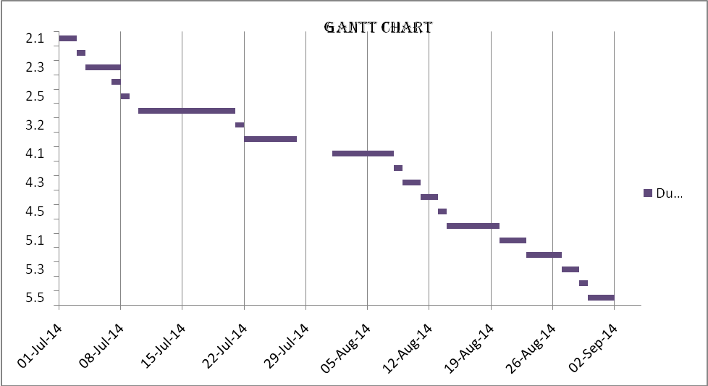
Gantt Chart:

