Add following Packages:
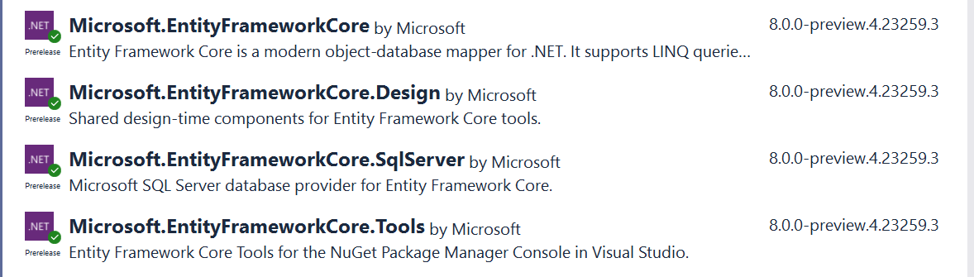
Note : Version may very depends on .Net version.
Set database connection string in appsettings.json:
For database first approach (model will create according database ) command run in PM console :
Scaffold-DbContext "Server=Mahabub; Database=DotNetPracticeProject; user Id=sa; Password=12774; Trusted_Connection=True;TrustServerCertificate=True;" Microsoft.EntityFrameworkCore.SqlServer -OutputDir Models.
After command run will generate db context file which like following:
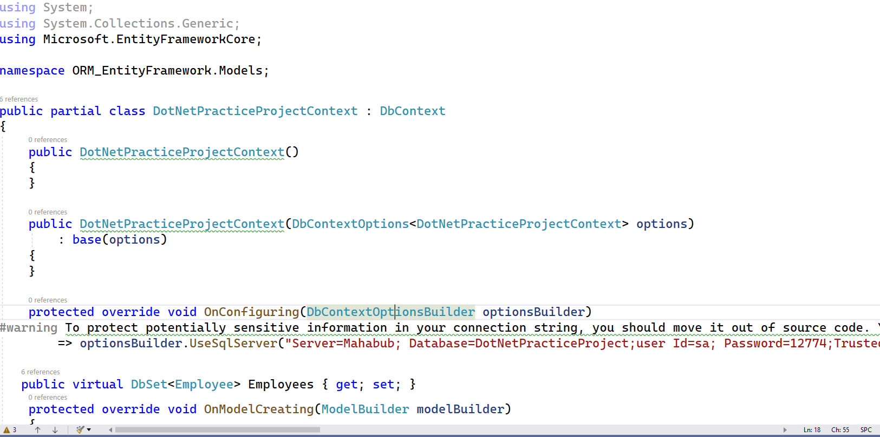

Add DBContext reference in Program.cs

Create userlogin class only for username & password field
You can add multiple class for data testing like Employee
You can complete full task in controller , but for well managed using repository Pattern in my project.
For new repository pattern add in program.cs

