Add following Packages:
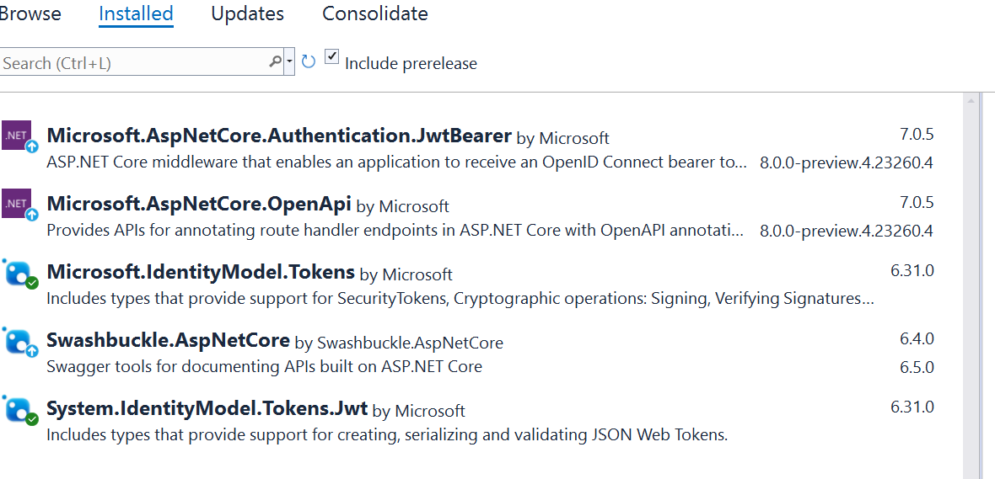
Note : Version may very depends on .Net version.
Add security key in project in appsettings following way:
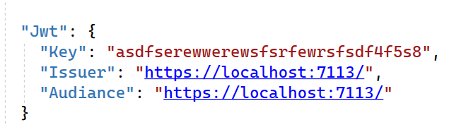

Add authorization reference in Program.cs

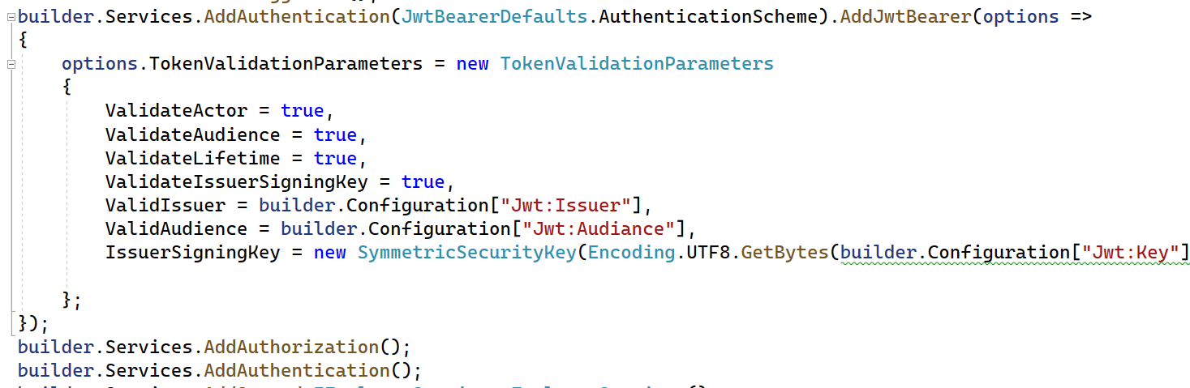
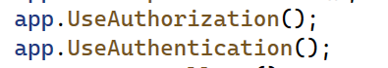

Create userlogin class only for username & password field
You can add multiple class for data testing like Employee
You can complete full task in controller , but for well managed using repository Pattern in my project.
For new repository pattern add in program.cs

