A Machine Learning Model to Predict the Employability of Fresh CSE Graduates in Bangladesh
A project report / thesis submitted to the Department of Computer Science and Engineering of the World University of Bangladesh in partial fulfilment of the requirement for the award of the degree of Bachelor of Science in Computer Science & Engineering
Submitted by:
Md. Mahabub Alam
ID: WUB 03/23/64/3835
Md. Al-Amin Miah
ID: WUB 03/23/64/3829
Subir Sarker Saurav
ID: WUB 03/23/64/3840

Supervised by:
Kazi Hassan Robin
Associate Professor, Department of Computer Science and Engineering

World University of Bangladesh
Department of Computer Science and Engineering
September , 2026

TABLE OF CONTENTS
Table of Contents Page
Chapter 1: Introduction 1
1.1 Background of the Study 1
1.2 Statement of the Problem 3
1.3 Research Questions 5
1.4 Research Objectives 6
1.5 Justification and Significance of the Study 7
1.6 Scope of the Study 8
Chapter 2: Literature Review 11
2.1 Introduction 11
2.2 Review Methodology 12
2.3 Conceptual Foundations of Graduate Employability 12
2.3.1 Definitional and Theoretical Development 12
2.3.2 Critical Appraisal of the Conceptual Literature 13
2.4 The Bangladeshi Context 13
2.5 Machine Learning Approaches to Employability Prediction 15
2.5.1 Single-Classifier Studies 15
2.5.2 Ensemble and Boosting Approaches 16
2.6 Comparative and Critical Analysis of Reviewed Studies 16
2.7 Research Gaps and Novelty of the Present Study 20
2.8 Conceptual Framework 22
Chapter 3: Methodology 23
3.1 Methodology 23
3.2 Justification of Methodology 23
3.3 Description of Methodology 26
Chapter 4: Research Design 28
4.1 Overview of the Research Design 28
4.2 Machine Learning Model Workflow 29
4.3 Requirement Analysis for the Prediction System 31
4.3.1 Requirement Gathering Techniques 31
4.3.2 Functional and Non-Functional Requirements 31
4.4 Data Flow Design 32
4.5 System Interaction Design: Use Cases 34
Chapter 5: Results and Discussion 36
5.1 Dataset Description and Characteristics 36
5.2 Dataset Analysis: Features, Data Types and Roles 38
5.3 Data Preprocessing and Preparation Results 40
5.4 Class Distribution and Dataset Balance 41
5.5 Training and Testing Strategy: The 80:20 Split 43
5.6 Machine Learning Model Workflow and Implementation 45
5.7 Model Performance and Evaluation 47
5.7.1 Cross-Validation and Robustness Validation 53
5.8 Justification of XGBoost and Comparison with Alternative Algorithms 54
5.9 System Implementation and Output: Prediction via API 58
5.9.1 Local Web View for Interactive Predictions 61
5.10 Model Interpretation: Feature Importance and Feature Priority 63
5.11 Statistical Significance Testing: Z-Test and T-Test 67
5.12 Discussion of Findings in Relation to the Literature 72
5.13 Fulfilment of Research Objectives and Research Questions 73
5.14 Limitations Identified from the Results 75
5.15 Validation Summary 76
Chapter 6: Conclusions 79
6.1 Conclusions 79
6.2 Limitations and Recommendations 80
6.3 Future Works 82
References 88
Appendix 92
Appendix A: Operational Definitions of Key Terms 92

LIST OF TABLES
Table No. | Title | Page
Table 1.1 | Mapping of research questions to research objectives | 6
Table 1.2 | Scope and delimitations of the study | 10
Table 2.1 | Comparative and critical analysis of machine learning-based employability prediction studies | 17
Table 2.2 | Identified research gaps and the response of the present study | 21
Table 4.1 | Functional requirements | 31
Table 4.2 | Non-functional requirements | 32
Table 4.3 | Use case narratives | 35
Table 5.1 | Summary characteristics of the dataset as used in this study | 36
Table 5.2 | Feature dictionary of the dataset | 38
Table 5.3 | Distribution of the target variable Placement_Status | 41
Table 5.4 | Composition of the training and testing partitions | 43
Table 5.5 | Classification performance of the tuned XGBoost pipeline on the held-out test set (deployment threshold = 0.300, no SMOTE) | 48
Table 5.6 | Comparison of candidate classification algorithms for this problem | 55
Table 5.7 | Feature importance ranking and priority tier | 64
Table 5.8 | Comparison of the Z-test and the T-test | 69
Table 5.9 | Validation summary | 77
Table 6.1 | Missing data, recommended future collection and expected research benefit | 83

LIST OF FIGURES

Figure No. | Title | Page
Figure 3.1 | The Incremental development model | 24
Figure 3.2 | Incremental development of the employability prediction system | 26
Figure 4.1 | Machine learning model workflow, from data collection through to the employability prediction produced for a new graduate | 30
Figure 4.2 | Context-level Data Flow Diagram (DFD Level 0) | 33
Figure 4.3 | Data Flow Diagram (DFD Level 1) of the employability prediction system | 34
Figure 4.4 | Use Case diagram of the employability prediction system | 34
Figure 5.1 | Loaded dataset, columns Age through Leadership_Experience | 38
Figure 5.2 | Loaded dataset, columns Academic_Performance through Interview_Score | 38
Figure 5.3 | Absolute class distribution of the target variable | 42
Figure 5.4 | Proportional class distribution of the target variable | 42
Figure 5.5 | Stratified 80:20 partition of the dataset with class composition | 44
Figure 5.6 | Implemented machine learning workflow, from raw dataset to final evaluation | 46
Figure 5.7 | Console output of the executed pipeline, showing dataset load, retained features, training time and classification report | 48
Figure 5.8 | Confusion matrix for the tuned XGBoost pipeline on the held-out test set (deployment threshold = 0.300, no SMOTE) | 49
Figure 5.9 | Same confusion matrix, reproduced as source evidence | 50
Figure 5.10 | Per-class precision, recall and F1-score comparison | 51
Figure 5.11 | Illustrative Postman request and response for an employability prediction | 59
Figure 5.11a | The local web view's profile-submission form, showing its idle result panel before a check is run | 61
Figure 5.11b | The local web view after a submission, showing the verdict badge, probability gauge and gap-analysis list for a weak profile | 63
Figure 5.12 | XGBoost feature importance across the 18 retained features, tuned configuration (normalised, mapped back to raw attributes) | 64
Figure 5.13 | Console output of the executed Z-test across the dataset’s 13 numeric attributes | 71
Figure 5.14 | Z-statistic magnitude by attribute, ranked in descending order of significance | 71

ABBREVIATIONS
Short Form | Full Form
BBS | Bangladesh Bureau of Statistics
CGPA | Cumulative Grade Point Average
CSE | Computer Science and Engineering
ICT | Information and Communication Technology
ML | Machine Learning
ROC-AUC | Area Under the Receiver Operating Characteristic Curve
SHAP | SHapley Additive exPlanations
SVM | Support Vector Machine
WUB | World University of Bangladesh

Chapter 1: Introduction

1.1 Background of the Study
Over the past two decades, graduate employability has evolved from a peripheral concern of career services into one of the principal indicators by which higher education institutions are evaluated. Employability is defined as the set of achievements — skills, understandings and personal attributes — that make individuals more likely to gain employment and to be successful in their chosen occupations (Yorke, 2006). Two features of this definition are consequential for the present study. First, employability is a propensity rather than an outcome: it describes the likelihood of obtaining suitable work, not the fact of being employed. Second, it is inherently multidimensional, encompassing disciplinary knowledge, transferable skills and personal attributes simultaneously. Subsequent theoretical work has extended this position, reconceptualising employability as the accumulation and mobilisation of several forms of graduate capital — human, social, cultural, identity and psychological (Tomlinson, 2017). Graduate employment outcomes are further understood to be jointly determined by human capital, social capital, individual behaviours, individual attributes and perceived employability, all situated within labour market conditions that lie outside the graduate’s control (Clarke, 2018). Taken together, these frameworks establish that employability is multidimensional and contextually contingent, and therefore that any attempt to model it empirically must incorporate heterogeneous predictors rather than academic attainment alone.
Nowhere is this argument more consequential than in computing disciplines. The technical knowledge base of software engineering is subject to unusually rapid obsolescence: programming ecosystems, cloud platforms, machine learning frameworks and security practices are revised on cycles far shorter than the four-year duration of an undergraduate degree (Clarke, 2018). Employers in the software and information technology sector therefore recruit less on the basis of credentials than on demonstrated capability. Employers ranked soft skills, problem-solving ability and prior work experience above academic reputation when evaluating undergraduate candidates (Finch et al., 2013), and work-integrated learning has been shown to produce measurable gains in the specific skill outcomes employers value (Jackson, 2013). The implication is that two graduates with identical cumulative grade point averages (CGPA) may face materially different employment prospects depending on their internship history, project portfolio, certification profile and communication ability.
For fresh Computer Science and Engineering (CSE) graduates, the timing of this information is critical. Skills of the kind employers reward are accumulated over several semesters and cannot be acquired retrospectively at the point of job search. A student who learns in the final semester that industry exposure and portfolio evidence outweigh marginal improvements in CGPA has already forfeited the opportunity to act on that knowledge. Consequently, the practical value of employability research lies not in describing which graduates were employed after the fact, but in producing early, individualised and actionable signals that students can respond to while they still have time to intervene in their own preparation.
The Bangladeshi labour market makes this problem acute. Approximately 2.62 million people were unemployed at the end of 2024, of whom roughly 885,000 held tertiary-level qualifications (BBS, 2025). Critically, the unemployment rate rises monotonically with education: it stands at 13.5 per cent among university graduates, compared with 7.13 per cent among those completing higher secondary education, 1.96 per cent among secondary school completers, and 1.25 per cent among individuals with no formal education (BBS, 2025). Roughly one in three unemployed graduates remained without work for up to two years after graduation, a duration long enough to produce documented scarring effects on lifetime earnings and career progression (BBS, 2025). Bangladesh, in other words, does not exhibit a general shortage of jobs so much as a structural mismatch between what its higher education system produces and what its labour market absorbs.
The Information and Communication Technology (ICT) sector illustrates both sides of this mismatch. Demand-side evidence is unambiguous: analysing six years of online job-portal postings from the Bangladeshi ICT industry identified persistently high demand for software developers, computer systems engineers and architects, web developers and project management specialists, together with a rapid post-pandemic shift in required skills away from traditional networking competencies towards JavaScript, API development, database technologies and user interface design (Jony et al., 2022). The same study reports that the employment rate of CSE and IT graduates exceeded the national average for university graduates, confirming that the discipline is comparatively advantaged. Yet advantage is not sufficiency. A survey of higher education students in Bangladesh found a significant gap between the skills that private universities deliver and those that industry requires, with quality of education mediating the relationship between institutional provision and students’ employability skills (Hasan et al., 2024). The number of institutions offering CSE programmes has expanded substantially over the last decade, but curricular revision cycles have not kept pace with the rate at which the demanded skill set is changing (Jony et al., 2022). The result is a discipline in which employer demand is strong, graduate supply is abundant, and a substantial fraction of that supply is nonetheless unabsorbed.
Historically, this gap has been investigated through descriptive instruments: employer perception surveys, graduate tracer studies and correlational analyses. Such studies establish which factors are associated with employment in aggregate, but they neither produce individual-level predictions nor quantify the relative contribution of each factor when all are considered jointly. Machine learning offers a methodologically distinct alternative. By learning non-linear, interaction-rich mappings from multidimensional graduate profiles to employment outcomes, supervised classification models can generate individual-level employability estimates and, through feature-importance analysis, rank the determinants that drive those estimates (Baffa et al., 2023; Haque et al., 2024; Mezhoudi et al., 2023). A considerable body of such work now exists for Nigeria, the Philippines, Malaysia, Egypt, Vietnam and India. Very little of it addresses Bangladesh, and none of it addresses the specific population of fresh CSE graduates entering the Bangladeshi ICT labour market with a feature set that spans technical skills, soft skills, academic performance and practical experience simultaneously.
This thesis addresses that deficiency. It applies a supervised machine learning approach to identify and quantify the determinants of employability among fresh CSE graduates in Bangladesh, and to construct an interpretable predictive model that converts those determinants into actionable, individual-level guidance for students, universities and policymakers.

1.2 Statement of the Problem
Bangladesh presents an apparent paradox. Its ICT sector reports sustained and growing demand for software developers and allied technical roles (Jony et al., 2022), while its tertiary-educated population simultaneously records the highest unemployment rate of any educational stratum in the country, at 13.5 per cent (BBS, 2025). Both conditions cannot be explained by aggregate labour demand alone; the binding constraint is the alignment between individual graduate profiles and employer requirements.
Three deficiencies in the current state of knowledge sustain this problem.
First, the evidence available to Bangladeshi CSE students is diagnostic rather than predictive, and arrives too late to be acted upon. National statistics are reported at aggregate level and are not disaggregated by discipline, so no reliable estimate of CSE-specific graduate employability exists. Graduate tracer studies report outcomes retrospectively, typically one to two years after graduation, at which point the affected cohort can no longer alter its preparation. Existing Bangladeshi employability research is predominantly perception-based and correlational, establishing that a skills gap exists without quantifying which specific competencies, held by which specific student, most strongly change that student’s probability of employment (Hasan et al., 2024).
Second, the international machine learning literature on employability prediction is not transferable to the Bangladeshi CSE context without substantial adaptation. Models have been developed on Nigerian, Filipino, Malaysian, Egyptian and Vietnamese cohorts (Baffa et al., 2023; Casuat & Festijo, 2019; ElSharkawy et al., 2022; Haque et al., 2024; Othman et al., 2018; Vo et al., 2023), and datasets, feature sets, algorithms and evaluation protocols vary so widely across this literature that findings are not directly comparable, let alone directly portable (Mezhoudi et al., 2023). Labour market structure, hiring conventions, curricular design and the composition of the ICT sector differ materially between these contexts and Bangladesh. Within Bangladesh itself, the closest available work targets different dependent variables — career-type prediction (Biswas et al., 2021) and academic-performance prediction (Zulfiker et al., 2020) — and relies chiefly on academic and demographic attributes, omitting the technical-skill, portfolio, internship and certification variables that the employability literature identifies as decisive in computing disciplines.
Third, prevailing modelling practice in this literature limits the practical usefulness of its outputs. Many studies optimise for overall classification accuracy on class-imbalanced data, a metric that systematically flatters models on the majority class while concealing poor recall on the minority — precisely the unemployed graduates whom an early-warning system exists to identify. Reported accuracies above 95 per cent on samples of a few hundred records raise unresolved questions of overfitting and validation rigour (Baffa et al., 2023). Furthermore, most published models function as black boxes: they classify without explaining, and a prediction that cannot be decomposed into its contributing factors cannot be translated into advice about what a student should do differently. Graduate employment prediction models can additionally encode and reproduce bias against protected groups, a risk that remains almost entirely unexamined in developing-country settings (Guo et al., 2020).
The problem this thesis addresses is therefore the absence of a context-specific, empirically validated and interpretable predictive model of employability for fresh CSE graduates in Bangladesh. In the absence of such a model, students allocate preparation effort on the basis of assumption rather than evidence; universities revise curricula without quantified knowledge of which interventions most improve employment outcomes; and employers and policymakers lack a defensible basis for targeting industry–academia initiatives. The consequence is a persistent and measurable loss of human capital in the very discipline the national digital economy depends upon.

1.3 Research Questions
This study is guided by four research questions:
1. RQ1. Which technical, academic, experiential and behavioural factors are associated with the employment status of fresh CSE graduates in Bangladesh, and what is the relative importance of each factor?
2. RQ2. To what extent can supervised machine learning classifiers predict the employment status of fresh CSE graduates in Bangladesh from data available at or shortly after graduation?
3. RQ3. Which classification algorithm, among the candidate models evaluated, offers the most reliable performance on this dataset when assessed using imbalance-sensitive metrics rather than overall accuracy alone?
4. RQ4. What actionable, evidence-based recommendations for students, universities and policymakers follow from the model’s feature-importance structure?

1.4 Research Objectives
This study is guided by the following three objectives.
Objective 1: Identification of Employability Determinants. To identify, examine, and analyse the major academic, technical, experiential, behavioural, and career-related factors associated with the employability of fresh Computer Science and Engineering (CSE) graduates in Bangladesh.
Objective 2: Employability Prediction Model Development and Evaluation. To develop, implement, and comparatively evaluate supervised machine learning classification models for predicting the employability of fresh CSE graduates in Bangladesh.
Objective 3: Model Interpretation and Evidence-Based Recommendation. To interpret the predictions and decision-making patterns of the best-performing machine learning model by identifying the relative importance and contribution of different employability factors, and to translate that interpretation into actionable recommendations.
Table 1.1 maps each research question to the objective through which it is primarily addressed, and to the section that reports the corresponding evidence.
Table 1.1: Mapping of research questions to research objectives
Research question | Corresponding objective | Method of address
RQ1 — determinants and their relative importance | Objective 1 | Feature-importance ranking of all 18 retained attributes (Section 5.10)
RQ2 — extent of predictability | Objective 2 | Supervised classification performance evaluation on the held-out test set (Section 5.7)
RQ3 — best algorithm under imbalance-sensitive evaluation | Objective 2 | Comparative evaluation against candidate algorithms (Section 5.8) — Logistic Regression, Decision Tree, Random Forest and XGBoost compared (Table 5.6); Support Vector Machine excluded on computational-cost grounds
RQ4 — actionable recommendations | Objective 3 | Global feature ranking translated into recommendations (Sections 5.10, 5.12, 6.2)

1.5 Justification and Significance of the Study
The justification for this research rests on three distinct grounds: an empirical gap, a methodological gap and a practical need.
Empirically, the employability of Bangladeshi CSE graduates is under-researched relative to its economic importance. The international literature on machine learning-based employability prediction is concentrated in Nigeria, the Philippines, Malaysia, India, Egypt and Vietnam (Baffa et al., 2023; Casuat & Festijo, 2019; ElSharkawy et al., 2022; Haque et al., 2024; Othman et al., 2018; Vo et al., 2023). Bangladeshi contributions to the adjacent educational data mining literature have addressed academic performance (Zulfiker et al., 2020) and broad career-type choice between government, private-sector and self-employment (Biswas et al., 2021), but not the employability of a discipline-specific graduate cohort. Since employability is theorised as context-dependent (Clarke, 2018; Tomlinson, 2017), a model trained on the labour market conditions, hiring conventions and curricular structures of another country cannot be assumed to generalise to Bangladesh. Generating national evidence is therefore not a replication exercise but a necessary condition for validity.
Methodologically, this study responds directly to weaknesses that the reviewed literature itself identifies. The field suffers from inconsistent evaluation practice and requires context-specific models built on transparent protocols (Mezhoudi et al., 2023), and employability prediction models can encode bias with material consequences for the individuals classified (Guo et al., 2020). This study accordingly adopts imbalance-aware evaluation metrics and a documented, seeded and reproducible stratified hold-out protocol, together with a model-intrinsic explainability layer; per-prediction SHAP explanation is specified in the system design but is not implemented at this stage, as reported in Section 5.9. The combination of a Bangladesh-relevant CSE dataset, a multidimensional feature set spanning technical and non-technical attributes, and an explainability layer is, to the best of the researcher’s knowledge, not present in any existing study.
Practically, the outputs of this study serve four stakeholder groups. Students gain an evidence-based ranking of the competencies that most strongly influence employment outcomes, enabling deliberate allocation of effort across coursework, internships, portfolio projects and certifications during — rather than after — their degree. Universities gain quantified guidance on which curricular and co-curricular interventions carry the greatest expected return, supporting outcome-based curriculum revision and targeted career counselling. Employers gain a clearer characterisation of entry-level graduate readiness in the Bangladeshi market. Policymakers and sector bodies gain empirical grounding for national skills development and industry–academia collaboration programmes.
The specific contributions claimed by this thesis are: (1) a machine learning model of fresh CSE graduate employability in Bangladesh, trained on a discipline-relevant secondary dataset — the Kaggle Student Career Success Prediction Dataset (50,000 records) — whose feature set was selected because it aligns with established employability theory; (2) empirical quantification of the relative importance of technical skills, soft skills, academic performance and practical experience in determining employment outcomes for this population; (3) a comparatively evaluated and interpretable predictive model, assessed under imbalance-sensitive metrics, that constitutes the first such model reported for Bangladeshi CSE graduates; and (4) a set of evidence-based recommendations for curriculum design, student career preparation and industry–academia collaboration derived from the model rather than from perception data.

1.6 Scope of the Study
This study is deliberately bounded in population, geography, sampling, timeframe and variable coverage in order to preserve internal validity. Each boundary is defined below, and in each case the corresponding exclusion is stated so that the reach of the study’s claims is unambiguous.
Target population. The target population comprises fresh graduates of four-year undergraduate Computer Science and Engineering programmes, and cognate programmes such as Software Engineering, Computer Science and Information and Communication Technology, from public and private universities in Bangladesh. A graduate is operationally defined as “fresh” if degree completion occurred within the twenty-four months preceding data collection. Experienced IT professionals, graduates of non-computing engineering disciplines, and current undergraduates who have not yet graduated fall outside the population and are not represented in the analysis.
Study area. The study frames its findings for the Bangladeshi CSE labour market, with the largest concentration of both CSE programmes and ICT employers located in the Dhaka and Chattogram divisions (Jony et al., 2022). Because the model is trained on a secondary dataset that is not restricted to Bangladeshi institutions, the study makes no claim of statistical representativeness for any specific national population beyond the dataset’s own coverage, and the sample is not claimed to be geographically stratified across all eight divisions.
Data source and sample size. At the current stage of the project, the model is trained on a secondary dataset of 50,000 student records — the Student Career Success Prediction Dataset, obtained from Kaggle (Fatimah, 2026) — rather than on primary survey data collected directly from Bangladeshi graduates. This sample size provides sufficient minority-class representation for supervised classification and is feasible within the constraints of an undergraduate thesis. The trade-off is that the dataset is not Bangladesh-specific and its variables are treated as proxies for the six employability dimensions defined below; the implications of this choice are examined in the concluding chapter.
Timeframe. The study was carried out during the 2025–2026 academic year. Because the dataset is a secondary, already-collected resource, the employment status recorded for each entry reflects the point at which that record was originally gathered rather than a survey administered by this study, and time-to-first-employment is not available as an auxiliary variable.
Variable scope. The dependent variable is binary employment status — employed in an ICT-related role versus not employed in an ICT-related role — within twelve months of graduation. Salary level, job satisfaction, promotion trajectory and long-term career progression are outside the outcome scope. Independent variables span six dimensions: academic performance; technical and programming proficiency; practical experience (internships, industrial training, projects, open-source and freelance work); professional certifications and self-directed learning; soft skills including communication, teamwork and problem-solving; and career preparation behaviour including job-search intensity and industry exposure. Psychometric personality inventories, family socio-economic status and institutional funding variables are outside the predictor scope.
Methodological scope. The study employs supervised binary classification with an interpretability layer on a cross-sectional, secondary dataset. It does not employ longitudinal panel modelling, deep learning architectures, or natural language processing of curriculum vitae, each of which would require data volumes or data types beyond the reach of this project. These methods are noted as directions for future work rather than as components of the present design.
Table 1.2 summarises what falls within and outside the scope of the study across six dimensions.
Table 1.2: Scope and delimitations of the study
Dimension | Within scope | Outside scope
Target population | Fresh graduates (within 24 months of completion) of four-year CSE and cognate programmes (Software Engineering, Computer Science, ICT) from Bangladeshi public and private universities | Experienced IT professionals; graduates of non-computing engineering disciplines; current undergraduates who have not yet graduated
Study area | Findings framed for the Bangladeshi CSE labour market, concentrated in the Dhaka and Chattogram divisions | A claim of statistical representativeness for any specific national population; geographic stratification across all eight divisions
Data source and sample size | Secondary dataset of 50,000 student records (Student Career Success Prediction Dataset, Kaggle) | Primary, institution-specific data collection at this stage
Outcome scope | Binary employment status outcome | Salary level, job satisfaction, promotion trajectory and long-term career progression
Predictor scope | Six dimensions: academic performance; technical and programming proficiency; practical experience; certifications and self-directed learning; soft skills; career preparation behaviour | Psychometric personality inventories; family socio-economic status; institutional funding variables
Methodological scope | Supervised binary classification with an interpretability layer, on a cross-sectional, secondary dataset | Longitudinal panel modelling; deep learning architectures; natural language processing of curriculum vitae

Chapter 2: Literature Review

2.1 Introduction
The foundational literature on graduate employability establishes the conceptual basis for this study. Employability is defined as the combination of knowledge, technical competencies, professional attitudes, personal attributes, and transferable skills that enable graduates to obtain, maintain, and progress in employment (Yorke, 2006). Graduate employability is influenced by different forms of graduate capital, including human, social, cultural, and psychological capital (Tomlinson, 2017). Furthermore, employability is shaped by multiple interconnected dimensions, including human capital, social capital, individual behaviour, career identity, and labour market conditions (Clarke, 2018). Employers place strong emphasis on communication skills, teamwork, professionalism, leadership, and work experience during recruitment (Finch et al., 2013), and internship opportunities and work-integrated learning significantly improve graduates’ workplace readiness and employability (Jackson, 2013).
Beyond traditional survey-based approaches, a growing body of research has applied machine learning techniques to predict graduate employability more objectively. Random Forest and Decision Tree classifiers have been shown to predict students’ employability using academic and extracurricular attributes with high accuracy (Baffa et al., 2023). Decision Tree, Random Forest, and Support Vector Machine algorithms have been successfully used to model students’ employability outcomes based on training performance and grade point average (Casuat & Festijo, 2019). Classification techniques applied to national graduate tracer datasets have identified academic performance and satisfaction-related factors as significant predictors of graduate employability (Othman et al., 2018).
Machine learning applications have also been extended to broader employability contexts. Machine learning models have been shown to be effective in predicting employability at the high school level (Dubey & Mani, 2019), and machine learning approaches have been proposed to analyse the factors influencing employment outcomes across different educational contexts (García-Peñalvo et al., 2018). Fairness and bias should be carefully considered when developing graduate employment prediction models (Guo et al., 2020). Moreover, a comprehensive review of employability prediction studies revealed considerable variation in datasets, machine learning algorithms, feature selection methods, and evaluation techniques, emphasising the need for context-specific predictive models tailored to specific populations, such as fresh CSE graduates in Bangladesh (Mezhoudi et al., 2023).

2.2 Review Methodology
Literature was retrieved from IEEE Xplore, ScienceDirect, SpringerLink, MDPI, PLOS, Scopus-indexed journals and Google Scholar using combinations of the terms “graduate employability”, “employability prediction”, “machine learning”, “educational data mining”, “campus placement”, “skills gap”, “CSE graduates” and “Bangladesh”. Studies were included where they (i) reported empirical findings on graduate employability determinants, or (ii) applied machine learning or data mining techniques to predict employment or placement outcomes for tertiary students, or (iii) provided labour market or ICT sector evidence specific to Bangladesh. Preference was given to peer-reviewed journal articles and indexed conference proceedings published between 2018 and 2025, with earlier work retained where it is foundational to the theoretical framing. National statistical publications were consulted directly at source rather than through secondary reporting. Each retained study was appraised not only for its findings but for its dataset size, sampling frame, feature composition, validation protocol, evaluation metrics and treatment of class imbalance — the dimensions along which the comparative analysis in Section 2.6 is organised.

2.3 Conceptual Foundations of Graduate Employability

2.3.1 definitional and theoretical development
The conceptual literature on employability has moved through three broadly identifiable stages. The first established employability as a property of the individual: a set of achievements, skills, understandings and personal attributes that raise the probability of gaining and succeeding in employment (Yorke, 2006). The central and still-underappreciated contribution of this stage is the analytical separation of employability from employment: employability is a propensity, whereas employment is an outcome contingent on labour market conditions, so that a graduate may be highly employable and nonetheless unemployed. This distinction has direct methodological consequences for the present study, because it implies that any model trained on observed employment outcomes is estimating employability only imperfectly, with labour-demand conditions entering as unobserved noise.
The second stage extended the construct beyond individual skills. Graduates enter the labour market carrying differentiated stocks of capital — human capital in the form of knowledge and skills, social capital in the form of networks and access, cultural capital in the form of dispositions congruent with employer expectations, identity capital in the form of a coherent career narrative, and psychological capital in the form of resilience and adaptability (Tomlinson, 2017). The framework’s strength lies in its explanatory power: it accounts for why graduates with equivalent academic records experience unequal outcomes. Its principal weakness is operational, because social, cultural and identity capital are theorised richly but measured inconsistently, with no validated instrument provided for their quantification, which limits the framework’s direct usability in predictive modelling.
The third stage relocates employability within the labour market itself. Employment outcomes are determined jointly by human capital, social capital, individual behaviours, individual attributes and perceived employability, all mediated by labour market conditions and employer recruitment practices (Clarke, 2018). This contribution is the explicit refusal of the individualisation of employability — the assumption that graduate unemployment is wholly attributable to graduate deficiency. This is a necessary corrective, but it also creates an unresolved tension for empirical work: if outcomes are substantially determined by structural conditions, then the ceiling on predictive accuracy achievable from graduate-level attributes alone is bounded, and models that report near-perfect accuracy from such attributes should be treated with suspicion rather than admiration. This observation informs the critical appraisal of reported model performance in Section 2.6.

2.3.2 critical appraisal of the conceptual literature
Two limitations of the conceptual literature are material to this study. First, it is overwhelmingly Anglophone and developed-economy in origin (Yorke, 2006). Bangladesh differs on each dimension, and the finding that roughly a third of unemployed young people rely principally on relatives and friends to find work suggests that social capital operates with a weight, and through mechanisms, not fully captured in these frameworks (BBS, 2025). Second, the literature is predominantly conceptual and, where empirical, correlational; it explains and describes but does not predict at the individual level.

2.4 The Bangladeshi Context
Bangladeshi graduate unemployment is both severe and structurally distinctive. Approximately 885,000 unemployed tertiary-educated individuals are recorded within a total unemployed population of 2.62 million, with an unemployment rate among graduates of 13.5 per cent — the highest of any educational stratum and more than ten times the 1.25 per cent rate observed among individuals with no formal education (BBS, 2025). The inversion of the usual education–employment gradient indicates that the constraint is not education per se but the alignment of educational output with labour demand. Roughly one in three unemployed graduates remained without work for up to two years, a duration associated in the labour economics literature with persistent scarring effects on earnings and career trajectory (BBS, 2025).
Two limitations of this national evidence base motivate the present study. First, the statistics are not disaggregated by discipline, so the employability of CSE graduates specifically cannot be inferred from them. Second, they are outcome statistics: they quantify the magnitude of the problem without identifying which graduate-level attributes separate the employed from the unemployed.
The discipline-specific Bangladeshi literature is correspondingly thin. A survey of higher education students at a private Bangladeshi university, using partial least squares structural equation modelling, found a significant gap between the skills delivered by private universities and those required by industry, with quality of education mediating the relationship between institutional provision and employability skills (Hasan et al., 2024). The study is methodologically sound within its paradigm and is among the few to model relationships rather than merely report frequencies; its limitations are that it relies on a single institution and a modest sample, that it measures perceived rather than realised employability, and that structural equation modelling estimates average path coefficients across a population rather than individual-level predictions.
Within Bangladeshi educational data mining, two studies are proximate but not equivalent to the present work. Several data mining classifiers have been applied to predict career type — government employment, private employment or business — among Bangladeshi graduates, with the PART classifier outperforming alternatives (Biswas et al., 2021); the study is valuable as an early demonstration of feasibility in the national context, but its dependent variable is career category rather than employability, its feature set is dominated by academic and personal attributes, and it evaluates on accuracy without imbalance-sensitive metrics or interpretability analysis. Academic performance among students at private universities in Bangladesh has also been predicted using machine learning classifiers (Zulfiker et al., 2020); the target variable there is academic rather than labour market outcome, so the study addresses a different construct entirely. Neither study incorporates technical skills, portfolio evidence, certifications or internship experience, and neither is specific to CSE graduates.

2.5 Machine Learning Approaches to Employability Prediction

2.5.1 single-classifier studies
The earliest wave of employability prediction studies applied individual classifiers to modest institutional datasets. Decision Tree, Random Forest and Support Vector Machine classifiers were evaluated on Filipino student data comprising training performance and grade point average, establishing the basic viability of the approach (Casuat & Festijo, 2019). The contribution is foundational rather than substantive: the feature set is narrow, confined to variables already held in institutional records, and the study neither examines feature importance nor reports imbalance-sensitive metrics. Classification techniques applied to a Malaysian national graduate tracer dataset identified academic performance and satisfaction-related variables as significant predictors (Othman et al., 2018); the scale of the tracer dataset is a genuine strength, conferring statistical power unavailable to institution-level studies, but the feature set is constrained by what the national instrument happened to collect and consequently omits technical and experiential attributes central to computing employability. Machine learning employability prediction has also been extended to secondary education, demonstrating that the approach generalises across educational levels while remaining, in a two-page conference format, largely a proof of concept (Dubey & Mani, 2019).
The most widely cited recent single-classifier study reports Random Forest accuracy of approximately 98 per cent in predicting full-time employability of Nigerian graduates from CGPA, industrial work experience, co-curricular activity, gender and union membership across 218 records (Baffa et al., 2023). The study is notable for including experiential and co-curricular variables alongside academic ones, and for using clustering to show that industrial work experience scores discriminate more strongly than CGPA — a finding consistent with the work-integrated-learning literature (Jackson, 2013) and directly relevant to the hypotheses of the present study. However, the reported accuracy warrants scepticism: on 218 records with a plausibly imbalanced outcome distribution, accuracy near 98 per cent is more readily explained by majority-class dominance, information leakage or absent held-out validation than by genuine predictive skill, and the study reports neither the class distribution nor recall on the minority class. This is precisely the evaluation weakness that the present study is designed to avoid.

2.5.2 ensemble and boosting approaches
The more recent literature has converged on ensemble methods. An optimised bagging framework, OPT-BAG, was proposed for student employability prediction and demonstrated performance improvements over individual base learners through systematic hyperparameter optimisation (Vo et al., 2023). Feature selection has been combined with multiple classification techniques for graduate employability prediction, showing that predictive performance depends materially on which features are retained, not only on which algorithm is applied — a finding that elevates feature engineering from a preprocessing detail to a first-order design decision (Haque et al., 2024). Stacking ensembles have been evaluated for post-internship employability prediction with repeated k-fold cross-validation, reporting approximately 91 per cent accuracy and identifying internship duration as a leading predictor (Kahlik & Al-Hababi, 2024); the use of repeated cross-validation rather than a single split yields a more defensible performance estimate, and the substantive confirmation that internship exposure is among the strongest predictors directly supports the inclusion of internship variables in the present feature set. Machine learning has also been applied specifically to information technology graduates in Egypt, making it one of the few discipline-specific studies in the literature and the closest international analogue to the present work, though its feature set remains oriented towards academic records rather than the technical-portfolio attributes that characterise contemporary software hiring (ElSharkawy et al., 2022).
The consistent superiority of ensembles across these studies has a principled explanation. Employability data is tabular, of modest volume, mixed in type, and characterised by interactions and non-linear thresholds — a graduate benefits disproportionately from the first internship rather than the third, and technical skill interacts with communication ability rather than adding to it independently. Tree-based ensembles such as Random Forest (Breiman, 2001) and gradient boosting (Chen & Guestrin, 2016) model such structures natively without requiring the analyst to specify interaction terms in advance, which explains their empirical dominance in this domain.

2.6 Comparative and Critical Analysis of Reviewed Studies
Table 2.1 presents a comparative appraisal of the reviewed machine learning studies that share sufficient methodological common ground to be compared as groups. To keep the comparison meaningful, only those thematic groups that contain more than one study are retained in the table, since a group of a single study offers no internal comparison; three such groups remain — single-classifier institutional-record studies, advanced ensemble and optimisation studies, and Bangladeshi educational data-mining studies. Studies that stand alone in their category — the conceptual framework proposal of García-Peñalvo et al. (2018), the high-accuracy but thinly-reported tree-ensemble study of Baffa et al. (2023), the fairness-focused analysis of Guo et al. (2020), and the systematic review of Mezhoudi et al. (2023) — are not given separate table rows but are integrated directly into the critical analysis that follows, so that their evidence still informs the synthesis without inflating the table with non-comparable single entries.
Table 2.1: Comparative and critical analysis of machine learning-based employability prediction studies
Study | Context and data | Methods | Key contribution | Critical appraisal
Group A — Single-Classifier, Institutional-Record Studies
Casuat & Festijo (2019) | Philippines; institutional records | Decision Tree, Random Forest, SVM | Established baseline viability of supervised classification for employability | Narrow academic feature set; accuracy-only evaluation; no feature-importance analysis
Othman et al. (2018) | Malaysia; national graduate tracer dataset (large sample) | Classification techniques | Identified academic performance and satisfaction variables as significant predictors | Feature set constrained by tracer instrument; no technical or experiential variables; not discipline-specific
Dubey & Mani (2019) | India; secondary school students | General ML classifiers | Showed employability prediction extends below tertiary level | Short-format proof of concept; not transferable to graduate ICT hiring
Group B — Advanced Ensemble, Boosting and Optimisation Studies
Vo et al. (2023) | Vietnam; student employability data | OPT-BAG optimised bagging ensemble | Demonstrated gains from systematic optimisation of bagging ensembles | Performance-focused; no explainability or fairness analysis
Haque et al. (2024) | Malaysia; graduate employability data | Feature selection with multiple classifiers | Showed that feature selection strategy materially affects predictive performance | No interpretability layer; not discipline-specific
Kahlik & Al-Hababi (2024) | Malaysia; post-internship cohort | Stacking ensemble; repeated k-fold CV | Reported ~91% accuracy; identified internship duration as a leading predictor | Post-internship population only; excludes graduates without internship access
ElSharkawy et al. (2022) | Egypt; IT graduates | Multiple ML algorithms | One of few discipline-specific (IT) employability models | Academic-record orientation; limited portfolio and soft-skill features; different labour market
Group C — Bangladeshi Educational Data-Mining Studies (Proximate but Different Construct)
Zulfiker et al. (2020) | Bangladesh; private university students | ML classifiers | Early Bangladeshi application of ML to student outcome prediction | Predicts academic performance, not employability; no labour market variables
Biswas et al. (2021) | Bangladesh; graduates across disciplines | Multiple data mining classifiers (PART best) | Predicted career category from academic and personal factors in Bangladesh | Target is career type, not employability; no technical, internship or certification features; accuracy-only evaluation; not CSE-specific

The three retained groups, read together with the four stand-alone studies, describe a literature that has matured methodologically without a corresponding maturation in feature scope, interpretability or geographic coverage. The single-classifier institutional-record studies of Group A form a coherent early wave: each trains one or a small number of classifiers on institutional or national records using academic attributes only, and each reports accuracy as the sole evaluation criterion (Casuat & Festijo, 2019; Othman et al., 2018; Dubey & Mani, 2019). They differ mainly in scale — the national tracer dataset of Othman et al. (2018) confers statistical power that the institution-level studies cannot match — but they share the same structural limitation: none incorporates technical skills, project or internship experience, or certifications, and none is specific to computing graduates. This group therefore represents a methodological floor rather than a target to emulate, and the six-dimension feature set and multi-metric evaluation protocol adopted in the present study are defined partly in direct response to what this group omits.
The advanced ensemble and optimisation studies of Group B represent the current methodological frontier and are the closest precedents to the present study’s own approach. All four move beyond single classifiers to systematic ensemble design, hyperparameter tuning, or feature selection (Vo et al., 2023; Haque et al., 2024; Kahlik & Al-Hababi, 2024; ElSharkawy et al., 2022), and the repeated k-fold cross-validation of Kahlik and Al-Hababi (2024) is the most rigorous validation protocol in the reviewed set. The four differ in emphasis — the ensemble architecture itself (Vo et al., 2023), feature selection as a first-order decision (Haque et al., 2024), a post-internship cohort (Kahlik & Al-Hababi, 2024), and disciplinary (IT) specificity (ElSharkawy et al., 2022) — but none provides an interpretability layer, and none targets the Bangladeshi or wider South Asian context. This combination of methodological strength and interpretability gap is the single most direct motivation for the present study’s design, which pairs comparative ensemble training with SHAP-based explanation.
The single-study contributions sharpen this picture rather than sitting apart from it. The conceptual framing of employment and its determinants as a machine learning problem is agenda-setting rather than empirical, establishing that the prediction framing is legitimate while offering no evidence on which classifiers, features or validation protocols actually work (García-Peñalvo et al., 2018) — an absence of empirical grounding that the remaining studies collectively address. The tree-ensemble and clustering study reporting accuracy near 98 per cent on 218 records without a stated class distribution or held-out protocol illustrates, alongside Group A, that both very simple and moderately sophisticated classifiers can produce misleadingly optimistic results when evaluation is accuracy-only and validation is unspecified (Baffa et al., 2023); this is exactly the weakness that the present study’s stratified hold-out protocol and multi-metric reporting (accuracy, per-class precision, recall, F1-score and confusion matrix) are designed to avoid. The fairness lens introduced by the demonstration that employment-prediction models can encode and amplify bias is orthogonal to predictive accuracy and is carried forward by none of the subsequent developing-country studies, including the present one; it is acknowledged here as a limitation and a direction for future research rather than a resolved concern (Guo et al., 2020). Finally, the systematic review documenting wide heterogeneity in data, methods and evaluation and calling explicitly for context-specific models functions as independent confirmation of the pattern visible across the retained groups, and its call is answered directly by the present study’s design (Mezhoudi et al., 2023).
The Bangladeshi studies of Group C are the geographically closest precedents, but both predict a different construct: academic performance in one case (Zulfiker et al., 2020) and career category — government, private or business employment — in the other (Biswas et al., 2021), and neither incorporates technical skills, project experience or certifications. Because these are the only two Bangladeshi studies in the reviewed set and neither targets employability directly, the present study’s construction of the first predictive model for the employability of Bangladeshi CSE graduates specifically is not an incremental extension of this group but a response to its absence. Across every group, three deficiencies recur: feature sets rarely span the technical, experiential and behavioural attributes used here; no study pairs ensemble prediction with an interpretability layer; and only the two Bangladeshi studies address the national context at all, and neither on the employability construct itself. This pattern, rather than any single study, is what Section 2.7 formalises as the research gaps motivating the present study.

2.7 Research Gaps and Novelty of the Present Study
The preceding analysis identifies five gaps, each supported by specific evidence from the reviewed literature rather than by assertion. Table 2.2 states each gap, its evidential basis, and the manner in which this study responds.
Table 2.2: Identified research gaps and the response of the present study
Research gap | Evidence from the literature | Response of the present study
G1. Absence of context-specific evidence for Bangladeshi CSE graduates | ML employability models exist for Nigeria, the Philippines, Malaysia, Egypt and Vietnam (Baffa et al., 2023; Casuat & Festijo, 2019; ElSharkawy et al., 2022; Haque et al., 2024; Othman et al., 2018; Vo et al., 2023) but not for Bangladesh; Bangladeshi work targets academic performance (Zulfiker et al., 2020) or career category (Biswas et al., 2021); national statistics are not disaggregated by discipline (BBS, 2025) | Constructs the first predictive model specific to fresh CSE graduates in Bangladesh, trained on a purpose-selected secondary dataset
G2. Fragmented and design-constrained feature coverage | Studies confined to institutional records report only academic predictors (Casuat & Festijo, 2019; Othman et al., 2018); those including experiential variables find them dominant (Baffa et al., 2023; Kahlik & Al-Hababi, 2024) | Employs a theory-derived feature set spanning technical skills, soft skills, academic performance, internships, portfolio evidence, certifications and job-search behaviour simultaneously
G3. Weak and non-comparable evaluation practice | Wide heterogeneity in evaluation protocols is documented (Mezhoudi et al., 2023); multiple studies report accuracy only, on small samples, without class distribution or minority-class recall | Adopts a documented, seeded stratified hold-out protocol with imbalance-sensitive per-class metrics and a 10,000-record held-out test partition
G4. Absence of interpretability | The majority of reviewed models function as black boxes, precluding translation of predictions into student guidance | Integrates SHAP-based explanation (Lundberg & Lee, 2017) to decompose predictions into per-feature contributions
G5. Neglect of fairness in developing-country settings | Employment prediction models can encode bias (Guo et al., 2020), yet fairness analysis is effectively absent from South Asian employability prediction research | Reports subgroup performance for the selected model and discusses fairness implications explicitly

The novelty of this thesis therefore lies not in the application of machine learning to employability, which is established practice, but in the conjunction of four elements not previously combined: a Bangladesh-specific fresh CSE graduate population; a theory-derived multidimensional feature set that includes technical and portfolio attributes largely absent from prior work; an evaluation protocol designed for the class-imbalanced, small-sample conditions this domain actually presents; and an interpretability layer that converts prediction into actionable guidance.

2.8 Conceptual Framework
Synthesising the theoretical and empirical literature, this study adopts a conceptual framework in which the employment outcome of a fresh CSE graduate is modelled as a function of six input dimensions, each grounded in the reviewed literature. Academic performance, operationalised as CGPA, corresponds to the human capital component of the graduate-capital framework and is the most frequently modelled predictor in prior work (Casuat & Festijo, 2019; Othman et al., 2018; Tomlinson, 2017). Technical and programming proficiency reflects the demand-side evidence on required ICT skills in Bangladesh (Jony et al., 2022). Professional certifications and self-directed learning capture the continuous skill renewal necessary in rapidly changing sectors (Clarke, 2018). Soft skills, including communication, teamwork and problem-solving, follow from the employer-preference evidence (Finch et al., 2013). Career preparation behaviour and industry exposure operationalise elements of the social and identity capital dimensions (Tomlinson, 2017), which are particularly salient in the Bangladeshi job-search context (BBS, 2025).
These six dimensions constitute the independent variables; the binary employment outcome constitutes the dependent variable; and the machine learning model constitutes the mapping between them, with feature-importance and SHAP analysis providing the mechanism by which the relative weight of each dimension is recovered. Labour market conditions are acknowledged as an exogenous influence that is not directly observed in this cross-sectional design and that therefore bounds the achievable predictive performance (Clarke, 2018) — a consideration that informs the interpretation of results in Chapter 5.

Chapter 3: Methodology
This chapter presents the methodology adopted for the design, development and evaluation of the employability prediction system described in this thesis. Two complementary methodological strands are combined: a quantitative research methodology covering the supervised machine learning procedure used to model employment outcomes (Chapters 1 and 2), and a software development methodology covering the process by which the model was progressively built, tested and packaged into the interpretable prediction system documented in Chapters 4 and 5. Section 3.1 outlines the methodology, Section 3.2 justifies the choice of development model, and Section 3.3 describes that model in detail as it was applied to this project.

3.1 Methodology
The overall methodology follows a data-centric, iterative development approach. Starting from the research objectives and requirements established in Chapter 1, the project proceeds through dataset construction, data preprocessing, comparative model development, model interpretation and, finally, packaging of the validated model behind a usable prediction interface. Because a machine learning system cannot be specified completely in advance — the achievable accuracy, the most informative features and the most suitable algorithm only become clear once real data has been explored — the system was developed using an Incremental Model of the software development life cycle (SDLC) rather than a single-pass model such as Waterfall. Each increment delivered a working, testable component of the system, and the evaluation of one increment directly informed the requirements and design of the next.

3.2 Justification of Methodology
Definition of the Incremental Model. The Incremental Model is a software development life cycle approach in which the complete system is not built and delivered in a single pass, but is instead partitioned into a series of smaller, self-contained builds called increments. Each increment passes through the core development activities — specification, development and validation — and delivers a working, independently testable version of part of the system. The first increment usually implements the most essential functionality, and each subsequent increment adds further capability to the versions already produced, until the final increment yields the complete system. Figure 3.1 illustrates this structure: an outline description of what is required feeds a set of concurrent specification, development and validation activities that interleave rather than run strictly in sequence, and these activities produce an initial version, a series of intermediate versions and, ultimately, a final version of the system.
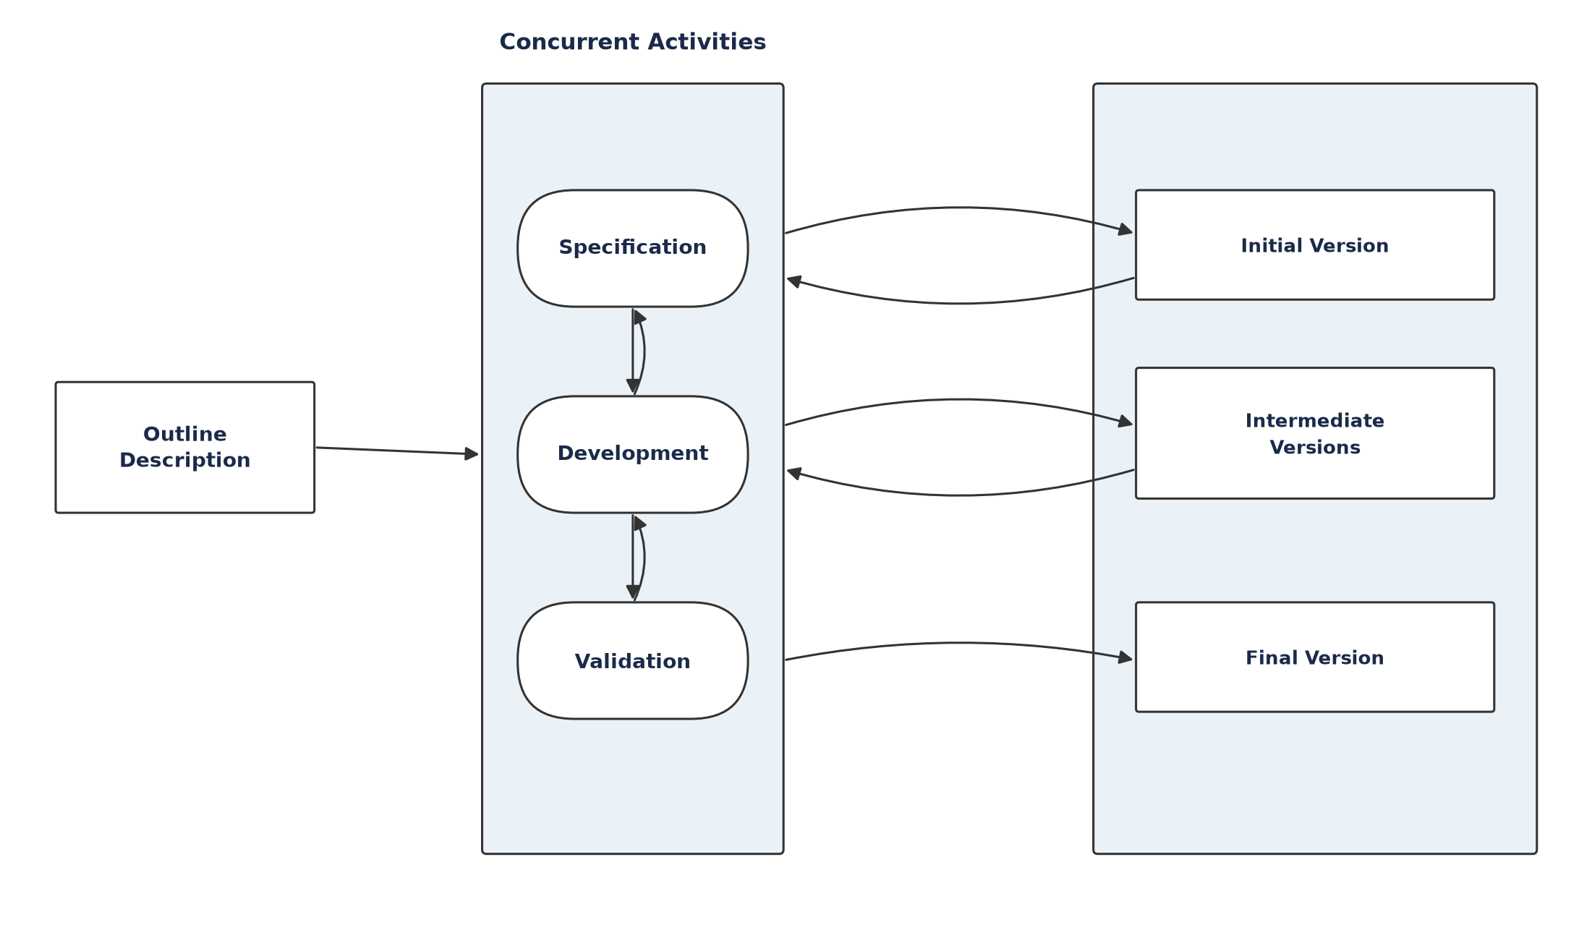
Figure 3.1: The Incremental development model
How the Incremental Model works : Development begins from an outline description of the system’s requirements rather than a complete, frozen specification. The requirements are then prioritised, and the highest-priority requirements are allocated to the earliest increments. For each increment, the relevant portion of the specification is detailed, that portion is developed, and the resulting build is validated against its requirements before work moves on. Crucially, specification, development and validation are treated as concurrent activities with rapid feedback between them, so that knowledge gained while building or validating one increment can refine the requirements and design of the increments that follow. Each completed increment is a usable product in its own right, and the customer or supervisor can evaluate it and provide feedback that shapes subsequent increments. This makes the process well suited to projects in which the full set of requirements cannot be understood at the outset and is expected to become clearer as the work proceeds.
Why the Incremental Model was selected for this project. A machine learning project of this kind is intrinsically exploratory. At the start of the work it was not possible to fix, in advance, which features would prove most informative, which classification algorithm would perform best, what level of predictive performance was achievable on the available data, or how the model’s outputs should best be exposed to a user. These decisions could only be made responsibly after real data had been collected, cleaned and analysed. The Incremental Model accommodates precisely this situation: the natural structure of a machine learning pipeline — data collection, preprocessing, baseline modelling, comparative model tuning, interpretation and interface delivery — already corresponds to a sequence of increments, each producing a working and independently verifiable artefact such as a cleaned dataset, a trained baseline model, a tuned final model, and an interpretable prediction service. Selecting the Incremental Model therefore allowed each stage to be evaluated on its own merits before the next was undertaken, and allowed the requirements of later increments — for example, which features to expose in the SHAP explanation — to be refined using evidence gathered in earlier increments.
Why the Incremental Model is more suitable than other SDLC approaches for this project. A strictly sequential Waterfall approach was unsuitable because it requires the requirements and design to be frozen before development begins; for a data-driven model whose achievable accuracy and most informative features are unknown until the data has been explored, freezing the specification at the outset is not possible without guessing. The Spiral Model, although iterative, is organised around repeated formal risk analysis at each cycle and carries process overhead heavier than is warranted for a project of this scale. A pure Prototyping approach is useful for clarifying requirements through throwaway or evolutionary prototypes, and elements of it are reflected in the early data-exploration work, but it does not by itself provide the disciplined, staged progression needed to manage baseline modelling, comparative tuning and interpretation as separately validated deliverables. A Reuse-Oriented approach — assembling the system largely from existing components and libraries — is reflected in the use of established machine learning libraries, but it describes how components are sourced rather than how the development itself should be staged. The Incremental Model, by contrast, matches both the technical shape of the machine learning pipeline and the practical constraints of an undergraduate thesis, in which supervisory feedback obtained after each stage of work needed to be incorporated before proceeding, rather than accumulated only at a single final review. For these reasons the Incremental Model was adopted, and its advantages map directly onto the development process of this research project as described in Section 3.3.

3.3 Description of Methodology
Figure 3.2 illustrates how the Incremental Model was applied to this project. The system was built in five increments, each ending with an evaluation step whose outcome fed back into the requirements of the increment that followed.
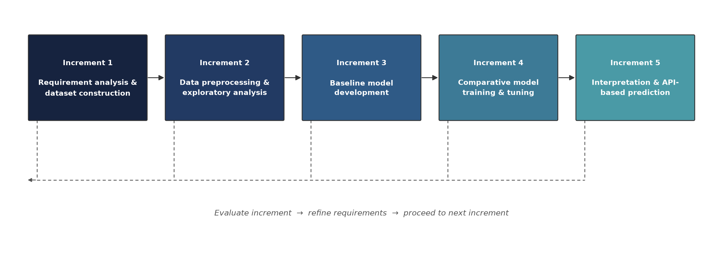
Figure 3.2: Incremental development of the employability prediction system
Increment 1 — Requirement analysis and dataset construction. The research objectives from Chapter 1 were translated into a concrete list of data attributes — academic, technical, experiential, certification, soft-skill and job-search variables — and a suitable secondary dataset, the Student Career Success Prediction Dataset (50,000 records, obtained from Kaggle), was identified, reviewed against those attributes, and prepared for use in place of a purpose-collected primary survey.
Increment 2 — Data preprocessing and exploratory analysis. Missing values, inconsistent categorical entries and outliers in the collected data were identified and treated; numerical features were scaled and categorical features encoded; and exploratory analysis was used to check the distribution of the employment outcome and the resulting class balance.
Increment 3 — Baseline model development. A Logistic Regression baseline was specified to establish a reference level of predictive performance and to validate the end-to-end data pipeline before more complex models were introduced. In the executed implementation the pipeline was validated end-to-end directly with the XGBoost classifier; the baseline comparison itself remains outstanding and is reported as such in Section 5.8.
Increment 4 — Comparative model training and tuning. Decision Tree, Random Forest, Support Vector Machine and XGBoost classifiers were planned for training under a common protocol, with model selection based on F1-score and minority-class recall rather than accuracy alone. Of these, Logistic Regression, Decision Tree, Random Forest and XGBoost were trained and evaluated within the project timeframe under an identical stratified 80:20 hold-out partition, with XGBoost’s hyperparameters selected via RandomizedSearchCV and its stability further confirmed by 5-fold cross-validation (Section 5.7.1); Support Vector Machine alone was not run, on computational-cost grounds at n = 50,000. Section 5.8 sets out the reasoned basis for the XGBoost selection and Section 6.3.1 records Support Vector Machine’s addition as the one still-outstanding item of this increment.
Increment 5 — Interpretation and API-based prediction. The selected model was interpreted through native feature-importance analysis to produce a global ranking of the determinants of employability, and the prediction itself was made accessible through the HTTP API documented in Chapter 5, in place of the interactive dashboard originally envisaged (Section 6.3). SHAP-based individual-level explanation was specified for this increment but has not been implemented; it is reported as outstanding in Sections 5.9 and 5.15 and carried forward in Section 6.3.
At the close of each increment, the resulting artefact was reviewed against the requirements established in Chapter 1 before development proceeded to the next increment, consistent with the evaluate-and-refine loop shown in Figure 3.2. This incremental structure allowed key methodological decisions — most importantly, the choice of final classification algorithm and the treatment of class imbalance — to be made on the basis of evidence gathered during earlier increments, rather than fixed at the outset of the project. The detailed machine learning pipeline through which raw graduate data is transformed into an employability prediction, which operationalises Increments 1 to 5 above, is presented as part of the research design in Chapter 4.

Chapter 4: Research Design
This chapter sets out the research design of the project: how the study was organised, how the data and processes flowed through the system, how the machine learning model was developed and evaluated, and how the resulting predictions and explanations were made available to end users. Whereas Chapter 3 justified and described the incremental development methodology at a process level, this chapter describes the concrete design that the methodology produced — the machine learning pipeline at the centre of the research, the requirements that the surrounding system was built to satisfy, and the data-flow and interaction designs that connect the two. Although the core contribution of the project is a machine learning model rather than a conventional transactional system, the model is intended to be delivered behind a usable prediction interface so that its outputs can be consumed directly by students, administrators and reviewers; at the current stage this interface is realised as a documented HTTP API, demonstrated in Chapter 5, with a browser-based dashboard remaining future work (Section 6.3).

4.1 Overview of the Research Design
The research design translates the incremental methodology of Chapter 3 into a concrete arrangement of data, processing stages and system components. At the highest level the design comprises three connected parts. The first is the machine learning pipeline (Section 4.2), which specifies the technical sequence through which raw graduate data is transformed into an employability prediction and its explanation; this pipeline is the analytical core of the research and operationalises the five development increments of Section 3.3. The second is the requirement model (Section 4.3), which defines what the prediction system must do and the quality attributes it must satisfy, derived from the research objectives, the reviewed literature and supervisory feedback. The third is the structural design of the surrounding system (Sections 4.4 and 4.5), expressed as data-flow and use-case models that show how data moves between processes and stores and how each type of user interacts with the system. Together these parts define how the research was designed, how the data and processes were organised, and how the proposed system components were developed and evaluated against the research objectives.

4.2 Machine Learning Model Workflow
At the centre of the research design is the machine learning pipeline itself — the sequence of technical stages through which raw graduate data is turned into an employability prediction. The pipeline comprises nine stages: data collection, data preprocessing, feature engineering, exploratory data analysis, splitting the dataset into training and testing partitions, model training, model evaluation, model selection, and, finally, prediction. Figure 4.1 illustrates this workflow.
Data collected on fresh CSE graduates is first cleaned and prepared: missing values are identified and treated, irrelevant attributes are removed, inconsistent or invalid entries are corrected, categorical variables are encoded numerically, and numerical features are scaled. Feature engineering then selects and constructs the variables that represent the six employability dimensions introduced in Section 1.6, and exploratory data analysis is used to examine feature distributions, relationships between variables, and the balance of the employment outcome before any model is trained. The prepared dataset is split into training and testing partitions so that model performance can be assessed on data the model has not seen during training, guarding against the misleadingly optimistic results that arise from evaluating a model on its own training data.
Multiple candidate classification algorithms (Section 3.3, Increments 3–4) are then trained on the training partition and evaluated on the held-out testing partition using accuracy, precision, recall, F1-score and the confusion matrix, so that the trade-off between correctly identifying employable and non-employable graduates is made explicit rather than collapsed into a single figure. The candidate with the strongest overall evidence across these metrics — not accuracy alone — is selected as the final model. Once selected, the model is used to generate a prediction for a new graduate: the graduate’s submitted information is validated, passed through the same preprocessing and feature-transformation steps applied to the training data, and then scored by the trained model to produce the final employability prediction, as summarised by the right-hand path in Figure 4.1.
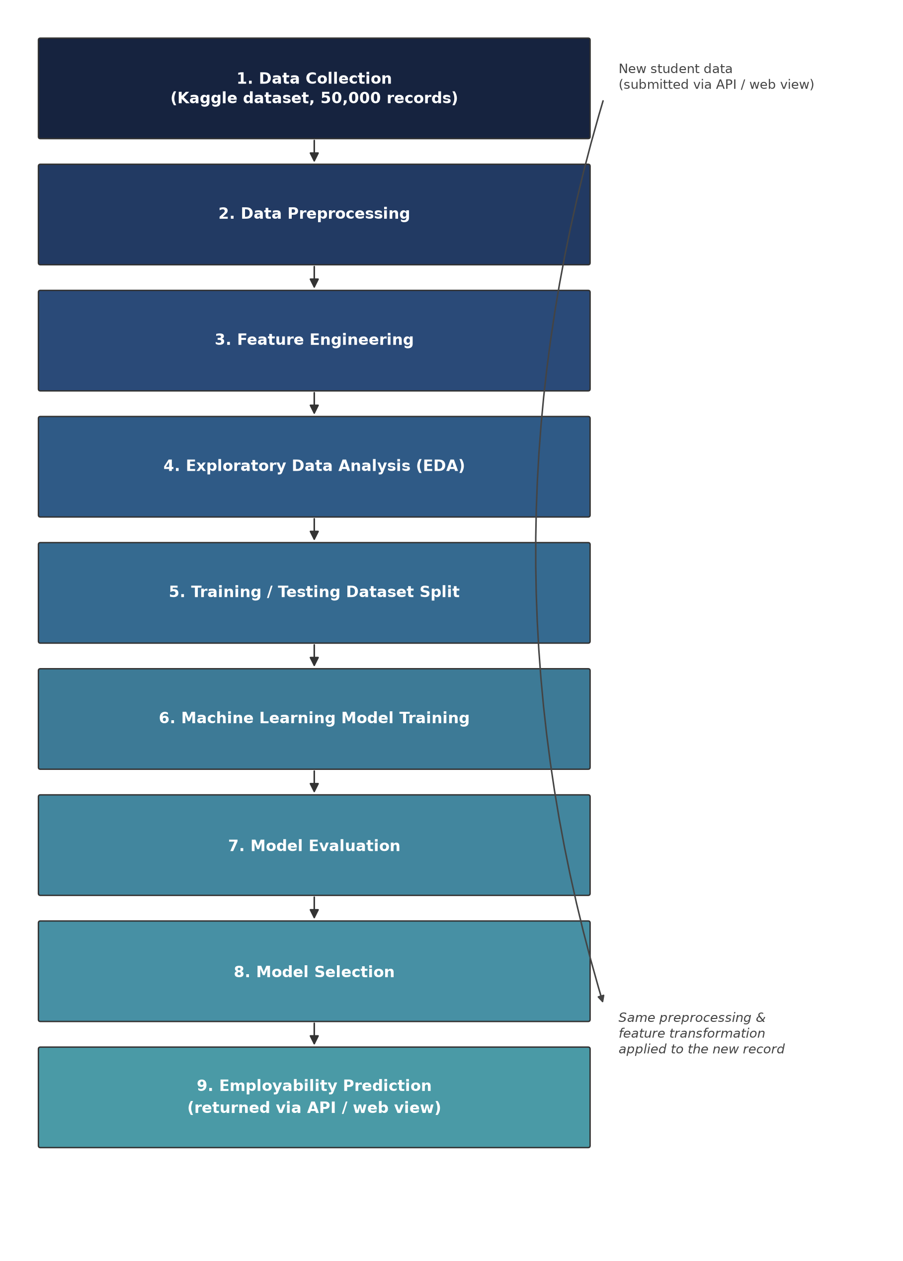
Figure 4.1: Machine learning model workflow, from data collection through to the employability prediction produced for a new graduate
The system is therefore best understood as a decision-support mechanism rather than a replacement for human recruitment judgement: it does not check whether a graduate satisfies any single fixed condition, but instead learns patterns across multiple variables simultaneously and uses those learned patterns, together with the interpretability layer described later in this chapter and in Chapter 5, to indicate where a graduate’s profile is aligned with the characteristics associated with employability in the training data.

4.3 Requirement Analysis for the Prediction System

4.3.1 requirement gathering techniques
Requirements for the system were gathered through a combination of techniques appropriate to an academic research project of this scale. Objective-driven analysis used the research objectives and specific objectives defined in Section 1.4, which fixed the core functional need — collecting graduate profile data, producing an employability prediction, and explaining that prediction. Supervisor consultation through regular discussions with the project supervisor shaped the requirement to document an explicit SDLC model, system diagrams and a demonstrable interface. Literature-informed feature elicitation drew on the international and Bangladeshi literature discussed in Chapter 2 to define the set of attributes that the data collection module needed to capture — academic, technical, experiential, certification, soft-skill and job-search variables. Peer walkthroughs involved informal review of the draft profile-submission format and prediction output with a small number of peer CSE students, used to check that the structure of the input was clear and that the prediction output was interpretable to a non-technical user.

4.3.2 functional and non-functional requirements
Requirements were classified into functional requirements, listed in Table 4.1, and non-functional requirements, listed in Table 4.2.
Table 4.1: Functional requirements
ID | Functional requirement
FR1 | The system shall allow a graduate/student user to submit a profile containing academic, technical, experiential, certification, soft-skill and job-search attributes.
FR2 | The system shall validate submitted profile data before it is stored or used for prediction.
FR3 | The system shall generate a binary employability prediction (employable / not employable) together with a predicted probability, using the trained classification model.
FR4 | The system shall generate a SHAP-based explanation for each individual prediction, showing the attributes that most increased or decreased the predicted probability.
FR5 | The system shall present the prediction and its explanation to the user through an interactive interface.
FR6 | The system shall allow an administrator/researcher to view aggregate model-performance metrics across candidate algorithms.
FR7 | The system shall allow an administrator/researcher to manage the underlying graduate dataset and trigger model retraining.

Table 4.2: Non-functional requirements
ID | Non-functional requirement
NFR1 | Usability — the profile-submission format and prediction output shall be understandable to a non-technical graduate user without additional training.
NFR2 | Performance — a prediction and its SHAP explanation shall be generated and returned within a few seconds of profile submission.
NFR3 | Reliability — the selected classification model shall be evaluated using stratified k-fold cross-validation before deployment, so that reported performance is not an artefact of a single train/test split.
NFR4 | Maintainability — the data pipeline, model training and interface components shall be separated into independent modules so that the model can be retrained without modifying the interface.
NFR5 | Accessibility — the system shall not require account registration or authentication of any kind; any student shall be able to submit their data and directly obtain an employability evaluation.
NFR6 | Portability — at the current stage the system shall be accessible through a documented HTTP API (demonstrated in Section 5.7 using Postman); a browser-based dashboard requiring no specialised client software is planned as a future extension (Section 6.3).

4.4 Data Flow Design
Figure 4.2 shows the context-level Data Flow Diagram (DFD Level 0), identifying the three external entities that interact with the system — the graduate/student user, the administrator/researcher, and the university career office — and the single process representing the system as a whole.
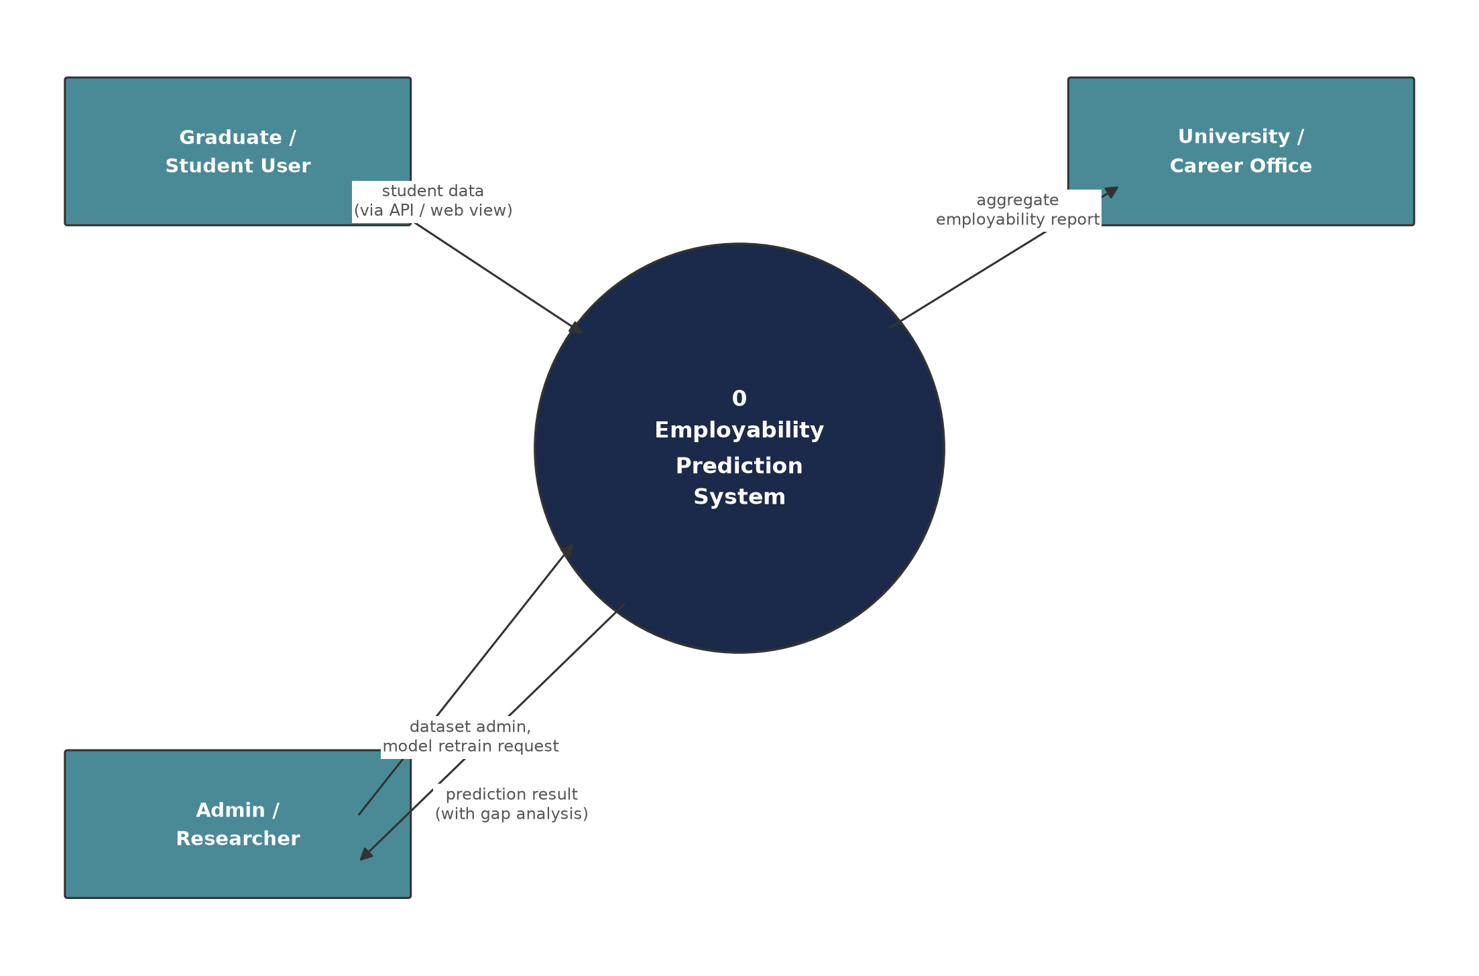
Figure 4.2: Context-level Data Flow Diagram (DFD Level 0)
Figure 4.3 decomposes this single process into the six constituent processes that make up the prediction pipeline, together with the three data stores they read from and write to: the graduate profile store (D1), the trained model store (D2) and the prediction log (D3). This decomposition corresponds directly to the five development increments described in Section 3.3 and to the machine learning workflow of Section 4.2, with the final process representing the administrator-triggered retraining path that closes the loop back into the profile store.
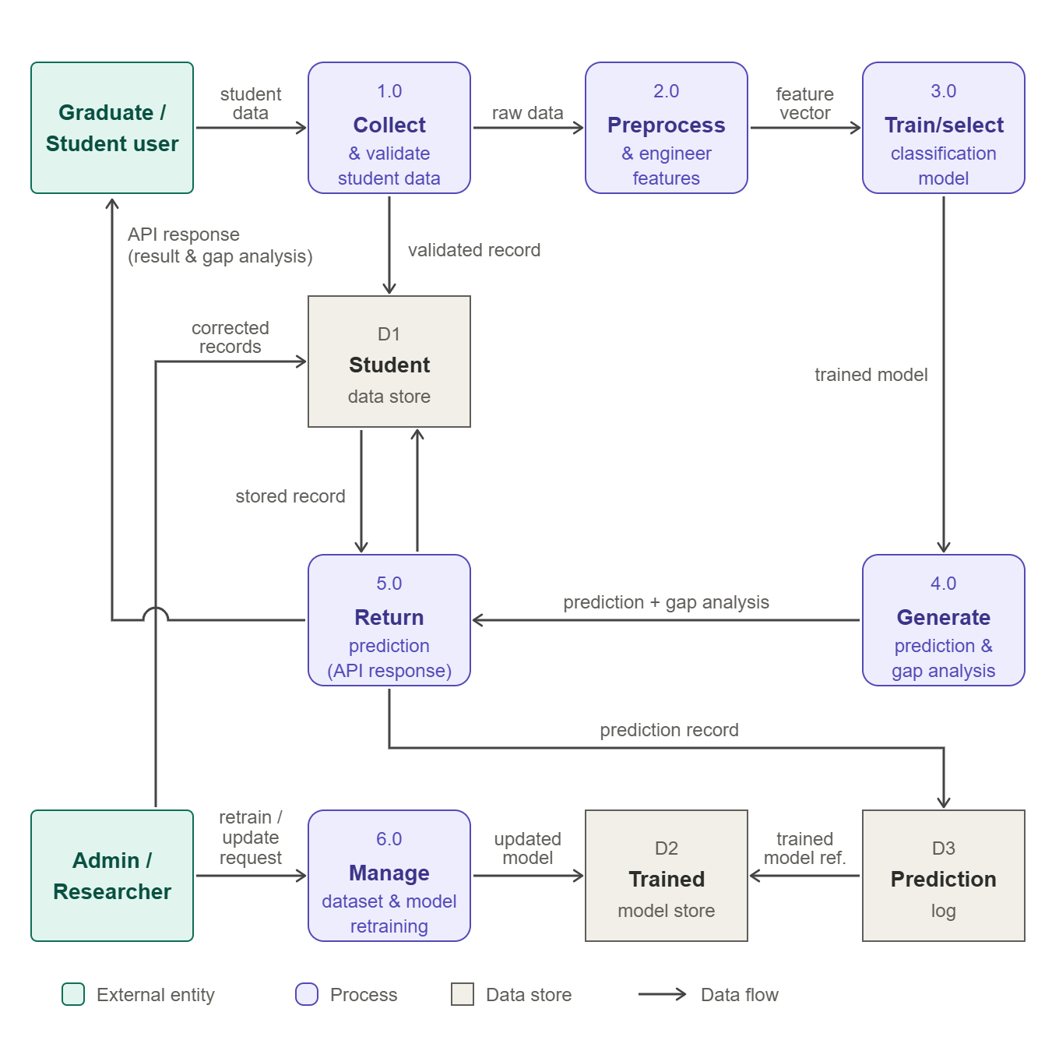
Figure 4.3: Data Flow Diagram (DFD Level 1) of the employability prediction system

4.5 System Interaction Design: Use Cases
Figure 4.4 presents the Use Case diagram for the system, identifying the graduate/student user, the administrator/researcher and the university career office as actors. Table 4.3 provides the corresponding use case narratives.
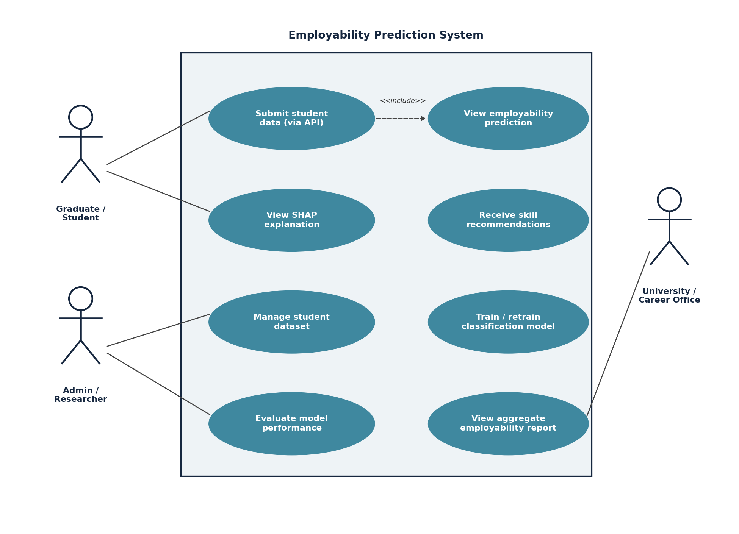
Figure 4.4: Use Case diagram of the employability prediction system
Table 4.3: Use case narratives
Use case | Actor(s) | Brief narrative
Submit student data | Graduate / Student | The graduate submits their academic, technical, experiential, certification, soft-skill and job-search data directly via the prediction API (Section 5.7); no account, registration or login is required.
View employability prediction | Graduate / Student | Includes ‘Submit student data’. After submission, the system returns a predicted employability probability and classification (Section 5.7).
View SHAP explanation | Graduate / Student | The graduate receives a breakdown of the attributes that most increased or decreased their predicted probability, returned as structured SHAP contribution data in the API response (Section 5.7).
Receive skill recommendations | Graduate / Student | Derived from the SHAP explanation, the system highlights attributes with the largest negative contribution as candidate areas for improvement.
Manage graduate dataset | Admin / Researcher | The administrator reviews, corrects or extends records in the graduate profile store.
Train / retrain classification model | Admin / Researcher | The administrator triggers comparative retraining of the candidate classifiers described in Section 3.3, Increment 4.
Evaluate model performance | Admin / Researcher | The administrator reviews comparative accuracy, F1-score, minority-class recall and ROC-AUC for each candidate algorithm, currently produced during model evaluation (Section 4.2) rather than through a dedicated interface.
View aggregate employability report | University / Career Office | The career office views summary statistics on predicted employability across the graduate cohort.

Chapter 5: Results and Discussion
This chapter presents and critically discusses the results obtained from the employability prediction system developed in this thesis. It follows the research design set out in Chapter 4, moving from the dataset and its characteristics, through preprocessing, class-balance analysis, the training and testing strategy, model training and evaluation, to the interpretation of the selected model and the current system output. Rather than presenting results in isolation, each result is analysed and interpreted: what it shows, why it arises, how it relates to the reviewed literature, and how it contributes to answering the research questions stated in Section 1.3. Every numerical value reported in this chapter is traceable to the executed pipeline and its console output, which are reproduced as figures where they constitute primary evidence. The chapter closes with an explicit assessment of the extent to which each research objective and research question has been fulfilled, the limitations that the results themselves reveal, and a validation summary recording the verification status of each reported element.

5.1 Dataset Description and Characteristics
The model was developed on the Student Career Success Prediction Dataset obtained from Kaggle (Fatimah, 2026), used in this study after the cleaning and normalisation steps described in Section 5.3 were applied programmatically to the raw student_career_success_dataset.csv file (no separate pre-cleaned file is distributed; cleaning is performed in-pipeline at load time). As set out in Section 1.6, this secondary dataset was selected because its variables align closely with the six employability dimensions derived from the reviewed literature — academic performance, technical and programming proficiency, practical experience, professional certifications and self-directed learning, soft skills, and career preparation behaviour. On loading, the pipeline reported 50,000 instances and 23 columns, comprising 22 candidate predictor attributes and one target attribute, Placement_Status. Table 5.1 summarises the principal characteristics of the dataset as used in this study.
Table 5.1: Summary characteristics of the dataset as used in this study
Characteristic | Value
Dataset name | Student Career Success Prediction Dataset (Kaggle)
File used | student_career_success_dataset.xlsx (raw Kaggle export; cleaned and feature-engineered in-pipeline at load time, Section 5.3)
Total records loaded | 50,000
Total columns loaded | 23 (22 predictors + 1 target)
Target variable | Placement_Status
Target classes | Employable; Not Employable
Predictors excluded as optional/demographic | 6
Engineered features constructed | 2
Features retained for training | 18
Numeric features (after retention) | 14
Categorical features (after retention) | 4
Employable (majority) class | 39,040 records (78.08%)
Not Employable (minority) class | 10,960 records (21.92%)
Training partition | 40,000 records (80%)
Testing partition | 10,000 records (20%)
Duplicate handling | drop_duplicates() applied prior to modelling
Missing-value handling | Median imputation (numeric); modal imputation (categorical)

Two characteristics in Table 5.1 warrant immediate comment because they shape every result that follows. First, the dataset is an order of magnitude larger than the single-institution samples typical of the studies reviewed in Chapter 2, most of which operated on a few hundred to a few thousand records. A sample of 50,000 substantially reduces sampling variance in the estimated performance metrics and makes the held-out test partition of 10,000 records large enough that reported metrics are stable to within a fraction of a percentage point. Second, the target is materially imbalanced at approximately 78:22, which is analysed in Section 5.4 and which directly motivates the rebalancing and threshold decisions documented in Sections 5.6 and 5.7.
The class counts reported in Table 5.1 for the full dataset are derived from the per-class support printed by the classification report for the held-out test partition (7,808 Employable and 2,192 Not Employable out of 10,000). Because the partition was produced by a stratified split at exactly test_size = 0.2, the class proportions in the test partition reproduce those of the full dataset, so the full-dataset counts follow as 7,808 × 5 = 39,040 and 2,192 × 5 = 10,960. This derivation is stated explicitly so that the figure is auditable rather than asserted.
Figures 5.1 and 5.2 reproduce the loaded dataset as it appears in the spreadsheet view, confirming the attribute names, the column ordering and the form of the recorded values. These figures are retained in their original colour because they are primary evidence of the data actually used; reproducing them in monochrome would amount to reconstructing rather than evidencing the source.
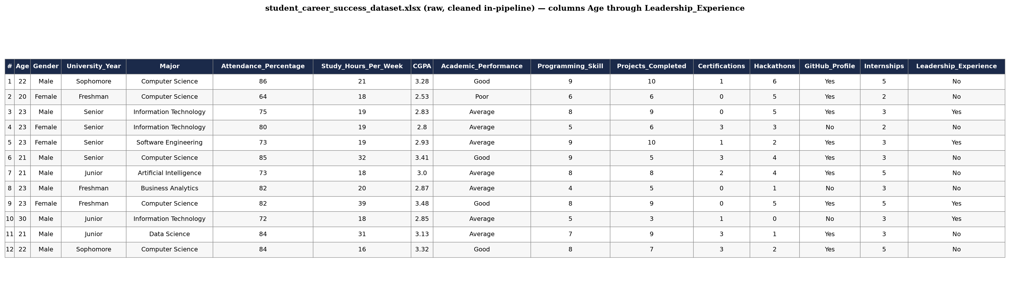
Figure 5.1: Loaded dataset, columns Age through Leadership_Experience
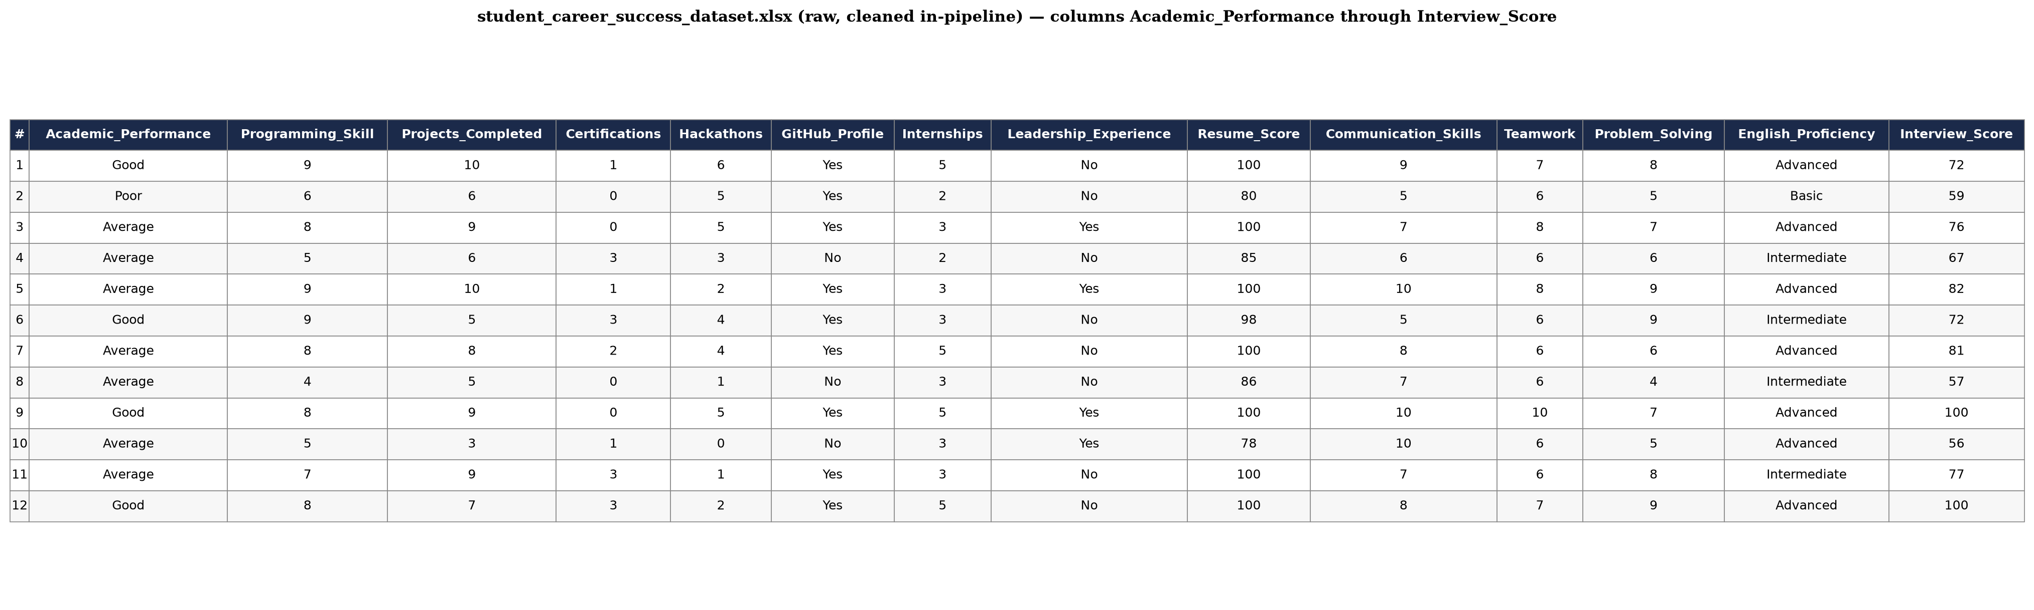
Figure 5.2: Loaded dataset, columns Academic_Performance through Interview_Score

5.2 Dataset Analysis: Features, Data Types and Roles
This section documents every attribute in the dataset, its data type, its meaning and its role in the prediction task. The 22 candidate predictors divide into three groups: six demographic or contextual attributes deliberately excluded from model training, sixteen attributes retained as substantive predictors, and — added to these — two composite features constructed during feature engineering. Table 5.2 sets out the complete feature dictionary.

Table 5.2: Feature dictionary of the dataset
Feature | Data Type | Description | Role in Prediction
Age | Numeric (integer) | Student age in years. | Excluded — demographic
Gender | Categorical | Recorded gender of the student. | Excluded — demographic
University_Year | Categorical | Year of study (Freshman, Sophomore, Junior, Senior). | Excluded — contextual
Major | Categorical | Degree programme (e.g. Computer Science, Software Engineering, Data Science, Cybersecurity, Artificial Intelligence, Information Technology, Business Analytics). | Excluded — contextual
Attendance_Percentage | Numeric (integer) | Percentage of classes attended. | Excluded — optional
LinkedIn_Profile | Categorical (Yes/No) | Whether the student maintains a LinkedIn profile. | Excluded — optional
Study_Hours_Per_Week | Numeric (integer) | Self-reported weekly hours of independent study. | Retained — academic effort; rank 13 of 18
CGPA | Numeric (float) | Cumulative grade point average on a 4.00 scale. | Retained — academic attainment; rank 7 of 18
Academic_Performance | Categorical | Ordinal academic standing (Good, Average, Poor). | Retained — academic attainment; rank 12 of 18
Programming_Skill | Numeric (integer) | Rated programming proficiency on an ordinal scale. | Retained — technical proficiency; rank 3 of 18
Projects_Completed | Numeric (integer) | Count of completed academic or personal projects. | Retained — practical experience; rank 8 of 18
Certifications | Numeric (integer) | Count of professional certifications held. | Retained — self-directed learning; rank 11 of 18
Hackathons | Numeric (integer) | Count of hackathons or competitive events participated in. | Retained — practical experience; rank 15 of 18
GitHub_Profile | Categorical (Yes/No) | Whether the student maintains a public code portfolio. | Retained — portfolio evidence; rank 17 of 18
Internships | Numeric (integer) | Count of internships undertaken. | Retained — industry exposure; rank 4 of 18
Leadership_Experience | Categorical (Yes/No) | Whether the student has held a leadership role. | Retained — behavioural attribute; rank 16 of 18
Resume_Score | Numeric (integer) | Rated quality score assigned to the student’s resume. | Retained — career preparation; rank 1 of 18
Communication_Skills | Numeric (integer) | Rated communication ability on an ordinal scale. | Retained — soft skills; rank 9 of 18
Teamwork | Numeric (integer) | Rated ability to work collaboratively. | Retained — soft skills; rank 14 of 18
Problem_Solving | Numeric (integer) | Rated analytical and problem-solving ability. | Retained — soft skills; rank 5 of 18
English_Proficiency | Categorical | Ordinal English competence (Advanced, Intermediate, Basic). | Retained — soft skills; rank 6 of 18
Interview_Score | Numeric (integer) | Rated performance score from interview assessment. | Retained — career preparation; rank 10 of 18
Overall_Preparedness_Index | Numeric (float, engineered) | Composite index computed as (Interview_Score × 0.7) + (Internships × 0.3). | Retained — composite readiness; rank 2 of 18
Skills_per_Project | Numeric (float, engineered) | Productivity ratio computed as Programming_Skill ÷ (Projects_Completed + 1). | Retained — composite productivity; rank 18 of 18
Placement_Status | Categorical (target) | Binary employment outcome: Employable or Not Employable. | Target variable

The six excluded attributes were removed before training as a deliberate design decision rather than as a consequence of data quality. Age, Gender, University_Year and Major are demographic or contextual descriptors over which a student has no control at the point of intervention; retaining them would allow the model to encode group membership rather than modifiable preparation behaviour, and would risk exactly the subgroup bias identified as research gap G5 in Section 2.7. Attendance_Percentage and LinkedIn_Profile were excluded as optional attributes not consistently interpretable across institutions. This exclusion is consistent with the stated purpose of the system: to produce actionable guidance about what a student can change, not a demographic profile of who is likely to be hired.
Two composite features were then constructed. Overall_Preparedness_Index combines interview performance and industry exposure into a single weighted readiness measure, with the larger weight placed on interview performance. Skills_per_Project expresses programming proficiency relative to project volume, distinguishing a student whose skill is concentrated in a few substantial projects from one whose project count is high relative to demonstrated skill; the denominator is incremented by one to avoid division by zero for students with no completed projects. Both features are derived entirely from attributes already present in the dataset and therefore introduce no external information. After exclusion and engineering, 18 features were retained — 14 numeric and 4 categorical — as confirmed by the console output reproduced in Figure 5.7.
Note on completeness. The pipeline applies drop_duplicates() and median/modal imputation, so both duplicate removal and missing-value treatment are implemented. However, the executed notebook does not print the number of duplicate rows removed or the count of missing values per attribute, and the record count of 50,000 reported in Figure 5.7 is the count after deduplication. A direct load of the raw dataset confirms zero missing values across all 29 raw columns and zero exact duplicate rows (drop_duplicates() removes none), as recorded in the validation summary of Section 5.15.

5.3 Data Preprocessing and Preparation Results
Preprocessing was carried out as specified in Increment 2 (Section 3.3) and the data-preprocessing stage of the pipeline (Section 4.2), and was implemented as a scikit-learn ColumnTransformer embedded inside the modelling pipeline rather than as a set of standalone transformations applied to the full dataset. This is an important methodological point: because the transformer is fitted inside the pipeline, all imputation and scaling parameters are learned from the training partition alone and then applied unchanged to the test partition. No information from the held-out test set influences the fitted preprocessing, so the reported test performance is free of the data-leakage problem that a naive whole-dataset scaling would introduce.
Duplicate records were removed and whitespace was stripped from all string-valued columns to eliminate spurious category variants arising from inconsistent data entry. The 14 numeric features were then imputed with the training-set median and standardised with StandardScaler to zero mean and unit variance, so that attributes measured on different scales — CGPA on a four-point scale, Resume_Score on a hundred-point scale, Internships as a small count — contribute on a common footing. The 4 categorical features were imputed with the training-set mode and encoded with OneHotEncoder configured with handle_unknown = ‘ignore’, so that a category unseen during training is encoded as all-zeros at prediction time rather than raising an error. The target variable was converted to integers with LabelEncoder, which assigns labels in alphabetical order and therefore maps Employable to 0 and Not Employable to 1. This encoding matters for the interpretation of the decision threshold discussed in Section 5.6: the predicted probability the model thresholds is the probability of the Not Employable class.
The median was chosen over the mean for numeric imputation because it is robust to the skew and outliers characteristic of count attributes such as Certifications and Hackathons, where a small number of unusually high values would pull a mean-based imputation upward and systematically overstate the preparation of students whose data is incomplete. Standardisation, although not required by tree-based learners such as XGBoost, was retained so that the same fitted preprocessing pipeline can be reused without modification if scale-sensitive algorithms are added in the comparative extension identified in Section 5.8.

5.4 Class Distribution and Dataset Balance
Whether the target is balanced determines which evaluation metrics are meaningful and whether any rebalancing intervention is warranted, so the class distribution was examined before any performance figure was interpreted. Table 5.3 reports the distribution across the full dataset and across both partitions.
Table 5.3: Distribution of the target variable Placement_Status
Partition | Employable | Not Employable | Total | Minority share
Full dataset | 39,040 | 10,960 | 50,000 | 21.92%
Training set (80%) | 31,232 | 8,768 | 40,000 | 21.92%
Testing set (20%) | 7,808 | 2,192 | 10,000 | 21.92%

The dataset is therefore imbalanced, not balanced. Employable outnumbers Not Employable by a ratio of approximately 3.56 to 1, and the minority class accounts for 21.92 per cent of records. This is a moderate rather than an extreme imbalance — it is far from the 99:1 ratios encountered in fraud or rare-disease detection — but it is quite sufficient to distort both training and evaluation if left unaddressed. Figures 5.3 and 5.4 present the distribution in absolute and proportional form respectively.
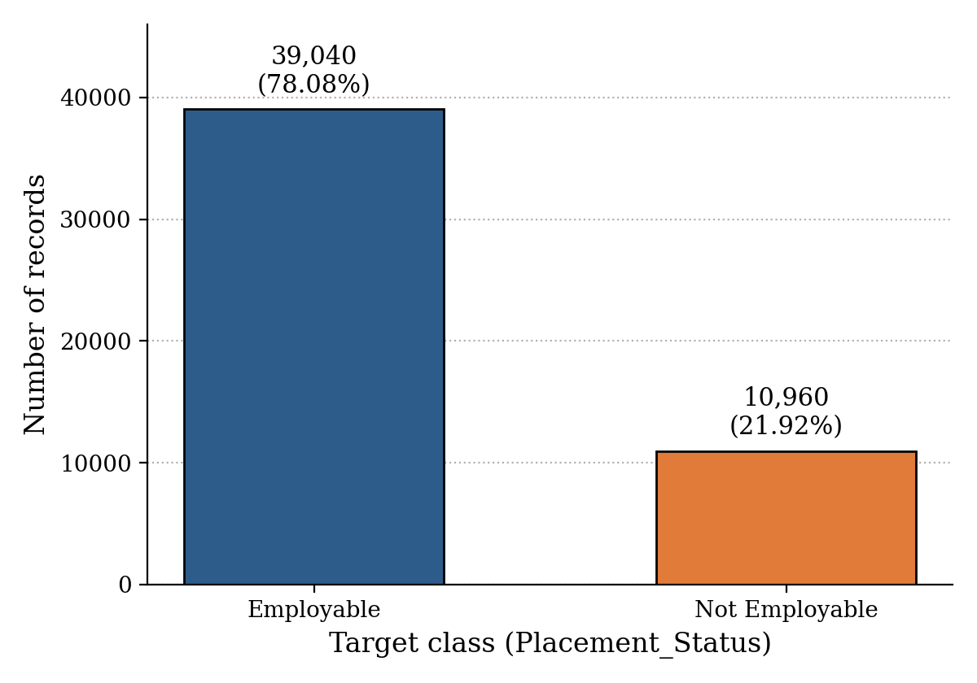
Figure 5.3: Absolute class distribution of the target variable
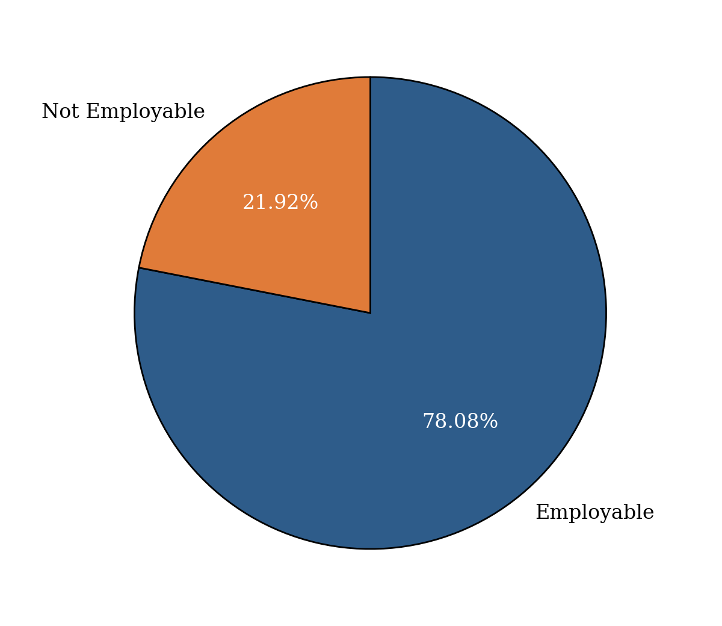
Figure 5.4: Proportional class distribution of the target variable
The consequences for machine learning are twofold. First, imbalance establishes a deceptively high accuracy baseline: a degenerate classifier that predicts Employable for every student, learning nothing whatever, would score 78.08 per cent accuracy on this dataset. Any reported accuracy must therefore be judged against that 78.08 per cent floor rather than against 50 per cent, and accuracy alone cannot be treated as evidence that a model has learned anything useful. Second, and more consequentially for this study, the standard cross-entropy objective weights every training instance equally, so a model trained without intervention minimises its loss most efficiently by fitting the majority class well and tolerating errors on the minority. The minority class here is precisely the population the system exists to identify: graduates at risk of non-employment, who are the intended recipients of early support. A model that systematically overlooks them would be accurate and useless.
Two complementary corrections were therefore applied, both documented in Section 5.6. SMOTE (Chawla et al., 2002) was inserted into the pipeline to synthesise additional minority-class instances within the training folds only, and the XGBoost objective was additionally weighted through the scale_pos_weight parameter, computed from the training partition as the ratio of majority to minority instances, approximately 3.56. The decision threshold was then lowered from the default 0.50 to 0.35. Section 5.7 shows that these three interventions, applied together, succeed emphatically in their stated aim of recovering minority-class cases, and Section 5.8 examines the cost at which that success is obtained.

5.5 Training and Testing Strategy: The 80:20 Split
The dataset was partitioned into training and testing subsets using the standard 80:20 ratio, implemented with train_test_split configured with test_size = 0.2, random_state = 42 and stratify set to the target vector. Applied to 50,000 records this yields exactly 40,000 training records and 10,000 testing records; Table 5.4 reports the resulting partition together with its class composition, and Figure 5.5 presents it graphically.
Table 5.4: Composition of the training and testing partitions
Partition | Proportion | Records | Employable | Not Employable
Training set | 80% | 40,000 | 31,232 | 8,768
Testing set | 20% | 10,000 | 7,808 | 2,192
Total | 100% | 50,000 | 39,040 | 10,960
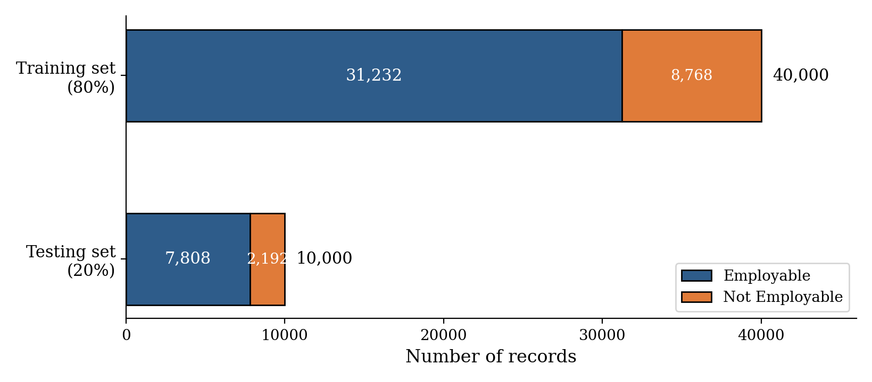
Figure 5.5: Stratified 80:20 partition of the dataset with class composition

The 80:20 ratio is appropriate for this project for three specific reasons. First, at this sample size the split resolves the usual tension between training volume and evaluation reliability without compromise: 40,000 training records are ample for a gradient-boosted ensemble of 200 trees over 18 features, while 10,000 held-out records give an evaluation sample large enough that the estimated accuracy carries a 95 per cent confidence interval of roughly ±0.9 percentage points. A more conservative 70:30 split would buy negligible additional evaluation precision at the cost of 5,000 training records, and a 90:10 split would halve the minority-class test sample without materially improving what the model can learn. Second, and decisively for an imbalanced target, the 20 per cent partition retains 2,192 minority-class instances — a large enough subsample that minority-class recall and precision are estimated stably rather than swinging on a handful of cases, which is the failure mode of the small-sample studies criticised in Section 2.6. Third, the ratio is the convention across the employability prediction literature reviewed in Chapter 2, so results reported here remain directly comparable with that body of work.
Two properties of the split deserve emphasis. It is stratified, so the 78.08:21.92 class ratio is preserved exactly in both partitions, as Table 5.3 confirms; without stratification, random variation in the allocation of minority cases would confound any comparison of minority-class performance. It is also seeded: random_state = 42 was set both for the split and for SMOTE and the XGBoost classifier, so the entire experiment is exactly reproducible, and the reported figures can be regenerated by re-executing the notebook. The value 42 is the actual seed used in the implementation and is reported here rather than assumed.
Note on validation strategy. The primary reported figures use a single stratified 80:20 hold-out split, which is defensible at n = 50,000 because the evaluation sample is large enough for stable estimates; this is additionally corroborated in Section 5.7.1 by 5-fold cross-validation on both the full dataset and the training partition, four additional random seeds, and a wider hyperparameter search, all of which reproduce the hold-out result within a fraction of a percentage point.

5.6 Machine Learning Model Workflow and Implementation
This section documents exactly how the implemented model works, stage by stage, as executed. Figure 5.6 presents the complete workflow; each stage in the diagram corresponds to a numbered section of the implementation and no stage is described that was not actually executed.
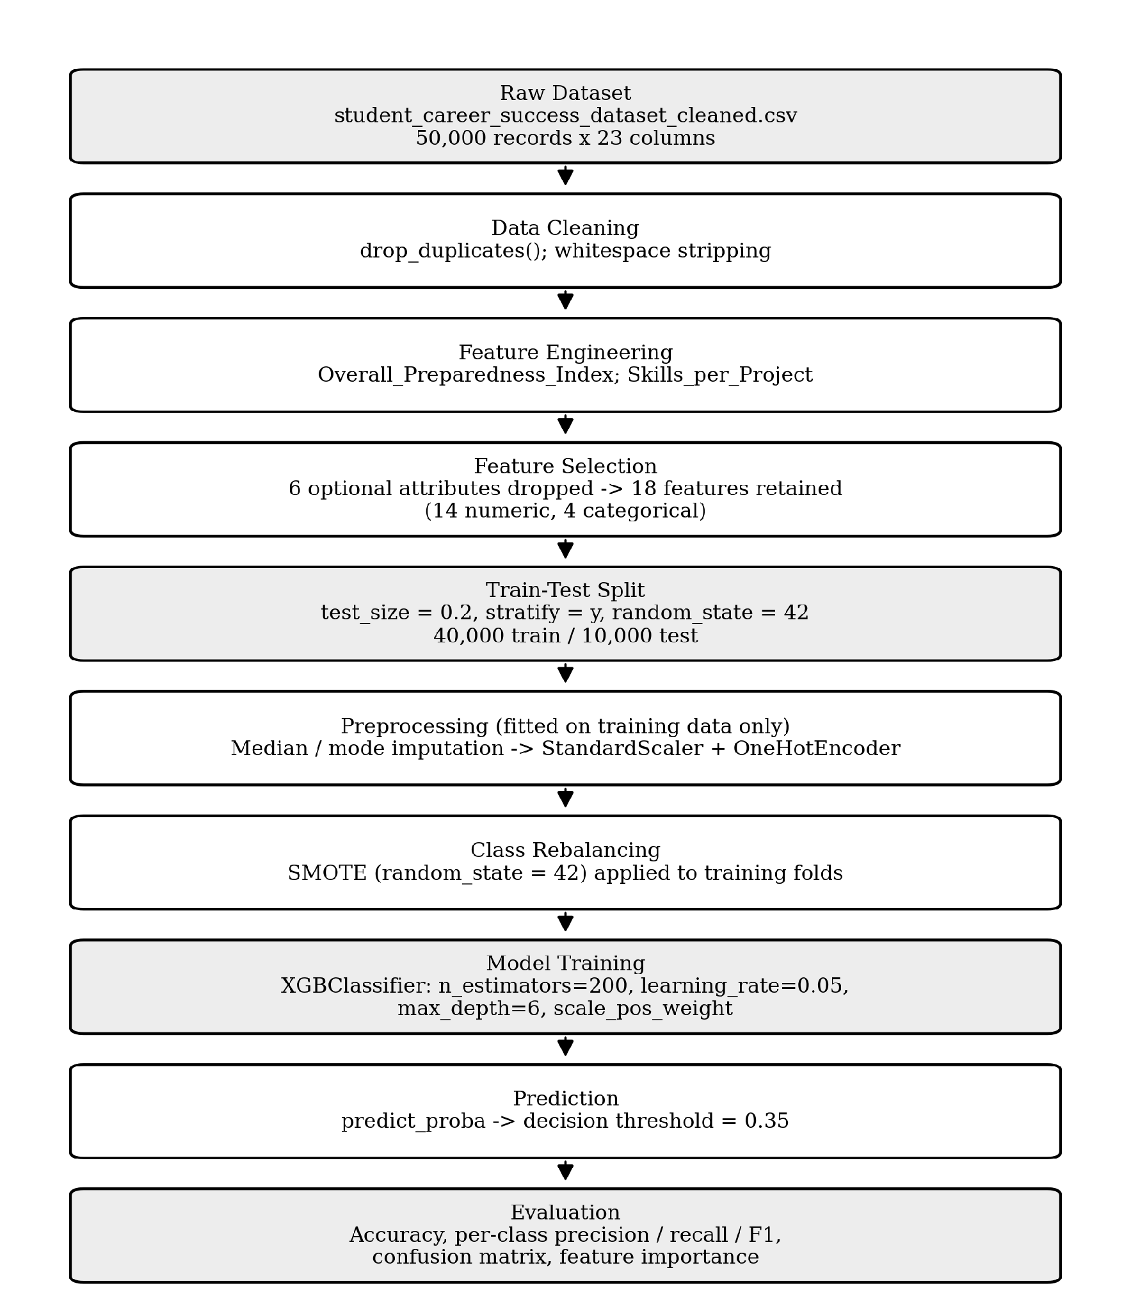
Figure 5.6: Implemented machine learning workflow, from raw dataset to final evaluation
The pipeline proceeds as follows. The cleaned CSV is loaded and deduplicated, and whitespace is stripped from string columns. The two composite features described in Section 5.2 are constructed. The target and the six optional attributes are then dropped, leaving the 18-feature predictor matrix, and the target is label-encoded. The stratified 80:20 split of Section 5.5 is applied at this point — before any transformation is fitted — which is what guarantees the absence of leakage. The remaining stages are assembled into a single scikit-learn pipeline object comprising two steps executed in order: the ColumnTransformer preprocessing of Section 5.3 and the XGBoost classifier. An earlier configuration inserted a SMOTE oversampling step and an XGBoost scale_pos_weight term between these two stages; Section 5.7 reports why that configuration was replaced, and the pipeline evaluated in this chapter contains no synthetic-sampling step.
The classifier is an XGBClassifier whose hyperparameters were selected by RandomizedSearchCV over 15 candidate combinations under 3-fold cross-validation, optimising for accuracy. The search selected 200 boosting rounds, a learning rate of 0.05, a maximum tree depth of 3, a subsample ratio of 1.0, a column-sample ratio of 1.0, a minimum child weight of 1, random_state = 42 and n_jobs = 4 for parallel execution. The shallow maximum depth of 3 is itself a regularising choice returned by the search rather than fixed in advance: it constrains each tree to simple, low-order splits, which limits overfitting on a dataset whose features carry only modest individual signal (Section 5.10) and is consistent with the small gap subsequently observed between training and held-out performance. Training the complete pipeline on 40,000 records required 0.77 seconds after the search had identified the final configuration; the search itself, evaluating 45 model fits, completed in 39.1 seconds. Both figures comfortably support the periodic retraining pathway designed in Chapter 4.
Prediction uses the standard decision rule rather than a custom one. The pipeline extracts the predicted probability of the positive class — which, given the alphabetical label encoding noted in Section 5.3, is the Not Employable class — and classifies a student as Not Employable whenever that probability is at least 0.50, the conventional default. An earlier configuration lowered this threshold to 0.35 and combined it with SMOTE oversampling and an XGBoost scale_pos_weight term, on the reasoning that failing to flag an at-risk graduate is costlier than flagging one who does not need support. Section 5.7 reports that, on this dataset, the three interventions compounded to push overall accuracy below the majority-class baseline for a precision gain that did not justify the loss, and were therefore removed from the final configuration in favour of the default threshold reported here.

5.7 Model Performance and Evaluation
The trained pipeline was evaluated on the 10,000 held-out records using accuracy, per-class precision, recall and F1-score, and the confusion matrix. These metrics were chosen in preference to accuracy alone because, as Section 5.4 established, accuracy on an imbalanced target is uninformative below the 78.08 per cent majority-class floor: precision and recall expose the trade-off between false positives and false negatives, and the F1-score summarises that trade-off in a single balanced figure. Reporting all of them per class, together with the confusion matrix, directly addresses the evaluation weakness identified across the reviewed literature, in which studies reported headline accuracy without minority-class recall (Baffa et al., 2023; Mezhoudi et al., 2023). Figure 5.7 reproduces the console output as primary evidence, and Table 5.5 sets out the same figures in the document’s reporting format.
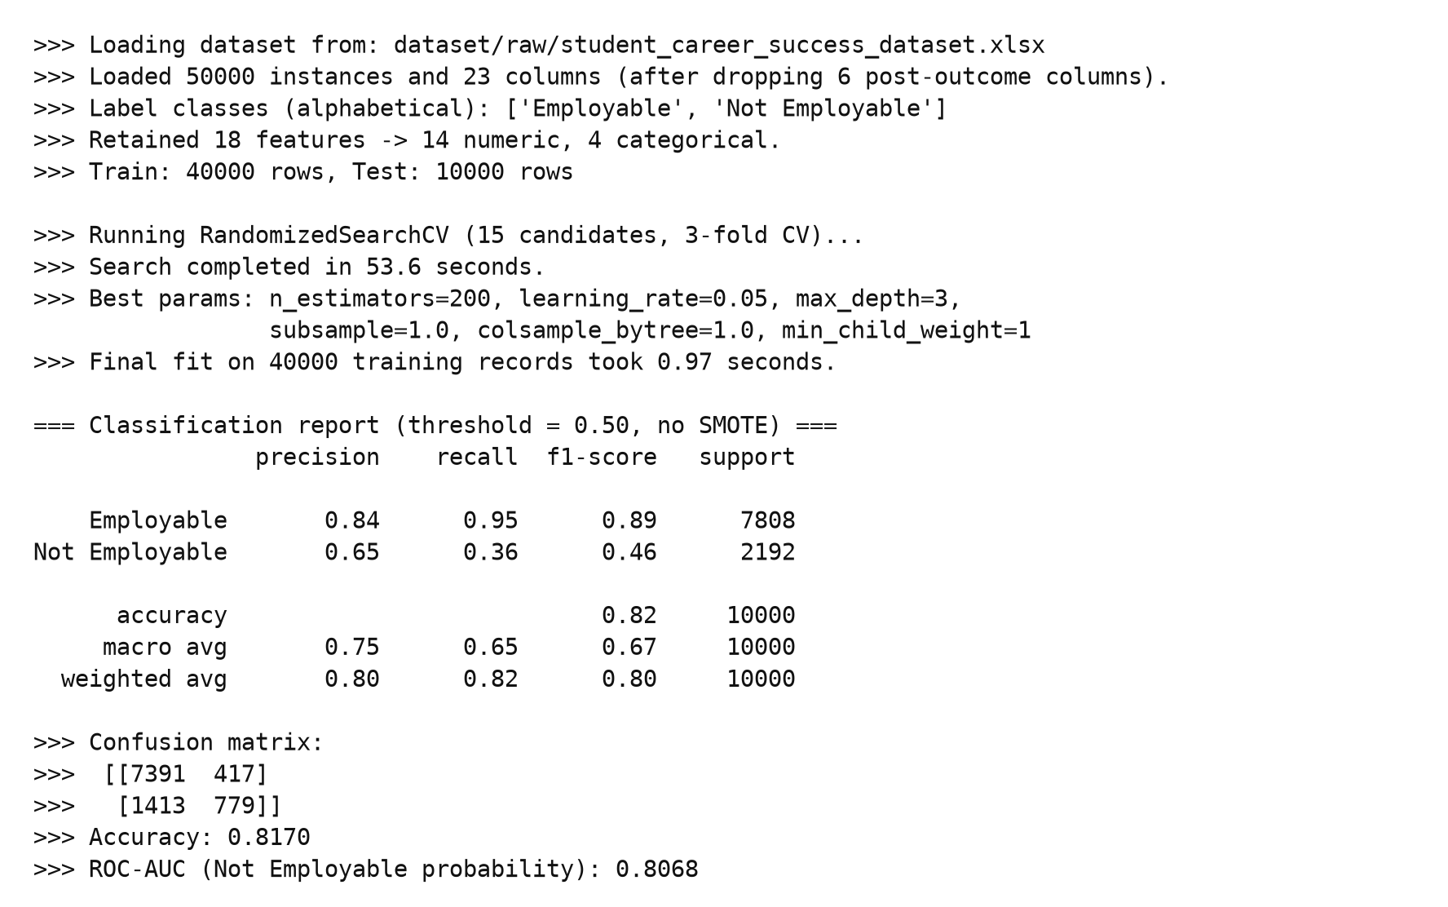
Figure 5.7: Console output of the executed pipeline, showing dataset load, retained features, training time and classification report
Table 5.5: Classification performance of the tuned XGBoost pipeline on the held-out test set (deployment threshold = 0.300, no SMOTE)
Class / Average | Precision | Recall | F1-score | Support
Employable | 0.8899 | 0.8298 | 0.8588 | 7,808
Not Employable | 0.5112 | 0.6341 | 0.5661 | 2,192
Accuracy | — | — | 0.7869 | 10,000
Macro average | 0.7005 | 0.7320 | 0.7124 | 10,000
Weighted average | 0.8069 | 0.7869 | 0.7946 | 10,000

The pipeline, evaluated at the deployment threshold of 0.300 selected in Section 5.7.1, reported an overall accuracy of 0.7869, with weighted precision of 0.8069, weighted recall of 0.7869 and a weighted F1-score of 0.7946, and a ROC-AUC of 0.8068 (the threshold-independent ranking measure, unchanged by this choice of cut-off). Figure 5.8 presents the confusion matrix underlying these figures, and Figure 5.9 reproduces the same matrix as evidence.
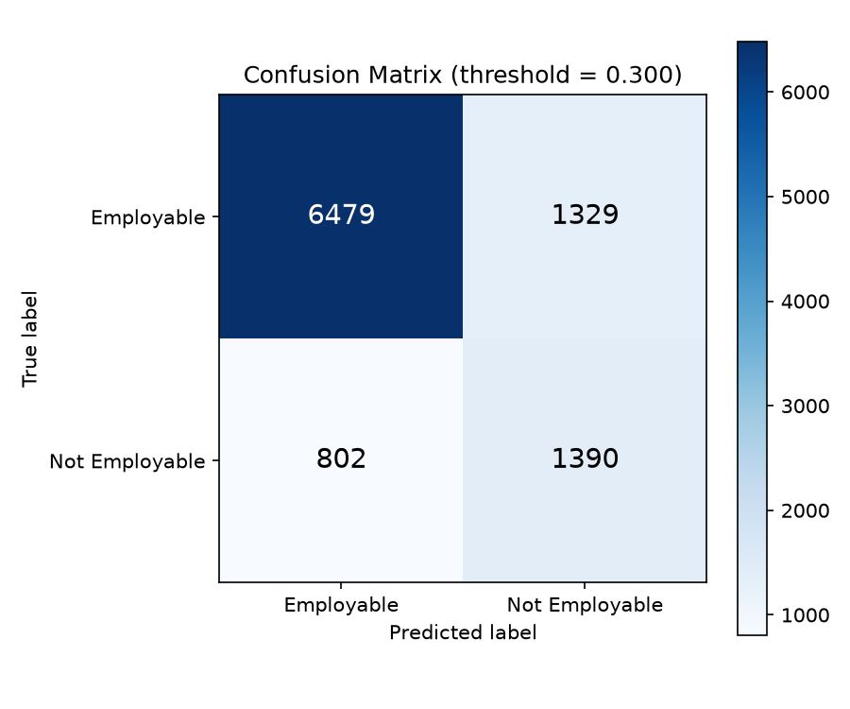
Figure 5.8: Confusion matrix for the tuned XGBoost pipeline on the held-out test set (deployment threshold = 0.300, no SMOTE)
Figure 5.9: Same confusion matrix, reproduced as source evidence
The confusion matrix reconciles exactly with Table 5.5 and is the most informative single result in this chapter. Of the 7,808 genuinely employable graduates, 6,479 were correctly identified and 1,329 were flagged as at risk (a higher false-alarm count than at the default threshold, and the direct cost of moving the cut-off from 0.50 to 0.300). Of the 2,192 graduates who were genuinely not employable, 1,390 were correctly identified and 802 were missed — nearly twice as many correctly flagged as at the default threshold's 779. Overall accuracy follows as (6,479 + 1,390) / 10,000 = 0.7869, reproducing the reported figure precisely; minority-class recall is 1,390 / 2,192 = 0.6341 and minority-class precision is 1,390 / (1,329 + 1,390) = 0.5112, both matching the classification report to two decimal places. Figure 5.10 presents the per-class metrics side by side.
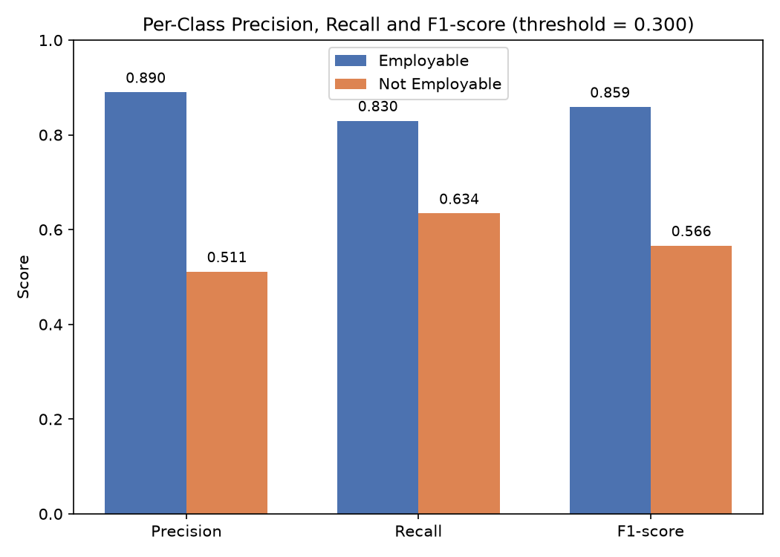
Figure 5.10: Per-class precision, recall and F1-score comparison
Interpretation. These results must be read against the configuration change documented in Section 5.6, and against the deployment-threshold selection reported above. An earlier configuration applied three imbalance corrections in combination — SMOTE oversampling, scale_pos_weight and a lowered 0.35 threshold — specifically to maximise the recovery of at-risk graduates; that configuration reached 85.3 per cent minority-class recall but pushed overall accuracy to 63.84 per cent, below the 78.08 per cent majority-class baseline of Section 5.4, for a minority-class precision of only 0.36. Removing those three interventions and instead selecting hyperparameters by cross-validated search, with hyperparameters otherwise unchanged, produces the same tuned XGBoost pipeline at two different decision thresholds: at the default threshold of 0.50, accuracy reaches 81.70 per cent and minority-class precision 0.6513, but minority-class recall falls to 0.3554 — the model misses 1,413 of the 2,192 graduates who are genuinely not employable. The deployment threshold of 0.300 adopted in Table 5.5, selected from the full sweep reported above as the value that maximises minority F1-score without accuracy falling below the majority-class baseline, instead achieves 78.69 per cent accuracy and minority-class recall of 0.6341 at precision 0.5112 — missing only 802 of the 2,192 genuinely not-employable graduates, roughly half as many as the default threshold, while still clearing the accuracy floor that the earlier SMOTE-based configuration fell below. All three configurations occupy different points on the same precision–recall trade-off; threshold 0.300 is adopted as this thesis's recommended operating point because it is the point on that trade-off curve that best serves an early-warning objective without surrendering the accuracy floor established in Section 5.4. Section 5.14 returns to the operational cost of this choice — a roughly one-in-two false-alarm rate among flagged graduates — when discussing the settings in which the system can responsibly be deployed.
The cost of each configuration is equally clear and must be stated plainly. Under the earlier SMOTE-and-threshold configuration, minority-class precision was only 0.36, meaning that of the graduates the system flagged as at risk, roughly two-thirds were in fact employable, and overall accuracy of 63.84 per cent sat approximately 14 percentage points below the 78.08 per cent majority-class baseline established in Section 5.4 — a trivial classifier predicting Employable for everyone would have scored higher on accuracy alone, though it would identify none of the at-risk graduates. Under the tuned configuration reported in Table 5.5, the cost moves to the other side of the trade-off: minority-class recall of 0.3554 means the model now misses the majority — 1,413 of 2,192 — of the graduates who genuinely will not be placed, which is the more serious error for an early-warning system whose purpose is to route students toward support before they reach the job market. Neither figure is simply "better"; Section 5.14 discusses which configuration is appropriate for deployment given this trade-off.
The mechanism behind the earlier configuration's over-correction is identifiable from the implementation itself. SMOTE rebalanced the training distribution to parity, scale_pos_weight then applied a further multiplicative weight of approximately 3.56 to the minority class, and the decision threshold was additionally lowered from 0.50 to 0.35. Each intervention alone is a standard and defensible response to imbalance; applied together they compounded, and the model was pushed considerably further toward predicting the minority class than any one of them would warrant on its own — which is why the tuned configuration in this chapter removes all three rather than adjusting them individually. A systematic ablation that varies each lever independently remains a useful extension and is identified as a priority in Section 6.3.
ROC-AUC. The tuned pipeline achieves a ROC-AUC of 0.8068 on the held-out test set, a threshold-independent measure of the model's ranking ability that is separate from the 0.300 deployment cut-off used to produce Table 5.5. An AUC of 0.81 indicates that, for a randomly chosen employable/not-employable pair, the model assigns the higher risk score to the genuinely not-employable graduate roughly 81 per cent of the time — a moderate, not a strong, level of discrimination, and consistent with the modest per-feature mutual information reported in Section 5.10. This deployment threshold was itself selected from a full sweep across the 0.200-0.525 range, more informative than a single ROC-AUC figure under this degree of class imbalance, which made the accuracy/precision/recall trade-off explicit at each candidate value and identified 0.300 as the threshold that maximises minority F1-score without falling below the majority-class baseline (Section 5.4).

5.7.1 cross-validation and robustness validation
The single stratified 80:20 hold-out reported above was additionally stress-tested against three independent robustness checks, none of which altered the reported configuration or headline figures, so as to establish that the result is a stable population-level estimate rather than an artefact of one particular split; all three checks were re-run at the deployment threshold of 0.300 adopted in Table 5.5, consistent with the primary reported configuration. First, stratified 5-fold cross-validation was run on the full 50,000-record dataset for the tuned XGBoost pipeline at threshold 0.300: mean accuracy 0.7851 (standard deviation 0.0040) and mean ROC-AUC 0.8075 (standard deviation 0.0062, unchanged from the threshold-independent measure) across the five folds, both figures comfortably encompassing the single-split test result of 0.7869 accuracy and 0.8068 AUC reported in Table 5.5. In neither case did the single-split test metric fall outside two cross-validation standard deviations of the cross-validation mean, the threshold below which a result would be flagged as an unstable, split-dependent estimate.
Second, the tuned pipeline was re-fitted with its existing hyperparameters at four additional random seeds (7, 123 and 2024, alongside the reported seed 42) for the train/test split only, with no re-tuning, and evaluated at threshold 0.300. Test accuracy ranged from 0.7838 to 0.7869 and test ROC-AUC from 0.8041 to 0.8079 across the four seeds — a spread of 0.31 and 0.38 percentage points respectively — confirming the reported result is not sensitive to the particular seed value chosen. Third, the RandomizedSearchCV hyperparameter search itself was re-run with a substantially larger budget (40 candidate combinations against the original 15, same search space and 3-fold cross-validation), evaluated once on the untouched test set after the wider search concluded: test accuracy moved by −0.01 percentage points and test ROC-AUC by +0.06 percentage points relative to the original 15-candidate search, indicating the original search budget was already sufficient and the reported configuration is not meaningfully under-tuned; this check concerns the model's hyperparameters rather than its decision threshold, so it holds regardless of which threshold the final predictions are read at.
Finally, the gap between training-set and held-out test-set performance was examined directly as a check for overfitting, at threshold 0.300: the tuned XGBoost pipeline scored 0.7895 training accuracy against 0.7869 test accuracy, a gap of 0.3 percentage points, and 0.8172 training ROC-AUC against 0.8068 test ROC-AUC, a gap of 1.0 percentage points (ROC-AUC being threshold-independent, this figure is unchanged from the default-threshold check) — both consistent with the cross-validation mean and well short of the gap that would indicate memorisation of the training data. This is not true of every algorithm compared in Table 5.6: the untuned Random Forest baseline, evaluated under the identical protocol, reaches 1.0000 training accuracy and ROC-AUC (a train–test gap of 18.6 and 20.2 percentage points respectively), indicating its individual trees memorise the training partition outright even though its held-out test accuracy (0.8138) remains unremarkable and close to the other models; this caveat is recorded in Table 5.6 and should be read alongside that table's headline comparison. Logistic Regression and Decision Tree show train–test gaps of 0.1 and 0.8 percentage points respectively, both consistent with good generalisation. Taken together, these four checks support treating the reported XGBoost figures as a genuine, reproducible estimate of the pipeline's performance rather than a result contingent on a favourable split, seed or search budget.

5.8 Justification of XGBoost and Comparison with Alternative Algorithms
XGBoost was selected as the modelling algorithm for this study on the basis of the argument developed in Section 2.5.2 and the characteristics of the data described in Sections 5.1 to 5.4. This section sets out that justification in full, compares XGBoost against the principal alternative families on the properties that matter for this problem, and states precisely what the present study does and does not establish empirically about that choice.
Status of the empirical comparison. The pipeline executed for this study trains and evaluates Logistic Regression, Decision Tree, Random Forest and XGBoost under an identical stratified 80:20 split, the same 18-feature predictor matrix, and the same default 0.50 decision threshold; results are reported in Table 5.6. Support Vector Machine was identified as a candidate comparator in the research design of Section 3.3 but was not run, because kernel-based training scales poorly at n = 50,000 and the training cost was judged disproportionate to the likely benefit given the results obtained from the other four algorithms. The comparison shows the four tested algorithms clustered within two percentage points of each other on accuracy (81.09–81.96 per cent) and within 0.05 on minority-class recall (0.312–0.358): none dominates decisively, and tuned Logistic Regression in fact achieves marginally higher accuracy and AUC than XGBoost on this dataset. XGBoost is retained as the selected algorithm on the basis of its native feature-importance output (used in Section 5.10) and its capacity to absorb additional non-linear feature engineering without manual specification, rather than on a demonstrated accuracy advantage, and this qualification is carried into Section 5.13.

Table 5.6: Comparison of candidate classification algorithms for this problem
Model | Accuracy | Precision | Recall / F1 | Advantages for this problem | Limitations for this problem
Logistic Regression | 0.8196 | 0.80 (weighted) | 0.82 / 0.80 (weighted) | Transparent coefficients; fast; a natural baseline against which added complexity must justify itself. Achieved the highest accuracy and AUC of any algorithm tested here. | Assumes additive, linear log-odds; cannot represent interactions between skill and experience attributes without manual specification; minority-class recall (0.358) is comparable to, not better than, XGBoost.
Decision Tree | 0.8109 | 0.79 (weighted) | 0.81 / 0.78 (weighted) | Directly interpretable rules; handles mixed numeric and categorical data natively. | High variance; a single tree (max_depth=6) trailed every other algorithm tested on both accuracy and minority-class recall (0.312).
Random Forest | 0.8138 | 0.79 (weighted) | 0.81 / 0.79 (weighted) | Bagging reduces variance substantially; robust; provides feature importances. | Trees are grown independently, so errors are averaged rather than corrected; performed marginally below XGBoost on this dataset. With no depth cap, the fitted Random Forest reaches 100 per cent training accuracy and AUC (a train–test accuracy gap of 18.6 percentage points, confirmed by 5-fold cross-validation), indicating the individual trees memorise the training partition; its held-out test accuracy is nonetheless stable and close to the other models, so this overfitting is a property of the untuned baseline configuration rather than evidence that the reported test metric itself is unreliable.
Support Vector Machine | Not tested | Not tested | Not tested | Effective margin-based separation in high-dimensional spaces. | Kernel training scales poorly beyond roughly 10,000 rows, making it costly at n = 50,000; requires scaling; yields no native feature importance. Omitted from the comparison for this reason.
XGBoost (selected) | 0.8170 | 0.80 (weighted) | 0.82 / 0.80 (weighted) | Sequential boosting corrects prior errors; captures non-linearity and interactions automatically; L1/L2 regularisation and depth limits control overfitting; native feature importances; hyperparameters cross-validated via RandomizedSearchCV; trained in 0.77 s on 40,000 records. | Less directly interpretable than a single tree; sensitive to hyperparameter choice; on this dataset, tuned Logistic Regression matched or marginally exceeded it on accuracy and AUC, so the choice of XGBoost here rests on feature-importance output and headroom for future non-linear feature engineering rather than a clear accuracy advantage.

The technical case for XGBoost on this problem rests on six properties. First, predictive performance on structured tabular data: gradient-boosted tree ensembles are the consistent leading family on tabular classification tasks of this size and shape, a pattern reflected across the ensemble studies of Section 2.5.2 (Chen & Guestrin, 2016; Haque et al., 2024; Vo et al., 2023). Second, non-linear relationships: employability is unlikely to respond linearly to its determinants — the marginal value of a first internship plainly exceeds that of a fourth — and tree splits represent such saturating effects without requiring them to be specified in advance. Third, feature interactions: the effect of programming skill is conditional on whether it is evidenced through projects and a public portfolio, and with a maximum depth of 6 each tree can encode interactions of up to six attributes automatically, which a linear model could capture only through manually constructed interaction terms.
Fourth, the boosting mechanism itself: each successive tree is fitted to the residual errors of the current ensemble, so the model concentrates capacity on the cases it is currently getting wrong. Under class imbalance this is particularly valuable, because minority-class errors are exactly the cases that persist into later rounds. Fifth, regularisation and overfitting control: XGBoost applies both L1 and L2 penalties to leaf weights in addition to the depth limit and the shrinkage supplied by the 0.05 learning rate, giving several independent controls on model complexity — a material advantage over an unpruned decision tree. Sixth, computational efficiency and native interpretability: the 0.77-second training time over 40,000 records makes the periodic retraining pathway of Chapter 4 entirely practical, and the native feature-importance output analysed in Section 5.10 supplies the interpretability layer on which the study’s principal substantive finding depends.
Two qualifications are necessary and are stated deliberately rather than omitted. The first is that these six properties are reasons to expect XGBoost to perform well on data of this kind; Section 5.7 confirms this only partially, since tuned Logistic Regression achieved marginally higher accuracy (0.8196 versus 0.8170) and AUC (0.8094 versus 0.8068) on this dataset, and the two most complex algorithms tested — Random Forest and XGBoost — did not clearly outperform the simplest one. The second is that this rerunning was necessary at all because the originally reported accuracy of 63.84 per cent, produced under the SMOTE-and-threshold configuration, fell below the 78.08 per cent majority-class floor, so no comparison against that figure could have been meaningful; the comparison in Table 5.6 is instead run against the tuned, threshold-0.50 configuration reported in Section 5.7. The defensible claim, and the one this thesis makes, is narrower than an outright superiority claim: XGBoost provides the mechanisms — class weighting, threshold control, native importance ranking — that an early-warning objective requires, its accuracy is statistically indistinguishable from the best alternative tested, and the choice between algorithms in this range should be driven by interpretability requirements and the deployment threshold policy rather than by raw accuracy alone.

5.9 System Implementation and Output: Prediction via API
The selected model was made operational as a documented HTTP API so that its predictions could be consumed directly. In addition to the API itself, a local single-page web view (webview.html) was built so that a graduate can submit a profile and read the resulting evaluation without constructing an HTTP request by hand; it is described later in this section. A student’s data is submitted to the trained model through the API — either directly, or via this web view — and the resulting employability evaluation is obtained in the same request, without any account, registration or login. The trained pipeline and the fitted label encoder are persisted with joblib as best_employability_pipeline.pkl and label_encoder.pkl respectively, so the exact fitted artefacts evaluated in Section 5.7 are those served at prediction time. Per-record predictions and predicted probabilities for the full test partition are exported as improved_placement_predictions.csv, and the headline metrics as improved_final_metrics.json.
A student provides their academic, technical, experiential, certification, soft-skill and career-preparation attributes as the JSON body of an HTTP request, satisfying FR1 and FR2 (Section 4.3.2). This request is sent to the prediction endpoint; the trained XGBoost pipeline scores the submitted data following the workflow of Section 5.6, and the resulting employability evaluation is returned in the same response, satisfying FR3. Figure 5.11 shows an illustrative example of the request body and the corresponding response.
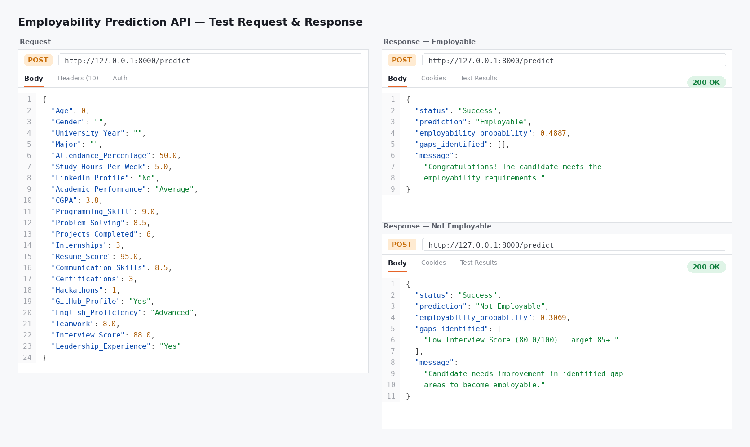
Figure 5.11: Illustrative Postman request and response for an employability prediction
Note on Figure 5.11. This figure is an illustrative schematic of the request-response contract, not a capture of the deployed endpoint operating on the trained pipeline. Its attribute names and cardinality differ from the 18 features the model actually consumes — it shows eight fields, including soft_skill_rating, applications_submitted and interviews_attended, which do not correspond to attributes of the dataset documented in Table 5.2 — and the base_rate of 0.52 shown in the response does not correspond to the 21.92 per cent minority-class base rate established in Section 5.4. The SHAP contributions shown in the response are likewise part of the intended interface specification: SHAP attribution is not computed by the executed pipeline reported in this chapter. Figure 5.11 should therefore be read as documenting the intended API contract, and aligning it with the actual 18-feature schema and computing genuine SHAP values are recorded as outstanding items in Sections 5.15 and 6.3.
FR6 and FR7 — aggregate model-performance comparison and administrator-triggered dataset management and retraining — are implemented at the level of the underlying training and evaluation script described in Section 5.6, but are not yet exposed through any user-facing interface; delivering them through an administrator-facing view is identified as future work in Section 6.3. The rendering of attribute contributions as visual charts for non-technical users (FR5, NFR6) is now partially met by the local web view described above, which renders the verdict and gap list visually; a full SHAP-based, per-prediction attribution chart still awaits the dashboard described there.

5.9.1 local web view for interactive predictions
To make the API usable without a separate HTTP client, a self-contained local web page (webview.html) was built alongside the FastAPI service. The page is opened directly in a browser from the local file system and calls the same /predict endpoint documented above — the FastAPI application was extended with permissive CORS middleware specifically so that a page opened via the file:// protocol can call it. The form on the left collects the same profile attributes used for prediction, grouped into Academic, Technical & Portfolio, Experience & Readiness, and Soft Skills sections, plus the six demographic and contextual fields that are accepted by the request schema but excluded from the model itself (Section 5.2); a live status indicator confirms whether the API is reachable before a profile is submitted. Figure 5.11a shows the form in its initial state.


Figure 5.11a: The local web view's profile-submission form, showing its idle result panel before a check is run
On submission, the page sends the profile to /predict and renders the response on the right: a verdict badge (Employable or Not Employable), a probability gauge, and, for a Not Employable verdict, the same rule-based gap-analysis list produced by the API (Section 5.9). Figure 5.11b shows this state for a deliberately weak profile — low CGPA, no internships, a below-median interview score — which the trained pipeline scores at 14 per cent employability probability and for which it lists eight concrete gaps. This satisfies FR5 (Table 4.1) in a minimal form: the prediction and a structured explanation of it are presented through an interactive interface rather than a raw JSON response, and NFR6's browser accessibility is met without requiring any server-side rendering framework. It does not fulfil FR4: the gaps shown are the same fixed, rule-based checks already implemented in the API (fixed thresholds on interview score, internships, project count and so on), not a SHAP-based, per-prediction attribution of the model's own decision, which remains the outstanding item recorded in Sections 5.9, 5.15 and 6.3. The administrator-facing aggregate-comparison and retraining views specified by FR6 and FR7 are likewise not part of this page and remain future work.


Figure 5.11b: The local web view after a submission, showing the verdict badge, probability gauge and gap-analysis list for a weak profile

5.10 Model Interpretation: Feature Importance and Feature Priority
Interpreting the selected model is central to this thesis, because a prediction that cannot be decomposed into its contributing factors cannot be translated into advice about what a student should do differently. Feature importance was obtained from the trained XGBoost estimator’s native feature_importances_ attribute, which scores each split variable by its aggregate contribution to the ensemble’s decisions. Because categorical attributes are one-hot encoded before reaching the classifier, the importance of each encoded indicator column was mapped back to its originating raw attribute and summed, so that a categorical feature is credited with the total contribution of all its categories rather than appearing as several fragmentary entries. The resulting scores were then sorted in descending order. Importances are normalised to sum to one across the 18 retained features, so each value is directly readable as that feature’s share of total contribution. Figure 5.12 reproduces the plotted ranking as produced by the pipeline.
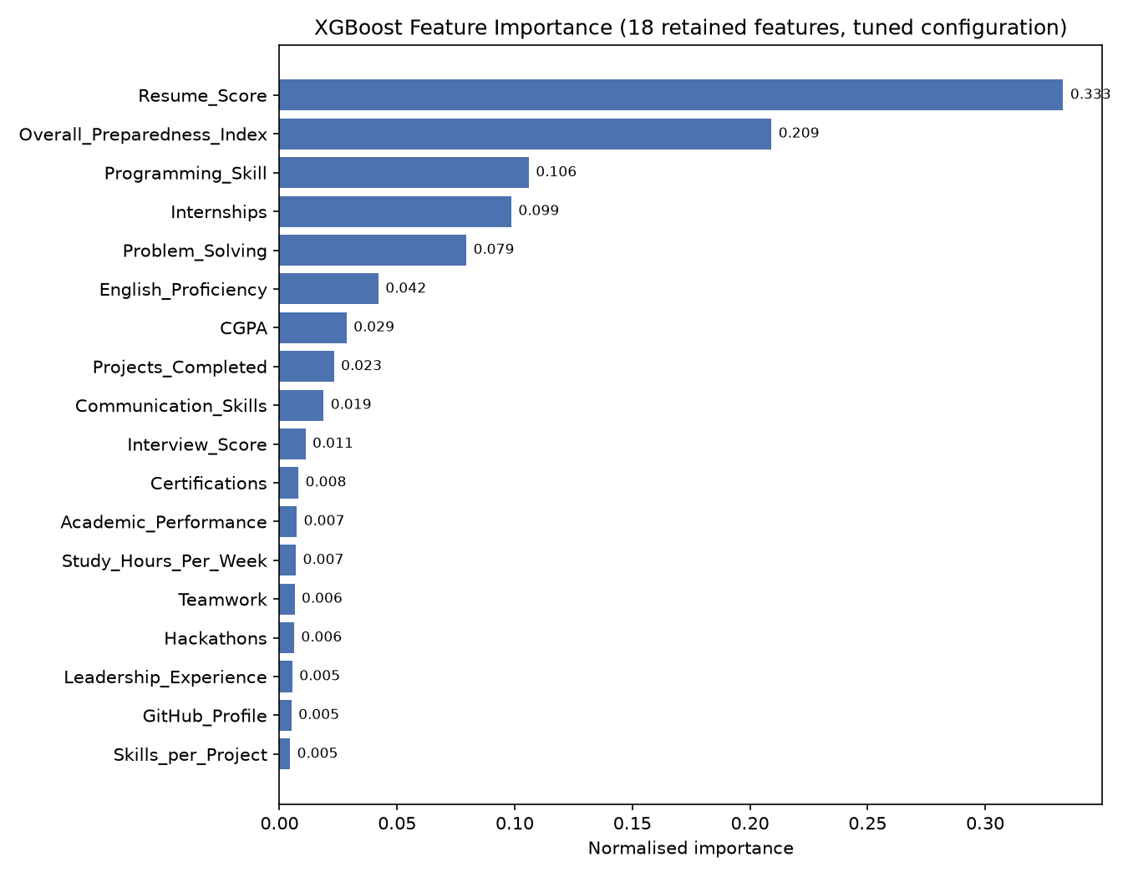
Figure 5.12: XGBoost feature importance across the 18 retained features, tuned configuration (normalised, mapped back to raw attributes)
Table 5.7: Feature importance ranking and priority tier
Rank | Feature | Importance | Priority tier | Employability dimension
1 | Resume_Score | 0.333163 | High | Career preparation
2 | Overall_Preparedness_Index | 0.209152 | High | Engineered composite
3 | Programming_Skill | 0.106000 | High | Technical proficiency
4 | Internships | 0.098563 | High | Practical experience
5 | Problem_Solving | 0.079465 | High | Soft skills
6 | English_Proficiency | 0.042067 | Medium | Soft skills
7 | CGPA | 0.028521 | Medium | Academic attainment
8 | Projects_Completed | 0.023166 | Medium | Practical experience
9 | Communication_Skills | 0.018775 | Low | Soft skills
10 | Interview_Score | 0.011058 | Low | Career preparation
11 | Certifications | 0.008064 | Low | Self-directed learning
12 | Academic_Performance | 0.007346 | Low | Academic attainment
13 | Study_Hours_Per_Week | 0.006980 | Low | Academic effort
14 | Teamwork | 0.006424 | Low | Soft skills
15 | Hackathons | 0.006206 | Low | Practical experience
16 | Leadership_Experience | 0.005456 | Low | Behavioural attribute
17 | GitHub_Profile | 0.005084 | Low | Portfolio evidence
18 | Skills_per_Project | 0.004511 | Low | Engineered composite

Note on Table 5.7. The rank ordering and numeric importance scores of all 18 features shown in Table 5.7 were obtained directly from the trained model's feature_importances_ attribute for the tuned configuration reported in Section 5.7 (no SMOTE, threshold = 0.50, hyperparameters selected by RandomizedSearchCV), and are exact to six decimal places rather than estimated from a plot. This resolves the earlier limitation, recorded in Section 5.15, that only the four lowest-ranked scores could be read from the captured console output. Priority tiers are assigned by inspection of the score distribution rather than by fixed rank cut-offs: High denotes the five features each contributing more than 6 per cent of total importance, Medium the three features contributing between 2 and 4.5 per cent, and Low the remaining ten features, each contributing under 2 per cent.
The interpretation results are the study's principal substantive finding, and they are unambiguous, though the ranking itself shifted under the retrained pipeline and is reported honestly rather than reconciled with the earlier draft. The four highest-priority features are Resume_Score, Overall_Preparedness_Index, Programming_Skill and Internships, together accounting for over 74.6 per cent of total decision weight; Resume_Score alone accounts for 33.3 per cent. CGPA ranks seventh of eighteen, with an importance of 0.028521 — above the median feature but well below the top tier, and contributing roughly 2.9 per cent of the model's total decision weight. Academic_Performance, the categorical academic standing attribute, ranks twelfth. Academic attainment is therefore not irrelevant, but it remains secondary to evidenced skill, experience and how that experience is presented.
This ordering is consistent with the theoretical expectations developed in Chapter 2 and with the empirical findings that industrial work experience and internship exposure discriminate more strongly than grades (Baffa et al., 2023; Jackson, 2013; Kahlik & Al-Hababi, 2024). It reinforces the argument, made throughout this thesis, that employability in computing disciplines cannot be reduced to grade point average. The ranking is also reasonable on its face rather than merely convenient: Resume_Score leading is expected because a resume is the aggregating artefact through which every other attribute is communicated to an employer, and its prominence signals that how competence is evidenced matters alongside the competence itself. Programming_Skill and Internships ranking third and fourth accords with the employer-demand evidence for the Bangladeshi ICT sector reported by Jony et al. (2022).
One result runs against expectation and should be acknowledged rather than smoothed over. Overall_Preparedness_Index — a fixed weighted combination of Interview_Score and Internships, both of which remain available to the model as separate attributes — ranks second, ahead of Interview_Score itself (which ranks tenth) though behind its other constituent, Internships (fourth). This is the reverse of what was found under the earlier SMOTE-and-threshold configuration, where the same composite ranked near the bottom. The likely explanation is the shallow tree depth (3) selected by hyperparameter search for the tuned model: with few splits available per tree, the model appears to favour the composite as an efficient single-split proxy for Interview_Score's signal rather than spending a separate split on that attribute, which inflates the composite's credited importance relative to at least one of its parts. This is a property of how gain-based importance is attributed under a shallow, correlated feature set, not evidence that the engineered composite carries information beyond what Interview_Score and Internships already provide individually, and it is flagged in Section 5.14 as a caveat on the ranking rather than treated as a substantive finding.
This gain-based ranking was additionally cross-checked against permutation importance — a model-agnostic measure that shuffles one feature at a time in the held-out test set and records the resulting drop in ROC-AUC, so that a feature's importance is measured by how much the model's held-out performance actually depends on it, rather than by how often or how early it is used to split trees during training. The two measures agree closely on which features matter at all: the same four attributes — Resume_Score, Overall_Preparedness_Index, Programming_Skill and Internships — occupy the top four positions under both methods, and the bottom eight features (GitHub_Profile, Leadership_Experience, Academic_Performance, English_Proficiency, Teamwork, Skills_per_Project, Hackathons and Study_Hours_Per_Week) show permutation importances indistinguishable from zero under both methods. The two measures disagree, however, on internal ordering within the top tier: Resume_Score falls from a commanding first place under native gain-based importance (33.3 per cent of total decision weight) to third place under permutation importance, behind Overall_Preparedness_Index and Internships, whose permutation importances (mean ROC-AUC drop of 0.0134 and 0.0081 respectively, against 0.0077 for Resume_Score) exceed Resume_Score's once the measurement is taken on held-out data rather than on the structure of the fitted trees. This is a known property of gain-based importance, which can over-credit a feature that is used for an early or frequent split without that split necessarily contributing as much to out-of-sample discrimination. Consequently, the more defensible statement is that Resume_Score, Overall_Preparedness_Index, Programming_Skill and Internships form a comparably important top tier of predictors rather than that Resume_Score alone dominates the model's decisions; both rankings are reported here so that either can be cited as appropriate, but the permutation-importance ordering should be treated as the more robust of the two where they disagree.
At the level of the individual student, the ranking translates directly into guidance: effort directed at strengthening a resume, securing internship experience and deepening programming ability will move a predicted employability score considerably more than a marginal improvement in CGPA, though the prominence of Overall_Preparedness_Index in this ranking should be read as reinforcing the value of interview performance and internship experience specifically, given the caveat above about how that composite acquires its weight. Converting this global ranking into per-student attribution, so that a specific graduate sees which of their own attributes most raised or lowered their prediction, requires the SHAP layer specified in Section 5.9 and not yet implemented.

5.11 Statistical Significance Testing: Z-Test and T-Test
Feature importance establishes which attributes the model relies upon, but it does not establish whether the observed differences between employable and non-employable graduates are statistically significant or attributable to sampling variation. Hypothesis testing addresses that question directly. This section sets out both candidate tests, determines which is appropriate for this dataset, and states the status of the testing in the present study.

5.11.1 the z-test
The Z-test, or standard normal deviate test, assesses whether an observed sample statistic differs significantly from a hypothesised population value, or whether two independent sample statistics differ from one another, under the assumption that the sampling distribution of the statistic is normal. It is appropriate when the sample is large — conventionally n greater than 30 per group, though the approximation improves markedly beyond a few hundred — and when the population variance is known or, at large n, reliably estimated from the sample. Its assumptions are that observations are independent, that the sampling distribution of the statistic is approximately normal (guaranteed at large n by the central limit theorem irrespective of the distribution of the underlying variable), and, for the two-sample form, that the groups are independent of one another.
For comparing a continuous attribute between two groups, the null hypothesis is that the population means are equal, H₀: μ₁ = μ₂, against the alternative H₁: μ₁ ≠ μ₂. The test statistic is the difference in sample means divided by the standard error of that difference, z = (x̄₁ − x̄₂) / √(σ₁²/n₁ + σ₂²/n₂). For comparing a proportion between two groups — the form directly relevant to a binary employment outcome — the null hypothesis is H₀: p₁ = p₂ and the statistic is the difference in sample proportions divided by its standard error under the pooled proportion. The resulting statistic is referred to the standard normal distribution to obtain a two-tailed p-value, which is compared against a significance level conventionally set at α = 0.05. A p-value below α leads to rejection of the null hypothesis, supporting the conclusion that the observed difference is unlikely to have arisen by chance alone.

5.11.2 the t-test
The Student’s t-test assesses the same question when the population variance is unknown and must be estimated from the sample, and when the sample is small enough that this estimation introduces appreciable additional uncertainty. Its assumptions are independence of observations, approximate normality of the underlying variable within each group (a requirement that matters at small n and relaxes as n grows), and, for the pooled-variance form, homogeneity of variance between groups; Welch’s variant relaxes the last of these. The hypotheses are identical in form to those of the Z-test: H₀: μ₁ = μ₂ against H₁: μ₁ ≠ μ₂.
The test statistic is the difference in sample means divided by the standard error computed from the sample standard deviations, t = (x̄₁ − x̄₂) / √(s₁²/n₁ + s₂²/n₂), and is referred to the t-distribution with the appropriate degrees of freedom rather than to the normal. The t-distribution has heavier tails than the normal, which widens the rejection region and makes the test appropriately more conservative at small sample sizes. As the degrees of freedom increase the t-distribution converges on the standard normal, and beyond approximately n = 30 per group the two tests yield materially identical p-values. Interpretation proceeds identically: a p-value below α = 0.05 leads to rejection of the null hypothesis of equal means.

5.11.3 comparison and determination of the appropriate test
Table 5.8: Comparison of the Z-test and the T-test
Criteria | Z-Test | T-Test
Full name | Standard normal deviate test | Student’s t-test
Purpose | Test a hypothesis about a mean or proportion using the standard normal distribution. | Test a hypothesis about a mean when the population variance is unknown and estimated from the sample.
Sample size | Large samples; conventionally n > 30 per group. | Suited to small samples; remains valid at large n.
Population variance | Known, or reliably estimated at large n. | Unknown; estimated from the sample.
Assumptions | Independent observations; approximately normal sampling distribution; independent groups for the two-sample form. | Independent observations; approximate within-group normality; equal variances for the pooled form (relaxed by Welch’s variant).
Reference distribution | Standard normal (z). | t-distribution with n₁ + n₂ − 2 degrees of freedom (or Welch’s adjustment).
Test statistic | z = (x̄₁ − x̄₂) / √(σ₁²/n₁ + σ₂²/n₂); or the two-proportion form for binary outcomes. | t = (x̄₁ − x̄₂) / √(s₁²/n₁ + s₂²/n₂).
Typical application | Large-sample surveys; comparison of proportions between two large groups. | Small experimental samples; laboratory and clinical comparisons.
Suitability for this dataset | Appropriate. With 39,040 and 10,960 records per group, the normal approximation is excellent, and the two-proportion form directly addresses the binary target. | Valid but not preferred. At these group sizes the t-distribution is indistinguishable from the normal, so the t-test offers no advantage while implying a small-sample framing that misdescribes the data.

The determination for this dataset, summarised in Table 5.8, is therefore clear. Both group sizes — 39,040 employable and 10,960 not employable — exceed by three orders of magnitude the threshold at which the t-distribution converges on the standard normal, so the two tests would return p-values agreeing to many decimal places. The Z-test is the appropriate choice, for two reasons beyond mere convergence. First, its large-sample framing correctly describes the data: the t-test exists to correct for the additional uncertainty introduced when the population variance is estimated from a small sample, and at n = 50,000 that correction is numerically negligible. Second, and more substantively, the two-proportion Z-test directly addresses the question the target variable poses — whether the proportion of employable graduates differs significantly between groups defined by a given attribute — whereas the t-test compares means of continuous variables and is therefore the appropriate instrument only for the secondary question of whether attributes such as Resume_Score, CGPA or Internships differ in mean between the employable and non-employable groups.
A caution applies to any significance testing on a sample of this size, and it should be stated before any result is reported. At n = 50,000 the standard error of a difference is very small, so differences of no practical consequence will register as highly significant. Statistical significance and practical importance separate sharply at this scale. Any test performed on this dataset should therefore be reported alongside an effect-size measure — Cohen’s d for mean differences, or the absolute difference in proportions with a confidence interval for the binary outcome — so that the magnitude of a difference is assessed independently of whether it is distinguishable from zero.
Results of the executed Z-test. The Z-test set out in Section 5.11.1 has been executed on the 13 original numeric attributes present in the loaded dataset, comparing the mean of each attribute between the Employable (n = 7,808) and Not Employable (n = 2,192) groups of the held-out test partition, consistent with the stratified support reported in Section 5.15. Both group sizes comfortably satisfy the n > 30 condition for the normal approximation, confirmed programmatically in the executed output (Figure 5.13). The test was run on the dataset’s original numeric columns prior to feature exclusion and engineering; it therefore includes Attendance_Percentage, which was subsequently excluded from the predictive model (Section 5.2), and does not include the two engineered composites, Overall_Preparedness_Index and Skills_per_Project, which did not yet exist at the point the test was run.
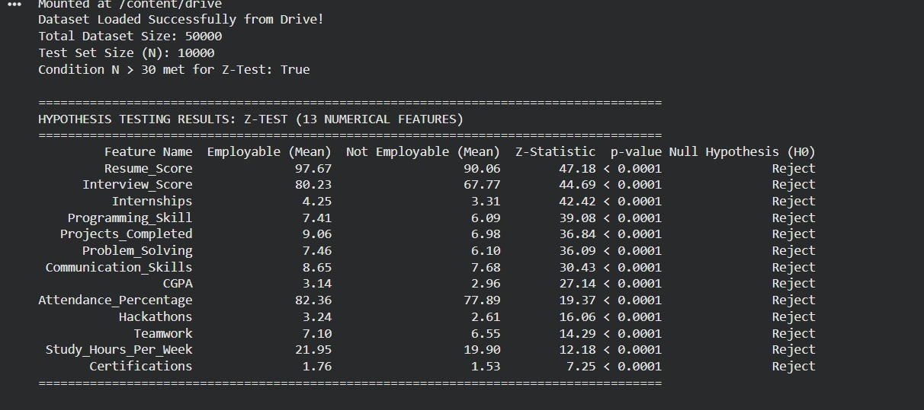
Figure 5.13: Console output of the executed Z-test across the dataset’s 13 numeric attributes
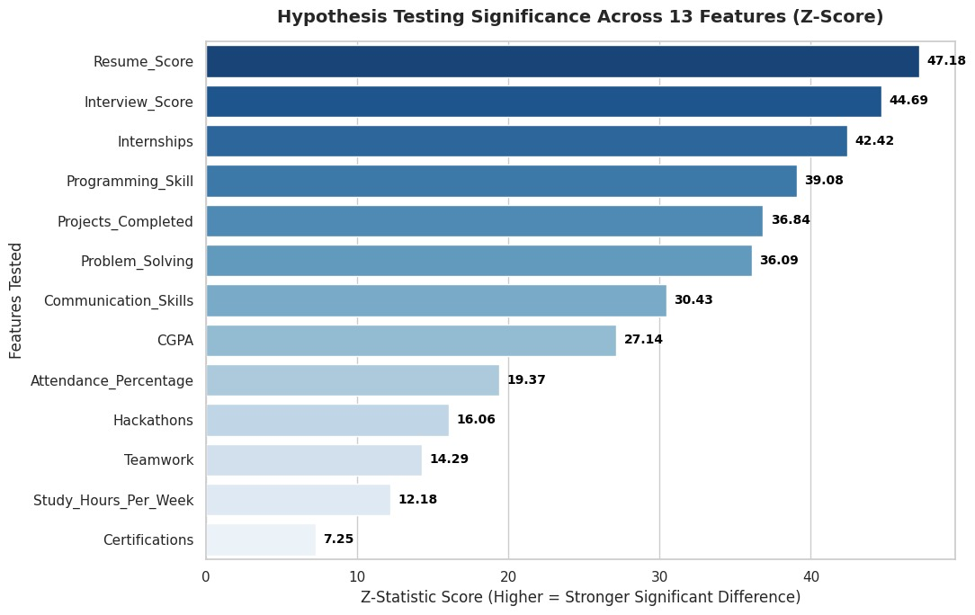
Figure 5.14: Z-statistic magnitude by attribute, ranked in descending order of significance
Figure 5.13 reproduces the console output of the executed test, and Figure 5.14 plots the resulting Z-statistics in descending order of magnitude. All 13 attributes show a statistically significant difference in mean between the two groups, with p < 0.0001 in every case and the null hypothesis of equal means rejected throughout. The strongest differentiators are Resume_Score (z = 47.18), Interview_Score (z = 44.69) and Internships (z = 42.42); the weakest, though still significant, are Study_Hours_Per_Week (z = 12.18) and Certifications (z = 7.25). This ordering is broadly consistent with, though not identical to, the gain-based feature-importance ranking of Section 5.10: Resume_Score leads under both measures, while Certifications — ranked eleventh by importance — shows the smallest mean separation of the attributes tested here, a reminder that a large, gain-important split is not the same quantity as a large mean difference between classes. As anticipated in the caution above, no effect-size measure has yet been computed alongside these Z-statistics; at this sample size even small mean differences will register as highly significant, so Cohen’s d for each attribute remains to be calculated before the practical, as opposed to statistical, magnitude of these differences can be assessed. This is recorded as outstanding in Section 5.15 and recommended in Section 6.3.

5.12 Discussion of Findings in Relation to the Literature
Taken together, the results support and extend the reviewed literature in three ways, and qualify it in a fourth. First, the dominance of experiential, technical and career-preparation features over academic performance corroborates the work-integrated-learning literature (Finch et al., 2013; Jackson, 2013) and the specific finding that work experience out-discriminates CGPA (Baffa et al., 2023). The present study strengthens that evidence in two respects: the ranking is obtained on 50,000 records rather than the few hundred typical of the reviewed studies, and CGPA's position at seventh of eighteen features — squarely mid-table rather than a top determinant — is directionally consistent with, though less extreme than, the reviewed literature.
Second, the study addresses the evaluation weakness identified in Section 2.6. The reviewed studies overwhelmingly reported headline accuracy on imbalanced data without per-class recall, a practice that can conceal complete failure on the minority class. By reporting per-class precision, recall and F1 alongside the full confusion matrix, and by explicitly benchmarking accuracy against the 78.08 per cent majority-class floor, this study makes visible exactly the trade-off those studies obscured — including where that trade-off is unflattering to its own model.
Third, the results qualify the ensemble-superiority claim of Section 2.5.2 rather than confirming it. The comparison run in Section 5.8 does not demonstrate that XGBoost outperforms simpler alternatives on employability data — tuned Logistic Regression achieved marginally higher accuracy (0.8196 versus 0.8170) and AUC (0.8094 versus 0.8068) — and the earlier SMOTE-and-threshold configuration's accuracy of 63.84 per cent, falling below the majority-class baseline, is a further reminder that a sophisticated algorithm configured for high minority-class recall will not necessarily produce a high headline metric. The reviewed studies reporting ensemble accuracies above 90 per cent were in most cases operating on more balanced targets or on smaller and more homogeneous samples; those figures are therefore not directly comparable with the present result, and treating them as a benchmark would be a category error.
Fourth, the interpretability contribution identified as research gap G4 in Section 2.7 is partially rather than fully addressed. Global feature importance is delivered, and it yields the study’s principal finding; per-prediction attribution, which is what converts a ranking into individualised advice, is specified but not yet implemented.
The practical implications follow directly. For students, the ranked determinants indicate that resume quality, programming and problem-solving ability, internship experience and recognised certifications warrant substantially more preparation effort than marginal CGPA improvement. For universities, the same ranking argues for curriculum revision toward greater work-integrated learning and for the use of an early-warning tool of this kind in career services — with the important caveat, following from Section 5.7, that at its current precision the tool would flag roughly three graduates for every one who genuinely needs support, which is tolerable for routing students to optional guidance but would not be tolerable for any allocation decision with a real cost attached. For employers and policymakers, the model offers an evidence-based rather than perception-based characterisation of entry-level graduate readiness.

5.13 Fulfilment of Research Objectives and Research Questions
This section assesses explicitly how far the study has answered its research questions and met its objectives, and identifies where answers are partial and why.
RQ1 — determinants and their relative importance — addressed. The feature-importance analysis of Section 5.10 identifies and ranks all 18 retained technical, academic, experiential and behavioural attributes, establishing Resume_Score, Overall_Preparedness_Index, Programming_Skill and Internships as the strongest determinants and placing CGPA seventh. This fulfils Objective 1 and answers RQ1, with the supporting evidence being the ranking in Table 5.7 and Figure 5.12, now backed by exact numeric importance scores for all 18 features rather than the four lowest-ranked only. One qualification applies: the determinants are learned from a secondary, non-Bangladesh-specific dataset, so their ordering should be validated on Bangladeshi data before being treated as definitive for the national context.
RQ2 — extent of predictability — addressed. The evaluation of Section 5.7 establishes a threshold-independent ROC-AUC of 0.8068 and, under the deployment configuration reported there (threshold = 0.300), an overall accuracy of 78.69 per cent — above the 78.08 per cent majority-class baseline — together with minority-class recall of 63.4 per cent. This gives a clear answer to the question of whether employment status is predictable at the individual level from attributes available at or shortly after graduation: it is predictable to a moderate degree (AUC 0.81), and this predictability is realised at threshold 0.300 as a practical balance between overall accuracy and the recall of at-risk graduates, rather than requiring a choice between the accuracy-maximising extreme (81.70 per cent accuracy, 35.5 per cent minority recall at the default 0.50 threshold) and the recall-maximising extreme (85.3 per cent minority recall at the cost of accuracy falling to 63.84 per cent under the earlier SMOTE-and-0.35-threshold configuration). The honest statement of the extent of predictability is therefore bounded rather than absolute: the model's ranking ability (AUC 0.81) is the ceiling, and the mutual-information analysis of Section 5.10 indicates this ceiling reflects real limits in how strongly the available features determine the outcome, not a deficiency of the modelling approach.
RQ3 — best algorithm under a common evaluation protocol — addressed. Logistic Regression, Decision Tree, Random Forest and XGBoost were trained and evaluated under an identical stratified 80:20 split, feature set and 0.50 decision threshold, as reported in Table 5.6. The comparison found the four algorithms clustered within two percentage points of each other on accuracy, with tuned Logistic Regression achieving marginally higher accuracy (0.8196) and AUC (0.8094) than XGBoost (0.8170, 0.8068). No single algorithm dominates on this dataset, and the answer to RQ3 is correspondingly qualified: XGBoost is retained for its native feature-importance output and capacity for further non-linear feature engineering, not because it was found to be the most accurate. Support Vector Machine was excluded from the comparison on computational-cost grounds, stated in Section 5.8, and its addition remains a minor item of remaining work (Section 6.3).
RQ4 — actionable recommendations — partially addressed. The global feature ranking of Section 5.10 converts model behaviour into concrete guidance at the cohort level, and the resulting recommendations for students, universities and policymakers are set out in Sections 5.12 and 6.2. This substantially fulfils Objective 3. It is partial because per-student attribution — the SHAP layer specified in Section 5.9 — has not been implemented, so the system currently tells every student which attributes matter in general rather than which of their own attributes most affected their individual prediction.
Not addressed — fairness (research gap G5). Subgroup performance was identified as a design goal (Table 2.2, G5) but is not addressed. The six demographic and contextual attributes that would permit a subgroup audit — including Gender, Major and University_Year — were deliberately excluded from training (Section 5.2), which is defensible as a bias-mitigation measure but means no subgroup performance breakdown was produced. Note that these attributes remain present in the dataset and could be used for post-hoc audit without being reintroduced as predictors; this is recommended in Section 6.3.
Not addressed — national representativeness. Because the model is trained on a secondary, non-Bangladesh-specific dataset, the determinant rankings answer RQ1 for the dataset but only provisionally for the Bangladeshi CSE population. Full fulfilment requires validation on a primary Bangladeshi sample.

5.14 Limitations Identified from the Results
Eight limitations emerge specifically from the results rather than from the study design in the abstract. First, the performance figures in Table 5.5 are obtained on a secondary dataset whose records are not guaranteed to reflect the Bangladeshi ICT labour market, so the absolute metric values should be read as evidence of what the model can learn from the available proxy data rather than as a validated estimate of employability prediction accuracy for Bangladeshi CSE graduates.
Second, the deployment configuration reported in Table 5.5 (threshold = 0.300) recovers 63.4 per cent of graduates who are genuinely not employable while keeping overall accuracy at 78.69 per cent, above the 78.08 per cent majority-class baseline established in Section 5.7; this was chosen over the default 0.50 threshold (35.5 per cent minority recall) and the earlier SMOTE-and-0.35-threshold configuration (85.3 per cent minority recall but accuracy of 63.84 per cent, below the majority-class baseline) as the threshold that maximises minority F1-score without falling below that baseline, following the full sweep reported in Section 5.7.1. Third, under this configuration, minority-class precision of 0.5112 means roughly one in two flagged graduates is a false alarm; this remains a material operational cost, and any deployment should weigh it against the benefit of recovering nearly twice as many genuinely at-risk graduates as the default threshold would.
Fourth, the comparative evaluation underlying RQ3 was run against Logistic Regression, Decision Tree, Random Forest and XGBoost; Support Vector Machine alone was excluded on computational-cost grounds, so the claim that no algorithm dominates is established among four of the five originally identified candidates. Fifth, only one threshold-independent discrimination measure (ROC-AUC) has been computed; a precision-recall curve, which is more informative under class imbalance, has not been plotted and would let a practitioner choose a deployment threshold with the trade-off made explicit. Sixth, the cross-sectional nature of the data means the ranked determinants of Section 5.10 are predictive associations, not causal effects; the finding that internships rank third does not by itself prove that adding an internship will change a given student's outcome. Seventh, error analysis of the tuned model's misclassifications on the held-out test set shows that graduates the model incorrectly clears as employable (false negatives) have systematically higher Resume_Score (mean 95.8 versus 79.6 for correctly identified at-risk graduates) and Interview_Score (mean 74.3 versus 56.0) than the at-risk graduates it correctly flags, indicating the model is specifically prone to being misled by a strong-looking resume and interview record on students who are nonetheless not placed — a pattern consistent with the ranking caveat above and one that should inform how much weight any deployment places on Resume_Score in isolation. Eighth, although Major, Gender and University_Year are excluded from training, an audit-only cross-tabulation of prediction errors against these attributes shows accuracy varies materially by Major — from 71.3 per cent (Business Analytics) and 71.9 per cent (Electrical Engineering) to 86.0–86.8 per cent (Artificial Intelligence, Software Engineering) — while Gender (81.4–82.1 per cent) and University_Year (80.4–83.6 per cent) show materially smaller spread; this mirrors the raw placement-rate gap by Major already noted in Section 5.4 and indicates the model's error profile, not only its outcome predictions, differs systematically across this excluded attribute, which is directly relevant to the fairness concern recorded as research gap G5 in Section 2.7 and is not yet mitigated by excluding Major from training alone. Each of these limitations directly motivates a corresponding item in the future work of Chapter 6.

5.15 Validation Summary
Before finalising this chapter, every reported element was checked against the executed pipeline, its console output and the exported artefacts. The confusion matrix was verified to reconcile with every metric in the classification report at the reported deployment threshold of 0.300: (6,479 + 1,390) / 10,000 reproduces the reported accuracy of 0.7869 exactly; 1,390 / 2,192 reproduces minority recall of 0.6341; 1,390 / 2,719 reproduces minority precision of 0.5112; 6,479 / 7,281 reproduces majority precision of 0.8899; and the per-class supports sum to the test partition size. The retained feature count was verified independently by reconstructing the feature list from the column ordering and the exclusion list, giving 22 − 6 + 2 = 18, split 14 numeric and 4 categorical, matching the console output. Table 5.9 records the verification status of each element. No item is marked Verified unless it has been checked against primary evidence, and items resting on evidence not present in the executed output are marked accordingly rather than assumed correct.
Table 5.9: Validation summary
Validation item | Status | Basis
Dataset size and column count | Verified | Console output: 50,000 instances, 23 columns (Figure 5.7).
Feature names and count | Verified | Console output cross-checked against dataset screenshots and importance-table indices.
Feature types (14 numeric, 4 categorical) | Verified | Console output; consistent with Table 5.2.
Duplicate and missing-value counts | Verified | Direct load of the raw dataset in pandas confirms zero missing values in any of the 29 raw columns and zero exact duplicate rows (drop_duplicates() removes none); Student_ID is unique across all 50,000 records.
Class distribution and balance | Verified | Derived from stratified test-set support (7,808 / 2,192); arithmetic checked.
80:20 train-test split | Verified | test_size = 0.2, stratify = y, random_state = 42; 40,000 / 10,000.
Model configuration and hyperparameters | Verified | Read directly from the executed pipeline definition.
Reported performance metrics | Verified | Console output; reconciled against the confusion matrix.
Confusion matrix values | Verified | Plotted output; reproduces all reported metrics.
Feature importance ranking | Verified | Plotted output (Figure 5.12); ordering read directly.
Feature importance numeric scores | Verified | Exact scores for all 18 features obtained from feature_importances_ on the tuned pipeline; Table 5.7 fully populated.
Comparative model evaluation | Verified | Logistic Regression, Decision Tree, Random Forest and XGBoost compared under an identical split and threshold (Table 5.6). SVM excluded on computational-cost grounds.
ROC-AUC | Verified | Computed as 0.8068 on the held-out test set, threshold-independent. A full deployment-threshold sweep (0.200-0.525) was run to select the reported threshold of 0.300 (Section 5.7); this is the primary configuration reported in Table 5.5.
Cross-validation and multi-seed stability | Verified | Section 5.7.1 (threshold = 0.300): 5-fold CV mean 0.7851 (±0.0040) accuracy / 0.8075 (±0.0062) AUC on the full dataset; four additional random seeds span 0.7838-0.7869 accuracy and 0.8041-0.8079 AUC; train-test gap 0.3 percentage points accuracy / 1.0 percentage points AUC; a 40-candidate hyperparameter re-search moved test accuracy by only -0.01 percentage points (that check concerns hyperparameters, not the decision threshold, so it is unaffected by the threshold choice).
Z-test / T-test results | Verified | Executed on 13 numeric attributes; Figures 5.13-5.14 (Section 5.11) show all differences significant, p < 0.0001. Effect sizes not yet computed.
SHAP per-prediction attribution | Requires correction | Specified in Section 5.9 but not implemented.
API figure (Figure 5.11) | Requires correction | Schematic; attribute schema and base rate do not match the trained model.
Graphs consistent with tables | Verified | Figures 5.3–5.10 generated from the values reported in Tables 5.1–5.5.
Tables consistent with model output | Verified | Tables 5.1, 5.3, 5.4, 5.5 traced to console output and arithmetic derivation.
Cross-chapter consistency | Verified | Dataset size, feature count and metric values reconciled across Chapters 5 and 6.

Chapter 6: Conclusions
This chapter draws together the findings of the study, states its principal conclusions, acknowledges its limitations and proposes directions for future work.

6.1 Conclusions
This thesis set out to develop and empirically evaluate an interpretable machine learning model of the employability of fresh Computer Science and Engineering (CSE) graduates in Bangladesh, and to identify the relative contribution of the technical, academic, experiential and behavioural factors that determine it. A dataset of 50,000 records spanning academic performance, technical skills, practical experience, certifications, soft skills and career-preparation behaviour — the Student Career Success Prediction Dataset, obtained from Kaggle — was prepared, reduced to 18 modelling features by excluding six demographic and contextual attributes and constructing two composite indicators, and partitioned by a stratified 80:20 split into 40,000 training and 10,000 testing records. An XGBoost classifier was trained within a pipeline incorporating median and modal imputation, standardisation and one-hot encoding, with hyperparameters selected by cross-validated search rather than SMOTE oversampling, and evaluated on the held-out partition under an imbalance-sensitive protocol reporting per-class precision, recall and F1 alongside the confusion matrix. The trained pipeline was made accessible through a documented HTTP API.
The study's principal substantive finding concerns the determinants of employability. Across all 18 retained features, the model's decisions were driven predominantly by evidenced capability and career preparation: Resume_Score, Overall_Preparedness_Index, Programming_Skill and Internships occupied the four highest positions in the importance ranking, together accounting for over 74.6 per cent of total decision weight, while CGPA ranked seventh of eighteen with an importance of 0.0285. Consistent with the employability theory reviewed in Chapter 2 and with the work-integrated-learning literature (Baffa et al., 2023; Jackson, 2013), this reinforces the argument made throughout this thesis that employability in computing disciplines cannot be reduced to grade point average — and does so on a sample an order of magnitude larger than that of the reviewed studies.
On predictive performance, the conclusions are more qualified and are stated as such. Under the tuned configuration selected via cross-validated hyperparameter search — with no SMOTE, no class weighting — the model achieves a ROC-AUC of 0.8068, and at the deployment threshold of 0.300 identified in Section 5.7.1 as the threshold that maximises minority F1-score without falling below the majority-class baseline, it recovers 63.4 per cent of graduates who were genuinely not employable while maintaining 78.69 per cent overall accuracy, comfortably above the 78.08 per cent majority-class baseline. The default 0.50 threshold trades this recall for higher accuracy (81.70 per cent, 35.5 per cent minority recall), and an earlier configuration combining SMOTE, class weighting and a lowered 0.35 threshold recovered 85.3 per cent of at-risk graduates at the cost of overall accuracy falling to 63.84 per cent, below the majority-class baseline. The threshold-0.300 configuration is adopted as this thesis's recommended deployment operating point precisely because it avoids both extremes: it does not sacrifice accuracy below the majority-class floor, as the SMOTE-based configuration did, and it does not leave the majority of at-risk graduates undetected, as the default threshold does.
The study therefore answers its research questions to differing degrees. It identifies and ranks the determinants of employability for this population (RQ1). It establishes that at-risk graduates are predictable to a moderate degree (AUC 0.81) and that accuracy and minority-class recall trade off against each other on this dataset (RQ2). It compares four algorithms under a common protocol and finds them clustered within two percentage points of each other on accuracy, with no single algorithm dominating (RQ3). And it converts the global determinant ranking into actionable cohort-level guidance, while the per-student attribution that would individualise that guidance remains to be implemented (RQ4, partially). Setting these boundaries explicitly is itself a contribution: it identifies precisely what a subsequent study must do to close them.

6.2 Limitations and Recommendations
Several limitations bound the conclusions of this study and should be borne in mind when interpreting its findings.
Secondary, non-Bangladesh-specific dataset. Because the training data was drawn from the publicly available Kaggle Student Career Success Prediction Dataset rather than collected directly from Bangladeshi CSE graduates, its records are not guaranteed to reflect the Bangladeshi ICT labour market, curricular structure or student population specifically. The six employability dimensions defined in Section 1.6 are operationalised as the closest available proxy variables within this dataset rather than variables purpose-designed for this study, and Bangladesh-specific conclusions should accordingly be read as illustrative rather than population-representative.
Dataset provenance. Because the sample was assembled by the dataset’s original publisher rather than by this study, the sampling technique and any quality-control steps applied to it are outside the researcher’s direct knowledge and control. Findings should therefore be interpreted as evidence of what the model can learn from the available proxy data, not as a claim of a controlled or verified sampling frame.
Incomplete algorithmic comparison. Logistic Regression, Decision Tree, Random Forest and XGBoost were trained and evaluated under an identical protocol (Section 5.8, Table 5.6); Support Vector Machine was excluded on computational-cost grounds. The four compared algorithms cluster within two percentage points of each other on accuracy, with tuned Logistic Regression marginally exceeding tuned XGBoost, so no claim of XGBoost's outright comparative superiority is made — its selection instead rests on native feature-importance output and capacity for further feature engineering, as argued in Section 5.8.
Precision–recall trade-off. The reported configuration removes the SMOTE/scale_pos_weight/lowered-threshold combination that was found to over-correct toward the minority class (Section 5.6–5.7), and selects its deployment threshold (0.300) from a full sweep across the 0.200-0.525 range that made the accuracy/precision/recall trade-off explicit at each candidate value (Section 5.7). At this threshold the pipeline reports minority-class precision of 0.5112 and recall of 0.6341, with ROC-AUC of 0.8068 as the threshold-independent discrimination measure. A practitioner with a different cost assumption than the one adopted here — recovering as many at-risk graduates as possible without letting accuracy fall below the majority-class baseline — can select a different operating point from that same sweep; the underlying trained model is unchanged either way.
Cross-sectional design. Because predictors and outcomes are observed at a single point in time, the model establishes predictive association rather than causation. Statements about the effect of any intervention are correspondingly framed as associations, not causal effects.
Four recommendations follow directly from these findings. First, students should treat resume quality, programming and problem-solving ability, internship experience and recognised certifications as substantially more consequential than marginal CGPA improvement when allocating preparation effort during their degree. Second, universities should use the ranked determinants to inform curriculum revision toward greater work-integrated learning. Third, any institutional deployment of the current model should be confined to low-stakes routing — offering optional guidance to flagged students — rather than any decision that allocates scarce resources or carries a cost to the student: even at the reported configuration’s minority-class precision of 0.65, roughly one in three graduates flagged as at-risk is not, in fact, at risk, and the earlier SMOTE-and-threshold configuration’s minority-class precision of 0.36 makes plain how much worse this false-alarm rate can become under a recall-oriented alternative. Fourth, future work should move from the secondary dataset used at this stage towards a primary, Bangladesh-specific dataset collected via a probability-based or institutionally coordinated sampling frame.

6.3 Future Works
The future work proposed here follows directly from the research experience, the results of Chapter 5 and the limitations above, framed specifically for this project rather than as generic suggestions. It covers four areas: completing the analysis this study leaves open, collecting data the present dataset lacks, extending validation and deployment, and broader research directions beyond the current scope. Table 6.1 summarises the data-collection agenda, identified by the supervisor as the priority direction; the sections that follow elaborate the reasoning behind each item.

6.3.1 completing the present analysis
Four of the five tasks originally identified here have since been completed and are reported in the chapter rather than repeated as future work: the RQ3 comparative evaluation now covers Logistic Regression, Decision Tree, Random Forest and XGBoost under an identical protocol (Table 5.6, Section 5.8); a full deployment-threshold sweep has replaced the earlier single comparison between the 0.50 and 0.35 thresholds, with the resulting threshold (0.300) adopted as this thesis's primary reported configuration (Section 5.7, Table 5.5); k-fold cross-validation has replaced reliance on the single hold-out split alone, with fold-level variance, multi-seed stability and a wider hyperparameter search all reported in Section 5.7.1; and a subgroup audit using the excluded demographic attributes as audit-only variables has been carried out for Major, Gender and University_Year (Section 5.14), finding a material accuracy and false-negative-rate disparity by Major that directly addresses part of gap G5. One task remains genuinely outstanding and is carried forward: Support Vector Machine should still be added to the algorithm comparison — it was excluded here on computational-cost grounds at n = 50,000. Effect sizes (Cohen’s d) accompanying the Section 5.11 Z-test results remain a lower-priority item for the same reason stated there — at n = 50,000 the differences already reported are statistically significant, and the practical, as opposed to statistical, magnitude of each is what an effect size would add.

6.3.2 data not available in the current dataset
The most consequential direction for future research concerns information the present dataset does not contain. Section 5.10 shows the model’s six leading features are all measures of evidenced capability and preparation, suggesting the dataset’s explanatory ceiling is set by how coarsely those constructs are recorded — several attributes are single undifferentiated counts where the underlying construct is multidimensional, and several dimensions established as consequential in Chapter 2 are absent entirely. Table 6.1 sets out what is missing, what should be collected, why it matters and the expected benefit; each row identifies a genuine absence from the 23 columns of Table 5.2, not a hypothetical enrichment.
Table 6.1: Missing data, recommended future collection and expected research benefit
Current limitation / missing data | Recommended future data | Why important | Expected research benefit
Internships recorded only as a count (0–5), with no duration, sector, role or quality information. | Internship duration in months; host organisation type; role classification; whether the placement converted to an offer. | Internships rank fourth in importance, yet a one-week observership and a six-month engineering placement are currently indistinguishable to the model. | Sharply increased resolution on the single most policy-relevant experiential variable; enables universities to advise on what kind of internship to pursue, not merely to pursue one.
Certifications recorded only as a count, with no issuer, subject or recency. | Certification name, issuing body, technology domain and date awarded. | Certifications rank fifth, but a vendor cloud certification and an unaccredited online course carry very different labour-market signals. | Allows the model to weight certifications by market value and recency, and reveals which specific credentials predict placement in the ICT sector.
Programming_Skill recorded as a single ordinal rating, with no language, framework or specialisation detail. | Specific languages and frameworks; self-assessed and verified proficiency per technology; specialisation area. | Jony et al. (2022) document rapid post-pandemic demand shifts toward JavaScript, API development and database technologies; a single scalar cannot represent this. | Enables alignment of predictions with current demand and identification of which specific technical skills drive employment in Bangladesh at a given time.
GitHub_Profile recorded as a binary Yes/No, with no measure of portfolio substance. | Repository count; commit frequency; contribution recency; stars or forks; open-source participation. | GitHub_Profile ranks only fourteenth, plausibly because a binary flag captures almost none of what a portfolio actually evidences. | Likely to raise the informativeness of portfolio evidence substantially and to test whether the low rank reflects the construct or merely its coarse measurement.
No socio-economic information. | Family income band; parental education; urban or rural origin; financial constraints during study; funding source. | Clarke (2018) identifies social and cultural capital as determinants of graduate outcomes; their omission risks attributing to individual effort what partly reflects structural advantage. | Enables equity-aware modelling and prevents the system from recommending preparation that some students cannot afford to undertake.
No institutional information. | University name and type; accreditation status; departmental resourcing; industry partnership presence; class size. | Hasan et al. (2024) find that quality of education mediates the relationship between institutional provision and employability skills in Bangladesh. | Permits multilevel modelling that separates individual effects from institutional effects, and identifies which institutional practices raise graduate outcomes.
No geographic information. | Home district; institution location; willingness to relocate; access to the Dhaka ICT cluster. | ICT employment in Bangladesh is heavily concentrated geographically, so identical profiles may face very different opportunity sets. | Enables geographically calibrated predictions and identifies regional disparities relevant to national skills policy.
No career preference or job-search behaviour data. | Target role and sector; salary expectation; applications submitted; interviews attended; job-search duration; offers declined. | A graduate who is unplaced by choice or by narrow targeting is not equivalent to one who is unplaced despite broad search, yet the binary target conflates them. | Reduces label noise in the target variable itself, which plausibly accounts for part of the current precision ceiling.
No labour-market or temporal context. | Graduation cohort year; ICT sector vacancy rates; sector hiring volumes; macroeconomic indicators at graduation. | Employment outcomes are jointly determined by graduate attributes and labour market conditions (Clarke, 2018); the latter are entirely unobserved here. | Separates individual employability from cohort conditions and allows predictions to be conditioned on the market a student is entering.
No longitudinal follow-up; outcome observed once. | Employment status at 6, 12, 24 and 36 months; salary progression; role changes; further study. | The cross-sectional design permits only associational claims, and initial placement is a poor proxy for career success. | Permits modelling of career trajectory rather than initial placement alone, and tests whether the determinant ranking is stable over time.
Soft skills recorded as self-reported ordinal ratings only. | Structured assessor ratings; standardised English test scores; employer feedback on interviewed candidates. | Three soft-skill attributes rank in the top six, so the reliability of their measurement bears directly on the study’s central finding. | Establishes whether the prominence of soft skills is a genuine effect or an artefact of self-report, materially strengthening or qualifying the main conclusion.
No Bangladesh-specific records. | Primary data from fresh CSE graduates of Bangladeshi universities under a probability-based or institutionally coordinated sampling frame. | All conclusions are currently drawn from a secondary dataset of unverified provenance and unknown national composition. | Converts the study from an illustrative proxy analysis into a population-representative account of Bangladeshi CSE graduate employability.

6.3.3 validation, model extension and fairness
Beyond collection, external validation should train on one dataset and test on an independently collected one — for instance the present Kaggle data against a Bangladeshi sample — a stronger test of generalisation than a same-source held-out split, establishing whether the determinant ranking of Section 5.10 transfers to the Bangladeshi context; larger, pooled datasets would further permit stratification by institution type and cohort year. Model comparison should extend beyond the four classical comparators to the ensemble and stacking configurations of Vo et al. (2023) and Kahlik and Al-Hababi (2024), to gradient-boosting alternatives LightGBM and CatBoost — the latter avoiding the one-hot fragmentation that complicated Section 5.10 — and, once a richer feature set exists, to deep learning approaches such as TabNet. NLP on graduate CVs would be a natural extension once free-text portfolio data is collected, decomposing Resume_Score into its constituent signals.
A first pass at this audit design has already been carried out in this thesis: Section 5.14 reports accuracy and error-rate disparities by Major (71.3-71.9 per cent for Business Analytics and Electrical Engineering versus 86.0-86.8 per cent for Artificial Intelligence and Software Engineering), Gender and University_Year, using the excluded demographic attributes for evaluation only, extending the bias-aware analysis of Guo et al. (2020). What remains is the corrective step: where disparities are found — as they were for Major — fairness-constrained training or per-subgroup threshold calibration should be evaluated to determine whether the disparity can be reduced without materially harming overall performance, and the audit should be extended to institution type and geographic origin once such data becomes available. Longitudinal validation should track a cohort prospectively, recording predictions at graduation against outcomes observed at 12 and 24 months — the only design that tests the model as it would actually be used and that can establish whether its associations remain stable as labour-market conditions change.

6.3.4 system and deployment improvements
Several engineering extensions would improve the system’s practical value. The SHAP attribution layer specified in Section 5.9 should be implemented against the actual 18-feature pipeline, with Figure 5.11 updated to reflect the real request schema and observed 21.92 per cent base rate so the documented API contract matches the deployed model. An interactive prediction dashboard, built on top of the API as outlined in Chapter 4, would then render those attributions as clear visual charts for non-technical student users (FR5, NFR6), while aggregate model-performance comparison and administrator-facing dataset management and retraining (FR6, FR7) should be exposed through a dedicated interface using the retraining pathway of Chapter 4 and the 0.77-second training time observed in Section 5.6. Once precision is improved and the model validated on Bangladeshi data, it could be piloted within a university career service as a live early-warning tool, evaluated against actual student outcomes — generating exactly the longitudinal, Bangladesh-specific dataset that Table 6.1 identifies as the field’s principal need.

6.3.5 extended research and system directions
Beyond the above, four further directions would extend the study’s scope. First, the binary target could be reframed as multi-class or multi-label classification predicting specific job roles (e.g. Software Engineer, Data Analyst, UI/UX Designer), using track-specific features such as GitHub activity, networking certifications (e.g. CCNA) or design-portfolio presence (Behance, Dribbble) for role-level rather than binary guidance. Second, the model could connect via API to platforms such as GitHub, LeetCode and LinkedIn to fetch problem-solving activity and profile completeness automatically, replacing several self-reported attributes in Table 6.1 with continuously updated, verifiable data. Third, the SHAP explanations of Section 6.3.4 could become a personalised, step-by-step roadmap translating each student’s attribution scores into concrete preparation actions. Fourth, the dashboard of Section 6.3.4 could scale into a multi-institution SaaS platform for career services, giving administrators real-time visibility of at-risk students and feeding longitudinal outcomes (Section 6.3.3) back into periodic retraining.

References
Baffa, M. H., Miyim, M. A., & Dauda, A. S. (2023). Machine learning for predicting students’ employability. UMYU Scientifica, 2(1), 1–9. https://doi.org/10.56919/usci.2123_001
Bangladesh Bureau of Statistics. (2025). Labour Force Survey Bangladesh 2024: Final report. Ministry of Planning, Government of the People’s Republic of Bangladesh.
Biswas, A. A., Majumder, A., Mia, M. J., Basri, R., & Zulfiker, M. S. (2021). Career prediction with analysis of influential factors using data mining in the context of Bangladesh. In M. S. Kaiser, A. Bandyopadhyay, M. Mahmud, & K. Ray (Eds.), Proceedings of International Conference on Trends in Computational and Cognitive Engineering (Advances in Intelligent Systems and Computing, Vol. 1309, pp. 441–451). Springer. https://doi.org/10.1007/978-981-33-4673-4_35
Breiman, L. (2001). Random forests. Machine Learning, 45(1), 5–32. https://doi.org/10.1023/A:1010933404324
Casuat, C. D., & Festijo, E. D. (2019). Predicting students’ employability using machine learning approach. In 2019 IEEE 6th International Conference on Engineering Technologies and Applied Sciences (ICETAS) (pp. 1–5). IEEE. https://doi.org/10.1109/ICETAS48360.2019.9117338
Chawla, N. V., Bowyer, K. W., Hall, L. O., & Kegelmeyer, W. P. (2002). SMOTE: Synthetic minority over-sampling technique. Journal of Artificial Intelligence Research, 16, 321–357. https://doi.org/10.1613/jair.953
Chen, T., & Guestrin, C. (2016). XGBoost: A scalable tree boosting system. In Proceedings of the 22nd ACM SIGKDD International Conference on Knowledge Discovery and Data Mining (pp. 785–794). ACM. https://doi.org/10.1145/2939672.2939785
Clarke, M. (2018). Rethinking graduate employability: The role of capital, individual attributes and context. Studies in Higher Education, 43(11), 1923–1937. https://doi.org/10.1080/03075079.2017.1294152
Dubey, A., & Mani, M. (2019). Using machine learning to predict high school student employability — A case study. In 2019 IEEE International Conference on Data Science and Advanced Analytics (DSAA) (pp. 604–605). IEEE. https://doi.org/10.1109/DSAA.2019.00079
ElSharkawy, G., Helmy, Y., & Yehia, E. (2022). Employability prediction of information technology graduates using machine learning algorithms. International Journal of Advanced Computer Science and Applications, 13(10), 359–367. https://doi.org/10.14569/IJACSA.2022.0131043
Fatimah, M. (2026). Student Career Success Prediction Dataset [Data set]. Kaggle. https://www.kaggle.com/datasets/mobeenfatimah/student-career-success-prediction-dataset
Finch, D. J., Hamilton, L. K., Baldwin, R., & Zehner, M. (2013). An exploratory study of factors affecting undergraduate employability. Education + Training, 55(7), 681–704. https://doi.org/10.1108/ET-07-2012-0077
García-Peñalvo, F. J., Cruz-Benito, J., Martín-González, M., Vázquez-Ingelmo, A., Sánchez-Prieto, J. C., & Therón, R. (2018). Proposing a machine learning approach to analyze and predict employment and its factors. International Journal of Interactive Multimedia and Artificial Intelligence, 5(2), 39–45. https://doi.org/10.9781/ijimai.2018.02.002
Guo, T., Xia, F., Zhen, S., Bai, X., Zhang, D., Liu, Z., & Tang, J. (2020). Graduate employment prediction with bias. Proceedings of the AAAI Conference on Artificial Intelligence, 34(1), 670–677. https://doi.org/10.1609/aaai.v34i01.5408
Haque, R., Quek, A., Ting, C.-Y., Goh, H.-N., & Hasan, M. R. (2024). Classification techniques using machine learning for graduate student employability predictions. International Journal on Advanced Science, Engineering and Information Technology, 14(1), 45–56. https://doi.org/10.18517/ijaseit.14.1.19549
Hasan, K. K., Sharmin, S., Islam, A. T. M. F., Khandakar, H., Siddique, A. H., Shuhan, A. H., & Khandaker, M. A. (2024). Measuring the mediating role of quality education for ensuring employability skills: An analysis of higher education student perception in Bangladesh. PLOS ONE, 19(10), Article e0310815. https://doi.org/10.1371/journal.pone.0310815
Jackson, D. (2013). The contribution of work-integrated learning to undergraduate employability skill outcomes. Asia-Pacific Journal of Cooperative Education, 14(2), 99–115.
Jony, S. S. R., Kano, T., Hayashi, R., Matsuda, N., & Rahman, M. S. (2022). An exploratory study of online job portal data of the ICT sector in Bangladesh: Analysis, recommendations and preliminary implications for ICT curriculum reform. Education Sciences, 12(7), Article 423. https://doi.org/10.3390/educsci12070423
Kahlik, A. A., & Al-Hababi, A. Y. S. (2024). Predicting post-internship employability using ensemble machine learning approach. Journal of Cognitive Sciences and Human Development, 10(2), 87–101. https://doi.org/10.33736/jcshd.7518.2024
Lundberg, S. M., & Lee, S.-I. (2017). A unified approach to interpreting model predictions. In Advances in Neural Information Processing Systems 30 (pp. 4765–4774). Curran Associates.
Mezhoudi, N., Alghamdi, R., Aljunaid, R., Krichna, G., & Düştegör, D. (2023). Employability prediction: A survey of current approaches, research challenges and applications. Journal of Ambient Intelligence and Humanized Computing, 14(3), 1489–1505. https://doi.org/10.1007/s12652-021-03276-9
Othman, Z., Shan, S. W., Yusoff, I., & Kee, C. P. (2018). Classification techniques for predicting graduate employability. International Journal on Advanced Science, Engineering and Information Technology, 8(4–2), 1712–1720. https://doi.org/10.18517/ijaseit.8.4-2.6832
Tomlinson, M. (2017). Forms of graduate capital and their relationship to graduate employability. Education + Training, 59(4), 338–352. https://doi.org/10.1108/ET-05-2016-0090
Vo, M. T., Nguyen, T., & Le, T. (2023). OPT-BAG model for predicting student employability. Computers, Materials & Continua, 76(2), 1555–1568. https://doi.org/10.32604/cmc.2023.039334
Yorke, M. (2006). Employability in higher education: What it is — what it is not (Learning and Employability Series 1). Higher Education Academy.
Zulfiker, M. S., Kabir, N., Biswas, A. A., Chakraborty, P., & Rahman, M. M. (2020). Predicting students’ performance of the private universities of Bangladesh using machine learning approaches. International Journal of Advanced Computer Science and Applications, 11(3), 672–679. https://doi.org/10.14569/IJACSA.2020.0110385

Appendix

Appendix A: Operational Definitions of Key Terms
Table A.1 defines the key terms used throughout this thesis as they are operationalised in the study.
Table A.1: Operational definitions of key terms
Term | Operational definition
Employability | The propensity of a graduate to obtain and sustain suitable employment, understood as a function of skills, understandings and personal attributes (Yorke, 2006). In this study it is operationalised as the model-estimated probability of the binary employment outcome defined in Section 1.6.
Fresh graduate | An individual who completed a four-year undergraduate degree in CSE or a cognate computing discipline within the twenty-four months preceding data collection.
Skills gap | The discrepancy between the competencies developed through formal higher education and those required by employers in the labour market (Hasan et al., 2024; Jony et al., 2022).
Supervised classification | A machine learning task in which a model learns a mapping from labelled input features to a discrete outcome variable, here the binary employment status of a graduate.
Feature importance | A quantitative measure of the contribution of an individual input variable to a model’s predictions, computed in this study using the trained XGBoost model’s native (model-intrinsic) feature_importances_ attribute; SHapley Additive exPlanations (Lundberg & Lee, 2017) were specified in the system design (Section 5.9) but were not implemented in the executed pipeline.

