interleave rather than run strictly in sequence, and these activities produce an initial version, a series of intermediate versions and, ultimately, a final version of the system.
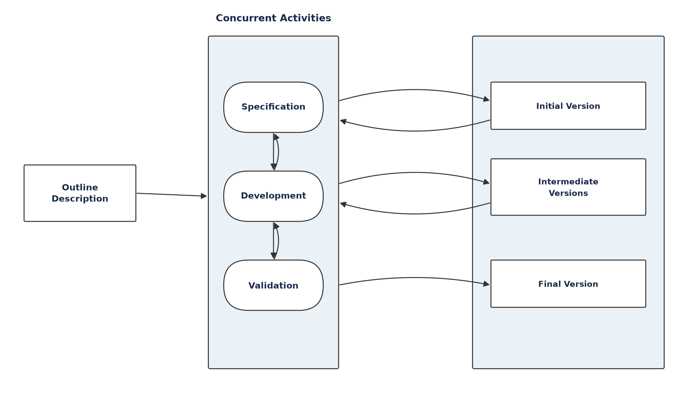
Figure 3.1: The Incremental development model
How the Incremental Model works : Development begins from an outline description of the system’s requirements rather than a complete, frozen specification. The requirements are then prioritised, and the highest-priority requirements are allocated to the earliest increments. For each increment, the relevant portion of the specification is detailed, that portion is developed, and the resulting build is validated against its requirements before work moves on. Crucially, specification, development and validation are treated as concurrent activities with rapid feedback between them, so that knowledge gained while building or validating one increment can refine the requirements and design of the increments that follow. Each completed increment is a usable product in its own right, and the customer or supervisor can evaluate it and provide feedback that shapes subsequent increments. This makes the process well suited to projects in which the full set of requirements cannot be understood at the outset and is expected to become clearer as the work proceeds.
Why the Incremental Model was selected for this project. A machine learning project of this kind is intrinsically exploratory. At the start of the work it was not possible to fix, in advance, which features would prove most informative, which classification algorithm would

3.3 Description of Methodology
Figure 3.2 illustrates how the Incremental Model was applied to this project. The system was built in five increments, each ending with an evaluation step whose outcome fed back into the requirements of the increment that followed.
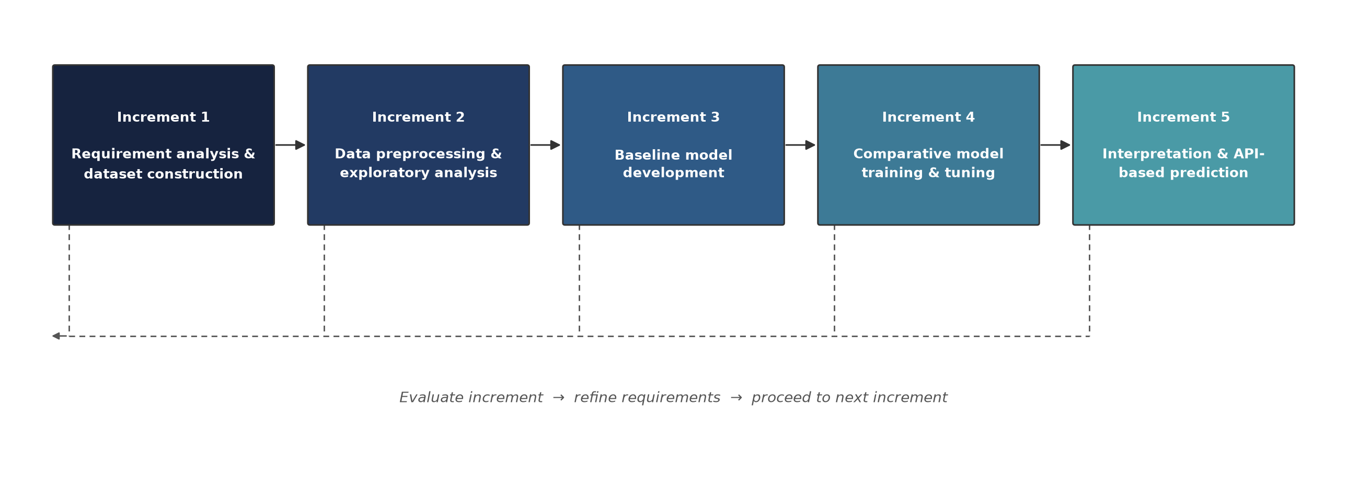
Figure 3.2: Incremental development of the employability prediction system
Increment 1 — Requirement analysis and dataset construction. The research objectives from Chapter 1 were translated into a concrete list of data attributes — academic, technical, experiential, certification, soft-skill and job-search variables — and a suitable secondary dataset, the Student Career Success Prediction Dataset (50,000 records, obtained from Kaggle), was identified, reviewed against those attributes, and prepared for use in place of a purpose-collected primary survey.
Increment 2 — Data preprocessing and exploratory analysis. Missing values, inconsistent categorical entries and outliers in the collected data were identified and treated; numerical features were scaled and categorical features encoded; and exploratory analysis was used to check the distribution of the employment outcome and the resulting class balance.
Increment 3 — Baseline model development. A Logistic Regression baseline was specified to establish a reference level of predictive performance and to validate the end-to-end data pipeline before more complex models were introduced. In the executed implementation the pipeline was validated end-to-end directly with the XGBoost classifier; the baseline comparison itself remains outstanding and is reported as such in Section 5.8.
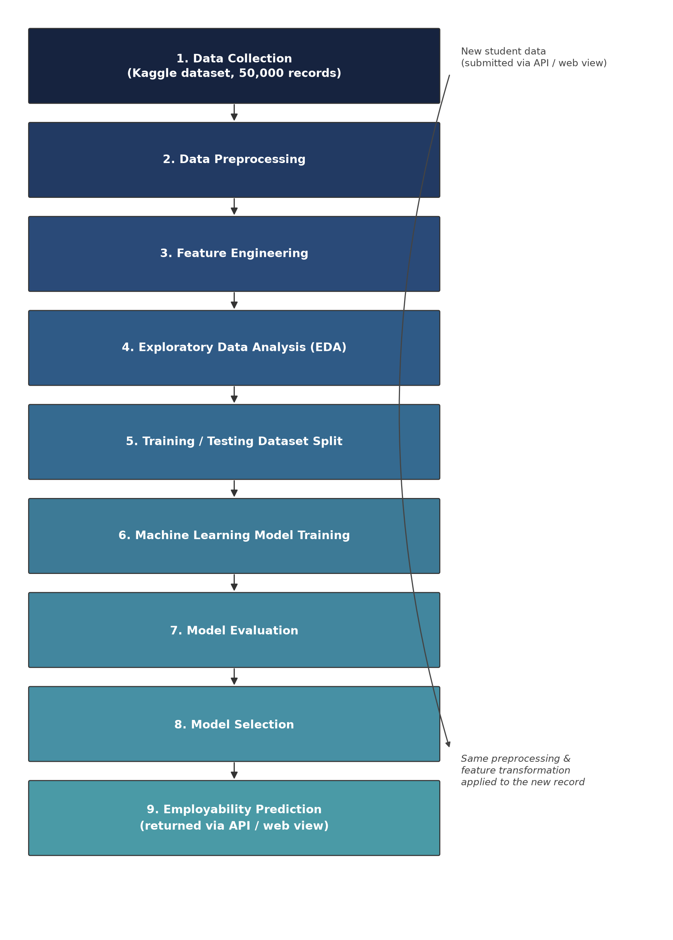
Figure 4.1: Machine learning model workflow, from data collection through to the employability prediction produced for a new graduate
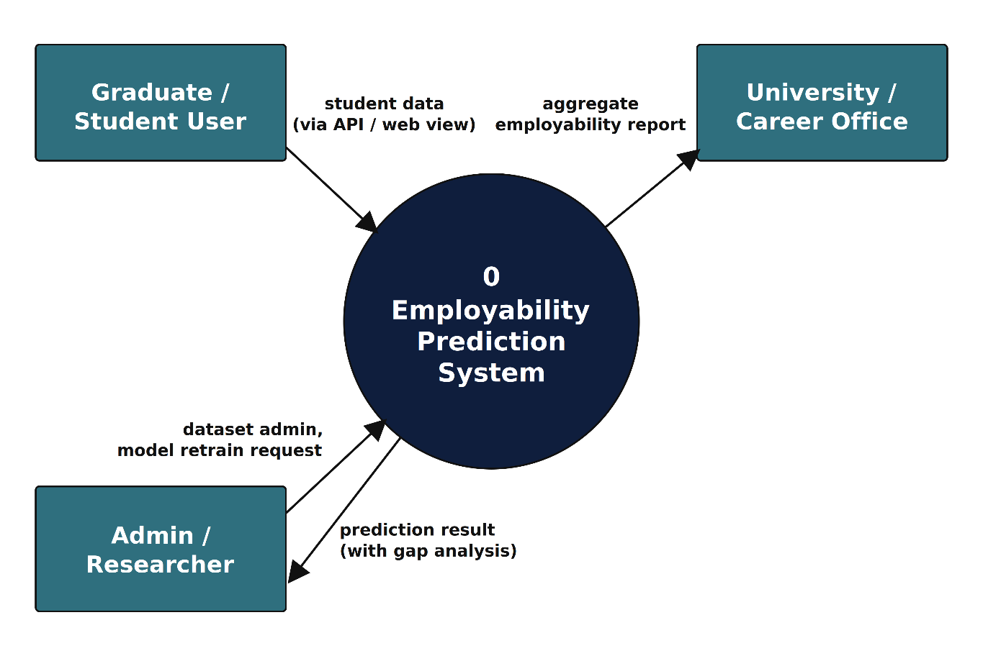
Figure 4.2: Context-level Data Flow Diagram (DFD Level 0)
Figure 4.3 decomposes this single process into the six constituent processes that make up the prediction pipeline, together with the three data stores they read from and write to: the graduate profile store (D1), the trained model store (D2) and the prediction log (D3). This decomposition corresponds directly to the five development increments described in Section 3.3 and to the machine learning workflow of Section 4.2, with the final process representing the administrator-triggered retraining path that closes the loop back into the profile store.
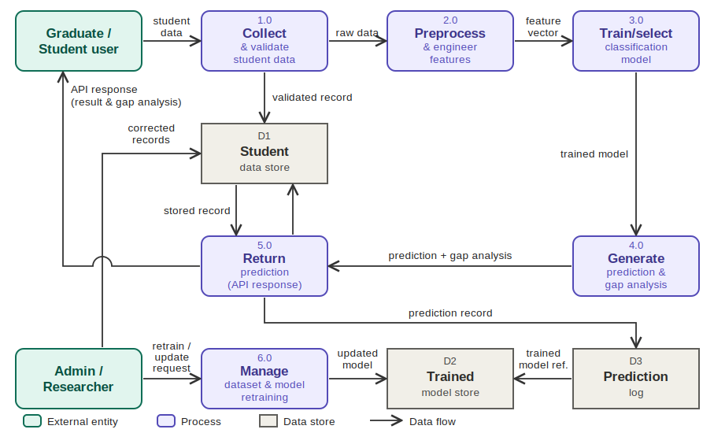
Figure 4.3: Data Flow Diagram (DFD Level 1) of the employability prediction system

4.5 System Interaction Design: Use Cases
Figure 4.4 presents the Use Case diagram for the system, identifying the graduate/student user, the administrator/researcher and the university career office as actors. Table 4.3 provides the corresponding use case narratives.
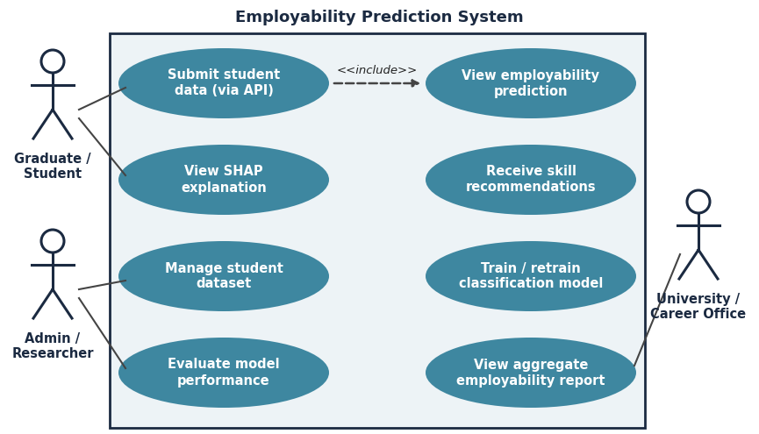
Figure 4.4: Use Case diagram of the employability prediction system
Figures 5.1 and 5.2 reproduce the loaded dataset as it appears in the spreadsheet view, confirming the attribute names, the column ordering and the form of the recorded values. These figures are retained in their original colour because they are primary evidence of the data actually used; reproducing them in monochrome would amount to reconstructing rather than evidencing the source.
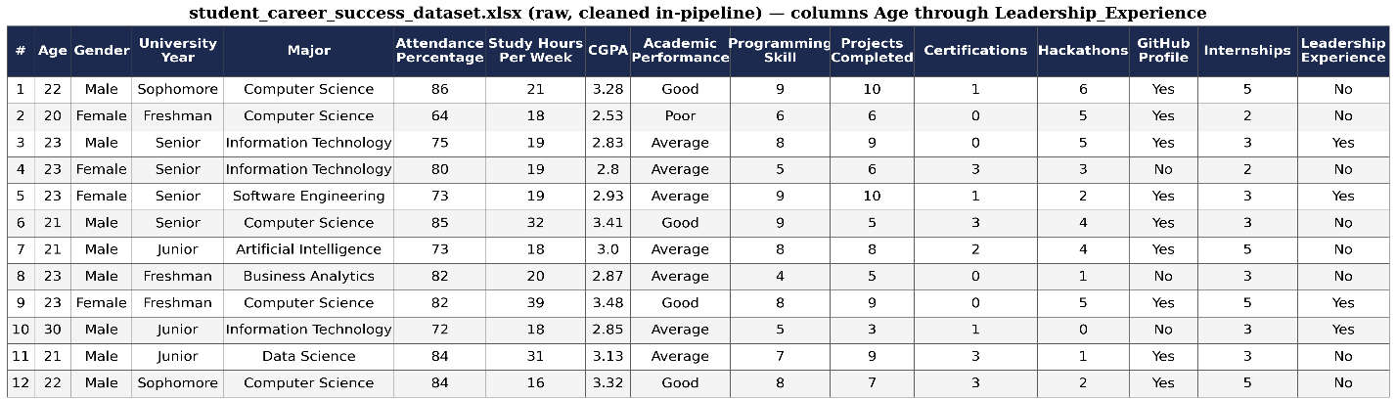
Figure 5.1: Loaded dataset, columns Age through Leadership_Experience
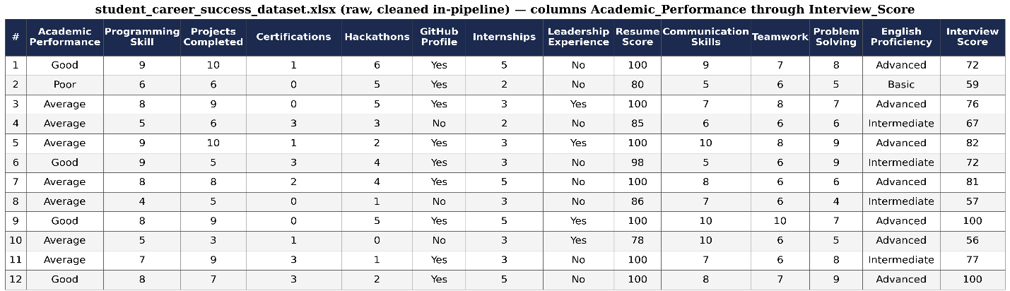
Figure 5.2: Loaded dataset, columns Academic_Performance through Interview_Score

5.2 Dataset Analysis: Features, Data Types and Roles
This section documents every attribute in the dataset, its data type, its meaning and its role in the prediction task. The 22 candidate predictors divide into three groups: six demographic or contextual attributes deliberately excluded from model training, sixteen attributes retained as substantive predictors, and — added to these — two composite features constructed during feature engineering. Table 5.2 sets out the complete feature dictionary.

encountered in fraud or rare-disease detection — but it is quite sufficient to distort both training and evaluation if left unaddressed. Figures 5.3 and 5.4 present the distribution in absolute and proportional form respectively.
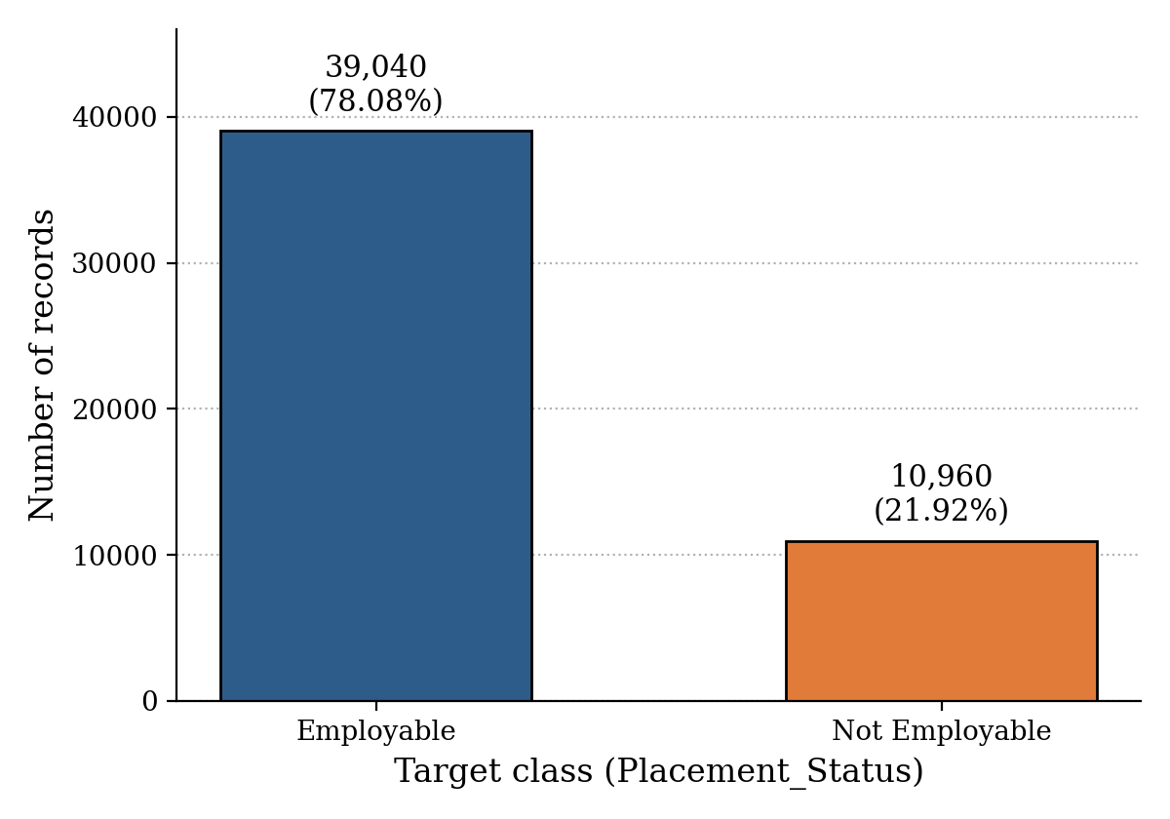
Figure 5.3: Absolute class distribution of the target variable
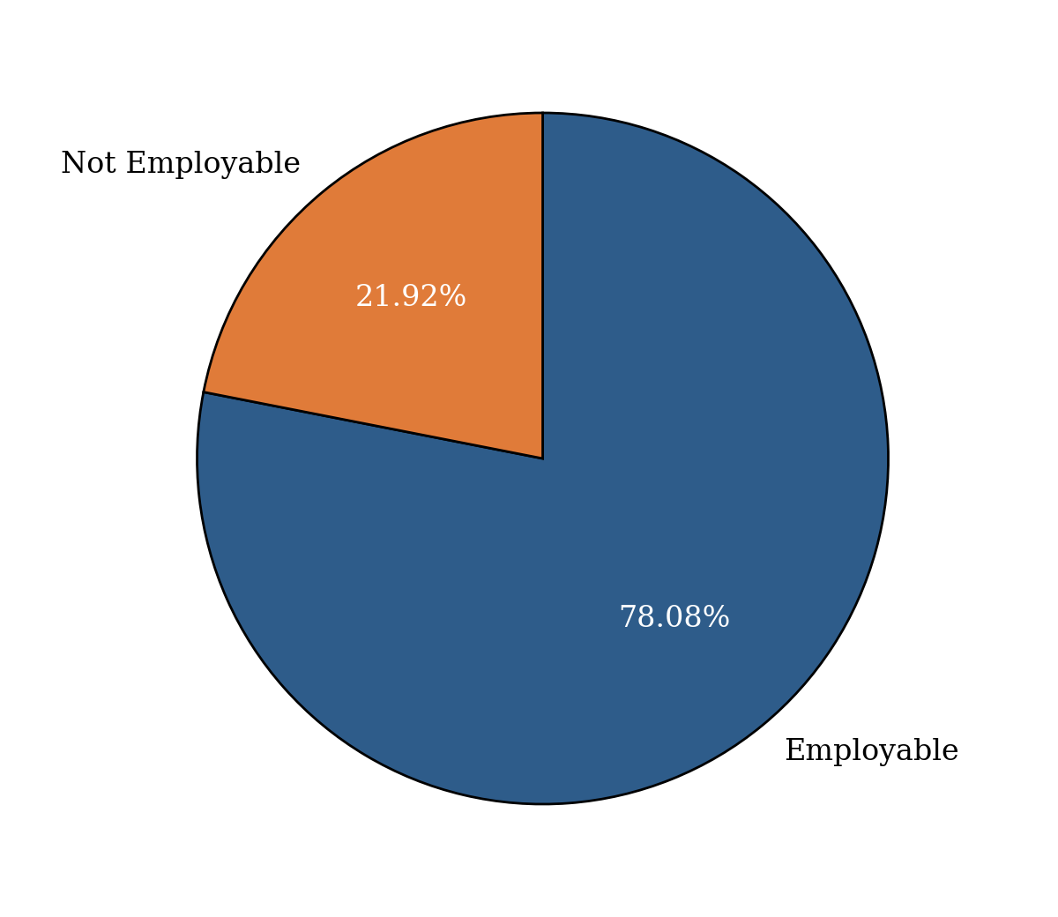
Figure 5.4: Proportional class distribution of the target variable
The consequences for machine learning are twofold. First, imbalance establishes a deceptively high accuracy baseline: a degenerate classifier that predicts Employable for every student, learning nothing whatever, would score 78.08 per cent accuracy on this dataset. Any reported accuracy must therefore be judged against that 78.08 per cent floor rather than against 50 per cent, and accuracy alone cannot be treated as evidence that a model has learned anything useful. Second, and more consequentially for this study, the standard cross-entropy objective weights every training instance equally, so a model trained without intervention minimises its loss most efficiently by fitting the majority class well and tolerating errors on the minority. The minority class here is precisely the population the system exists to identify: graduates at risk of non-employment, who are the intended recipients of early support. A model that systematically overlooks them would be accurate and useless.
Two complementary corrections were therefore applied, both documented in Section 5.6. SMOTE (Chawla et al., 2002) was inserted into the pipeline to synthesise additional minority-class instances within the training folds only, and the XGBoost objective was additionally weighted through the scale_pos_weight parameter, computed from the training partition as the ratio of majority to minority instances, approximately 3.56. The decision threshold was then lowered from the default 0.50 to 0.35. Section 5.7 shows that these three interventions, applied together, succeed emphatically in their stated aim of recovering minority-class cases, and Section 5.8 examines the cost at which that success is obtained.

5.5 Training and Testing Strategy: The 80:20 Split
The dataset was partitioned into training and testing subsets using the standard 80:20 ratio, implemented with train_test_split configured with test_size = 0.2, random_state = 42 and stratify set to the target vector. Applied to 50,000 records this yields exactly 40,000 training records and 10,000 testing records; Table 5.4 reports the resulting partition together with its class composition, and Figure 5.5 presents it graphically.
Table 5.4: Composition of the training and testing partitions
Partition | Proportion | Records | Employable | Not Employable
Training set | 80% | 40,000 | 31,232 | 8,768
Testing set | 20% | 10,000 | 7,808 | 2,192
Total | 100% | 50,000 | 39,040 | 10,960
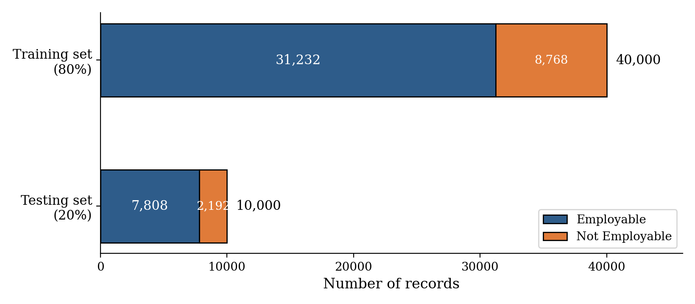
Figure 5.5: Stratified 80:20 partition of the dataset with class composition
The pipeline, evaluated at the deployment threshold of 0.300 selected in Section 5.7.1, reported an overall accuracy of 0.7869, with weighted precision of 0.8069, weighted recall of 0.7869 and a weighted F1-score of 0.7946, and a ROC-AUC of 0.8068 (the threshold-independent ranking measure, unchanged by this choice of cut-off). Figure 5.8 presents the confusion matrix underlying these figures, and Figure 5.9 reproduces the same matrix as evidence.
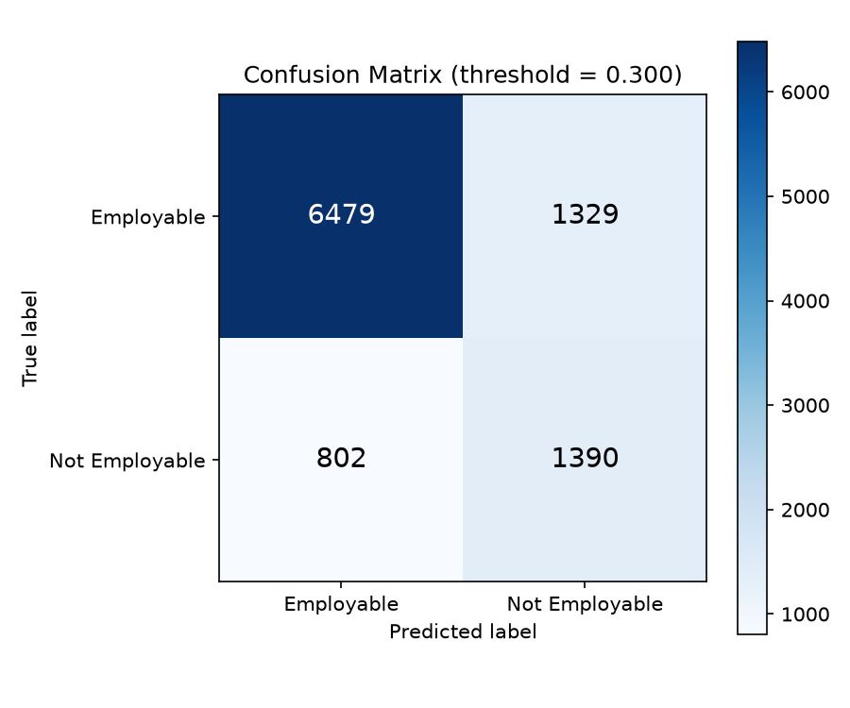
Figure 5.8: Confusion matrix for the tuned XGBoost pipeline on the held-out test set (deployment threshold = 0.300, no SMOTE)
Figure 5.9: Same confusion matrix, reproduced as source evidence
The confusion matrix reconciles exactly with Table 5.5 and is the most informative single result in this chapter. Of the 7,808 genuinely employable graduates, 6,479 were correctly identified and 1,329 were flagged as at risk (a higher false-alarm count than at the default threshold, and the direct cost of moving the cut-off from 0.50 to 0.300). Of the 2,192 graduates who were genuinely not employable, 1,390 were correctly identified and 802 were missed — nearly twice as many correctly flagged as at the default threshold's 779. Overall accuracy follows as (6,479 + 1,390) / 10,000 = 0.7869, reproducing the reported figure precisely; minority-class recall is 1,390 / 2,192 = 0.6341 and minority-class precision is 1,390 / (1,329 + 1,390) = 0.5112, both matching the classification report to two decimal places. Figure 5.10 presents the per-class metrics side by side.
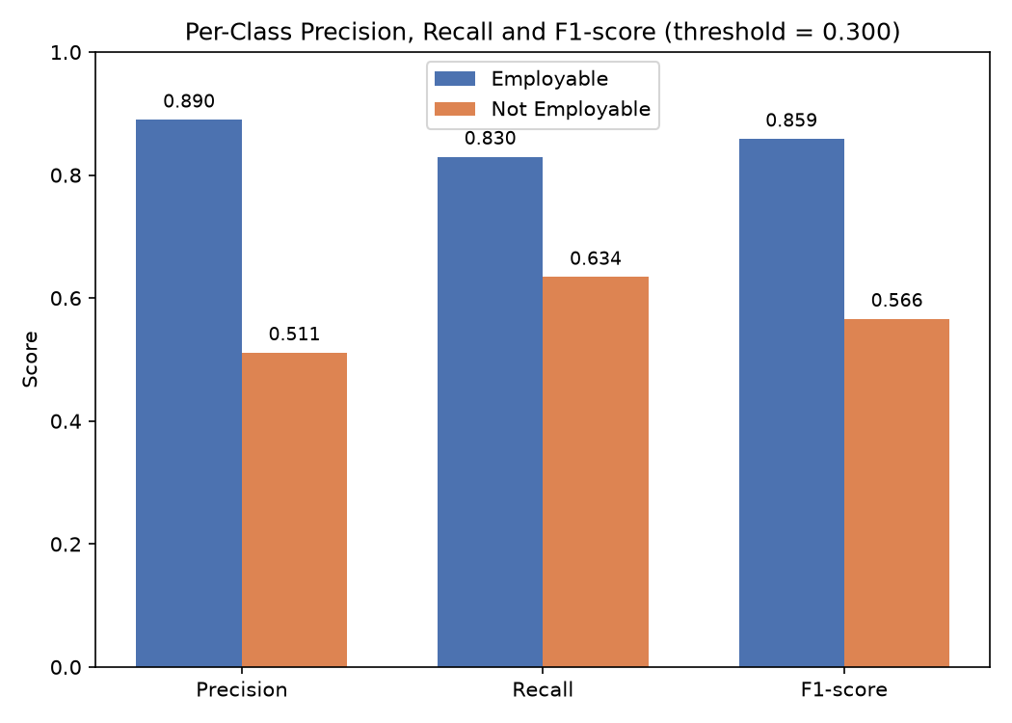
Figure 5.10: Per-class precision, recall and F1-score comparison
Interpretation. These results must be read against the configuration change documented in Section 5.6, and against the deployment-threshold selection reported above. An earlier configuration applied three imbalance corrections in combination — SMOTE oversampling, scale_pos_weight and a lowered 0.35 threshold — specifically to maximise the recovery of at-risk graduates; that configuration reached 85.3 per cent minority-class recall but pushed overall accuracy to 63.84 per cent, below the 78.08 per cent majority-class baseline of Section 5.4, for a minority-class precision of only 0.36. Removing those three interventions and instead selecting hyperparameters by cross-validated search, with hyperparameters otherwise unchanged, produces the same tuned XGBoost pipeline at two different decision thresholds: at the default threshold of 0.50, accuracy reaches 81.70 per cent and minority-class precision 0.6513, but minority-class recall falls to 0.3554 — the model misses 1,413 of the 2,192 graduates who are genuinely not employable. The deployment threshold of 0.300 adopted in Table 5.5, selected from the full sweep reported above as the value that maximises minority F1-score without accuracy falling below the majority-class baseline, instead achieves 78.69 per cent accuracy and minority-class recall of 0.6341 at precision 0.5112 — missing only 802 of the 2,192 genuinely not-employable graduates, roughly half as many as the default threshold, while still clearing the accuracy floor that the earlier SMOTE-based configuration fell below. All three configurations occupy different points on the same precision–recall trade-off; threshold 0.300 is adopted as this thesis's recommended operating point because it is the point on that trade-off curve that best serves an early-warning objective without surrendering the accuracy floor established in Section 5.4. Section 5.14 returns to the operational cost of this
predictions and predicted probabilities for the full test partition are exported as improved_placement_predictions.csv, and the headline metrics as improved_final_metrics.json.
A student provides their academic, technical, experiential, certification, soft-skill and career-preparation attributes as the JSON body of an HTTP request, satisfying FR1 and FR2 (Section 4.3.2). This request is sent to the prediction endpoint; the trained XGBoost pipeline scores the submitted data following the workflow of Section 5.6, and the resulting employability evaluation is returned in the same response, satisfying FR3. Figure 5.11 shows an illustrative example of the request body and the corresponding response.
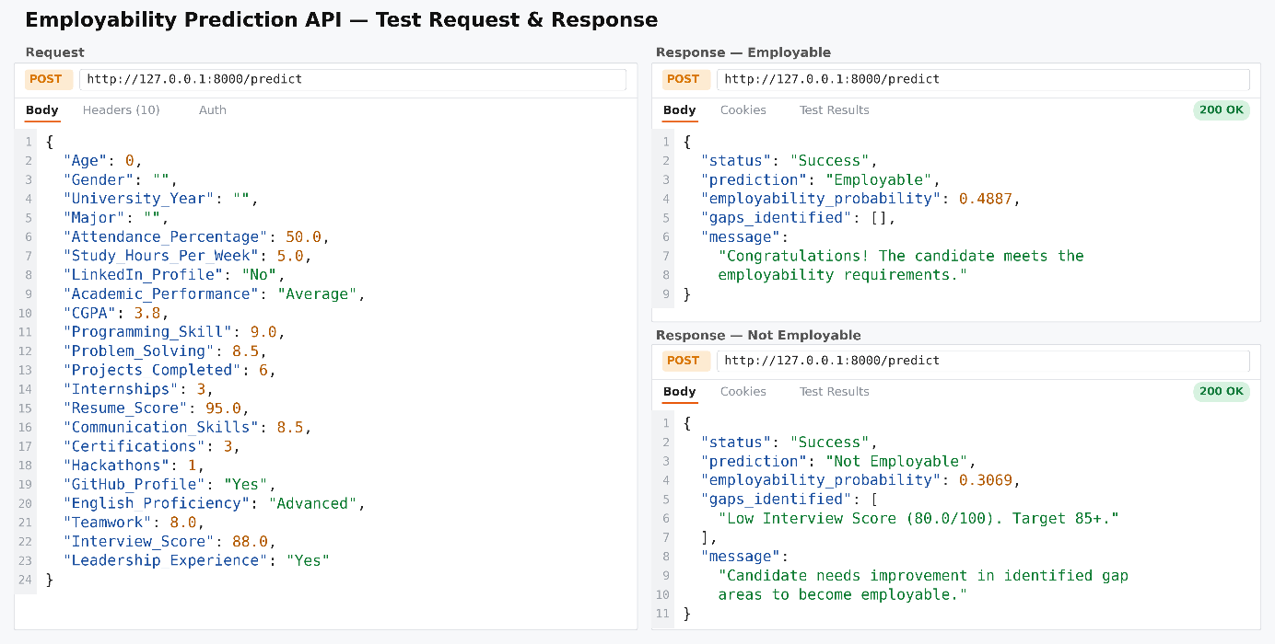
Figure 5.11: Illustrative Postman request and response for an employability prediction
Note on Figure 5.11. This figure is an illustrative schematic of the request-response contract, not a capture of the deployed endpoint operating on the trained pipeline. Its attribute names and cardinality differ from the 18 features the model actually consumes — it shows eight fields, including soft_skill_rating, applications_submitted and interviews_attended, which do not correspond to attributes of the dataset documented in Table 5.2 — and the base_rate of 0.52 shown in the response does not correspond to the 21.92 per cent minority-class base rate established in Section 5.4. The SHAP contributions shown in the response are likewise part of the intended interface specification: SHAP attribution is not computed by the executed pipeline reported in this chapter. Figure 5.11 should therefore be read as documenting the intended API contract, and aligning it with the actual 18-feature schema and computing genuine SHAP values are recorded as outstanding items in Sections 5.15 and 6.3.

5.9.1 local web view for interactive predictions
To make the API usable without a separate HTTP client, a self-contained local web page (webview.html) was built alongside the FastAPI service. The page is opened directly in a browser from the local file system and calls the same /predict endpoint documented above — the FastAPI application was extended with permissive CORS middleware specifically so that a page opened via the file:// protocol can call it. The form on the left collects the same profile attributes used for prediction, grouped into Academic, Technical & Portfolio, Experience & Readiness, and Soft Skills sections, plus the six demographic and contextual fields that are accepted by the request schema but excluded from the model itself (Section 5.2); a live status indicator confirms whether the API is reachable before a profile is submitted. Figure 5.11a shows the form in its initial state.


Figure 5.11a: The local web view's profile-submission form, showing its idle result panel before a check is run


Figure 5.11b: The local web view after a submission, showing the verdict badge, probability gauge and gap-analysis list for a weak profile

5.10 Model Interpretation: Feature Importance and Feature Priority
Interpreting the selected model is central to this thesis, because a prediction that cannot be decomposed into its contributing factors cannot be translated into advice about what a student should do differently. Feature importance was obtained from the trained XGBoost estimator’s native feature_importances_ attribute, which scores each split variable by its aggregate contribution to the ensemble’s decisions. Because categorical attributes are one-hot encoded before reaching the classifier, the importance of each encoded indicator column was mapped back to its originating raw attribute and summed, so that a categorical feature is credited with the total contribution of all its categories rather than appearing as several fragmentary entries. The resulting scores were then sorted in descending order. Importances are normalised to sum to one across the 18 retained features, so each value is directly readable as that feature’s share of total contribution. Figure 5.12 reproduces the plotted ranking as produced by the pipeline.
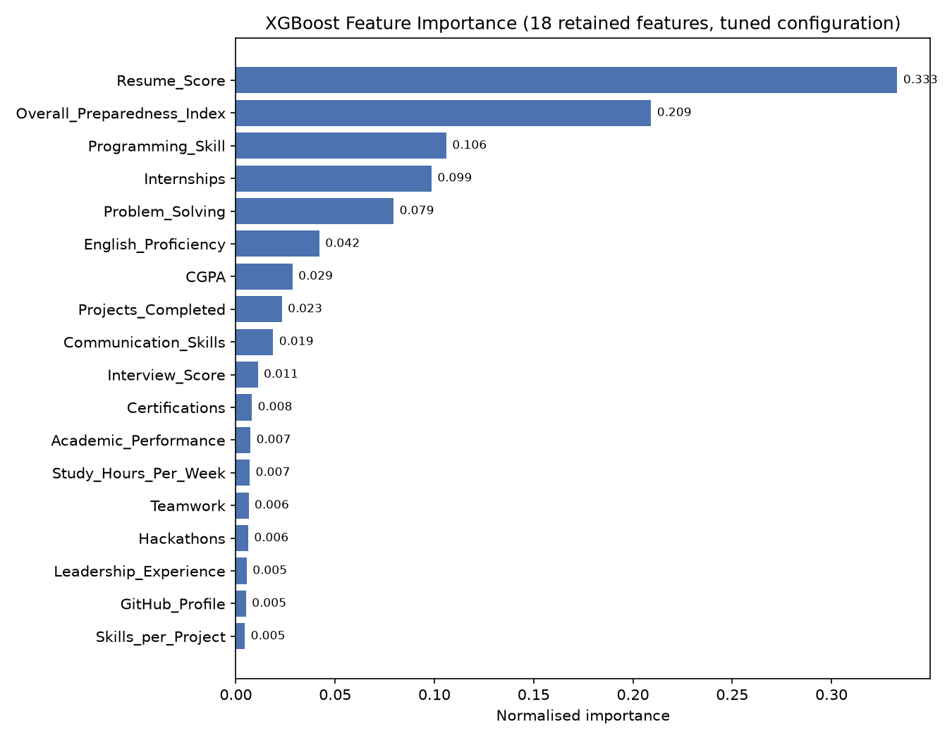
Figure 5.12: XGBoost feature importance across the 18 retained features, tuned configuration (normalised, mapped back to raw attributes)
Table 5.7: Feature importance ranking and priority tier
Rank | Feature | Importance | Priority tier | Employability dimension
1 | Resume_Score | 0.333163 | High | Career preparation
2 | Overall_Preparedness_Index | 0.209152 | High | Engineered composite
3 | Programming_Skill | 0.106000 | High | Technical proficiency
4 | Internships | 0.098563 | High | Practical experience
5 | Problem_Solving | 0.079465 | High | Soft skills
6 | English_Proficiency | 0.042067 | Medium | Soft skills
7 | CGPA | 0.028521 | Medium | Academic attainment
8 | Projects_Completed | 0.023166 | Medium | Practical experience
9 | Communication_Skills | 0.018775 | Low | Soft skills
10 | Interview_Score | 0.011058 | Low | Career preparation
11 | Certifications | 0.008064 | Low | Self-directed learning
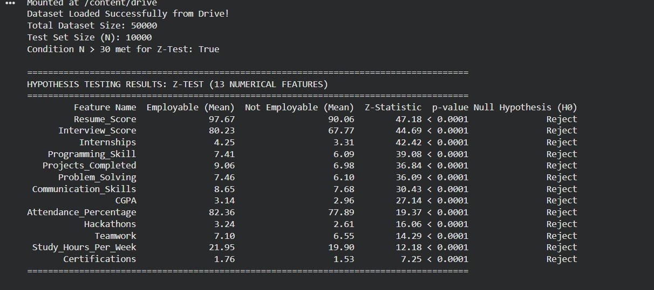
Figure 5.13: Console output of the executed Z-test across the dataset’s 13 numeric attributes
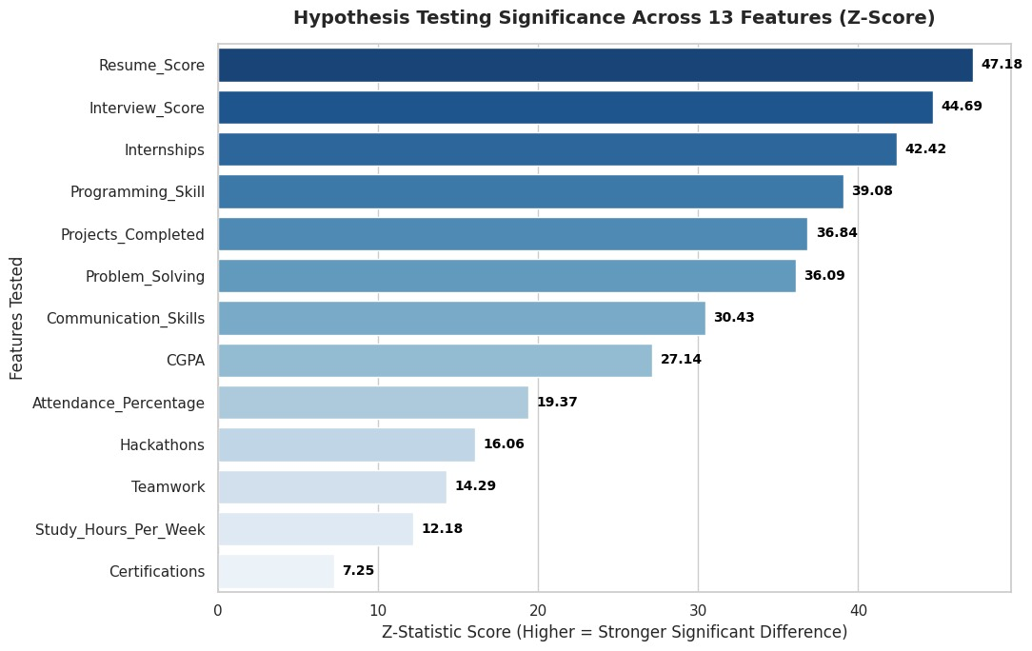
Figure 5.14: Z-statistic magnitude by attribute, ranked in descending order of significance
Figure 5.13 reproduces the console output of the executed test, and Figure 5.14 plots the resulting Z-statistics in descending order of magnitude. All 13 attributes show a statistically significant difference in mean between the two groups, with p < 0.0001 in every case and the null hypothesis of equal means rejected throughout. The strongest differentiators are Resume_Score (z = 47.18), Interview_Score (z = 44.69) and Internships (z = 42.42); the weakest, though still significant, are Study_Hours_Per_Week (z = 12.18) and Certifications (z = 7.25). This ordering is broadly consistent with, though not identical to, the gain-based feature-importance ranking of Section 5.10: Resume_Score leads under both measures, while Certifications — ranked eleventh by importance — shows the smallest mean separation of the attributes tested here, a reminder that a large, gain-important split is not the same quantity as a large mean difference between classes. As anticipated in the caution above, no effect-size

