Assignment 1 Report
DEVS Simulation of Parking Lot Model

Mahad Ahmed 101220427
Yusuf Ibrahim 101231208
SYSC4906 - G
Gabriel Wainer
Wednesday February 25, 2026

Table of Contents

Model Selection 3
Model Specification and DEVS Model Design 4
DEVS Graph Modeler 4
Model Definition 4
DEVS Formal Specification 5
Atomic Models 5
Access Control A 6
Access Control B 7
Screen 8
Side A 9
Side B 10
Coupled Models 12
ParkingLot 12
Experimentation Framework 13
Simulation and Experimental Analysis 14
Github Repository 14
Execution Results 14
Access Control A – Results 14
Access Control B – Results 15
Screen – Results 16
Side A – Results 17
Side B – Results 18
Parking Lot – Results 19
Parking System - Results 21
Summary 24

Model Selection

We opted to use an existing model, being the Parking Lot model. This model already included the required atomic components such as access controls, screens and sections/sides to the parking lot. While this was a strong starting point, the original model only had a single level and did not fully meet the multi-level structure required for this assignment when in a group of two members. To address this, we expanded the model by introducing additional hierarchical levels. By decomposing the parking lot into coupled submodels for Side A and Side B, each with their own sensors and aggregators, and connecting the access control and screen components, allowed the model to be expanded to satisfy the assignment’s requirements.

Model Specification and DEVS Model Design
This project focuses on modeling the behaviour of an underground parking lot. The parking lot is split into two sections with 25 parking spaces each, totaling 50 parking spaces. Sensors will be implemented above each parking space to indicate to the system if the space is available. There will be screens at various points in the parking lot indicating the number and direction of available parking spaces, allowing drivers to find empty parking quicker and reducing the queue time.

DEVS Graph Modeler
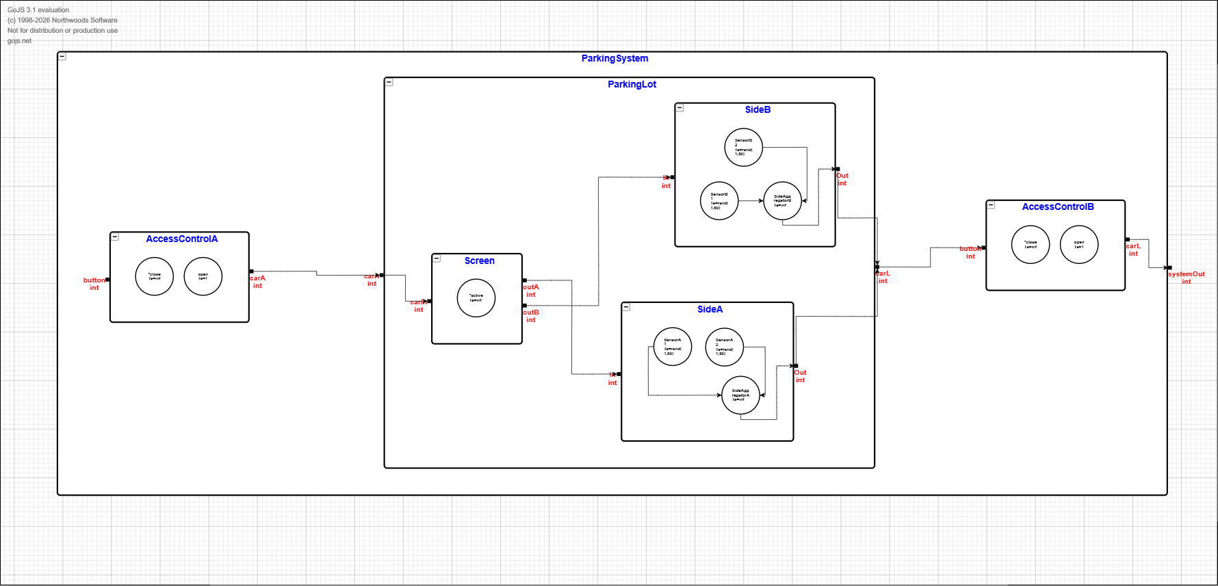
Figure 1 - DEVS Graph of the atomic models

Model Definition
The project is composed of multiple components that together model the behavior of an underground parking lot, the components are as following:
- Access Control A - Represents the entrance gate, simulates arrival of a car through a random input and produces an output when a driver presses the entry button
- Screen - Represents the display that receives an input of incoming cars and determines which side of parking lot to be directed to, producing an output toward Side A or Side B
- Side A - Represents a section of the parking lot, receives an input from the Screen regarding incoming cars, and generate an output when a car occupying a space triggers the sensor (whether activating on arrival or deactivating on departure)
- Side B - Represents a section of the parking lot, receives an input from the Screen regarding incoming cars, and generate an output when a car occupying a space triggers the sensor (whether activating on arrival or deactivating on departure)
- Access Control B - Represents the exit gate, simulates departure of a car through a random input and produces an output when the exit gate lifts/activates
- Parking Lot - Represents the parking lot as a whole, formed by the Screen, Side A and Side B submodels, receives input from Access Control A regarding incoming cars
For clarification on the system’s behavior, using Figure 1, start with an example of an empty parking lot. A car arrives and presses the entry button (at Access Control A) and the gate lifts. Once the car enters the parking lot, the driver can see the screen showcasing the available parking spots on either section (Side A or Side B, both with 25 available parking spaces). Assuming the car goes to Side A and parks into any available parking space, the sensor for the parking space will activate and subtract the space in the screen. Thus leaving the total available spaces in Side A down to 24 parking spaces. When the car leaves, the sensor will deactivate and add the space in the screen, returning the total available spaces in Side A back to 25 parking spaces.

DEVS Formal Specification
As shown in our DEVS graph, Parking Lot has one input and one output. The input is generated by Access Gate A, indicating a car’s arrival, which produces an output when it is activated. The output from the Parking Lot then becomes the input for Access Gate B which once activated, allows the car to exit the parking lot. The Parking Lot is composed of three components, being the Screen, Side A and Side B. The Screen directs incoming cars to either Side A or Side B. The selected side then activates the sensor in the parking space occupied, only deactivating that specific sensor when the car leaves the parking spot which generates an output for the Parking Lot.

Atomic Models
Atomic DEVS = < S , X , Y , δ_{int} , δ_{ext} , λ , ta >
- X : external input event set
- Y : external output event set
- S : state set
- δ_{int}: internal transition function
- δ_{ext} : external transition function
- λ : output function
- ta : time advance function

Access Control A
This model represents the entrance gate to the parking lot. It starts closed and idle. When a person clicks the entry button, the gate opens. After 1 time unit (simulate gate being open and car entering), it automatically closes again and sends a signal indicating that a car has entered.
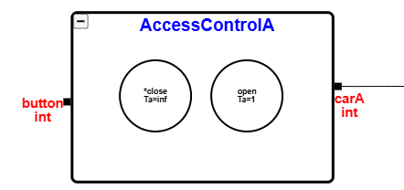
Figure 2 - Atomic model of Access Control A
Component X:
- X = {button}
- One input: a signal from a driver pressing the entry button.
Component Y:
- Y = {carA}
- One output: a signal indicating that a car has arrived.
Component S:
- S = {close, open}
- Two states: The initial close state indicates that the gate is shut and idle, and the open state indicates that the gate is open and a car is entering.
Component δ_{int}:
- δ_{int} (open) = close
- Internal transition: After the gate has been open for 1 time unit, it automatically closes.
Component δ_{ext}:
- δ_{ext} (close, e, button) = open
- External transition: If the gate is in the close state and a button signal arrives, it moves to open. Input e is for elapsed time.
Component λ:
- λ (open) = carA
- Output function: Just before the internal transition transitions from open to close, signal that a car has entered.
Component ta:
- ta (close) = ∞ // ta (open) = 1
- Time advance: Time advance: In close state, wait forever, in open state wait exactly 1 time unit before automatically closing.

Access Control B
This model has the same structure as Access Control A, but represents the exit gate.
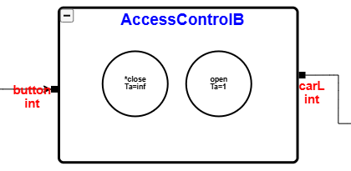
Figure 3 - Atomic model of Access Control B

Component X:
- X = {button}
- One input: a signal from a driver pressing the exit button.
Component Y:
- Y = {carL}
- One output: a signal indicating that a car has left.
Component S:
- S = {close, open}
- Two states: The initial close state indicates that the gate is shut and idle, and the open state indicates that the gate is open and a car is exiting.
Component δ_{int}:
- δ_{int} (open) = close
- Internal transition: After the gate has been open for 1 time unit, it automatically closes.
Component δ_{ext}:
- δ_{ext} (close, e, button) = open
- External transition: If the gate is in the close state and a button signal arrives, it moves to open. Input e is for elapsed time.
Component λ:
- λ (open) = carA
- Output function: Just before the internal transition transitions from open to close, signal that a car has exited.
Component ta:
- ta (close) = ∞ // ta (open) = 1
- Time advance: Time advance: In close state, wait forever, in open state wait exactly 1 time unit before automatically closing.

Screen
The screen model receives a signal when a car arrives, and decides which side (A or B) to route the car to. It also tracks the total number of available spaces. The state includes a subphase. When a car arrives, the model transitions to a “routing” phase to produce its output, then it returns to active.

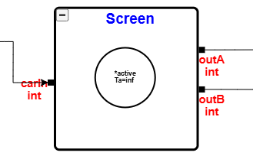
Figure 3 - Atomic model of Screen

Component X:
- X = {carIn}
- One input: a signal that a car has entered.

Component Y:
- Y = {outA, outB}
- Two outputs: outA to direct a car to side A and outB to direct a car to side B.

Component S:
- S = {(phase, spaces, turn) | phase ∈ {active, routing}, spaces ∈ [0..50], turn ∈ {A, B}}
- Three component state: It tracks the current phase, the number of available parking spaces, and which side to route the next car to. Initially it starts with all 50 spaces available, and routing to SideA.

Component δ_{int}:
- δ_{int} (routing, sp, A) = (active, sp, B) // δ_{int}(routing, sp, B) = (active, sp, A)
- Internal transition: After routing a car, flip the destination to the other side and return to active.

Component δ_{ext}:
- δ_{ext} ((active, sp, t), e, carIn) = (routing, sp-1, t)
- External transition: When a signal arrives for a car, decrement the available spaces by 1 and enter the routing phase.

Component λ:
- λ (routing, sp, A) = outA // λ (routing, sp, B) = outB
- Output function: Just before the internal transition transitions, route the car to the appropriate side based on the current turn.

Component ta:
- ta(active, ...) = ∞ // ta(routing, ...) = 1
- Time advance: When active wait forever, when routing, 1 time unit.

Side A
Side A represents one of the sections of the parking lot. It receives a signal from the Screen when a car is routed to it. A parking space becomes occupied and stays occupied as long as a car is parked. When the car departs, a signal is generated.

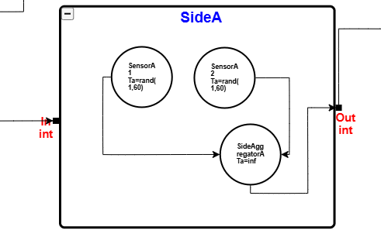
Figure 4 - Atomic model of Side A

Component X:
- X = {in}
- One input: a signal from the screen routing a car to sideA

Component Y:
- Y = {out}
- One output: a signal indicating that a car has left side A.

Component S:
- S = {idle, occupied}
- Two states: The initial idle state for when no car is occupying a space, and occupied when a car is parked.

Component δ_{int}:
- δ_{int}(occupied) = idle
- Internal transition: After the parking duration expires, the parking space returns to idle.

Component δ_{ext}:
- δ_{ext} (idle, e, in) = occupied
- External transition: If in the idle state and an arrival signal is received, the space becomes occupied.

Component λ:
- λ (occupied) = out
- Output function: Just before the internal transition transitions, signal that a car has left.

Component ta:
- ta(idle) = ∞ // ta(occupied) = random
- Time advance: Wait indefinitely when idle. When occupied, wait a random amount of time units before the car departs.

Side B
Side B has the same structure as Side A but represents the other section of the parking lot.

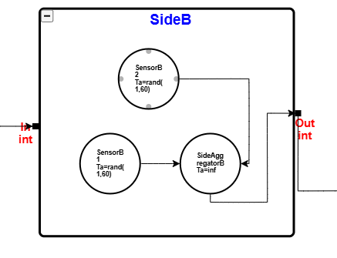
Figure 5 - Atomic model of Side B

Component X:
- X = {in}
- One input: a signal from the screen routing a car to side B

Component Y:
- Y = {out}
- One output: a signal indicating that a car has left side B.

Component S:
- S = {idle, occupied}
- Two states: The initial idle state for when no car is occupying a space, and occupied when a car is parked.

Component δ_{int}:
- δ_{int}(occupied) = idle
- Internal transition: After the parking duration expires, the parking space returns to idle.

Component δ_{ext}:
- δ_{ext} (idle, e, in) = occupied
- External transition: If in the idle state and an arrival signal is received, the space becomes occupied.

Component λ:
- λ (occupied) = out
- Output function: Just before the internal transition transitions, signal that a car has left.

Component ta:
- ta(idle) = ∞ // ta(occupied) = random
- Time advance: Wait indefinitely when idle. When occupied, wait a random amount of time units before the car departs.

Coupled Models

ParkingLot
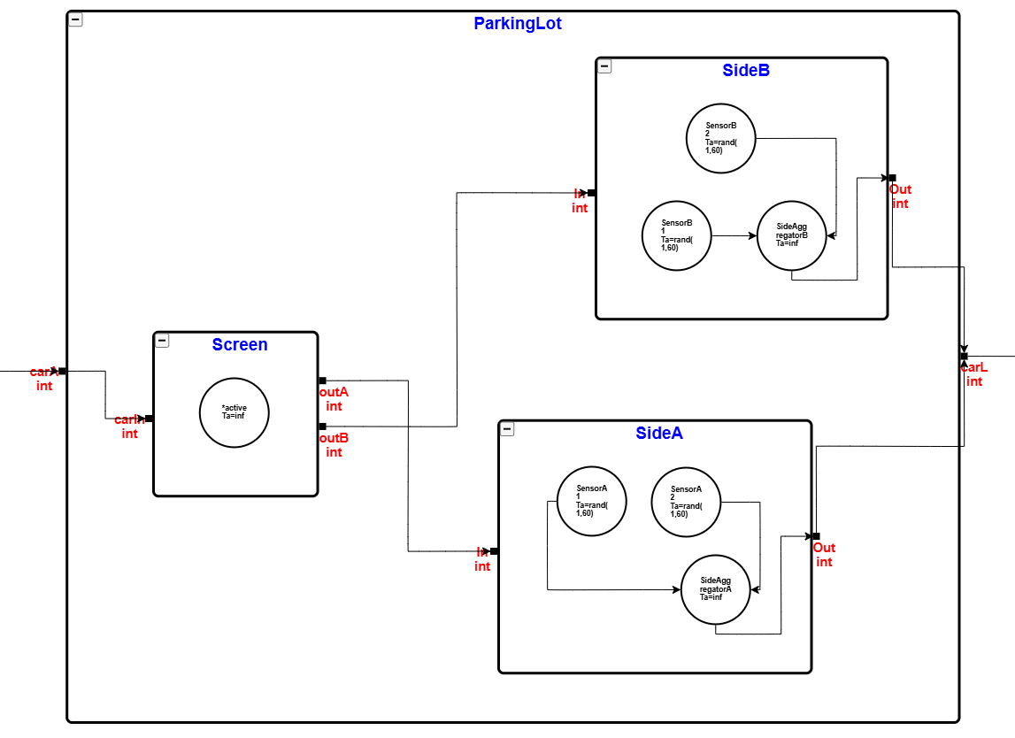
Figure 6 - Coupled model of Parking Lot
Component X:
- X = {carA}
- One input: a signal from Access Control A indicating a car has entered the parking lot.
Component Y:
- Y = {carL}
- One output: a signal indicating a car is ready to exit, sent to Access Control B.
Component D:
- D = {Screen, SideA, SideB}
- Three components: the routing display and both parking sections.
Component EIC:
- EIC = {(ParkingLot.carA to Screen.carIn)}
- External input coupling: the car arrival signal is forwarded to the Screen for routing.
Component EOC:
- EOC = {(SideA.out to ParkingLot.carL), (SideB.out to ParkingLot.carL)}
- External output coupling: departure signals from either side exit the ParkingLot as a carL signal.
Component IC:
- IC = {(Screen.outA to SideA.in), (Screen.outB to SideB.in)}
- Internal coupling: the Screen routes the car to either Side A or Side B.
Component SELECT:
- SELECT({Screen, SideA}) = Screen
- SELECT({Screen, SideB}) = Screen
- SELECT({SideA, SideB}) = SideA
- Tie-breaking: the Screen takes priority over either side. Side A takes priority over Side B when both transition simultaneously.

Experimentation Framework
The experimentation framework will consist of a combination of the experiments executed in the original document as well as new ones to ensure there is an incremental expansion of the tests, starting from the atomic models and gradually reaching the coupled model system. Below is a table organising the experiments to be implemented using Cadmium.
Model Level | Model Tested | Purpose of Experiment | Input Stimuli | Expected Behavior | Notes
Atomic | Access Control A | Test entrance gate and output | Car press entry button at different times | Inputs produce an output after some time to mimic a car entering the parking lot | Reused from CD++
Atomic | Access Control B | Test exit gate timing behavior | Car press exit button to trigger event | Inputs produce an output after some time to mimic a car exiting the parking lot | New experiment
Atomic | Screen | Test routing logic between Side A and Side B | Multiple arrival events with different availability values | Outputs are directed to a side when space is available | New experiment
Coupled (Level 3) | Side A  (Sensors + Aggregator) | Test tracking occupants and departure generation | Car routed to Side A | Parking space count adjusts based on arrival and parking time, output generated on departure | New experiment
Coupled (Level 3) | Side B  (Sensors + Aggregator) | Test tracking occupants and departure generation | Car routed to Side B | Parking space count adjusts based on arrival and parking time, output generated on departure | New experiment
Coupled (Level 2) | Parking Lot (Screen + Side A + Side B) | Validate interaction between routing to parking availability | Multiple car arrivals | Cars routed to a side and exit events generated, parking spaces adjusted correctly | Reused from CD++ (updated hierarchy)
System (Top) | Full Parking System | Validate end-to-end behavior of the complete hierarchy | Car arrivals at entrance | Cars pass through entrance, are routed, park, and exit through exit gate | New experiment

Simulation and Experimental Analysis

Github Repository
The source code for this system can be found at this link → https://github.com/mahad-a/4906-devs-parking-lot

Execution Results

Access Control A – Results
sep=;
time;model_id;model_name;port_name;data
0;1;access_control_a;;0
0;2;iestream;;1
0;1;access_control_a;out;1
0;1;access_control_a;;inf
1;1;access_control_a;;5
1;2;iestream;out;1
1;2;iestream;;10
6;1;access_control_a;out;1
6;1;access_control_a;;inf
11;1;access_control_a;;5
11;2;iestream;out;1
11;2;iestream;;10
16;1;access_control_a;out;1
16;1;access_control_a;;inf
21;1;access_control_a;;5
21;2;iestream;out;1
21;2;iestream;;inf
26;1;access_control_a;out;1
26;1;access_control_a;;inf
26;1;access_control_a;;inf
26;2;iestream;;inf

The results show that Access Control A consistently reacts to the input button by generating a car arrival on its output port. The internal state alternates between close and open as expected, with ta=inf when idle and a brief period when processing a car. This confirms that the model correctly simulates cars arriving at the parking lot whenever the button is pressed, otherwise it remains idle when no input occurs.

Access Control B – Results
sep=;
time;model_id;model_name;port_name;data
0;1;access_control_b;;0
0;2;iestream;;3
0;1;access_control_b;out;1
0;1;access_control_b;;inf
3;1;access_control_b;;5
3;2;iestream;out;1
3;2;iestream;;10
8;1;access_control_b;out;1
8;1;access_control_b;;inf
13;1;access_control_b;;5
13;2;iestream;out;1
13;2;iestream;;10
18;1;access_control_b;out;1
18;1;access_control_b;;inf
23;1;access_control_b;;5
23;2;iestream;out;1
23;2;iestream;;inf
28;1;access_control_b;out;1
28;1;access_control_b;;inf
28;1;access_control_b;;inf
28;2;iestream;;inf

Access Control B acts similarly to Access Control A, producing a car leaving when a car reaches the exit. The timing and outputs match the expected gate operation, with the close and open transition. The model demonstrates that it correctly synchronizes with the capacity of the parking lot by ensuring cars exit only after being processed by the parking lot.

Screen – Results
sep=;
time;model_id;model_name;port_name;data
0;1;screen;;available_spaces:50
0;2;iestream;;2
0;1;screen;out;1
0;1;screen;out;50
0;1;screen;;available_spaces:50
2;1;screen;;available_spaces:49
2;2;iestream;out;1
2;2;iestream;;5
3;1;screen;out;1
3;1;screen;out;49
3;1;screen;;available_spaces:49
7;1;screen;;available_spaces:48
7;2;iestream;out;1
7;2;iestream;;5
8;1;screen;out;1
8;1;screen;out;48
8;1;screen;;available_spaces:48
12;1;screen;;available_spaces:47
12;2;iestream;out;1
12;2;iestream;;inf
13;1;screen;out;1
13;1;screen;out;47
13;1;screen;;available_spaces:47
13;1;screen;;available_spaces:47
13;2;iestream;;inf

The Screen model accurately tracks available spaces on each side, with each incoming car updating the side’s parking space availability by one, and outputs which side the car is directed to. The results also show available_spaces decrementing sequentially as cars enter the parking lot, further proving the routing logic for cars to either side based on availability

Side A – Results
sep=;
time;model_id;model_name;port_name;data
0;2;side_aggregator;;0
0;3;sensor2;;0
0;4;sensor1;;0
0;5;iestream;;1
0;2;side_aggregator;out;1
0;2;side_aggregator;;1
0;3;sensor2;out;1
0;3;sensor2;;inf
0;4;sensor1;out;1
0;4;sensor1;;inf
1;2;side_aggregator;out;1
1;2;side_aggregator;;inf
1;3;sensor2;;1
1;4;sensor1;;1
1;5;iestream;out;1
1;5;iestream;;9
2;2;side_aggregator;;1
2;3;sensor2;out;1
2;3;sensor2;;inf
2;4;sensor1;out;1
2;4;sensor1;;inf
3;2;side_aggregator;out;1
3;2;side_aggregator;;inf
10;3;sensor2;;1
10;4;sensor1;;1
10;5;iestream;out;1
10;5;iestream;;10
11;2;side_aggregator;;1
11;3;sensor2;out;1
11;3;sensor2;;inf
11;4;sensor1;out;1
11;4;sensor1;;inf
12;2;side_aggregator;out;1
12;2;side_aggregator;;inf
20;3;sensor2;;1
20;4;sensor1;;1
20;5;iestream;out;1
20;5;iestream;;inf
21;2;side_aggregator;;1
21;3;sensor2;out;1
21;3;sensor2;;inf
21;4;sensor1;out;1
21;4;sensor1;;inf
22;2;side_aggregator;out;1
22;2;side_aggregator;;inf
22;2;side_aggregator;;inf
22;3;sensor2;;inf
22;4;sensor1;;inf
22;5;iestream;;inf

Side A sensors respond correctly to incoming cars by decrementing availability and sending output signals after random parking duration. Aggregator outputs combine sensor states as expected, showing a single event when one car parks. This execution confirms proper synchronization with Screen and Parking Lot with accurate occupancy updates

Side B – Results
sep=;
time;model_id;model_name;port_name;data
0;2;side_aggregator;;0
0;3;sensor2;;0
0;4;sensor1;;0
0;5;iestream;;2
0;2;side_aggregator;out;1
0;2;side_aggregator;;1
0;3;sensor2;out;1
0;3;sensor2;;inf
0;4;sensor1;out;1
0;4;sensor1;;inf
1;2;side_aggregator;out;1
1;2;side_aggregator;;inf
2;3;sensor2;;1
2;4;sensor1;;1
2;5;iestream;out;1
2;5;iestream;;10
3;2;side_aggregator;;1
3;3;sensor2;out;1
3;3;sensor2;;inf
3;4;sensor1;out;1
3;4;sensor1;;inf
4;2;side_aggregator;out;1
4;2;side_aggregator;;inf
12;3;sensor2;;1
12;4;sensor1;;1
12;5;iestream;out;1
12;5;iestream;;10
13;2;side_aggregator;;1
13;3;sensor2;out;1
13;3;sensor2;;inf
13;4;sensor1;out;1
13;4;sensor1;;inf
14;2;side_aggregator;out;1
14;2;side_aggregator;;inf
22;3;sensor2;;1
22;4;sensor1;;1
22;5;iestream;out;1
22;5;iestream;;inf
23;2;side_aggregator;;1
23;3;sensor2;out;1
23;3;sensor2;;inf
23;4;sensor1;out;1
23;4;sensor1;;inf
24;2;side_aggregator;out;1
24;2;side_aggregator;;inf
24;2;side_aggregator;;inf
24;3;sensor2;;inf
24;4;sensor1;;inf
24;5;iestream;;inf

Side B has the same behaviour as Side A, with sensors also activating on cars arrival and outputs stagger after assigned parking duration. The results also indicate a coordinated state changes with the aggregator which validates the independent tracking of occupancy into the overall parking lot system

Parking Lot – Results
sep=;
time;model_id;model_name;port_name;data
0;3;side_aggregator;;0
0;4;sensor2;;0
0;5;sensor1;;0
0;6;screen;;available_spaces:50
0;8;side_aggregator;;0
0;9;sensor2;;0
0;10;sensor1;;0
0;11;iestream;;1
0;3;side_aggregator;out;1
0;3;side_aggregator;;1
0;4;sensor2;out;1
0;4;sensor2;;inf
0;5;sensor1;out;1
0;5;sensor1;;inf
0;6;screen;out;1
0;6;screen;out;50
0;6;screen;;available_spaces:49
0;8;side_aggregator;out;1
0;8;side_aggregator;;1
0;9;sensor2;out;1
0;9;sensor2;;inf
0;10;sensor1;out;1
0;10;sensor1;;inf
1;3;side_aggregator;out;1
1;3;side_aggregator;;inf
1;4;sensor2;;1
1;5;sensor1;;1
1;6;screen;out;1
1;6;screen;out;49
1;6;screen;;available_spaces:48
1;8;side_aggregator;out;1
1;8;side_aggregator;;inf
1;9;sensor2;;1
1;10;sensor1;;1
1;11;iestream;out;1
1;11;iestream;;9
2;3;side_aggregator;;1
2;4;sensor2;out;1
2;4;sensor2;;inf
2;5;sensor1;out;1
2;5;sensor1;;inf
2;6;screen;out;1
2;6;screen;out;48
2;6;screen;;available_spaces:48
2;8;side_aggregator;;1
2;9;sensor2;out;1
2;9;sensor2;;inf
2;10;sensor1;out;1
2;10;sensor1;;inf
3;3;side_aggregator;out;1
3;3;side_aggregator;;inf
3;6;screen;;available_spaces:47
3;8;side_aggregator;out;1
3;8;side_aggregator;;inf
4;6;screen;out;1
4;6;screen;out;47
4;6;screen;;available_spaces:47
10;4;sensor2;;1
10;5;sensor1;;1
10;9;sensor2;;1
10;10;sensor1;;1
10;11;iestream;out;1
10;11;iestream;;10
11;3;side_aggregator;;1
11;4;sensor2;out;1
11;4;sensor2;;inf
11;5;sensor1;out;1
11;5;sensor1;;inf
11;8;side_aggregator;;1
11;9;sensor2;out;1
11;9;sensor2;;inf
11;10;sensor1;out;1
11;10;sensor1;;inf
12;3;side_aggregator;out;1
12;3;side_aggregator;;inf
12;6;screen;;available_spaces:46
12;8;side_aggregator;out;1
12;8;side_aggregator;;inf
13;6;screen;out;1
13;6;screen;out;46
13;6;screen;;available_spaces:46
20;4;sensor2;;1
20;5;sensor1;;1
20;9;sensor2;;1
20;10;sensor1;;1
20;11;iestream;out;1
20;11;iestream;;inf
21;3;side_aggregator;;1
21;4;sensor2;out;1
21;4;sensor2;;inf
21;5;sensor1;out;1
21;5;sensor1;;inf
21;8;side_aggregator;;1
21;9;sensor2;out;1
21;9;sensor2;;inf
21;10;sensor1;out;1
21;10;sensor1;;inf
22;3;side_aggregator;out;1
22;3;side_aggregator;;inf
22;6;screen;;available_spaces:45
22;8;side_aggregator;out;1
22;8;side_aggregator;;inf
23;6;screen;out;1
23;6;screen;out;45
23;6;screen;;available_spaces:45
23;3;side_aggregator;;inf
23;4;sensor2;;inf
23;5;sensor1;;inf
23;6;screen;;available_spaces:45
23;8;side_aggregator;;inf
23;9;sensor2;;inf
23;10;sensor1;;inf
23;11;iestream;;inf

The coupled Parking Lot model correctly aggregates the behavior of Side A, Side B and Screen, while interfacing with Access Control A and Access Control B. Cars entering via Access Control A, being routed by the Screen, occupying a parking space on the sides, and then finally leaving through Access Control B. This behavior aligns with expectations and confirms that the multiple level expansion preserved the intended model operations

Parking System - Results
sep=;
time;model_id;model_name;port_name;data
0;1;access_control_b;;0
0;4;side_aggregator;;0
0;5;sensor2;;0
0;6;sensor1;;0
0;7;screen;;available_spaces:50
0;9;side_aggregator;;0
0;10;sensor2;;0
0;11;sensor1;;0
0;12;access_control_a;;0
0;13;iestream;;0
0;1;access_control_b;out;1
0;1;access_control_b;;5
0;4;side_aggregator;out;1
0;4;side_aggregator;;1
0;5;sensor2;out;1
0;5;sensor2;;1
0;6;sensor1;out;1
0;6;sensor1;;1
0;7;screen;out;1
0;7;screen;out;50
0;7;screen;;available_spaces:49
0;9;side_aggregator;out;1
0;9;side_aggregator;;1
0;10;sensor2;out;1
0;10;sensor2;;1
0;11;sensor1;out;1
0;11;sensor1;;1
0;12;access_control_a;out;1
0;12;access_control_a;;5
0;13;iestream;out;1
0;13;iestream;;10
1;1;access_control_b;;5
1;4;side_aggregator;out;1
1;4;side_aggregator;;1
1;5;sensor2;out;1
1;5;sensor2;;inf
1;6;sensor1;out;1
1;6;sensor1;;inf
1;7;screen;out;1
1;7;screen;out;49
1;7;screen;;available_spaces:48
1;9;side_aggregator;out;1
1;9;side_aggregator;;1
1;10;sensor2;out;1
1;10;sensor2;;inf
1;11;sensor1;out;1
1;11;sensor1;;inf
2;1;access_control_b;;5
2;4;side_aggregator;out;1
2;4;side_aggregator;;inf
2;7;screen;out;1
2;7;screen;out;48
2;7;screen;;available_spaces:47
2;9;side_aggregator;out;1
2;9;side_aggregator;;inf
3;1;access_control_b;;5
3;7;screen;out;1
3;7;screen;out;47
3;7;screen;;available_spaces:47
5;5;sensor2;;1
5;6;sensor1;;1
5;10;sensor2;;1
5;11;sensor1;;1
5;12;access_control_a;out;1
5;12;access_control_a;;inf
6;4;side_aggregator;;1
6;5;sensor2;out;1
6;5;sensor2;;inf
6;6;sensor1;out;1
6;6;sensor1;;inf
6;9;side_aggregator;;1
6;10;sensor2;out;1
6;10;sensor2;;inf
6;11;sensor1;out;1
6;11;sensor1;;inf
7;4;side_aggregator;out;1
7;4;side_aggregator;;inf
7;7;screen;;available_spaces:46
7;9;side_aggregator;out;1
7;9;side_aggregator;;inf
8;1;access_control_b;out;1
8;1;access_control_b;;5
8;7;screen;out;1
8;7;screen;out;46
8;7;screen;;available_spaces:46
10;12;access_control_a;;5
10;13;iestream;out;1
10;13;iestream;;10
13;1;access_control_b;out;1
13;1;access_control_b;;inf
15;5;sensor2;;1
15;6;sensor1;;1
15;10;sensor2;;1
15;11;sensor1;;1
15;12;access_control_a;out;1
15;12;access_control_a;;inf
16;4;side_aggregator;;1
16;5;sensor2;out;1
16;5;sensor2;;inf
16;6;sensor1;out;1
16;6;sensor1;;inf
16;9;side_aggregator;;1
16;10;sensor2;out;1
16;10;sensor2;;inf
16;11;sensor1;out;1
16;11;sensor1;;inf
17;4;side_aggregator;out;1
17;4;side_aggregator;;inf
17;7;screen;;available_spaces:45
17;9;side_aggregator;out;1
17;9;side_aggregator;;inf
18;1;access_control_b;;5
18;7;screen;out;1
18;7;screen;out;45
18;7;screen;;available_spaces:45
20;12;access_control_a;;5
20;13;iestream;out;1
20;13;iestream;;inf
23;1;access_control_b;out;1
23;1;access_control_b;;inf
25;5;sensor2;;1
25;6;sensor1;;1
25;10;sensor2;;1
25;11;sensor1;;1
25;12;access_control_a;out;1
25;12;access_control_a;;inf
26;4;side_aggregator;;1
26;5;sensor2;out;1
26;5;sensor2;;inf
26;6;sensor1;out;1
26;6;sensor1;;inf
26;9;side_aggregator;;1
26;10;sensor2;out;1
26;10;sensor2;;inf
26;11;sensor1;out;1
26;11;sensor1;;inf
27;4;side_aggregator;out;1
27;4;side_aggregator;;inf
27;7;screen;;available_spaces:44
27;9;side_aggregator;out;1
27;9;side_aggregator;;inf
28;1;access_control_b;;5
28;7;screen;out;1
28;7;screen;out;44
28;7;screen;;available_spaces:44
33;1;access_control_b;out;1
33;1;access_control_b;;inf
33;1;access_control_b;;inf
33;4;side_aggregator;;inf
33;5;sensor2;;inf
33;6;sensor1;;inf
33;7;screen;;available_spaces:44
33;9;side_aggregator;;inf
33;10;sensor2;;inf
33;11;sensor1;;inf
33;12;access_control_a;;inf
33;13;iestream;;inf
The results for the overall Parking System demonstrate correct behavior. Cars entering the parking lot through Access Control A are routed to an available side by the Screen. The number of available parking spaces adjust consistently. Departure events are generated correctly by either side and car exiting handled correctly by Access Control B

Summary
Overall, no significant deviations were necessary from the original atomic model specifications. The main adjustment involved expanding the hierarchical structure to include aggregators for each side, ensuring proper event propagation and visibility of individual sensor states. All internal and external transitions operate as intended as shown from the execution results

