Building a Library of Finite State Machines in Cadmium

Mahad Ahmed (101220427) Yusuf Ibrahim (101231208)
Department of Systems and Computer Engineering
Carleton University
1125 Colonel By Drive
Ottawa, ON. K1S-5B6 Canada
{mahadahmed3, yusufibrahim3}@cmail.carleton.ca

Abstract
This paper explains the design and implementation of a reusable Finite State Machine (FSM) library built for the Cadmium v2 DEVS simulation framework. It takes two FSM approaches that were originally used in the CD++ simulator, the rule-based formalism and the token-passing formalism, and maps them into two Cadmium v2 atomic models called FsmRule and FsmToken. To test the library, twelve FSM simulation models from six different application areas were built using only these two atomic models. These included seven Moore machines, such as an ATM transaction controller, vending machine, traffic light controller, and alarm system, as well as six other FSMs built with the rule-based approach, including a boiling water controller, parity checker, turnstile access gate, and sequence detector. All of the models were verified through simulation using Cadmium v2’s CSV logging system. The results showed that both Moore and Mealy machines behaved correctly, including self-loops, error transitions, and Mealy output actions, which demonstrates that these two atomic models are enough to build a wide range of FSMs without needing to modify the atomic models themselves.

1 Introduction

1.1 Motivation
Finite State Machines are one of the most basic and widely used modelling concepts in computer science and engineering. They are used in areas like digital circuit design, communication protocols, embedded controllers, and software system specification. Even though FSMs are so common, there is still no standard FSM library for the Cadmium v2 DEVS simulation framework. Because of that, anyone who wants to simulate FSM behaviour in DEVS usually has to either build each FSM manually as a separate atomic model or depend on the older CD++ simulator, which is no longer actively maintained.

The CD++ simulator included two FSM models contributed by the community: a rule-based model, which is referred to in this paper as FSM1 and originally developed by Gabriel Wainer, and a token-passing Moore machine formalism, which is referred to as FSM2 and developed by Tao Zheng at Carleton University in 2002. Cadmium v2, introduced a significantly redesigned API built around native C++17 features, an updated port system, and a new CSV logging infrastructure. At the time of writing, there is no Cadmium v2 version of either FSM formalism in the existing literature.

1.2 Goals
This project has three main objectives. The first is to formalize and port FSM1, which uses the rule-based approach, from its original CD++ implementation into a Cadmium v2 atomic model while keeping its core behavior intact. This includes keeping its support for both Moore and Mealy style outputs, as well as the shared last-state mechanism that plays an important role in how the model operates. The second objective is to formalize and port FSM2, which uses the token-passing approach, from CD++ into a Cadmium v2 atomic model while maintaining the token-passing behavior that defines how state changes are coordinated, along with its per-state value output. The third objective is to demonstrate that the library is genuinely reusable in practice by building twelve different FSM models from multiple application areas using only these two atomic models. In doing so, the project aims to show that a wide range of FSM behaviors can be represented without modifying the atomic models themselves, which helps confirm the flexibility and general usefulness of the library.

1.3 Contributions
The main contributions of this work are the development of a formal DEVS specification for the FsmToken atomic model, which follows the token-passing approach and supports pure Moore machine behavior, and a formal DEVS specification for the FsmRule atomic model, which follows the rule-based approach and supports both Moore and Mealy behavior. In addition to these two atomic models, the project also includes twelve coupled FSM models drawn from a range of application areas, including banking, telecommunications, process control, access control, digital signal processing, embedded control, and interactive entertainment. Another important contribution is the set of Cadmium v2 simulation scripts and CSV log files used to verify all twelve models against their original CD++ versions. Finally, the project provides the complete source library in the Cadmium-FSM-Library/ repository so that it can be reused, studied, and extended by other engineers in the future.

2 Background

2.1 The DEVS Formalism
The Discrete Event System Specification, or DEVS, was introduced by Zeigler [1] as a formal way to model systems whose state changes happen at specific points in time rather than continuously [2]. One of the main strengths of DEVS is that it provides a modular and hierarchical structure, which makes it easier to represent complex systems by breaking them into smaller components. DEVS separates models into two main categories: atomic models and coupled models.

An atomic DEVS model represents the basic building block of a system. Formally, it is defined as a 7-tuple consisting of the input set, state set, output set, external transition function, internal transition function, output function, and time advance function. Together, these elements describe what inputs the model can receive, what states it can be in, what outputs it can produce, how it reacts to incoming events, how it changes state on its own over time, what output it generates before an internal transition, and how long it remains in a given state before that transition occurs.

A coupled DEVS model represents a larger system built by connecting multiple atomic or other coupled models together. It is also defined as a 7-tuple, which includes the overall input and output sets, the set of component names, the collection of component models, and the coupling relationships between them. These couplings specify how inputs enter the system, how outputs leave the system, and how components communicate internally with one another. This structure allows more complex systems to be built in a clear and organized way from simpler submodels.

2.2 Cadmium v2
Cadmium v2 is an open-source, header-only C++17 library that implements the DEVS formalism. For this project, a few parts of its design are especially important. Atomic models are created by inheriting from Atomic<StateType> and implementing four main functions: externalTransition, internalTransition, output, and timeAdvance. Ports are defined as Port<T> member variables and then registered using addInPort<T>() and addOutPort<T>(). Larger systems are built as coupled models by inheriting from Coupled, adding components with addComponent<M>(), and connecting them through addCoupling(). Simulation is managed by the RootCoordinator, while outputs are recorded using CSVLogger, which stores results in a structured CSV format that includes the time, model ID, model name, port name, and data value. Input is typically provided through lib::IEStream<T>, which reads time-stamped event sequences from plain text files [5].

Compared to Cadmium v1, Cadmium v2 introduced enough API changes that this project could not simply reuse or lightly adapt older implementations. The atomic base class changed, port declarations were redesigned, transition and output functions now follow a different structure, and the time representation was simplified to use double instead of a template-based time type. Message passing and logging were also updated, and the input system now relies on lib::IEStream<T>. Because of these changes, moving the earlier FSM implementations into Cadmium v2 required a full re-implementation rather than a direct port with small adjustments [4].

2.3 Finite State Machine
A Finite State Machine, or FSM, is a mathematical model of computation made up of a finite set of states, transitions between those states that are triggered by inputs, and outputs that are tied either to states or to transitions [6]. FSMs are commonly used to describe systems whose behavior can be represented as moving from one clearly defined state to another based on events or input conditions.

In a Moore machine, the output depends only on the current state. This means the output is produced when the machine enters a state, regardless of which input caused the transition into that state. Because of this, the behavior of a Moore machine is often easier to follow since each state has a fixed output associated with it.

In a Mealy machine, the output depends on both the current state and the input symbol [7]. Instead of being tied only to the state itself, the output is produced during the transition. This can make Mealy machines more compact, since they can often represent the same behavior as a Moore machine using fewer states.

Although Moore and Mealy machines define outputs differently, they are equivalent in expressive power. Any Mealy machine can be converted into an equivalent Moore machine, and any Moore machine can be represented as a Mealy machine as well. This idea is used directly in this library. The FsmToken atomic model implements Moore-style behavior, while FsmRule is designed to support both Moore and Mealy behavior through its optional action_rules parameter.

2.4 CD++ FSM Formalisms

2.4.1 FSM1: Rule-Based Formalism
FSM1, which is implemented in CDPP-FSM/fsm.cpp, represents a complete FSM as a collection of CD++ atomic model instances, where each instance corresponds to a single state in the machine. Its behavior is rule-based, meaning that each state keeps a list of activation rules that determine when it should become active. These rules are based on two pieces of information: the last state that fired and the current input event. In other words, a state will fire only if the previous active state and the current event match one of its defined rules.

To make this work, all state instances share a single static variable called lst, which stores the identity of the last state that fired. Whenever a state becomes active, it updates this shared variable. For any given event, only one state is allowed to fire. The initial state is treated a little differently, since it fires unconditionally on the first event in order to bootstrap the system. FSM1 also supports Mealy-style behavior through a second set of rules called action rules, which can trigger output through the acting port during a transition.

2.4.2 FSM2: Token-Passing Formalism
FSM2, implemented in CDPP-FSM2/moorestate.cpp by Tao Zheng in 2002 [3], also models each FSM state as its own separate atomic model, but it works differently from FSM1. Instead of relying on a shared variable to track the last active state, FSM2 uses a token-passing approach. At any given time, exactly one state is active, meaning it holds the token. When that active state receives an input event, it determines which state should come next, sends that next-state code through transitionOut, and then becomes inactive. The destination state, which is currently passive, listens for its matching code on transitionIn. Once it receives that code, it becomes active and outputs its stateValue through stateOut. Unlike FSM1, FSM2 only supports Moore-style behavior, so outputs are tied to states rather than transitions.

2.4.3 Comparison of FSM1 and FSM2
The main difference between the two approaches is how they manage activation and output. FSM1 uses a shared lst variable to decide which state should fire next and can support both Moore and Mealy behavior through its activation and action rules. FSM2, on the other hand, uses an explicit token-passing mechanism, only supports Moore semantics, and makes state changes by passing control from one state model to another. They also differ in how transitions, outputs, initialization, and error handling are represented, which is why comparing them is useful before mapping them into Cadmium v2 as FsmRule and FsmToken.

3 Atomic Model Design

3.1 FsmToken: Token-Passing Moore FSM Atomic
FsmToken is the Cadmium v2 version of the original FSM2 approach. Instead of representing an entire finite state machine as one large model, it provides a single reusable atomic model that can be instantiated multiple times and connected together to form a complete Moore machine. In this structure, each instance represents one state in the FSM, and the overall machine behavior emerges from how those instances communicate with each other.

3.1.1 Formal DEVS Specification
7-Tuple: M = <X, Y, S, δ_{ext}, δ_{int}, λ, ta>
- X (Input Set):
Each atomic state component receives two input ports:
  - event_in: Z (integer event codes broadcast to all states)
  - transition_in: Z (the next-state code emitted by the currently active state)
- Y (Output Set)
Each atomic state component has three output ports:
  - state_out: Z (emits the Moore output value when this state becomes active)
  - transition_out: Z (emits the target next-state code upon receiving an event)
  - error_out: {-999} (emits on undefined transition)
- S (State Set)
For each atomic component representing state i:
S_{i} = { (phase, state_code, state_value, transitions, temp_next, is_event, has_error, σ) }
Where:
- phase ∈ {active, passive}
- state_code ∈ Z — unique identifier of this state
- state_value ∈ Z — Moore output associated with this state
- transitions ⊆ Z × Z — set of (event_code, next_state_code) pairs
- temp_next ∈ Z — next-state code resolved during event processing
- is_event ∈ {true, false} — determines which port fires in λ
- has_error ∈ {true, false}
- σ ∈ ℝ≥0 ∪ {∞}

- δext (External Transition Function)
Let s ∈ S_{i}, elapsed time e, and input x:
- Case 1: phase = active, event arrives on event_in:
Let ev = event_in.getBag().back()
If ∃ (ev, ns) ∈ transitions:
s' = s[temp_next ← ns, is_event ← true, has_error ← false, σ ← 0]
Else:
s' = s[has_error ← true, error_code ← -999, is_event ← true, σ ← 0]
- Case 2: phase = passive, code arrives on transition_in:
Let code = transition_in.getBag().back()
If code = state_code:
s' = s[phase ← active, is_event ← false, σ ← 0]
Else:
s' = s (no change)

- δint (Internal Transition Function)
If has_error:
s' = s[σ ← ∞]
Else if is_event = true: //(just emitted transition_out → deactivate)
s' = s[phase ← passive, σ ← ∞]
Else: //(just emitted state_out → stay active, await next event)
s' = s[phase ← active, σ ← ∞]
- λ (Output Function)
If has_error:
error_out ← -999
Else if is_event = true:
transition_out ← temp_next
Else (is_event = false):
state_out ← state_value
- ta (Time Advance Function)
ta(s) = σ
Where σ = 0 when a transition is pending, ∞ otherwise (passive/idle).

From a DEVS perspective, FsmToken is defined as an atomic model with its own input set, state set, output set, external transition function, internal transition function, output function, and time advance function. Its state includes the state code, the value associated with that state, whether the instance is currently active or passive, a temporary next-state value, flags for whether an input event has been received or an error has occurred, the list of valid transitions, and the current time advance value. Together, these variables capture everything the model needs in order to respond to inputs, decide whether it should activate another state, and generate the correct output.

The model receives two types of input: regular events through event_in and transition codes through transition_in. It can also produce three types of output: a transition code through transition_out, a state value through state_out, and an error signal through error_out. When the model is active and receives an input event, it checks its transition list to see whether that event matches a valid transition. If it does, the model stores the next-state code, marks that an event has occurred, and schedules an immediate internal transition. If no matching transition exists, it instead marks an error and again schedules an immediate internal transition. When the model is passive, it listens for a matching transition code on transition_in. If it receives a code equal to its own state code, it becomes active and schedules an immediate internal transition so that it can output its state value.

The output behavior depends on the model’s current condition. If an error has been detected, it outputs an error value of -999 through error_out. If it is processing an event that leads to another state, it outputs the next-state code through transition_out. Otherwise, it outputs its own state_value through state_out, which reflects the Moore-style behavior of tying outputs to states rather than transitions. After producing output, the internal transition updates the phase of the model and returns it to an idle waiting state unless an error condition changes that flow. The time advance is simply given by the current value of sigma, which determines whether the model should react immediately or remain inactive until another input arrives.

3.1.2 Token-Passing Protocol
The token-passing behavior for each input event happens in two steps. In the first step, the state that is currently active receives the input through event_in, checks its transition table to find the correct next-state code, sends that code through transition_out, and then becomes passive. In the second step, all passive states receive that code through transition_in, but only the one whose state_code matches the received value becomes active. That state then outputs its state_value through state_out and becomes the new holder of the token. Since sigma = 0 in both steps, this entire handoff happens at the same DEVS simulation time point.

3.1.3 Port Couplings in FsmToken-based Models
In any coupled model built using FsmToken, input events are broadcast to all state instances through event_in. The transition connections are then set up so that the transition_out port of each state is linked to the transition_in port of every state it is allowed to move to. Even though all states receive the input event, only the one that is currently active actually responds to it. Passive states ignore incoming event_in messages, and they also ignore any transition_in messages whose code does not match their own state_code.

3.2 FsmRule: Rule-Based Moore and Mealy FSM Atomic
FsmRule is the Cadmium v2 version of the original FSM1 approach. Unlike FsmToken, where each state passes control to a target state, FsmRule works by letting each state define the exact conditions under which it should activate. In other words, each instance decides for itself when it should fire based on the previous state and the current input event.

3.2.1 Formal DEVS Specification
7-Tuple: M = <X, Y, S, δ_{ext}, δ_{int}, λ, ta>
- Shared global state (across all atomic components of one FSM):
- lst ∈ Z — index of the last state that fired
- err_in ∈ {true, false} — global halt flag; once set no further transitions occur
- X (Input Set):
Each atomic state component receives:
  - event_in: Z (input event code, broadcast to all states)
  - transition_in: ∅ or {arm_signal} signals that the previous state just fired, arming this component to evaluate the next event
- Y (Output Set)
Each atomic state component has three output ports:
  - out: Z — emits the triggering event id when this state fires successfully
  - errout: Z — emits the triggering event id when no rule matches (halts FSM)
  - acting: {1} — (Mealy only) emits 1 when an action rule matches
- S (State Set)
For each atomic component representing state i:
S_{i} = { (state_no, init_state, tran, ev_id, ax, action_fired, demo_time, rules, action_rules, σ) }
Where:
- state_no ∈ Z — unique identifier for this state component
- init_state ∈ {true, false} — true only for the FSM's initial state (bootstrap)
- tran ∈ {0, 1} — 1 = armed (received transition_in, ready to evaluate next event)
- ev_id ∈ Z — the current event being evaluated
- ax ∈ {true, false} — true when a transition rule matched
- action_fired ∈ {true, false} — true when a Mealy action rule matched
- demo_time ∈ ℝ>0 — hold time before emitting output (default 0.001 s)
- rules ⊆ Z × Z — set of (last_state, event_code) triggering conditions
- action_rules ⊆ Z × Z — set of (last_state, event_code) Mealy action conditions
- σ ∈ ℝ≥0 ∪ {∞}

- δext (External Transition Function)
Let s ∈ S_{i}, elapsed time e, and input x:
- Step 1 - arm signal:
If transition_in is not empty AND err_in = false:
s.tran ← 1
If transition_in is not empty AND err_in = true:
s.tran ← 0
- Step 2 - process event:
If event_in is not empty:
s.ev_id ← event_in.getBag().back()
If init_state = true: (bootstrap: fires unconditionally on first event)
s.σ ← demo_time
Else if tran = 1:
If ∃ (lst, ev_id) ∈ rules:
s.ax ← true
s.tran ← 0
If ∃ (lst, ev_id) ∈ action_rules:
s.action_fired ← true
s.σ ← demo_time
(else: no change — this state does not fire)

- δint (Internal Transition Function)
s' = s[init_state ← false, ax ← false, action_fired ← false, σ ← ∞]
The bootstrap flag is consumed on the first internal transition. Shared global lst is updated in λ (see below).
- λ (Output Function)
If ax = true OR init_state = true:
out ← ev_id
lst ← state_no (update shared global: broadcast which state just fired)
Else:
errout ← ev_id
err_in ← true (set global halt flag)
lst ← state_no
If action_fired = true:
acting ← 1
- ta (Time Advance Function)
ta(s) = σ
Where σ = demo_time when armed and a rule matched (output pending), ∞ otherwise.
From a DEVS point of view, FsmRule is defined as an atomic model whose overall state includes both per-instance data and a small amount of shared information used across all instances. Each individual instance stores its own state number, whether it is the initial state, transition status, current event ID, activation flags, whether an action output has fired, a delay value, its activation rules, its optional action rules, and its time advance value. In addition to that, all instances share two important values: lst, which stores the last state that fired, and err_in, which acts as a global error flag. These shared values are what allow the rule-based coordination between different state instances.

The external transition behavior follows the same overall logic as the original FSM1 model. When a transition signal is received, the model updates its local transition status depending on whether the global error flag has been set. When an input event is received through event_in, the model stores that event value and then checks whether it should respond. If the instance is the initial state, it can fire as part of the bootstrap step. Otherwise, if transitions are currently allowed, it searches its rule list for a pair matching the last fired state and the current event. If a match is found, the instance marks itself for activation, optionally checks its action_rules to determine whether a Mealy-style action output should also be produced, and schedules an internal transition.

The output behavior depends on whether the state successfully activates. If activation occurs, the model sends the current event ID through the out port and updates the shared lst value to its own state number. If activation does not occur when expected, it sends the event ID through errout and sets the shared error flag. If an action rule has also fired, the model additionally emits a value of 1 through the acting port. After that, the internal transition resets the temporary activation flags, clears the initial-state bootstrap flag, and returns the model to an idle state by setting the time advance back to infinity.

One important advantage of FsmRule is that the same atomic model can support both Moore and Mealy behavior without needing two separate implementations. This is controlled through the constructor. If action_rules is left empty, the model behaves like a Moore machine and only produces output on out. If action_rules is provided, the model can also generate Mealy-style outputs through the acting port when the right transition conditions are met. Because of this, the same FsmRule class can be reused for both styles of FSM behavior without any changes to the atomic model itself.

3.2.2 Moore vs. Mealy Configuration
The FsmRule atomic model supports both output styles through its constructor arguments. In addition to the basic parameters such as the state identifier, state number, initial-state flag, delay value, and transition rules, the constructor can also take an optional action_rules parameter. If action_rules is left out or passed in as an empty list, the model behaves like a Moore machine and only produces output on the out port. If action_rules is provided, the model can also behave like a Mealy machine by emitting an additional value of 1 on the acting port whenever a matching action rule is triggered. This means the same FsmRule class can support both Moore and Mealy behavior without requiring any changes to the atomic model itself.

3.2.3 Port Couplings in FsmRule-Based Models
In a model built using FsmRule, the out port of each state is connected to the transition_in ports of all states it is allowed to move to, including itself in cases where self-loops are possible. When a state receives this signal, it sets tran = 1, which means it is armed and ready to evaluate the next input event. Although every state receives each event through event_in, only the armed state whose rule matches the current value of lst will actually fire.

3.3 Comparative Summary

The main difference between FsmToken and FsmRule is that FSM2 is based on a token-passing approach, while FsmRule is based on the FSM1 rule-based approach. In terms of behavior, FsmToken only supports Moore-style output, whereas FsmRule supports both Moore and Mealy behavior. Another major difference is that FsmToken does not rely on any shared state, while FsmRule uses the shared variables lst and err_in to coordinate activation and error handling across instances.

The two models also differ in how states become active and how outputs are produced. In FsmToken, a state activates when the value received on transition_in matches its state_code. In FsmRule, a state activates only when it is armed with tran = 1 and its rule matches the current value of lst. For normal output, FsmToken emits a state value through state_out, while FsmRule emits the event ID throughout. Only FsmRule supports Mealy-style output, which it sends through the acting port as a value of 1. Error handling is also different: FsmToken uses error_out with a value of -999, while FsmRule emits the event ID on errout and stops further progression of the FSM.

There are also differences in initialization and timing. In FsmToken, the initial state starts as active through the constructor by setting phase = true. In FsmRule, the initial state is handled through the bootstrap mechanism using init_state = true. Timing is immediate in FsmToken, where sigma = 0, while FsmRule uses demo_time as its holding time before transition. Finally, self-loops are handled differently in each model: FsmToken uses a transition coupling that points back to the same state, while FsmRule handles self-loops through rules that reference the same state as both the previous and next condition.

4 Coupled FSM Models
Twelve coupled FSM models were built using the two atomic models developed in this project. Each model is created by instantiating one FsmToken or FsmRule for every state in the FSM, setting up the required transitions, and defining the appropriate port couplings between states. In this way, complete finite state machines can be assembled from reusable atomic components rather than being implemented from scratch each time. All of these models are located in the Cadmium-FSM-Library/top_model/ directory.

4.1 Token-Passing Models (Fsm Token)

4.1.1 Vending Machine
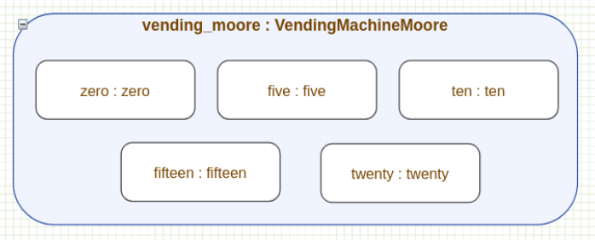
Figure 1: Vending Machine Moore DEVS Model
This model is a five-state Moore machine that represents a simple coin-operated vending machine. It accepts nickels and dimes and supports both dispensing and refund actions. Each state keeps track of the current coin total, which is stored as the state_value. The machine transitions between states as coins are inserted, and once enough value is reached, it either dispenses an item or returns to the initial state after a refund. This model is based on the original vendor_moore.cpp implementation.

Table 1: Vending Machine Moore State Table
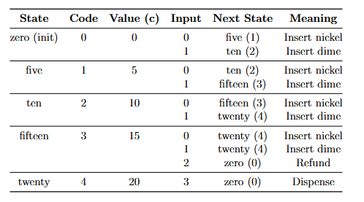

4.1.2 ATM Transaction Controller
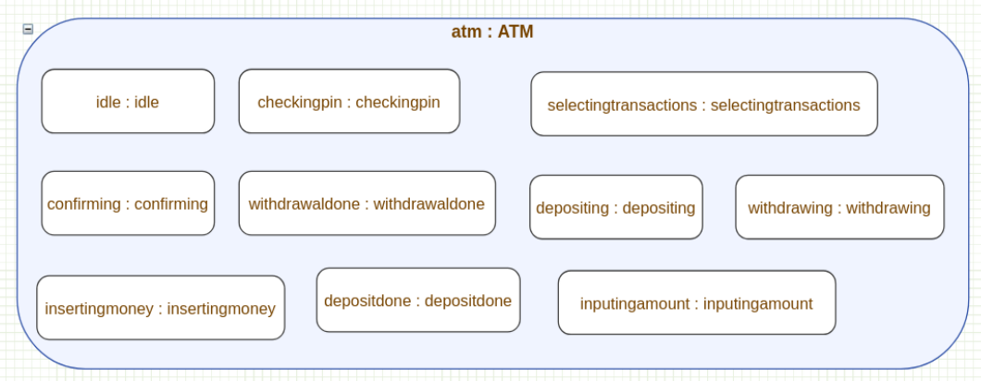
Figure 2: ATM DEVS Model
This is a ten-state Moore machine that models the behavior of an ATM system. It supports both withdrawal and deposit operations, including handling incorrect PIN entries and allowing the user to retry. The model starts in an idle state, moves through PIN verification, and then branches into different transaction flows depending on the user’s choice. Because of its number of states and transitions, this is the most complex FSM included in the library. It was ported from ATM.cpp.

Table 2: ATM State Table

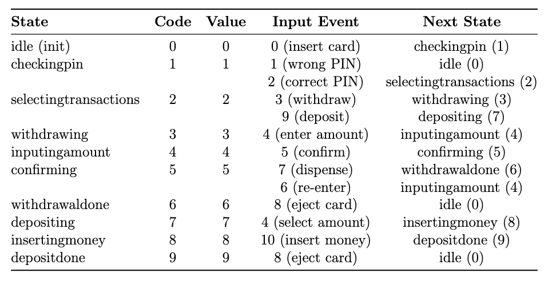

4.1.3 Telephone Call Handler
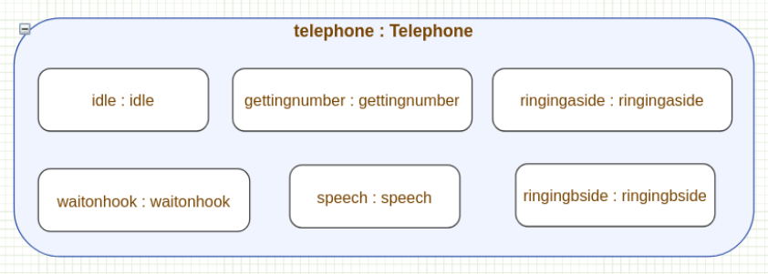
Figure 3: Telephone DEVS Model
This six-state Moore machine models a telephone system that handles both incoming and outgoing calls. It includes states for dialing, ringing, active conversation, and being placed on hold. The model captures common call flows such as picking up the phone, dialing a number, answering a call, and hanging up. It was ported from telephone.cpp.

Table 3: Telephone State Table
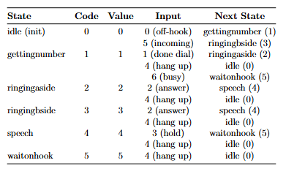

4.1.4 Traffic Light Controller
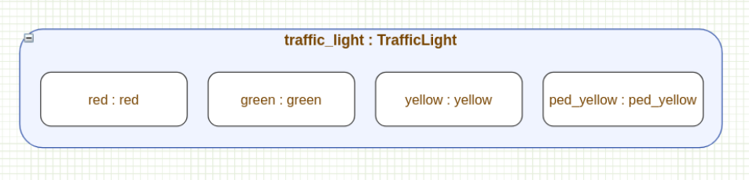
Figure 4: Traffic Light DEVS Model
This four-state Moore machine represents a traffic light system at an intersection, including support for pedestrian crossing requests. Each state corresponds to a specific light phase, and transitions are triggered by timer events or pedestrian input. A special state is included to handle pedestrian-triggered transitions, allowing downstream systems to distinguish between normal and pedestrian-controlled light changes. This model was ported from traffic_light.cpp [10].

Table 4: Traffic Light State Table
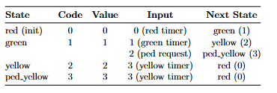

4.1.5 Alarm System
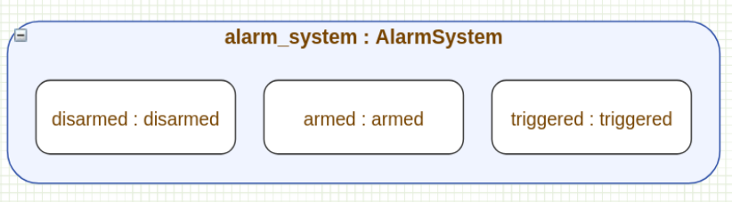
Figure 5: Alarm System DEVS Model
This three-state Moore machine models a basic security alarm system with states for disarmed, armed, and triggered [11]. The triggered state represents an active alarm condition. The system can transition back to the disarmed state either by a standard disarm action or by a reset, which represent different user interactions. This model was ported from alarm_system.cpp.

Table 5: Alarm State Table
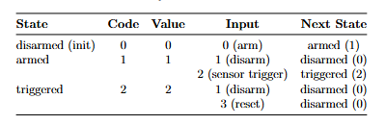

4.1.6 Game State Controller
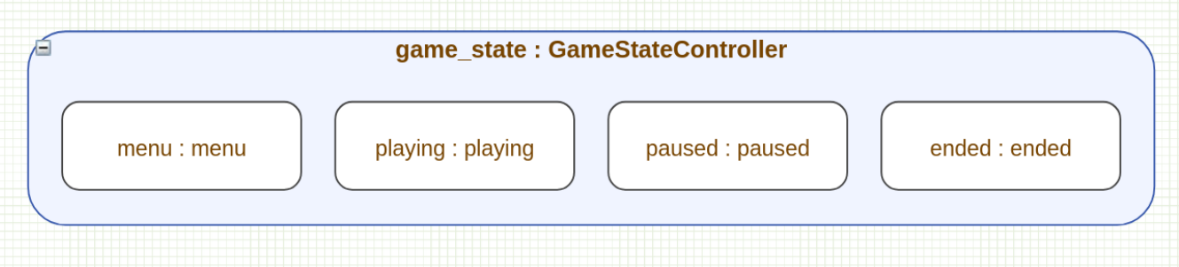
Figure 6: Game State DEVS Model
This four-state Moore machine represents the lifecycle of a video game session. It includes states for the main menu, active gameplay, paused gameplay, and game over. Transitions occur based on player actions such as starting the game, pausing, resuming, or restarting. The state_value reflects the current screen or mode. This model was ported from game_state.cpp [12].

Table 6: Game State Table
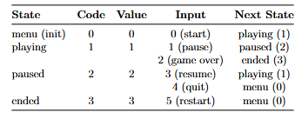

4.2 Rule-Based Models (FsmRule)

4.2.1 Boiling Water Controller
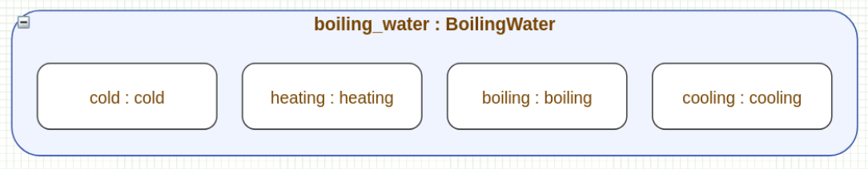
Figure 7: Boiling Water DEVS Model
This four-state Moore FSM models a water heating system with states such as cold, heating, boiling, and cooling. One of the key features of this model is its use of self-loops, which are naturally supported by the rule-based approach. For example, the system can remain in the heating or boiling state while heat continues to be applied. This model is a direct port of the original CD++ version.

Table 7: Boiling Water State Table
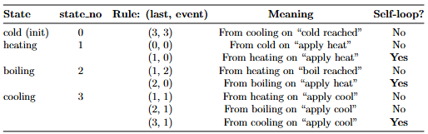

4.2.2 Parity Checker
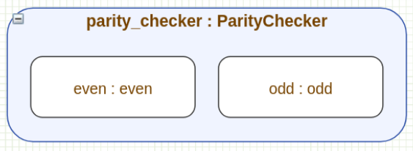
Figure 8: Parity Checker DEVS Model
This two-state FSM tracks whether a binary input stream has even or odd parity. Even though it is implemented using FsmRule without action rules, it behaves similarly to a Mealy machine because the output reflects the transition rather than a fixed state value. The model switches between even and odd states depending on the input bits. It was ported from parity_checker.cpp [9].

Table 8: Parity Checker State Table
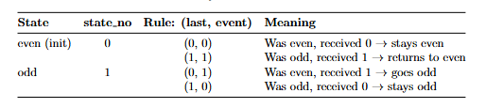
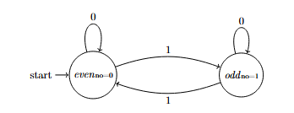

4.2.3 Vending Machine (Mealy / Rule-Based)
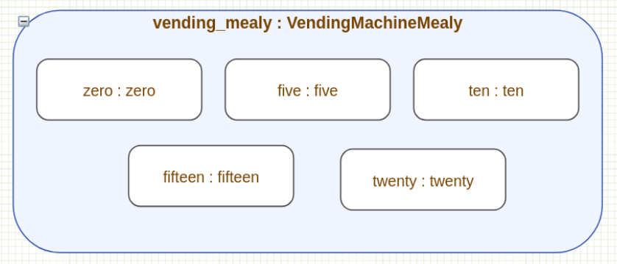
Figure 9: Vending Machine Mealy DEVS Model
This is a rule-based version of the vending machine, implemented as a Mealy machine. It uses the same basic structure as the Moore version, but now outputs are triggered during transitions. In particular, the model emits a signal when a product is dispensed or a refund occurs. This is handled through the acting port, which is activated when specific transitions occur. This model was ported from vendor_mealy.cpp.

Table 9: Vending Machine Mealy State Table
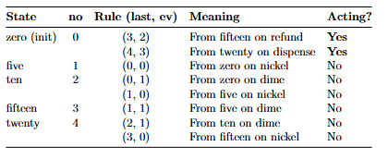

4.2.4 Turnstile
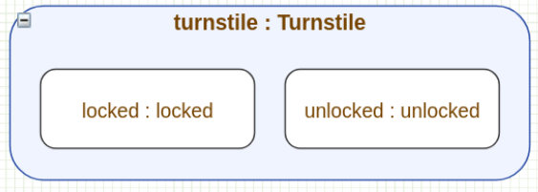
Figure 10: Turnstile DEVS Model
This two-state Mealy FSM models a coin-operated turnstile. The system alternates between locked and unlocked states, with outputs depending on both the current state and the input. For example, inserting a coin unlocks the gate, and pushing while unlocked allows passage. This is a classic example of a Mealy machine and was ported from turnstile.cpp.

Table 10: Turnstile State Table
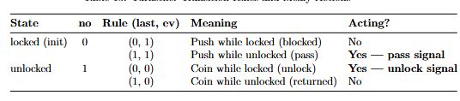
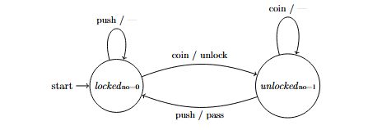

4.2.5 Sequence Detector
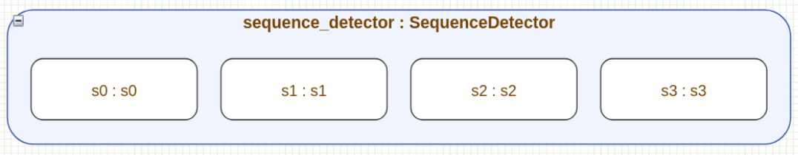
Figure 11: Sequence Detector DEVS Model
This four-state Mealy FSM detects the binary pattern “101” in a stream of input bits. It supports overlapping detection, meaning it can recognize patterns that share bits. The acting port is triggered exactly when the full sequence is detected. The design carefully routes transitions so that partial matches are preserved when possible. This model was ported from sequence_detector.cpp [8].

Table 11: Sequence Detector State Table
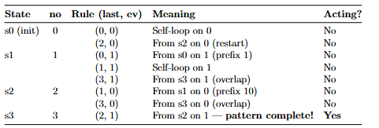

4.2.6 Debounce Filter
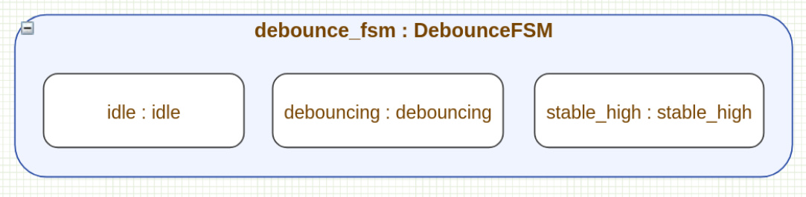
Figure 12: Debounce DEVS Model
This three-state Mealy FSM filters noisy binary signals by requiring consistent input before confirming a state change. It is commonly used in embedded systems to clean up unstable inputs such as button presses. The model distinguishes between valid transitions, noise, and signal stabilization, and uses the acting port to indicate meaningful events such as confirmed rising edges, falling edges, or rejected noise. This model was ported from debounce.cpp.

Table 12: Debounce State Table
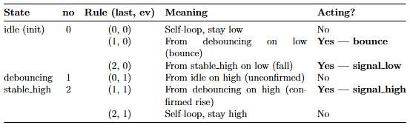

5 Simulation Results

5.1 Experiment Setup
All twelve FSM models were built and run using the project makefile. Each model takes a text file of timed input events, runs through the simulation engine, and writes its output to a CSV log file. Since this project does not use Cell DEVS, there are no visual animations to show. The CSV logs serve as the record of execution, and that is what the analysis in each section below is based on. Two types of rows appear in every log: state snapshots, which show what each atomic looks like at a given moment, and port output rows, which show the actual signals the model produced. Input events are spaced ten milliseconds apart. Models built with FsmRule have a one millisecond internal delay before firing, which keeps everything orderly between events. To check correctness, the output from each log was compared against the expected state sequence traced by hand from the design.

5.2 Model Simulation Results

5.2.1 ATM Transaction Controller
The ATM model is the largest in the library with ten states, and it was run through two full transaction flows: a cash withdrawal and a cash deposit. A wrong PIN event was also deliberately sent partway through to make sure the error handling worked. When the first event arrives, the idle state passes control to the checkingpin state, which immediately signals back that it is now active. That handoff happens at the same point in simulated time, which confirms the token-passing mechanism is working as it should. When the wrong PIN event arrives, the model catches it because checkingpin has no path defined for that input, and it signals an error without crashing or getting stuck. A correct PIN event sent right after resumes the flow normally. From there the withdrawal path and the deposit path each run through their respective states and both return to idle at the end. Every state that becomes active outputs the value it was given at setup, which confirms that the output never depends on how a state was reached, only on which state it is.

5.2.2 Traffic Light Controller
The traffic light model was run through two kinds of cycle: a normal timed rotation and one triggered by a pedestrian crossing request. Starting from red, a timer event moves the light to green, which works as expected. The interesting part is what happens when a pedestrian request comes in while the light is green. Instead of going to the normal yellow state, the model moves to a separate pedestrian yellow state that outputs a different value. Both yellow states eventually return to red on the same timer event, so the exit behaviour is identical, but the different output values mean that anything reading the log can tell the two cases apart without any extra logic. The simulation ran through both paths and confirmed that the pedestrian yellow and the standard yellow behave correctly in their own ways, and that the light always finds its way back to red when the yellow phase ends.

5.2.3 Turnstile: Mealy Output Verification
The turnstile is the clearest example in the library of why Mealy output matters. The model has two states, locked and unlocked, and it responds to two inputs, a coin and a push. What makes it Mealy is that the output depends not just on which state the machine is in, but on what combination of state and input triggered the transition. When a coin is inserted while the gate is locked, an unlock signal fires. When someone pushes through while the gate is unlocked, a pass signal fires. But if a coin arrives when the gate is already unlocked, or someone pushes when it is already locked, nothing fires. The simulation was run through six events covering all four of these combinations, and the output matched exactly. The two meaningful actions produced a signal, and the two meaningless ones did not. That distinction is something a Moore machine cannot express without adding extra states, which is exactly why the Mealy option exists in the library.

5.2.4 Debounce Filter: Signal Conditioning Verification
The debounce filter models the kind of noise filtering that is common in hardware, where a mechanical button press can produce a rapid flicker of on and off signals before settling. The model requires two consecutive identical readings before it commits to a state change. The simulation was run with a sequence of nine readings that included a clean rising edge, a sustained high, a falling edge, a single noisy blip, and then another rising edge. The results came out correctly across the board. A single high reading on its own did not trigger the rising edge signal. Two consecutive highs did. When the signal dropped to low after being stable, the falling edge fired as expected. When a high was immediately followed by a low with no second confirmation, it was correctly flagged as a bounce rather than a real edge. The model handled all three cases, confirmed rise, confirmed fall, and rejected noise, using the same output port but only firing it when the specific state and input combination actually warranted it.

5.2.5 Boiling Water Controller: Self-Loop Verification
The boiling water model was included specifically to test self-loops, which is where a state transitions back to itself rather than moving to a different state. This happens when, for example, heat is applied while the water is already heating, or cool air is applied while it is already cooling. The simulation was run through fourteen events that included multiple consecutive occurrences of these situations. The heating state looped back to itself twice in a row before moving on, the boiling state looped once, and the cooling state looped once. In every case the model stayed in the correct state, produced the right output, and then continued normally when an event came along that required an actual state change. Self-loops are handled in this library through a simple rule that says the previous state was the same as the current one, and the results confirmed that mechanism works reliably with no special handling needed.

5.2.6 Vending Machine: Moore vs. Mealy Comparison
The vending machine is the one model in the library that was built twice, once in each style, so the two approaches could be compared directly. Both versions accumulate coins and dispense when twenty cents is reached, but they communicate with the outside world differently. The Moore version outputs the current coin total every time a state is entered. A consumer reading the log always knows how much has been deposited. The downside is that when the machine resets after dispensing, it outputs zero, which looks identical to the initial startup state. There is no way to tell from the output alone whether the machine just dispensed something or simply started up. The Mealy version does not output a coin total at all. Instead it fires a dedicated signal only when a dispense or refund actually happens, and stays quiet otherwise. A consumer does not need to track the running total because the signal itself is the meaningful event. Neither approach is strictly better. The Moore version is more informative during accumulation, and the Mealy version is cleaner at the moment of action. Having both in the library lets a designer pick whichever fits their use case.

5.2.7 Alarm System
The alarm system model has three states, disarmed, armed, and triggered, and was run through two full arm-to-reset cycles with a deliberate invalid-input case inserted between them. The first cycle steps through the normal path: a disarm event, arm event, trigger event, and reset event each produce the correct handoff at the same point in simulated time. When the invalid event arrives while the model is in disarmed, which has no transition defined for that code, the error port fires with the sentinel value and the model stays in place rather than crashing. The arm event immediately following resumes the flow without issue. The second cycle exercises the two different exit paths from triggered, confirming both the reset code and the disarm code lead cleanly back to disarmed. The final events arm and then disarm directly from the armed state, bypassing triggered entirely. Every state produced only its own assigned output, and the error port fired exactly once.

5.2.8 Game State Controller
The game state controller has four states, menu, playing, paused, and ended, and was run through two full game sessions across eleven input events. The first session exercised the complete lifecycle in sequence: menu to playing on a start event, playing to paused on a pause, paused back to playing on a resume, playing to ended on a game-over, and ended back to menu on the return event. Every handoff produced the correct state_out value at the same point in simulated time as the transition_out. The second session took a different path through the same states: the game was started, paused, and then quit directly back to menu without resuming, which confirmed the paused state correctly offers both exits. A short third mini-session immediately followed, going from menu through playing to ended and back without ever pausing. Across all three sessions the model never visited the wrong state and no handoff was delayed.

5.2.9 Parity Checker
The parity checker has two states, even and odd, and reports whether the running count of one-bits seen so far is even or odd. It was run with fifteen input bits chosen to cover all four state-and-input combinations and to include several consecutive identical inputs. The sequence opens with two zeros, which both leave the machine in even, confirming that a zero never changes parity regardless of the current state. A one then moves it to odd, and a second consecutive one moves it straight back to even, confirming back-to-back toggles work without any mis-fire between them. Two consecutive zeros later in the sequence arrive while the machine is in odd and both leave it there, verifying the same hold behaviour from the other side. The final bit brings the total one-count to eight and the machine ends in even. Across all fifteen events, exactly one state fired per input and the shared last-state variable updated correctly between them.

5.2.10 Sequence Detector
The sequence detector watches a binary stream for the pattern 101 and fires a Mealy acting signal on each detection, with support for overlapping matches. The input sequence of twelve bits was designed to produce three detections and to exercise both the overlapping path and the self-loop on s1. The first detection fires at t=0.041, when the fourth bit completes a 101 match, and the acting port fires at that same timestamp alongside the regular state output. Because overlapping is supported the machine does not reset afterward. A zero following the detection moves it to s2, representing a partial 10 prefix, and the next one immediately triggers a second detection at t=0.061. Two consecutive zeros then walk the machine back through s0 and clear the match progress entirely. A fresh run-up of 1, 1, 0, 1 builds toward a third detection; the second consecutive one causes s1 to loop back to itself, which is the correct behaviour since a lone one is still only a partial prefix. The third detection fires at t=0.121. The acting port fired exactly three times and was silent at every other point.

5.2.11 Telephone Controller
The telephone controller is the second largest model in the library with six states, and its fourteen-event input sequence covers four distinct call scenarios back to back. The first is an outgoing call: idle moves to gettingnumber on an off-hook event, then to ringingaside when a number is dialed, then through speech and waitonhook back to idle when the call ends. The second is an incoming call, where idle moves directly to ringingbside, skipping the dialing phase entirely, and follows the same speech and waitonhook path home. The ring-to-answer interval in this scenario was compressed to five milliseconds rather than the standard ten, and the model handled the tighter spacing without issue. The third scenario is an abandoned call, where an abandon event in gettingnumber sends the model straight to waitonhook, bypassing both ringing states. The fourth is a cancelled dial, where a hangup during gettingnumber returns it directly to idle. All four scenarios produced the correct state_out on every activation.

5.3 Summary of Simulation Correctness
All twelve models ran to completion and produced output that matched the expected behaviour in every case. For the six token-passing models, the handoff between states always happened at the same point in simulated time with no gaps, which is exactly what the mechanism is supposed to guarantee. No state produced output when it should have been waiting, and no state held on after it was supposed to hand off. For the six rule-based models, only one state fired per event throughout every run, meaning the shared tracking variable that makes the formalism work never caused a conflict. Four of the models included self-loops and all of them handled consecutive self-loop firings cleanly before resuming normal transitions. The four Mealy models only fired their action signal on the transitions that were supposed to trigger it, and never on any others. Two models were given inputs that had no valid transition defined, and both reported the error correctly without stopping the rest of the simulation. Taken together, the results show that both atomic models behave as intended across a range of different FSM structures and application domains.

5.4 Library Reusability Assessment
One of the main goals of this project was to build a library where new FSM models can be added without ever touching the underlying atomic code. All twelve models confirm that this works. Every model was built by writing constructor calls for each state, declaring the connections between them, and providing an input file. The two atomic implementations, FsmToken and FsmRule, stayed completely unchanged from the first model to the last. The six models that were newly designed for this project, three Moore and three Mealy, were built the same way as the ported ones and required no special treatment. Adding a Moore model means defining the states and wiring up the transitions. Adding a Mealy model means doing the same thing and additionally marking which state and input combinations should fire the action signal. That is the only difference. The results across all twelve models show that the two atomics are flexible enough to cover a wide range of FSM designs without modification, which is the core reusability property the library was designed to provide.

6 Conclusions
This paper presented the design, implementation, and validation of a reusable FSM library for the Cadmium v2 DEVS simulation framework. Two atomic models, FsmToken and FsmRule, were formally defined and implemented as Cadmium v2 versions of the original CD++ FSM2 and FSM1 approaches. Both were developed entirely in C++17 without requiring any changes to the Cadmium v2 library itself.

To evaluate the library, twelve FSM models from six different application areas were built and simulated successfully. These areas included banking, telecommunications, process control, access control, digital signal processing, and interactive entertainment. Each model was created only by providing constructor arguments and defining port couplings, without modifying the atomic models themselves. The simulation results matched both the expected theoretical behavior of the FSMs and the behavior of the original CD++ versions, including support for self-loops, error handling, and Mealy-style output where applicable. In addition, model behavior can be further checked using the DEVS-Graph-GUI repository by generating a model, exporting its CSV output, and comparing that output against the CSV logs produced by the Cadmium implementation [13].

One of the main strengths of the library is how compact it is. The two atomic model implementations, fsm_rule.hpp and fsm_token.hpp, together take up only about 400 lines of C++17 code. Each of the twelve coupled models also remains relatively small, generally requiring fewer than 100 lines of code. This shows that the DEVS coupled model structure provides a practical and effective way to build larger FSMs from small reusable components.

There are still a few limitations to note. FsmToken only supports Moore-style behavior, so extending it to support Mealy outputs would require adding another output port and expanding the transition representation to include output values. FsmRule also relies on the shared static variables lst and err_in, which means two separate FsmRule-based FSMs cannot safely run at the same time in the same simulation. This limitation comes directly from the original CD++ FSM1 design. Another limitation is that transition tables are currently defined directly in C++ constructor calls. A higher-level configuration format, such as JSON or a small domain-specific language, would make it easier to define larger FSMs with many states.

There are several natural directions for future work. One would be to create a Mealy version of the token-passing model, such as FsmTokenMealy, so that the library fully supports both output styles across both approaches. Another would be to build a configuration-based loader that can automatically generate FsmToken or FsmRule coupled models from a declarative FSM description. A graphical state-diagram visualizer could also be added and integrated with Cadmium v2’s visualization tools. Finally, a namespace-scoped version of FsmRule could be developed so that multiple independent FSM1-based models can run concurrently without interfering with one another through shared state.

References
[1] B. P. Zeigler, H. Praehofer, and T. G. Kim, Theory of Modeling and Simulation: Integrating Discrete Event and Continuous Complex Dynamic Systems, 2nd ed. San Diego, CA, USA: Academic Press, 2000.

[2] G. Wainer, “CD++: A toolkit to develop DEVS models,” Software: Practice and Experience, vol. 32, no. 13, pp. 1261-1306, 2002.

[3] T. Zheng and G. A. Wainer, “Implementing finite state machines using the CD++ toolkit,” in Proc. Summer Computer Simulation Conference (Student Workshop), Montreal, QC, Canada, 2003.

[4] G. A. Wainer and C. Ruiz Martin, “Defining DEVS Models Using the Cadmium Toolkit,” in Proc. 2022 Winter Simulation Conference (WSC), 2022, pp. 1356-1370.

[5] C. Ruiz Martin and G. A. Wainer, Cadmium: A Tool for DEVS Modeling and Simulation, User’s Guide. Ottawa, ON, Canada: Carleton University, draft, Feb. 19, 2020.

[6] R. H. Gohary, “Finite State Machines,” Carleton University, SYSC 2320 course notes. [Online]. Available through Carleton University course materials.

[7] P. Garapati and S. Musala, “Moore and Mealy Negative Edge detector A VHDL Example for Finite State Machine,” in 2020 International Conference on Communication and Signal Processing (ICCSP), Chennai, India, 2020, pp. 1159-1161, doi: 10.1109/ICCSP48568.2020.9182310.

[8] R. Mishra, B. K. Singh, H. Singh, and V. K. Sharma, “101 sequence detector using QCA technology,” in 2023 International Conference on Computer Communication and Informatics (ICCCI), Coimbatore, India, 2023, pp. 1-5, doi: 10.1109/ICCCI56745.2023.10128312.

[9] A. Eshra and A. El-Sayed, “An Odd Parity Checker Prototype Using DNAzyme Finite State Machine,” IEEE/ACM Transactions on Computational Biology and Bioinformatics, vol. 11, no. 2, pp. 316-324, Mar.-Apr. 2014, doi: 10.1109/TCBB.2013.2295803.

[10] P. J. M., S. M., K. K. P., P. P., and K. P., “Fully Automated Traffic Light Controller system for a four-way intersection using Verilog,” in 2022 IEEE International Conference on Electronics, Computing and Communication Technologies (CONECCT), Bangalore, India, 2022, pp. 1-5, doi: 10.1109/CONECCT55679.2022.9865755.

[11] S. Sai Vandana, K. Abinandhan, and S. R. Ramesh, “Implementation of Smart Home using Finite State Machine Model,” in 2022 7th International Conference on Communication and Electronics Systems (ICCES), Coimbatore, India, 2022, pp. 45-49, doi: 10.1109/ICCES54183.2022.9835949.

[12] W. Hu, Q. Zhang, and Y. Mao, “Component-based hierarchical state machine: A reusable and flexible game AI technology,” in 2011 6th IEEE Joint International Information Technology and Artificial Intelligence Conference, Chongqing, China, 2011, pp. 319-324, doi: 10.1109/ITAIC.2011.6030340.

[13] Uchenna Obikwelu and Matthew Khoury, “GitHub - ucheeaa/DEVS-Graph-GUI,” GitHub, 2025. https://github.com/ucheeaa/DEVS-Graph-GUI (accessed Apr. 23, 2026).

