Assignment 2 Report
Cell-DEVS Simulation of Crime Drug Model

Mahad Ahmed 101220427
SYSC4906 - G
Gabriel Wainer
Wednesday March 25, 2026

Table of Contents

Table of Contents 2
Model Selection 3
Model Specification and Cell-DEVS Model Design 4
DEVS Formal Specification 4
Atomic Models 4
Druggist Basic Model 5
Addiction Model 6
Final Crime Drug Model 7
Experimentation Framework 9
Simulation and Experimental Analysis 10
GitHub Repository 10
Execution Results 10
Druggist Model 10
Addiction Model 11
Final Crime Drug Model 12

Model Selection

The model represents a 20×20 grid where each cell corresponds to a person in the population. Three models of increasing complexity are implemented and tested: a basic druggist spread model, an addiction model, and a full crime-drug pipeline model. The full model incorporates four actor types across four layers:
- Susceptible Person (SP): a healthy individual who does not consume drugs but may be influenced by neighbouring drug users.
- Low Risk Person (LRP): a person who has begun consuming drugs occasionally.
- High Risk Person (HRP): a person who is fully addicted to drugs.
- Incapacitated Person (IP): a person who has been arrested or treated and removed from the active population.
Each layer of the coupled Cell-DEVS model represents one stage in this progression, with transition rules governing how individuals move between states based on the composition of their neighbourhood and probabilistic factors modelled using a normal distribution.

Model Specification and Cell-DEVS Model Design
This project focuses on modelling the spread of hard drug consumption and criminal behaviour across a population using Cell-DEVS. The model is based on the observed relationship between drug addiction and criminal activity, where individuals progress through distinct stages of drug use before eventually committing crimes to support their habit. Incapacitation, representing the removal of criminals from society through arrest or treatment, is also modelled as a mechanism that can slow the spread of criminal behaviour in an area.

DEVS Formal Specification

Atomic Models
Atomic Cell-DEVS = TDC = IDC = < X , Y , I , S , θ , N , d , δ_{int} , δ_{ext} , τ , λ , D >
- X ⊆ T: set of input external events
- Y ⊆ T : set of output external events
- I = < η, μ, Px, Py > : model’s modular interface
  - η member of N, η < infinity : the neighborhood size,
  - μ member of N, μ < infinity : the number of other input-output ports not in the neighborhood
- S ⊆ T : set of possible sequential states for a given cell
- N ∈ S^{η + μ} : the set of the stored input events (states)
- θ : the definition of the cell’s state variables
- δ_{int}: internal transition function
- δ_{ext} : external transition function
- τ : local computing function
- λ : output function
- D : θ x N x d R₀⁺ = the duration function of the state (lifetime)

Druggist Basic Model
Component X / Y / S:
- X = Y = S = {0, 1}
- 0 = healthy non-druggist; 1 = druggist
Component I:
- I = < η, μ, Px, Py > with η = 8, μ = 0, Px = {Ø}, Py = {Ø}
Component N:
- N = { (−2,0), (−1,0), (1,0), (2,0), (0,−2), (0,−1), (0,1), (0,2) }
Component d:
- type = transport; d = 1.0
Component δint, δext, λ, D:
- Defined by the Cell-DEVS specification
Component τ — Zone: nondrugtodrug-transition { (0,0)..(19,19) }
- Rule 1: lrp = 1 if lrp = 0 AND 2+ immediate neighbours have lrp = 1 AND uniform(0, 1) < 0.70
- Rule 2: lrp = 1 if lrp = 0 AND exactly 1 immediate neighbour has lrp = 1 AND uniform(0, 1) < 0.15
- Rule 3: lrp = 1 if lrp = 0 AND normal(0.4, 0.3) > 1.0
- Rule 4: lrp = 0 if TRUE

Addiction Model
Component X / Y / S:
- X = Y = S = { lrp ∈ {0,1}, hrp ∈ {0,2} }
- 0 = healthy; 1 = Low Risk Person (LRP); 2 = High Risk Person (HRP)
Component I:
- I = < η, μ, Px, Py > with η = 8, μ = 0, Px = {Ø}, Py = {Ø}
Component N:
- N = { (−2,0), (−1,0), (1,0), (2,0), (0,−2), (0,−1), (0,1), (0,2) }
Component d:
- type = transport; d = 1.0
Component δint, δext, λ, D:
- Defined by the Cell-DEVS specification
Component τ — LRP layer
- Rule 1: lrp = 1 if lrp = 0 AND 2+ immediate neighbours have lrp = 1 AND uniform(0, 1) < 0.70
- Rule 2: lrp = 1 if lrp = 0 AND exactly 1 immediate neighbour has lrp = 1 AND uniform(0, 1) < 0.15
- Rule 3: lrp = 1 if lrp = 0 AND normal(0.4, 0.3) > 1.0
- Rule 4: lrp = 0 if TRUE
Component τ — HRP layer
- Rule 1: hrp = 2 if hrp = 0 AND lrp = 1 AND 2+ immediate neighbours have lrp = 1
- Rule 2: hrp = 0 if TRUE

Final Crime Drug Model
Component X / Y / S:
- X = Y = S = { lrp ∈ {0,1}, hrp ∈ {0,2}, crime ∈ {0,3}, incap ∈ {0,4} }
- 0 = healthy; 1 = LRP; 2 = HRP; 3 = Criminal; 4 = Incapacitated
Component I:
- I = < η, μ, Px, Py > with η = 8, μ = 0, Px = {Ø}, Py = {Ø}
Component N:
- N = { (−2,0), (−1,0), (1,0), (2,0), (0,−2), (0,−1), (0,1), (0,2) }
Component d:
- type = transport; d = 1.0
Component δint, δext, λ, D:
- Defined by the Cell-DEVS specification
Component τ — LRP layer
- Rule 1: lrp = 1 if lrp = 0 AND 2+ immediate neighbours have lrp = 1 AND uniform(0, 1) < 0.70
- Rule 2: lrp = 1 if lrp = 0 AND exactly 1 immediate neighbour has lrp = 1 AND uniform(0, 1) < 0.15
- Rule 3: lrp = 1 if lrp = 0 AND normal(0.4, 0.3) > 1.0
- Rule 4: lrp = 0 if TRUE
Component τ — HRP layer
- Rule 1: hrp = 2 if hrp = 0 AND lrp = 1 AND 2+ immediate neighbours have lrp = 1
- Rule 2: hrp = 0 if TRUE
Component τ — Crime layer
- Rule 1: crime = 3 if crime = 0 AND hrp = 2 AND any neighbour within range 2 has hrp = 2
- Rule 2: crime = 0 if TRUE
Component τ —Incapacitation layer
- Rule 1: incap = 4 if incap = 0 AND crime = 3 AND hrp = 2 AND normal(0.4, 0.3) > 0.1
- Rule 2: incap = 0 if TRUE

Experimentation Framework
The experimentation framework will consist of a combination of the experiments executed in the original document, starting from the atomic models and gradually reaching the coupled model system. Below is a table organising the experiments to be implemented using Cadmium.
Model Level | Model Tested | Purpose of Experiment | Input Stimuli | Expected Behavior
Atomic | DruggistBasicModel | Test how drug use spreads through a population | All people start healthy; some become druggists randomly | Druggist cells spread to neighbours over time
Coupled (2 levels) | AddictionModel | Test how drug users become fully addicted | All people start healthy; some begin using drugs randomly | Drug use spreads in first layer, with addiction appearing in second layer when surrounded by drug users
Coupled (4 layers) | FinalCrimeDrugModel | Test full progression from healthy person to incapacitation | All people start healthy;  some begin using drugs randomly | People progress from drug use to addiction to crime to incapacitation across each layer

Simulation and Experimental Analysis

GitHub Repository
The source code for this system can be found at this link → https://github.com/mahad-a/cell-devs-crime-drug

Execution Results
Execution results are placed into videos and kept in the GitHub repository. For this report, they were implemented as gifs into the document. Each model generated a csv log file, which along side the configuration file, was uploaded to the Cell-DEVS web viewer. Note the following values:

- If cell is WHITE, SP active (a healthy person who currently doesn’t consume drugs but may be influenced
- If cell is RED, LRP active (low risk person, a person who just started drugs on occasion)
- If cell is GREEN, HRP active (high risk person, a person addicted to drugs)
- If cell is ORANGE, CRIME active (a person committing crimes)
- If cell is PURPLE, INCAPACITATED active (a person who has been arrested or treated and removed from the active population)

Druggist Model
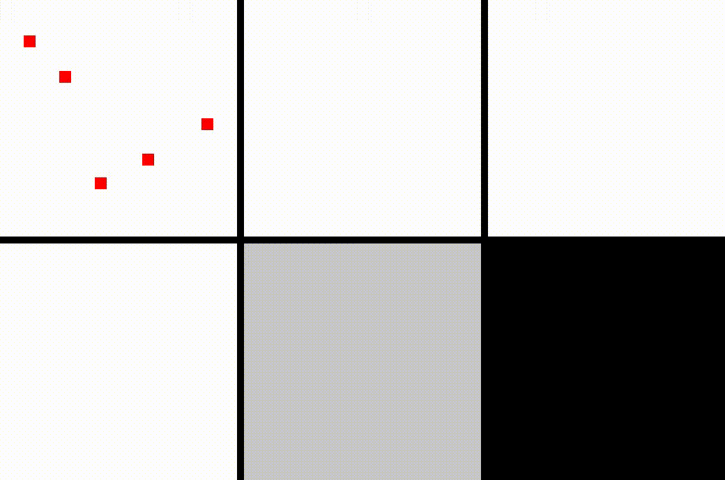

To produce these results, upload the following files to the Cell-DEVS web viewer:

druggist_config.json
druggist_log.csv

Addiction Model
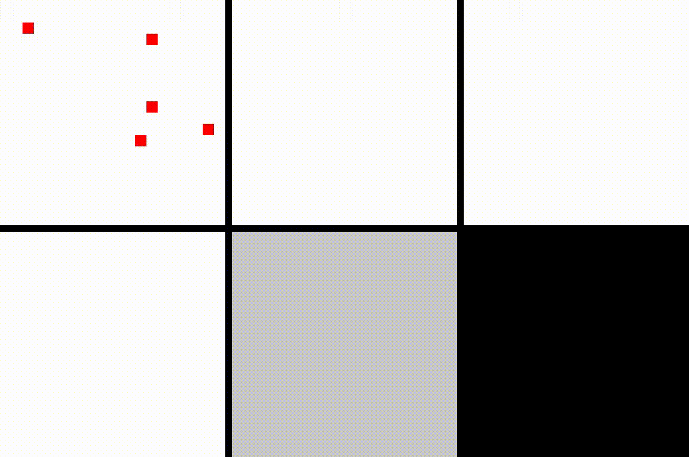

To produce these results, upload the following files to the Cell-DEVS web viewer:

addiction_config.json
addiction_log.csv

Final Crime Drug Model
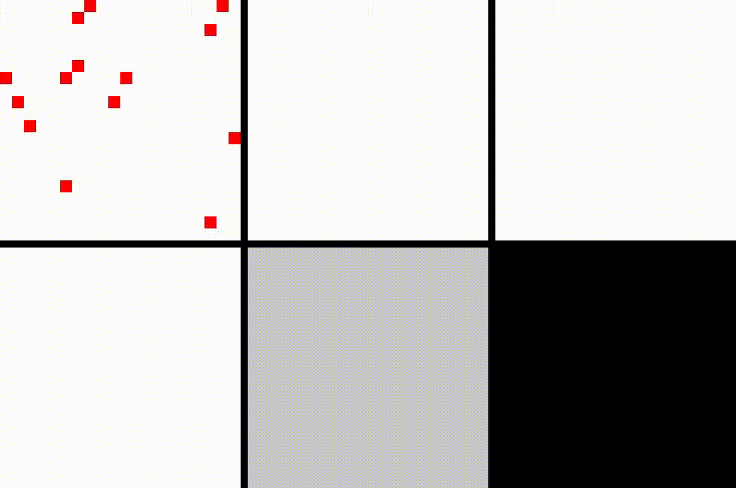

To produce these results, upload the following files to the Cell-DEVS web viewer:

crimedrug_config.json
crimedrug_log.csv

