Face Recognition Attendance System | AI-Based Attendance Management using OpenCV & Flask

Problem Statement: Traditional attendance systems are time-consuming, prone to errors, and vulnerable to proxy attendance. Although face recognition systems automate attendance marking, many existing solutions can still be bypassed using photos or videos.
This project introduces an AI-based Face Recognition Attendance System that combines real-time face recognition with eye-blink based liveness detection to verify the physical presence of students before marking attendance. The system helps improve accuracy, security, and efficiency in attendance management.

##Features
- Real-time face detection and recognition
- Eye-blink based liveness detection
- Automatic attendance marking
- Prevention of proxy attendance
- Attendance score calculation based on timing
- Flask-based web dashboard
- CSV-based attendance record storage
- Email warning system for low attendance
- User-friendly interface for attendance monitoring
- Secure and efficient attendance management system
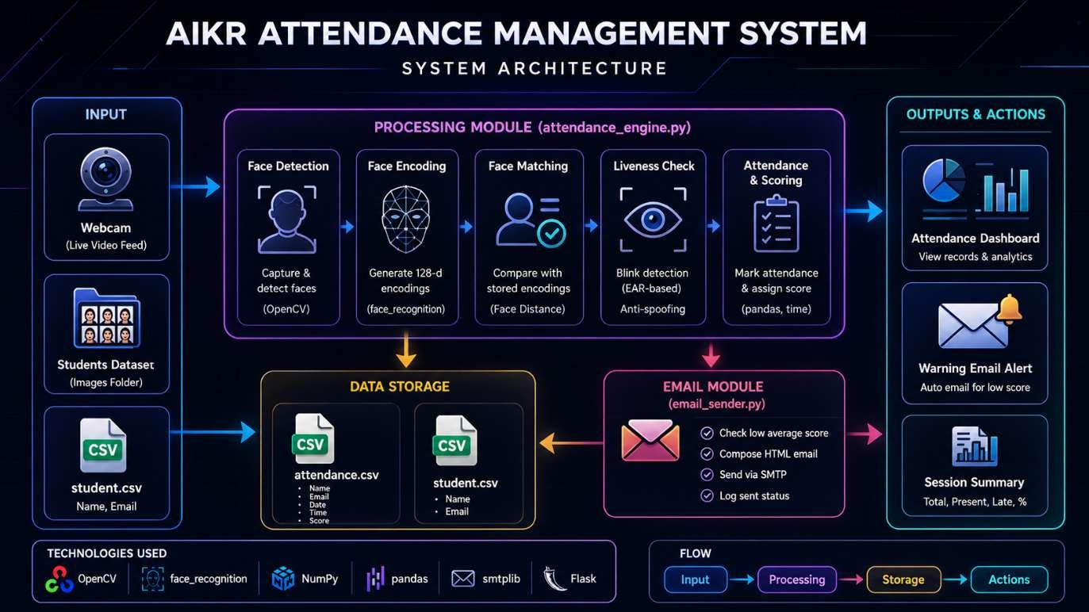

AI Techniques Used
- Face Recognition for student identification
- Eye-blink based liveness detection to prevent spoofing
- Rule-based decision system for attendance validation
- Real-time video frame processing using OpenCV
- CSV-based data storage for attendance records
- Threshold-based attendance score calculation
- Flask web dashboard for monitoring and analytics
- SMTP-based email notification system for low attendance alerts

Results & Testing
The system was tested under multiple scenarios to evaluate its performance, accuracy, and decision-making capability.
Test Case 1: Valid Student Detection
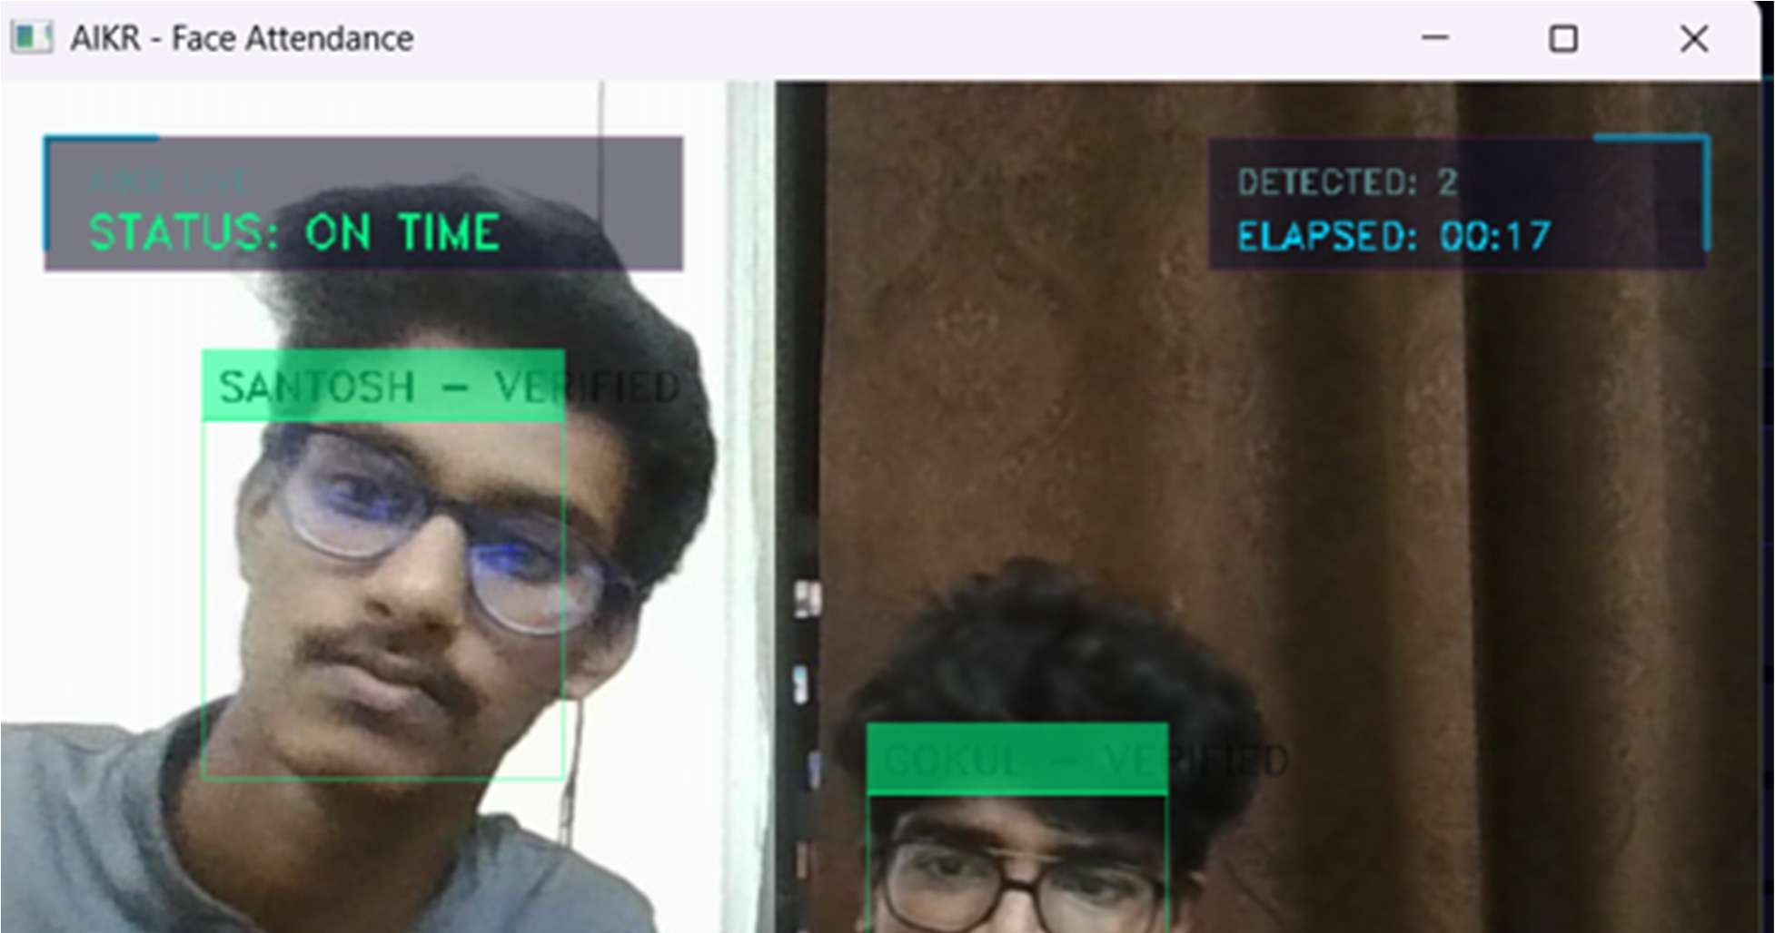

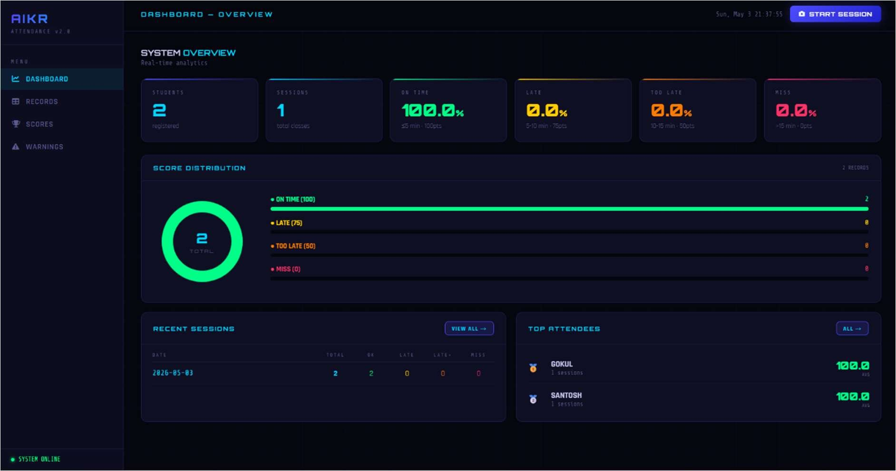
A registered student was successfully detected and verified using face recognition and eye-blink based liveness detection. Attendance was marked and stored correctly.
Test Case 2: Proxy Attempt Detection
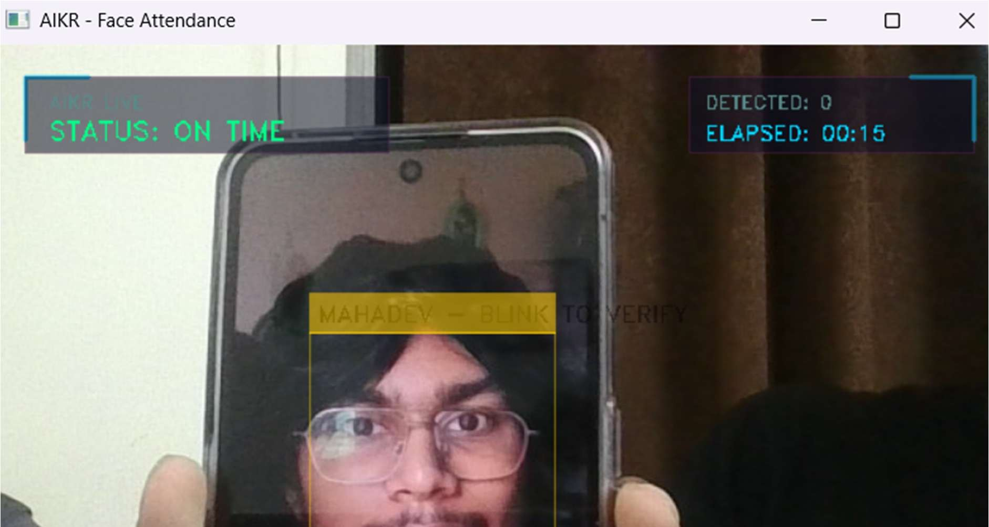
A spoofing attempt using a static image or without blink verification was performed. The system rejected the attendance request, demonstrating effective liveness detection.
Test Case 3: Late Attendance Detection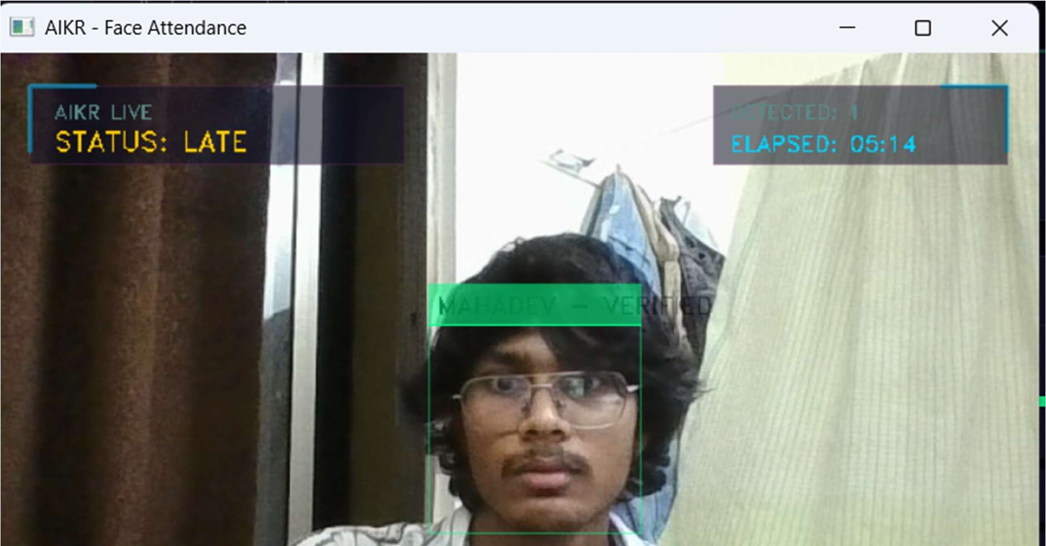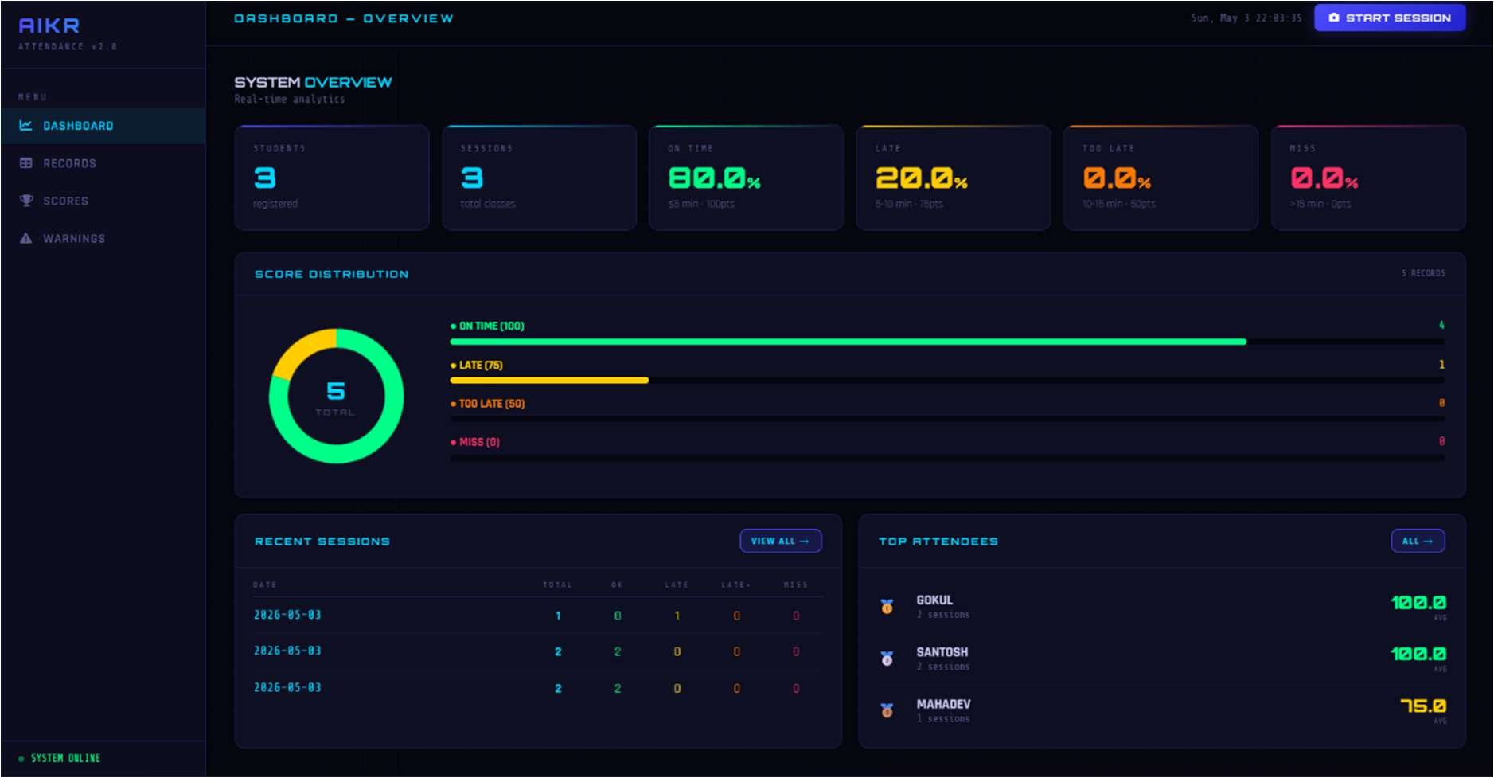
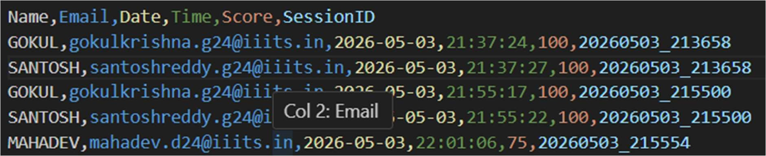

When a student entered after the scheduled time, the system successfully assigned a reduced attendance score based on predefined timing rules.

Results
- Successfully detected and recognized registered students in real time
- Prevented proxy attendance using eye-blink based liveness detection
- Automatically marked and stored attendance records efficiently
- Generated attendance scores based on student entry time
- Displayed attendance records and analytics through the Flask dashboard
- Improved accuracy, security, and automation in attendance management systems

Demo Video Link:
https://youtu.be/dLr2B8PW6cc

