Experiment No. 6

Name: Mahadev Navnath Sole

Roll no.: 19

Subject: Web Development

**Alert Box:**

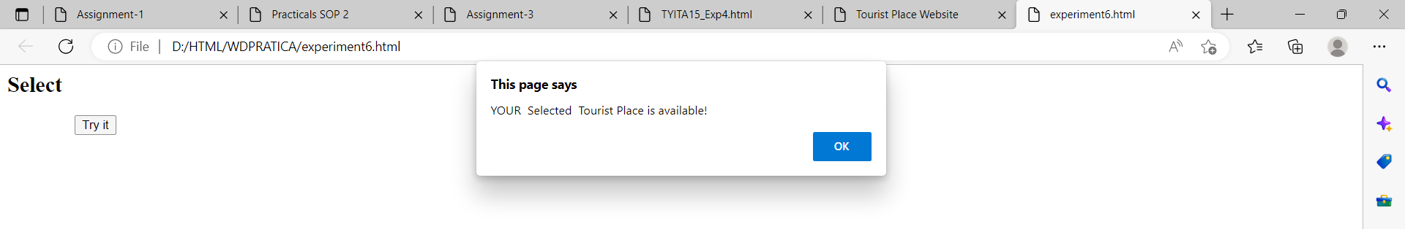

**Confirm Box:**

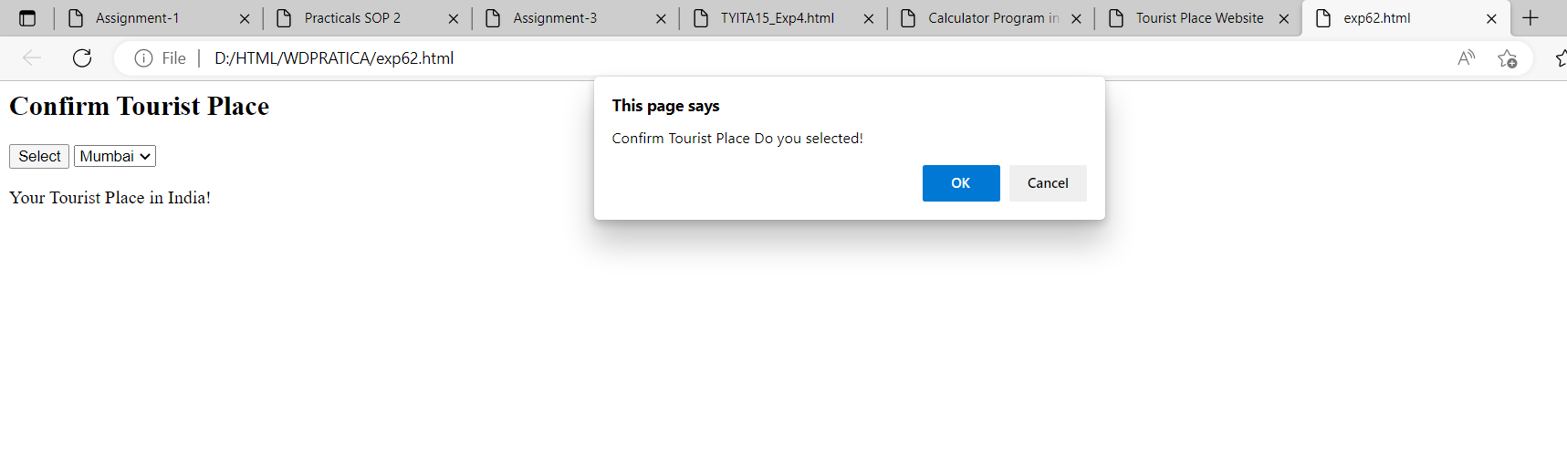

**Prompt Box:**

