DBMS Assignment 1

--Q1

--1

select * from emp where sal>2000 and comm>200;

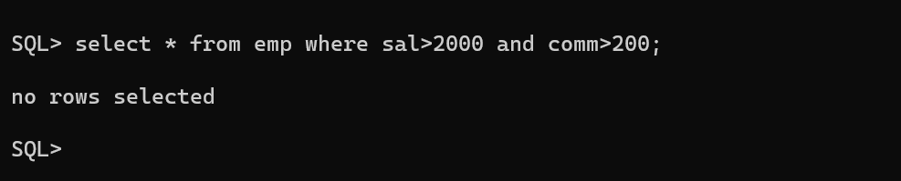

--2

select * from emp where job='CLERK' and sal>2000;

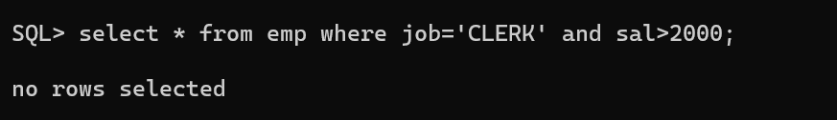

--3

select * from emp where sal in (1250,1100,2850);

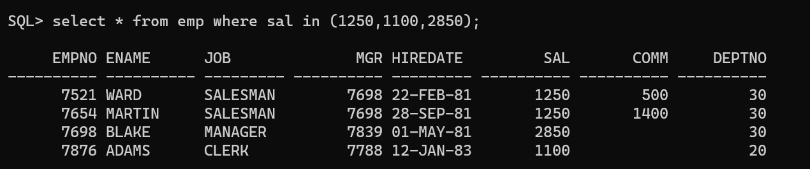

--4

select * from emp where sal >1250 and sal < 2850;

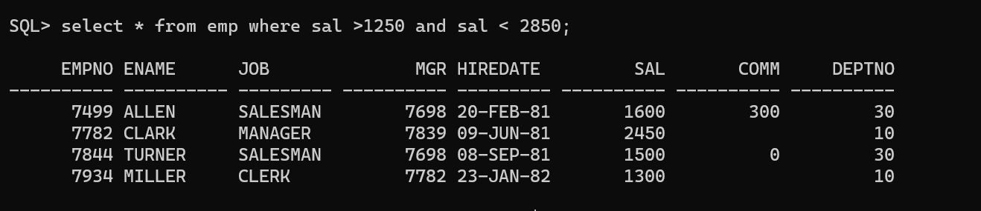

--5

select * from emp where regexp_like(ename,'AS$');



--6

select * from emp where regexp_like(job,'^C.*K$');

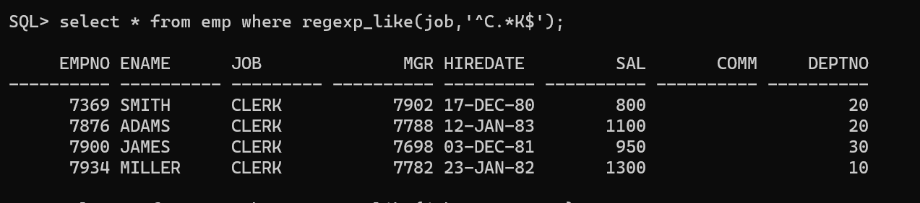

--7

select * from emp where regexp_like(job,'..L.*M..');

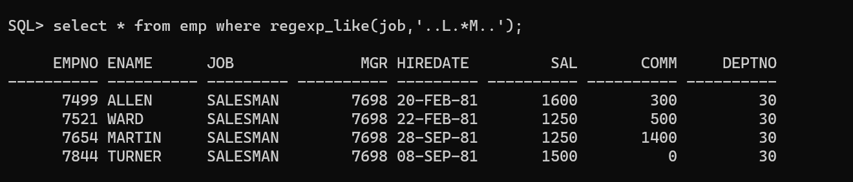

--8

select * from emp where sal not in (1250,1100,2850);

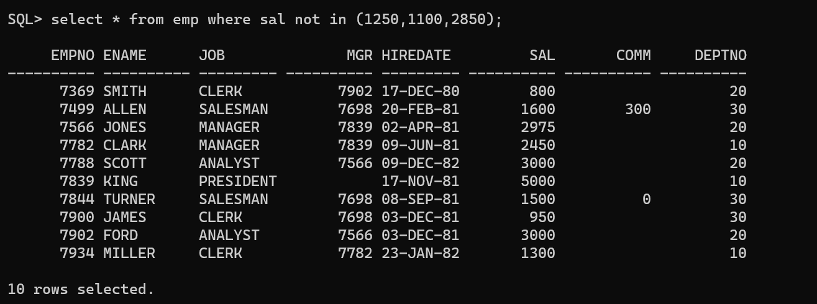

--9

select * from emp where sal not between 1250 and 2850;

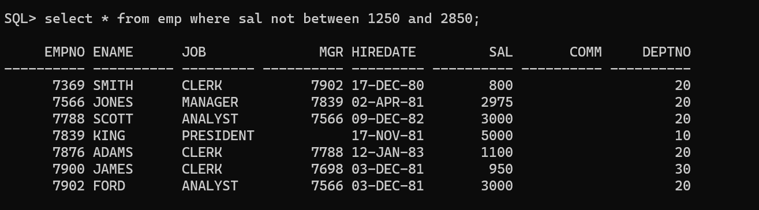

--10

select * from emp where regexp_like(job,'^C..E.*k$');



--11

select * from emp where comm is null;// is operator is used with null

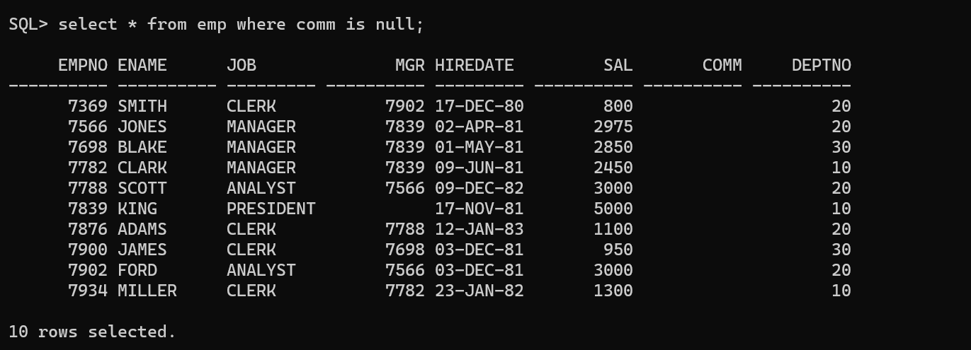

--12

select * from emp where sal = null and regexp_like(ename,'^S');

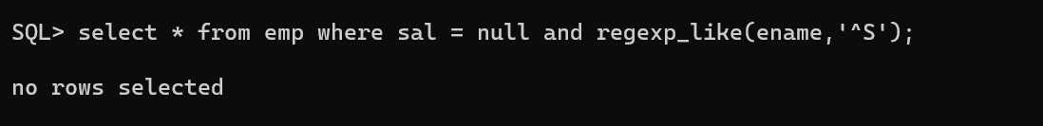

--13

select * from emp where regexp_like(job,'.....');

select * from emp where regexp_like(job,'.{5}');

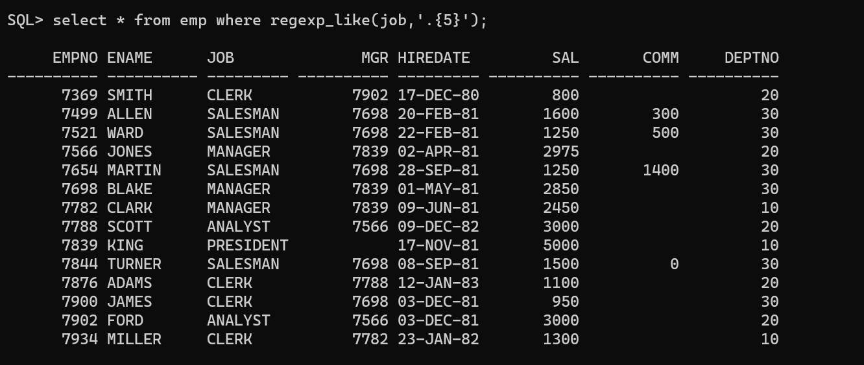

--14

select * from emp where regexp_like(job,'^A.{4}');

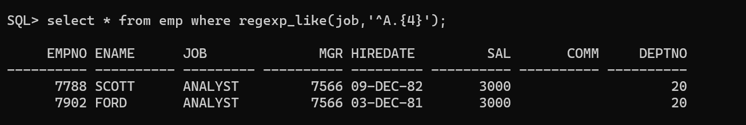

--Q2

--1

select ename,sal,deptno from emp where deptno in (10,20,30);

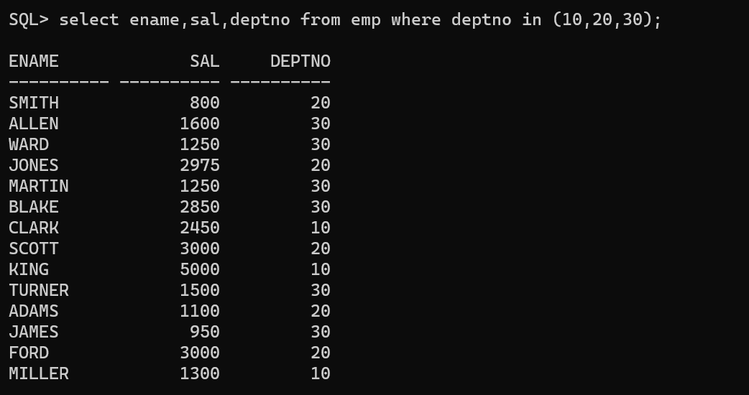

--2

select sal+nvl(comm,0)+sal*0.1 tot_sal from emp;

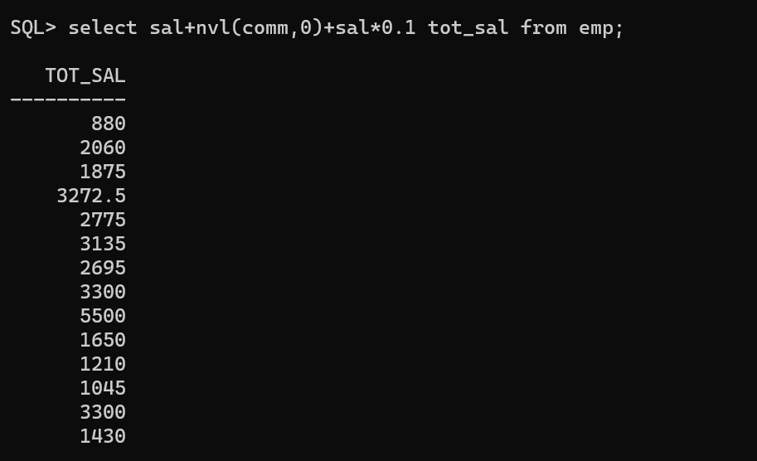

--3

select ename NAME,job U_JOB from emp where hiredate<'1-JAN-1986' AND SAL BETWEEN 1200 AND 2500;

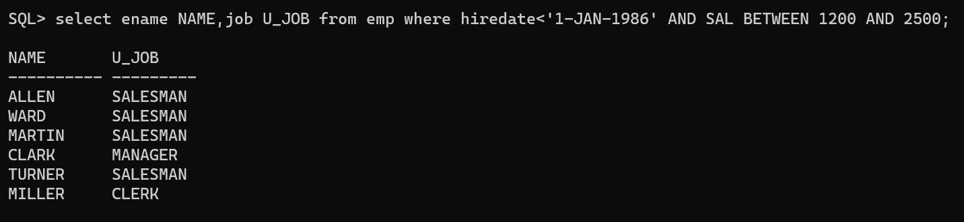

--4

SELECT EMPNO,ENAME,DEPTNO FROM EMP WHERE MGR=7698;

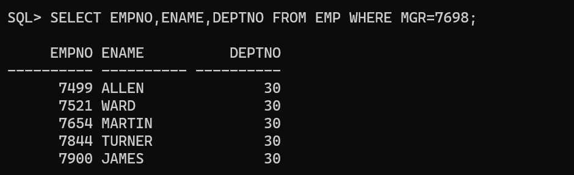

--5

SELECT EMPNO,JOB,SAL FROM EMP WHERE DEPTNO IN (10,30);

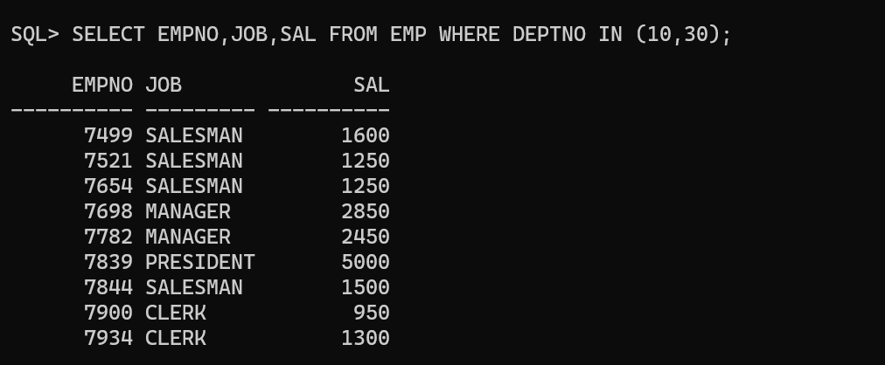

--6

SELECT CONCAT(ENAME,DEPTNO) FROM EMP;

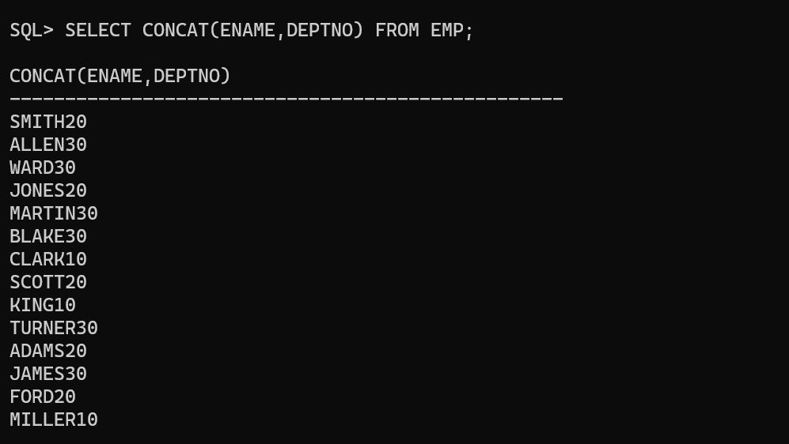

--7

SELECT * FROM EMP WHERE MGR IS NULL;

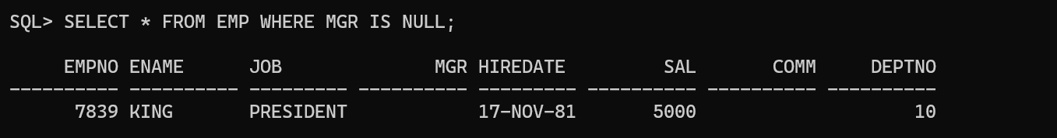

--8

SELECT ENAME,DEPTNO,HIREDATE FROM EMP WHERE HIREDATE='01-JAN-1981' AND HIREDATE='31-MAR-1983' ORDER BY HIREDATE;



--9

SELECT * FROM EMP WHERE REGEXP_LIKE(JOB,'AGE');

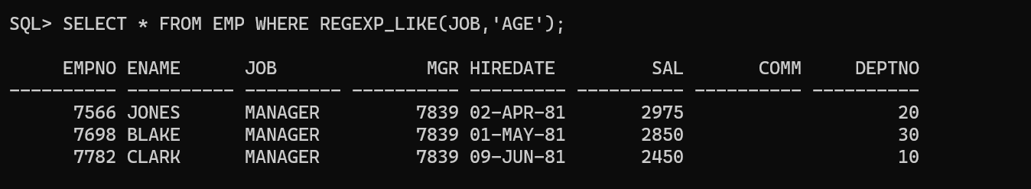

--11

SELECT * FROM EMP WHERE ENAME LIKE 'A%S' or ((ENAME LIKE '_N%' or ENAME LIKE '__N%') AND (ENAME LIKE '%N' or ENAME LIKE '%S'));

SELECT * FROM EMP WHERE REGEXP_LIKE(ENAME,'^A.*S$|^..?N.*[NS]$');

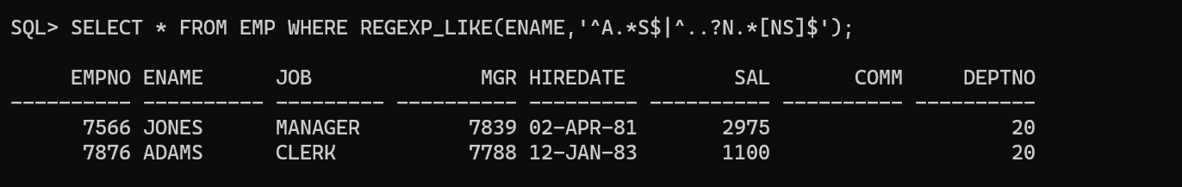

--12

SELECT * FROM EMP WHERE REGEXP_LIKE(ENAME,'_');



Group functions

--1

SELECT DEPTNO,MAX(SAL) Maximum,MIN(SAL),SUM(SAL),AVG(SAL) FROM EMP GROUP BY DEPTNO ;

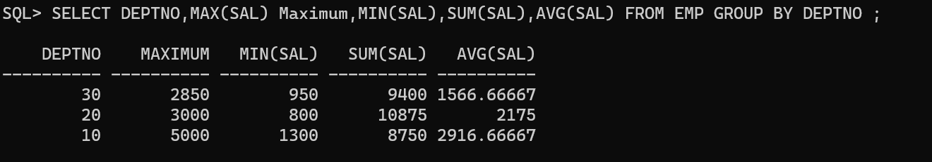

--2

SELECT DEPTNO,count(MGR) Total_Number_of_Managers FROM EMP GROUP BY DEPTNO;

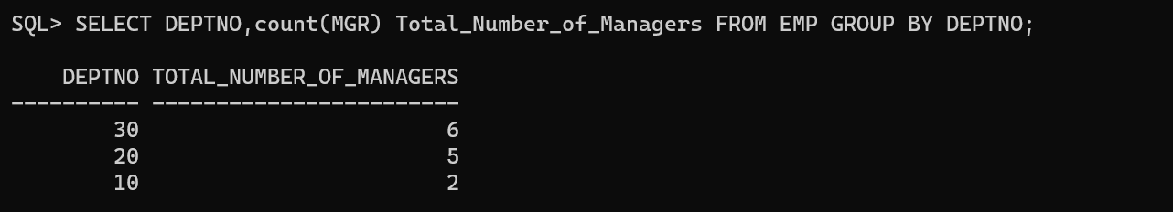

--3

SELECT DEPTNO,SUM(SAL) FROM EMP WHERE JOB !='MANAGER' GROUP BY DEPTNO HAVING SUM(SAL)>20000;

