Java:

Java is a **programming language** and a **platform**. Java is a high level, robust, object-oriented and secure programming language.

Java was developed by Sun Microsystems (which is now the subsidiary of Oracle) in the year 1995. James Gosling is known as the father of Java. Before Java, its name was Oak. Since Oak was already a registered company, so James Gosling and his team changed the name from Oak to Java.

Features of Java

The primary objective of [Java programming](https://www.javatpoint.com/java-tutorial) language creation was to make it portable, simple and secure programming language. Apart from this, there are also some excellent features which play an important role in the popularity of this language. The features of Java are also known as Java buzzwords.

A list of the most important features of the Java language is given below.

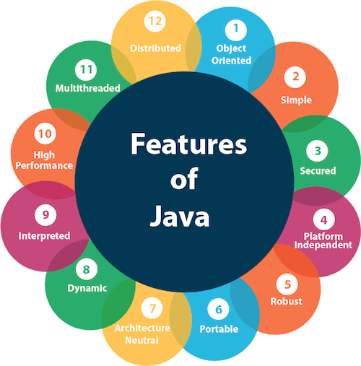

1. [Simple](https://www.javatpoint.com/features-of-java#Simple)
2. [Object-Oriented](https://www.javatpoint.com/features-of-java#Object-Oriented)
3. [Portable](https://www.javatpoint.com/features-of-java#Portable)
4. [Platform independent](https://www.javatpoint.com/features-of-java#Platform-independent)
5. [Secured](https://www.javatpoint.com/features-of-java#Secured)
6. [Robust](https://www.javatpoint.com/features-of-java#Robust)
7. [Architecture neutral](https://www.javatpoint.com/features-of-java#Architecture-neutral)
8. [Interpreted](https://www.javatpoint.com/features-of-java#Interpreted)
9. [High Performance](https://www.javatpoint.com/features-of-java#High-Performance)
10. [Multithreaded](https://www.javatpoint.com/features-of-java#Multithreaded)
11. [Distributed](https://www.javatpoint.com/features-of-java#Distributed)
12. [Dynamic](https://www.javatpoint.com/features-of-java#Dynamic)

Simple

Java is very easy to learn, and its syntax is simple, clean and easy to understand. According to Sun Microsystem, Java language is a simple programming language because:

* Java syntax is based on C++ (so easier for programmers to learn it after C++).
* Java has removed many complicated and rarely-used features, for example, explicit pointers, operator overloading, etc.
* There is no need to remove unreferenced objects because there is an Automatic Garbage Collection in Java.

Object-oriented

Java is an [object-oriented](https://www.javatpoint.com/java-oops-concepts) programming language. Everything in Java is an object. Object-oriented means we organize our software as a combination of different types of objects that incorporate both data and behavior.

Object-oriented programming (OOPs) is a methodology that simplifies software development and maintenance by providing some rules.

Basic concepts of OOPs are:

1. [Object](https://www.javatpoint.com/object-and-class-in-java)
2. [Class](https://www.javatpoint.com/object-and-class-in-java#class)
3. [Inheritance](https://www.javatpoint.com/inheritance-in-java)
4. [Polymorphism](https://www.javatpoint.com/runtime-polymorphism-in-java)
5. [Abstraction](https://www.javatpoint.com/abstract-class-in-java)
6. [Encapsulation](https://www.javatpoint.com/encapsulation)

Platform Independent

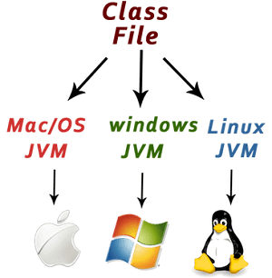

Java is platform independent because it is different from other languages like [C](https://www.javatpoint.com/c-programming-language-tutorial), [C++](https://www.javatpoint.com/cpp-tutorial), etc. which are compiled into platform specific machines while Java is a write once, run anywhere language. A platform is the hardware or software environment in which a program runs.

There are two types of platforms software-based and hardware-based. Java provides a software-based platform.

The Java platform differs from most other platforms in the sense that it is a software-based platform that runs on top of other hardware-based platforms. It has two components:

1. Runtime Environment
2. API(Application Programming Interface)

Java code can be executed on multiple platforms, for example, Windows, Linux, Sun Solaris, Mac/OS, etc. Java code is compiled by the compiler and converted into bytecode. This bytecode is a platform-independent code because it can be run on multiple platforms, i.e., Write Once and Run Anywhere (WORA).

Secured

Java is best known for its security. With Java, we can develop virus-free systems. Java is secured because:

* **No explicit pointer**
* **Java Programs run inside a virtual machine sandbox**

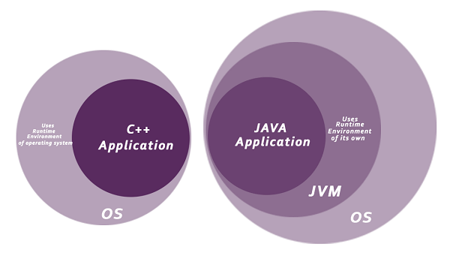

* **Classloader:** Classloader in Java is a part of the Java Runtime Environment (JRE) which is used to load Java classes into the Java Virtual Machine dynamically. It adds security by separating the package for the classes of the local file system from those that are imported from network sources.
* **Bytecode Verifier:** It checks the code fragments for illegal code that can violate access rights to objects.
* **Security Manager:** It determines what resources a class can access such as reading and writing to the local disk.

Java language provides these securities by default. Some security can also be provided by an application developer explicitly through SSL, JAAS, Cryptography, etc.

Robust

The English mining of Robust is strong. Java is robust because:

* It uses strong memory management.
* There is a lack of pointers that avoids security problems.
* Java provides automatic garbage collection which runs on the Java Virtual Machine to get rid of objects which are not being used by a Java application anymore.
* There are exception handling and the type checking mechanism in Java. All these points make Java robust.

Architecture-neutral

Java is architecture neutral because there are no implementation dependent features, for example, the size of primitive types is fixed.

In C programming, int data type occupies 2 bytes of memory for 32-bit architecture and 4 bytes of memory for 64-bit architecture. However, it occupies 4 bytes of memory for both 32 and 64-bit architectures in Java.

Portable

Java is portable because it facilitates you to carry the Java bytecode to any platform. It doesn't require any implementation.

High-performance

Java is faster than other traditional interpreted programming languages because Java bytecode is "close" to native code. It is still a little bit slower than a compiled language (e.g., C++). Java is an interpreted language that is why it is slower than compiled languages, e.g., C, C++, etc.

Distributed

Java is distributed because it facilitates users to create distributed applications in Java. RMI and EJB are used for creating distributed applications. This feature of Java makes us able to access files by calling the methods from any machine on the internet.

Multi-threaded

A thread is like a separate program, executing concurrently. We can write Java programs that deal with many tasks at once by defining multiple threads. The main advantage of multi-threading is that it doesn't occupy memory for each thread. It shares a common memory area. Threads are important for multi-media, Web applications, etc.

Dynamic

Java is a dynamic language. It supports the dynamic loading of classes. It means classes are loaded on demand. It also supports functions from its native languages, i.e., C and C++.

Difference between JDK, JRE, and JVM

1. [A summary of JVM](https://www.javatpoint.com/difference-between-jdk-jre-and-jvm)
2. [Java Runtime Environment (JRE)](https://www.javatpoint.com/difference-between-jdk-jre-and-jvm#jre)
3. [Java Development Kit (JDK)](https://www.javatpoint.com/difference-between-jdk-jre-and-jvm#jdk)

We must understand the differences between JDK, JRE, and JVM before proceeding further to [Java](https://www.javatpoint.com/java-tutorial). See the brief overview of JVM here.

If you want to get the detailed knowledge of Java Virtual Machine, move to the next page. Firstly, let's see the differences between the JDK, JRE, and JVM.

JVM

JVM (Java Virtual Machine) is an abstract machine. It is called a virtual machine because it doesn't physically exist. It is a specification that provides a runtime environment in which Java bytecode can be executed. It can also run those programs which are written in other languages and compiled to Java bytecode.

JVMs are available for many hardware and software platforms. JVM, JRE, and JDK are platform dependent because the configuration of each [OS](https://www.javatpoint.com/os-tutorial) is different from each other. However, Java is platform independent. There are three notions of the JVM: *specification*, *implementation*, and *instance*.

The JVM performs the following main tasks:

* Loads code
* Verifies code
* Executes code
* Provides runtime environment

[More Details.](https://www.javatpoint.com/internal-details-of-jvm)

JRE

JRE is an acronym for Java Runtime Environment. It is also written as Java RTE. The Java Runtime Environment is a set of software tools which are used for developing Java applications. It is used to provide the runtime environment. It is the implementation of JVM. It physically exists. It contains a set of libraries + other files that JVM uses at runtime.

The implementation of JVM is also actively released by other companies besides Sun Micro Systems.

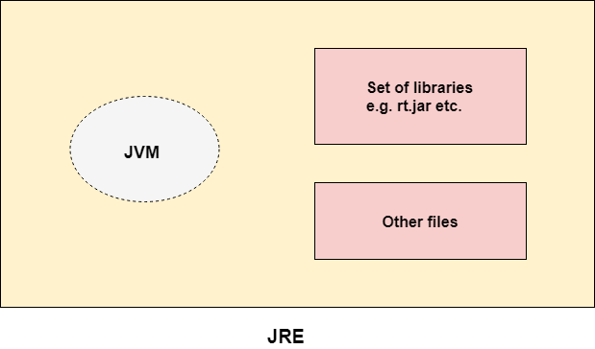

JDK

JDK is an acronym for Java Development Kit. The Java Development Kit (JDK) is a software development environment which is used to develop Java applications and [applets](https://www.javatpoint.com/java-applet). It physically exists. It contains JRE + development tools.

JDK is an implementation of any one of the below given Java Platforms released by Oracle Corporation:

* Standard Edition Java Platform
* Enterprise Edition Java Platform
* Micro Edition Java Platform

The JDK contains a private Java Virtual Machine (JVM) and a few other resources such as an interpreter/loader (java), a compiler (javac), an archiver (jar), a documentation generator (Javadoc), etc. to complete the development of a Java Application.

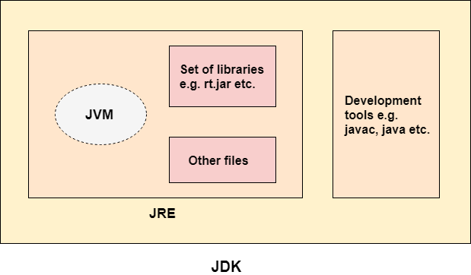

**class** Simple{

**public** **static** **void** main(String args[]){

     System.out.println("Hello Java");

    }

}

Steps:

1) javac Simple.java ->.class ---🡪byte code instructions

2) java Simple

U need to convert byte code into machine language instructions so that it will understand by every one

JVM (Java Virtual Machine) Architecture

JVM (Java Virtual Machine) is an abstract machine. It is a specification that provides runtime environment in which java bytecode can be executed.

**Java Virtual Machine (JVM)** is a engine that provides runtime environment to drive the Java Code or applications. It converts Java bytecode into machines language. JVM is a part of Java Run Environment (JRE).

1. **Runtime Instance** Whenever you write java command on the command prompt to run the java class, an instance of JVM is created.

What it does

The JVM performs following operation:

* Loads code
* Verifies code
* Executes code
* Provides runtime environment

JVM provides definitions for the:

* Memory area
* Class file format
* Register set
* Garbage-collected heap
* Fatal error reporting etc.

## JVM Architecture

Let's understand the internal architecture of JVM. It contains classloader, memory area, execution engine etc.

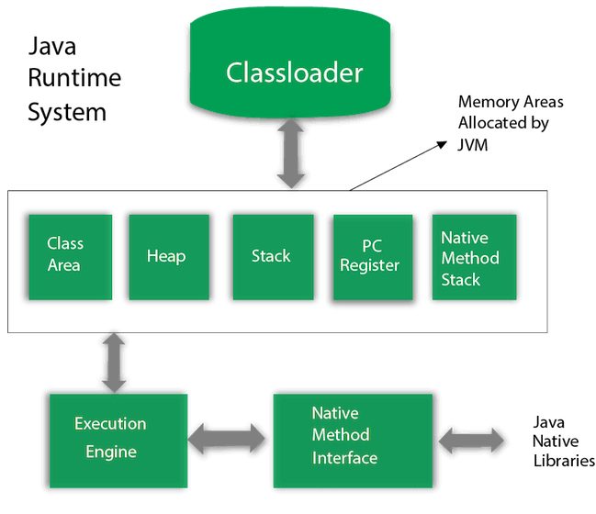

Class(Method) Area

Class(Method) Area stores per-class structures such as the runtime constant pool, field and method data, the code for methods.

3) Heap

It is the runtime data area in which objects are allocated.

4) Stack

Java Stack stores frames. It holds local variables and partial results, and plays a part in method invocation and return.

Each thread has a private JVM stack, created at the same time as thread.

A new frame is created each time a method is invoked. A frame is destroyed when its method invocation completes.

5) Program Counter Register

PC (program counter) register contains the address of the Java virtual machine instruction currently being executed.

6) Native Method Stack

It contains all the native methods used in the application.

7) Execution Engine

It contains:

1. **A virtual processor**
2. **Interpreter:** Read bytecode stream then execute the instructions.
3. **Just-In-Time(JIT) compiler:** It is used to improve the performance. JIT compiles parts of the byte code that have similar functionality at the same time, and hence reduces the amount of time needed for compilation. Here, the term "compiler" refers to a translator from the instruction set of a Java virtual machine (JVM) to the instruction set of a specific CPU.

8) Java Native Interface

Java Native Interface (JNI) is a framework which provides an interface to communicate with another application written in another language like C, C++, Assembly etc. Java uses JNI framework to send output to the Console or interact with OS libraries.

# Java Variables

A variable is a container which holds the value while the [Java program](https://www.javatpoint.com/simple-program-of-java) is executed. A variable is assigned with a data type.

Variable is a name of memory location. There are three types of variables in java: local, instance and static.

There are two types of [data types in Java](https://www.javatpoint.com/java-data-types): primitive and non-primitive.

## Variable

A variable is the name of a reserved area allocated in memory. In other words, it is a name of the memory location. It is a combination of "vary + able" which means its value can be changed.

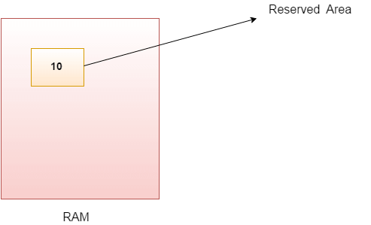

1. **int** data=50;//Here data is variable

### Types of Variables

There are three types of variables in [Java](https://www.javatpoint.com/java-tutorial):

* local variable
* instance variable
* static variable

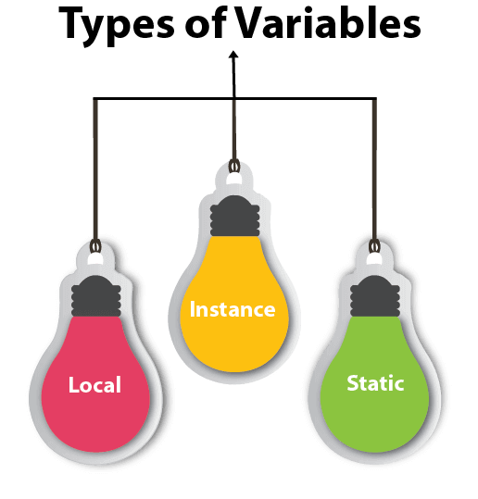

#### 1) Local Variable

A variable declared inside the body of the method is called local variable. You can use this variable only within that method and the other methods in the class aren't even aware that the variable exists.

A local variable cannot be defined with "static" keyword.

#### 2) Instance Variable

A variable declared inside the class but outside the body of the method, is called an instance variable. It is not declared as [static](https://www.javatpoint.com/static-keyword-in-java).

It is called an instance variable because its value is instance-specific and is not shared among instances.

#### 3) Static variable

A variable that is declared as static is called a static variable. It cannot be local. You can create a single copy of the static variable and share it among all the instances of the class. Memory allocation for static variables happens only once when the class is loaded in the memory.

**package** com.demo5;

**public** **class** Sample {

**int** id=10;//instance

**static** String *s*="sample"; //static

**public** **static** **void** main(String[] args) {

Sample sam=**new** Sample();

System.***out***.println(sam.id);

System.***out***.println(Sample.*s*);

}

}

### Example to understand the types of variables in java

1. **public** **class** A
2. {
3. **static** **int** m=100;//static variable
4. **void** method()
5. {
6. **int** n=90;//local variable
7. }
8. **public** **static** **void** main(String args[])
9. {
10. **int** data=50;//instance variable
11. }
12. }//end of class

### Java Variable Example: Add Two Numbers

1. **public** **class** Simple{
2. **public** **static** **void** main(String[] args){
3. **int** a=10;
4. **int** b=10;
5. **int** c=a+b;
6. System.out.println(c);
7. }
8. }

**Output:**

20

### Java Variable Example: Widening

1. **public** **class** Simple{
2. **public** **static** **void** main(String[] args){
3. **int** a=10;
4. **float** f=a;
5. System.out.println(a);
6. System.out.println(f);
7. }}

**Output:**

10

10.0

### Java Variable Example: Narrowing (Typecasting)

1. **public** **class** Simple{
2. **public** **static** **void** main(String[] args){
3. **float** f=10.5f;
4. //int a=f;//Compile time error
5. **int** a=(**int**)f;
6. System.out.println(f);
7. System.out.println(a);
8. }}

**Output:**

10.5

10

### Java Variable Example: Overflow

1. **class** Simple{
2. **public** **static** **void** main(String[] args){
3. //Overflow
4. **int** a=130;
5. **byte** b=(**byte**)a;
6. System.out.println(a);
7. System.out.println(b);
8. }}

**Output:**

130

-126

### Java Variable Example: Adding Lower Type

1. **class** Simple{
2. **public** **static** **void** main(String[] args){
3. **byte** a=10;
4. **byte** b=10;
5. //byte c=a+b;//Compile Time Error: because a+b=20 will be int
6. **byte** c=(**byte**)(a+b);
7. System.out.println(c);
8. }}

# Data Types in Java

Data types specify the different sizes and values that can be stored in the variable. There are two types of data types in Java:

1. **Primitive data types:** The primitive data types include boolean, char, byte, short, int, long, float and double.
2. **Non-primitive data types:** The non-primitive data types include [Classes](https://www.javatpoint.com/object-and-class-in-java), [Interfaces](https://www.javatpoint.com/interface-in-java), and [Arrays](https://www.javatpoint.com/array-in-java).

## Java Primitive Data Types

In Java language, primitive data types are the building blocks of data manipulation. These are the most basic data types available in [Java language](https://www.javatpoint.com/java-tutorial).

Java is a statically-typed programming language. It means, all [variables](https://www.javatpoint.com/java-variables) must be declared before its use. That is why we need to declare variable's type and name.

There are 8 types of primitive data types:

Exception Handling in Java - Javatpoint

* boolean data type
* byte data type
* char data type
* short data type
* int data type
* long data type
* float data type
* double data type

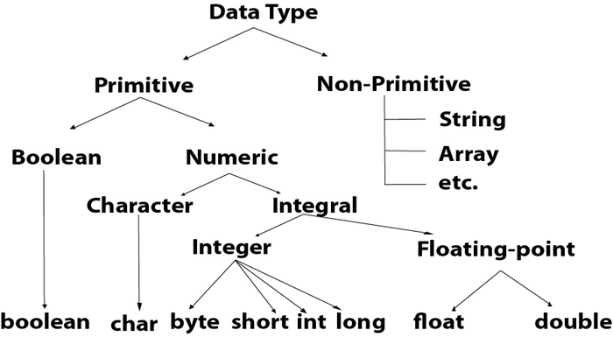

|  |  |  |
| --- | --- | --- |
| **Data Type** | **Default Value** | **Default size** |
| boolean | false | 1 bit |
| char | '\u0000' | 2 byte |
| byte | 0 | 1 byte |
| short | 0 | 2 byte |
| int | 0 | 4 byte |
| long | 0L | 8 byte |
| float | 0.0f | 4 byte |
| double | 0.0d | 8 byte |

## Boolean Data Type

The Boolean data type is used to store only two possible values: true and false. This data type is used for simple flags that track true/false conditions.

The Boolean data type specifies one bit of information, but its "size" can't be defined precisely.

**Example:**

1. Boolean one = **false**

## Byte Data Type

The byte data type is an example of primitive data type. It isan 8-bit signed two's complement integer. Its value-range lies between -128 to 127 (inclusive). Its minimum value is -128 and maximum value is 127. Its default value is 0.

The byte data type is used to save memory in large arrays where the memory savings is most required. It saves space because a byte is 4 times smaller than an integer. It can also be used in place of "int" data type.

**Example:**

1. **byte** a = 10, **byte** b = -20

## Short Data Type

The short data type is a 16-bit signed two's complement integer. Its value-range lies between -32,768 to 32,767 (inclusive). Its minimum value is -32,768 and maximum value is 32,767. Its default value is 0.

The short data type can also be used to save memory just like byte data type. A short data type is 2 times smaller than an integer.

**Example:**

1. **short** s = 10000, **short** r = -5000

## Int Data Type

The int data type is a 32-bit signed two's complement integer. Its value-range lies between - 2,147,483,648 (-2^31) to 2,147,483,647 (2^31 -1) (inclusive). Its minimum value is - 2,147,483,648and maximum value is 2,147,483,647. Its default value is 0.

The int data type is generally used as a default data type for integral values unless if there is no problem about memory.

**Example:**

1. **int** a = 100000, **int** b = -200000

## Long Data Type

The long data type is a 64-bit two's complement integer. Its value-range lies between -9,223,372,036,854,775,808(-2^63) to 9,223,372,036,854,775,807(2^63 -1)(inclusive). Its minimum value is - 9,223,372,036,854,775,808and maximum value is 9,223,372,036,854,775,807. Its default value is 0. The long data type is used when you need a range of values more than those provided by int.

**Example:**

1. **long** a = 100000L, **long** b = -200000L

## Float Data Type

The float data type is a single-precision 32-bit IEEE 754 floating point.Its value range is unlimited. It is recommended to use a float (instead of double) if you need to save memory in large arrays of floating point numbers. The float data type should never be used for precise values, such as currency. Its default value is 0.0F.

**Example:**

1. **float** f1 = 234.5f

## Double Data Type

The double data type is a double-precision 64-bit IEEE 754 floating point. Its value range is unlimited. The double data type is generally used for decimal values just like float. The double data type also should never be used for precise values, such as currency. Its default value is 0.0d.

**Example:**

1. **double** d1 = 12.3

## Char Data Type

The char data type is a single 16-bit Unicode character. Its value-range lies between '\u0000' (or 0) to '\uffff' (or 65,535 inclusive).The char data type is used to store characters.

**Example:**

1. **char** letterA = 'A'

# Operators in Java:

## Java Operator Precedence

|  |  |  |
| --- | --- | --- |
| **Operator Type** | **Category** | **Precedence** |
| Unary | postfix | expr++ expr-- |
| prefix | ++expr --expr +expr -expr ~ ! |
| Arithmetic | multiplicative | * / % |
| additive | + - |
| Shift | shift | << >> >>> |
| Relational | comparison | < > <= >= instanceof |
| equality | == != |
| Bitwise | bitwise AND | & |
| bitwise exclusive OR | ^ |
| bitwise inclusive OR | | |
| Logical | logical AND | && |
| logical OR | || |
| Ternary | ternary | ? : |
| Assignment | assignment | = += -= *= /= %= &= ^= |= <<= >>= >>>= |

### Java Unary Operator Example: ++ and --

1. **public** **class** OperatorExample{
2. **public** **static** **void** main(String args[]){
3. **int** x=10;
4. System.out.println(x++);//10 (11)
5. System.out.println(++x);//12
6. System.out.println(x--);//12 (11)
7. System.out.println(--x);//10
8. }}

### Java Arithmetic Operator Example

1. **public** **class** OperatorExample{
2. **public** **static** **void** main(String args[]){
3. **int** a=10;
4. **int** b=5;
5. System.out.println(a+b);//15
6. System.out.println(a-b);//5
7. System.out.println(a*b);//50
8. System.out.println(a/b);//2
9. System.out.println(a%b);//0
10. }}

### Java Ternary Operator Example

1. **public** **class** OperatorExample{
2. **public** **static** **void** main(String args[]){
3. **int** a=2;
4. **int** b=5;
5. **int** min=(a<b)?a:b;
6. System.out.println(min);
7. }}

### Java Assignment Operator

Java assignment operator is one of the most common operators. It is used to assign the value on its right to the operand on its left.

### Java Assignment Operator Example

1. **public** **class** OperatorExample{
2. **public** **static** **void** main(String args[]){
3. **int** a=10;
4. **int** b=20;
5. a+=4;//a=a+4 (a=10+4)
6. b-=4;//b=b-4 (b=20-4)
7. System.out.println(a);
8. System.out.println(b);
9. }}

# Java Keywords

Java keywords are also known as reserved words. Keywords are particular words that act as a key to a code. These are predefined words by Java so they cannot be used as a variable or object name or class name.

## List of Java Keywords

A list of Java keywords or reserved words are given below:

1. [**abstract**](https://www.javatpoint.com/abstract-keyword-in-java)**:** Java abstract keyword is used to declare an abstract class. An abstract class can provide the implementation of the interface. It can have abstract and non-abstract methods.
2. [**boolean:**](https://www.javatpoint.com/boolean-keyword-in-java) Java boolean keyword is used to declare a variable as a boolean type. It can hold True and False values only.
3. [**break**](https://www.javatpoint.com/java-break)**:** Java break keyword is used to break the loop or switch statement. It breaks the current flow of the program at specified conditions.
4. [**byte**](https://www.javatpoint.com/byte-keyword-in-java)**:** Java byte keyword is used to declare a variable that can hold 8-bit data values.
5. [**case**](https://www.javatpoint.com/case-keyword-in-java)**:** Java case keyword is used with the switch statements to mark blocks of text.
6. [**catch**](https://www.javatpoint.com/try-catch-block)**:** Java catch keyword is used to catch the exceptions generated by try statements. It must be used after the try block only.
7. [**char**](https://www.javatpoint.com/char-keyword-in-java)**:** Java char keyword is used to declare a variable that can hold unsigned 16-bit Unicode characters
8. [**class**](https://www.javatpoint.com/class-keyword-in-java)**:** Java class keyword is used to declare a class.
9. [**continue**](https://www.javatpoint.com/java-continue)**:** Java continue keyword is used to continue the loop. It continues the current flow of the program and skips the remaining code at the specified condition.
10. [**default**](https://www.javatpoint.com/default-keyword-in-java)**:** Java default keyword is used to specify the default block of code in a switch statement.
11. [**do**](https://www.javatpoint.com/java-do-while-loop)**:** Java do keyword is used in the control statement to declare a loop. It can iterate a part of the program several times.
12. [**double**](https://www.javatpoint.com/double-keyword-in-java)**:** Java double keyword is used to declare a variable that can hold 64-bit floating-point number.
13. [**else**](https://www.javatpoint.com/java-if-else)**:** Java else keyword is used to indicate the alternative branches in an if statement.
14. [**enum**](https://www.javatpoint.com/enum-in-java)**:** Java enum keyword is used to define a fixed set of constants. Enum constructors are always private or default.
15. [**extends**](https://www.javatpoint.com/inheritance-in-java)**:** Java extends keyword is used to indicate that a class is derived from another class or interface.
16. [**final**](https://www.javatpoint.com/final-keyword)**:** Java final keyword is used to indicate that a variable holds a constant value. It is used with a variable. It is used to restrict the user from updating the value of the variable.
17. [**finally**](https://www.javatpoint.com/finally-block-in-exception-handling)**:** Java finally keyword indicates a block of code in a try-catch structure. This block is always executed whether an exception is handled or not.
18. [**float**](https://www.javatpoint.com/float-keyword-in-java)**:** Java float keyword is used to declare a variable that can hold a 32-bit floating-point number.
19. [**for**](https://www.javatpoint.com/java-for-loop)**:** Java for keyword is used to start a for loop. It is used to execute a set of instructions/functions repeatedly when some condition becomes true. If the number of iteration is fixed, it is recommended to use for loop.
20. [**if**](https://www.javatpoint.com/java-if-else)**:** Java if keyword tests the condition. It executes the if block if the condition is true.
21. [**implements**](https://www.javatpoint.com/interface-in-java)**:** Java implements keyword is used to implement an interface.
22. [**import**](https://www.javatpoint.com/package)**:** Java import keyword makes classes and interfaces available and accessible to the current source code.
23. [**instanceof**](https://www.javatpoint.com/downcasting-with-instanceof-operator)**:** Java instanceof keyword is used to test whether the object is an instance of the specified class or implements an interface.
24. [**int**](https://www.javatpoint.com/int-keyword-in-java)**:** Java int keyword is used to declare a variable that can hold a 32-bit signed integer.
25. [**interface**](https://www.javatpoint.com/interface-in-java)**:** Java interface keyword is used to declare an interface. It can have only abstract methods.
26. [**long**](https://www.javatpoint.com/long-keyword-in-java)**:** Java long keyword is used to declare a variable that can hold a 64-bit integer.
27. **native:** Java native keyword is used to specify that a method is implemented in native code using JNI (Java Native Interface).
28. [**new**](https://www.javatpoint.com/new-keyword-in-java)**:** Java new keyword is used to create new objects.
29. [**null**](https://www.javatpoint.com/null-keyword-in-java)**:** Java null keyword is used to indicate that a reference does not refer to anything. It removes the garbage value.
30. [**package**](https://www.javatpoint.com/package)**:** Java package keyword is used to declare a Java package that includes the classes.
31. [**private**](https://www.javatpoint.com/private-keyword-in-java)**:** Java private keyword is an access modifier. It is used to indicate that a method or variable may be accessed only in the class in which it is declared.
32. [**protected**](https://www.javatpoint.com/protected-keyword-in-java)**:** Java protected keyword is an access modifier. It can be accessible within the package and outside the package but through inheritance only. It can't be applied with the class.
33. [**public**](https://www.javatpoint.com/public-keyword-in-java)**:** Java public keyword is an access modifier. It is used to indicate that an item is accessible anywhere. It has the widest scope among all other modifiers.
34. [**return**](https://www.javatpoint.com/return-keyword-in-java)**:** Java return keyword is used to return from a method when its execution is complete.
35. [**short**](https://www.javatpoint.com/short-keyword-in-java)**:** Java short keyword is used to declare a variable that can hold a 16-bit integer.
36. [**static**](https://www.javatpoint.com/static-keyword-in-java)**:** Java static keyword is used to indicate that a variable or method is a class method. The static keyword in Java is mainly used for memory management.
37. [**strictfp**](https://www.javatpoint.com/strictfp-keyword)**:** Java strictfp is used to restrict the floating-point calculations to ensure portability.
38. [**super**](https://www.javatpoint.com/super-keyword)**:** Java super keyword is a reference variable that is used to refer to parent class objects. It can be used to invoke the immediate parent class method.
39. [**switch**](https://www.javatpoint.com/java-switch)**:** The Java switch keyword contains a switch statement that executes code based on test value. The switch statement tests the equality of a variable against multiple values.
40. [**synchronized**](https://www.javatpoint.com/synchronization-in-java)**:** Java synchronized keyword is used to specify the critical sections or methods in multithreaded code.
41. [**this**](https://www.javatpoint.com/this-keyword)**:** Java this keyword can be used to refer the current object in a method or constructor.
42. [**throw**](https://www.javatpoint.com/throw-keyword)**:** The Java throw keyword is used to explicitly throw an exception. The throw keyword is mainly used to throw custom exceptions. It is followed by an instance.
43. [**throws**](https://www.javatpoint.com/throws-keyword-and-difference-between-throw-and-throws)**:** The Java throws keyword is used to declare an exception. Checked exceptions can be propagated with throws.
44. [**transient**](https://www.javatpoint.com/transient-keyword)**:** Java transient keyword is used in serialization. If you define any data member as transient, it will not be serialized.
45. [**try**](https://www.javatpoint.com/try-catch-block)**:** Java try keyword is used to start a block of code that will be tested for exceptions. The try block must be followed by either catch or finally block.
46. **void:** Java void keyword is used to specify that a method does not have a return value.
47. [**volatile**](https://www.javatpoint.com/volatile-keyword-in-java)**:** Java volatile keyword is used to indicate that a variable may change asynchronously.
48. [**while**](https://www.javatpoint.com/java-while-loop)**:** Java while keyword is used to start a while loop. This loop iterates a part of the program several times. If the number of iteration is not fixed, it is recommended to use the while loop.

**Control Statements:**

Java provides three types of control flow statements.

1. Decision Making statements
   * if statements
   * switch statement
2. Loop statements
   * do while loop
   * while loop
   * for loop
   * for-each loop
3. Jump statements
   * break statement
   * continue statement

**Example:**

1. **public** **class** Student {
2. **public** **static** **void** main(String[] args) {
3. String city = "Delhi";
4. **if**(city == "Meerut") {
5. System.out.println("city is meerut");
6. }**else** **if** (city == "Noida") {
7. System.out.println("city is noida");
8. }**else** **if**(city == "Agra") {
9. System.out.println("city is agra");
10. }**else** {
11. System.out.println(city);
12. }
13. }
14. }

**Switch:**

**Student.java**

1. **public** **class** Student **implements** Cloneable {
2. **public** **static** **void** main(String[] args) {
3. **int** num = 2;
4. **switch** (num){
5. **case** 0:
6. System.out.println("number is 0");
7. **break**;
8. **case** 1:
9. System.out.println("number is 1");
10. **break**;
11. **default**:
12. System.out.println(num);
13. }
14. }
15. }

**For:**

1. **public** **class** Calculattion {
2. **public** **static** **void** main(String[] args) {
3. // TODO Auto-generated method stub
4. **int** sum = 0;
5. **for**(**int** j = 1; j<=10; j++) {
6. sum = sum + j;
7. }
8. System.out.println("The sum of first 10 natural numbers is " + sum);
9. }
10. }

**For each:**

**Calculation.java**

1. **public** **class** Calculation {
2. **public** **static** **void** main(String[] args) {
3. // TODO Auto-generated method stub
4. String[] names = {"Java","C","C++","Python","JavaScript"};
5. System.out.println("Printing the content of the array names:\n");
6. **for**(String name:names) {
7. System.out.println(name);
8. }
9. }
10. }

**While:**

**Calculation .java**

1. **public** **class** Calculation {
2. **public** **static** **void** main(String[] args) {
3. // TODO Auto-generated method stub
4. **int** i = 0;
5. System.out.println("Printing the list of first 10 even numbers \n");
6. **while**(i<=10) {
7. System.out.println(i);
8. i = i + 2;
9. }
10. }
11. }

**Do while:**

1. **public** **class** Calculation {
2. **public** **static** **void** main(String[] args) {
3. // TODO Auto-generated method stub
4. **int** i = 0;
5. System.out.println("Printing the list of first 10 even numbers \n");
6. **do** {
7. System.out.println(i);
8. i = i + 2;
9. }**while**(i<=10);
10. }
11. }

**Break:**

**BreakExample.java**

1. **public** **class** BreakExample {
3. **public** **static** **void** main(String[] args) {
4. // TODO Auto-generated method stub
5. **for**(**int** i = 0; i<= 10; i++) {
6. System.out.println(i);
7. **if**(i==6) {
8. **break**;
9. }
10. }
11. }
12. }

### Java continue statement

Unlike break statement, the [continue statement](https://www.javatpoint.com/java-continue) doesn't break the loop, whereas, it skips the specific part of the loop and jumps to the next iteration of the loop immediately.

Consider the following example to understand the functioning of the continue statement in Java.

1. **public** **class** ContinueExample {
3. **public** **static** **void** main(String[] args) {
4. // TODO Auto-generated method stub
6. **for**(**int** i = 0; i<= 2; i++) {
8. **for** (**int** j = i; j<=5; j++) {
10. **if**(j == 4) {
11. **continue**;
12. }
13. System.out.println(j);
14. }
15. }
16. }
18. }

# Method in Java

In general, a **method** is a way to perform some task. Similarly, the **method in Java** is a collection of instructions that performs a specific task. It provides the reusability of code. We can also easily modify code using **methods**. In this section, we will learn **what is a method in Java, types of methods, method declaration,** and **how to call a method in Java**.

## What is a method in Java?

A **method** is a block of code or collection of statements or a set of code grouped together to perform a certain task or operation. It is used to achieve the **reusability** of code. We write a method once and use it many times. We do not require to write code again and again. It also provides the **easy modification** and **readability** of code, just by adding or removing a chunk of code. The method is executed only when we call or invoke it.

The most important method in Java is the **main()** method. If you want to read more about the main() method, go through the

### Method Declaration

The method declaration provides information about method attributes, such as visibility, return-type, name, and arguments. It has six components that are known as **method header**, as we have shown in the following figure.

21.2M

464

How to find Nth Highest Salary in SQL

**Next**

**Stay**

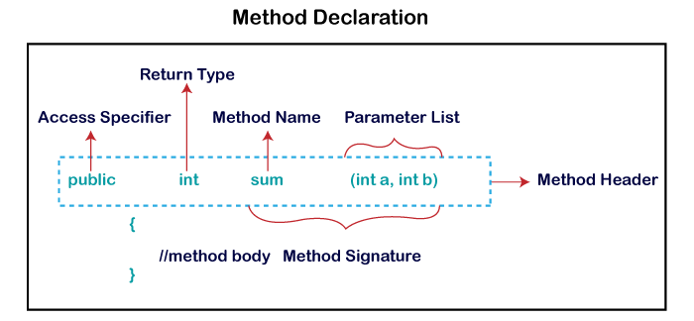

**Method Signature:** Every method has a method signature. It is a part of the method declaration. It includes the **method name** and **parameter list**.

**Access Specifier:** Access specifier or modifier is the access type of the method. It specifies the visibility of the method. Java provides **four** types of access specifier:

* **Public:** The method is accessible by all classes when we use public specifier in our application.
* **Private:** When we use a private access specifier, the method is accessible only in the classes in which it is defined.
* **Protected:** When we use protected access specifier, the method is accessible within the same package or subclasses in a different package.
* **Default:** When we do not use any access specifier in the method declaration, Java uses default access specifier by default. It is visible only from the same package only.

**Return Type:** Return type is a data type that the method returns. It may have a primitive data type, object, collection, void, etc. If the method does not return anything, we use void keyword.

**Method Name:** It is a unique name that is used to define the name of a method. It must be corresponding to the functionality of the method. Suppose, if we are creating a method for subtraction of two numbers, the method name must be **subtraction().** A method is invoked by its name.

**Parameter List:** It is the list of parameters separated by a comma and enclosed in the pair of parentheses. It contains the data type and variable name. If the method has no parameter, left the parentheses blank.

**Method Body:** It is a part of the method declaration. It contains all the actions to be performed. It is enclosed within the pair of curly braces.

## Naming a Method

While defining a method, remember that the method name must be a **verb** and start with a **lowercase** letter. If the method name has more than two words, the first name must be a verb followed by adjective or noun. In the multi-word method name, the first letter of each word must be in **uppercase** except the first word. For example:

**Single-word method name:** sum(), area()

**Multi-word method name:** areaOfCircle(), stringComparision()

It is also possible that a method has the same name as another method name in the same class, it is known as **method overloading**.

## Types of Method

There are two types of methods in Java:

* Predefined Method
* User-defined Method

### Predefined Method

In Java, predefined methods are the method that is already defined in the Java class libraries is known as predefined methods. It is also known as the **standard library method** or **built-in method**. We can directly use these methods just by calling them in the program at any point. Some pre-defined methods are **length(), equals(), compareTo(), sqrt(),** etc. When we call any of the predefined methods in our program, a series of codes related to the corresponding method runs in the background that is already stored in the library.

Each and every predefined method is defined inside a class. Such as **print()** method is defined in the **java.io.PrintStream** class. It prints the statement that we write inside the method. For example, **print("Java")**, it prints Java on the console.

Let's see an example of the predefined method.

**Demo.java**

1. **public** **class** Demo
2. {
3. **public** **static** **void** main(String[] args)
4. {
5. // using the max() method of Math class
6. System.out.print("The maximum number is: " + Math.max(9,7));
7. }
8. }

**Output:**

The maximum number is: 9

In the above example, we have used three predefined methods **main(), print(),** and **max()**. We have used these methods directly without declaration because they are predefined. The print() method is a method of **PrintStream** class that prints the result on the console. The max() method is a method of the **Math** class that returns the greater of two numbers.

We can also see the method signature of any predefined method by using the link <https://docs.oracle.com/>. When we go through the link and see the max() method signature, we find the following:

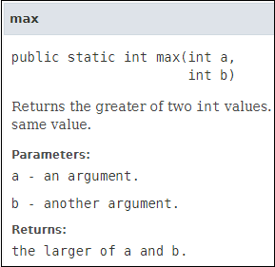

In the above method signature, we see that the method signature has access specifier **public**, non-access modifier **static**, return type **int**, method name **max(),** parameter list **(int a, int b).** In the above example, instead of defining the method, we have just invoked the method. This is the advantage of a predefined method. It makes programming less complicated.

Similarly, we can also see the method signature of the print() method.

### User-defined Method

The method written by the user or programmer is known as **a user-defined** method. These methods are modified according to the requirement.

### How to Create a User-defined Method

Let's create a user defined method that checks the number is even or odd. First, we will define the method.

1. //user defined method
2. **public** **static** **void** findEvenOdd(**int** num)
3. {
4. //method body
5. **if**(num%2==0)
6. System.out.println(num+" is even");
7. **else**
8. System.out.println(num+" is odd");
9. }

We have defined the above method named findevenodd(). It has a parameter **num** of type int. The method does not return any value that's why we have used void. The method body contains the steps to check the number is even or odd. If the number is even, it prints the number **is even**, else prints the number **is odd**.

### How to Call or Invoke a User-defined Method

Once we have defined a method, it should be called. The calling of a method in a program is simple. When we call or invoke a user-defined method, the program control transfer to the called method.

1. **import** java.util.Scanner;
2. **public** **class** EvenOdd
3. {
4. **public** **static** **void** main (String args[])
5. {

Int num=10;

1. //method calling
2. findEvenOdd(num);
3. }

In the above code snippet, as soon as the compiler reaches at line **findEvenOdd(num),** the control transfer to the method and gives the output accordingly.

# Constructors in Java:

In [Java](https://www.javatpoint.com/java-tutorial)

, a constructor is a block of codes similar to the method. It is called when an instance of the [class](https://www.javatpoint.com/object-and-class-in-java)

is created. At the time of calling constructor, memory for the object is allocated in the memory.

It is a special type of method which is used to initialize the object.

Every time an object is created using the new() keyword, at least one constructor is called.

It calls a default constructor if there is no constructor available in the class. In such case, Java compiler provides a default constructor by default.

### Rules for creating Java constructor

There are two rules defined for the constructor.

1. Constructor name must be the same as its class name
2. A Constructor must have no explicit return type
3. A Java constructor cannot be abstract, static, final, and synchronized

#### Note: We can use [access modifiers](https://www.javatpoint.com/access-modifiers)

#### while declaring a constructor. It controls the object creation. In other words, we can have private, protected, public or default constructor in Java.

## Types of Java constructors

There are two types of constructors in Java:

1. Default constructor (no-arg constructor)
2. Parameterized constructor
3. **class** Bike1{
4. //creating a default constructor
5. Bike1(){System.out.println("Bike is created");}
6. //main method
7. **public** **static** **void** main(String args[]){
8. //calling a default constructor
9. Bike1 b=**new** Bike1();
10. }
11. }

# Parameterized constructor:

1. **class** Student4{
2. **int** id;
3. String name;
4. //creating a parameterized constructor
5. Student4(**int** i,String n){
6. id = i;
7. name = n;
8. }
9. //method to display the values
10. **void** display(){System.out.println(id+" "+name);}
12. **public** **static** **void** main(String args[]){
13. //creating objects and passing values
14. Student4 s1 = **new** Student4(111,"Karan");
15. Student4 s2 = **new** Student4(222,"Aryan");
16. //calling method to display the values of object
17. s1.display();
18. s2.display();
19. }
20. }

|  |  |
| --- | --- |
| **Java Constructor** | **Java Method** |
| A constructor is used to initialize the state of an object. | A method is used to expose the behavior of an object. |
| A constructor must not have a return type. | A method must have a return type. |
| The constructor is invoked implicitly. | The method is invoked explicitly. |
| The Java compiler provides a default constructor if you don't have any constructor in a class. | The method is not provided by the compiler in any case. |
| The constructor name must be same as the class name. | The method name may or may not be same as the class name. |

# Static keyword:

The **static keyword** in [Java](https://www.javatpoint.com/java-tutorial)

is used for memory management mainly. We can apply static keyword with [variables](https://www.javatpoint.com/java-variables)

, methods, blocks.

. The static keyword belongs to the class than an instance of the class.

The static can be:

1. Variable (also known as a class variable)
2. Method (also known as a class method)
3. Block

### Example of static variable

1. //Java Program to demonstrate the use of static variable
2. **class** Student{
3. **int** rollno;//instance variable
4. String name;
5. **static** String college ="ITS";//static variable
6. //constructor
7. Student(**int** r, String n){
8. rollno = r;
9. name = n;
10. }
11. //method to display the values
12. **void** display (){System.out.println(rollno+" "+name+" "+college);}
13. }
14. //Test class to show the values of objects
15. **public** **class** TestStaticVariable1{
16. **public** **static** **void** main(String args[]){
17. Student s1 = **new** Student(111,"Karan");
18. Student s2 = **new** Student(222,"Aryan");
19. //we can change the college of all objects by the single line of code
20. //Student.college="BBDIT";
21. s1.display();
22. s2.display();
23. }
24. }

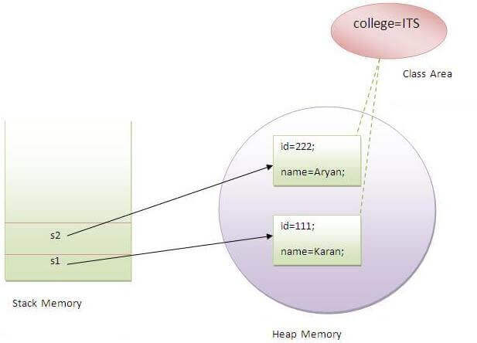

### Q) Why is the Java main method static?

Ans) It is because the object is not required to call a static method. If it were a non-static method,

creates an object first then call main() method that will lead the problem of extra memory allocation.

## 3) Java static block

* Is used to initialize the static data member.
* It is executed before the main method at the time of classloading.

### Example of static block

1. **class** A2{
2. **static**{System.out.println("static block is invoked");}
3. **public** **static** **void** main(String args[]){
4. System.out.println("Hello main");
5. }
6. }

# this keyword in Java

There can be a lot of usage of **Java this keyword**. In Java, this is a **reference variable** that refers to the current object.

## Usage of Java this keyword

Here is given the 6 usage of java this keyword.

1. [this can be used to refer current class instance variable.](https://www.javatpoint.com/this1)
2. [this can be used to invoke current class method (implicitly)](https://www.javatpoint.com/this2)
3. [this() can be used to invoke current class constructor.](https://www.javatpoint.com/this3)
4. [this can be passed as an argument in the method call.](https://www.javatpoint.com/this4)
5. [this can be passed as argument in the constructor call.](https://www.javatpoint.com/this5)
6. [this can be used to return the current class instance from the method.](https://www.javatpoint.com/this6)
7. **class** Student{
8. **int** rollno;
9. String name;
10. **float** fee;
11. Student(**int** rollno,String name,**float** fee){
12. this.rollno=rollno;
13. **this**.name=name;
14. **this**.fee=fee;
15. }
16. **void** display(){System.out.println(rollno+" "+name+" "+fee);}
17. }

Void display2()

{

This.display();

}

1. **class** TestThis2{
2. **public** **static** **void** main(String args[]){
3. Student s1=**new** Student(111,"ankit",5000f);
4. Student s2=**new** Student(112,"sumit",6000f);
5. s1.display();
6. s2.display();
7. }}

## OOPs (Object-Oriented Programming System)

**Object** means a real-world entity such as a pen, chair, table, computer, watch, etc. **Object-Oriented Programming** is a methodology or paradigm to design a program using classes and objects. It simplifies software development and maintenance by providing some concepts:

* [Object](https://www.javatpoint.com/object-and-class-in-java)
* Class
* [Inheritance](https://www.javatpoint.com/inheritance-in-java)
* [Polymorphism](https://www.javatpoint.com/runtime-polymorphism-in-java)
* [Abstraction](https://www.javatpoint.com/abstract-class-in-java)
* [Encapsulation](https://www.javatpoint.com/encapsulation)
* [Inheritance](https://www.javatpoint.com/inheritance-in-java):

**Inheritance in Java** is a mechanism in which one object acquires all the properties and behaviors of a parent object. It is an important part of [OOPs](https://www.javatpoint.com/java-oops-concepts)

(Object Oriented programming system).

The idea behind inheritance in Java is that you can create new [classes](https://www.javatpoint.com/object-and-class-in-java)

that are built upon existing classes.

### Why use inheritance in java

* For [Method Overriding](https://www.javatpoint.com/method-overriding-in-java)

(so [runtime polymorphism](https://www.javatpoint.com/runtime-polymorphism-in-java)

can be achieved).

* For Code Reusability.

### Terms used in Inheritance

* **Class:** A class is a group of objects which have common properties. It is a template or blueprint from which objects are created.
* **Sub Class/Child Class:** Subclass is a class which inherits the other class. It is also called a derived class, extended class, or child class.
* **Super Class/Parent Class:** Superclass is the class from where a subclass inherits the features. It is also called a base class or a parent class.
* **Reusability:** As the name specifies, reusability is a mechanism which facilitates you to reuse the fields and methods of the existing class when you create a new class. You can use the same fields and methods already defined in the previous class.

1. **class** Subclass-name **extends** Superclass-name
2. {
3. //methods and fields
4. }
5. **class** Employee{
6. **float** salary=40000;
7. }
8. **class** Programmer **extends** Employee{
9. **int** bonus=10000;
10. **public** **static** **void** main(String args[]){
11. Programmer p=**new** Programmer();
12. System.out.println("Programmer salary is:"+p.salary);
13. System.out.println("Bonus of Programmer is:"+p.bonus);
14. }
15. }
16. **class** Animal{
17. **void** eat(){System.out.println("eating...");}
18. }
19. **class** Dog **extends** Animal{
20. **void** bark(){System.out.println("barking...");}
21. }
22. **class** BabyDog **extends** Dog{
23. **void** weep(){System.out.println("weeping...");}
24. }
25. **class** TestInheritance2{
26. **public** **static** **void** main(String args[]){
27. BabyDog d=**new** BabyDog();
28. d.weep();
29. d.bark();
30. d.eat();
31. }}

Aggregation in Java

If a class have an entity reference, it is known as Aggregation. Aggregation represents HAS-A relationship.

Consider a situation, Employee object contains many informations such as id, name, emailId etc. It contains one more object named address, which contains its own informations such as city, state, country, zipcode etc. as given below.

1. **class** Employee{
2. **int** id;
3. String name;
4. Address address;//Address is a class
5. ...
6. }

In such case, Employee has an entity reference address, so relationship is Employee HAS-A address.

Why use Aggregation?

* For Code Reusability.

#### Address.java

1. **public** **class** Address {
2. String city,state,country;
4. **public** Address(String city, String state, String country) {
5. **this**.city = city;
6. **this**.state = state;
7. **this**.country = country;
8. }
10. }

#### Emp.java

1. **public** **class** Emp {
2. **int** id;
3. String name;
4. Address address;
6. **public** Emp(**int** id, String name,Address address) {
7. **this**.id = id;
8. **this**.name = name;
9. **this**.address=address;
10. }
12. **void** display(){
13. System.out.println(id+" "+name);
14. System.out.println(address.city+" "+address.state+" "+address.country);
15. }
17. **public** **static** **void** main(String[] args) {
18. Address address1=**new** Address("gzb","UP","india");
19. Address address2=**new** Address("gno","UP","india");
21. Emp e=**new** Emp(111,"varun", address1);
22. Emp e2=**new** Emp(112,"arun",address2);
24. e.display();
25. e2.display();
27. }
28. }

* [Polymorphism](https://www.javatpoint.com/runtime-polymorphism-in-java):

# Polymorphism in Java

**Polymorphism in Java** is a concept by which we can perform a single action in different ways. Polymorphism is derived from 2 Greek words: poly and morphs. The word "poly" means many and "morphs" means forms. So polymorphism means many forms.

There are two types of polymorphism in Java: compile-time polymorphism and runtime polymorphism. We can perform polymorphism in java by method overloading and method overriding.

# Method Overloading in Java

If a [class](https://www.javatpoint.com/object-and-class-in-java) has multiple methods having same name but different in parameters, it is known as **Method Overloading**.

If we have to perform only one operation, having same name of the methods increases the readability of the [program](https://www.javatpoint.com/java-programs).

Suppose you have to perform addition of the given numbers but there can be any number of arguments, if you write the method such as a(int,int) for two parameters, and b(int,int,int) for three parameters then it may be difficult for you as well as other programmers to understand the behavior of the method because its name differs.

So, we perform method overloading to figure out the program quickly.

OOPs Concepts in Java

## Advantage of method overloading

Method overloading increases the readability of the program.

### Different ways to overload the method

There are two ways to overload the method in java

1. By changing number of arguments
2. By changing the data type

#### In Java, Method Overloading is not possible by changing the return type of the method only.

1. **class** Adder{
2. **static** **int** add(**int** a,**int** b){
3. **return** a+b;
4. }
5. **static** **int** add(**int** a,**int** b,**int** c){
6. **return** a+b+c;
7. }
8. }
9. **class** TestOverloading1{
10. **public** **static** **void** main(String[] args){
11. System.out.println(Adder.add(11,11));
12. System.out.println(Adder.add(11,11,11));
13. }}
14. **class** Adder{
15. **static** **int** add(**int** a, **int** b){
16. **return** a+b;
17. }
18. **static** **double** add(**double** a, **double** b){
19. **return** a+b;
20. }
21. }
22. **class** TestOverloading2{
23. **public** **static** **void** main(String[] args){
24. System.out.println(Adder.add(11,11));
25. System.out.println(Adder.add(12.3,12.6));
26. }}

# Method Overriding in Java

If subclass (child class) has the same method as declared in the parent class, it is known as **method overriding in Java**.

In other words, If a subclass provides the specific implementation of the method that has been declared by one of its parent class, it is known as method overriding.

### Usage of Java Method Overriding

* Method overriding is used to provide the specific implementation of a method which is already provided by its superclass.
* Method overriding is used for runtime polymorphism

#### Rules for Java Method Overriding

1. The method must have the same name as in the parent class
2. The method must have the same parameter as in the parent class.
3. There must be an IS-A relationship (inheritance).
4. **class** Vehicle{
5. //defining a method
6. **void** run(){
7. System.out.println("Vehicle is running");
8. }
9. }
10. //Creating a child class
11. **class** Bike2 **extends** Vehicle{
12. //defining the same method as in the parent class
13. **void** run(){
14. System.out.println("Bike is running safely");
15. }
17. **public** **static** **void** main(String args[]){
18. Bike2 obj = **new** Bike2();//creating object
19. obj.run();//calling method
20. }
21. }

## Usage of Java super Keyword

1. super can be used to refer immediate parent class instance variable.
2. super can be used to invoke immediate parent class method.
3. super() can be used to invoke immediate parent class constructor.

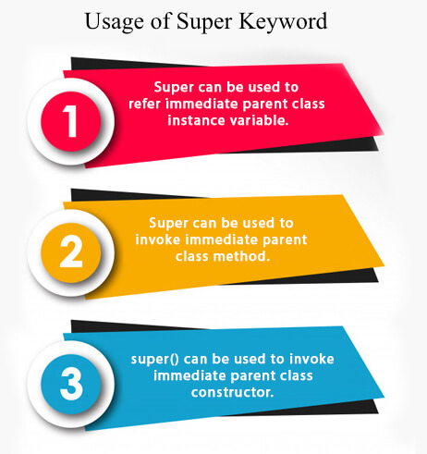

## 1) super is used to refer immediate parent class instance variable.

We can use super keyword to access the data member or field of parent class. It is used if parent class and child class have same fields.

1. **class** Animal{
2. String color="white";
3. }
4. **class** Dog **extends** Animal{
5. String color="black";
6. **void** printColor(){
7. System.out.println(color);//prints color of Dog class
8. System.out.println(**super**.color);//prints color of Animal class
9. }
10. }
11. **class** TestSuper1{
12. **public** **static** **void** main(String args[]){
13. Dog d=**new** Dog();
14. d.printColor();
15. }}

The **final keyword** in java is used to restrict the user. The java final keyword can be used in many context. Final can be:

1. variable
2. method
3. class
4. **package** com.demo5;
5. **final** **class** Bike10{
6. **final** **int** speedlimit=90;//final variable
7. **final** **void** run(){
8. speedlimit=400;
9. }
10. }
11. **public** **class** Sample **extends** Bike10 {
12. **void** run(){
13. speedlimit=400;
14. }
15. **public** **static** **void** main(String[] args) {
16. Sample sam=**new** Sample();

19. }
20. }

## 1) Java final variable

If you make any variable as final, you cannot change the value of final variable(It will be constant).

## 2) Java final method

If you make any method as final, you cannot override it.

## 3) Java final class

If you make any class as final, you cannot extend it.

* [Abstraction](https://www.javatpoint.com/abstract-class-in-java):

### Abstraction in Java

**Abstraction** is a process of hiding the implementation details and showing only functionality to the user.

Another way, it shows only essential things to the user and hides the internal details, for example, sending SMS where you type the text and send the message. You don't know the internal processing about the message delivery.

There are two ways to achieve abstraction in java

1. Abstract class (0 to 100%)
2. Interface (100%)

### Abstract class in Java

A class which is declared as abstract is known as an **abstract class**. It can have abstract and non-abstract methods. It needs to be extended and its method implemented. It cannot be instantiated.

#### Points to Remember

* An abstract class must be declared with an abstract keyword.
* It can have abstract and non-abstract methods.
* It cannot be instantiated.
* It can have [constructors](https://www.javatpoint.com/java-constructor) and static methods also.
* It can have final methods which will force the subclass not to change the body of the method.

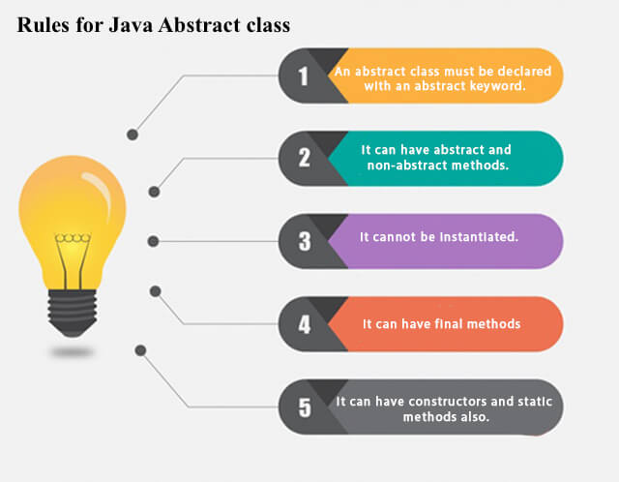

**Example of abstract class**

1. **abstract** **class** A{}

### Abstract Method in Java

A method which is declared as abstract and does not have implementation is known as an abstract method.

**Example of abstract method**

1. **abstract** **void** printStatus();//no method body and abstract

### Example of Abstract class that has an abstract method

In this example, Bike is an abstract class that contains only one abstract method run. Its implementation is provided by the Honda class.

1. **abstract** **class** Bike{
2. **abstract** **void** run();

void display()

{

System.out.println("running safely");

}

1. }
2. **class** Honda4 **extends** Bike{
3. **void** run(){
4. System.out.println("running safely");
5. }
6. **public** **static** **void** main(String args[]){
7. Bike obj = **new** Honda4();
8. obj.run();
9. }
10. }

Interface:

1. An **interface in Java** is a blueprint of a class. It has static constants and abstract methods.
2. The interface in Java is a mechanism to achieve [*abstraction*](https://www.javatpoint.com/abstract-class-in-java). There can be only abstract methods in the Java interface, not method body. It is used to achieve abstraction and multiple [inheritance in Java](https://www.javatpoint.com/inheritance-in-java).

## Why use Java interface?

There are mainly three reasons to use interface. They are given below.

* It is used to achieve abstraction.
* By interface, we can support the functionality of multiple inheritance.
* It can be used to achieve loose coupling.

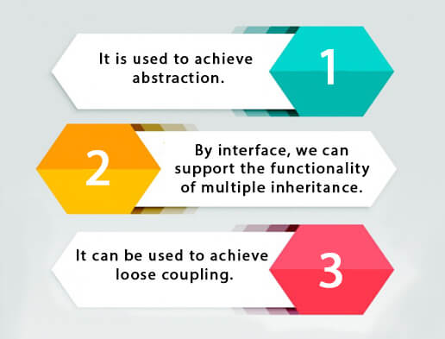

## How to declare an interface?

An interface is declared by using the interface keyword. It provides total abstraction; means all the methods in an interface are declared with the empty body, and all the fields are public, static and final by default. A class that implements an interface must implement all the methods declared in the interface.

### Syntax:

1. **interface** <interface_name>{
3. // declare constant fields
4. // declare methods that abstract
5. // by default.
6. }
7. **interface** printable{
8. **abstract void** print();
9. }
10. **class** A6 **implements** printable{
11. **public** **void** print(){System.out.println("Hello");}
13. **public** **static** **void** main(String args[]){
14. A6 obj = **new** A6();
15. obj.print();
16. }
17. }

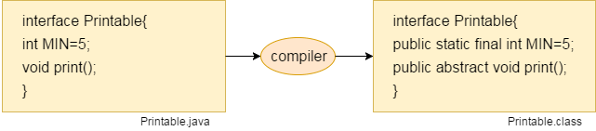

A **java package** is a group of similar types of classes, interfaces and sub-packages.

Package in java can be categorized in two form, built-in package and user-defined package.

There are many built-in packages such as java, lang, awt, javax, swing, net, io, util, sql etc.

Here, we will have the detailed learning of creating and using user-defined packages.

Hello Java Program for Beginners

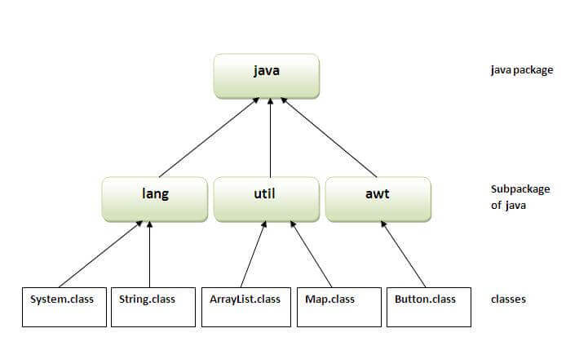

There are four types of Java access modifiers:

1. **Private**: The access level of a private modifier is only within the class. It cannot be accessed from outside the class.
2. **Default**: The access level of a default modifier is only within the package. It cannot be accessed from outside the package. If you do not specify any access level, it will be the default.
3. **Protected**: The access level of a protected modifier is within the package and outside the package through child class. If you do not make the child class, it cannot be accessed from outside the package.
4. **Public**: The access level of a public modifier is everywhere. It can be accessed from within the class, outside the class, within the package and outside the package.

# Encapsulation in Java

**Encapsulation in Java** is a process of wrapping code and data together into a single unit, for example, a capsule which is mixed of several medicines.



We can create a fully encapsulated class in Java by making all the data members of the class private. Now we can use setter and getter methods to set and get the data in it.

The **Java Bean** class is the example of a fully encapsulated class.

### Advantage of Encapsulation in Java

By providing only a setter or getter method, you can make the class **read-only or write-only**. In other words, you can skip the getter or setter methods.

Simple Example of Encapsulation in Java

Let's see the simple example of encapsulation that has only one field with its setter and getter methods.

*File: Student.java*

1. //A Java class which is a fully encapsulated class.
2. //It has a private data member and getter and setter methods.
3. **package** com.javatpoint;
4. **public** **class** Student{
5. //private data member
6. **private** String name;
7. //getter method for name
8. **public** String getName(){
9. **return** name;
10. }
11. //setter method for name
12. **public** **void** setName(String name){
13. **this**.name=name
14. }
15. }

*File: Test.java*

1. //A Java class to test the encapsulated class.
2. **package** com.javatpoint;
3. **class** Test{
4. **public** **static** **void** main(String[] args){
5. //creating instance of the encapsulated class
6. Student s=**new** Student();
7. //setting value in the name member
8. s.setName("vijay");
9. //getting value of the name member
10. System.out.println(s.getName());
11. }
12. }

# Java Arrays

Normally, an array is a collection of similar type of elements which has contiguous memory location.

**Java array** is an object which contains elements of a similar data type. Additionally, The elements of an array are stored in a contiguous memory location. It is a data structure where we store similar elements. We can store only a fixed set of elements in a Java array.

Array in Java is index-based, the first element of the array is stored at the 0th index, 2nd element is stored on 1st index and so on.

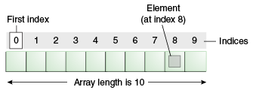

Disadvantages

* **Size Limit:** We can store only the fixed size of elements in the array. It doesn't grow its size at runtime. To solve this problem, collection framework is used in Java which grows automatically.

Types of Array in java

There are two types of array.

* Single Dimensional Array
* Multidimensional Array
* **class** Testarray{
* **public** **static** **void** main(String args[]){
* **int** a[]=**new** **int**[5];//declaration and instantiation
* a[0]=10;//initialization
* a[1]=20;
* a[2]=70;
* a[3]=40;
* a[4]=50;
* //traversing array
* **for**(**int** i=0;i<a.length;i++)//length is the property of array
* System.out.println(a[i]);
* }}

1. **class** Testarray1{
2. **public** **static** **void** main(String args[]){
3. **int** a[]={33,3,4,5};//declaration, instantiation and initialization
4. //printing array
5. **for**(**int** i=0;i<a.length;i++)//length is the property of array
6. System.out.println(a[i]);
7. }}

**Example to instantiate Multidimensional Array in Java**

1. **int**[][] arr=**new** **int**[3][3];//3 row and 3 column

**Example to initialize Multidimensional Array in Java**

1. arr[0][0]=1;
2. arr[0][1]=2;
3. arr[0][2]=3;
4. arr[1][0]=4;
5. arr[1][1]=5;
6. arr[1][2]=6;
7. arr[2][0]=7;
8. arr[2][1]=8;
9. arr[2][2]=9;

### Example of Multidimensional Java Array

Let's see the simple example to declare, instantiate, initialize and print the 2Dimensional array.

1. //Java Program to illustrate the use of multidimensional array
2. **class** Testarray3{
3. **public** **static** **void** main(String args[]){
4. //declaring and initializing 2D array
5. **int** arr[][]={{1,2,3},{2,4,5},{4,4,5}};
6. //printing 2D array
7. **for**(**int** i=0;i<3;i++){
8. **for**(**int** j=0;j<3;j++){
9. System.out.print(arr[i][j]+" ");
10. }
11. System.out.println();
12. }
13. }}

# Object class in Java

The **Object class** is the parent class of all the classes in java by default. In other words, it is the topmost class of java.

### Methods of Object class

|  |
| --- |
| The Object class provides many methods. They are as follows: |

|  |  |
| --- | --- |
| **Method** | **Description** |
| public final Class getClass() | returns the Class class object of this object. The Class class can further be used to get the metadata of this class. |
| public int hashCode() | returns the hashcode number for this object. |
| public boolean equals(Object obj) | compares the given object to this object. |
| protected Object clone() throws CloneNotSupportedException | creates and returns the exact copy (clone) of this object. |
| public String toString() | returns the string representation of this object. |
| public final void notify() | wakes up single thread, waiting on this object's monitor. |
| public final void notifyAll() | wakes up all the threads, waiting on this object's monitor. |
| public final void wait(long timeout)throws InterruptedException | causes the current thread to wait for the specified milliseconds, until another thread notifies (invokes notify() or notifyAll() method). |
| public final void wait(long timeout,int nanos)throws InterruptedException | causes the current thread to wait for the specified milliseconds and nanoseconds, until another thread notifies (invokes notify() or notifyAll() method). |
| public final void wait()throws InterruptedException | causes the current thread to wait, until another thread notifies (invokes notify() or notifyAll() method). |
| protected void finalize()throws Throwable | is invoked by the garbage collector before object is being garbage collected. |

# Wrapper classes in Java

The **wrapper class in Java** provides the mechanism to convert primitive into object and object into primitive.

Since J2SE 5.0, **autoboxing** and **unboxing** feature convert primitives into objects and objects into primitives automatically. The automatic conversion of primitive into an object is known as autoboxing and vice-versa unboxing.

|  |  |
| --- | --- |
| **Primitive Type** | **Wrapper class** |
| boolean | [Boolean](https://www.javatpoint.com/java-boolean) |
| char | [Character](https://www.javatpoint.com/post/java-character) |
| byte | [Byte](https://www.javatpoint.com/java-byte) |
| short | [Short](https://www.javatpoint.com/java-short) |
| int | [Integer](https://www.javatpoint.com/java-integer) |
| long | [Long](https://www.javatpoint.com/java-long) |
| float | [Float](https://www.javatpoint.com/java-float) |
| double | [Double](https://www.javatpoint.com/java-double) |

## Autoboxing

The automatic conversion of primitive data type into its corresponding wrapper class is known as autoboxing, for example, byte to Byte, char to Character, int to Integer, long to Long, float to Float, boolean to Boolean, double to Double, and short to Short.

Since Java 5, we do not need to use the valueOf() method of wrapper classes to convert the primitive into objects.

**Wrapper class Example: Primitive to Wrapper**

1. //Java program to convert primitive into objects
2. //Autoboxing example of int to Integer
3. **public** **class** WrapperExample1{
4. **public** **static** **void** main(String args[]){
5. //Converting int into Integer
6. **int** a=20;
7. Integer i=Integer.valueOf(a);//converting int into Integer explicitly
8. Integer j=a;//autoboxing, now compiler will write Integer.valueOf(a) internally
10. System.out.println(a+" "+i+" "+j);
11. }}

Output:

20 20 20

## Unboxing

The automatic conversion of wrapper type into its corresponding primitive type is known as unboxing. It is the reverse process of autoboxing. Since Java 5, we do not need to use the intValue() method of wrapper classes to convert the wrapper type into primitives.

**Wrapper class Example: Wrapper to Primitive**

1. //Java program to convert object into primitives
2. //Unboxing example of Integer to int
3. **public** **class** WrapperExample2{
4. **public** **static** **void** main(String args[]){
5. //Converting Integer to int
6. Integer a=**new** Integer(3);
7. **int** i=a.intValue();//converting Integer to int explicitly
8. **int** j=a;//unboxing, now compiler will write a.intValue() internally
10. System.out.println(a+" "+i+" "+j);
11. }}

Output:

3 3 3

Simple example of command-line argument in java

|  |
| --- |
| In this example, we are receiving only one argument and printing it. To run this java program, you must pass at least one argument from the command prompt. |

1. **class** CommandLineExample{
2. **public** **static** **void** main(String args[]){
3. System.out.println("Your first argument is: "+args[0]);
4. }
5. }
6. compile by > javac CommandLineExample.java
7. run by > java CommandLineExample sonoo

# Java String:

In [Java](https://www.javatpoint.com/java-tutorial), string is basically an object that represents sequence of char values. An [array](https://www.javatpoint.com/array-in-java) of characters works same as Java string. For example:

1. **char**[] ch={'j','a','v','a','t','p','o','i','n','t'};
2. String s=**new** String(ch);

is same as:

1. String s="javapoint";

**Java String** class provides a lot of methods to perform operations on strings such as compare(), concat(), equals(), split(), length(), replace(), compareTo(), intern(), substring() etc.

### What is String in Java?

Generally, String is a sequence of characters. But in Java, string is an object that represents a sequence of characters. The java.lang.String class is used to create a string object.

### How to create a string object?

There are two ways to create String object:

1. By string literal
2. By new keyword

### 1) String Literal

Java String literal is created by using double quotes. For Example:

1. String s="welcome";

Each time you create a string literal, the JVM checks the "string constant pool" first. If the string already exists in the pool, a reference to the pooled instance is returned. If the string doesn't exist in the pool, a new string instance is created and placed in the pool. For example:

1. String s1="Welcome";
2. String s2="Welcome";//It doesn't create a new instance

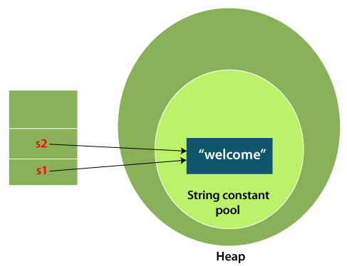

In the above example, only one object will be created. Firstly, JVM will not find any string object with the value "Welcome" in string constant pool that is why it will create a new object. After that it will find the string with the value "Welcome" in the pool, it will not create a new object but will return the reference to the same instance.

#### Note: String objects are stored in a special memory area known as the "string constant pool".

### Why Java uses the concept of String literal?

To make Java more memory efficient (because no new objects are created if it exists already in the string constant pool).

### 2) By new keyword

1. String s=**new** String("Welcome");//creates two objects and one reference variable

In such case, [JVM](https://www.javatpoint.com/jvm-java-virtual-machine) will create a new string object in normal (non-pool) heap memory, and the literal "Welcome" will be placed in the string constant pool. The variable s will refer to the object in a heap (non-pool).

### Java String Example

**StringExample.java**

1. **public** **class** StringExample{
2. **public** **static** **void** main(String args[]){
3. String s1="java";//creating string by Java string literal
4. **char** ch[]={'s','t','r','i','n','g','s'};
5. String s2=**new** String(ch);//converting char array to string
6. String s3=**new** String("example");//creating Java string by new keyword
7. System.out.println(s1);
8. System.out.println(s2);
9. System.out.println(s3);
10. }}

[**Test it Now**](https://www.javatpoint.com/opr/test.jsp?filename=StringExample)

**Output:**

java

strings

example

The above code, converts a **char** array into a **String** object. And displays the String objects **s1, s2**, and **s3** on console using **println()** method.

### Java String class methods

The java.lang.String class provides many useful methods to perform operations on sequence of char values.

|  |  |  |
| --- | --- | --- |
| **No.** | **Method** | **Description** |
| 1 | [char charAt(int index)](https://www.javatpoint.com/java-string-charat) | It returns char value for the particular index |
| 2 | [int length()](https://www.javatpoint.com/java-string-length) | It returns string length |
| 3 | [static String format(String format, Object... args)](https://www.javatpoint.com/java-string-format) | It returns a formatted string. |
| 4 | [static String format(Locale l, String format, Object... args)](https://www.javatpoint.com/java-string-format) | It returns formatted string with given locale. |
| 5 | [String substring(int beginIndex)](https://www.javatpoint.com/java-string-substring) | It returns substring for given begin index. |
| 6 | [String substring(int beginIndex, int endIndex)](https://www.javatpoint.com/java-string-substring) | It returns substring for given begin index and end index. |
| 7 | [boolean contains(CharSequence s)](https://www.javatpoint.com/java-string-contains) | It returns true or false after matching the sequence of char value. |
| 8 | [static String join(CharSequence delimiter, CharSequence... elements)](https://www.javatpoint.com/java-string-join) | It returns a joined string. |
| 9 | [static String join(CharSequence delimiter, Iterable<? extends CharSequence> elements)](https://www.javatpoint.com/java-string-join) | It returns a joined string. |
| 10 | [boolean equals(Object another)](https://www.javatpoint.com/java-string-equals) | It checks the equality of string with the given object. |
| 11 | [boolean isEmpty()](https://www.javatpoint.com/java-string-isempty) | It checks if string is empty. |
| 12 | [String concat(String str)](https://www.javatpoint.com/java-string-concat) | It concatenates the specified string. |
| 13 | [String replace(char old, char new)](https://www.javatpoint.com/java-string-replace) | It replaces all occurrences of the specified char value. |
| 14 | [String replace(CharSequence old, CharSequence new)](https://www.javatpoint.com/java-string-replace) | It replaces all occurrences of the specified CharSequence. |
| 15 | [static String equalsIgnoreCase(String another)](https://www.javatpoint.com/java-string-equalsignorecase) | It compares another string. It doesn't check case. |
| 16 | [String[] split(String regex)](https://www.javatpoint.com/java-string-split) | It returns a split string matching regex. |
| 17 | [String[] split(String regex, int limit)](https://www.javatpoint.com/java-string-split) | It returns a split string matching regex and limit. |
| 18 | [String intern()](https://www.javatpoint.com/java-string-intern) | It returns an interned string. |
| 19 | [int indexOf(int ch)](https://www.javatpoint.com/java-string-indexof) | It returns the specified char value index. |
| 20 | [int indexOf(int ch, int fromIndex)](https://www.javatpoint.com/java-string-indexof) | It returns the specified char value index starting with given index. |
| 21 | [int indexOf(String substring)](https://www.javatpoint.com/java-string-indexof) | It returns the specified substring index. |
| 22 | [int indexOf(String substring, int fromIndex)](https://www.javatpoint.com/java-string-indexof) | It returns the specified substring index starting with given index. |
| 23 | [String toLowerCase()](https://www.javatpoint.com/java-string-tolowercase) | It returns a string in lowercase. |
| 24 | [String toLowerCase(Locale l)](https://www.javatpoint.com/java-string-tolowercase) | It returns a string in lowercase using specified locale. |
| 25 | [String toUpperCase()](https://www.javatpoint.com/java-string-touppercase) | It returns a string in uppercase. |
| 26 | [String toUpperCase(Locale l)](https://www.javatpoint.com/java-string-touppercase) | It returns a string in uppercase using specified locale. |
| 27 | [String trim()](https://www.javatpoint.com/java-string-trim) | It removes beginning and ending spaces of this string. |
| 28 | [static String valueOf(int value)](https://www.javatpoint.com/java-string-valueof) | It converts given type into string. It is an overloaded method. |

How to create Immutable class?

There are many immutable classes like String, Boolean, Byte, Short, Integer, Long, Float, Double etc. In short, all the wrapper classes and String class is immutable. We can also create immutable class by creating final class that have final data members as the example given below:

Example to create Immutable class

In this example, we have created a final class named Employee. It have one final datamember, a parameterized constructor and getter method.

**ImmutableDemo.java**

1. **public** **final** **class** Employee
2. {
3. **final** String pancardNumber;
4. **public** Employee(String pancardNumber)
5. {
6. **this**.pancardNumber=pancardNumber;
7. }
8. **public** String getPancardNumber(){
9. **return** pancardNumber;
10. }
11. }
12. **public** **class** ImmutableDemo
13. {
14. **public** **static** **void** main(String ar[])
15. {
16. Employee e = **new** Employee("ABC123");
17. String s1 = e.getPancardNumber();
18. System.out.println("Pancard Number: " + s1);
19. }
20. }

# Java toString() Method

If you want to represent any object as a string, **toString() method** comes into existence.

The toString() method returns the String representation of the object.

If you print any object, Java compiler internally invokes the toString() method on the object. So overriding the toString() method, returns the desired output, it can be the state of an object etc. depending on your implementation.

### Advantage of Java toString() method

By overriding the toString() method of the Object class, we can return values of the object, so we don't need to write much code.

26.1M

599

Exception Handling in Java - Javatpoint

### Understanding problem without toString() method

Let's see the simple code that prints reference.

**Student.java**

1. **class** Student{
2. **int** rollno;
3. String name;
4. String city;
6. Student(**int** rollno, String name, String city){
7. **this**.rollno=rollno;
8. **this**.name=name;
9. **this**.city=city;
10. }
12. **public** **static** **void** main(String args[]){
13. Student s1=**new** Student(101,"Raj","lucknow");
14. Student s2=**new** Student(102,"Vijay","ghaziabad");
16. System.out.println(s1);//compiler writes here s1.toString()
17. System.out.println(s2);//compiler writes here s2.toString()
18. }
19. }

**Output:**

Student@1fee6fc

Student@1eed786

As you can see in the above example, printing s1 and s2 prints the hashcode values of the objects but I want to print the values of these objects. Since Java compiler internally calls toString() method, overriding this method will return the specified values. Let's understand it with the example given below:

## Example of Java toString() method

Let's see an example of toString() method.

**Student.java**

1. **class** Student{
2. **int** rollno;
3. String name;
4. String city;
6. Student(**int** rollno, String name, String city){
7. **this**.rollno=rollno;
8. **this**.name=name;
9. **this**.city=city;
10. }
12. **public** String toString(){//overriding the toString() method
13. **return** rollno+" "+name+" "+city;
14. }
15. **public** **static** **void** main(String args[]){
16. Student s1=**new** Student(101,"Raj","lucknow");
17. Student s2=**new** Student(102,"Vijay","ghaziabad");
19. System.out.println(s1);//compiler writes here s1.toString()
20. System.out.println(s2);//compiler writes here s2.toString()
21. }
22. }

**Output:**

101 Raj lucknow

102 Vijay ghaziabad

In the above program, Java compiler internally calls **toString()** method, overriding this method will return the specified values of **s1** and **s2** objects of Student class.

# Java StringBuffer Class

Java StringBuffer class is used to create mutable (modifiable) String objects. The StringBuffer class in Java is the same as String class except it is mutable i.e. it can be changed.

# Exception Handling in Java

The **Exception Handling in Java** is one of the powerful mechanism to handle the runtime errors so that the normal flow of the application can be maintained.

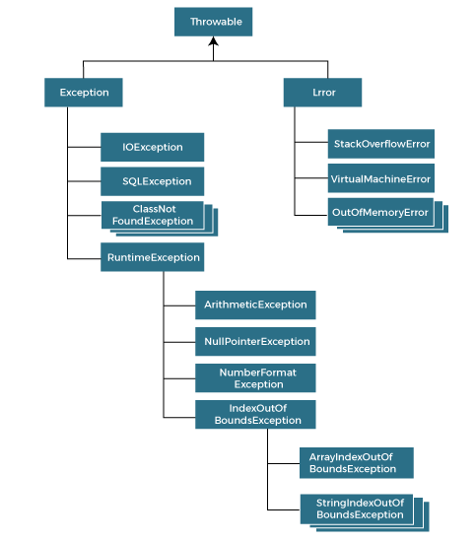

|  |  |
| --- | --- |
| **Keyword** | **Description** |
| try | The "try" keyword is used to specify a block where we should place an exception code. It means we can't use try block alone. The try block must be followed by either catch or finally. |
| catch | The "catch" block is used to handle the exception. It must be preceded by try block which means we can't use catch block alone. It can be followed by finally block later. |
| finally | The "finally" block is used to execute the necessary code of the program. It is executed whether an exception is handled or not. |
| throw | The "throw" keyword is used to throw an exception. |
| throws | The "throws" keyword is used to declare exceptions. It specifies that there may occur an exception in the method. It doesn't throw an exception. It is always used with method signature. |

1. **public** **class** JavaExceptionExample{
2. **public** **static** **void** main(String args[]){
3. **try**{
4. //code that may raise exception
5. **int** data=100/0;
6. }**catch**(ArithmeticException e){System.out.println(e);}
7. //rest code of the program
8. System.out.println("rest of the code...");
9. }
10. }

## Common Scenarios of Java Exceptions

There are given some scenarios where unchecked exceptions may occur. They are as follows:

### 1) A scenario where ArithmeticException occurs

If we divide any number by zero, there occurs an ArithmeticException.

1. **int** a=50/0;//ArithmeticException

### 2) A scenario where NullPointerException occurs

If we have a null value in any [variable](https://www.javatpoint.com/java-variables), performing any operation on the variable throws a NullPointerException.

1. String s=**null**;
2. System.out.println(s.length());//NullPointerException

### 3) A scenario where NumberFormatException occurs

If the formatting of any variable or number is mismatched, it may result into NumberFormatException. Suppose we have a [string](https://www.javatpoint.com/java-string) variable that has characters; converting this variable into digit will cause NumberFormatException.

1. String s="abc";
2. **int** i=Integer.parseInt(s);//NumberFormatException

### 4) A scenario where ArrayIndexOutOfBoundsException occurs

When an array exceeds to it's size, the ArrayIndexOutOfBoundsException occurs. there may be other reasons to occur ArrayIndexOutOfBoundsException. Consider the following statements.

1. **int** a[]=**new** **int**[5];
2. a[10]=50; //ArrayIndexOutOfBoundsException

# Java throw Exception

In Java, exceptions allows us to write good quality codes where the errors are checked at the compile time instead of runtime and we can create custom exceptions making the code recovery and debugging easier.

## Java throw keyword

The Java throw keyword is used to throw an exception explicitly.

We specify the **exception** object which is to be thrown. The Exception has some message with it that provides the error description. These exceptions may be related to user inputs, server, etc.

We can throw either checked or unchecked exceptions in Java by throw keyword. It is mainly used to throw a custom exception. We will discuss custom exceptions later in this section.

We can also define our own set of conditions and throw an exception explicitly using throw keyword. For example, we can throw ArithmeticException if we divide a number by another number. Here, we just need to set the condition and throw exception using throw keyword.

The syntax of the Java throw keyword is given below.

throw Instance i.e.,

1. **throw** **new** exception_class("error message");

Let's see the example of throw IOException.

1. **throw** **new** IOException("sorry device error");

Where the Instance must be of type Throwable or subclass of Throwable. For example, Exception is the sub class of Throwable and the user-defined exceptions usually extend the Exception class.

## Java throw keyword Example

### Example 1: Throwing Unchecked Exception

In this example, we have created a method named validate() that accepts an integer as a parameter. If the age is less than 18, we are throwing the ArithmeticException otherwise print a message welcome to vote.

**TestThrow1.java**

In this example, we have created the validate method that takes integer value as a parameter. If the age is less than 18, we are throwing the ArithmeticException otherwise print a message welcome to vote.

1. **public** **class** TestThrow1 {
2. //function to check if person is eligible to vote or not
3. **public** **static** **void** validate(**int** age) {
4. **if**(age<18) {
5. //throw Arithmetic exception if not eligible to vote
6. **throw** **new** ArithmeticException("Person is not eligible to vote");
7. }
8. **else** {
9. System.out.println("Person is eligible to vote!!");
10. }
11. }
12. //main method
13. **public** **static** **void** main(String args[]){
14. //calling the function
15. validate(13);
16. System.out.println("rest of the code...");
17. }
18. }

# Java throws keyword

The **Java throws keyword** is used to declare an exception. It gives an information to the programmer that there may occur an exception. So, it is better for the programmer to provide the exception handling code so that the normal flow of the program can be maintained.

1. **import** java.io.IOException;
2. **class** Testthrows1{
3. **void** m()**throws** IOException{
4. **throw** **new** IOException("device error");//checked exception
5. }
6. **void** n()**throws** IOException{
7. m();
8. }
9. **void** p(){
10. **try**{
11. n();
12. }**catch**(Exception e){System.out.println("exception handled");}
13. }
14. **public** **static** **void** main(String args[]){
15. Testthrows1 obj=**new** Testthrows1();
16. obj.p();
17. System.out.println("normal flow...");
18. }
19. }

# Collections in Java

1. [Java Collection Framework](https://www.javatpoint.com/collections-in-java)
2. [Hierarchy of Collection Framework](https://www.javatpoint.com/collections-in-java#collectionhierarchy)
3. [Collection interface](https://www.javatpoint.com/collections-in-java#collectionmethods)
4. [Iterator interface](https://www.javatpoint.com/collections-in-java#collectioniterator)

The **Collection in Java** is a framework that provides an architecture to store and manipulate the group of objects.

Java Collections can achieve all the operations that you perform on a data such as searching, sorting, insertion, manipulation, and deletion.

Java Collection means a single unit of objects. Java Collection framework provides many interfaces (Set, List, Queue, Deque) and classes ([ArrayList](https://www.javatpoint.com/java-arraylist), Vector, [LinkedList](https://www.javatpoint.com/java-linkedlist), [PriorityQueue](https://www.javatpoint.com/java-priorityqueue), HashSet, LinkedHashSet, TreeSet).

#### What is Collection in Java

A Collection represents a single unit of objects, i.e., a group.

### Methods of Collection interface

|  |  |  |
| --- | --- | --- |
| **No.** | **Method** | **Description** |
| 1 | public boolean add(E e) | It is used to insert an element in this collection. |
| 2 | public boolean addAll(Collection<? extends E> c) | It is used to insert the specified collection elements in the invoking collection. |
| 3 | public boolean remove(Object element) | It is used to delete an element from the collection. |
| 4 | public boolean removeAll(Collection<?> c) | It is used to delete all the elements of the specified collection from the invoking collection. |
| 5 | default boolean removeIf(Predicate<? super E> filter) | It is used to delete all the elements of the collection that satisfy the specified predicate. |
| 6 | public boolean retainAll(Collection<?> c) | It is used to delete all the elements of invoking collection except the specified collection. |
| 7 | public int size() | It returns the total number of elements in the collection. |
| 8 | public void clear() | It removes the total number of elements from the collection. |
| 9 | public boolean contains(Object element) | It is used to search an element. |
| 10 | public boolean containsAll(Collection<?> c) | It is used to search the specified collection in the collection. |
| 11 | public Iterator iterator() | It returns an iterator. |
| 12 | public Object[] toArray() | It converts collection into array. |
| 13 | public <T> T[] toArray(T[] a) | It converts collection into array. Here, the runtime type of the returned array is that of the specified array. |
| 14 | public boolean isEmpty() | It checks if collection is empty. |
| 15 | default Stream<E> parallelStream() | It returns a possibly parallel Stream with the collection as its source. |
| 16 | default Stream<E> stream() | It returns a sequential Stream with the collection as its source. |
| 17 | default Spliterator<E> spliterator() | It generates a Spliterator over the specified elements in the collection. |
| 18 | public boolean equals(Object element) | It matches two collections. |
| 19 | public int hashCode() | It returns the hash code number of the collection. |

There are many methods declared in the Collection interface. They are as follows:

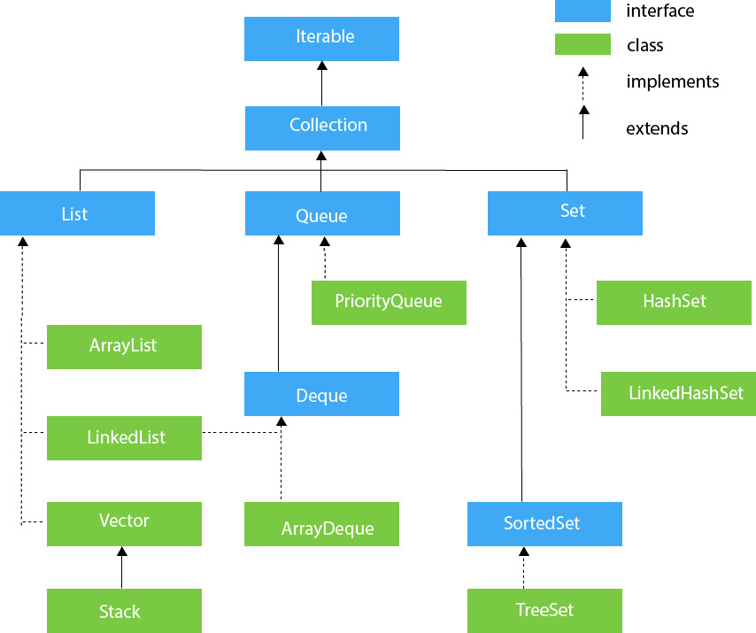

1. **import** java.util.*;
2. **public** **class** ArrayListExample1{
3. **public** **static** **void** main(String args[]){
4. ArrayList<String> list=**new** ArrayList<String>();//Creating arraylist
5. list.add("Mango");//Adding object in arraylist
6. list.add("Apple");
7. list.add("Banana");
8. list.add("Grapes");
9. //Printing the arraylist object
10. System.out.println(list);
11. }
12. }
13. **import** java.util.*;
14. **class** HashSet2{
15. **public** **static** **void** main(String args[]){
16. //Creating HashSet and adding elements
17. HashSet<String> set=**new** HashSet<String>();
18. set.add("Ravi");
19. set.add("Vijay");
20. set.add("Ravi");
21. set.add("Ajay");
22. //Traversing elements
23. Iterator<String> itr=set.iterator();
24. **while**(itr.hasNext()){
25. System.out.println(itr.next());
26. }
27. }