IT CHRONICLES
Department of Information Technology · IT CHRONICLES
Vol. 1 Issue 1 · 2026-2027 · Odd Semester (July - December 2026) · October 2026
IT CHRONICLES · RESEARCH & INNOVATION VOL. 1 · ISSUE 1
HTTPS://DOI.ORG/10.1109/TA.2026.001
Advanced Quantum AI for Document Automation
By Dr. John Smith, Dr. Alice Johnson
IEEE Transactions on Automation · October 2026
This paper presents a novel quantum architecture for normalizing dynamic newsletter components.
🏆 View Certificate & Project Demo

Test - 1
By Mahadhevan, Mahadhevan
Q1 journal · February 2026
Nothing

HTTPS://DOI.ORG/10.1109/TNNLS.2026.109283
Distributed Deep Learning Models for Natural Language Generation
By Dr. John Smith, Dr. Sarah Jenkins
IEEE Transactions on Neural Networks · September 2026
Presents a novel gradient compression algorithm for multi-node deep learning clusters reducing inter-node communication latency by 45%.
🏆 View Certificate & Project Demo

GRANT AMOUNT: $75,000
AI-Powered Smart Grid Monitoring & Anomaly Detection System
By Dr. S. Kulkarni (PI), Prof. R. Varma (Co-PI)
Department of Science & Technology (DST) · October 2026
Sanctioned 3-year research project focused on deploying IoT sensors and edge computing models to detect electrical network grid faults in real time.
🏆 View Certificate & Project Demo
IT CHRONICLES · FACULTY ACHIEVEMENTS VOL. 1 · ISSUE 1
NATIONAL ISTE AWARD
Outstanding National Educator & Pedagogy Excellence Award 2026
By Prof. Rajesh Varma
Indian Society for Technical Education (ISTE) · September 2026
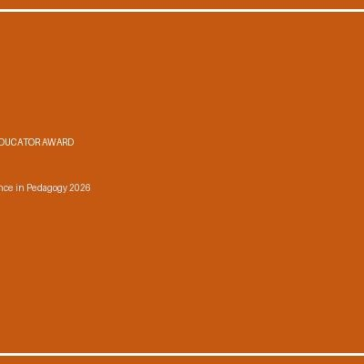  Prof. Rajesh Varma receiving the National Educator Trophy from the Chairman of ISTE | Conferred the prestigious National Educator Award during the 54th Annual ISTE Convention for ground-breaking curriculum design in Cloud Computing and undergraduate research mentorship.  🎖️ View Official Citation

Outstanding Educator & Researcher Award 2026
By Prof. Rajesh Varma
Indian Society for Technical Education (ISTE) · September 2026
Conferred the prestigious National Educator Award for excellence in computer science pedagogy and undergraduate research mentorship.

Best Researcher Award 2026
By Prof. Rajesh Varma
International Science Foundation · September 2026
Awarded for exceptional contributions to distributed cloud computing architectures.

KEYNOTE SPEAKER
Keynote Lecture on Cybersecurity & Zero Trust Frameworks
By Ms. P. Nair
International Cyber Defense Summit 2026 · October 2026
Delivered an invited expert keynote address on enterprise Zero Trust Architecture to over 500 cybersecurity practitioners and C-suite executives.
🎖️ View Official Citation

Keynote Speaker on Cybersecurity & Zero Trust Frameworks
By Ms. P. Nair
International Cyber Defense Summit 2026 · October 2026
Delivered an invited expert keynote session on enterprise Zero Trust Architecture to over 500 cybersecurity professionals.
IT CHRONICLES · STUDENT ACHIEVEMENTS VOL. 1 · ISSUE 1
1ST PRIZE (CASH AWARD $5,000 / ₹4,10,000)
Global Smart Cities Hackathon Championship 2026
By Rohan Sharma, Anita Roy, Kevin Patel (Dept of IT)
TechGiant Inc. & IEEE Computer Society · October 2026
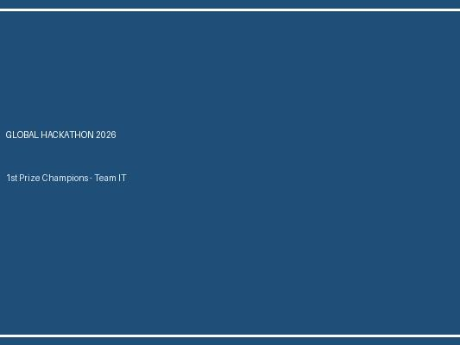
Left to Right: Rohan Sharma, Anita Roy, Kevin Patel holding the 1st Place Hackathon Trophy
Secured 1st rank among 350+ international university teams by developing an autonomous AI disaster dispatch drone management system capable of optimizing medical kit deliveries during flood relief operations.
🏆 View Certificate & Project Demo

1ST PRIZE ($5,000)
Global Smart Cities Hackathon Championship 2026
By Rohan Sharma, Anita Roy, Kevin Patel
TechGiant Inc. & IEEE · October 2026
Left to Right: Rohan Sharma, Anita Roy, Kevin Patel with 1st Prize trophy
Built an autonomous drone dispatch platform for disaster relief operations.
🏆 View Certificate & Project Demo

1ST PRIZE (CASH AWARD $5,000)
Global Hackathon Championship 2026
By Rohan Sharma, Anita Roy, Kevin Patel
TechGiant Inc. & IEEE Computer Society · October 2026
Secured 1st rank out of 350 international teams for constructing an autonomous AI disaster response drone dispatch dashboard.
🏆 View Certificate & Project Demo

1ST PLACE (CASH PRIZE $2000)
National AI Hackathon 2026
By Rohan Sharma, Anita Roy
TechCorp India · October 2026
Built an automated newsletter builder platform using document transformation engines.
IT CHRONICLES · INDUSTRY, ALUMNI & OUTREACH VOL. 1 · ISSUE 1
MOU SIGNED (COE SETUP)
Strategic Academic MoU with CloudTech Systems India
By Dr. S. Kulkarni
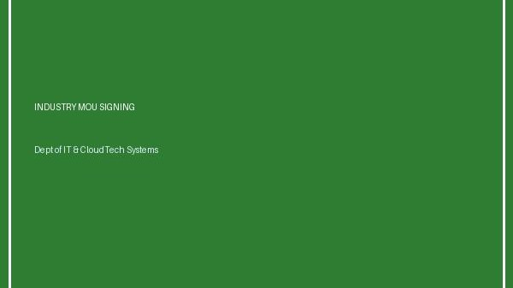
MoU Signing Ceremony between Dept of IT Leadership and CloudTech Directors
Executed a 3-year comprehensive MoU establishing a dedicated Cloud Computing Center of Excellence in the department, including hardware sponsorship and internship tracks for students.
View details

Strategic Academic MoU with CloudTech Systems
By Dr. S. Kulkarni
Signed an MoU establishing a specialized Cloud Computing Center of Excellence in the department with $20,000 industry hardware sponsorship.
IT CHRONICLES · DEPARTMENTAL HIGHLIGHTS VOL. 1 · ISSUE 1
Inauguration of Advanced High-Performance AI Computing Lab
By Dr. A. Sharma, Prof. R. Varma
Upgraded departmental computing facility with 40 high-end GPU workstations dedicated to Deep Learning, Computer Vision, and Data Analytics labs.

