IT CHRONICLES | DEPARTMENT OF INFORMATION TECHNOLOGY
FACULTY ACHIEVEMENTS

TOTAL SUBMISSIONS  12 | ACTIVE CATEGORIES  2 | EDITORIAL STATUS  VERIFIED & APPROVED

★ SPOTLIGHT & LANDMARK HIGHLIGHTS
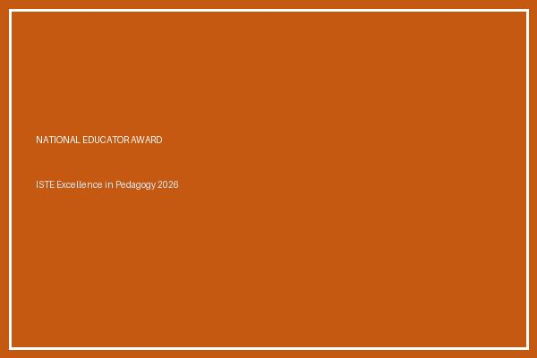  Prof. Rajesh Varma receiving the National Educator Trophy from the Chairman of ISTE | ★ SPOTLIGHT FEATURE | [NATIONAL ISTE AWARD]  Outstanding National Educator & Pedagogy Excellence Award 2026  Lead: Prof. Rajesh Varma • Date: September 2026  Venue / Host: Indian Society for Technical Education (ISTE)  Conferred the prestigious National Educator Award during the 54th Annual ISTE Convention for ground-breaking curriculum design in Cloud Computing and undergraduate research mentorship.  🔗 Verification & Details: https://isteonline.in/awards/2026/prof_varma.pdf

◆ AWARDS & HONORS RECEIVED
AWARDS & HONORS RECEIVED [International]
Best Researcher Award 2026
By: Prof. Rajesh Varma | Date: September 2026 | International Science Foundation
Awarded for exceptional contributions to distributed cloud computing architectures.

AWARDS & HONORS RECEIVED [International]
Best Researcher Award 2026
By: Prof. Rajesh Varma | Date: September 2026 | International Science Foundation
Awarded for exceptional contributions to distributed cloud computing architectures.

AWARDS & HONORS RECEIVED [International]
Best Researcher Award 2026
By: Prof. Rajesh Varma | Date: September 2026 | International Science Foundation
Awarded for exceptional contributions to distributed cloud computing architectures.

AWARDS & HONORS RECEIVED [National Level]
Outstanding Educator & Researcher Award 2026
By: Prof. Rajesh Varma | Date: September 2026 | Indian Society for Technical Education (ISTE)
Conferred the prestigious National Educator Award for excellence in computer science pedagogy and undergraduate research mentorship.

AWARDS & HONORS RECEIVED [National Level]
Outstanding Educator & Researcher Award 2026
By: Prof. Rajesh Varma | Date: September 2026 | Indian Society for Technical Education (ISTE)
Conferred the prestigious National Educator Award for excellence in computer science pedagogy and undergraduate research mentorship.

AWARDS & HONORS RECEIVED [National Level]
Outstanding Educator & Researcher Award 2026
By: Prof. Rajesh Varma | Date: September 2026 | Indian Society for Technical Education (ISTE)
Conferred the prestigious National Educator Award for excellence in computer science pedagogy and undergraduate research mentorship.

AWARDS & HONORS RECEIVED [International]
Best Researcher Award 2026
By: Prof. Rajesh Varma | Date: September 2026 | International Science Foundation
Awarded for exceptional contributions to distributed cloud computing architectures.

◆ INVITED KEYNOTE / EXPERT LECTURES DELIVERED
INVITED KEYNOTE / EXPERT LECTURES DELIVERED [Keynote Speaker]
Keynote Lecture on Cybersecurity & Zero Trust Frameworks
By: Ms. P. Nair | Date: October 2026 | International Cyber Defense Summit 2026
Delivered an invited expert keynote address on enterprise Zero Trust Architecture to over 500 cybersecurity practitioners and C-suite executives.
Proof / Link: https://cyberdefense2026.org/speakers/p-nair

INVITED KEYNOTE / EXPERT LECTURES DELIVERED [International Level]
Keynote Speaker on Cybersecurity & Zero Trust Frameworks
By: Ms. P. Nair | Date: October 2026 | International Cyber Defense Summit 2026
Delivered an invited expert keynote session on enterprise Zero Trust Architecture to over 500 cybersecurity professionals.

INVITED KEYNOTE / EXPERT LECTURES DELIVERED [International Level]
Keynote Speaker on Cybersecurity & Zero Trust Frameworks
By: Ms. P. Nair | Date: October 2026 | International Cyber Defense Summit 2026
Delivered an invited expert keynote session on enterprise Zero Trust Architecture to over 500 cybersecurity professionals.

INVITED KEYNOTE / EXPERT LECTURES DELIVERED [International Level]
Keynote Speaker on Cybersecurity & Zero Trust Frameworks
By: Ms. P. Nair | Date: October 2026 | International Cyber Defense Summit 2026
Delivered an invited expert keynote session on enterprise Zero Trust Architecture to over 500 cybersecurity professionals.

