IT CHRONICLES · STUDENT ACHIEVEMENTS VOL. 1 · ISSUE 1
1ST PRIZE (CASH AWARD $5,000 / ₹4,10,000)
Global Smart Cities Hackathon Championship 2026
By Rohan Sharma, Anita Roy, Kevin Patel (Dept of IT)
TechGiant Inc. & IEEE Computer Society · October 2026
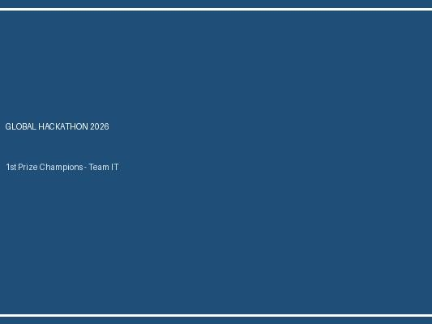
Left to Right: Rohan Sharma, Anita Roy, Kevin Patel holding the 1st Place Hackathon Trophy
Secured 1st rank among 350+ international university teams by developing an autonomous AI disaster dispatch drone management system capable of optimizing medical kit deliveries during flood relief operations.
🏆 View Certificate & Project Demo

1ST PRIZE ($5,000)
Global Smart Cities Hackathon Championship 2026
By Rohan Sharma, Anita Roy, Kevin Patel
TechGiant Inc. & IEEE · October 2026
Left to Right: Rohan Sharma, Anita Roy, Kevin Patel with 1st Prize trophy
Built an autonomous drone dispatch platform for disaster relief operations.
🏆 View Certificate & Project Demo

1ST PRIZE (CASH AWARD $5,000)
Global Hackathon Championship 2026
By Rohan Sharma, Anita Roy, Kevin Patel
TechGiant Inc. & IEEE Computer Society · October 2026
Secured 1st rank out of 350 international teams for constructing an autonomous AI disaster response drone dispatch dashboard.
🏆 View Certificate & Project Demo

1ST PLACE (CASH PRIZE $2000)
National AI Hackathon 2026
By Rohan Sharma, Anita Roy
TechCorp India · October 2026
Built an automated newsletter builder platform using document transformation engines.

