IT CHRONICLES · STUDENT ACHIEVEMENTS
1ST PRIZE CHAMPIONS
Global Smart Cities Hackathon Championship 2026
By Rohan Sharma, Anita Roy, Kevin Patel
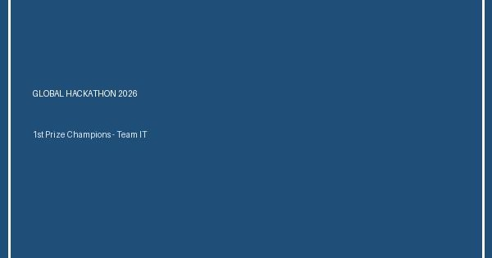
Left to Right: Rohan Sharma, Anita Roy, Kevin Patel with 1st Prize trophy
Built an autonomous drone dispatch platform for disaster relief operations.
View details

1ST PRIZE ($5,000)
Global Smart Cities Hackathon Championship 2026
By Rohan Sharma, Anita Roy, Kevin Patel (Dept of IT)
Left to Right: Rohan Sharma, Anita Roy, Kevin Patel holding the 1st Place Hackathon Trophy
Secured 1st rank among 350+ international university teams by developing an autonomous AI disaster dispatch drone management system capable of optimizing medical kit deliveries during flood relief operations.
View details

Global Hackathon Championship 2026
By Rohan Sharma, Anita Roy, Kevin Patel
Secured 1st rank out of 350 international teams for constructing an autonomous AI disaster response drone dispatch dashboard.
View details

National AI Hackathon 2026
By Rohan Sharma, Anita Roy
Built an automated newsletter builder platform using document transformation engines.

