**TAMPERE UNIVERSITY OF TECHNOLOGY**

**DEE-33116 Power Electronic Converters**

**BRIEF STUDY OF STEADY STATE OPERATION OF A DC/DC BUCK CONVERTER BY USING THE CONVENTIONAL SIMULINK-BLOCKS**

**Simulation Exercise-2 Report**

|  |  |
| --- | --- |
| **Name** | **ID** |
| Mahabub Hasan Parvez | 281749 |
| Md Nurunnabi Emon | 281732 |
| Sayad Mohammad Mahadi Hassan | 281750 |
| Dilshan Chathuranga Subasinghe | 281753 |
| Gowtham Chegatagare Narasimhareddy | 281742 |

Date:20-Nov-2018

**TABLE OF CONTENTS**

1. **INTRODUCTION1**
2. **THEORY4**
3. **SIMULATION MODEL 4**
4. **RESULTS 4**
5. **CONCLUSIONS 4**
6. **REFERENCES 4**
7. **INTRODUCTION**

Practically, a DC-DC buck converter can be operated in two different modes of operation which are called (1) Continuous Current Conduction (CCM) and (2) Discontinuous Current Conduction (DCM). The theory behind these operation modes will be discussed in Section 2 Theory.

Power electronics systems can be simulated using computer software for analysis and design purposes. Matlab SIMULINK is one of the advanced software which is utilized for simulations and it has a powerful graphical user interface to handle dynamic systems using circuit blocks. In this exercise a DC/DC buck converter model has been implemented and analyzed the model by using Matlab SIMULINK.

As denoted by the name, it produces a lower DC output voltage than the DC input voltage. Buck converters can be found many of applications such as power supplies, interface between battery and components, telecom and datacom systemsetc.

1. **THEORY**

The main working principle of buck converter is that when the switch is ON the diode in Fig 2(a) become reverse biased and current flows through the inductor and the load. When the switch is OFF the inductor current flows through the diode and also some of its energy transfers to the load. The capacitor used in the circuit is assumed to be large enough and so that normally the output voltage is assumed as nearly constant. Fig 2(b) shows the input voltage waveform to the LC low pass filter which is almost same as output voltage. Buck converters can be found many of applications such as power supplies, interface between battery and components, telecom and datacom systems etc.Fig 1 shows an ideal step-down (buck) converter.

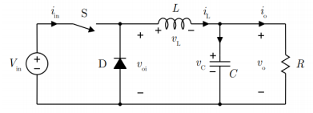

Fig 1: Ideal buck converter

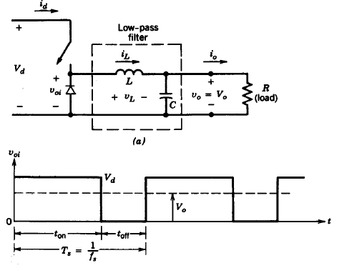

Fig 2: (a) Step-down DC-DC converter (b) The input voltage waveform to the LC low pass filter

The controlled switch is turned on and off by using Pulse Width Modulation (PWM).In PWM switching, the switching control signal will be generated by comparing a control signal ($v_{control}$) and repetitive sawtooth waveform as shown in the Fig 3. It can be expressed the duty ratio as,

$$D=\frac{t_{on}}{T_{s}}=\frac{v_{control}}{V_{st}}$$

Where $V_{st}$ is the peak of the sawtooth waveform,

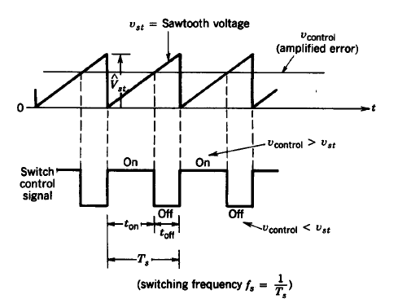

Fig 3: PWM output signal.

As stated in Section 1, DC-DC converter can be operated in two different modes of operation which are called (1) Continuous Current Conduction (CCM) and (2) Discontinuous Current Conduction (DCM). In step-down converter average output current equals to the average inductor current.

1. **Continuous Current Conduction (CCM)**

Fig 4, shows waveform for CCM operation where inductor current flows continuously over time. In the steady state operation, the integral of the inductor voltage vL over one duty cycle must be zero. Therefore,

$${ (V}_{d}-V_{o} ) t_{on}{-V}_{o}(T_{s}-t_{on})=0$$

$$\frac{V_{o}}{V_{d}}=\frac{t_{on}}{T_{s}}=D/D=duty ratio$$

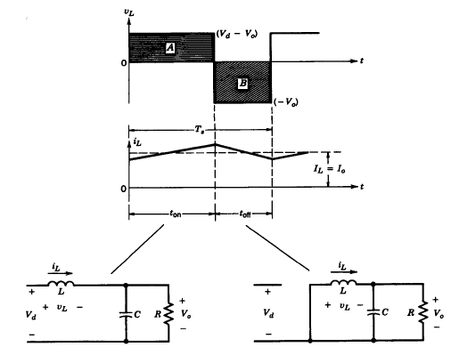

Fig 4. Step down DC-DC converter CCM mode operation

1. **Discontinuous Current Conduction (DCM)**

In the DCM mode, the inductor current is zero during a part of the cycle (Fig 5). The integral of the inductor voltage over one duty cycle can be obtained as below and it is equal to zero

$${(V}_{d}-V_{o} ) DT_{s}- V_{d}∆_{1}T_{s}=0$$

$$\frac{V_{o}}{V_{d}}=\frac{D}{∆_{1}+D} D=duty ratio$$

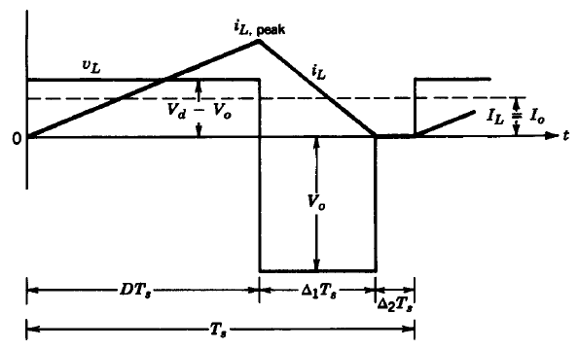

Fig 5: Step down DC-DC converter DCM mode operation

1. **SIMULATION MODEL**

The simulation model, can be shown in Fig 6, is created by using the conventional Simulink-blocks (i.e.: constant, repeating sequence, relational operator and scope etc.) and main parameters of the converter are presented in Table 1.

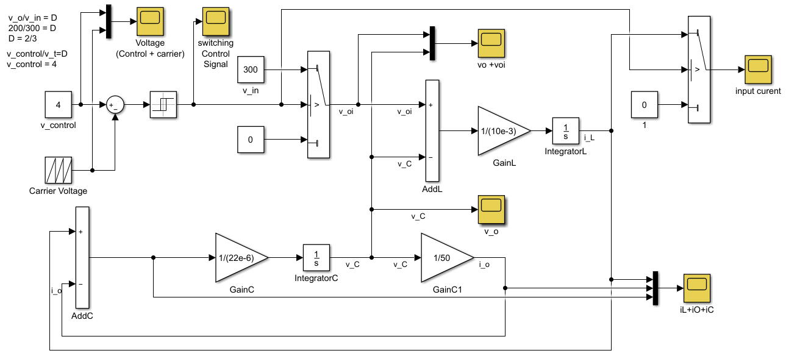

Fig 6: MATLAB Simulation Model of DC-DCBuck Converter.

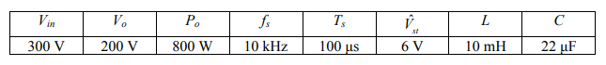

Table 1: Properties of the simulated buck converter

The simulation model is created using following equations. The equation relating inductor current and voltage is a first order differential equation.

$v_{L}=L\frac{di_{L}}{dt}$…………………….………(1)

For simulation purposes, differential equations are transformed into integral form. The integral form of the eq. 1

$i_{L}=\frac{1}{L}\int_{0}^{t}{v_{L}dt}+i_{L}(0)$………….………(2)

Since, it is only considered the steady state, $i_{L}\left(0\right)=0$,

$$v_{L}=v_{oi}-v_{c}$$

Thus,

$i_{L}=\frac{1}{L}\int_{0}^{t}{v_{oi}-v_{c}dt}$………………..….. (3)

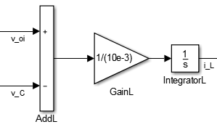

Fig 7:Computation of inductor current

The voltage $v_{oi}$ depends on the state of the main switch S, when the switch is on, the voltage $v_{oi}$ equals $v_{in}$ and off, the voltage is zero.This switching action is modeled using switch block as illustrated in Fig. 8.

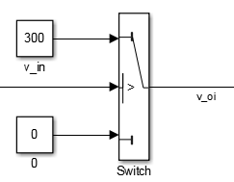

Fig 8: Voltage $v_{oi}$

The equation relating capacitor voltage and current in integral form is stated below and illustrated in Fig 9.

$i_{c}=C \frac{dv_{c}}{dt}→\frac{1}{C}\int_{0}^{t}{\left(i_{L}-i_{o}\right)dt}$……… (4)

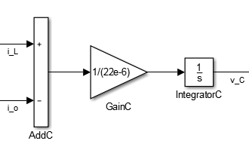

Fig 9: Computation of capacitor voltage

The load current can be computed from below equation and illustrated in Fig 10,

$i_{o}=\frac{1}{R_{eq}}v_{o}$…………. (5)

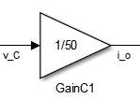

Fig 10:Computation of load current

1. **RESULTS**
   1. **Schematic of the simulation model:**

TheSchematic of the simulation model is shown in Fig. 6.

* 1. **Simulated waveforms of the PWM control voltage and carrier voltage in same figure:**

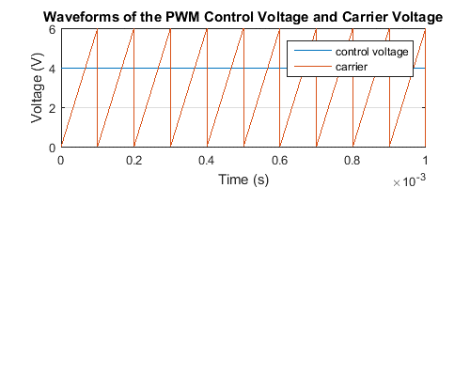

Fig 11: Waveforms of the PWM control voltage and carrier voltage.

The Fig 11.Shows the waveforms of the PWM control voltage and carrier voltage. The switch control signal is generated by comparing this control voltage level and repetitive waveform. The frequency of the repetitive waveform is constant and it becomes the switching frequency of the PWM signal. It is waveform with a constant peak which is shown as a sawtooth. In this simulation, control voltage is used as constant 4V. By varying this signal slowly with compared to switching frequency, the output PWM signal can be controlled.

* 1. **Simulated waveform of the switch control signal:**

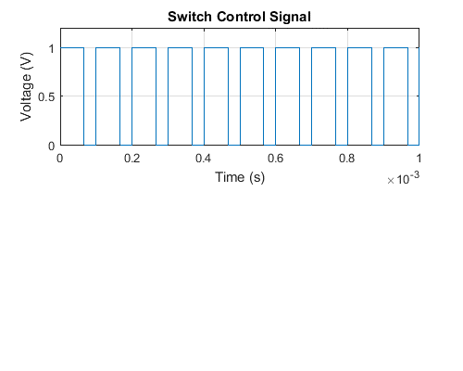

Fig 12: waveforms of the switch control signal

Switch control signal is a square waveform is shown in Fig 12 and it is applied to the switch. The signal is high meant switch is on and otherwise switch is off. The signal has a duty ratio of .

* 1. **Simulated waveform of the output voltage vo and voltage voi in same figure:**

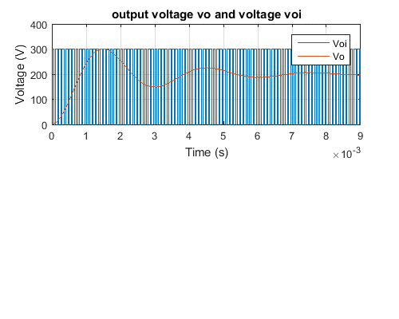

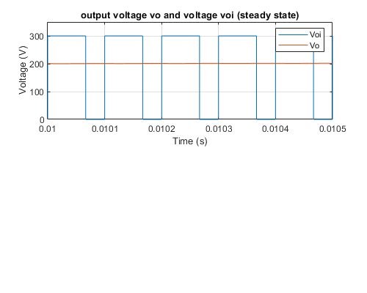

Fig 13: (a)vo and voltage voi in same figure (b) Steady state waveform

The Fig 13 (a) shows the output voltage v­oand input voltage v­oi and Fig 13 (b) shows the Steady state waveform of the input v­oi­ to the LC low pass filter and the output of the load voltagev­o. v­oi­ is formed a square waveform due to the switching of the switch. The DC component of the v­­oi­ becomes v­o­, where v­o­ is constant DC voltage because filter capacitor at the output is large enough.

* 1. 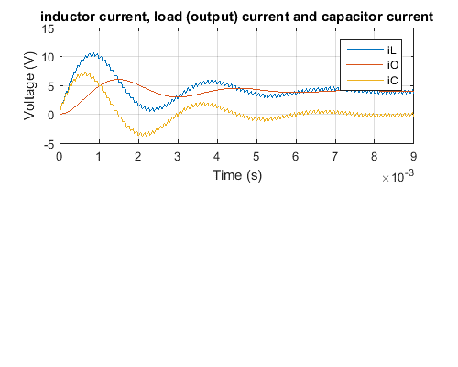**Simulated waveform of the inductor current, load (output) current and capacitor current in same figure:**

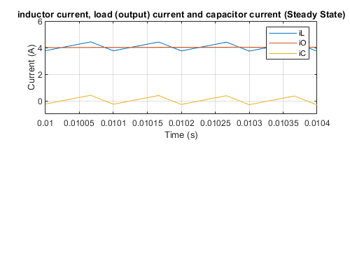

Fig 14: (a) Inductor current, load (output) current and capacitor current in same figure (b) Steady state waveforms

From Fig 14 (a) and (b)average inductor current equals to average output current and average capacitor current is zero in steady state from, inductor current and capacitor current consist of ripples.

* 1. **Simulated waveform of the input current:**

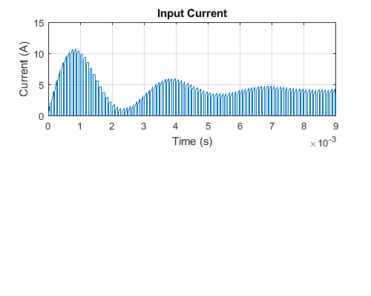

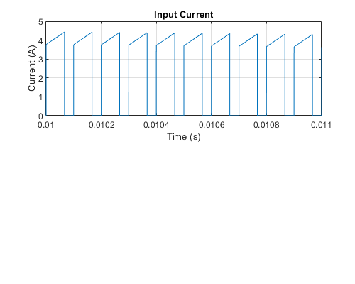

Fig 15: (a) Input current (b) Steady state waveform

When the switch is off, the inductor current flows through the diode and input current becomes zero, and when switch is on, input current equals to the inductor current. Therefore, input current will be same as inductor current, but during t­off­, input current will be zero.

$$i_{d}=\left\{\begin{aligned}i_{L} ;t_{on} \\ 0 ;t_{off}\end{aligned}\right.$$

1. **CONCLUSION**

Actually inDC-DC buck converter we have done simulation with mathematical modeling and we used equation instead of direct component in Simulink. We also simulated waveforms of the PWM control voltage and carrier voltage,waveform of the switch control signal, waveform of the output voltage vo and voltage voi, waveform of the inductor current, load (output) current and capacitor current. We analyzed each and every figure we got from our simulation. As we have previous knowledge from the boost converter and MATLab so we managed to found all the waveform of the different locations of the model.

We learned that varying the signal slowly with compared to switching frequency, the output PWM signal can be controlled. For the switch control signal we learned the signal is high meant switch is on and otherwise switch is off. From waveform of the inductor current, load (output) current and capacitor current we learned that average inductor current equals to average output current and average capacitor current is zero in steady state from, inductor current and capacitor current consist of ripples.

At last we also made some MATLab coding to plot the figures so that we can take a close look on the simulation figures.

1. **MATLAB SCRIPT RELATED TO FIGURE GENERATION**

% set start and end times

t_start = 0;

t_end = 10e-4;

% plot PWM control voltage and carrier voltage

figure(1);

set(gcf,'Position', [100, 100, 500, 400]);

set(gcf,'color','w');

subplot(2,1,1);

plot(control.time, control.signals.values());

grid on;

title('Waveforms of the PWM Control Voltage and Carrier Voltage');

xlabel('Time (s)');

ylabel('Voltage (V)');

xlim([t_start t_end]);

legend('control voltage','carrier');

shg;

% plot waveform of the switch control signal

figure(2);

set(gcf,'Position', [100, 100, 500, 400]);

set(gcf,'color','w');

subplot(2,1,1);

plot(switching.time, switching.signals.values(:));

grid on;

title('Switch Control Signal');

xlabel('Time (s)');

ylabel('Voltage (V)');

xlim([t_start t_end]);

ylim([0 1.2]);

shg;

% plot waveform of the output voltage vo and voltage voi

figure(3);

set(gcf,'Position', [100, 100, 500, 400]);

set(gcf,'color','w');

subplot(2,1,1);

plot(voandvoi.time, voandvoi.signals.values());

grid on;

title('output voltage vo and voltage voi');

xlabel('Time (s)');

ylabel('Voltage (V)');

xlim([0 0.009]);

legend('Voi','Vo');

shg;

% plot waveform of the output voltage vo and voltage voi (steadt state)

figure(4);

set(gcf,'Position', [100, 100, 500, 400]);

set(gcf,'color','w');

subplot(2,1,1);

plot(voandvoi.time, voandvoi.signals.values());

grid on;

title('output voltage vo and voltage voi (steady state)');

xlabel('Time (s)');

ylabel('Voltage (V)');

xlim([0.01 0.0105]);

ylim([0 350]);

legend('Voi','Vo');

shg;

**% plot waveform of inductor current, load (output) current and capacitor**

**% current);**

figure(5);

set(gcf,'Position', [100, 100, 500, 400]);

set(gcf,'color','w');

subplot(2,1,1);

plot(iLiOiC.time, iLiOiC.signals.values());

grid on;

title('inductor current, load (output) current and capacitor current');

xlabel('Time (s)');

ylabel('Current (A)');

xlim([0 0.009]);

legend('iL','iO', 'iC');

shg;

% plot waveform of inductor current, load (output) current and capacitor

% current (Steady State)

figure(6);

set(gcf,'Position', [100, 100, 500, 400]);

set(gcf,'color','w');

subplot(2,1,1);

plot(iLiOiC.time, iLiOiC.signals.values());

grid on;

title('inductor current, load (output) current and capacitor current (Steady State)');

xlabel('Time (s)');

ylabel('Current (A)');

xlim([0.01 0.0104]);

ylim([-1 6]);

legend('iL','iO', 'iC');

shg;

% plot waveform of the input current ;

figure(7);

set(gcf,'Position', [100, 100, 500, 400]);

set(gcf,'color','w');

subplot(2,1,1);

plot(inputcurrent.time, inputcurrent.signals.values());

grid on;

title('Input Current');

xlabel('Time (s)');

ylabel('Current (A)');

xlim([0 0.009]);

shg;

% plot waveform of the input current (Steady State)

figure(8);

set(gcf,'Position', [100, 100, 500, 400]);

set(gcf,'color','w');

subplot(2,1,1);

plot(inputcurrent.time, inputcurrent.signals.values());

grid on;

title('Input Current');

xlabel('Time (s)');

ylabel('Current (A)');

xlim([0.01 0.012]);

shg;

1. **REFERENCES**

[1] Mohan, N., Undeland, T. M., & Robbins, W. P. (2007). *Power electronics: Converters, applications, and design*. New Delhi, India: John Wiley & Sons.