# Education

**B.Sc.in Computer Science and Engineering(CSE)**

Daffordil International University

**Higher Secondary Certificate (HSC) 2019**

Holy Land College

4.75

**Secondary School Certificate (SSC) 2017**

Thakurgon Government Boys High School

4.82

# Skill

* Programming Languages: C, C++, Python, HTML, CSS, JavaScript
* Version Control: Git, GitHub
* Office Tools: Microsoft Office 2016(Word, PowerPoint), Google Docs
* Operating System: Windows

# Hobbies

* Music
* Traveling
* Bike Ride
* Reading

# Achievement

• Take-off Programming Contest 2021

• DIU Intra University Programming Contest 2021

• Solved more than 669 problem in various online Judge

Student and Programmer

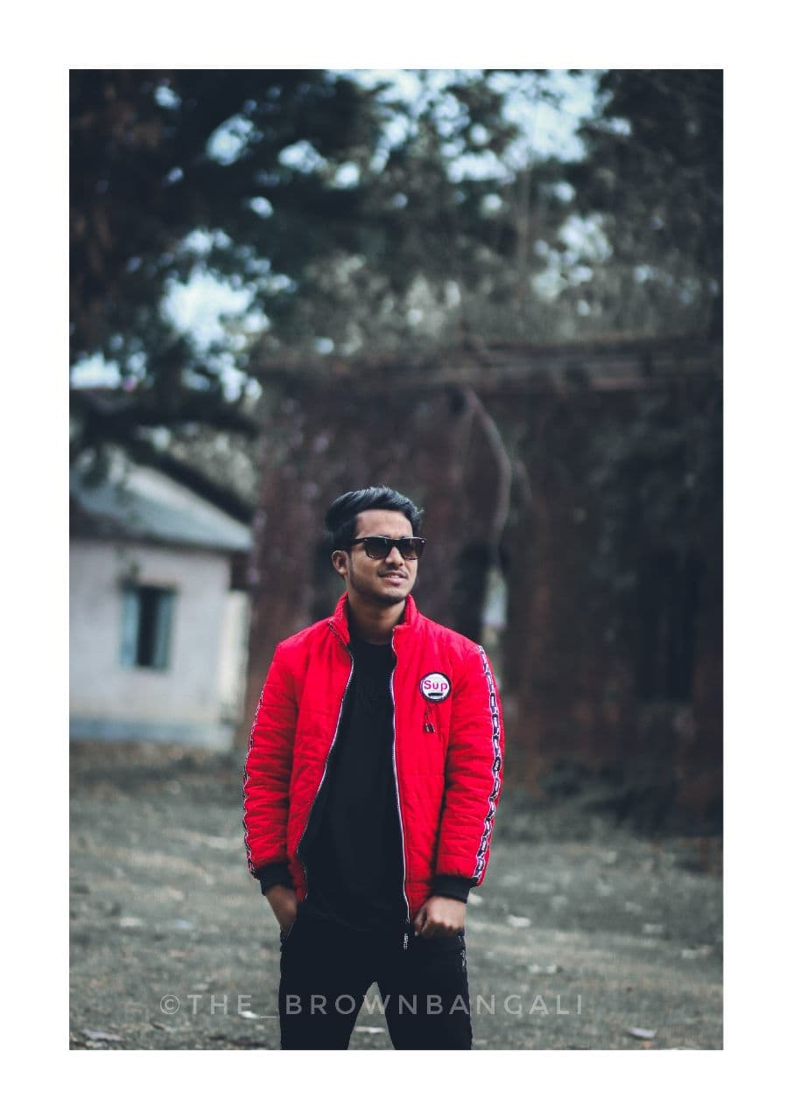

**Phone:**

01311660856

**E-Mail:**

mahadi15-14752@diu.edu.bd

**Adress:**

**Hazipara,Thakurgon**

# Personal Details

**Date of Birth:**

21/11/2001

**Nationality:**

Bangladeshi

**Marital Status:**

Single

# Languages

Bengali

English

MD. MAHADI HASAN SHANU