## A web based application: Karucart BY

**Abdur Rob Aziz ID: 191-15-12969**

## Prince Saha ID: 191-15-12978

**Shahariar Sajol ID: 191-15-12982**

This Report Presented in Partial Fulfillment of the Requirements for the Degree of Bachelor of Science in Computer Science and Engineering

Supervised By

**Zerin Nasrin Tumpa** Senior Lecturer Department of CSE

Daffodil International University Co-Supervised By

# Md Azharul Islam Tazib

Lecturer Department of CSE

Daffodil International University



# DAFFODIL INTERNATIONAL UNIVERSITY

**DHAKA, BANGLADESH DECEMBER 2022**

# APPROVAL

This Project titled “Karucart”, submitted by *Abdur Rob Aziz* *Prince Saha* and

*Shahariar Sajol* to the Department of Computer Science and Engineering, Daffodil International University, has been accepted as satisfactory for the partial fulfillment of the requirements for the degree of B.Sc. in Computer Science and Engineering and approved as to its style and contents. The presentation has been held on * December 2022 *.

**BOARD OF EXAMINERS**

## (Name) Chairman

**Designation**

Department of CSE

Faculty of Science & Information Technology Daffodil International University

## (Name) Internal Examiner

**Designation**

Department of CSE

Faculty of Science & Information Technology Daffodil International University

## (Name) External Examiner

**Designation**

Department of -------

Jahangirnagar University

# DECLARATION

We hereby declare that, this project has been done by us under the supervision of **Zerin Nasrin Tumpa**, Senior lecturer, Department of CSE Daffodil International University. We also declare that neither this project nor any part of this project has been submitted elsewhere for award of any degree or diploma.

## Supervised by:

**Zerin Nasrin Tumpa** Senior Lecturer Department of CSE

Daffodil International University

## Co-Supervised by:

**Md Azharul Islam Tazib**

Lecturer Department of CSE

Daffodil International University

## Submitted by:

**Abdur Rob Aziz**

ID: -191-15-12969

Department of CSE

Daffodil International University

## Prince Saha

ID: -191-15-12978

Department of CSE

Daffodil International University

## Saharaiar Sajol

ID: -191-15-12982

Department of CSE

Daffodil International University

# ACKNOWLEDGEMENT

First we express our heartiest thanks and gratefulness to almighty God for His divine blessing makes us possible to complete the final year project/internship successfully.

We really grateful and wish our profound our indebtedness to **Zerin Nasrin Tumpa**, **Senior Lecturer**, Department of CSE Daffodil International University, Dhaka. Deep Knowledge & keen interest of our supervisor in the field of “*Karucart*” to carry out this project. His endless patience ,scholarly guidance ,continual encouragement , constant and energetic supervision, constructive criticism , valuable advice ,reading many inferior draft and correcting them at all stage have made it possible to complete this project.

We would like to express our heartiest gratitude to Professor **Dr. Touhid Bhuiyan**, professor and head, Department of CSE, for his kind help to finish our project and also to other faculty member and the staff of CSE department of Daffodil International University.

We would like to thank our entire course mate in Daffodil International University, who took part in this discuss while completing the course work.

Finally, we must acknowledge with due respect the constant support and patients of our parents.

# ABSTRACT

Our country is a land of cultural heritage. We are very rich in our culture. Our clothes and folk arts are our cultures. The relation between clothes and folk arts with our country is from the ancient age. We are very creative in crafting. Folk artists are passing their creativity from generation to generation. But it is a matter of sorrow that our traditional folk arts and artists are disappearing day by day due to a lack of demand and exposure. By this, the market of folk products is shrinking as well. “Karucart” a web based application which is mainly an e-Commerce site targeting to revive the folk arts and build a platform for everyone to earn money by using their creative and artistic mind. This project will inspire our folk artists to come forward showcase their products and earn money through their art. We declared that we have built a strong platform which will create an opportunity for the new and small entrepreneurs in the clothing business who are having trouble finding a platform for selling their goods.

|  |  |
| --- | --- |
| **TABLE OF CONTENTS** |  |
| **CONTENTS** | **PAGE** |
| Board of examiners | ii |
| Declaration | iii |
| Acknowledgements | v |
| Abstract | vi |
| **CHAPTER 1: INRODUCTION** | **1-5** |
| 1.1 Introduction | 1 |
| 1.2 Motivation | 2 |
| 1.3 Objectives | 7 |
| 1.4 About Our website | 7 |
| 1.5 Future Scope of the project | 7 |
| **CHAPTER 2: LITERATURE REVIEW** | **8-10** |
| 2.1 Introduction | 8 |
| 2.2 E-commerce site | 8 |
| 2.3 Aarong | 9 |
| 2.4 Karighor | 9 |
| 2.5 UpoharBD | 10 |
| 2.6 a2i | 10 |

CHAPTER 3: BACKGROUND 11-14

* 1. Introduction 11
  2. Related works 11
  3. Comparative studies 14
  4. Challenges 14

CHAPTER 4: BUSINESS PROCESS MODEL 15-18

* 1. Introduction 15
  2. Business process model 15
  3. Data flow model for admin 16
  4. Data flow model for buyer 17
  5. Data flow model for seller/artists 18

CHAPTER 5: REQUIRMENT SPECIFICATION 19-21

* 1. Introduction 19
  2. External Interface Requirements 19
  3. Functional Requirements 20
  4. Non-Functional Requirements 20
  5. Design Requirements 20

CHAPTER 6: UML DIAGRAMS 22-26

* 1. Introduction 22
  2. Use case diagram for buyer 23
  3. Use case diagram for seller 24
  4. Use case diagram for admin 25
  5. Class diagram 26

CHAPTER 7: DESIGN SPECIFICATION 27-40

* 1. Introduction 27
  2. Font-end design 28
  3. Back-end Design 39
  4. Laravel 39
  5. MySQL 39

CHAPTER 8: IMPLEMENTATION AND TESTING 41-44

* 1. Introduction 41
  2. Implementation 41
  3. Incremental model 42
  4. Testing 42

CHAPTER 9: IMPACT ON SOCEITY 45-46

* 1. Introduction 45
  2. Impact on society 45
  3. Impact on Environment 45
  4. Sustainability Plan 46
  5. Ethical Aspects 46

CHAPTER 10: CONCLUSION 47-48

* 1. Conclusion 47
  2. Future plans 47

**APPENDIX 49-50**

**REFERENCES 51-52**

# LIST OF FIGURES

|  |  |
| --- | --- |
| **FIGURES** | **PAGE NO** |
| Figure 1.1: Survey results | 2 |
| Figure 1.2 Survey results | 3 |
| Figure 1.3: Survey results | 4 |
| Figure 1.4: Survey results | 5 |
| Figure 1.5: Survey results | 6 |
| Figure 4.1: Data flow diagram for admin | 16 |
| Figure 4.2: Data flow diagram for buyer | 17 |
| Figure 4.3: Data flow diagram for Sellers/artists | 18 |
| Figure 6.1: Use case diagram for Buyers | 23 |
| Figure 6.2: Use case diagram for Sellers | 24 |
| Figure 6.3: Use case diagram for Admin | 25 |
| Figure 6.4: Class Diagram | 26 |
| Figure 7.1: Login page | 28 |
| Figure 7.2: Registration page | 29 |
| Figure 7.3: Buyer Front-end view | 30 |
| Figure 7.4: Buyer Front-end view | 31 |
| Figure 7.5: Add to cart | 32 |
| Figure 7.6: Payment | 33 |

|  |  |
| --- | --- |
| Figure 7.7: Seller Dashboard | 34 |
| Figure 7.8: Add Product | 35 |
| Figure 7.9: Admin Dashboard | 36 |
| Figure 7.10: Add category | 37 |
| Figure 7.11: Approve Product | 38 |
| Figure8.1: Incremental Model | 42 |
| Figure: Backend CSS and JS | 49 |
| Figure: Front-End CSS and JS | 50 |

**LIST OF TABLES**

|  |  |
| --- | --- |
| **FIGURES** | **PAGE NO** |
| Table 3.1: differences between Karucart and other related works | 13 |
| Table 8.1: Browser Testing Result | 44 |

# CHAPTER 1 INTRODUCTION

## Introduction

“Karucart” is an end-to-end E-commerce based website where people can sell and buy only clothing items and folk arts through online. We want to respawn our folk arts like weaving, clay arts, paper arts, metal arts, wooden arts, jute arts, and paintings through our website. This website will work as a bridge between the buyers who are interested in buying folk products and the folk artists. We are also inspiring small entrepreneurs in the online clothing business sector to reach their goods to consumers through our website.

## Motivation

We have going through a research where many people want to be young entrepreneur by starting a part time clothing business through online. Our purpose behind launching this project is to remove the unemployment problem, inspire small entrepreneurship and raise women empowerment. A report of Bangladesh Association of Software and Information Services BASIS, says around 300,000 people — where almost half of them women — in Bangladesh are running their businesses with the help of Facebook and they earn between €100 and €1,000 per month [1]. Beside another main motivation of this project is to revive the folk arts that being lost day by day. Folk arts is the part and parcel of Bengali culture. This project will raise the artistic and innovative mind of Bengalis about folk arts .There are lots of people who adopt folk arts as their hobby. This project will help them to earn money from their works. It will inspire new and small entrepreneurship which will help to boost up our economics and help people to become self-reliant.

According to a research almost 2.70 millions of people were unemployed in Bangladesh in 2020 [2] and it is increasing day by day. This website can be a hub for the unemployed people who wants to earn money by online clothing business and folk arts. We have gone through a survey where almost 50 people attended. The outputted result is given below.

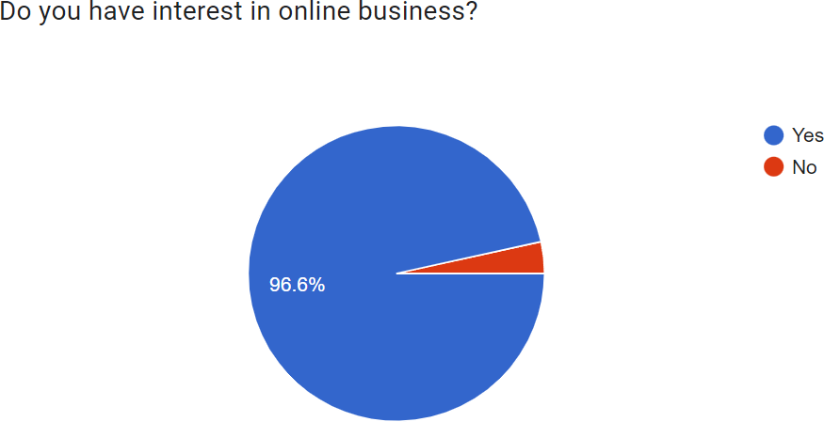

**Figure 1.1:** Survey results

Almost 96% of have shown their interests in online business. It proves that majority of the people want to start a business or already running a business through online.

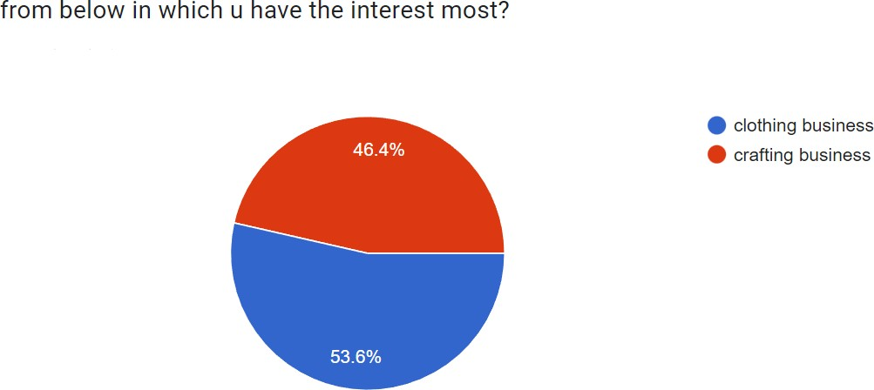

**Figure 1.2** Survey results

In our survey about 47% of people have interests in Crafting business and 53% of people have interest in crafting business. Majority of the people have interests in clothing business.

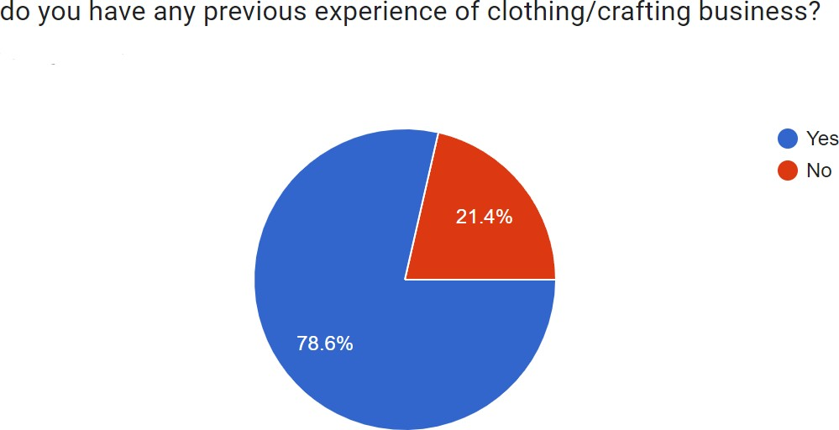

**Figure 1.3:** Survey results

Our survey shows that almost 78 % of people have previous experience of clothing and crafting business where 22 % of people wants to start up or have not interests in clothing and crafting business.

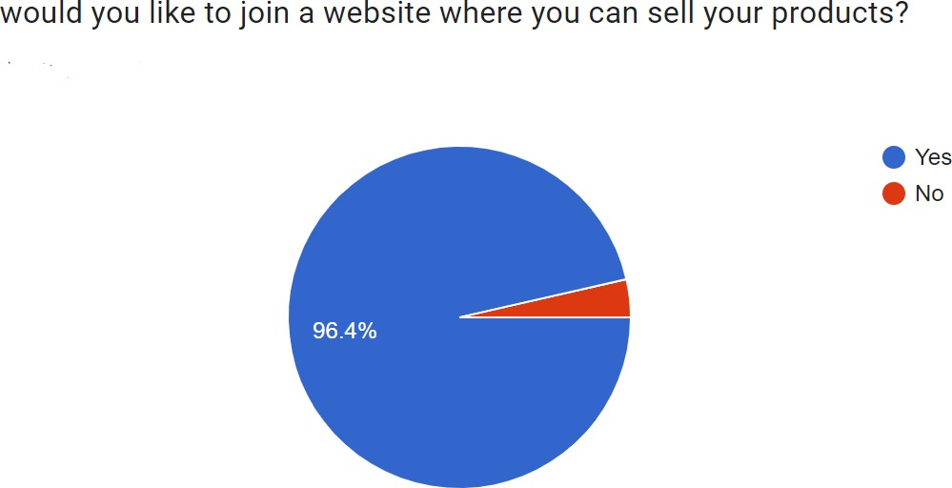

**Figure 1.4:** Survey results

Here 96.4 % of people wants to join in a online portal where they can sell their clothing or crafting product .It proves that the demand of e-commerce based application is huge and has a great market.

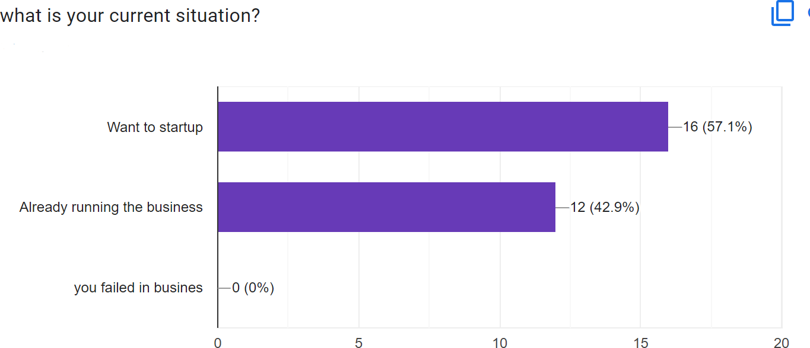

**Figure 1.5:** Survey results

Here it shows us that 57.1 % of people want to start up. 42.9% of people already running clothing or crafting business through online or offline. It is good not see that no one have failed in their business

## Objectives

We are going through a trend of online shopping. Our objective is to develop our website a user friendly website where people of any age can get their desired product at the shortest period of time. We want to make ecommerce platform easier and more efficient for the unemployed people where users can sell and buy products without any complexity and hesitation. Besides To give people an opportunity where they can be self-reliant by earning money. We want to fill up the gap between the artists and the sellers which will help to stop losing our traditional crafting from our culture.

## About our Website

Karucart will provide Business-to-business (B2B) service where people can sell and buy goods. It is a webpage based application. There will be three types of users.

* + 1. Seller
    2. Buyer
    3. Admin

Here the artists and the small entrepreneur can upload their products to sell. Buyers will explore our website and choose their desired product. Admin will manage, approve, Build, test and deploy all the internal affairs of our site to make it more functional.

## Future scope of the project

This project can play a small role to reduce the unemployment problem from our society. Artists will be more inspired and dedicated towards their Arts. It will help to build the society more creative, more artistic, and more fashionable. It will be a modern technology that will fulfill our traditional demands. A start up that will inspire hundreds of more startups. Additionally, Karucart will make us feel more connected to our culture and tradition.

# CHAPTER 2 LETARATURE REVIEW

## Introduction

Literature review refers documentation form the previous survey, report and research on the related field. By this we can get to know about the similarities and differences between our work and the previous work. Literature review is part and parcel of a project report. It gives us opportunity to improve our project by implementing different kind of functionalities and features that have not use anywhere before and build a unique project and get benefited as much as possible .In this part of our Report we have displayed some of the work related to our project and discuss about the pros and cons of our report comparing with other reports.

## E-commerce site

E-commerce is mainly an online based market through online transactions like card payment, Mobile banking, .Net banking etc. The relation between Bangladesh and the Ecommerce site is not that much old. Bangladesh has introduced to ecommerce mainly in 2009 when Bangladesh bank the central bank of Bangladesh approved online transactions. In 2011 the first fully fledged ecommerce site was launched in Bangladesh name akhoni.com .Later in 2013 Bangladesh Bank the central bank of Bangladesh gave the permission for purchasing and selling of products and service [3]. According to research there are almost 2500 E-commerce based websites are available in Bangladesh [4] .Almost 2 million people do online shopping in Bangladesh [5]. The ecommerce business mainly boosted by the covid pandemic situation in 2020 where most of the people were forced to do online shopping. Now Ecommerce site is very popular in our country. Almost in every house in our society are using ecommerce sites in their daily life. It has made our life

comfortable. Now we don’t have to go to market by ourselves to buy our desired product

.Now we just need a device, internet connection and a website that can provide our desired service. We just need to choose the product and pay through mobile banking, card or net banking and the next day the product will be at our door. By this we can save much of our valuable time and stay away from the touch of pandemic.

## Aarong

Aarong is a well-known clothes and crafting brand in Bangladesh which also provide their services via online and offline [6].They mainly helps the women from rural area of our country to become economically established and empowered through their creative and artistic works. They have many artist all over the country who works for them.

They are popular and praised for their product’s quality and already established in the market. Aarong works to improve the life style of our people both folk artist and consumers which will also the motive of Karucart. Though there are similarities our project is different from Aarong in some sectors. In Aarong all products are showcase by their company’s brand name. But In our website the artists can make their own brand. They will not work for us or our website.There are no dependencies. There are full freedom for artist to display their creation .Besides we are working to inspire artist to get established not inspiring to work under an already established brand. So in this section Karucart is providing extra features over Aarong

## Karighor

Karighor is an E-commerce based website whose main target is to provide traditional crafting products through their website with the help of NGO and LSP [7]. Mainly the rural, marginalized people who have creativity to craft different kind of products will be able to showcase their works and financially benefited. Though the concept is closer to our project but there are some difference. There is no prototype of this portal available in the

online. It is not practically completed project.We have not found any website named karighor in the internet that provides the promised services. Besides, they are not targeting the small entrepreneurs in clothing business which is available in karucart. The process of using this website is very lengthy as they are registering with NGO’s via Local Service Providers (LSP). So karucart is less time consuming and easier to use.

## UpoharBD

UpoharBD is an online platform that provides the service of selling gift product. Before that they used to be an offline gift shop in Dhaka. It is a very popular website in Bangladesh that provide their services all over the country and outside the country [8]. People can pay for their product through card or mobile banking. They also sell Crafting product in their website. But it is not an open user website. They mainly sell their product and some selected brand’s product in their website. People of all stages will not get the access to use their website as a platform to sell their goods. But we are only targeting clothing and crafting products. Karucart users can be financially benefited by our extra given features.

## a2i

A2i is an initiative by the government of Bangladesh to improve the life style of the people of Bangladesh and completed the vision of 2041. This will help the people of Bangladesh to get empowered and inspire them to come with the unique and strong ideas. It is mainly a portal created by government which will give a platform for different kind of Ecommerce sites in Bangladesh targeting the rural people of our country [9]. This website is being created thinking the rural people as a buyer but we are building our website targeting the rural people as the sellers so that they can earn some money. Many Big companies are involved in this project where we are targeting the rural people. By this our project is different.

# CHAPTER 3 BACKGROUND

## Introduction

Before building a project we have to think about lots of things like possible outcomes, market studies, challenges that we will need to face in the whole process. This kind of studies help us to make a strong project or else you will have to face sufferings. To work smoothly we will concentrate in some studies that will be beneficial for our project building.

## Related works

Though our website is Unique there are lots of individual works that is similar to our website. Some of them are being mentioned below:

## Facebook market place

Market place is a feature provided by facebook where anyone can buy and sell things . This product can be new or used. Market place is very popular among the people all over the world [10]

## FashionTIY

FashionTIY is a global online wholesale market. They provide their service of online wholesale market. FashionTIY is not that much popular in our country but it provides a good service in wholesale business[11]

## Priyoshop

PriyoShop is another well-known ecommerce site in Bangladesh. It is a customer centric website that opens small business holders to reach their authentic products to the consumers. They are trying to gather the small entrepreneurs under their network [12].

## DARAZ

Daraz is the most popular name among the ecommerce sites in Bangladesh. Its mainly a south asia based e-commerce site. Daraz providing their service in Bangladesh, Srilanka and Pakistan. People can buy and sell things here easily [13].

|  |  |
| --- | --- |
| **Other websites** | **Karucart** |
| **Facebook Marketplace**: Facebook has become a platform for online business .But there are some problems too. Not everyone in Facebook uses Facebook for online shopping. Besides sellers need to pay a large amount of money to boost up their products to reach people which is a complex process. There are also lots of reports of cheating buy the sellers of Facebook marketplace. According to a report one out of six customer get cheated  in Facebook marketplace [14]. | **karucart**: karucart can solve this problems. Shopping hub is specially designed for Clothing and folk items where consumers will come only for shopping. The sellers don’t need to pay any kind of money to boost up their products. Here we will boost up our website through different ways so that sellers don’t need to boost up. All the sellers will be verified and analyzed by the admin panel and they will be in the monitoring so that customers don’t need  not face any kind of Cheat and harassment. |
| **FashionTIY**: FashionTIY is a global marketplace. Its an online wholesale market. So u cannot buy little amount of  product here. It can be useful for the sellers | **Karucart:** karucart gives you the opportunity to sale and wholesale your products according to the consumers  demand. Here consumer can buy products |

|  |  |
| --- | --- |
| who wants to store products in cheap cost but not for the consumers who just want to buy a single product. But you need to pay  a huge amount of shipping cost. | at little amount or in huge amount. There is also no shipping cost .so it’s more beneficial than fashionTIY. |
| **PriyoShop:** Priyoshop is very popular online shopping site in Bangladesh. But they only highlights the already wellestablished brands, manufacturers and shops. They don’t sell the folk products either. They are not targeting any individual products, they sell everything like electronics, groceries, books, home  and livings, car and bikes etc. | **Karucart:** Karucart is mainly targeting to help the sellers who are not well established, new and small entrepreneurs, unemployed man and women and who doesn’t have any war house or shops. Besides it will inspire the folk artist across the country to come forward and contribute to revive the folk culture and earn some  money. |
| **DARAZ**: Daraz is the most popular online shopping sites in Bangladesh. But if you want to sell products in daraz you have to face a complex step. You will need a shop, Trade licenses, bank cheque. If you don’t have any of this you cant sell product in Daraz. There are also some fraud reports about Daraz as a result many customers  lose their trust on this ecommerce giant. | **Karucart:** Karucart provides the easiest way of shopping for both buyers and sellers. Here you just need to open an account and internet connection. There is no need of bank cheque, Trading license or shops which makes it easier for its users |

**Table 3.1:** differences between Karucart and other related works

## comparative studies

Our project has some limitations. This is mainly a webpage based project. We have not build any dedicated android application of our project. People have to use karucart through a browser. Vendors will not able to use our website if his/her age is below 18 as the NID card is mandatory for the vendors. The artist have to go themselves or find a third party to deliver their products to the consumers. We are not providing any features to deliver the product.

## Challenges

Our project is unique than any other E-commerce based websites in Bangladesh. So we have to face many different and new challenges to complete our project. We r have to always go through competition and obstacle, have to think out of the box. We must have a vast knowledge and skills in web development sector. We have to stay in touch all the technology that are being introduced to the world every day .We have always tried our best to develop our website more functional and user friendly.

We have to also provide security for our website to protect from any kind of unauthorized access and cyber-attacks and make our website fraud free.

# CHAPTER 4 BUSINESS PROCESS MODEL

## Introduction

Business process model (BPM) is o model of multiple processes related to the business and explains about the operations and functionalities of an objective that is necessary to run a business accurately [15]. Business process is necessary for a company to make the current process more efficient, analyzed and automated.

## Business process model of Karucart

Here is a summary of the Business processes of Karucart:

* + 1. There will be three types of users.
       1. Admin
       2. Artist
       3. Buyers
    2. Buyers can buy products of different artists according to their needs and choice.
    3. Buyers will make payment through mobile banking like Bkash , Nogod, Rocket.
    4. Crafters will upload their product on our website and set their expected price.
    5. Artists will take necessary steps to make their war house more attractive.
    6. Artists will deliver the product, consumer will pay the delivery charge.
    7. Admin will make money through advertisements.

## Data flow diagram for admin

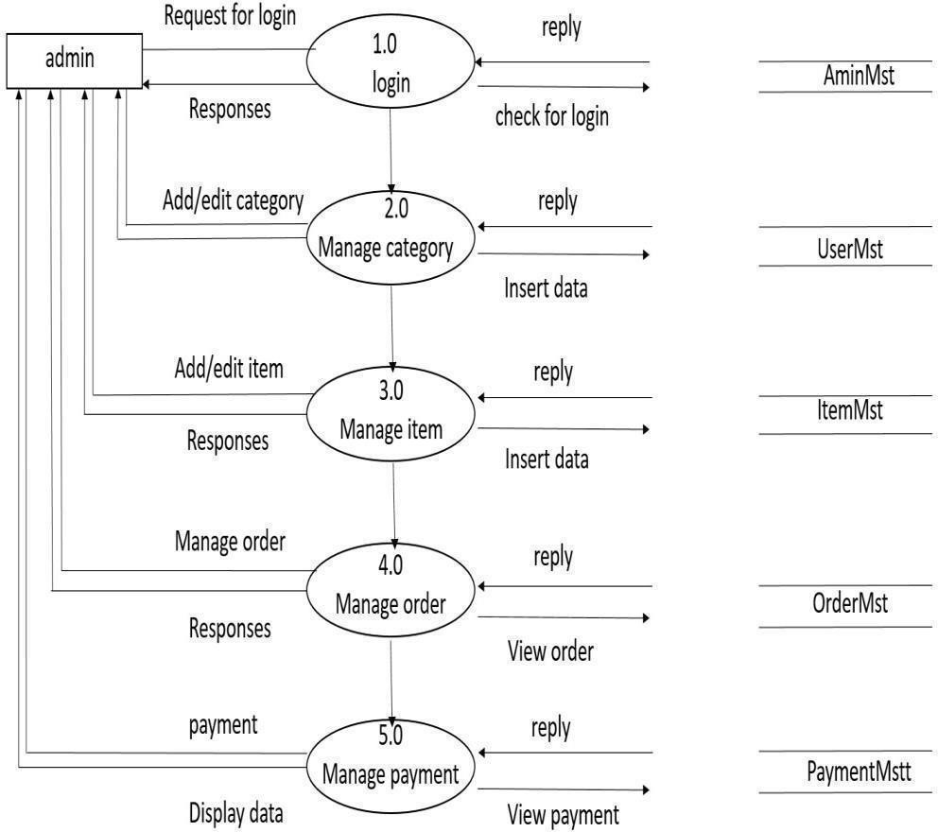

**Figure 4.1:** Data flow diagram for admin

## Data flow diagram for buyer

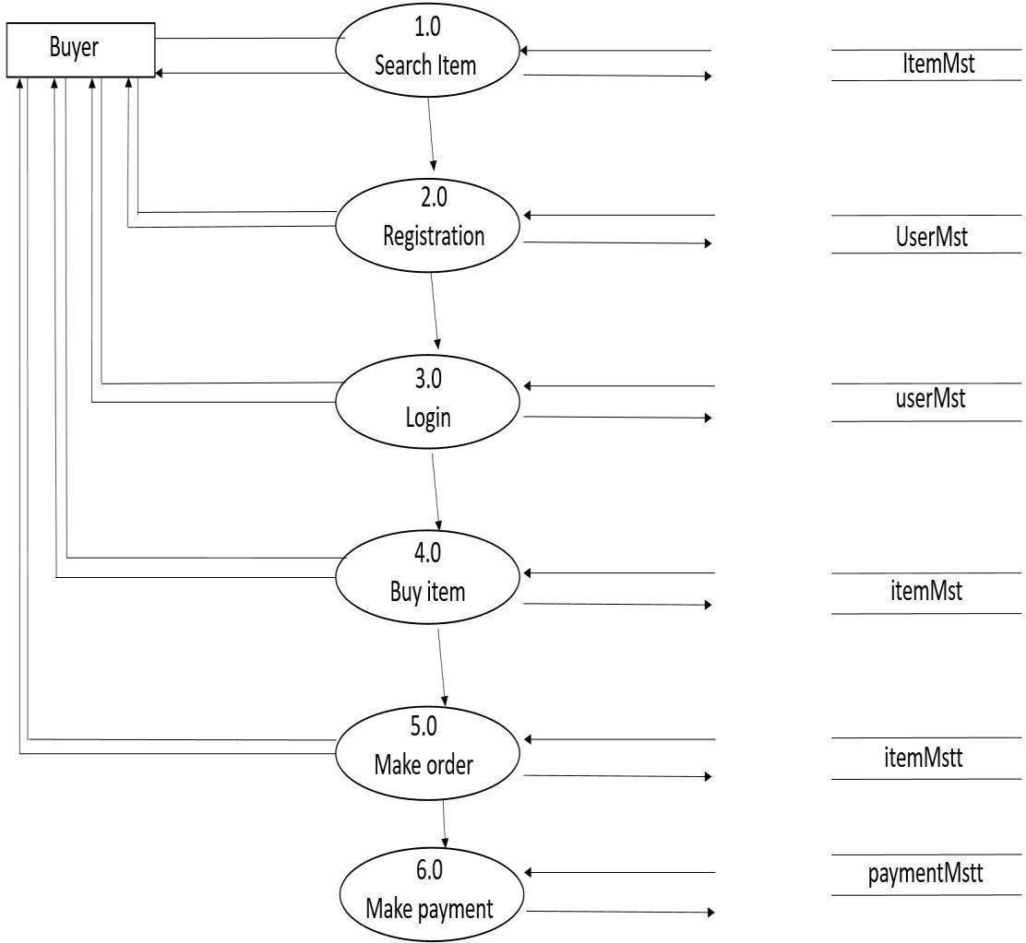

**Figure 4.2**: Data flow diagram for buyer

## 4.4 Data flow diagram for Sellers/artists

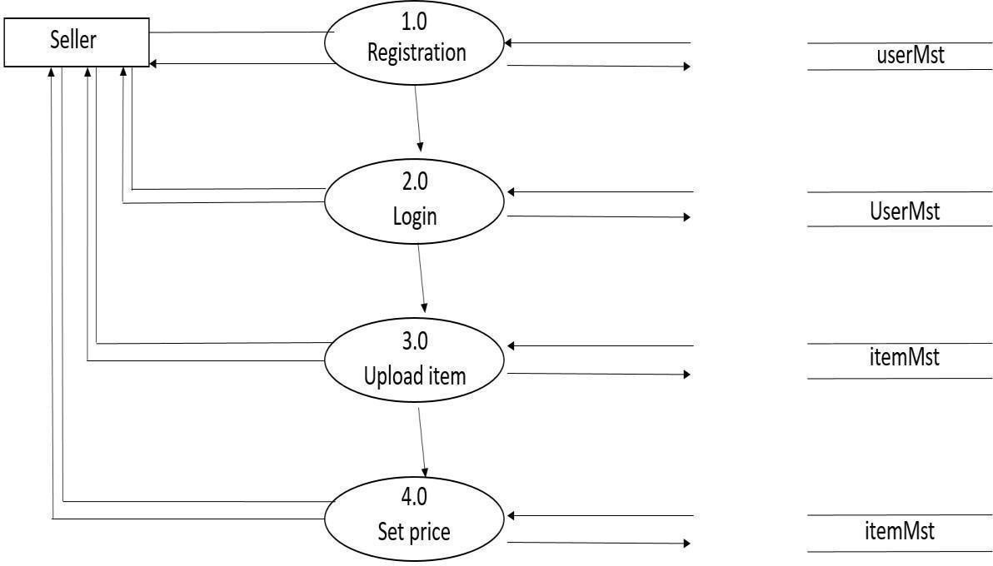

**Figure 4.3:** Data flow diagram for Sellers/artists

# CHAPTER 5 REQUIRMENT SPECIFICATION

## Introduction

Require specification is the sets of collection that is need to be imposed on a design and to verify the model [16]. It refers all the tools and steps that is required to make the design more functional, user friendly and accurate. In this part we have discussed about all the tools that is required for our project.

## External Interface Requirements

**5.2.2 Operating Environment**

The product will be operating in a windows environment. Shopping hub system is a website and shall operate in all famous browsers, for a model we are talking about Microsoft Internet Explorer, Microsoft Edge, Google Chrome, and Mozilla FireFox. Also it will be compatible with IE 6.0. Most of the features will be compatible with the Mozilla Firefox and Opera 7.0 or higher version. The only requirements to use this online product would be the internet connection.

## Hardware Interfaces Hardware Requirement:

* Quad core, 2.5 GHz Intel® Xeon Processor
* 8 MB cache
* 8 GB RAM
* 1000 GB (RAID 1) - file system for server
* 15 inch color monitor

## Software interface

Tools: Microsoft Visual studio code, Apache Version: Apache/2.4.4, XAMP contrller Font End: HTML, CSS, Javascript, bootstrap, jquery, Ajax

Back End: PHP Laravel , MySQL Operating system: Microsoft Windows

## Functional Requirement

Functional requirement’s refers to the technological feature of the system that must be implemented by the developers for makes it user friendly [17] .In our project only admin can access the functional requirements like maintaining the server, handling the database of the website.

## Non-Functional Requirements

Non-functional requirements specifies the operation of the software in a different conditions like security, bugs and errors, flexibility, shorter response time etc. . It measures how fast and accurately our website is working .Besides the server and frameworks we have used in our project. We are concerned about the Non-functional requirements in developing our project.

## Design Requirements

* + 1. To use our website user have to login first to get authentication. So we have designed a registration and log in section in our Website.
    2. User can visit their as well as others profile so we have designed profile information section.
    3. Buyers can search products they want so have designed search menu.
    4. We have designed a slider so that buyer can be notified about the exclusive products and the sales.
    5. For the interaction between buyers and sellers we have designed a message option.
    6. As it is an Ecommerce site cart is mandatory. So there is a cart and wish list menu available in our website.
    7. We have also designed where the buyers can see recently arrived and popular products We also designed a section to make payment to the artists or vendors
  1. **Introduction**

# CHAPTER 6 UML DIAGRAMS

UML Diagram which is the short form of Unified modeling language that is used to present different kind of model and design of a software system. In this section we have represented some of the diagram that is necessary to implement our project. Like

* + 1. Use case Diagram
    2. Class Diagram

## Use case diagram for Buyers

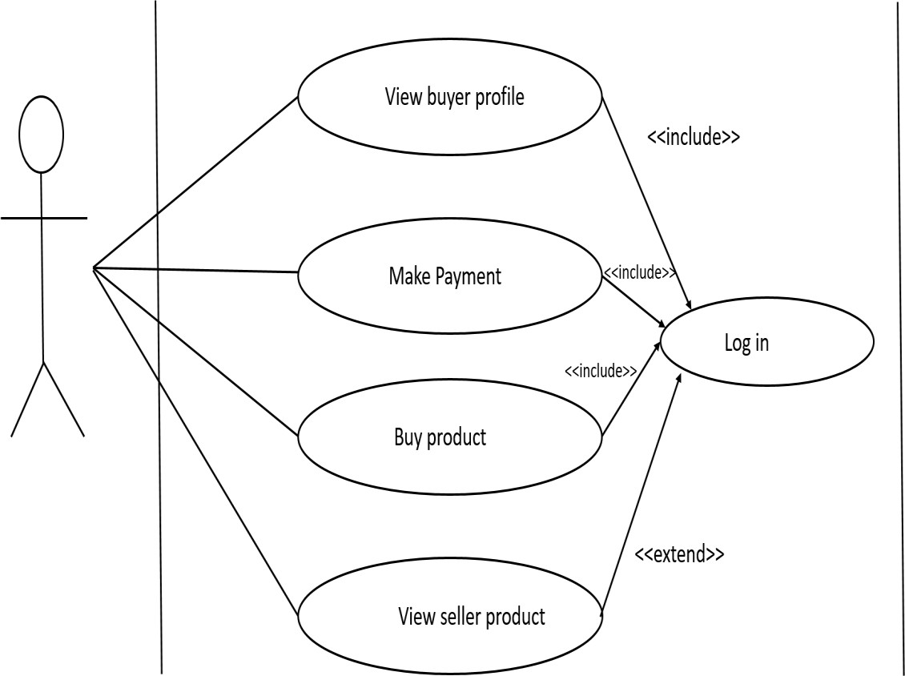

**Figure 6.1:** Use case diagram for Buyers

## Use case diagram for Seller

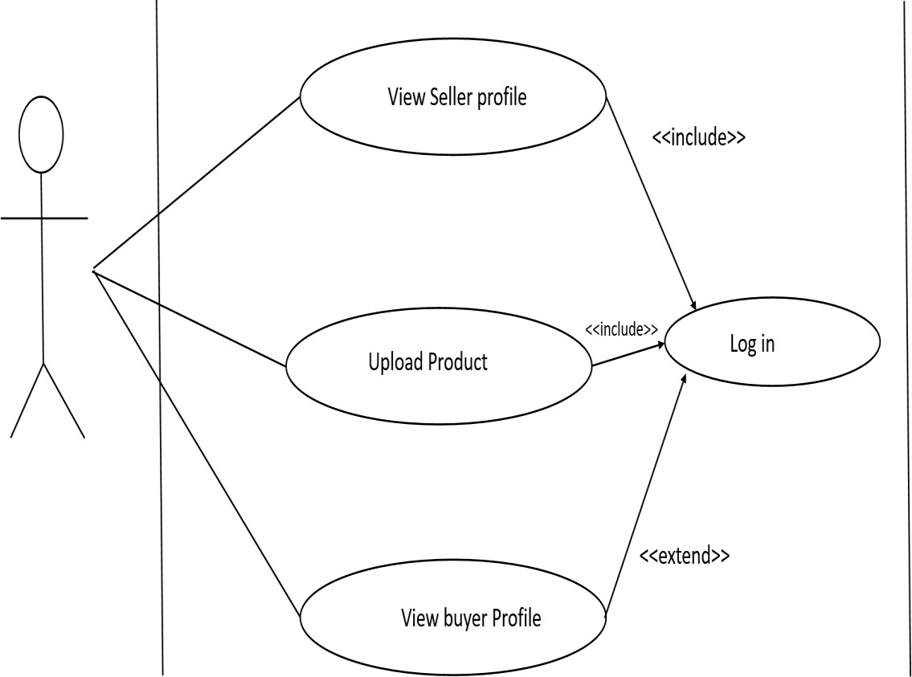

**Figure 6.2:** Use case diagram for Sellers

## Use case Diagram for admin

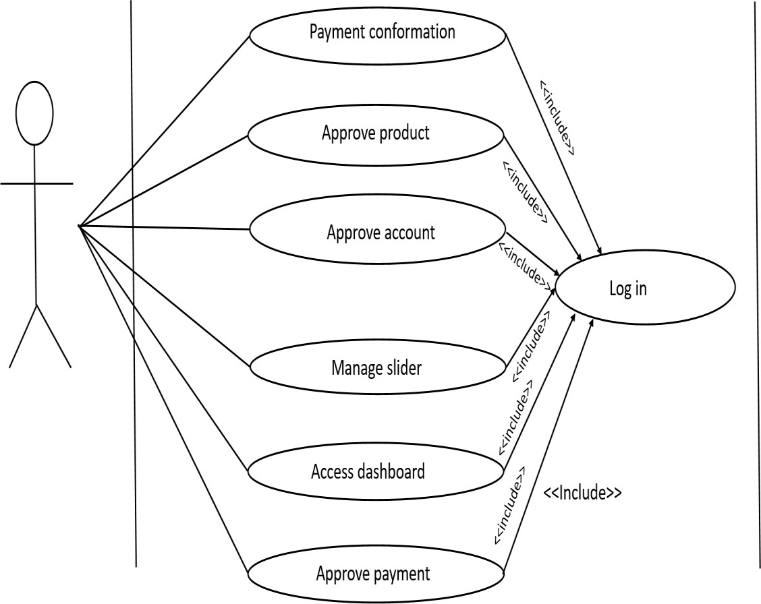

**Figure 6.3:** Use case diagram for Admin

## Class Diagram

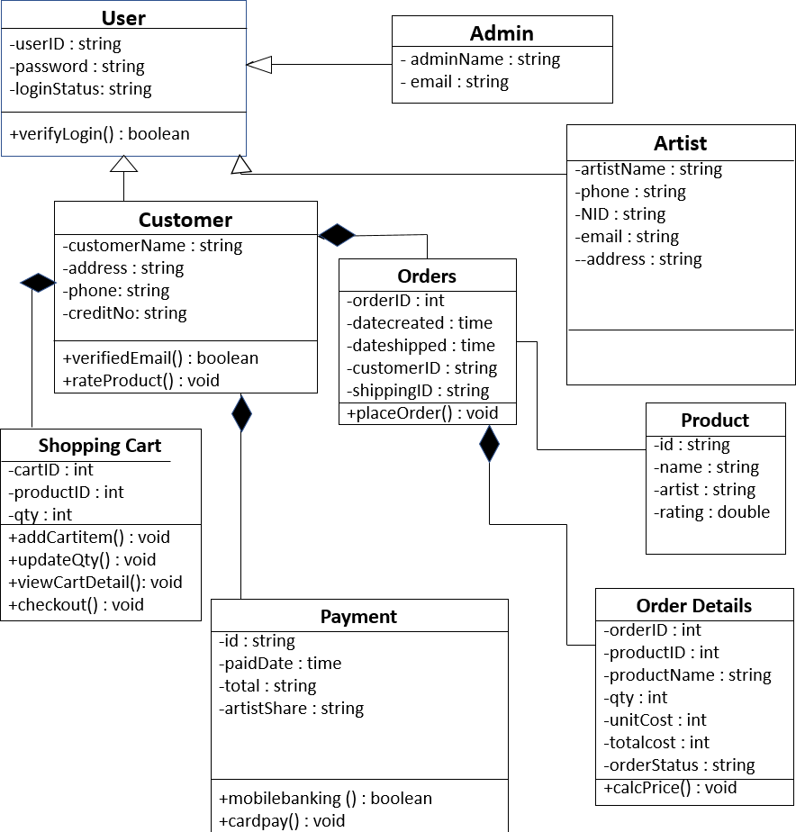

**Figure 6.4:** Class Diagram

# CHAPTER 7 DESIGN SPECIFICATION

## Introduction

Design specification refers to the documented representation where we elaborately discuss about the design of a project. It is necessary for a project .Here we have discussed about the frontend design and the back-end design of our project step by step.

## Font-end design

Font-end design prefers the user interface means how a user will view the website when he/she use it [18]. Font-end design must be attractive. It is designed thinking the content of the website and the targeted viewers taste. The website is designed by using some style sheet language and their frameworks. Some of the languages are

* HTML or Hyper Text Markup Language
* CSS or Cascading Style Sheets.
* Java script

We have also use frameworks like

* Bootstrap (A framework of CSS)
* JQuery (A framework of JS)
* Ajax (A cross browser framework)

We have used these stylesheet language and framework to develop a simple and user friendly design for our website. We have attached the screenshots of some of the key functionalities of our website here.

## Login page

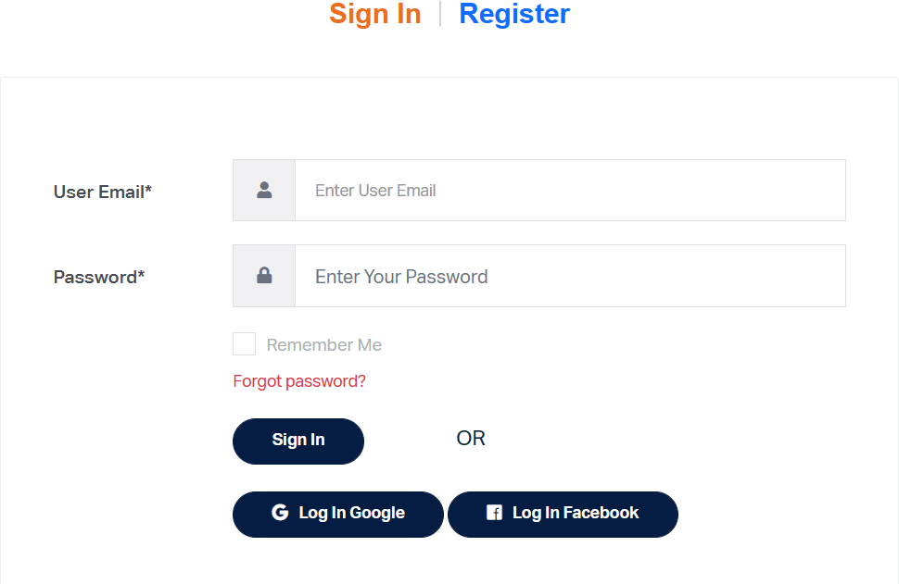

**Figure 7.1:** Login page

## Registration Page

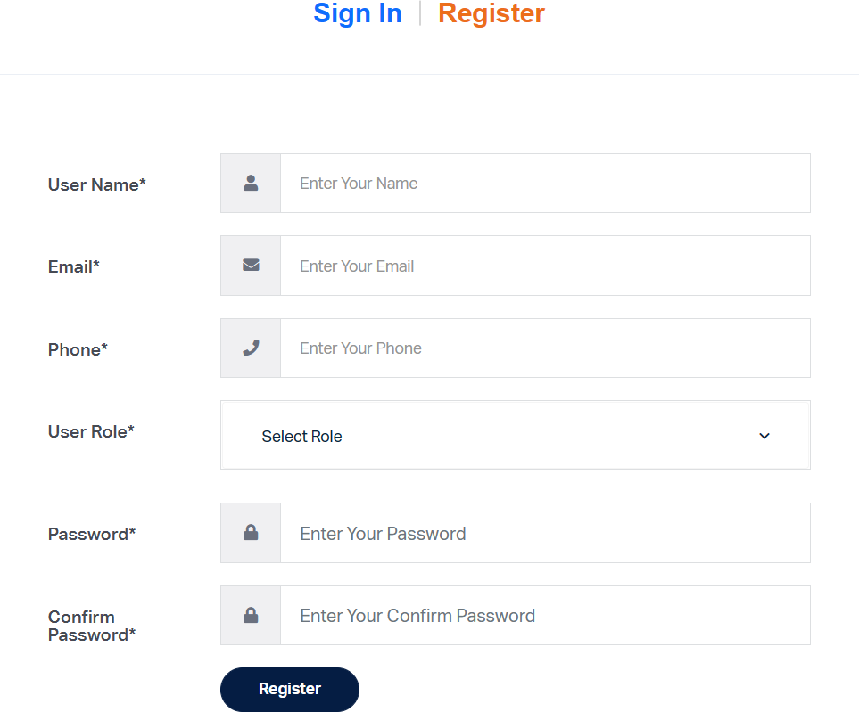

**Figure 7.2:** Registration page

## Buyer Front-end view

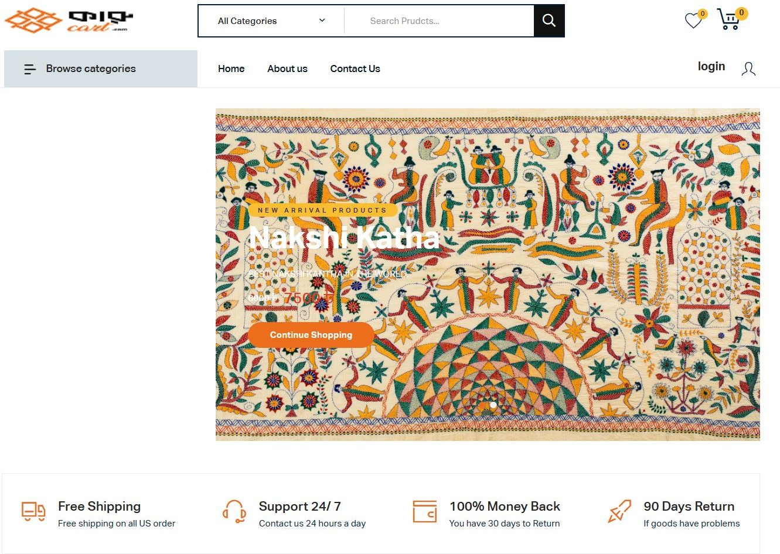

**Figure 7.3:** Buyer Front-end view

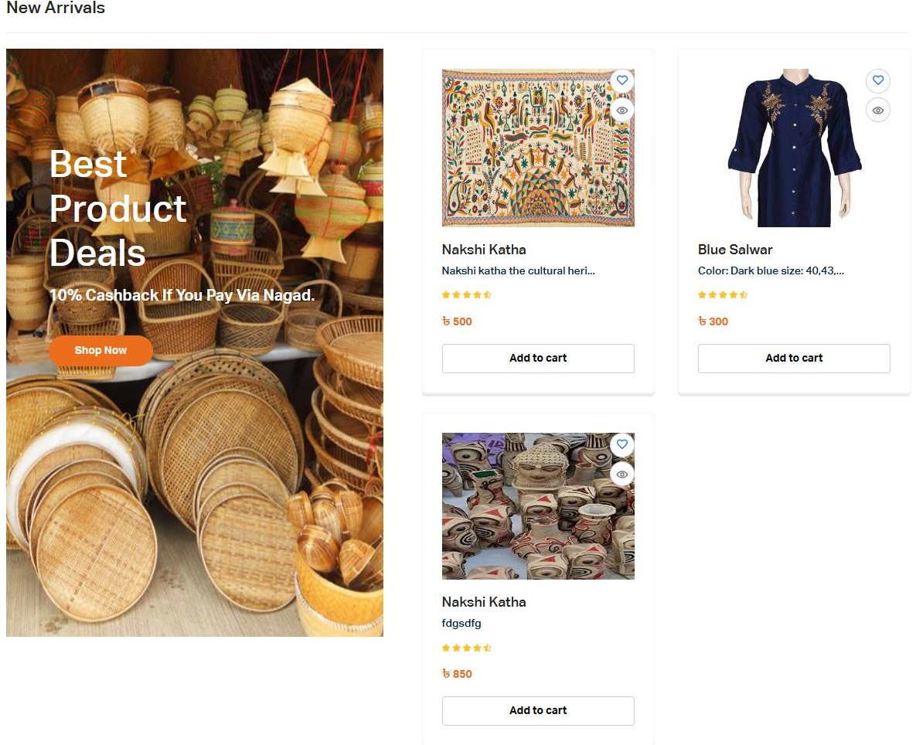

**Figure 7.4:** Buyer Front-end view

## Add to cart

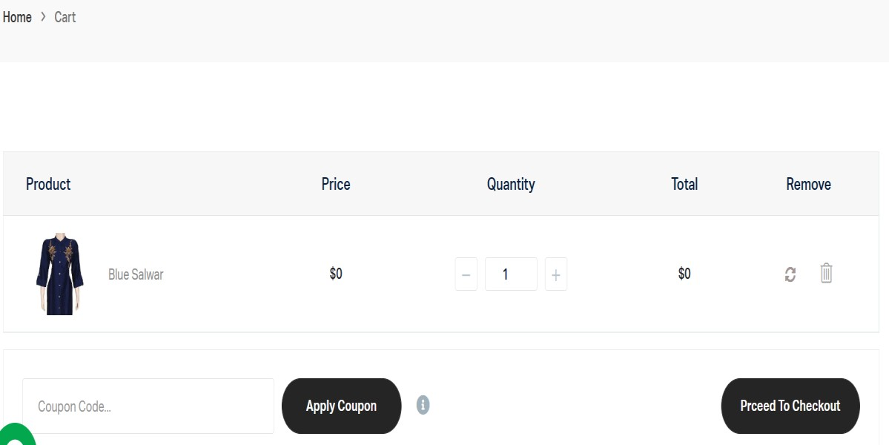

**Figure 7.5:** Add to cart

## Payment

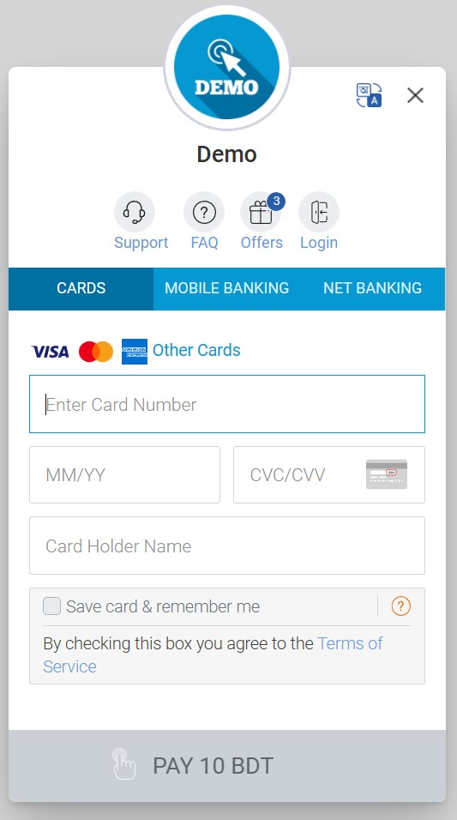

**Figure 7.6:** Payment

## Seller Dashboard

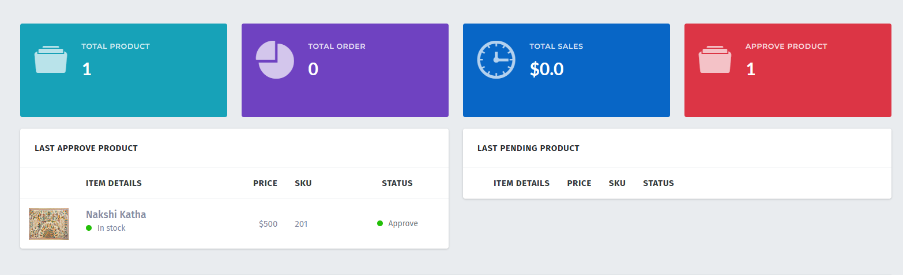

**Figure 7.7:** Seller Dashboard

## Add product

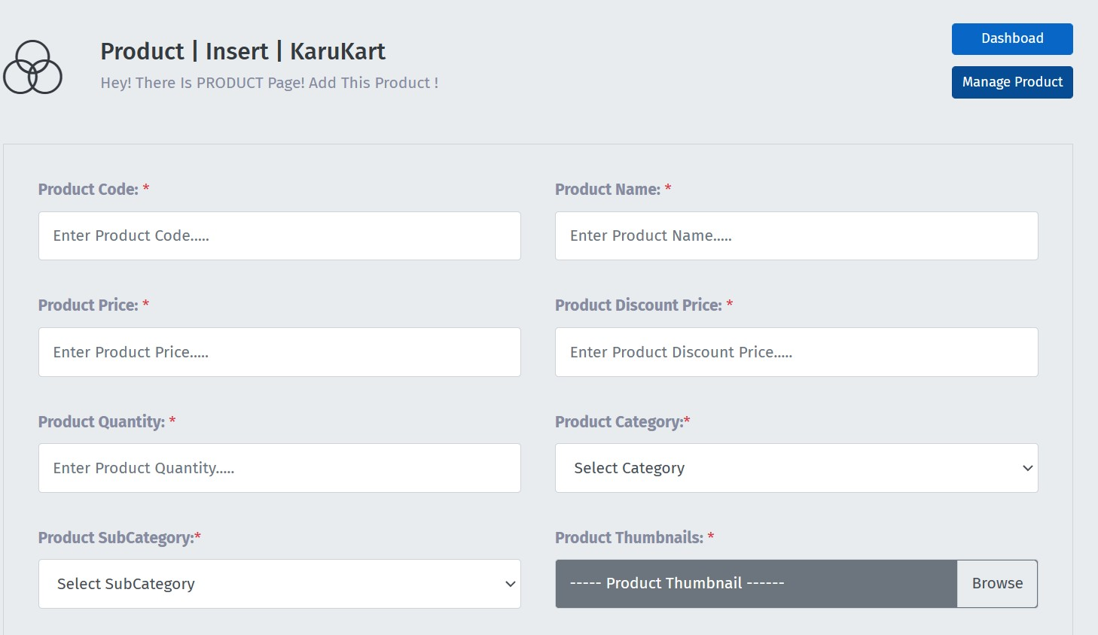

**Figure 7.8:** Add Product

## Admin Dashboard

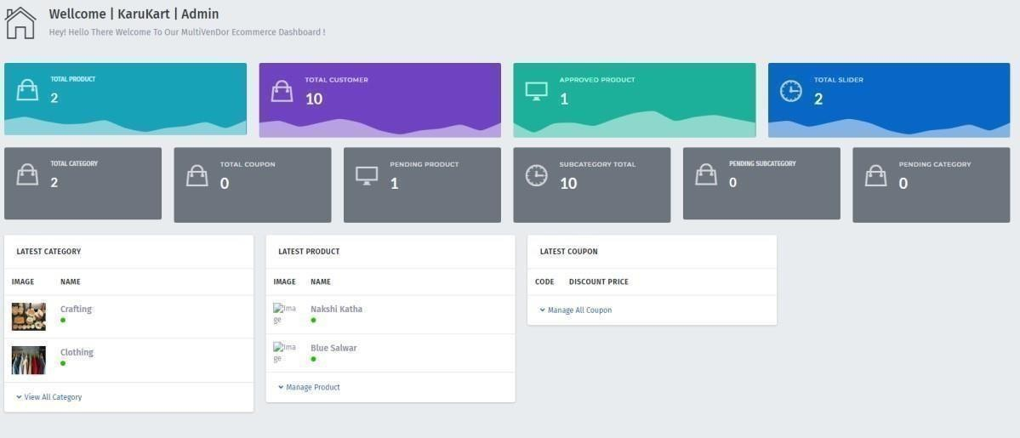

**Figure 7.9:** Admin Dashboard

## Add category

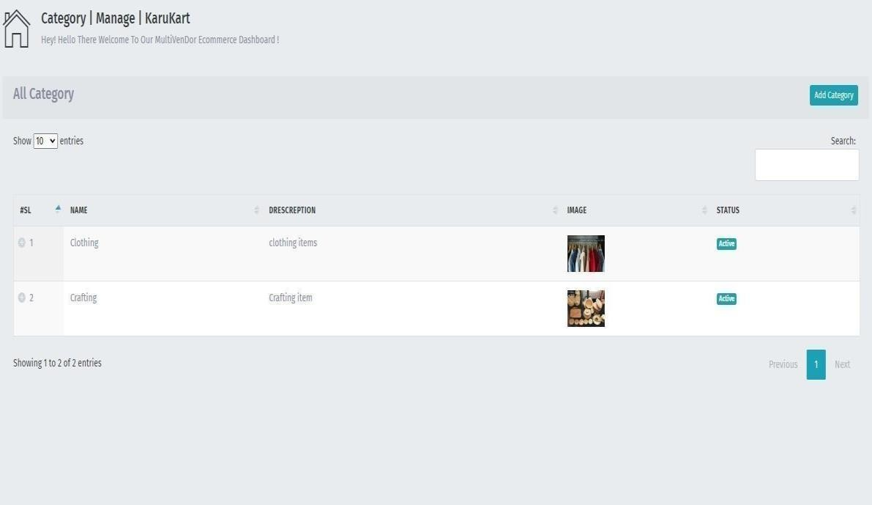

**Figure 7.10:** Add category

## Approve Products

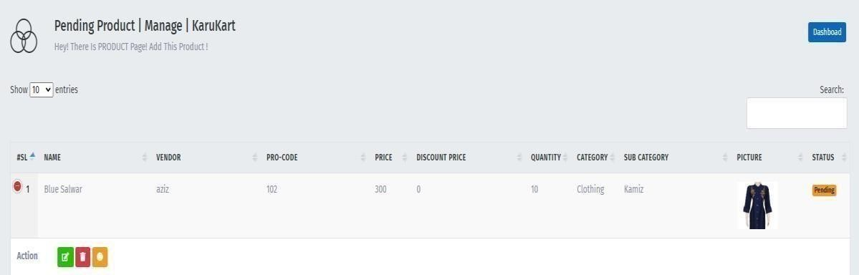

**Figure 7.11:** Approve Product

## Back-end Design

Back-end is mainly the process about how a website is developed. It contains bunch of codes that approve a website as functional and responsive .User can not have the access of backend. Only developers have the access. Developer maintain the whole website through the back end. For the backend, we choose the Laravel PHP framework because of its robust features and simplicity of usage. Furthermore, we chose laravel for the backend because its vast collection of packages makes it simple to finish all of the work. We also use MySQL for the database because it works well with Laravel.

## Laravel

Laravel is the most popular and powerful PHP framework that is being used all over the world. It is mainly a open source PHP framework that provides expressive syntax [19]. The reason that is one of the most popular framework because it has many built in functionality that removes the pain of thousands of developers. It makes possible hundreds lines of code compressed into few lines. This feature makes it fast and user friendly. It works by following Model View Controller (MVC) configuration design. The fundamental features of PHP frameworks like CodeIgniter, Yii, and other programming languages like Ruby on Rails are incorporated into Laravel's extensive functionalities. To use laravel developer must need a good skill and a strong knowledge about the core PHP.

## MySQL

MySQL is one of the most popular database management system .It is open source system by this anyone can use MySQL for free. It provides multi user access to support many storage engines and not only this but it also provides the several of features like good connectivity so that anyone can connect with various databases and clients .It is cheap cost and flexible [20]. It provides various tools such as mysql work bench which is mainly a dashboard that enables you to prepare models, monitor and configure data and perform

data migration etc .To develop an E-commerce site we have to manage different sets of data. With MySQL we can organized data perfectly. Besides with the collaboration of laravel it works even better.

# CHAPTER 8 IMPLEMENTATION AND TESTING

## Introduction

Implementation and Testing are the major part in launching a project. Implementation is related to hardware and software system also included some specific software specification [21].It helps an organization to take new procedure or updatation in the software by taking strategic approach.

## implementation in Karucart

In our website the implementation section will include:

* Server testing and setup including all the cost and expenses.
* Improving the skills and knowledge of the developers through trainings.
* In order to easy browsing we will have to by domain and hosting for our website.
* We have to buy a SSl for the safe transaction.

## Incremental model

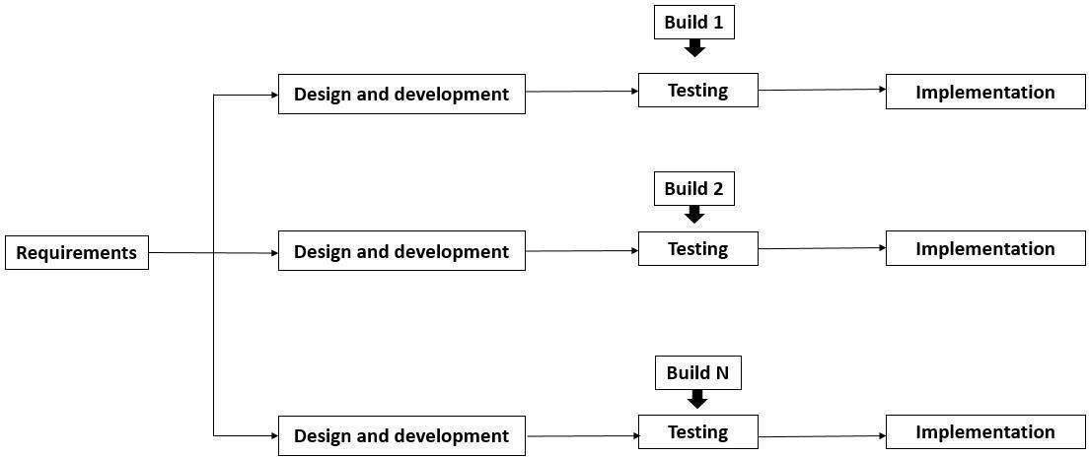

**Figure8.1:** Incremental Model

## Testing

Testing is a procedure to verify is the outputted result is similar to our expectation result or not [22]. It shows how accurately a software is working and what are the lacking in the software. Testing helps software to give an accurate outcomes and shows a path where to improve. We have to gone through different kind of testing for our project.

* Functional testing.
* Regression testing.
* Integration testing.
* Load testing.
* Cross-browser compatibility testing.

## Functional Testing

Functional Testing including all types of verification and validation of our system. Users have to registration first before using our service .So all registration will be checked to avoid fraud issue and build our website user friendly. For the user 10 digit NID number is mandatory to use our website.

## Regression Testing

Regression testing ensured that all the system workflow is fines and responsive. The web page and its functionalities and specifications perform their tasks perfectly. It also ensured No bugs and error found during the test.

## Integration Testing

Integration testing is very important for this kind of website. There are multiple functionalities in our website .We have done thousands lines of code to execute these functionalities. Integration testing ensures that those codes of the functionalities do not conflict with each other and works smoothly.

## Load Testing

Load testing refers to traffic management of a website. It ensure when multiple users use our website it does not slow down the server. This test is needed to perform a website fast.

## Cross-browser Compatibility Testing

This testing is done to ensure that our website is running, functional and responsive in several web browser. We have test this in different popular web browser like Chrome,

Microsoft Edge, UC Brower, opera etc. and it works perfectly and similar in all of the browser.

|  |  |  |  |  |
| --- | --- | --- | --- | --- |
| **Test case** | **Browsers** | **Expected**  **output** | **Actual Output** | **Result** |
| Cross browser compatibility testing | Tested on 1.Chrome 2.Edge 3.mozilla Firefox  4.opera mini | Successful and similar in all the browser | Successful and similar | Passed |
| Compile | Compile Successfully  the codes | Show the actual result | Actual Output | Passed |

**Table 8.1:** Browser Testing Result

# CHAPTER 9 IMPACT ON SOCIETY

## Introduction

In this part of our report we discussed about the impact and effects of our project in the society. Besides we have discussed about the impact on environment, sustainability plan and ethical aspects which is very important to reach the mass consumers and become a trustworthy site which proves our determinations for our users. For any kind of work an impact can be advantageous or negative. We are determined to do a positive impact in our society as much as possible through our work

## Impact on Society

Karucat can be a platform to change the socio-economic scene of the rural side of our country. Most of the women in rural area are still neglected and not financially independent. Karucart can be a hub for them to become financially independent and increase women empowerment. This project has enough potential to contribute in reducing unemployment from our society. People are able to showcase their creativity and skills in crafting. Besides new entrepreneur in clothing and crafting business will be inspired if they find out that there is an easy medium to sell their products. Safe and easy marketplace will be created which will save lots of valuable time.

## Impact on environment

Every work has both negative sides and positive sides. Nothing is perfect, no work is perfect. Neither our project is out of this rule. There are few negative impacts that our project can occur in the environment. There are lots of crafting products like clay craft, metal craft is built by burning its materials which causes carbon emissions in our environment. This can causes several health issues. Besides Emissions of carbon is responsible for global warming which becomes a headache of our modern world. To build wooden craft wood is necessary and we get wood from the tress. So making wooden

products can play a small role in deforestation. The products will be delivered in plastic products and plastic is harmful for environment as it takes many decades to become decompose from our environment. We inspire our consumers to reduce the plastic bags in delivering product and use the alternative bags which are eco-friendly.

## Sustainability plan

The market of ecommerce site is enlarging day by day. So it will be a challenge for us to keep our sustainability in the market. But if we have a clear strategy we can make it easy. First we need to be trustworthy for our consumers and make it a fraud free website. There are lots of functionalities in our website which is able to do that like NID verification for the vendors. Karucart is a place where a seller can make the highest profit as there is no third party who can have a share of his profit and we will make sure that the consumer will get price at a fair price and the most quality products. We will follow the 4 p’s in marketing which are product, pricing, promotion and place. We will promote our website in social media and other sites so that we can hit the mass market and popularity. The functionalities of our website is user friendly which can help us to sustain in local ecommerce market.

## Ethical Aspects

To make this a successful project we as well as our users must be trustworthy. We are always prepared to detect any kind of unexpected situation in our website and determine to make this website safe and fraud free. We are also determined to hide the personal information of our user which are stored in our database. Our users also must follow the code of ethics so that no one get harmed by their activities. We will make sure that no transaction will be delivered without being payed and established a healthy business opportunity for all.

# CHAPTER 10 CONCLUSION AND FUTURE PLANS

## Conclusion

Our website run successfully in different web browser proves that our project is implemented well. Admin, Artists and the consumers can access their part perfectly after sign in in our website. Our design is user friendly and understandable so that people from anywhere can understand how to use our website easily. There are hardly any website available like karucart in the internet or any app in the play store. Kaucart can be a path for the unemployed, rural people and the women to earn money and get economically sufficient. We have tried our level best to fulfill all the required functionalities and specification for now in our websites. We expect that people will be benefited after using this website and will get the expected service. We will try our best to maintain the quality and security of our website so that people feel inspired and safe in using our website.

## Future plan

Our website is not a perfect website. There are some lacking available in our website. Our main target is to fulfill all the lacking in our website to make it more accurate and user friendly .We will fulfill those lacking step by step in near future. We will like to mention some of the lacking that we will want to improve in future.

* + 1. As karucart is a website it will only run in a browser .In future we want to develop an android based application to provide our service.
    2. We are not providing OTP service during log in via phone or Email. In future we will improve our website by using this system.
    3. In future we will try to provide delivery man so that sellers can easily deliver the product to the consumers.
    4. We want to provide some more category like cooking items, Gardening items and cultivated items into our website to make it beneficial for most of the people.
    5. We want to work more in our design in future.

# APPENDIX

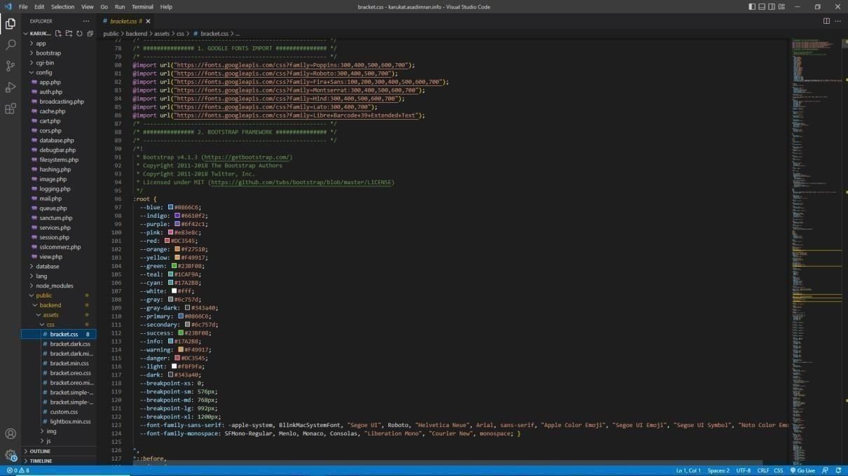

**Figure:** Backend CSS

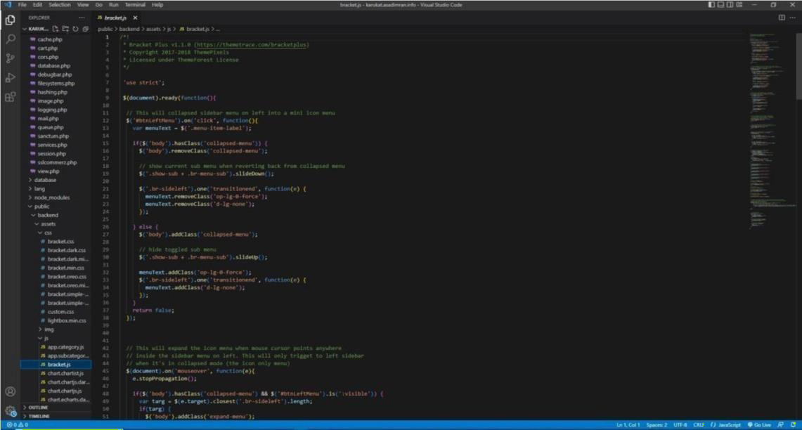

**Figure:** Backend JS

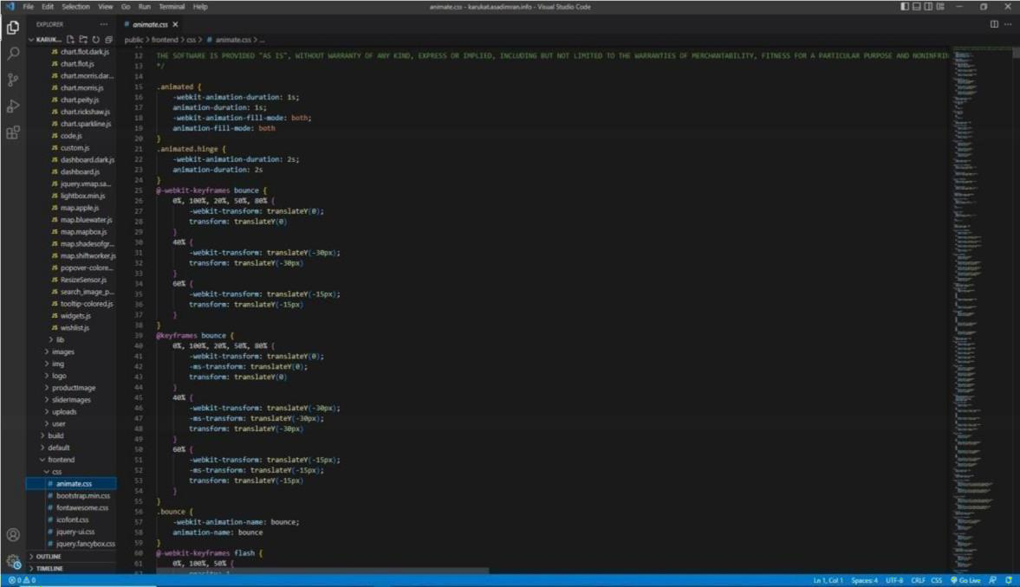

**Figure:** Front-End CSS

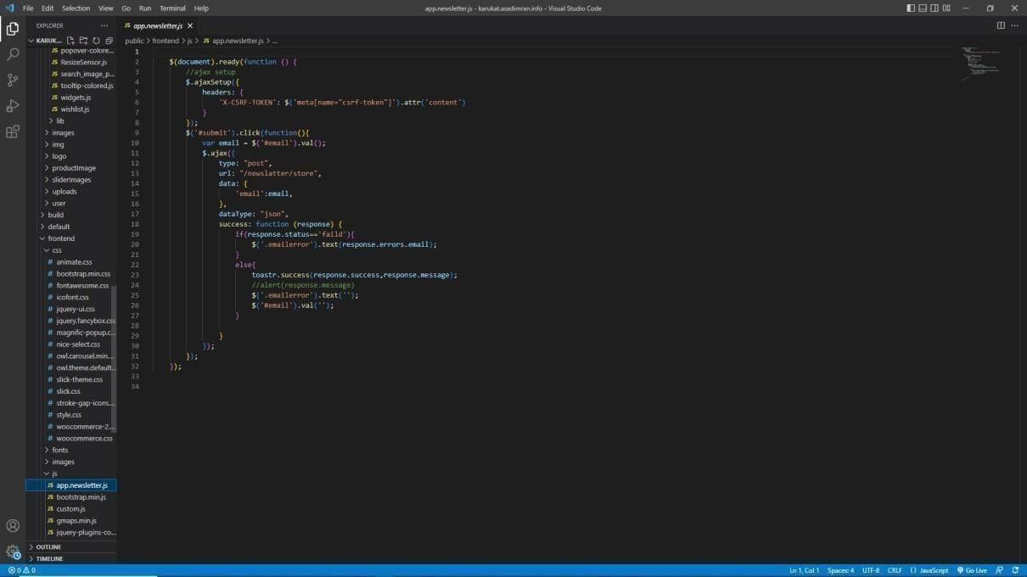

**Figure:** Front-End JS

# REFERENCES

1. “Many women in Bangladesh create online businesses during pandemic,” The Financial Express. [Online]. Available: <<https://thefinancialexpress.com.bd/trade/many-women-in- bangladeshcreateonlinebusinesses-during-pandemic-1609255446. >> [Accessed: 03-Jan-2023]
2. “Bangladesh unemployed PERSONS2022 data - 2023 forecast”. Available at:

<<<https://tradingeconomics.com/bangladesh/unemployed-persons>>> [Accessed: January 3, 2023].

1. “Bangladesh - eCommerce,” International Trade Administration | Trade.gov. [Online]. Available at:

<<[https://www.trade.gov/country-commercial-guides/bangladesh-ecommerce.](https://www.trade.gov/country-commercial-guides/bangladesh-ecommerce)>> [Accessed: 03-Jan-2023].

1. “Historical development of eCommerce in Bangladesh,” Business Inspection BD, 19-Mar-2022. [Online]. Available at: <<[https://businessinspection.com.bd/historical-development-of-ecommerce-in-bd/.](https://businessinspection.com.bd/historical-development-of-ecommerce-in-bd/)>> [Accessed: 01-Jan-2023].
2. “E-commerce of Bangladesh: Shaping the future of shopping,” Idlc.com. [Online]. Available:

<<[https://idlc.com/mbr/article.php?id=136.](https://idlc.com/mbr/article.php?id=136)>> [Accessed: 01-Jan-2023].

1. “Web usability of aarong e-commerce (no date) Assignment Point”. Available at:

<<<https://assignmentpoint.com/webusability-of-aarong-e-commerce/>>> [Accessed: December 31, 2023].

1. N. Arif and F. T. Zohora, “Karighor: arts and crafts for rural development,” 2016.
2. ”Facebook.com.” [Online]. Available at:

<<[https://www.facebook.com/business/help/289268564912664?id=2427773070767892.](https://www.facebook.com/business/help/289268564912664?id=2427773070767892.%20) >> [Accessed: 03- Jan-2023].

1. T. Ahmed, “E-business job qualification of Upoharbd.com,” 2016.
2. “Researchgate.net.” [Online]. Available at:

<<https://[www.researchgate.net/profile/FernandoReimers/publication/350447171_An_educational_calamit](http://www.researchgate.net/profile/FernandoReimers/publication/350447171_An_educational_calamit) y_Learning_and_teaching_during_the_Covid19_pandemic/links/60659b37299bf1252e1d832a/An- educational-calamity-Learning-and-teaching-during-theCovid19-pandemic.pdf#page=28.>> [Accessed: 04- Jan-2023].

1. “What is fashiontiy (2014) FashionTIY.” Available at :<< https://docs.fashiontiy.com/ >> [Accessed: January 1, 2023].
2. “Trusted online shopping in Bangladesh,” Priyoshop.com. [Online]. Available at: https://priyoshop.com/about-us. [Accessed: 03-Jan-2023]
3. “Bangladesh - eCommerce,” International Trade Administration | Trade.gov. [Online]. Available at:

<<[https://www.trade.gov/country-commercial-guides/bangladesh-ecommerce.](https://www.trade.gov/country-commercial-guides/bangladesh-ecommerce)>> [Accessed: 01-Jan-2023].

1. “One in six Brits scammed on Facebook Marketplace - spot the 7 warning signs,” mirror, 06- Jan2022. [Online]. Available at: <<https://[www.mirror.co.uk/money/quarter-brits-been-scammed-](http://www.mirror.co.uk/money/quarter-brits-been-scammed-) facebook25873919.>> [Accessed: 01-Jan-2023].
2. “Ibm.com.” [Online]. Available at:

<<https://[www.ibm.com/cloud/blog/businessprocessmodeling.%20Accessed%2031%20Dec.%202022.](http://www.ibm.com/cloud/blog/businessprocessmodeling.%20Accessed%2031%20Dec.%202022)>> [Accessed: 03-Jan-2023].

1. “Wikipedia.org.” [Online]. Available at:

<<[https://en.wikipedia.org/w/index.php?title=Software_requirements_specificat.](https://en.wikipedia.org/w/index.php?title=Software_requirements_specificat)>> [Accessed: 03-Jan- 2023].

1. “Altexsoft.com.” [Online]. Available at:

<<[https://www.altexsoft.com/blog/business/functionalandnonfunctionalrequirements.](https://www.altexsoft.com/blog/business/functionalandnonfunctionalrequirements)>> [Accessed: 02- Jan2023].

1. “Adobe.com.” [Online]. Available at: <<https://xd.adobe.com/ideas/principles/web- design/frontenduxdesignfordevelopers/.>> [Accessed: 02-Jan-2023].
2. “Laravel - the PHP framework for web artisans,” Laravel.com. [Online]. Available at:

<<[https://laravel.com/.](https://laravel.com/)>> [Accessed: 01-Jan-2023].

1. Wikipedia contributors, “MySQL,” Wikipedia, The Free Encyclopedia, 17-Dec-2022. [Online]. Available at: <[https://en.wikipedia.org/w/index.php?title=MySQL&oldid=1127875696.](https://en.wikipedia.org/w/index.php?title=MySQL&oldid=1127875696)> [Accessed: 03- Jan-2023].
2. “Techtarget.com.” [Online]. Available at:

<<[https://www.techtarget.com/searchcustomerexperience/definition/implementa.](https://www.techtarget.com/searchcustomerexperience/definition/implementa)>> [Accessed: 03-Jan- 2023].

1. “What is software testing? Definition,” Guru99, 02-Jan-2020. [Online]. Available at:

<<[https://www.guru99.com/software-testing-introduction-importance.html.](https://www.guru99.com/software-testing-introduction-importance.html)>> [Accessed: 03-Jan-2023].